Supplementary Material

# Supplementary Figures and Tables



# Supplementary Table 1: List of sample sites and the associated sample bag IDs. Bulk soil samples were extracted for *S. lindsayae* and are archived in the Monte L. Bean Life Sciences Museum frozen soil repository in Provo, Utah and remain available for subsequent examination.

**Supplementary Figure 1:** Rarefaction curve identifying the number of different haplotypes (y-axis) found across the number of sequences (x-axis) indicating the number of individuals sequenced and the recovered haplotypes possible. Rarefaction curve was calculated with the Spider package in R using the random method and 1000 permutations (Brown *et al.* 2012*)*.

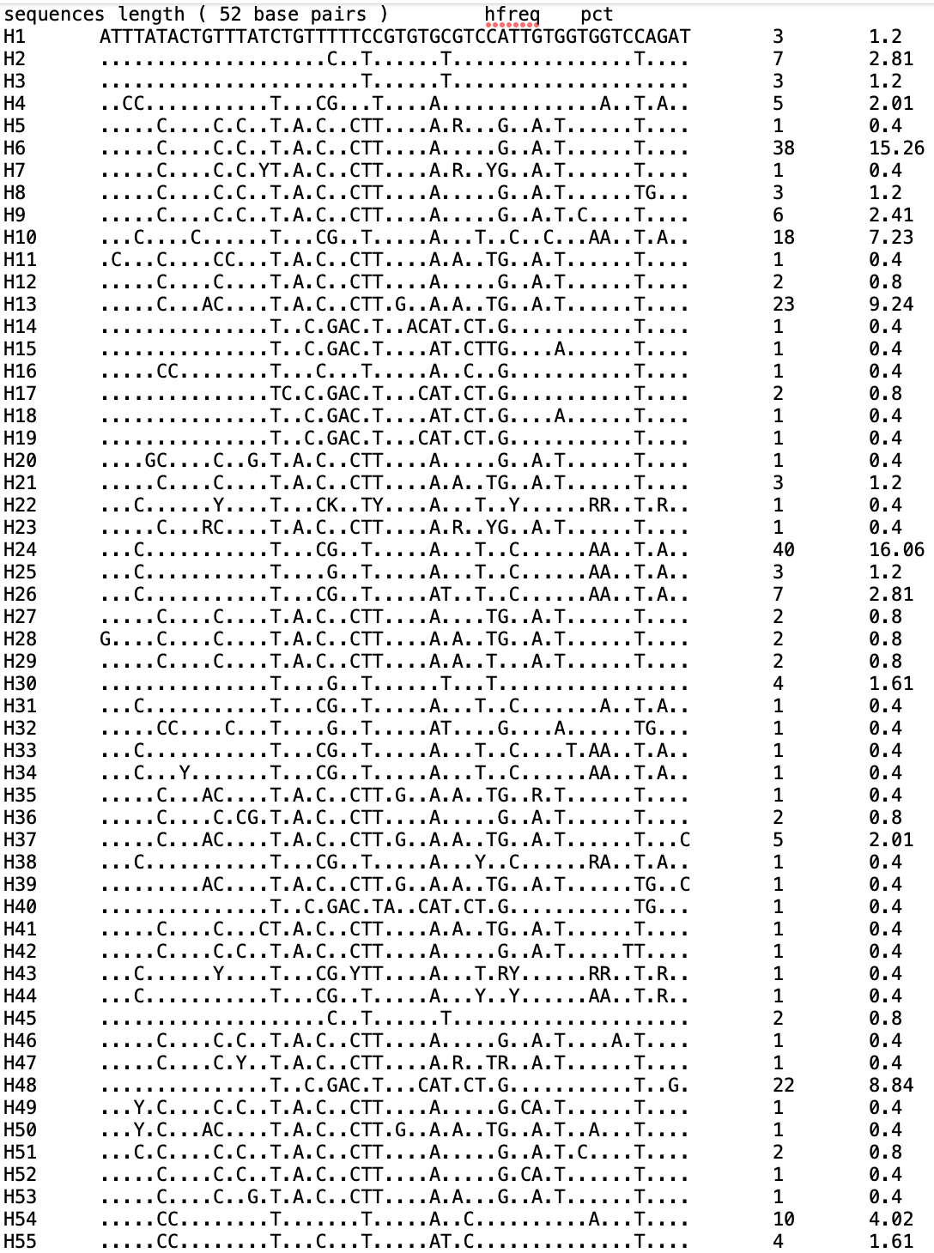 **Supplementary Figure 2:** Table indicating the number of haplotypes (H#) followed by the variable sequences of each haplotype, the frequency, and percent of that haplotype.

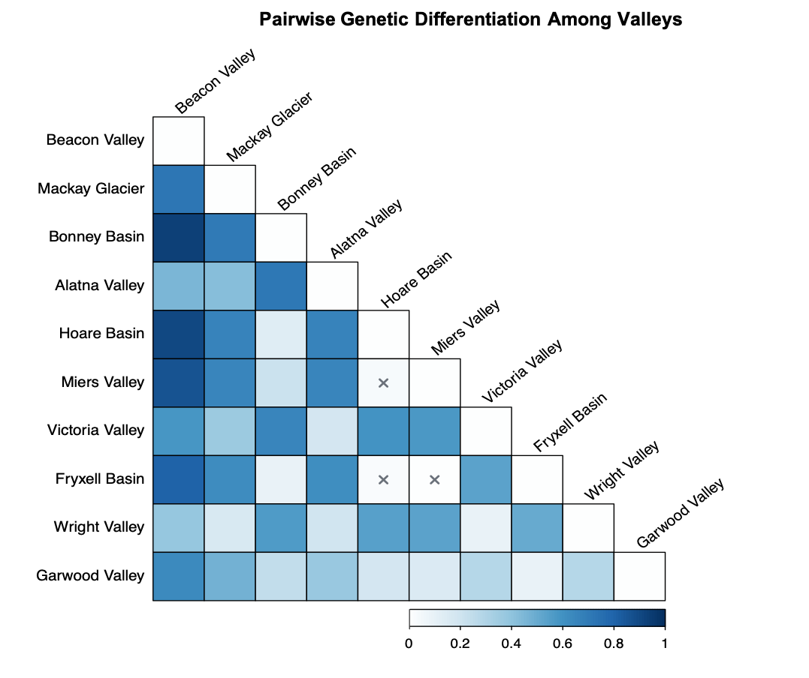**Supplementary Figure 3:** Genetic differentiation matrix calculated with Kimura 2P test of pooled populations within each valley. Darker colors indicate larger FST values between two populations designated on the horizontal and vertical. “X” marks correspond to p-values < 0.05.

**Supplementary** **Figure 4:** Pairwise FST among each sample location calculated in ARLEQUIN using Kimura 2P gamma 4 model. Red corresponds to FST values below average and green to values above average.



**Supplementary Figure 5:** Maximum likelihood phylogeny of *Scottnema lindsayae* COI sequences inferred using IQ-TREE under the HKY+F+G4 model with 10,000 ultrafast bootstrap replicates. Bootstrap support values ≥50% are shown along branches. Tip labels denote sampling sites and are color-coded by location to match Figure 2. All sequences were retained to preserve information on within-site variation. While many internal nodes have low support, this tree is concordant with phylogenetic relationships in the population-level dendrogram (Figure 5) and haplotype network (Figure 3).

|  |  |  |  |  |
| --- | --- | --- | --- | --- |
| **Within population F** |  |  |  |  |
| **Model parameters** | **df** | **AIC** | **∆** | **Weight** |
| Elevation + Soil Moisture + Elevation × Soil Moisture | 5 | 139.62 | 0 | 0.37 |
| Elevation + Soil Moisture | 4 | 141.49 | 1.87 | 0.15 |
| Elevation + Glacial History | 4 | 142.34 | 2.73 | 0.09 |
| Elevation + EC | 4 | 142.34 | 2.73 | 0.10 |
| Glacial History + EC + Glacial History × EC | 5 | 143.80 | 4.18 | 0.05 |
| Elevation + EC + Elevation × EC | 5 | 143.81 | 4.19 | 0.05 |
| Glacial History + Soil Moisture + Glacial History × Soil Moisture | 5 | 144.24 | 4.62 | 0.04 |
| Elevation + Glacial History + Soil Moisture | 5 | 144.46 | 4.84 | 0.03 |
| Elevation + Glacial History + Elevation x Glacial History | 5 | 144.86 | 5.24 | 0.03 |
| Glacial History + Soil Moisture | 4 | 145.05 | 5.43 | 0.02 |
| Glacial History + EC | 4 | 145.49 | 5.87 | 0.02 |
| Glacial History + Distance to the Coast | 4 | 145.55 | 5.94 | 0.02 |
| Glacial History + Dist to Coast + Glacial History x Dist to Coast | 5 | 145.75 | 6.14 | 0.02 |
| Soil Moisture + Dist to Coast | 4 | 147.25 | 7.64 | 0.01 |
| Soil Moisture + EC | 4 | 147.82 | 8.20 | 0.01 |
| Distance to Coast + EC | 4 | 148.54 | 8.92 | 0.00 |
| Soil Moisture + Dist to Coast + Soil Moisture x Dist to Coast | 5 | 148.61 | 9.00 | 0.00 |
| Soil Moisture + EC + Soil Moisture x EC | 5 | 150.27 | 10.65 | 0.00 |
| Dist to Coast + EC + Dist to Coast x EC | 5 | 151.63 | 12.01 | 0.00 |
| **Haplotype Diversity** |  |  |  |  |
| **Model parameters** | **df** | **AIC** | **∆** | **Weight** |
| Elevtion + Glacial History + Elevation x Glacial History | 5 | 2.63 | 0 | 0.76 |
| Elevation + Galcial History | 4 | 5.43 | 2.80 | 0.19 |
| Elevation + Soil Moisture | 5 | 8.52 | 5.89 | 0.04 |
| Elevation + EC | 4 | 12.95 | 10.31 | 0.00 |
| Elevation + Soil Moisture | 4 | 13.18 | 10.54 | 0.00 |
| Elevation + EC + Elecation × EC | 5 | 15.56 | 12.92 | 0.00 |
| Elevation + Soil Moisture + Elevation × Soil Moisture | 5 | 15.97 | 13.34 | 0.00 |
| Dist to Coast + EC | 4 | 17.61 | 14.98 | 0.00 |
| Glacial History + Dist to Coast | 4 | 17.98 | 15.35 | 0.00 |
| Soil Moisture + Dist to Coast | 4 | 17.99 | 15.35 | 0.00 |
| Glacial History + Soil Moisture | 4 | 19.17 | 16.54 | 0.00 |
| Glacial History + EC | 4 | 19.28 | 16.65 | 0.00 |
| Soil Moisture + EC | 4 | 19.36 | 16.73 | 0.00 |
| Glacial History + Dist to Coast + Glacial History x Dist to Coast | 5 | 20.46 | 17.83 | 0.00 |
| Dist to Coast + EC + Dist to Coast x EC | 5 | 20.71 | 18.08 | 0.00 |
| Soil Moisture + Dist to Coast + Soil Moisture x Dist to Coast | 5 | 20.79 | 18.16 | 0.00 |
| Glacial History + EC + Glacial History × EC | 5 | 21.82 | 19.19 | 0.00 |
| Glacial History + Soil Moisture | 5 | 22.23 | 19.60 | 0.00 |
| Soil Moisture + EC + Soil Moisture x EC | 5 | 22.27 | 19.63 | 0.00 |

**Supplementary Figure 6:** Full list of models developed for model selection for within population genetic divergence (top) and ecological conditions. Ecological conditions included elevation (mamsl), soil moisture (%g/g), glacial history, electrical conductivity (EC; dS/m), and distance to the coast (km). We report each parameter per model (model parameter), degrees of freedom (df), Aikaike’s Information criterion (AICC), difference in AICC value comparted to top model (∆), and AICC model weight (Wi). Models with Wi > 0.05 were judged to contain informative parameters and were included in conditional model averaging (Table 5 and Table 6).