Supplementary Material
Global organization of phenylpropanoid and anthocyanin pathways revealed by proximity labeling of trans-cinnamic acid 4-hydroxylase in Petunia inflata petal protoplasts
Javiera Aravena-Calvo¹, Silas Busck-Mellor¹, Tomas Laursen^{1,*}
* Correspondence:
Corresponding Author: tola@plen.ku.dk

Supplementary Figures

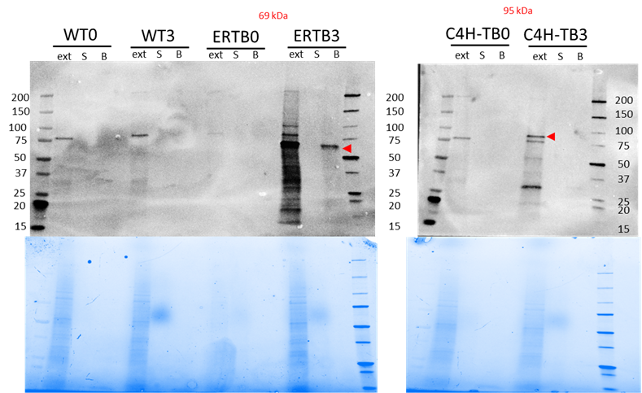

Supplementary Figure 1. Immunoblots to monitor affinity purification step. Protoplasts untransformed (WT) and transformed with plasmids for expression of ER-TurboID-EGFP (ERTB), C4H-TurboID (C4H-TB) and untransformed (WT) were incubated with 50 µM biotin for 0 and 3 hours. After several washing steps, protoplasts were lysed and total protein was isolated. Biotinylated proteins were affinity purified using streptavidin coated beads. A) Immunoblot of the control samples WT and ERTB at 0 and 3 hours after incubation. B) Immunoblot for samples expressing C4H-TurboID (C4H-TB). Lanes: ext: total protein extract, S: supernatant collected after affinity purification. B: proteins eluted from the beads after affinity purification. Red arrows indicate the band corresponding to “self” biotinylation.

Supplementary Figure 2. Principal component analysis of proximity labeling experiment. Petunia petal protoplasts expressing C4Ha-TurboID (C4H), ER-TurboID (ERTB) and untransformed (WT) were collected at 0 and 180 min of biotin incubation. Each treatment is represented by a color, and different shapes correspond to each biological replicate.

B
A
Supplementary Figure 3. Volcano plots of differentially enriched proteins in A) C4H-TurboID vs ER-TurboID-EGFP at t=0 and B) C4H-TurboID vs ER-TurboID-EGFP at t=180 min. Abbreviated enzyme names are indicated with boxes: A3’MT: Anthocyanin 3’-methyltransferase (MT/A3'MT); A3’5’MT2: Anthocyanin 3’5’-methyltransferase (MF2/A3'5’MT2); AN9: glutathione transferase; C4HI, C4Hb, C4Hc: C4H paralogs; C3Ha: cinnamate 3-hydroxylase a; CAD7: cinnamyl alcohol dehydrogenase 7a; CCoAMT3: Caffeoyl-CoA O-methyltransferase 3; Cyt b5b1: Cytochrome b5b 1; KAT1: 3-ketoacyl-CoA thiolase 1; KAT2: 3-ketoacyl-CoA thiolase 2; RT: anthocyanin rhamnosyltransferase.

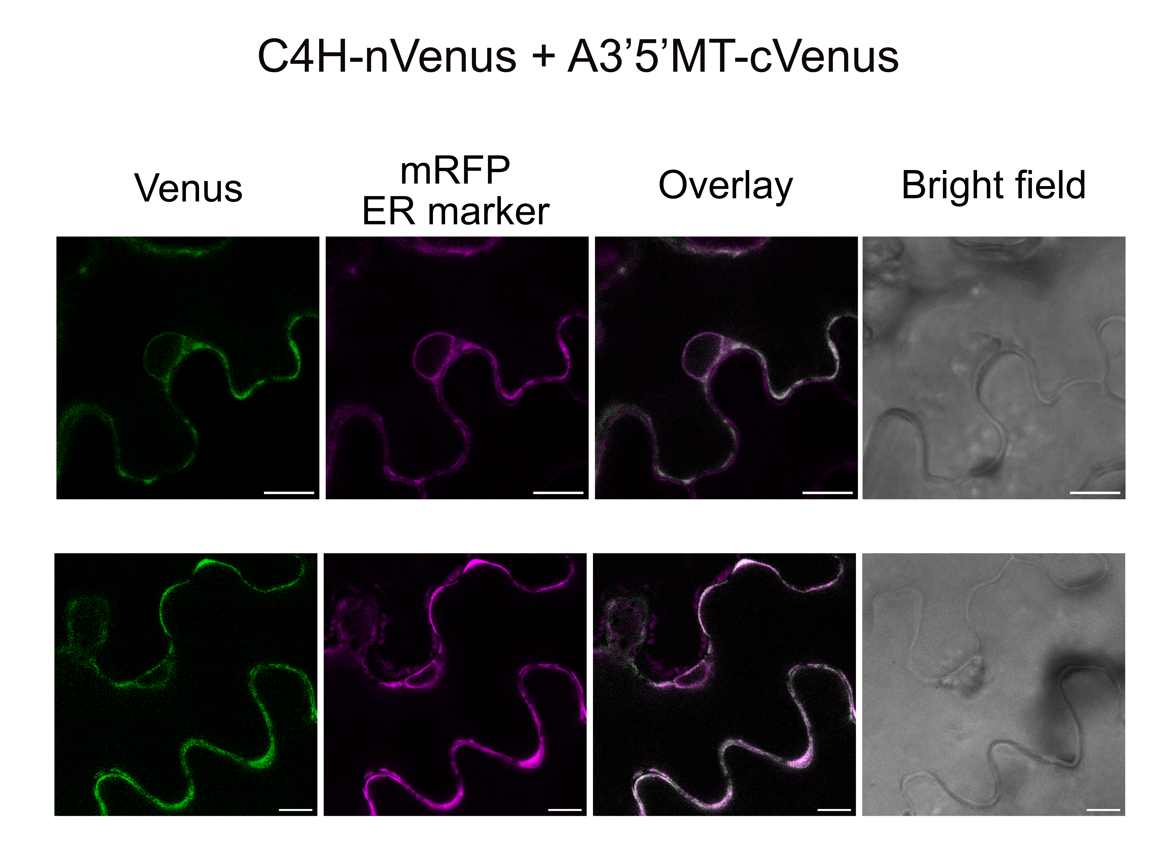

Supplementary Figure 4. Co-expression of C4H-nVenus and A3’5’MT-cVenus in N. benthamiana epidermal cells results in Venus fluorescence complementation, which co-localizes with ER marker (mRFP). Venus fluorescence is particularly faint in the ER portion surrounding the nucleus. Scale bars = 10 µm



