Supplementary Figures to manuscript:

Unraveling the impact of lanthanum on methane consuming microbial communities in rice field soils

**Ruyan Liu1, Ziting Wei1, Wanying Dong1, Rui Wang1, Jonathan M. Adams2, Lin Yang2, Sascha M.B. Krause1\***

1School of Ecology and Environmental Sciences, East China Normal University, Shanghai, China

2School of Geographic and Oceanographic Sciences, Nanjing University, Nanjing, China

**Supplementary Figure S1.** Top 30 microbes for start material; control (CK), 300 (L), 600 (M), and 1200 (H) mg/L La treatments at the ASV level in three different pH samples, from top to bottom respectively are acidic (a), neutral (b), alkaline (c) samples.

**Supplementary Figure S2.** β-diversity for start material, control (CK), 300 (L), 600 (M), and 1200 (H) mg/L La treatments in acidic (a), neutral (b), and alkaline (c) samples over time.

**Supplementary Figure S3.** Shannon diversity in three samples at different pH for start material, control (CK), 300 (L), 600 (M), and 1200 (H) mg/L La treatments (*, *P* < 0.05; **, *P* < 0.01; ***, *P* < 0.001; ****, *P* < 0.0001; ns, no significance). Distinct letters in the plot indicate statistically differences among different La3+ treatments (*P*<0.05).

**Supplementary Figure S4.** The concentration of La in the supernatant for control (CK), 300 (L), 600 (M), and 1200 (H) mg/L La treatments (*, *P* < 0.05; **, *P* < 0.01; ***, *P* < 0.001; ****, *P* < 0.0001; ns, no significance). Error bars indicate SD (n=3), distinct letters in the plot indicate statistically differences among different La3+ treatments (*P*<0.05).

**Supplementary Figure S5.** Contents of NH4+, Ca2+, NO3-, and PO43- in the supernatant for control (CK), 300 (L), 600 (M), and 1200 (H) mg/L La treatments (*, *P* < 0.05; **, *P* < 0.01; ***, *P* < 0.001; ****, *P* < 0.0001; ns, no significance). Error bars indicate SD (n=3), distinct letters in the plot indicate statistically differences among different La3+ treatments (*P*<0.05).

**Supplementary Figure S6.** Fractions of La3+ content recovered after 4 weeks of incubation in soil particles and supernatant of 300 (L), 600 (M), and 1200 (H) La treatments.

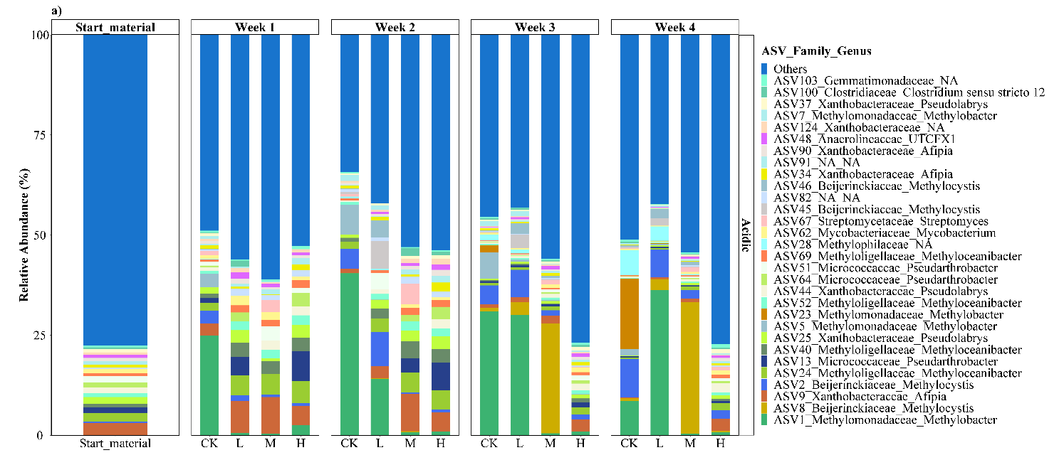

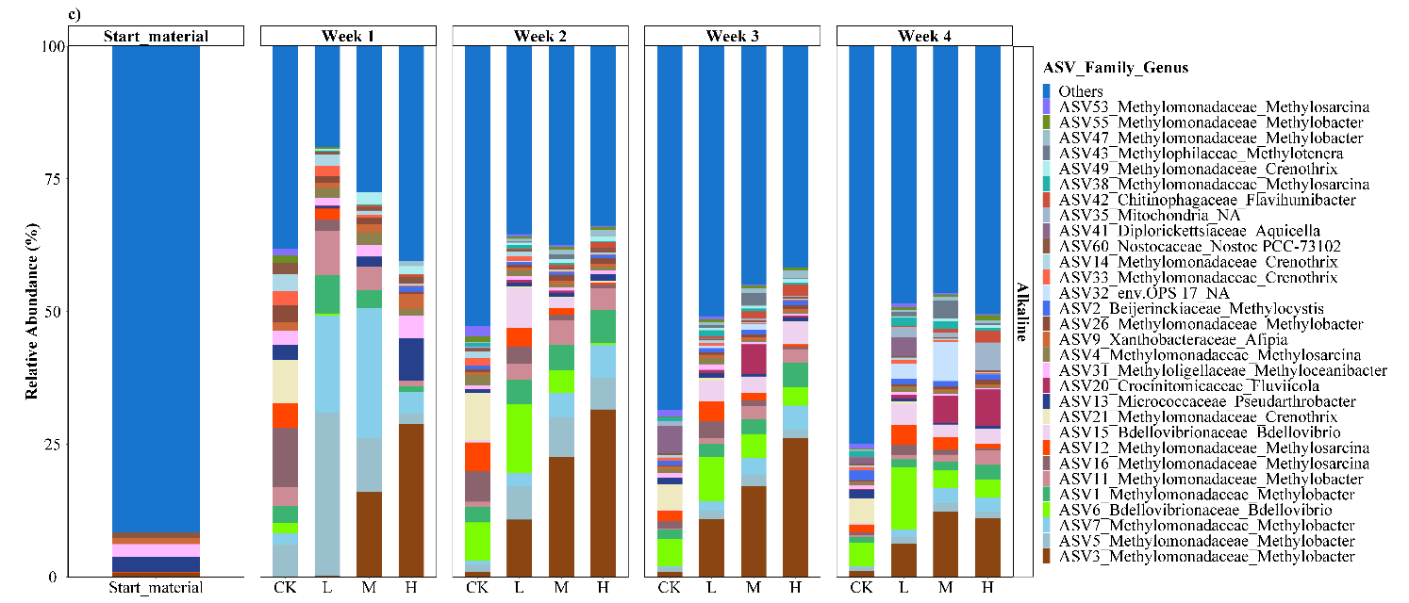

**Supplementary Figure S1.** Top 30 microbes for start material; control (CK), 300 (L), 600 (M), and 1200 (H) mg/L La treatments at the ASV level in three different pH samples, from top to bottom respectively are acidic (a), neutral (b), alkaline (c) samples.



**Supplementary Figure S2.** β-diversity for start material, control (CK), 300 (L), 600 (M), and 1200 (H) mg/L La treatments in acidic (a), neutral (b), and alkaline (c) samples over time.

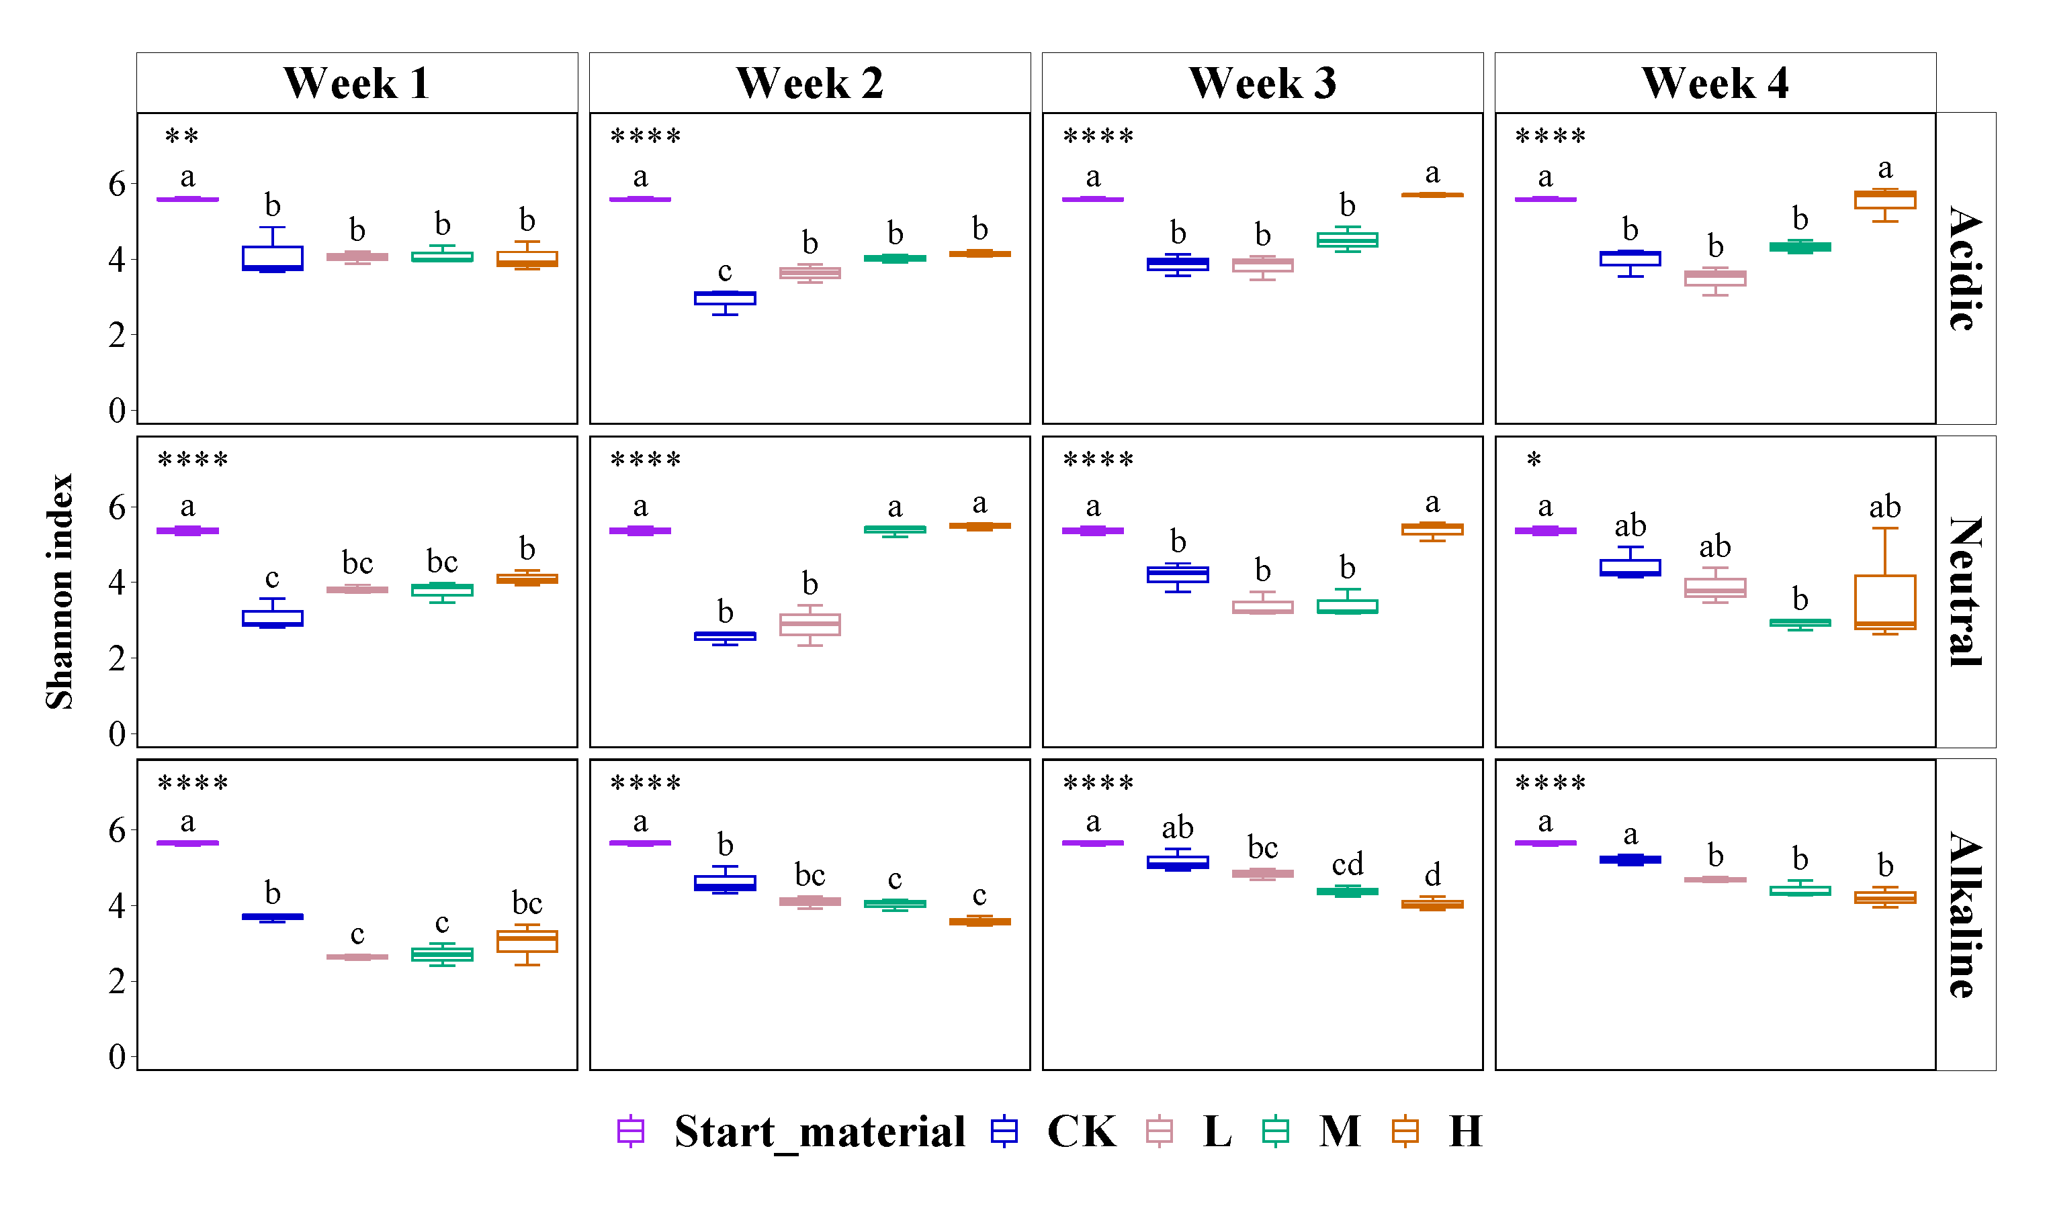

**Supplementary Figure S3.** Shannon diversity in three samples at different pH for start material, control (CK), 300 (L), 600 (M), and 1200 (H) mg/L La treatments (*, *P* < 0.05; **, *P* < 0.01; ***, *P* < 0.001; ****, *P* < 0.0001; ns, no significance). Distinct letters in the plot indicate statistically differences among different La3+ treatments (*P*<0.05).

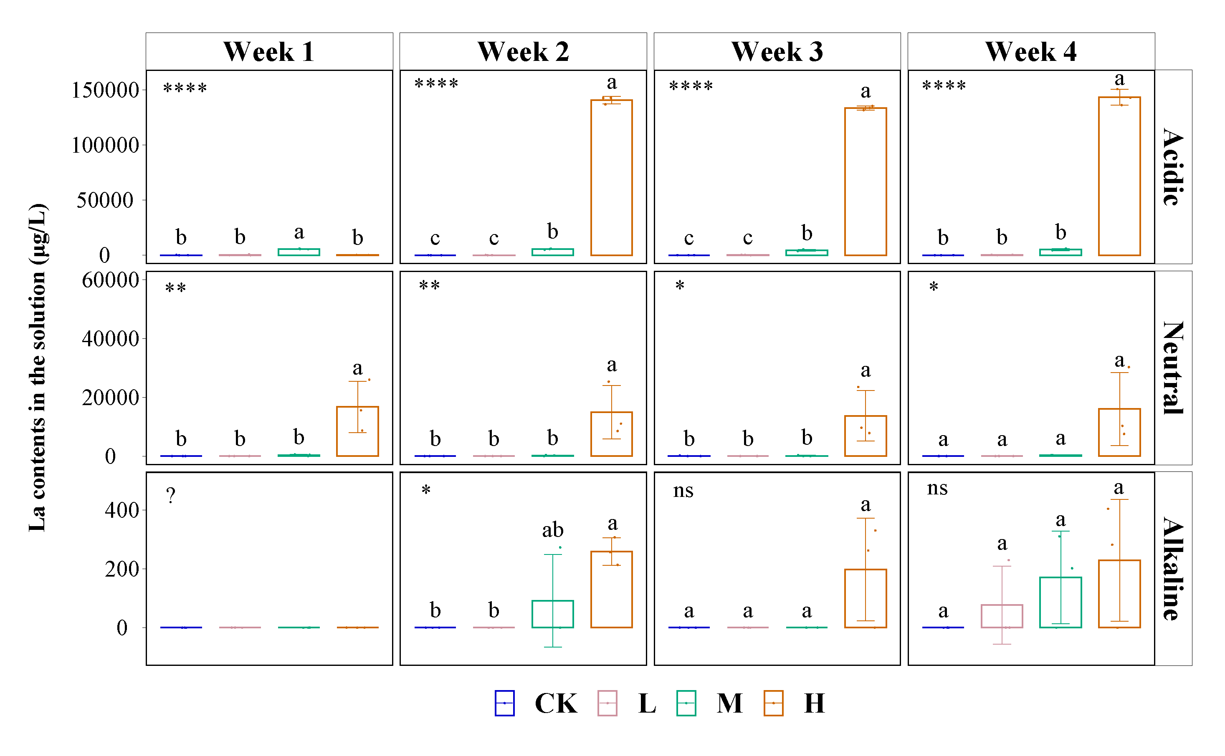

**Supplementary Figure S4.** The concentration of La in the supernatant for control (CK), 300 (L), 600 (M), and 1200 (H) mg/L La treatments (*, *P* < 0.05; **, *P* < 0.01; ***, *P* < 0.001; ****, *P* < 0.0001; ns, no significance). Error bars indicate SD (n=3), distinct letters in the plot indicate statistically differences among different La3+ treatments (*P*<0.05).

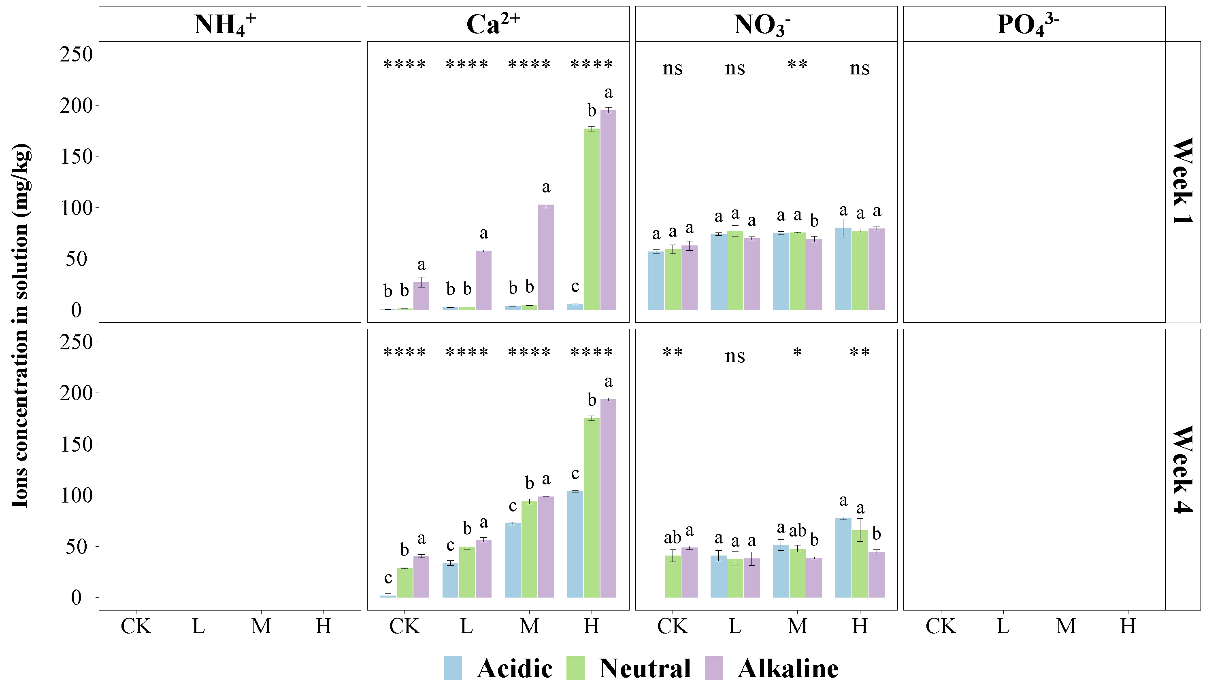

**Supplementary Figure S5.** Contents of NH4+, Ca2+, NO3-, and PO43- in the supernatant for control (CK), 300 (L), 600 (M), and 1200 (H) mg/L La treatments (*, *P* < 0.05; **, *P* < 0.01; ***, *P* < 0.001; ****, *P* < 0.0001; ns, no significance). Error bars indicate SD (n=3), distinct letters in the plot indicate statistically differences among different La3+ treatments (*P*<0.05).

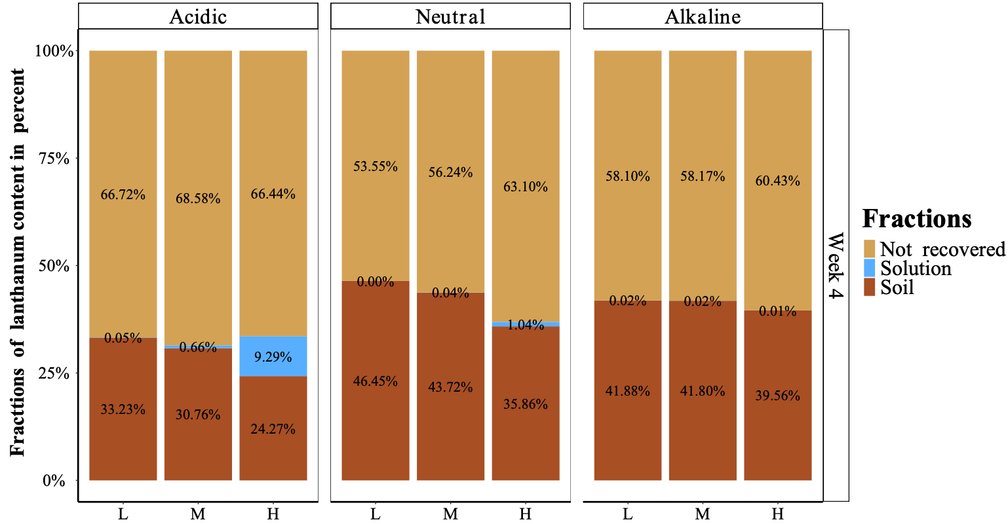

**Supplementary Figure S6.** Fractions of La3+ content recovered after 4 weeks of incubation in soil particles and supernatant of 300 (L), 600 (M), and 1200 (H) La treatments.