***Supplementary Material***

# Supplementary Data

* 1. **Terminology used**

Trust and respect were selected as proxies to evaluate the state of relationships between protected areas authorities and local communities. Trust is the “judgement that the system is responsive and will do what is right even in the absence of constant scrutiny” (Ugur-Cinar *et al*., 2020). Respect is the “politeness, honour, and care shown towards someone or something that is considered important” (Cambridge Dictionary, 2023).

A note on protected areas authorities, or rangers, in Thailand: PA authorities in Thailand work for the government under the Department of National Parks, Wildlife and Plant Conservation (DNP). They fall under two categories: (1) permanent employees, i.e., receive a monthly salary with social security, or (2) temporary employees, i.e., one-year contract with no additional benefits. To obtain permanent employment, they must work at least 5 years in a PA and obtain a reference letter from their superintendent. Additionally, they must pass a physical exam and an interview. A ranger’s work range is wide and covers six key areas: patrolling, monitoring wildlife, combating poaching, engaging local communities, managing fires, and assisting with tourism.

* 1. ***Respondents’ demographic information summarized***

| **Nearby Parks** | **n** | **%** |  | **Age** | **n** | **%** |
| --- | --- | --- | --- | --- | --- | --- |
| Khlong Lan National Park | 84 | 42 |  | Below 30 years | 19 | 9.5 |
| Mae Wong National Park | 116 | 58 |  | 31-50 years | 96 | 48 |
| *Total* | *200* | *100* |  | Above 50 years | 85 | 42.5 |
|  |  |  |  | *Total* | *200* | *100* |
| **Sex** | **n** | **%** |  |  |  |  |
| Female | 91 | 45.5 |  | **Friend or family employed as ranger** | **n** | **%** |
| Male | 106 | 53 |  | No | 143 | 71.5 |
| NA | 3 | 1.5 |  | Yes | 57 | 28.5 |
| *Total* | *200* | *100* |  | *Total* | *200* | *100* |
|  |  |  |  |  |  |  |
| **Employed ranger** | n | % |  | **Education level** | **n** | **%** |
| No | 191 | 95.5 |  | Higher bachelor’s | 2 | 1 |
| Yes | 8 | 4 |  | Bachelor's degree | 17 | 8.5 |
| NA | 1 | 0.5 |  | Grade 12 | 54 | 27 |
| *Total* | *200* | *100* |  | Grade 9 | 55 | 27.5 |
|  |  |  |  | Grade 6 | 55 | 27.5 |
| **Occupation** | **n** | **%** |  | NA | 17 | 8.5 |
| Agriculture | 110 | 55 |  | *Total* | *200* | *100* |
| Business | 19 | 9.5 |  |  |  |  |
| Employee | 45 | 22.5 |  |  |  |  |
| Work for government | 7 | 3.5 |  |  |  |  |
| Unemployed | 16 | 8 |  |  |  |  |
| NA | 3 | 1.5 |  |  |  |  |
| *Total* | *200* | *100* |  |  |  |  |

## *Survey questionnaire*

**BASIC INFORMATION (TO BE FILLED OUT BY EXAMINER)**

Date: __________

Respondent code: _______________

Gender: __________

Nearby Park(s) name: _____________________

Country: _______________

Location of survey: _____________________

**SECTION 1.**

PART 1: Please provide the following information about yourself.

1. What is your age? ____

2. What is the highest level of education you have received? _____________________

3. How long have you been living in the community (approximate to the nearest year):  _____ year(s)

4. Are you employed?                                                                                             YES / NO

         4.1. If YES to 4, what is your occupation: _________________

5. Have you ever been employed as a ranger?                                                             YES / NO

6. Do you have friends or family that are employed as rangers?                                 YES / NO

7. What is your gross annual income? __________________

8. Are you married?                                                                                                 YES / NO

9. Do you have children?                                                                                             YES / NO

**SECTION 2.**

10. How likely would YOU be to do each of the following? Please **CIRCLE** the number which corresponds with your response. Refer to the nearby conservation agency in blank.

|  | Very unlikely | Unlikely | Likely | Very likely |
| --- | --- | --- | --- | --- |
| a. Attend a community meeting hosted by the Park authorities to learn about conservation. | 1 | 2 | 3 | 4 |
| b. Call Park authorities if you saw a person entering the conservation area illegally. | 1 | 2 | 3 | 4 |
| c. Call Park managers if you noticed a community problem, such as problem wildlife entering the community. | 1 | 2 | 3 | 4 |
| d. Call Park rangers if you noticed a community problem, such as problem wildlife entering the community. | 1 | 2 | 3 | 4 |
| e. Tell Park managers if you had information about wildlife crime or suspected offenders. | 1 | 2 | 3 | 4 |
| f. Tell Park rangers if you had information about wildlife crime or suspected offenders. | 1 | 2 | 3 | 4 |
| g. Tell the police if you had information about wildlife crime or suspected offenders. | 1 | 2 | 3 | 4 |

11. Please tell us how much you agree or disagree with each of the following statements. Please **CIRCLE** the number which corresponds with your response. Refer to the nearby conservation agency in blank.

|  | Strongly disagree | Disagree | Agree | Strongly agree |
| --- | --- | --- | --- | --- |
| a. Park management treats people with respect. | 1 | 2 | 3 | 4 |
| b. Park management treats people fairly. | 1 | 2 | 3 | 4 |
| c. Park management takes the time to listen to people. | 1 | 2 | 3 | 4 |
| d. Park management makes decisions based on facts and law, not on their personal opinions. | 1 | 2 | 3 | 4 |
| e. Park management explains their decisions to people. | 1 | 2 | 3 | 4 |
| f. Park management does a good job of keeping the community safe from wildlife. | 1 | 2 | 3 | 4 |
| g. Park management is often rude or discourteous. | 1 | 2 | 3 | 4 |
| h. When the Park management issues a formal order, you should do what they want even if you disagree with it. | 1 | 2 | 3 | 4 |
| i. Park management gives equal services to both the wealthy and the poor. | 1 | 2 | 3 | 4 |
| j. You should accept Park rangers’ decisions even if you think they are wrong. | 1 | 2 | 3 | 4 |
| k. Communities should be able to provide input for conservation decision-making. | 1 | 2 | 3 | 4 |
| l. It would be hard to justify disobeying a Park ranger. | 1 | 2 | 3 | 4 |
| m. Park rangers are generally honest. | 1 | 2 | 3 | 4 |
| n. Most Park rangers do their jobs well. | 1 | 2 | 3 | 4 |
| o. Park rangers provide equal services to people of all ethnicities. | 1 | 2 | 3 | 4 |
| p. Park rangers can be trusted to do what’s good for my community. | 1 | 2 | 3 | 4 |
| q. If a Park ranger did something wrong, I trust that the Park management would fix the problem. | 1 | 2 | 3 | 4 |
| r. Communities are able to provide input to conservation decision- making. | 1 | 2 | 3 | 4 |
| s. The local community benefits from local conservation efforts. | 1 | 2 | 3 | 4 |
| t. If animals damage community property, community members should be compensated. | 1 | 2 | 3 | 4 |
| u. Park laws and rules are clearly articulated to the community by Park management. | 1 | 2 | 3 | 4 |
| v. Most community members know how to contact Park management should they need assistance. | 1 | 2 | 3 | 4 |
| w. Most community members are familiar with the punishments associated with violating Park laws and regulations. | 1 | 2 | 3 | 4 |
| x. Punishments for violating Park laws and regulations are clearly articulated by Park management. | 1 | 2 | 3 | 4 |
| y. Communities are comfortable with contacting Park authorities for assistance. | 1 | 2 | 3 | 4 |

12. Overall, how satisfied are you with the following? Please **CIRCLE** the number which corresponds with your response. Refer to the nearby conservation agency in blank.

|  | Very poor | Poor | Good | Very good |
| --- | --- | --- | --- | --- |
| a. Park management. | 1 | 2 | 3 | 4 |
| b. Local police agency. | 1 | 2 | 3 | 4 |
| c. Local government. | 1 | 2 | 3 | 4 |
| d. Community involvement in Park management. | 1 | 2 | 3 | 4 |
| e. Monetary benefits from local conservation efforts. | 1 | 2 | 3 | 4 |
| f. The services provided by Park management to the local community. | 1 | 2 | 3 | 4 |
| g. Infrastructure to support local conservation efforts. | 1 | 2 | 3 | 4 |

13. We would like to know what you think about laws. Please **CIRCLE** the number which corresponds with your response.

|  | Strongly disagree | Disagree | Agree | Strongly agree |
| --- | --- | --- | --- | --- |
| a. Endangered wildlife should be protected. | 1 | 2 | 3 | 4 |
| b. Wildlife laws are an important tool to protect endangered wildlife. | 1 | 2 | 3 | 4 |
| c. Wildlife laws were developed to help local communities. | 1 | 2 | 3 | 4 |
| d. Wildlife laws reflect local community values. | 1 | 2 | 3 | 4 |
| e. Current laws unfairly restrict access to important resources (e.g. firewood). | 1 | 2 | 3 | 4 |
| f. Current laws unfairly restrict access to important medicinal resources. | 1 | 2 | 3 | 4 |
| g. Current laws unfairly restrict access to resources important for cultural practices. | 1 | 2 | 3 | 4 |

14. Please tell us how much you agree or disagree with each of the following statements. Please **CIRCLE** the number which corresponds with your response. Refer to the nearby conservation agency in blank.

|  | Strongly disagree | Disagree | Agree | Strongly agree |
| --- | --- | --- | --- | --- |
| a. If approached, Park rangers would accept a monetary bribe. | 1 | 2 | 3 | 4 |
| b. If approached, Park rangers would accept a non-monetary gift (e.g. food). | 1 | 2 | 3 | 4 |
| c. If caught accepting a bribe or gift, rangers would be punished by their supervisors. | 1 | 2 | 3 | 4 |
| d. Park rangers would report their fellow rangers to Park management if they were involved in corruption or misconduct. | 1 | 2 | 3 | 4 |

15. Please tell us how much you agree or disagree with each of the following statements. Please **CIRCLE** the number which corresponds with your response. Refer to the nearby conservation agency in blank.

|  | Strongly disagree | Disagree | Agree | Strongly agree |
| --- | --- | --- | --- | --- |
| a. Community members believe that conservation is important. | 1 | 2 | 3 | 4 |
| b. Community members believe that they benefit from conservation. | 1 | 2 | 3 | 4 |
| c. Community members have a sense of ownership for the Park(s). | 1 | 2 | 3 | 4 |
| d. Park management regularly communicates information about the Park(s) to the communities. | 1 | 2 | 3 | 4 |
| e. Most community members are aware of the benefits of the Park(s). | 1 | 2 | 3 | 4 |
| f. Park wildlife pose a threat to the physical safety of community members. | 1 | 2 | 3 | 4 |
| g. Park wildlife poses a threat to the livelihoods (e.g. income) of community members. | 1 | 2 | 3 | 4 |
| h. Park rangers believe that conservation is important. | 1 | 2 | 3 | 4 |
| i. Park rangers believe that they benefit from conservation. | 1 | 2 | 3 | 4 |
| j. Park rangers have a sense of ownership for the Park(s). | 1 | 2 | 3 | 4 |
| k. The community and the Park rangers generally have the same sense of right and wrong. | 1 | 2 | 3 | 4 |

16. Please tell us how much you agree or disagree with each of the following statements. Please **CIRCLE** the number which corresponds with your response.

|  | Strongly disagree | Disagree | Agree | Strongly agree |
| --- | --- | --- | --- | --- |
| a. Communities should be directly involved in decision-making about conservation efforts. | 1 | 2 | 3 | 4 |
| b. Park management needs to be supported by the local community in order to be effective. | 1 | 2 | 3 | 4 |
| c. Local community members should work alongside Park rangers to reduce poaching. | 1 | 2 | 3 | 4 |
| d. Mutual respect between the community and the Park rangers is needed in order for conservation efforts to succeed. | 1 | 2 | 3 | 4 |
| e. Mutual trust between the community and Park rangers is needed in order for conservation efforts to succeed. | 1 | 2 | 3 | 4 |
| f. Park management listens to the needs and concerns of the community. | 1 | 2 | 3 | 4 |
| g. Conservation efforts will only be effective if the community is involved. | 1 | 2 | 3 | 4 |
| h. Park management can be effective without the help of the community. | 1 | 2 | 3 | 4 |
| i. The community respects Park rangers. | 1 | 2 | 3 | 4 |
| j. The community trusts the Park rangers. | 1 | 2 | 3 | 4 |
| k. The community are fearful of the Park rangers. | 1 | 2 | 3 | 4 |
| l. Park rangers respect the community. | 1 | 2 | 3 | 4 |
| m. Park management trusts the community. | 1 | 2 | 3 | 4 |

17. Have you ever heard or witnessed Park rangers engaging in misbehavior or misconduct?  YES/NO

17.1. If YES to 17, can you please describe what you have heard or witnessed? If NO to 17, please continue to Question 18.

______________________________________________________________________________

18. Have you ever heard or witnessed Park rangers engaging in corruption?                       YES/NO

18.1. If YES to 18, can you please describe what you have heard or witnessed? If NO to 18, please continue to Question 19.

______________________________________________________________________________

19. Have you ever heard or witnessed Park rangers engaging in crime?                          YES/NO

19.1. If YES to 19, can you please describe what you have heard or witnessed? If NO to 19, please continue to Question 20.

______________________________________________________________________________

20. Tell us if you agree or disagree with each of the following statements. **CIRCLE** the number corresponding with your response.

|  | Strongly disagree | Disagree | Agree | Strongly agree |
| --- | --- | --- | --- | --- |
| a. Park rangers participate in corruption because of low salaries. | 1 | 2 | 3 | 4 |
| b. Park rangers participate in corruption because of poor facilitation (e.g. equipment and training). | 1 | 2 | 3 | 4 |
| c. Park rangers participate in corruption because they have family or friends living in nearby communities. | 1 | 2 | 3 | 4 |
| d. Park rangers participate in corruption because of greed. | 1 | 2 | 3 | 4 |
| e. Park rangers participate in corruption because other government officials also participate in such behavior. | 1 | 2 | 3 | 4 |
| f. Park rangers participate in corruption because other Park rangers also participate in such behavior. | 1 | 2 | 3 | 4 |
| g. Park rangers participate in corruption because they believe they will not be caught. | 1 | 2 | 3 | 4 |
| h. Park rangers participate in corruption because they believe they will not be punished. | 1 | 2 | 3 | 4 |
| i. Park rangers participate in corruption because their supervisors also participate in such behavior. | 1 | 2 | 3 | 4 |

21. Have you ever attended a meeting hosted by the Park authorities?                                  YES / NO

21.1. IF YES to 21, please tell us how much you agree or disagree with each of the following statements. Please **CIRCLE** the number which corresponds with your response. If NO to 21, please continue to Question 22.

|  | Strongly disagree | Disagree | Agree | Strongly agree |
| --- | --- | --- | --- | --- |
| a. The meeting provided useful information regarding the benefits of the conservation area. | 1 | 2 | 3 | 4 |
| b. The meeting provided useful information regarding local conservation efforts. | 1 | 2 | 3 | 4 |
| c. The meeting provided useful information regarding conservation/ wildlife laws, rules, and regulations. | 1 | 2 | 3 | 4 |
| d. The meeting provided useful information regarding the work being performed by the park rangers and management. | 1 | 2 | 3 | 4 |

21.2. IF YES to 21, please tell us what topics should have been discussed during these meetings that were **not** discussed? If NO to 21, please continue to Question 22.

_________________________________________________________________________________

22. Have you ever had an encounter with a Park ranger?                                                YES / NO

22.1. IF YES to 22, please tell us how much you agree or disagree with each of the following statements. Please **CIRCLE** the number which corresponds with your response. If NO to 22, please continue to Question 23.

|  | Strongly disagree | Disagree | Agree | Strongly agree |
| --- | --- | --- | --- | --- |
| a. The Park ranger treated me with respect. | 1 | 2 | 3 | 4 |
| b. The Park ranger listened to my needs and concerns. | 1 | 2 | 3 | 4 |
| c. The Park ranger was polite. | 1 | 2 | 3 | 4 |
| d. The Park ranger was helpful. | 1 | 2 | 3 | 4 |
| e. The Park ranger was knowledgeable. | 1 | 2 | 3 | 4 |
| f. I felt that I was able to speak my opinion. | 1 | 2 | 3 | 4 |

23. Have you ever had an encounter with wildlife from the park?                                   YES / NO

         23.1 If YES to 23, did you lose livestock as a result of this encounter?           YES / NO

                                 23.1.1. If YES to 23.1, were you compensated for this loss?       YES / NO

         23.2. If YES to 23, did you lose crops as a result of this encounter?                    YES / NO

                     23.2.1. If YES to 23.2, were you compensated for this loss?       YES / NO

         23.3. If YES to 23, were you or your family harmed as a result of this encounter?   YES / NO

                                 23.3.1 If Yes to 23.3, were you or your family compensated?     YES / NO

24. What advice would you give to Park management in order for local conservation efforts to be successful?

_________________________________________________________________________________

# Supplementary Figures

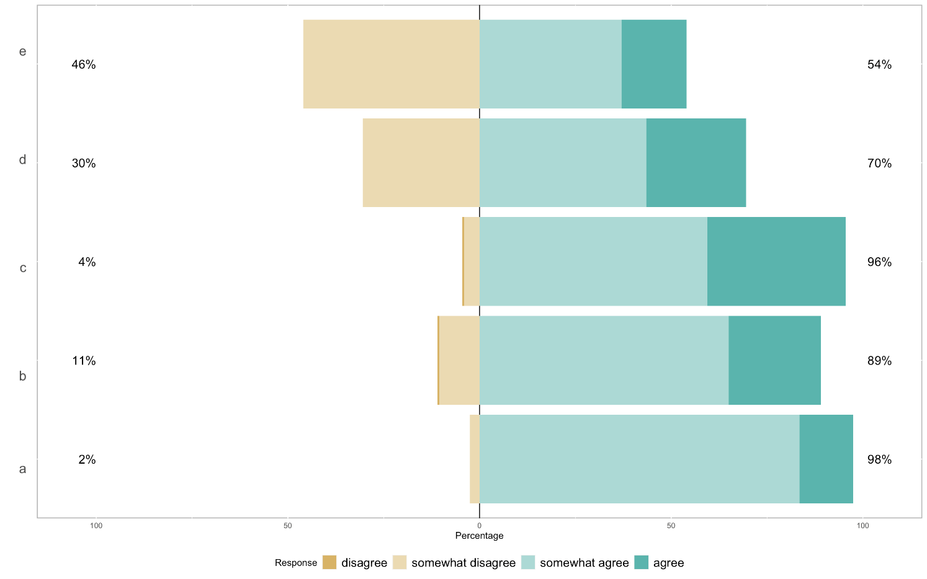

Figure 3. Stacked bar graph of the responses to question 10. From top to bottom: (e) Tell park managers if you had information about wildlife crime or suspected offender, (d) Call park rangers if you noticed a community problem, such as problem wildlife entering the community, (c) Call park managers if you noticed a community problem, such as problem wildlife entering the community, (b) Call park authorities if you saw a person entering the conservation area illegally, and (a) Attend a community meeting hosted by the park authorities to learn about conservation.

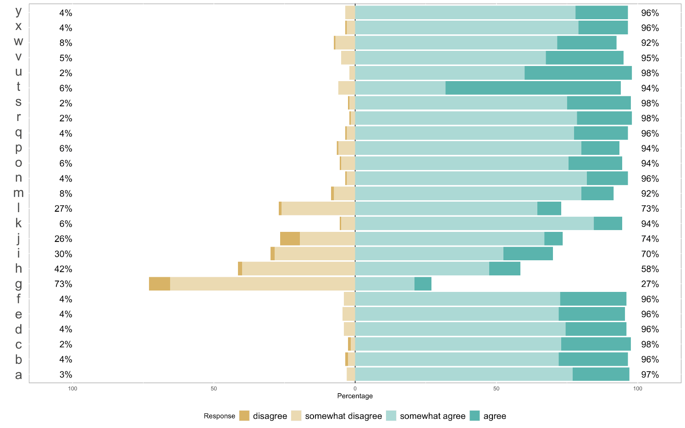

Figure 4. Stacked bar graph of the responses to question 11. From top to bottom: (y) Communities are comfortable with contacting park authorities for assistance, (x) Punishments for violating park laws and regulations are clearly articulated by park management, (w) Most community members are familiar with the punishments associated with violating park laws and regulations, (u) Park laws and rules are clearly articulated to the community by park management, (t) If animals damage community property, community members should be compensated, (r) Communities are able to provide input to conservation decision making, (q) If a Park ranger did something wrong, I trust that the park management would fix the problem, (p) Park rangers can be trusted to do what’s good for my community, (o) Park rangers provide equal services to people of all ethnicities, (n) Most park rangers do their jobs well, (m) Park rangers are generally honest, (l) . It would be hard to justify disobeying a park ranger, (k) Communities should be able to provide input for conservation decision making, (j) You should accept Park rangers’ decisions even if you think they are wrong, (i) Park management give equal services to both the wealthy and the poor, (h) When the park management issue a formal order, you should do what they even if you disagree with it, (g) Park management are often rude or discourteous, (f) Park management do a good job of keeping the community safe from wildlife, (e) Park management explain their decisions to people, (d) Park management make decisions based on facts and law, not on their personal opinions, (c) Park management take the time to listen to people, (b) Park management treat people fairly, and (a) Park management treat people with respect.

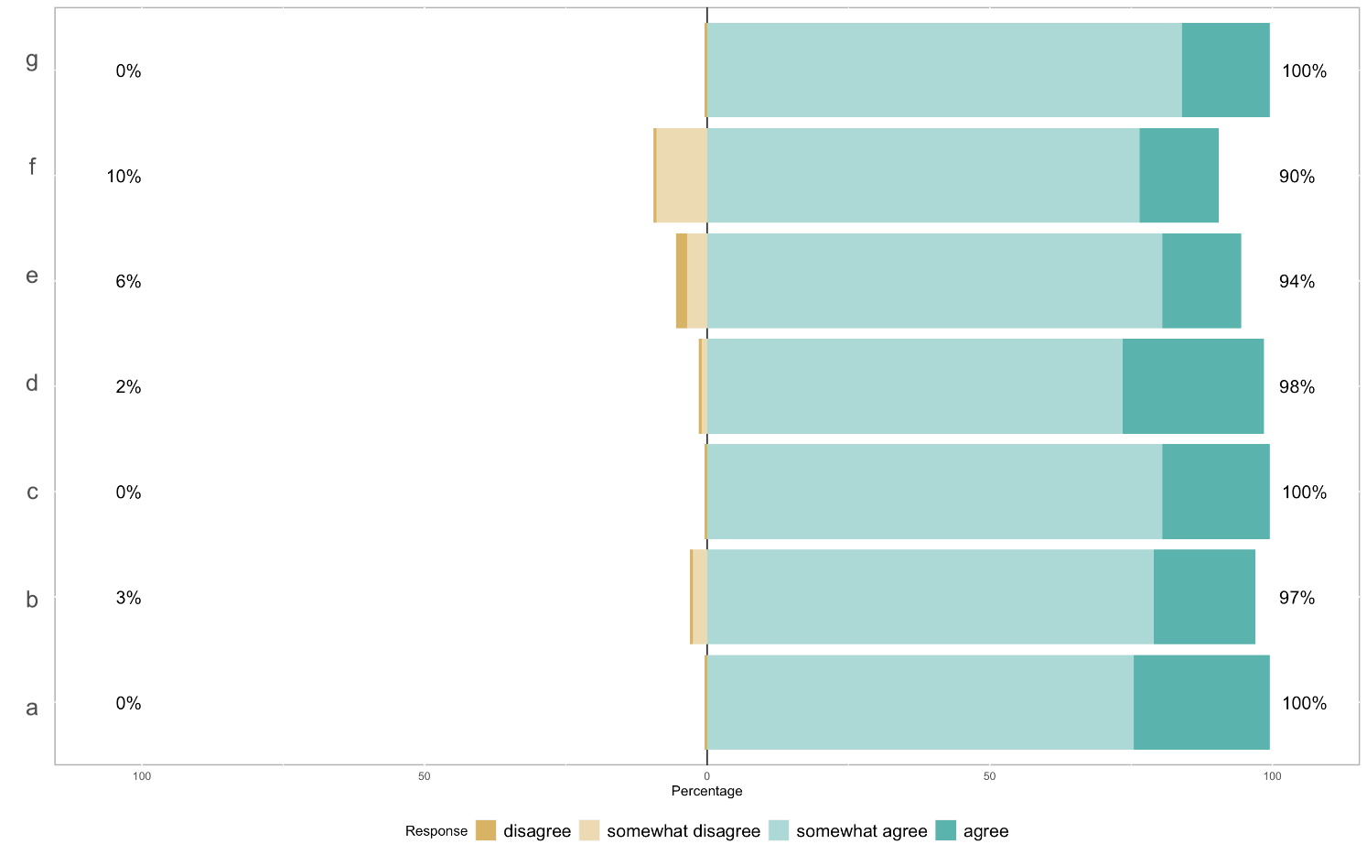

Figure 5. Stacked bar graph of the responses to question 12. From top to bottom: (g) Satisfaction in: Infrastructure to support local conservation efforts, (f) The services provided by Park management to the local community, (e) Monetary benefits from local conservation efforts, (d) Community involvement in park management, (c) Satisfaction in: Local government, (b) Local police agency, and (a) Park management.

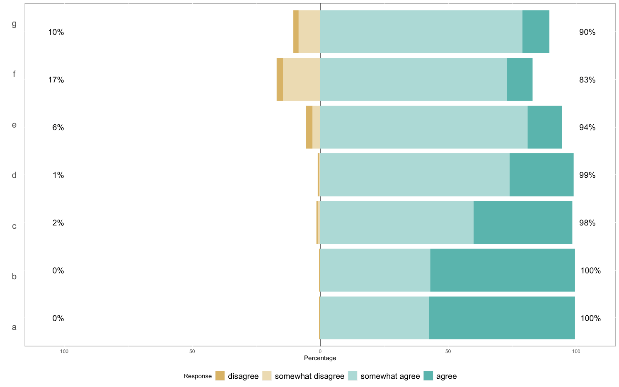

Figure 6. Stacked bar graph of the responses to question 13. From top to bottom: (g) Current laws unfairly restrict access to resources important for cultural practices, (f) Current laws unfairly restrict access to important medicinal resources, (e) Current laws unfairly restrict access to important resources (e.g. firewood), (d) Wildlife laws reflect local community values, (c) Wildlife laws were developed to help local communities, (b) Wildlife laws are an important tool to protect endangered wildlife, and (a) Endangered wildlife should be protected.

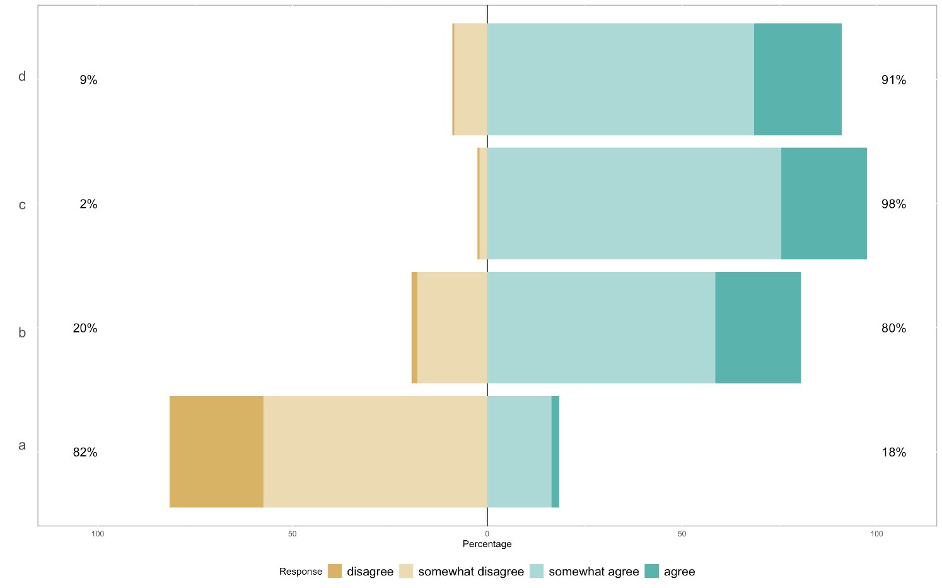

Figure 7. Stacked bar graph of the responses to question 14. From top to bottom: (d) Park rangers would report their fellow rangers to park management if they were involved in corruption or misconduct, (c) If caught accepting a bribe or gift, rangers would be punished by their supervisors, (b) If approached, park rangers would accept a non-monetary gift (e.g. food), and (a) If approached, park rangers would accept a monetary bribe.

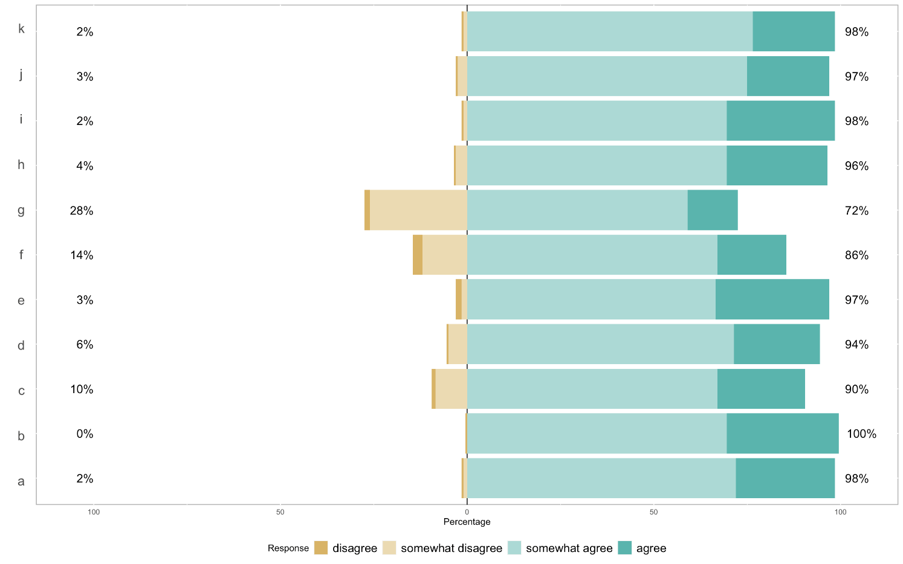

Figure 8. Stacked bar graph of the responses to question 15. From top to bottom: (k) The community and the park rangers generally have the same sense of right and wrong, (j) Park rangers have a sense of ownership for the park(s), (i) Park rangers believe that they benefit from conservation, (h) Park rangers believe that conservation is important, (g) Park wildlife post a threat to the livelihoods (e.g. income) of community members, (f) Park wildlife pose a threat to the physical safety of community members, (e) Most community members are aware of the benefits of the park(s), (d) Park management regularly communicates information about the park(s) to the communities, (c) Community members have a sense of ownership for the park(s), (b) Community members believe that they benefit from conservation, and (a) Community members believe that conservation is important.

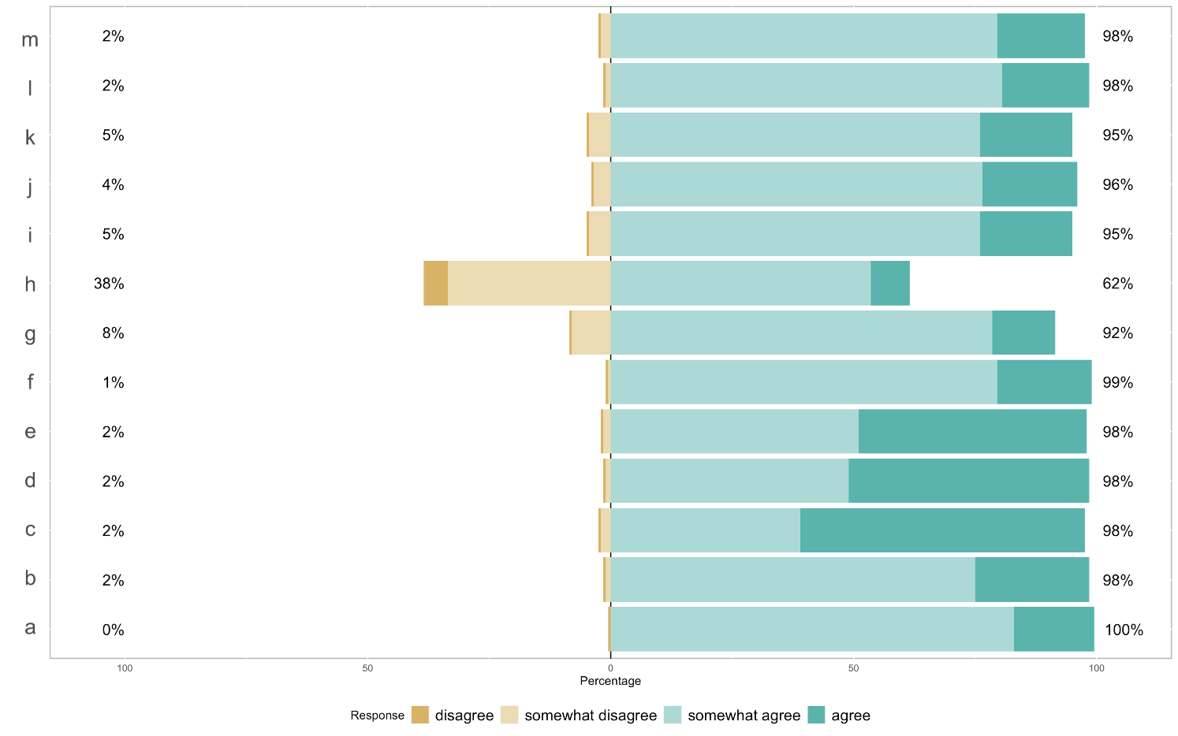

Figure 9. Stacked bar graph of the responses to question 16. From top to bottom: (m) Park management trusts the community, (l) Park rangers respect the community, (k) The community are fearful of the Park rangers, (j) The community trusts the park rangers, (i) The community respects park rangers, (h) Park management can be effective without the help of the community, (g) Conservation efforts will only be effective if the community is involved, (f) Park management listens to the needs and concerns of the community, (e) Mutual trust between the community and Park rangers is needed in order for conservation efforts to succeed, (d) Mutual respect between the community and the Park rangers is needed in order for conservation efforts to succeed, (c) Local community members should work alongside Park rangers to reduce poaching, (b) Park management needs to be supported by the local community in order to be effective, and (a) Communities should be directly involved in decision-making about conservation efforts.

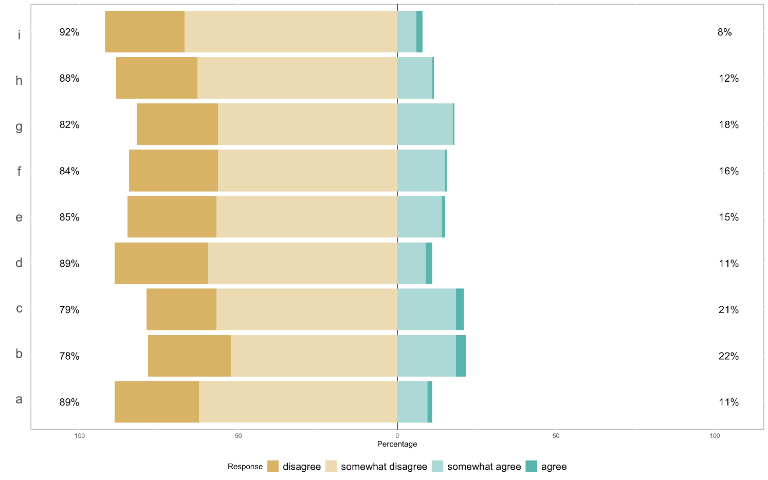

Figure 10. Stacked bar graph of the responses to question 20. From top to bottom: (i) Park rangers participate in corruption because their supervisors also participate in such behavior, (h) Park rangers participate in corruption because they believe they will not be punished, (g) Park rangers participate in corruption because they believe they will not be caught, (f) Park rangers participate in corruption because other park rangers also participate in such behavior, (e) Park rangers participate in corruption because other government officials also participate in such behavior, (d) Park rangers participate in corruption because of greed, (c) Park rangers participate in corruption because they have family or friends living in nearby communities, (b) Park rangers participate in corruption because of poor facilitation (e.g. equipment and training), and (a) Park rangers participate in corruption because of low salary.