Supplementary Material
Figure S1. Assumptions in MR analysis.
Figure S2. Funnel plot of the forward MR analysis of HSV infections (A), HSV keratitis and keratoconjunctivitis (B), anogenital HSV infection (C), VZV IgG (D), EBV (E), CMV IgG (F), HHV-6 IgG (G), HHV-7 IgG (H) causal association on ALS.
Figure S3. Leave-on-out analysis to evaluate whether every single SNP was driving the causal association of HSV infections (A), HSV keratitis and keratoconjunctivitis (B), anogenital HSV infection (C), VZV IgG (D), EBV(E), CMV IgG(F), HHV-6 IgG (G), HHV-7 IgG (H) on ALS in the forward MR analysis.
Figure S4. Funnel plot of the reverse MR analysis of ALS on HSV infections (A), HSV keratitis and keratoconjunctivitis (B), anogenital HSV infection (C), VZV IgG (D), EBV (E), CMV IgG (F), HHV-6 IgG (G), and HHV-7 IgG (H).
Figure S5. Leave-on-out analysis to evaluate whether every single SNP was driving the causal association of ALS on HSV infections (A), HSV keratitis and keratoconjunctivitis (B), anogenital HSV infection(C), VZV IgG (D), EBV (E), CMV IgG (F), HHV-6 IgG (G), and HHV-7 IgG (H) in the reverse MR analysis.
Table S1. Details of the genome-wide association studies and datasets used in this study.
Table S2. Detailed information on the instrumental variables (IVs) for HSV infections and ALS in the forward MR analysis.
Table S3. Detailed information on the instrumental variables (IVs) for HSV keratitis, keratoconjunctivitis, and ALS in the forward MR analysis.
Table S4. Detailed information on the instrumental variables (IVs) for Anogenital HSV infection and ALS in the forward MR analysis.
Table S5. Detailed information on the instrumental variables (IVs) for VZV IgG and ALS in the forward MR analysis.
Table S6. Detailed information on the EBV and ALS instrumental variables (IVs) in the forward MR analysis.
Table S7. Detailed information on the CMV IgG and ALS instrumental variables (IVs) in the forward MR analysis.
Table S8. Detailed information on the instrumental variables (IVs) for HHV-6 IgG and ALS in the forward MR analysis.
Table S9. Detailed information on the instrumental variables (IVs) for HHV-7 IgG and ALS in the forward MR analysis.
Table S10. Detailed information on the instrumental variables (IVs) for ALS and HSV infections in the reverse MR analysis.
Table S11. Detailed information on the instrumental variables (IVs) for ALS and HSV keratitis and keratoconjunctivitis in the reverse MR analysis.
Table S12. Detailed information on the instrumental variables (IVs) for ALS and anogenital HSV infection in the reverse MR analysis.
Table S13. Detailed information on the ALS and VZV IgG instrumental variables (IVs) in the reverse MR analysis.
Table S14. Detailed information on ALS and EBV instrumental variables (IVs) in the reverse MR analysis.
Table S15. Detailed information on the ALS and CMV IgG instrumental variables (IVs) in the reverse MR analysis.
Table S16. Detailed information on the instrumental variables (IVs) for ALS and HHV-6 IgG in the reverse MR analysis.
Table S17. Detailed information on the instrumental variables (IVs) for ALS and HHV-7 IgG in the reverse MR analysis.

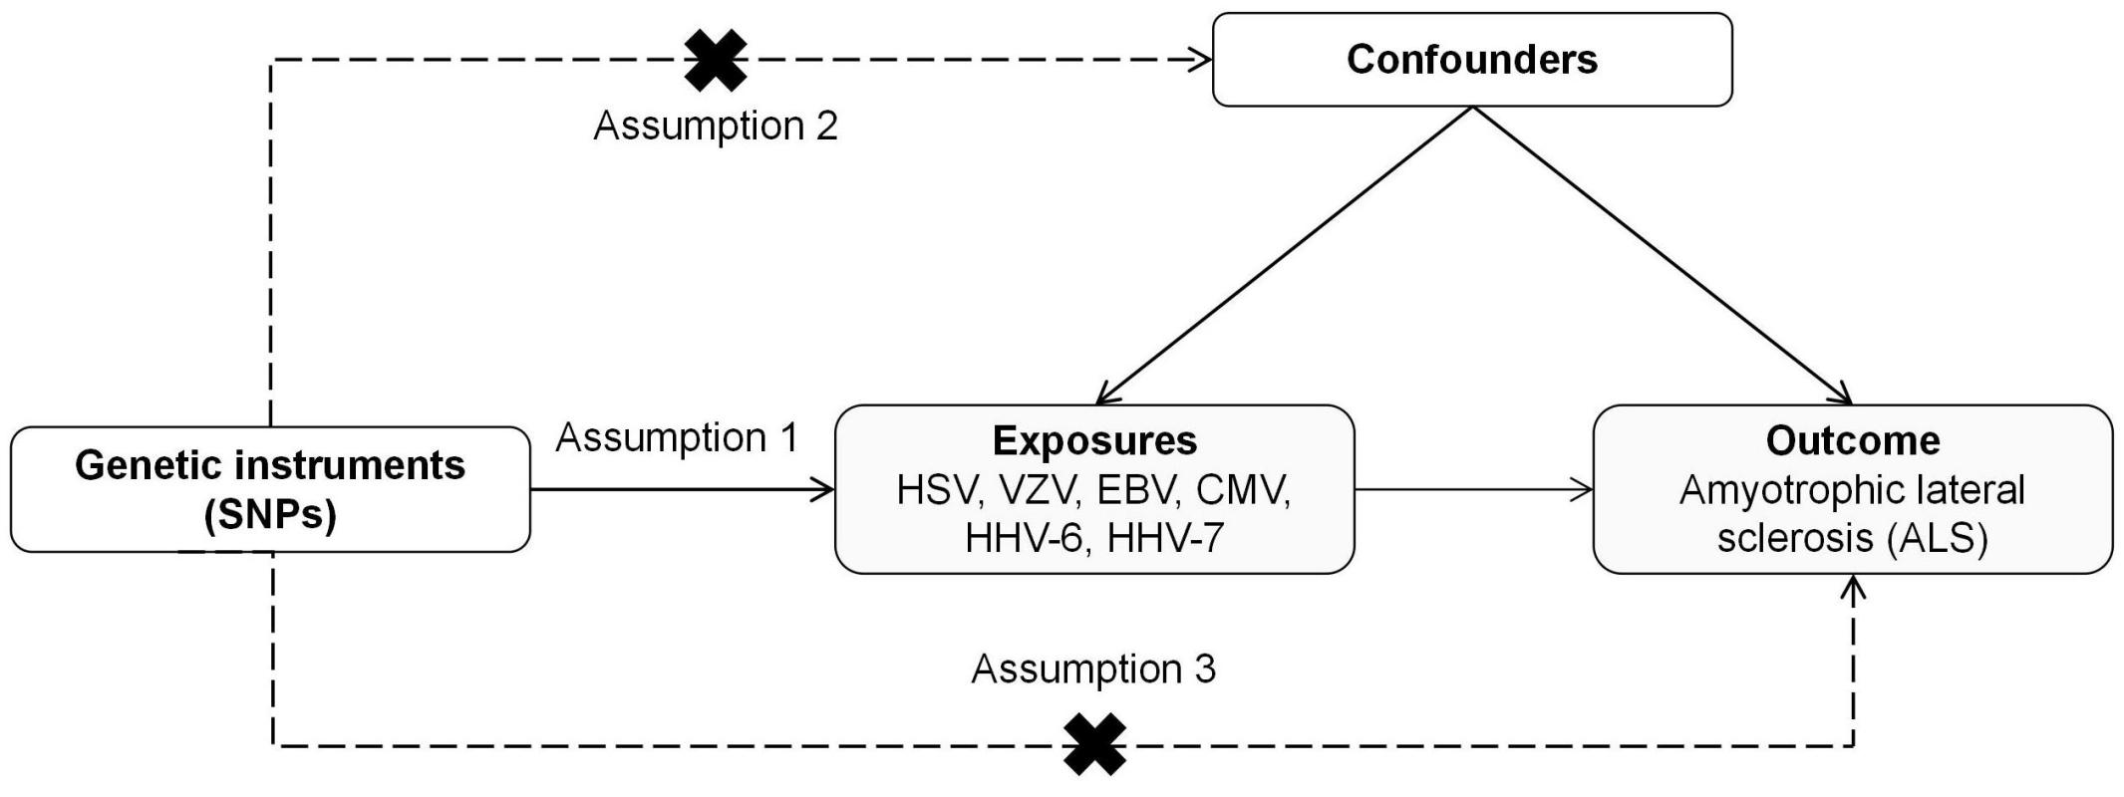

Figure S1. Assumptions in MR analysis. Three assumptions of MR are as follows: (1) Assumption 1: Genetic instruments must be significantly associated with the exposure; (2) Assumption 2: Genetic instruments are independent of confounders; (3) Assumption 3: Genetic instruments affect the outcome only via exposure.

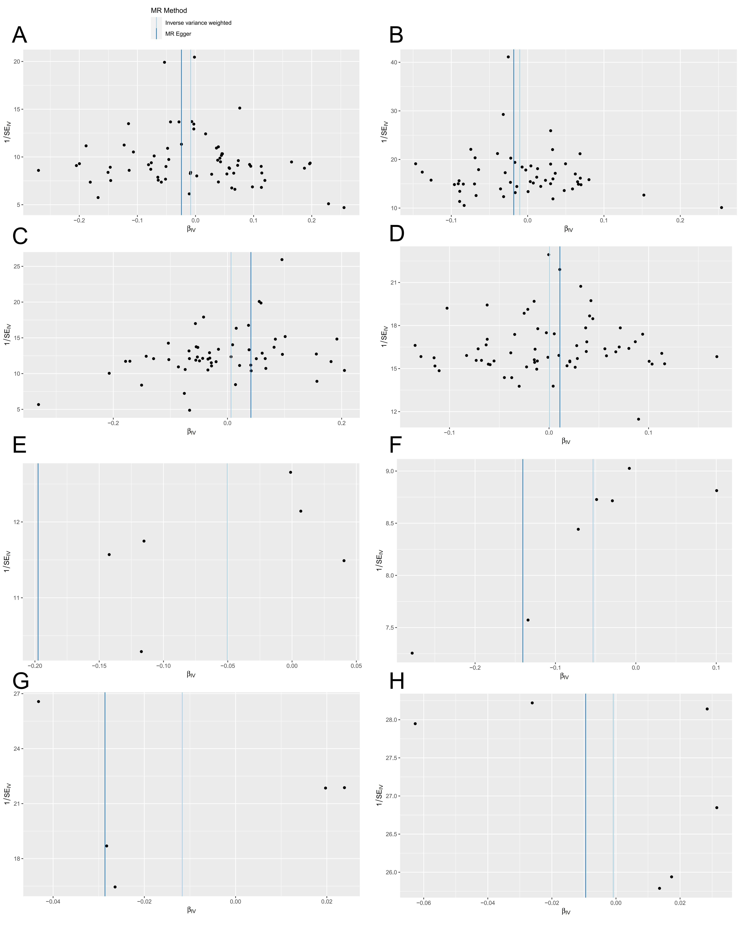
Figure S2. Funnel plot of the forward MR analysis of HSV infections (A), HSV keratitis and keratoconjunctivitis (B), anogenital HSV infection (C), VZV IgG (D), EBV (E), CMV IgG (F), HHV-6 IgG (G), HHV-7 IgG (H) causal association on ALS.

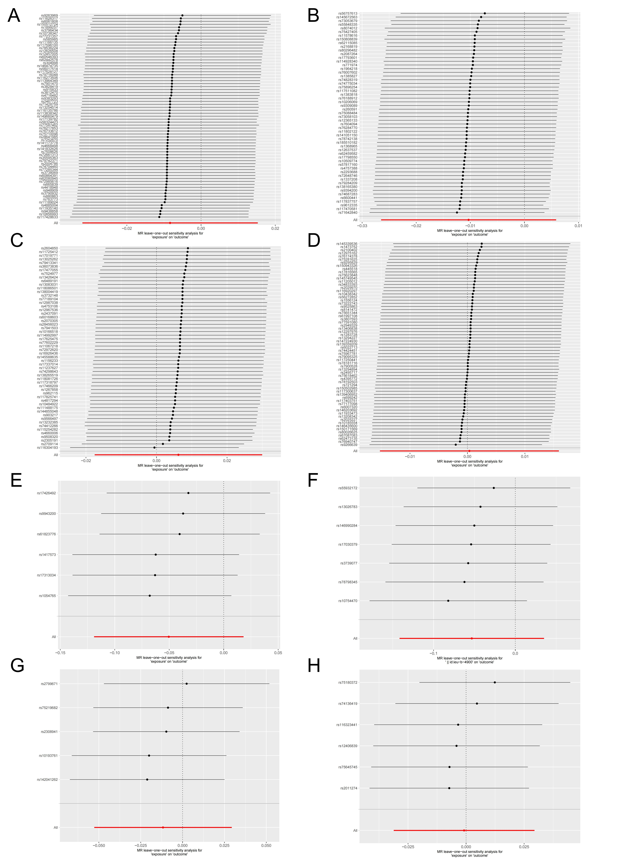

Figure S3. Leave-on-out analysis to evaluate whether every single SNP was driving the causal association of HSV infections (A), HSV keratitis and keratoconjunctivitis (B), anogenital HSV infection (C), VZV IgG (D), EBV(E), CMV IgG(F), HHV-6 IgG (G), HHV-7 IgG (H) on ALS in the forward MR analysis.

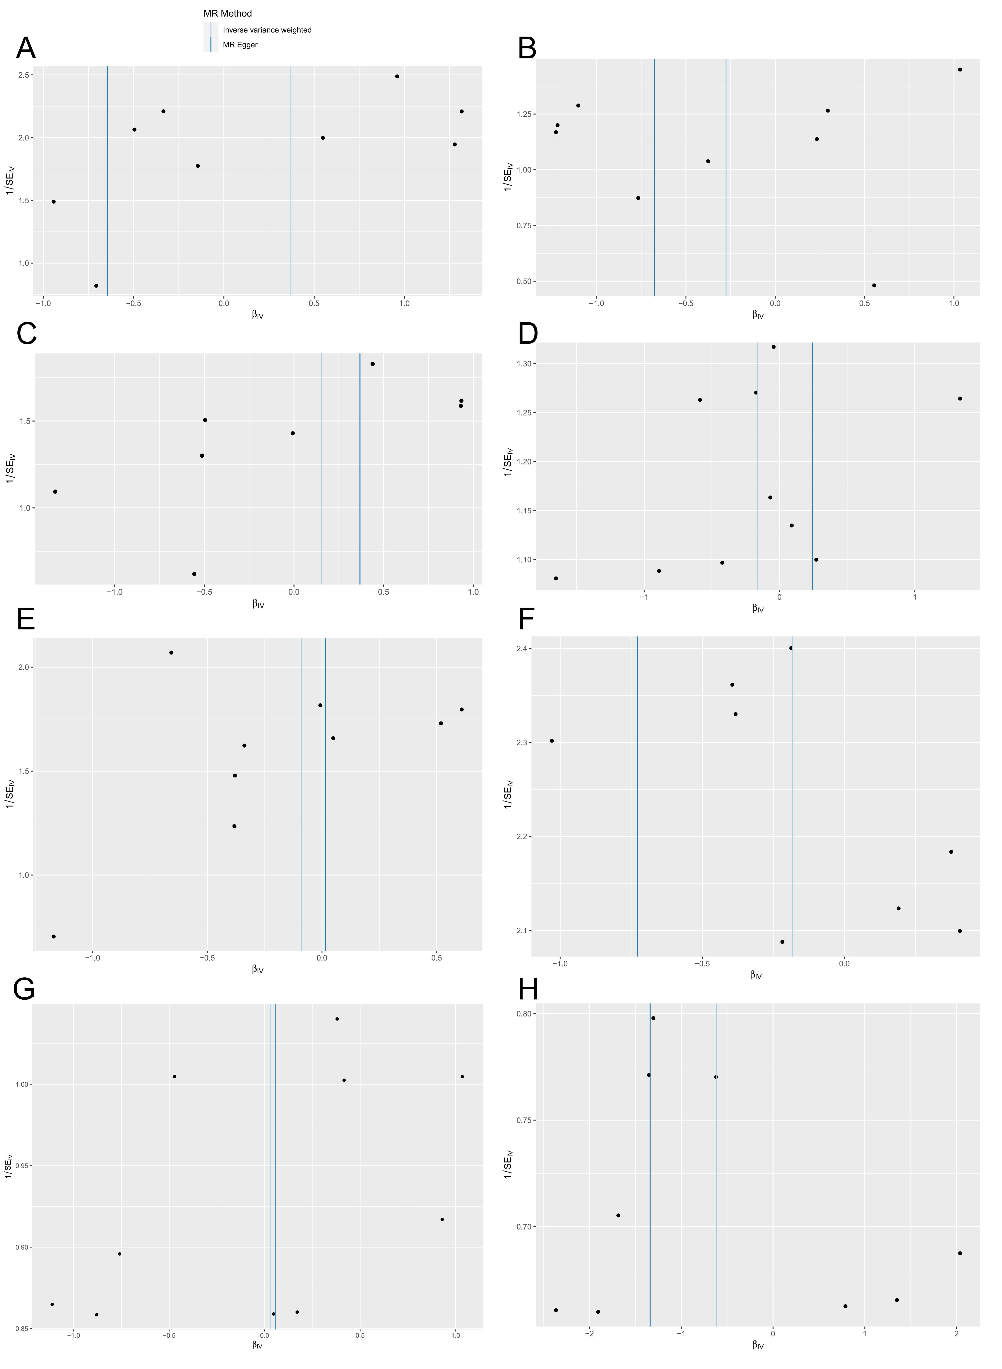
Figure S4. Funnel plot of the reverse MR analysis of ALS on HSV infections (A), HSV keratitis and keratoconjunctivitis (B), anogenital HSV infection (C), VZV IgG (D), EBV (E), CMV IgG (F), HHV-6 IgG (G), and HHV-7 IgG (H).

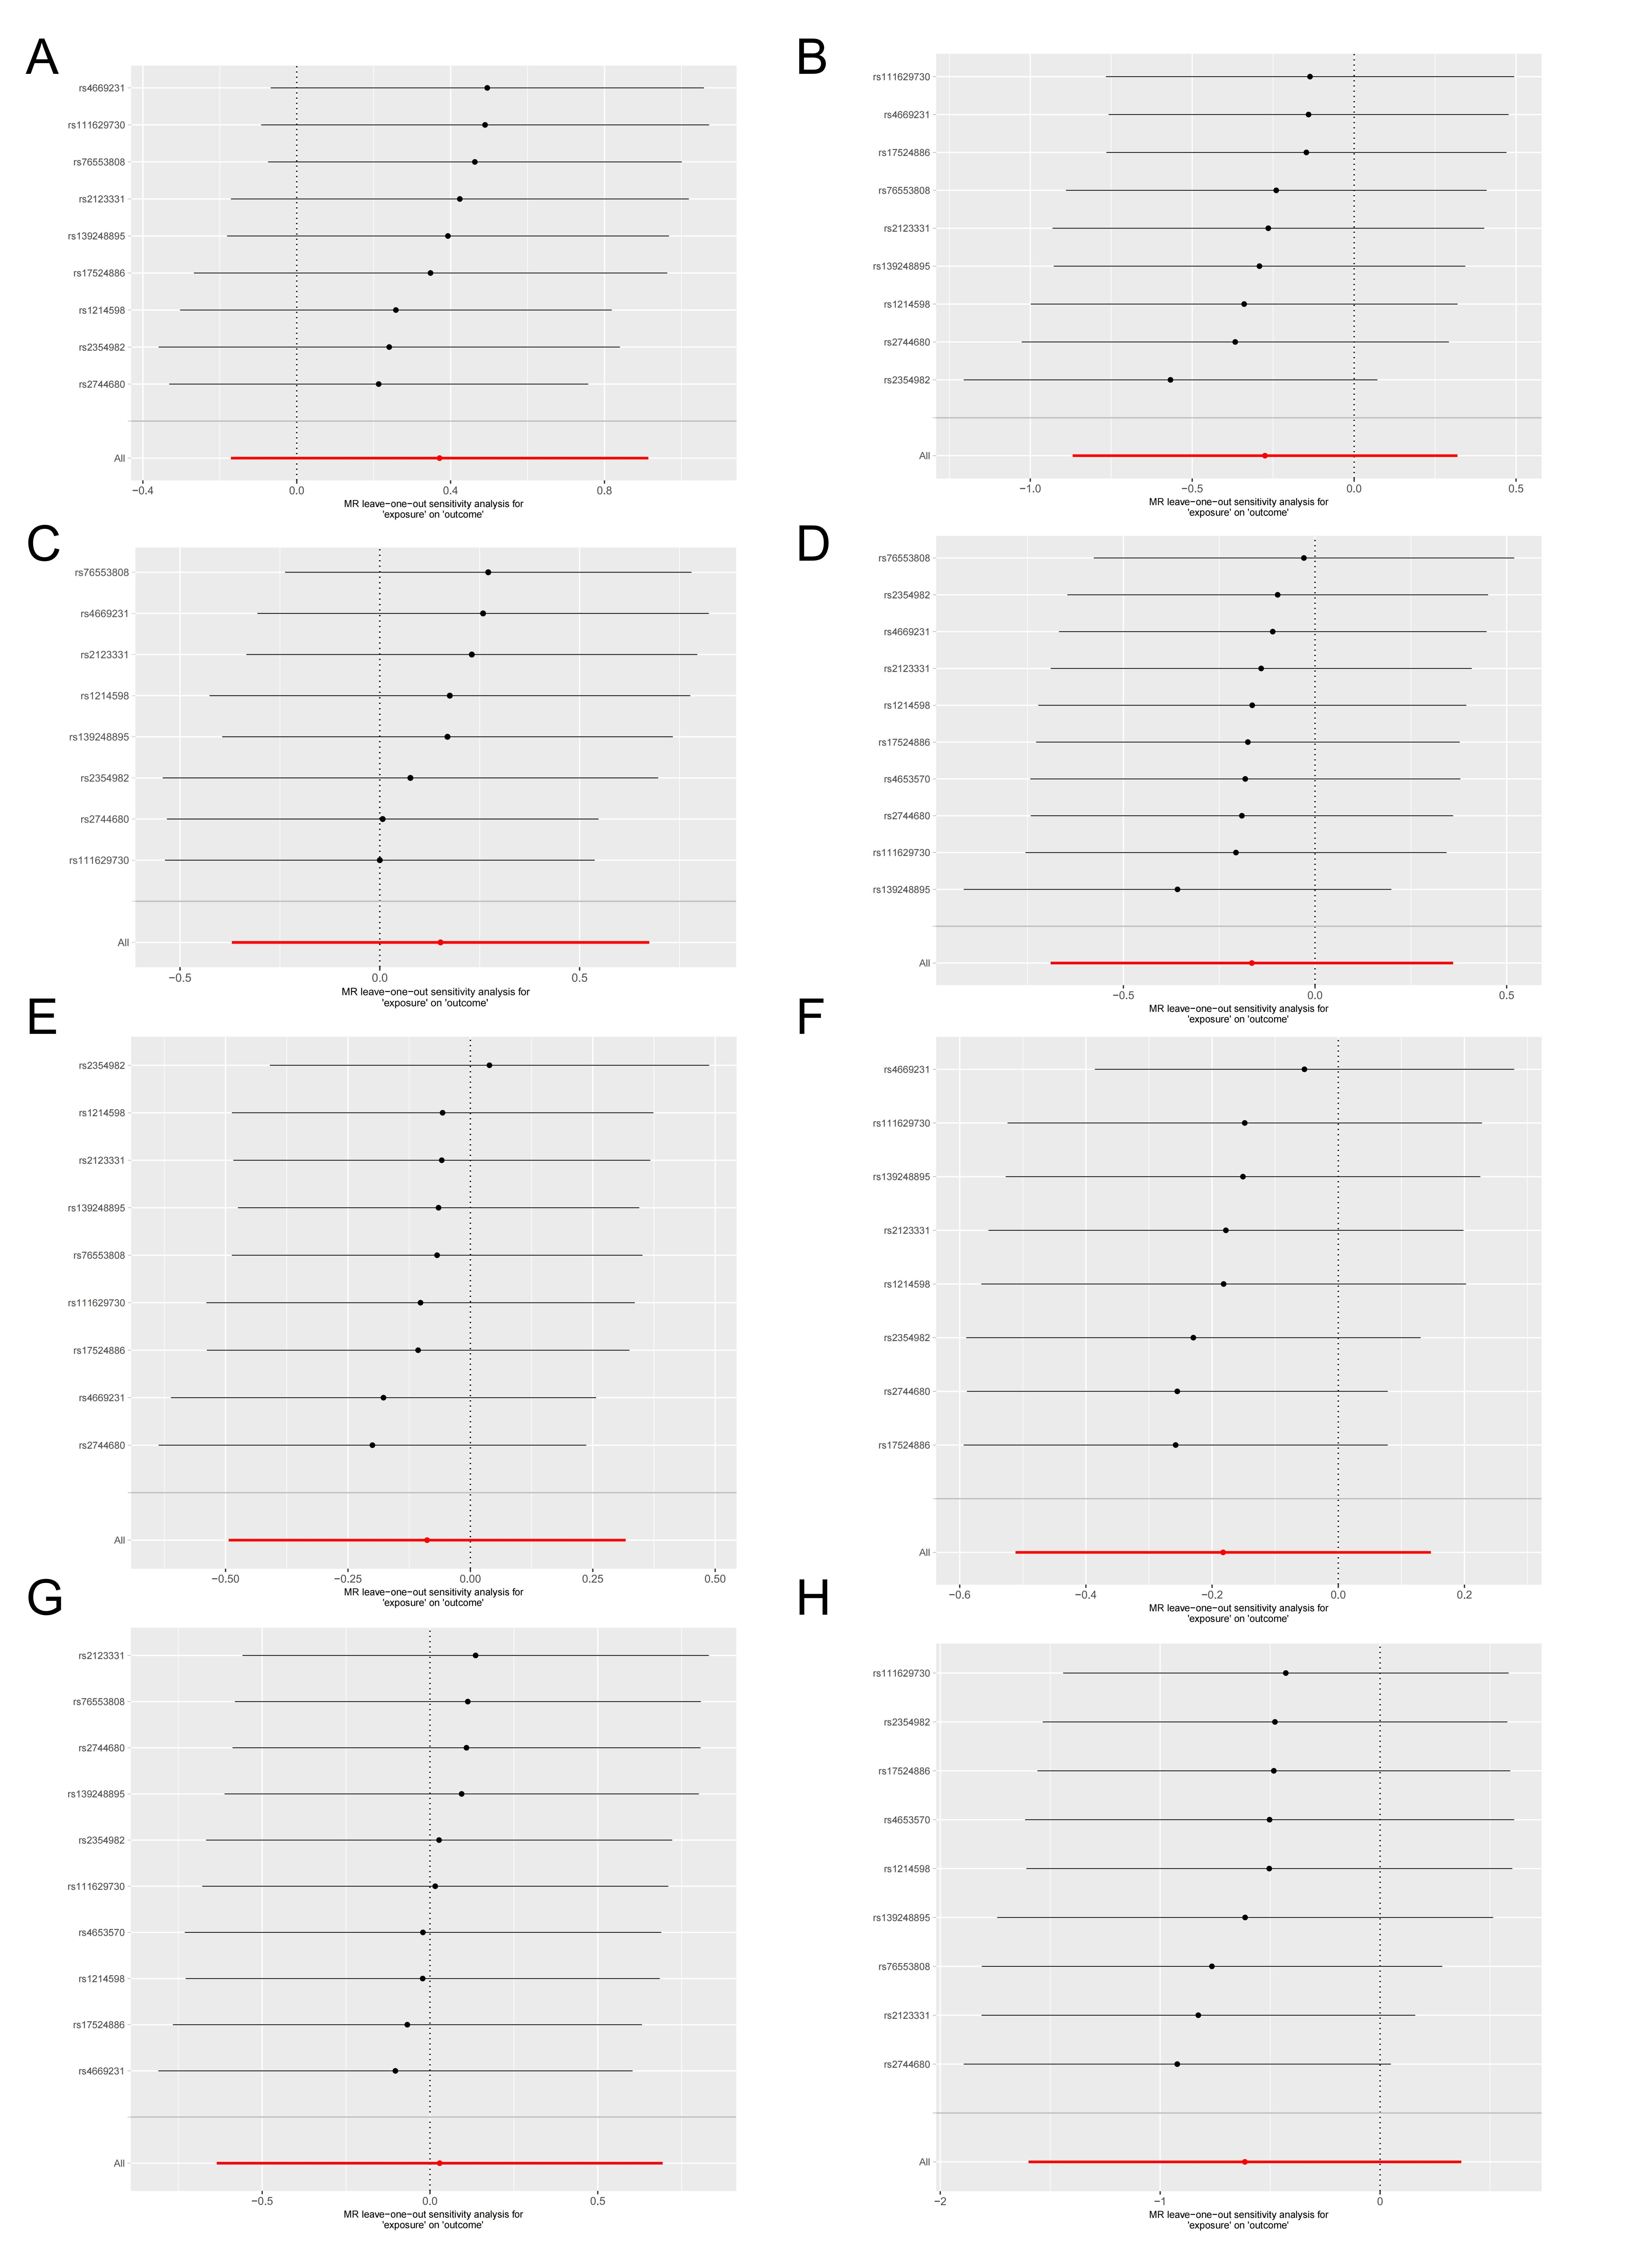
Figure S5. Leave-on-out analysis to evaluate whether every single SNP was driving the causal association of ALS on HSV infections (A), HSV keratitis and keratoconjunctivitis (B), anogenital HSV infection(C), VZV IgG (D), EBV (E), CMV IgG (F), HHV-6 IgG (G), and HHV-7 IgG (H) in the reverse MR analysis.
Table S1. Details of the genome-wide association studies and datasets used in this study.

Exposure and outcome | Source | GWAS ID | Sample size | Cases | Controls | SNP | Ancestry | Access Link
HSV infections | FinnGen (r9) | finn-b-AB1_HERPES_SIMPLEX | 213,451 | 1,595 | 211,856 | 16,380,457 | European | https://r9.finngen.fi/
HSV keratitis and keratoconjunctivitis | FinnGen (r9) | finn-b-H7_HERPESKERATITIS | 209,860 | 573 | 209,287 | 16,380,429 | European | https://r9.finngen.fi/
Anogenital HSV infection | FinnGen (r9) | finn-b-AB1_ANOGENITAL_HERPES_SIMPLEX | 213,843 | 891 | 212,952 | 16,380,455 | European | https://r9.finngen.fi/
VZV IgG | Butler-Laporte G | GCST90006928 | 8,735 | - | - | 25,472,218 | European | https://www.ebi.ac.uk/gwas/home
EBV | FinnGen (r9) | finn-b-AB1_EBV | 214,904 | 1,238 | 213,666 | 16,380,461 | European | https://r9.finngen.fi/
CMV IgG | Chong A | ieu-b-4900 | 5,010 | - | - | 7,002,835 | European | https://gwas.mrcieu.ac.uk/
HHV-6 IgG | Butler-Laporte G | GCST90006902 | 8,735 | - | - | 25,472,218 | European | https://www.ebi.ac.uk/gwas/home
HHV-7 IgG | Butler-Laporte G | GCST90006908 | 8,735 | - | - | 25,472,218 | European | https://www.ebi.ac.uk/gwas/home
ALS | van Rheenen W | GCST90027164 | 138,086 | 27,205 | 110,881 | 10,461,755 | European | https://www.ebi.ac.uk/gwas/

Table S2. Detailed information on the instrumental variables (IVs) for HSV infections and ALS in the forward MR analysis.

SNP | EA | OA | Exposure (HSV infections) |  |  |  | Outcome (ALS)
SNP | EA | OA | beta | se | P | eaf | beta | se | P | eaf
rs10738347 | C | G | 0.13273 | 0.0275784 | 1.49E-06 | 0.249836 | -0.0163 | 0.0118 | 0.1694 | 0.3118
rs10856993 | C | T | 0.103908 | 0.0244863 | 2.20E-05 | 0.518708 | 0.0205 | 0.0111 | 0.06353 | 0.5037
rs11166135 | G | A | 0.153443 | 0.0373855 | 4.05E-05 | 0.111124 | -0.0231 | 0.0183 | 0.207 | 0.1049
rs11189024 | T | C | -0.144228 | 0.0349002 | 3.59E-05 | 0.158067 | -0.0163 | 0.016 | 0.3069 | 0.1572
rs113838342 | T | C | 0.788806 | 0.191132 | 3.67E-05 | 0.00261531 | -0.0023 | 0.061 | 0.9697 | 0.0114
rs113964349 | A | G | 0.178847 | 0.0403915 | 9.52E-06 | 0.0914463 | -0.0116 | 0.0227 | 0.6095 | 0.0625
rs116135786 | A | G | 0.280463 | 0.061619 | 5.32E-06 | 0.035233 | 6.00E-04 | 0.035 | 0.9854 | 0.0309
rs11626317 | A | G | -0.405951 | 0.085183 | 1.88E-06 | 0.0274886 | 0.0468 | 0.0301 | 0.1195 | 0.0395
rs116273506 | A | G | 0.271639 | 0.0655184 | 3.38E-05 | 0.0315204 | -0.0125 | 0.0279 | 0.6552 | 0.0466
rs117428633 | G | A | 1.0208 | 0.250707 | 4.67E-05 | 0.00134854 | 0.0777 | 0.0675 | 0.2499 | 0.008
rs117528127 | C | T | -0.524611 | 0.110174 | 1.92E-06 | 0.0174775 | 0.0252 | 0.0481 | 0.6002 | 0.0146
rs117596100 | T | C | 0.170078 | 0.0416302 | 4.40E-05 | 0.0859492 | -0.0308 | 0.0231 | 0.1818 | 0.0609
rs11935140 | C | T | -0.122237 | 0.0286268 | 1.95E-05 | 0.253358 | -0.0202 | 0.0129 | 0.1176 | 0.2463
rs12457005 | C | T | 0.29529 | 0.0587016 | 4.90E-07 | 0.0383833 | -0.0127 | 0.0216 | 0.5549 | 0.0778
rs12626508 | C | G | -0.448129 | 0.104652 | 1.85E-05 | 0.0185145 | 0.0654 | 0.0595 | 0.272 | 0.0102
rs13254514 | G | A | -0.202815 | 0.0459026 | 9.94E-06 | 0.0866272 | 0.0013 | 0.0148 | 0.9326 | 0.163
rs141173778 | T | C | -0.160415 | 0.0388778 | 3.69E-05 | 0.122811 | -0.0069 | 0.0169 | 0.6843 | 0.1342
rs141832626 | A | C | -0.392021 | 0.0966514 | 4.99E-05 | 0.0211867 | -0.0384 | 0.0571 | 0.5014 | 0.0133
rs146474735 | G | A | 0.332848 | 0.0819143 | 4.84E-05 | 0.0186898 | -0.0558 | 0.0579 | 0.335 | 0.0118
rs149660479 | G | T | -0.690904 | 0.162543 | 2.13E-05 | 0.00899136 | 0.002 | 0.0514 | 0.9686 | 0.0131
rs150512724 | A | G | -0.987704 | 0.222265 | 8.84E-06 | 0.00567538 | 0.0527 | 0.0496 | 0.2878 | 0.0143
rs17139782 | G | T | -0.100722 | 0.0247308 | 4.65E-05 | 0.587841 | -0.0028 | 0.0123 | 0.8212 | 0.6489
rs1899257 | G | A | 0.104122 | 0.0247344 | 2.56E-05 | 0.530368 | -0.0208 | 0.0112 | 0.06461 | 0.5306
rs2004786 | T | G | -0.118916 | 0.0262753 | 6.02E-06 | 0.33131 | -0.0053 | 0.0117 | 0.6521 | 0.3405
rs2467723 | A | G | 0.112386 | 0.0273601 | 4.00E-05 | 0.709145 | -0.001 | 0.0136 | 0.9403 | 0.7705
rs28641985 | A | G | 0.116726 | 0.0268756 | 1.40E-05 | 0.271678 | 0.0063 | 0.0142 | 0.6601 | 0.1844
rs304998 | A | G | -0.111774 | 0.0269881 | 3.45E-05 | 0.726971 | 0.0085 | 0.0119 | 0.477 | 0.691
rs35595363 | C | G | -0.341274 | 0.0794812 | 1.76E-05 | 0.0302792 | -0.0197 | 0.0385 | 0.6091 | 0.0295
rs3738069 | T | A | 0.142717 | 0.0318542 | 7.45E-06 | 0.166475 | 0.0065 | 0.0138 | 0.6378 | 0.1955
rs3790932 | T | C | -0.102034 | 0.0246232 | 3.42E-05 | 0.457942 | -0.0097 | 0.0113 | 0.3901 | 0.422
rs3796434 | A | G | -0.100998 | 0.0245053 | 3.76E-05 | 0.475976 | 0.0207 | 0.0111 | 0.06167 | 0.4792
rs3812470 | G | A | -0.158869 | 0.0381849 | 3.18E-05 | 0.126713 | 0.0082 | 0.0207 | 0.692 | 0.0762
rs3828419 | C | T | 0.426938 | 0.092224 | 3.67E-06 | 0.0136501 | -0.0274 | 0.0564 | 0.6263 | 0.0183
rs4418948 | A | T | -0.159164 | 0.0390878 | 4.66E-05 | 0.120309 | -0.019 | 0.0211 | 0.3686 | 0.0811
rs4668498 | G | T | 0.109559 | 0.0259969 | 2.51E-05 | 0.650468 | 0.0046 | 0.0111 | 0.6791 | 0.472
rs4716482 | C | A | -0.128065 | 0.0244759 | 1.67E-07 | 0.518843 | 0.0031 | 0.0113 | 0.7859 | 0.5312
rs4885004 | G | A | 0.117364 | 0.0289187 | 4.94E-05 | 0.222863 | 0.022 | 0.0133 | 0.09714 | 0.2597
rs56017514 | G | A | -0.148077 | 0.0361177 | 4.13E-05 | 0.143927 | 0.0114 | 0.017 | 0.5008 | 0.1348
rs56324423 | A | G | 0.190406 | 0.0467297 | 4.61E-05 | 0.0655603 | 0.0075 | 0.0258 | 0.7723 | 0.0511
rs585985 | G | T | 0.186244 | 0.0454904 | 4.24E-05 | 0.912655 | -0.0199 | 0.0177 | 0.2611 | 0.8906
rs60546393 | T | C | 0.327496 | 0.0806497 | 4.89E-05 | 0.0189379 | -0.0233 | 0.0324 | 0.4718 | 0.031
rs6061808 | G | C | 0.130632 | 0.0280365 | 3.17E-06 | 0.240092 | -0.0353 | 0.0152 | 0.0199 | 0.2698
rs60864391 | T | C | -0.263423 | 0.0648717 | 4.89E-05 | 0.0429953 | -0.0122 | 0.0255 | 0.6307 | 0.0478
rs62080945 | T | G | 0.21345 | 0.0525964 | 4.94E-05 | 0.0507471 | 0.0084 | 0.0193 | 0.6648 | 0.0871
rs62442578 | T | C | -0.200265 | 0.0441421 | 5.71E-06 | 0.0935134 | 0.0162 | 0.0218 | 0.4567 | 0.0732
rs665839 | C | T | 0.113099 | 0.0270076 | 2.82E-05 | 0.27074 | 0.0082 | 0.0124 | 0.5076 | 0.2947
rs71428759 | G | T | 0.322959 | 0.0720334 | 7.34E-06 | 0.0242308 | -0.0027 | 0.0385 | 0.9433 | 0.0256
rs7252670 | G | T | 0.110138 | 0.0256581 | 1.77E-05 | 0.330415 | 0.0042 | 0.0114 | 0.7113 | 0.3982
rs72661313 | T | C | 0.196228 | 0.0468151 | 2.77E-05 | 0.0655024 | 0.0115 | 0.0223 | 0.6066 | 0.072
rs72985616 | C | A | -0.286598 | 0.0684868 | 2.86E-05 | 0.0399417 | -0.0656 | 0.0562 | 0.2432 | 0.0133
rs74704460 | G | A | 0.362378 | 0.0762866 | 2.03E-06 | 0.0212182 | 0.0411 | 0.0532 | 0.4397 | 0.0158
rs7508626 | A | G | 0.126206 | 0.0305408 | 3.59E-05 | 0.187319 | 0.0083 | 0.0152 | 0.5821 | 0.1746
rs75710096 | G | A | 0.253334 | 0.052802 | 1.60E-06 | 0.0485965 | 0.0044 | 0.0204 | 0.8289 | 0.0817
rs76217853 | G | A | 0.415299 | 0.0967413 | 1.76E-05 | 0.0124937 | 0.0259 | 0.0615 | 0.673 | 0.0095
rs763773 | T | G | -0.109614 | 0.0267193 | 4.09E-05 | 0.313483 | -0.0102 | 0.0119 | 0.3921 | 0.3067
rs76733612 | T | C | 0.37627 | 0.086065 | 1.23E-05 | 0.0159907 | 0.0255 | 0.0569 | 0.6541 | 0.0099
rs77231357 | G | A | 0.222173 | 0.0493916 | 6.85E-06 | 0.0590823 | -0.0326 | 0.0249 | 0.1908 | 0.0625
rs77285344 | T | C | -0.34393 | 0.0823493 | 2.96E-05 | 0.0276264 | -0.0879 | 0.0732 | 0.2301 | 0.0071
rs77587462 | G | C | -0.664702 | 0.154277 | 1.64E-05 | 0.009661 | 0.0012 | 0.0325 | 0.97 | 0.0293
rs78536224 | G | C | 0.142761 | 0.0317324 | 6.83E-06 | 0.16735 | -0.0163 | 0.0166 | 0.3248 | 0.1332
rs7901470 | G | A | 0.137694 | 0.0337131 | 4.42E-05 | 0.144638 | -0.007 | 0.0153 | 0.6484 | 0.1734
rs79716048 | G | C | 0.541379 | 0.13168 | 3.93E-05 | 0.00652187 | -0.0154 | 0.0396 | 0.6973 | 0.0295
rs79742371 | A | G | 0.432985 | 0.104187 | 3.24E-05 | 0.0109877 | 0.0156 | 0.0396 | 0.6944 | 0.0227
rs880863 | A | G | 0.130624 | 0.030445 | 1.78E-05 | 0.786629 | 0.0149 | 0.0157 | 0.3425 | 0.8436
rs915833 | C | T | -0.209162 | 0.0500862 | 2.97E-05 | 0.944287 | 0.0123 | 0.0284 | 0.6645 | 0.9516
rs9263969 | T | C | -0.141794 | 0.0288529 | 8.91E-07 | 0.248506 | 0.0267 | 0.0127 | 0.03518 | 0.2454
rs9383293 | G | A | 0.13008 | 0.0310854 | 2.86E-05 | 0.186526 | -0.0014 | 0.0212 | 0.9461 | 0.105
rs9438858 | A | C | -0.104926 | 0.0247741 | 2.28E-05 | 0.444311 | -0.0206 | 0.0113 | 0.06913 | 0.4268
rs948909 | A | G | 0.145237 | 0.0350111 | 3.35E-05 | 0.134237 | 0.0107 | 0.0151 | 0.4801 | 0.1849
Abbreviation: SNP, single nucleotide polymorphism; EA, Effect allele; OA, other allele; beta, estimate coefficient; se, standard error of coefficient estimate; eaf, effect allele frequency; ALS, amyotrophic lateral sclerosis.

Table S3. Detailed information on the instrumental variables (IVs) for HSV keratitis, keratoconjunctivitis, and ALS in the forward MR analysis.

SNP | EA | OA | Exposure (HSV keratitis and keratoconjunctivitis) |  |  |  | Outcome (ALS)
SNP | EA | OA | beta | se | P | eaf | beta | se | P | eaf
rs10206069 | C | T | 0.246476 | 0.0597983 | 3.76E-05 | 0.124321 | -0.004 | 0.0187 | 0.8299 | 0.106
rs10509774 | T | C | -0.301088 | 0.072338 | 3.15E-05 | 0.108052 | -0.0177 | 0.0216 | 0.4141 | 0.0747
rs114928340 | T | C | 0.874225 | 0.210733 | 3.35E-05 | 0.00531349 | -0.0345 | 0.0412 | 0.4022 | 0.0193
rs11578616 | C | A | -0.209377 | 0.0499801 | 2.80E-05 | 0.246715 | 0.0188 | 0.0134 | 0.1619 | 0.2192
rs117470581 | T | C | -1.01075 | 0.215456 | 2.72E-06 | 0.0174369 | -0.0305 | 0.039 | 0.4348 | 0.0269
rs117511082 | A | G | 0.537195 | 0.122426 | 1.14E-05 | 0.0212076 | -0.0169 | 0.0435 | 0.6979 | 0.0214
rs117837757 | A | G | 0.541164 | 0.125468 | 1.61E-05 | 0.0195008 | 0.0824 | 0.0427 | 0.0538 | 0.0186
rs11802122 | T | G | -0.226915 | 0.0556427 | 4.54E-05 | 0.18901 | -0.0039 | 0.0157 | 0.8045 | 0.1547
rs12365133 | G | A | -0.172988 | 0.0415895 | 3.19E-05 | 0.512738 | -6.00E-04 | 0.0112 | 0.9568 | 0.4891
rs12637537 | T | C | -0.246131 | 0.0562553 | 1.21E-05 | 0.188742 | -0.0074 | 0.0164 | 0.6521 | 0.1688
rs1337208 | T | C | -0.18185 | 0.0435662 | 2.99E-05 | 0.678506 | -0.0119 | 0.0118 | 0.3103 | 0.6623
rs1368965 | A | C | -0.183839 | 0.0437667 | 2.66E-05 | 0.682145 | -0.0043 | 0.0117 | 0.715 | 0.6539
rs138165380 | A | G | -0.513844 | 0.116789 | 1.08E-05 | 0.045831 | -0.0321 | 0.0302 | 0.2887 | 0.0366
rs1383818 | C | T | 0.510791 | 0.111129 | 4.30E-06 | 0.950773 | -0.0115 | 0.0334 | 0.7312 | 0.9652
rs1385827 | A | G | 0.629083 | 0.147995 | 2.13E-05 | 0.0130467 | -0.0523 | 0.0597 | 0.3808 | 0.0118
rs141051150 | G | A | -0.973416 | 0.233664 | 3.10E-05 | 0.0146707 | -0.0116 | 0.0595 | 0.846 | 0.0115
rs145672563 | A | G | 1.57847 | 0.356027 | 9.27E-06 | 0.0012221 | -0.2179 | 0.0907 | 0.01623 | 0.0049
rs150808839 | G | A | 1.54819 | 0.344595 | 7.03E-06 | 0.00125572 | -0.0494 | 0.0529 | 0.3505 | 0.0103
rs17793601 | C | T | 0.178791 | 0.0425916 | 2.70E-05 | 0.362065 | -0.0159 | 0.0133 | 0.2328 | 0.3597
rs17798550 | T | C | 0.208063 | 0.0509829 | 4.48E-05 | 0.18742 | 0.0069 | 0.013 | 0.5929 | 0.2467
rs185510182 | T | C | 1.02844 | 0.246837 | 3.09E-05 | 0.00371671 | 0.0134 | 0.0568 | 0.8137 | 0.0114
rs1964218 | A | G | 0.185228 | 0.0456643 | 4.99E-05 | 0.274547 | -0.0165 | 0.0163 | 0.3092 | 0.2381
rs2087264 | G | A | -0.185177 | 0.0455103 | 4.72E-05 | 0.320711 | 0.0156 | 0.0124 | 0.209 | 0.291
rs2168819 | A | G | 0.181539 | 0.0445467 | 4.60E-05 | 0.294615 | -0.0165 | 0.0121 | 0.1715 | 0.299
rs2293688 | G | C | 0.17437 | 0.0429243 | 4.86E-05 | 0.342742 | 0.0116 | 0.0117 | 0.3202 | 0.3421
rs260591 | G | A | 0.221361 | 0.048622 | 5.30E-06 | 0.728532 | -0.0016 | 0.012 | 0.891 | 0.6726
rs4757388 | G | A | 0.219127 | 0.0474343 | 3.84E-06 | 0.715308 | 0.0066 | 0.0115 | 0.5689 | 0.5853
rs55848335 | T | A | -0.198422 | 0.0479519 | 3.50E-05 | 0.27788 | 0.0251 | 0.0126 | 0.04711 | 0.3253
rs56757613 | T | G | -0.548664 | 0.129307 | 2.20E-05 | 0.0365614 | 0.0805 | 0.0287 | 0.004953 | 0.0392
rs57817160 | A | G | -0.198995 | 0.0437142 | 5.31E-06 | 0.367568 | -0.0072 | 0.0116 | 0.5346 | 0.3449
rs62115085 | T | C | 0.192864 | 0.0440692 | 1.21E-05 | 0.302702 | -0.0185 | 0.013 | 0.1547 | 0.3318
rs62459582 | A | G | -0.6382 | 0.154983 | 3.82E-05 | 0.0269768 | -0.0306 | 0.0469 | 0.5141 | 0.0196
rs6600441 | A | G | 0.457919 | 0.0985759 | 3.40E-06 | 0.939639 | 0.0368 | 0.0289 | 0.2038 | 0.9449
rs71642840 | T | G | 0.760404 | 0.185623 | 4.19E-05 | 0.00784587 | 0.0522 | 0.0359 | 0.1452 | 0.0263
rs72648746 | A | G | -0.296099 | 0.0666099 | 8.78E-06 | 0.128113 | -0.0207 | 0.02 | 0.302 | 0.0864
rs73053679 | T | C | -0.885583 | 0.211453 | 2.81E-05 | 0.0167253 | 0.0659 | 0.0401 | 0.1008 | 0.0195
rs73058103 | C | G | 0.4565 | 0.107007 | 1.99E-05 | 0.0294156 | -0.0011 | 0.0256 | 0.9655 | 0.0524
rs74687283 | A | G | -0.374566 | 0.0880724 | 2.11E-05 | 0.0738459 | -0.0186 | 0.0196 | 0.343 | 0.0961
rs74775034 | A | G | -0.632694 | 0.14495 | 1.27E-05 | 0.0312094 | 0.014 | 0.0312 | 0.6529 | 0.0416
rs74828319 | G | A | -0.649801 | 0.150547 | 1.59E-05 | 0.0298953 | 0.0191 | 0.0376 | 0.6121 | 0.0266
rs75088484 | G | A | -0.507398 | 0.118794 | 1.94E-05 | 0.043309 | -3.00E-04 | 0.0379 | 0.9928 | 0.0495
rs75427405 | T | C | -0.427191 | 0.0968588 | 1.03E-05 | 0.0618307 | 0.0294 | 0.021 | 0.1609 | 0.0741
rs75896254 | T | C | 0.431025 | 0.101271 | 2.08E-05 | 0.0327563 | -0.0153 | 0.0309 | 0.6207 | 0.0444
rs76007602 | A | C | 0.408793 | 0.0984795 | 3.31E-05 | 0.0365135 | -0.0276 | 0.0325 | 0.3948 | 0.0395
rs7604094 | G | T | 0.187966 | 0.0437206 | 1.71E-05 | 0.544308 | 0.0014 | 0.0124 | 0.9107 | 0.5245
rs76188912 | T | C | 0.479151 | 0.117202 | 4.35E-05 | 0.0235198 | -0.008 | 0.0247 | 0.7467 | 0.0589
rs76284770 | G | A | 0.489443 | 0.115847 | 2.39E-05 | 0.0240606 | 0.0021 | 0.0262 | 0.9373 | 0.0468
rs771974 | A | G | -0.291739 | 0.0697985 | 2.92E-05 | 0.919283 | 0.0203 | 0.0195 | 0.2986 | 0.9099
rs78742138 | C | T | 0.434161 | 0.0900348 | 1.42E-06 | 0.0417909 | 0.0144 | 0.0365 | 0.694 | 0.0257
rs79284209 | C | T | 0.336133 | 0.075248 | 7.93E-06 | 0.0665494 | 0.0232 | 0.0208 | 0.2655 | 0.0792
rs80296482 | T | C | 0.59452 | 0.145565 | 4.42E-05 | 0.013963 | -0.0382 | 0.0332 | 0.2502 | 0.0276
rs8074012 | C | T | -1.51672 | 0.369188 | 3.99E-05 | 0.00824674 | 0.0384 | 0.0369 | 0.2978 | 0.024
rs9309089 | A | G | 0.19779 | 0.0468024 | 2.38E-05 | 0.244147 | -0.0028 | 0.0137 | 0.84 | 0.2011
rs9394200 | C | T | 0.71613 | 0.171892 | 3.10E-05 | 0.976823 | 0.0234 | 0.0325 | 0.4713 | 0.9646
rs9612335 | A | C | -0.170821 | 0.0416599 | 4.12E-05 | 0.573129 | -0.0434 | 0.0169 | 0.01034 | 0.5821
Abbreviation: SNP, single nucleotide polymorphism; EA, Effect allele; OA, other allele; beta, estimate coefficient; se, standard error of coefficient estimate; eaf, effect allele frequency; ALS, amyotrophic lateral sclerosis.

Table S4. Detailed information on the instrumental variables (IVs) for Anogenital HSV infection and ALS in the forward MR analysis.

SNP | EA | OA | Exposure (Anogenital HSV infection) |  |  |  | Outcome (ALS)
SNP | EA | OA | beta | se | P | eaf | beta | se | P | eaf
rs10166518 | T | C | 0.142296 | 0.034824 | 4.39E-05 | 0.629271 | -0.0044 | 0.0117 | 0.7069 | 0.6618
rs10484922 | T | C | -0.253258 | 0.0522413 | 1.25E-06 | 0.131991 | -0.0154 | 0.0197 | 0.4345 | 0.0882
rs11067218 | C | T | 0.136201 | 0.0335077 | 4.81E-05 | 0.43972 | -0.0038 | 0.0123 | 0.7574 | 0.4476
rs111488175 | A | T | 0.278294 | 0.06741 | 3.65E-05 | 0.0555181 | 0.0436 | 0.0312 | 0.1623 | 0.0367
rs11237627 | A | G | 0.21312 | 0.0467356 | 5.11E-06 | 0.135887 | 0.003 | 0.0252 | 0.9044 | 0.0584
rs114992997 | A | G | 0.50891 | 0.125432 | 4.97E-05 | 0.0135011 | -0.0144 | 0.0442 | 0.7437 | 0.0245
rs115254282 | T | C | 0.495873 | 0.117692 | 2.52E-05 | 0.0153333 | 0.1016 | 0.0475 | 0.03255 | 0.0194
rs1156233 | T | C | 0.159376 | 0.0378993 | 2.61E-05 | 0.23986 | 0.001 | 0.0129 | 0.9399 | 0.2472
rs116304193 | A | C | -1.10757 | 0.250348 | 9.68E-06 | 0.00883833 | -0.1057 | 0.0427 | 0.01328 | 0.0218
rs11725412 | G | A | 0.277962 | 0.0657155 | 2.34E-05 | 0.918878 | -0.0475 | 0.0237 | 0.0451 | 0.9342
rs117318797 | T | C | 0.53118 | 0.129971 | 4.37E-05 | 0.0126742 | 0.0217 | 0.0475 | 0.6476 | 0.021
rs117825741 | C | G | 0.621406 | 0.146131 | 2.11E-05 | 0.00932659 | 0.0229 | 0.0371 | 0.5362 | 0.0271
rs118081726 | T | G | -0.44554 | 0.102922 | 1.50E-05 | 0.0349385 | -0.0185 | 0.0429 | 0.6656 | 0.0196
rs118086501 | T | C | -0.835502 | 0.197558 | 2.35E-05 | 0.0117091 | 0.0718 | 0.0764 | 0.3473 | 0.0062
rs1267858 | T | C | -0.251356 | 0.0618124 | 4.77E-05 | 0.0918962 | -0.0127 | 0.0208 | 0.5404 | 0.0748
rs12967536 | A | G | 0.209317 | 0.0501962 | 3.05E-05 | 0.113275 | -0.0155 | 0.0198 | 0.4326 | 0.1007
rs12987038 | T | C | -0.162099 | 0.037807 | 1.81E-05 | 0.760023 | 0.0108 | 0.0134 | 0.4213 | 0.7721
rs13025262 | G | T | -0.23377 | 0.0558423 | 2.84E-05 | 0.112847 | 0.0242 | 0.0164 | 0.14 | 0.1649
rs13083031 | T | C | 0.233726 | 0.0540184 | 1.51E-05 | 0.0919896 | -0.0128 | 0.017 | 0.4504 | 0.1295
rs13232385 | G | C | 0.7211 | 0.154329 | 2.98E-06 | 0.00750701 | 0.0401 | 0.0359 | 0.2632 | 0.0262
rs13426424 | A | G | 0.162597 | 0.0400077 | 4.82E-05 | 0.201545 | -0.0167 | 0.0136 | 0.2184 | 0.2173
rs138004419 | A | G | -0.574435 | 0.140409 | 4.29E-05 | 0.0205995 | 0.0864 | 0.0685 | 0.2071 | 0.0071
rs138265519 | C | A | -0.750015 | 0.183311 | 4.29E-05 | 0.0138049 | -0.0115 | 0.0459 | 0.8029 | 0.0243
rs144855048 | A | G | -0.398157 | 0.0954692 | 3.04E-05 | 0.0407101 | -0.0325 | 0.0291 | 0.264 | 0.0426
rs145588635 | T | C | -0.342158 | 0.0753184 | 5.55E-06 | 0.0634442 | 0.0227 | 0.0702 | 0.7461 | 0.0096
rs16926436 | A | G | 0.200608 | 0.0493851 | 4.86E-05 | 0.115306 | -0.004 | 0.0172 | 0.8177 | 0.1292
rs17019771 | G | A | -0.17141 | 0.0396907 | 1.57E-05 | 0.250384 | 0.0244 | 0.0138 | 0.07802 | 0.209
rs17337014 | G | A | 0.267967 | 0.0611824 | 1.19E-05 | 0.0687803 | 0.0024 | 0.0191 | 0.9011 | 0.0945
rs17466209 | T | A | -0.171951 | 0.041892 | 4.05E-05 | 0.212366 | -0.0065 | 0.0129 | 0.6165 | 0.2662
rs17477055 | G | T | -0.334808 | 0.080114 | 2.93E-05 | 0.0550596 | 0.0188 | 0.0197 | 0.3397 | 0.0857
rs17625475 | T | G | 0.210088 | 0.0495315 | 2.22E-05 | 0.115335 | -0.0072 | 0.02 | 0.7176 | 0.1162
rs2070305 | G | T | -0.135829 | 0.0333162 | 4.56E-05 | 0.471163 | 0.0059 | 0.0112 | 0.5994 | 0.4329
rs2305191 | T | C | -0.14391 | 0.0338323 | 2.10E-05 | 0.427082 | -0.0224 | 0.0113 | 0.04669 | 0.4042
rs2437091 | T | C | 0.149667 | 0.0350571 | 1.96E-05 | 0.636051 | -0.0083 | 0.0126 | 0.5105 | 0.7411
rs2604850 | C | T | 0.363135 | 0.0894442 | 4.91E-05 | 0.953356 | -0.0648 | 0.031 | 0.03688 | 0.9573
rs2709114 | G | A | 0.225414 | 0.0541521 | 3.15E-05 | 0.881235 | 0.0432 | 0.0152 | 0.004363 | 0.8445
rs28456023 | C | T | 0.200215 | 0.0491442 | 4.62E-05 | 0.116407 | -0.0063 | 0.0155 | 0.6852 | 0.1772
rs36073836 | T | C | 0.188579 | 0.0462836 | 4.61E-05 | 0.136135 | -0.0244 | 0.0156 | 0.1174 | 0.1513
rs3732148 | T | C | -0.333293 | 0.081148 | 4.00E-05 | 0.0554307 | 0.0173 | 0.0244 | 0.4782 | 0.0732
rs4660006 | G | A | -0.20189 | 0.0394385 | 3.07E-07 | 0.791535 | -0.0204 | 0.0133 | 0.1251 | 0.7741
rs4753106 | A | G | -0.140449 | 0.0333129 | 2.49E-05 | 0.557745 | 0.0074 | 0.0114 | 0.5139 | 0.476
rs4817294 | A | G | -0.211737 | 0.0518317 | 4.41E-05 | 0.132121 | -0.014 | 0.0175 | 0.4222 | 0.1164
rs60168603 | G | A | 0.183732 | 0.0439701 | 2.93E-05 | 0.155565 | -0.009 | 0.0156 | 0.5633 | 0.1565
rs6489191 | G | A | 0.151436 | 0.0362122 | 2.89E-05 | 0.668419 | -0.0102 | 0.0115 | 0.3748 | 0.5985
rs72972620 | G | A | -0.209017 | 0.0465713 | 7.19E-06 | 0.164983 | 0.0033 | 0.0156 | 0.8351 | 0.1423
rs74298643 | T | C | 0.183733 | 0.0442457 | 3.29E-05 | 0.155757 | 0.0039 | 0.0165 | 0.8138 | 0.154
rs74412266 | A | C | 0.560369 | 0.135685 | 3.63E-05 | 0.0104417 | 0.0329 | 0.0282 | 0.2446 | 0.0398
rs7524977 | C | T | -0.941749 | 0.225889 | 3.06E-05 | 0.00989665 | 0.0394 | 0.0526 | 0.4542 | 0.0152
rs77189104 | C | T | 0.33272 | 0.080479 | 3.56E-05 | 0.0384544 | -0.1101 | 0.0587 | 0.06054 | 0.0236
rs77602229 | C | T | -0.377391 | 0.0918487 | 3.98E-05 | 0.0416995 | 0.0285 | 0.0522 | 0.5848 | 0.025
rs79413341 | C | A | -0.290228 | 0.0690638 | 2.64E-05 | 0.0731826 | 0.0601 | 0.0289 | 0.03736 | 0.0482
rs7941503 | T | C | 0.140699 | 0.0343568 | 4.22E-05 | 0.366963 | -0.0048 | 0.0117 | 0.6808 | 0.3806
rs903217 | A | T | 0.143368 | 0.034701 | 3.60E-05 | 0.329653 | 0.0138 | 0.0113 | 0.222 | 0.3851
rs9508320 | A | G | 0.512668 | 0.125263 | 4.26E-05 | 0.012722 | 0.093 | 0.0439 | 0.03427 | 0.0202
rs9566497 | C | T | -0.250344 | 0.0613657 | 4.51E-05 | 0.0922213 | -0.021 | 0.0169 | 0.2163 | 0.1197
rs962115 | C | A | -0.14584 | 0.0356032 | 4.20E-05 | 0.704313 | -0.0098 | 0.0136 | 0.4717 | 0.7795
Abbreviation: SNP, single nucleotide polymorphism; EA, Effect allele; OA, other allele; beta, estimate coefficient; se, standard error of coefficient estimate; eaf, effect allele frequency; ALS, amyotrophic lateral sclerosis.

Table S5. Detailed information on the instrumental variables (IVs) for VZV IgG and ALS in the forward MR analysis.

SNP | EA | OA | Exposure (VZV IgG) |  |  |  | Outcome (ALS)
SNP | EA | OA | beta | se | P | eaf | beta | se | P | eaf
rs10185554 | A | G | 0.560054 | 0.132806 | 2.47E-05 | 0.0275645 | 0.0401 | 0.0314 | 0.2024 | 0.0345
rs10438342 | A | G | 0.199867 | 0.0451572 | 9.60E-06 | 0.343837 | -0.0069 | 0.0115 | 0.5499 | 0.362
rs11205012 | C | T | -0.191538 | 0.0461511 | 3.32E-05 | 0.322259 | 0.013 | 0.0123 | 0.291 | 0.339
rs116920297 | A | G | -0.646066 | 0.152773 | 2.35E-05 | 0.0205235 | 0.0357 | 0.0416 | 0.3911 | 0.0223
rs117250441 | C | T | -0.515085 | 0.114494 | 6.83E-06 | 0.0354322 | -0.0093 | 0.0339 | 0.784 | 0.0312
rs117300637 | G | C | -0.964974 | 0.234649 | 3.92E-05 | 0.00916638 | -0.0868 | 0.0841 | 0.3016 | 0.0109
rs117403751 | A | T | -0.649889 | 0.149117 | 1.31E-05 | 0.0217187 | -0.0375 | 0.0409 | 0.36 | 0.0293
rs11933473 | C | G | -0.497963 | 0.119153 | 2.93E-05 | 0.0338808 | -0.0334 | 0.0308 | 0.2773 | 0.0339
rs12297976 | A | G | -0.186735 | 0.0435647 | 1.82E-05 | 0.442559 | 0.0027 | 0.0121 | 0.8209 | 0.4422
rs1283728 | A | G | -0.681653 | 0.165358 | 3.75E-05 | 0.017974 | 0.008 | 0.0439 | 0.8554 | 0.0179
rs12975162 | T | C | 0.209493 | 0.0480065 | 1.28E-05 | 0.270651 | -0.0242 | 0.0133 | 0.06923 | 0.262
rs13208342 | A | T | 0.191453 | 0.0446924 | 1.84E-05 | 0.36994 | 0.0135 | 0.0116 | 0.2423 | 0.3828
rs13294227 | T | C | -0.768909 | 0.180629 | 2.07E-05 | 0.0148254 | 0.0095 | 0.0514 | 0.8532 | 0.0144
rs13294894 | A | G | -1.19814 | 0.27836 | 1.68E-05 | 0.00659252 | -0.0129 | 0.0547 | 0.8132 | 0.0098
rs13406838 | T | C | -0.249838 | 0.0602038 | 3.33E-05 | 0.14558 | 0.0037 | 0.016 | 0.8182 | 0.1547
rs139359209 | G | C | -1.12859 | 0.237543 | 2.02E-06 | 0.00925181 | 4.00E-04 | 0.0492 | 0.9933 | 0.0135
rs139406952 | C | T | -0.769174 | 0.188638 | 4.55E-05 | 0.0140341 | -0.0245 | 0.0371 | 0.5085 | 0.0257
rs145339536 | A | G | -0.66461 | 0.144872 | 4.48E-06 | 0.0228928 | 0.0681 | 0.0346 | 0.04931 | 0.0287
rs145749545 | T | G | -0.797598 | 0.168087 | 2.08E-06 | 0.0173788 | 0.0504 | 0.0479 | 0.2922 | 0.018
rs146203692 | T | C | -1.15244 | 0.255109 | 6.26E-06 | 0.00787266 | -0.0485 | 0.0584 | 0.4063 | 0.0098
rs146435600 | C | G | 0.894674 | 0.220034 | 4.78E-05 | 0.0100265 | 0.09 | 0.0577 | 0.119 | 0.0114
rs147224930 | T | G | -1.23006 | 0.288633 | 2.03E-05 | 0.00628604 | 0.0033 | 0.0703 | 0.9621 | 0.0087
rs1473752 | T | C | -0.324016 | 0.0791123 | 4.21E-05 | 0.919191 | 0.0436 | 0.0195 | 0.02514 | 0.9115
rs150171569 | A | C | -0.732065 | 0.172681 | 2.24E-05 | 0.0158101 | -0.0758 | 0.0478 | 0.1128 | 0.0163
rs150502985 | A | G | -1.12203 | 0.264798 | 2.26E-05 | 0.00726811 | -0.0413 | 0.0629 | 0.511 | 0.0103
rs150943326 | A | G | 0.665102 | 0.151933 | 1.20E-05 | 0.0213938 | -0.0551 | 0.0418 | 0.1869 | 0.0255
rs1556124 | A | G | 0.218473 | 0.0502278 | 1.36E-05 | 0.769548 | -0.0098 | 0.0152 | 0.5177 | 0.7778
rs17816565 | G | A | -0.877737 | 0.213816 | 4.04E-05 | 0.0105251 | 0.0545 | 0.0515 | 0.2895 | 0.0134
rs2025227 | A | C | 0.187011 | 0.0438479 | 2.00E-05 | 0.35945 | 0.015 | 0.0114 | 0.1904 | 0.3583
rs2029970 | C | T | -0.190919 | 0.047066 | 4.98E-05 | 0.716376 | 0.0113 | 0.0125 | 0.3663 | 0.7196
rs2100402 | G | A | -0.207468 | 0.0505043 | 3.99E-05 | 0.237224 | 0.0267 | 0.0131 | 0.0415 | 0.2414
rs2495717 | G | A | -0.175087 | 0.0424319 | 3.69E-05 | 0.491757 | -0.0046 | 0.0116 | 0.6932 | 0.4997
rs2949329 | T | C | 0.30935 | 0.0718159 | 1.65E-05 | 0.0950518 | -0.0035 | 0.0174 | 0.8423 | 0.1102
rs34833393 | T | G | -0.183681 | 0.0431429 | 2.07E-05 | 0.451257 | 0.0112 | 0.012 | 0.3541 | 0.4488
rs3807593 | G | T | -0.513958 | 0.121585 | 2.37E-05 | 0.0324181 | 0.0116 | 0.034 | 0.7338 | 0.0308
rs4395772 | C | T | 0.327009 | 0.0742231 | 1.05E-05 | 0.904848 | 0.0091 | 0.0197 | 0.6425 | 0.8814
rs445518 | T | C | 0.196513 | 0.0457973 | 1.78E-05 | 0.330203 | -0.014 | 0.012 | 0.2433 | 0.3271
rs56272852 | G | T | -0.814504 | 0.194951 | 2.94E-05 | 0.0127065 | 0.0313 | 0.0506 | 0.537 | 0.0163
rs6007320 | G | A | 0.566737 | 0.129961 | 1.30E-05 | 0.0288274 | 0.0318 | 0.0346 | 0.3581 | 0.0282
rs6022713 | C | T | -0.179959 | 0.0436036 | 3.67E-05 | 0.407525 | 2.00E-04 | 0.0114 | 0.9844 | 0.4044
rs61997108 | A | C | 0.213415 | 0.0519734 | 4.02E-05 | 0.219632 | -0.0064 | 0.0155 | 0.6785 | 0.2096
rs62473135 | C | G | -0.325315 | 0.0703844 | 3.80E-06 | 0.102007 | -0.0306 | 0.0187 | 0.1015 | 0.1038
rs67087083 | T | C | 0.237665 | 0.0585505 | 4.93E-05 | 0.161782 | 0.0276 | 0.0155 | 0.0744 | 0.1645
rs699242 | A | G | -0.265112 | 0.0562388 | 2.43E-06 | 0.826903 | -0.0108 | 0.0142 | 0.4467 | 0.8024
rs721294 | G | T | -0.392941 | 0.0863689 | 5.38E-06 | 0.0689469 | -0.0149 | 0.0233 | 0.5215 | 0.0714
rs73222743 | A | G | -1.08029 | 0.255151 | 2.30E-05 | 0.00771014 | 0.027 | 0.0573 | 0.6375 | 0.0126
rs74424451 | T | C | -0.648874 | 0.158517 | 4.25E-05 | 0.0186792 | -0.0027 | 0.0471 | 0.955 | 0.021
rs75281625 | T | C | -0.519817 | 0.121021 | 1.74E-05 | 0.0315662 | 0.0574 | 0.035 | 0.1012 | 0.0343
rs75618462 | A | G | -0.34071 | 0.0781147 | 1.29E-05 | 0.0798512 | -0.0097 | 0.0217 | 0.6538 | 0.0826
rs75623848 | G | C | -0.691351 | 0.161623 | 1.89E-05 | 0.0184316 | 0.0506 | 0.0444 | 0.2538 | 0.0211
rs75651344 | T | A | -0.480389 | 0.0953268 | 4.67E-07 | 0.054108 | 0.0072 | 0.0244 | 0.7688 | 0.0631
rs75967781 | A | C | 0.341492 | 0.082237 | 3.29E-05 | 0.0751982 | 0.0018 | 0.0196 | 0.9278 | 0.0937
rs76174378 | A | G | -0.455404 | 0.107996 | 2.48E-05 | 0.0413247 | 0.0522 | 0.03 | 0.08183 | 0.0387
rs76940747 | T | C | -0.790173 | 0.187643 | 2.54E-05 | 0.0140417 | -0.0895 | 0.0492 | 0.06914 | 0.0146
rs77177098 | G | A | -0.798164 | 0.194724 | 4.15E-05 | 0.0127674 | -0.0351 | 0.0432 | 0.4167 | 0.0177
rs77591080 | A | G | -0.670402 | 0.143067 | 2.79E-06 | 0.0233559 | 0.0094 | 0.041 | 0.8181 | 0.0221
rs78181716 | T | C | -0.665348 | 0.155727 | 1.93E-05 | 0.020014 | -0.0139 | 0.043 | 0.7465 | 0.0217
rs78192503 | A | T | -0.213709 | 0.0465516 | 4.42E-06 | 0.336073 | -0.008 | 0.0132 | 0.5444 | 0.3385
rs7900528 | T | G | -0.268627 | 0.0656013 | 4.22E-05 | 0.118985 | -0.0056 | 0.0173 | 0.7447 | 0.1248
rs79095325 | A | G | -0.20215 | 0.0489799 | 3.67E-05 | 0.253009 | -0.002 | 0.0127 | 0.8756 | 0.2559
rs80026625 | A | T | 0.6276 | 0.149479 | 2.69E-05 | 0.0217341 | 0.0544 | 0.0372 | 0.1433 | 0.0272
rs8141472 | T | C | 0.186789 | 0.0457635 | 4.47E-05 | 0.370908 | -0.007 | 0.013 | 0.5917 | 0.3877
rs9266639 | T | C | 0.196322 | 0.0466551 | 2.58E-05 | 0.286909 | 0.0331 | 0.0124 | 0.007695 | 0.2769
rs9295829 | G | A | -0.242872 | 0.0473848 | 2.97E-07 | 0.274356 | 0.0151 | 0.0125 | 0.2251 | 0.2752
rs9525863 | A | G | -0.487728 | 0.111109 | 1.14E-05 | 0.0390384 | 0.0104 | 0.0255 | 0.6822 | 0.047
Abbreviation: SNP, single nucleotide polymorphism; EA, Effect allele; OA, other allele; beta, estimate coefficient; se, standard error of coefficient estimate; eaf, effect allele frequency; ALS, amyotrophic lateral sclerosis.

Table S6. Detailed information on the EBV and ALS instrumental variables (IVs) in the forward MR analysis.

SNP | EA | OA | Exposure (EBV) |  |  |  | Outcome (ALS)
SNP | EA | OA | beta | se | P | eaf | beta | se | P | eaf
rs1054765 | A | C | -0.160851 | 0.0385281 | 2.98E-05 | 0.839535 | -0.0065 | 0.014 | 0.6423 | 0.8015
rs1417573 | A | T | 0.175901 | 0.0356565 | 8.09E-07 | 0.197221 | -2.00E-04 | 0.0139 | 0.9872 | 0.1927
rs17313034 | C | T | -0.146924 | 0.0339207 | 1.48E-05 | 0.267227 | -0.001 | 0.0121 | 0.9349 | 0.3084
rs17426492 | A | G | 0.345936 | 0.0852659 | 4.97E-05 | 0.0241986 | -0.0492 | 0.0299 | 0.0994 | 0.035
rs61823776 | T | A | -0.199634 | 0.0488296 | 4.34E-05 | 0.117262 | 0.0234 | 0.0194 | 0.2262 | 0.1306
rs9943200 | C | T | -0.139796 | 0.0332357 | 2.60E-05 | 0.287166 | 0.0161 | 0.0119 | 0.1757 | 0.3335
Abbreviation: SNP, single nucleotide polymorphism; EA, Effect allele; OA, other allele; beta, estimate coefficient; se, standard error of coefficient estimate; eaf, effect allele frequency; ALS, amyotrophic lateral sclerosis.

Table S7. Detailed information on the CMV IgG and ALS instrumental variables (IVs) in the forward MR analysis.

SNP | EA | OA | Exposure (CMV IgG) |  |  |  | Outcome (ALS)
SNP | EA | OA | beta | se | P | eaf | beta | se | P | eaf
rs10754470 | G | A | 0.100463 | 0.0226194 | 9.18E-06 | 0.43456 | 0.0101 | 0.0114 | 0.3743 | 0.4471
rs13026783 | C | G | 0.344527 | 0.0845332 | 4.68E-05 | 0.019227 | -0.0462 | 0.0455 | 0.3101 | 0.0207
rs146990284 | A | G | 0.416181 | 0.0855153 | 1.18E-06 | 0.016825 | -0.0298 | 0.0493 | 0.5464 | 0.0151
rs17030379 | A | G | 0.200724 | 0.0447383 | 7.45E-06 | 0.069338 | -0.0098 | 0.023 | 0.6696 | 0.0668
rs3739077 | T | C | 0.0993517 | 0.0227082 | 1.25E-05 | 0.4198 | -0.0029 | 0.0114 | 0.7978 | 0.421
rs55932172 | G | A | 0.275684 | 0.063435 | 1.42E-05 | 0.03163 | -0.0767 | 0.038 | 0.04363 | 0.0261
rs78798345 | C | T | -0.470242 | 0.104973 | 7.69E-06 | 0.011526 | 0.0038 | 0.0521 | 0.9414 | 0.0132
Abbreviation: SNP, single nucleotide polymorphism; EA, Effect allele; OA, other allele; beta, estimate coefficient; se, standard error of coefficient estimate; eaf, effect allele frequency; ALS, amyotrophic lateral sclerosis.

Table S8. Detailed information on the instrumental variables (IVs) for HHV-6 IgG and ALS in the forward MR analysis.

SNP | EA | OA | Exposure (HHV-6 IgG) |  |  |  | Outcome (ALS)
SNP | EA | OA | beta | se | P | eaf | beta | se | P | eaf
rs10193761 | T | C | 0.410777 | 0.101018 | 4.78E-05 | NA | 0.0081 | 0.0188 | 0.6682 | 0.9049
rs142041262 | T | G | -0.947028 | 0.20057 | 2.34E-06 | NA | -0.0226 | 0.0433 | 0.601 | 0.0204
rs2308941 | A | G | -0.867024 | 0.202538 | 1.86E-05 | NA | 0.0229 | 0.0527 | 0.6638 | 0.0163
rs2799671 | T | C | -0.882115 | 0.185737 | 2.04E-06 | NA | 0.0381 | 0.0332 | 0.2506 | 0.0321
rs75219682 | T | C | -0.399977 | 0.0973627 | 3.99E-05 | NA | 0.0113 | 0.0214 | 0.5988 | 0.0842
Abbreviation: SNP, single nucleotide polymorphism; EA, Effect allele; OA, other allele; beta, estimate coefficient; se, standard error of coefficient estimate; eaf, effect allele frequency; ALS, amyotrophic lateral sclerosis.

Table S9. Detailed information on the instrumental variables (IVs) for HHV-7 IgG and ALS in the forward MR analysis.

SNP | EA | OA | Exposure (HHV-7 IgG) |  |  |  | Outcome (ALS)
SNP | EA | OA | beta | se | P | eaf | beta | se | P | eaf
rs116323441 | T | C | -1.19918 | 0.279689 | 1.81E-05 | NA | -0.0163 | 0.0465 | 0.727 | 0.0219
rs12406839 | A | C | -0.806712 | 0.191863 | 2.62E-05 | NA | -0.014 | 0.0311 | 0.6529 | 0.0368
rs2011274 | C | T | 0.495288 | 0.112867 | 1.14E-05 | NA | 0.0141 | 0.0176 | 0.4237 | 0.8802
rs74136419 | T | G | -0.558768 | 0.132021 | 2.31E-05 | NA | 0.0146 | 0.0198 | 0.4603 | 0.1038
rs75180372 | A | G | -0.785342 | 0.176136 | 8.24E-06 | NA | 0.0492 | 0.0281 | 0.0802 | 0.0463
rs75645745 | T | G | -0.743656 | 0.183255 | 4.95E-05 | NA | -0.0234 | 0.0277 | 0.3975 | 0.0467
Abbreviation: SNP, single nucleotide polymorphism; EA, Effect allele; OA, other allele; beta, estimate coefficient; se, standard error of coefficient estimate; eaf, effect allele frequency; ALS, amyotrophic lateral sclerosis.

Table S10. Detailed information on the instrumental variables (IVs) for ALS and HSV infections in the reverse MR analysis.

SNP | EA | OA | Exposure (ALS) |  |  |  | Outcome (HSV infections)
SNP | EA | OA | beta | se | P | eaf | beta | se | P | eaf
rs111629730 | T | C | 0.1987 | 0.0475 | 2.87E-05 | 0.0153 | -0.0665251 | 0.0899181 | 0.459396458 | 0.0187903
rs1214598 | A | G | -0.0555 | 0.0117 | 2.10E-06 | 0.371 | -0.0709856 | 0.0285221 | 0.012817761 | 0.247197
rs139248895 | T | G | -0.1898 | 0.0463 | 4.14E-05 | 0.0162 | 0.134137 | 0.231581 | 0.562438835 | 0.00301107
rs17524886 | T | C | -0.0491 | 0.011 | 8.06E-06 | 0.5154 | -0.0269416 | 0.0245701 | 0.272851384 | 0.475317
rs2123331 | A | G | -0.0489 | 0.0115 | 2.12E-05 | 0.6409 | 0.0070571 | 0.0275458 | 0.797800164 | 0.725902
rs2354982 | T | C | 0.0823 | 0.0193 | 2.01E-05 | 0.8988 | 0.0790125 | 0.0330774 | 0.016907387 | 0.83445
rs2744680 | A | G | -0.0667 | 0.0149 | 7.59E-06 | 0.8343 | -0.0878679 | 0.0301965 | 0.003615787 | 0.803079
rs4669231 | A | G | 0.136 | 0.033 | 3.77E-05 | 0.0414 | -0.0673593 | 0.0658974 | 0.306693592 | 0.0358933
rs76553808 | T | C | -0.1002 | 0.0243 | 3.73E-05 | 0.0548 | 0.0944678 | 0.0672525 | 0.16011841 | 0.0343774
Abbreviation: SNP, single nucleotide polymorphism; EA, Effect allele; OA, other allele; beta, estimate coefficient; se, standard error of coefficient estimate; eaf, effect allele frequency; ALS, amyotrophic lateral sclerosis.

Table S11. Detailed information on the instrumental variables (IVs) for ALS and HSV keratitis and keratoconjunctivitis in the reverse MR analysis.

SNP | EA | OA | Exposure (ALS) |  |  |  | Outcome (HSV keratitis and keratoconjunctivitis)
SNP | EA | OA | beta | se | P | eaf | beta | se | P | eaf
rs111629730 | T | C | 0.1987 | 0.0475 | 2.87E-05 | 0.0153 | -0.219124 | 0.154253 | 0.155447 | 0.018808
rs1214598 | A | G | -0.0555 | 0.0117 | 2.10E-06 | 0.371 | -0.0129303 | 0.0487963 | 0.791021 | 0.247296
rs139248895 | T | G | -0.1898 | 0.0463 | 4.14E-05 | 0.0162 | -0.105108 | 0.394574 | 0.789943 | 0.0030135
rs17524886 | T | C | -0.0491 | 0.011 | 8.06E-06 | 0.5154 | 0.0602721 | 0.0420273 | 0.151539 | 0.475387
rs2123331 | A | G | -0.0489 | 0.0115 | 2.12E-05 | 0.6409 | 0.0183671 | 0.0471139 | 0.696651 | 0.726085
rs2354982 | T | C | 0.0823 | 0.0193 | 2.01E-05 | 0.8988 | 0.0851364 | 0.0567782 | 0.133755 | 0.834369
rs2744680 | A | G | -0.0667 | 0.0149 | 7.59E-06 | 0.8343 | -0.0196252 | 0.0527121 | 0.709663 | 0.802955
rs4669231 | A | G | 0.136 | 0.033 | 3.77E-05 | 0.0414 | -0.165722 | 0.113337 | 0.143686 | 0.0359015
rs76553808 | T | C | -0.1002 | 0.0243 | 3.73E-05 | 0.0548 | 0.0768128 | 0.114741 | 0.50321 | 0.0344209
Abbreviation: SNP, single nucleotide polymorphism; EA, Effect allele; OA, other allele; beta, estimate coefficient; se, standard error of coefficient estimate; eaf, effect allele frequency; ALS, amyotrophic lateral sclerosis.

Table S12. Detailed information on the instrumental variables (IVs) for ALS and anogenital HSV infection in the reverse MR analysis.

SNP | EA | OA | Exposure (ALS) |  |  |  | Outcome (Anogenital HSV infection)
SNP | EA | OA | beta | se | P | eaf | beta | se | P | eaf
rs111629730 | T | C | 0.1987 | 0.0475 | 2.87E-05 | 0.0153 | 0.185562 | 0.122901 | 0.131083 | 0.0187853
rs1214598 | A | G | -0.0555 | 0.0117 | 2.10E-06 | 0.371 | 0.000396464 | 0.038828 | 0.991853 | 0.247189
rs139248895 | T | G | -0.1898 | 0.0463 | 4.14E-05 | 0.0162 | 0.105558 | 0.306341 | 0.730412 | 0.00300067
rs2123331 | A | G | -0.0489 | 0.0115 | 2.12E-05 | 0.6409 | 0.0250713 | 0.0375951 | 0.50485 | 0.72593
rs2354982 | T | C | 0.0823 | 0.0193 | 2.01E-05 | 0.8988 | 0.0361078 | 0.0450022 | 0.422347 | 0.834489
rs2744680 | A | G | -0.0667 | 0.0149 | 7.59E-06 | 0.8343 | -0.0620778 | 0.0420209 | 0.139593 | 0.803014
rs4669231 | A | G | 0.136 | 0.033 | 3.77E-05 | 0.0414 | -0.0674237 | 0.090319 | 0.455361 | 0.0358307
rs76553808 | T | C | -0.1002 | 0.0243 | 3.73E-05 | 0.0548 | 0.133458 | 0.0916228 | 0.145225 | 0.0343748
Abbreviation: SNP, single nucleotide polymorphism; EA, Effect allele; OA, other allele; beta, estimate coefficient; se, standard error of coefficient estimate; eaf, effect allele frequency; ALS, amyotrophic lateral sclerosis.

Table S13. Detailed information on the ALS and VZV IgG instrumental variables (IVs) in the reverse MR analysis.

SNP | EA | OA | Exposure (ALS) |  |  |  | Outcome (VZV IgG)
SNP | EA | OA | beta | se | P | eaf | beta | se | P | eaf
rs111629730 | T | C | 0.1987 | 0.0475 | 2.87E-05 | 0.0153 | 0.053981 | 0.180652 | 0.765083 | 0.0136584
rs1214598 | A | G | -0.0555 | 0.0117 | 2.10E-06 | 0.371 | 0.00959297 | 0.0436864 | 0.826193 | 0.380301
rs139248895 | T | G | -0.1898 | 0.0463 | 4.14E-05 | 0.0162 | -0.253202 | 0.150123 | 0.0916732 | 0.0200596
rs17524886 | T | C | -0.0491 | 0.011 | 8.06E-06 | 0.5154 | 0.00335711 | 0.0422053 | 0.936601 | 0.516714
rs2123331 | A | G | -0.0489 | 0.0115 | 2.12E-05 | 0.6409 | 0.0206761 | 0.0445831 | 0.642816 | 0.639298
rs2354982 | T | C | 0.0823 | 0.0193 | 2.01E-05 | 0.8988 | -0.0732957 | 0.0756127 | 0.332367 | 0.9100245
rs2744680 | A | G | -0.0667 | 0.0149 | 7.59E-06 | 0.8343 | -0.00603575 | 0.0587771 | 0.91821 | 0.847761
rs4653570 | A | T | 0.0741 | 0.0148 | 5.54E-07 | 0.8092 | -0.00323749 | 0.0562604 | 0.954111 | 0.819248
rs4669231 | A | G | 0.136 | 0.033 | 3.77E-05 | 0.0414 | -0.079862 | 0.10768 | 0.458293 | 0.0399198
rs76553808 | T | C | -0.1002 | 0.0243 | 3.73E-05 | 0.0548 | 0.165532 | 0.0927108 | 0.0741864 | 0.0555556
Abbreviation: SNP, single nucleotide polymorphism; EA, Effect allele; OA, other allele; beta, estimate coefficient; se, standard error of coefficient estimate; eaf, effect allele frequency; ALS, amyotrophic lateral sclerosis.

Table S14. Detailed information on ALS and EBV instrumental variables (IVs) in the reverse MR analysis.

SNP | EA | OA | Exposure (ALS) |  |  |  | Outcome (EBV)
SNP | EA | OA | beta | se | P | eaf | beta | se | P | eaf
rs111629730 | T | C | 0.1987 | 0.0475 | 2.87E-05 | 0.0153 | -0.00141413 | 0.109384 | 0.989685 | 0.0187665
rs1214598 | A | G | -0.0555 | 0.0117 | 2.10E-06 | 0.371 | 0.0187766 | 0.034202 | 0.58301 | 0.247323
rs139248895 | T | G | -0.1898 | 0.0463 | 4.14E-05 | 0.0162 | 0.222043 | 0.269542 | 0.410064 | 0.00301734
rs17524886 | T | C | -0.0491 | 0.011 | 8.06E-06 | 0.5154 | -0.00240459 | 0.0296111 | 0.935278 | 0.47515
rs2123331 | A | G | -0.0489 | 0.0115 | 2.12E-05 | 0.6409 | 0.0185626 | 0.0330686 | 0.574569 | 0.72593
rs2354982 | T | C | 0.0823 | 0.0193 | 2.01E-05 | 0.8988 | -0.0540585 | 0.0397607 | 0.173958 | 0.834397
rs2744680 | A | G | -0.0667 | 0.0149 | 7.59E-06 | 0.8343 | -0.0406242 | 0.0371299 | 0.273906 | 0.802986
rs4669231 | A | G | 0.136 | 0.033 | 3.77E-05 | 0.0414 | 0.0705424 | 0.078625 | 0.369612 | 0.0359321
rs76553808 | T | C | -0.1002 | 0.0243 | 3.73E-05 | 0.0548 | 0.0382654 | 0.0811275 | 0.637162 | 0.0344195
Abbreviation: SNP, single nucleotide polymorphism; EA, Effect allele; OA, other allele; beta, estimate coefficient; se, standard error of coefficient estimate; eaf, effect allele frequency; ALS, amyotrophic lateral sclerosis.

Table S15. Detailed information on the ALS and CMV IgG instrumental variables (IVs) in the reverse MR analysis.

SNP | EA | OA | Exposure (ALS) |  |  |  | Outcome (CMV IgG)
SNP | EA | OA | beta | se | P | eaf | beta | se | P | eaf
rs111629730 | T | C | 0.1987 | 0.0475 | 2.87E-05 | 0.0153 | -0.0783542 | 0.0841427 | 0.351746935 | 0.017593
rs1214598 | A | G | -0.0555 | 0.0117 | 2.10E-06 | 0.371 | 0.0103738 | 0.0231215 | 0.65367358 | 0.37898
rs139248895 | T | G | -0.1898 | 0.0463 | 4.14E-05 | 0.0162 | 0.0726738 | 0.0814551 | 0.372288638 | 0.020161
rs17524886 | T | C | -0.0491 | 0.011 | 8.06E-06 | 0.5154 | -0.0184482 | 0.0224854 | 0.411958264 | 0.48962
rs2123331 | A | G | -0.0489 | 0.0115 | 2.12E-05 | 0.6409 | 0.0106709 | 0.0234216 | 0.648677058 | 0.64715
rs2354982 | T | C | 0.0823 | 0.0193 | 2.01E-05 | 0.8988 | 0.0156661 | 0.0387584 | 0.686066513 | 0.904842
rs2744680 | A | G | -0.0667 | 0.0149 | 7.59E-06 | 0.8343 | -0.0270825 | 0.0317697 | 0.393957058 | 0.15319
rs4669231 | A | G | 0.136 | 0.033 | 3.77E-05 | 0.0414 | -0.13996 | 0.0590837 | 0.017843834 | 0.041261
Abbreviation: SNP, single nucleotide polymorphism; EA, Effect allele; OA, other allele; beta, estimate coefficient; se, standard error of coefficient estimate; eaf, effect allele frequency; ALS, amyotrophic lateral sclerosis.

Table S16. Detailed information on the instrumental variables (IVs) for ALS and HHV-6 IgG in the reverse MR analysis.

SNP | EA | OA | Exposure (ALS) |  |  |  | Outcome (HHV-6 IgG)
SNP | EA | OA | beta | se | P | eaf | beta | se | P | eaf
rs111629730 | T | C | 0.1987 | 0.0475 | 2.87E-05 | 0.0153 | 0.0338317 | 0.231005 | 0.883563 | 0.0136584
rs1214598 | A | G | -0.0555 | 0.0117 | 2.10E-06 | 0.371 | -0.0230955 | 0.0553624 | 0.676555 | 0.380301
rs139248895 | T | G | -0.1898 | 0.0463 | 4.14E-05 | 0.0162 | 0.089508 | 0.188915 | 0.635642 | 0.0200596
rs17524886 | T | C | -0.0491 | 0.011 | 8.06E-06 | 0.5154 | -0.0456599 | 0.0535434 | 0.39379 | 0.516714
rs2123331 | A | G | -0.0489 | 0.0115 | 2.12E-05 | 0.6409 | 0.0543967 | 0.0565408 | 0.33601 | 0.639298
rs2354982 | T | C | 0.0823 | 0.0193 | 2.01E-05 | 0.8988 | 0.00387623 | 0.0958089 | 0.967728 | 0.9100245
rs2744680 | A | G | -0.0667 | 0.0149 | 7.59E-06 | 0.8343 | 0.0506541 | 0.0744542 | 0.49629 | 0.847761
rs4653570 | A | T | 0.0741 | 0.0148 | 5.54E-07 | 0.8092 | 0.0281285 | 0.0712444 | 0.692978 | 0.819248
rs4669231 | A | G | 0.136 | 0.033 | 3.77E-05 | 0.0414 | 0.140775 | 0.13537 | 0.298373 | 0.0399198
Abbreviation: SNP, single nucleotide polymorphism; EA, Effect allele; OA, other allele; beta, estimate coefficient; se, standard error of coefficient estimate; eaf, effect allele frequency; ALS, amyotrophic lateral sclerosis.

Table S17. Detailed information on the instrumental variables (IVs) for ALS and HHV-7 IgG in the reverse MR analysis.

SNP | EA | OA | Exposure (ALS) |  |  |  | Outcome (HHV-7 IgG)
SNP | EA | OA | beta | se | P | eaf | beta | se | P | eaf
rs111629730 | T | C | 0.1987 | 0.0475 | 2.87E-05 | 0.0153 | -0.470122 | 0.300706 | 0.11796 | 0.0136584
rs1214598 | A | G | -0.0555 | 0.0117 | 2.10E-06 | 0.371 | 0.0750146 | 0.0719625 | 0.297221 | 0.380301
rs139248895 | T | G | -0.1898 | 0.0463 | 4.14E-05 | 0.0162 | 0.117916 | 0.24641 | 0.632268 | 0.0200596
rs17524886 | T | C | -0.0491 | 0.011 | 8.06E-06 | 0.5154 | 0.0827529 | 0.0696186 | 0.234573 | 0.516714
rs2123331 | A | G | -0.0489 | 0.0115 | 2.12E-05 | 0.6409 | -0.0660001 | 0.0734749 | 0.369043 | 0.639298
rs2354982 | T | C | 0.0823 | 0.0193 | 2.01E-05 | 0.8988 | -0.156802 | 0.124694 | 0.208574 | 0.9100245
rs2744680 | A | G | -0.0667 | 0.0149 | 7.59E-06 | 0.8343 | -0.135943 | 0.0970194 | 0.161155 | 0.847761
rs4653570 | A | T | 0.0741 | 0.0148 | 5.54E-07 | 0.8092 | -0.0966367 | 0.0928697 | 0.298078 | 0.819248
Abbreviation: SNP, single nucleotide polymorphism; EA, Effect allele; OA, other allele; beta, estimate coefficient; se, standard error of coefficient estimate; eaf, effect allele frequency; ALS, amyotrophic lateral sclerosis.

