Supplementary Material

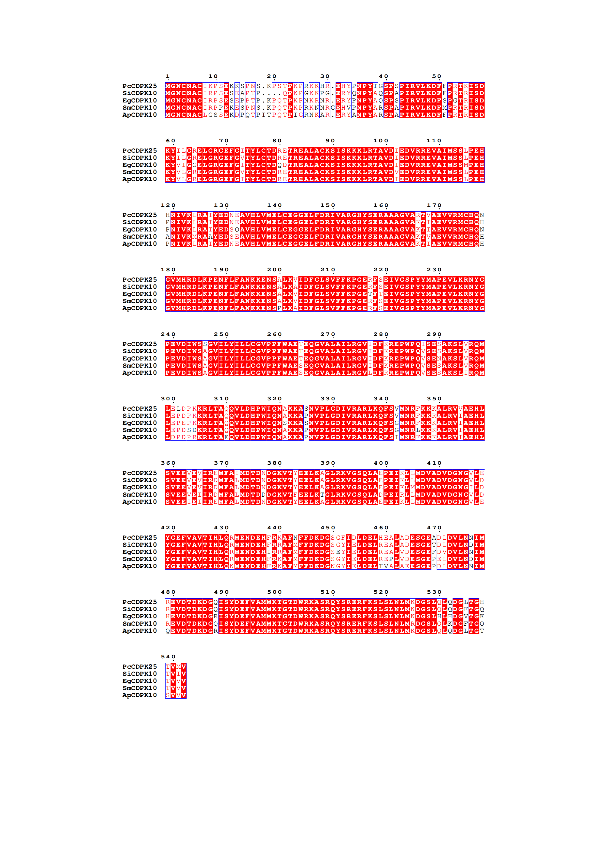

Supplementary Figure 1. Multiple sequence alignment of PcCDPK25 with other species.



Supplementary Figure 2. Multiple sequence alignment of PcCDPK38 with other species.