Supplemental Information

Online Monitoring the Hydrolysis of Uranium Hexafluoride for Intermediates by Cryogenic Layering and FTIR

Louis E. McNamara, John T. Kelly, Abigail M. Waldron, Eliel Villa-Aleman, K. Alicia Strange Fessler

**Table of Contents:**

Figure S1. PCA loadings spectra 500-1000 cm-1 ...………………………………………. Page 2

Figure S2. PCA loadings spectra 1000-4000 cm-1 ….……………………………………. Page 3

Figure S3. Score Plot………………………………………….….………………………. Page 4

PCA Eigen Values……………………………………………………….………………...Page 5

Figure S1. Infrared spectrum of the UF6 hydrolysis at (a) initial cryogenic layering and (d) final product state. Principal component analysis provides two principal components**,** PC1 (b) and PC2(c) that can better show the differences in stable intermediate formation.

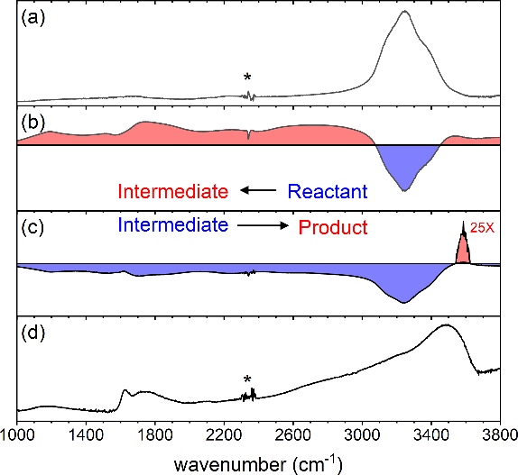

Figure S2. Infrared spectrum of the UF6 hydrolysis at (a) initial cryogenic layering and (d) final product state. Principal component analysis provides two principal components, PC1 (b) and PC2 (c) that can better show the differences in stable aqueous spectrum and proton transfer process.

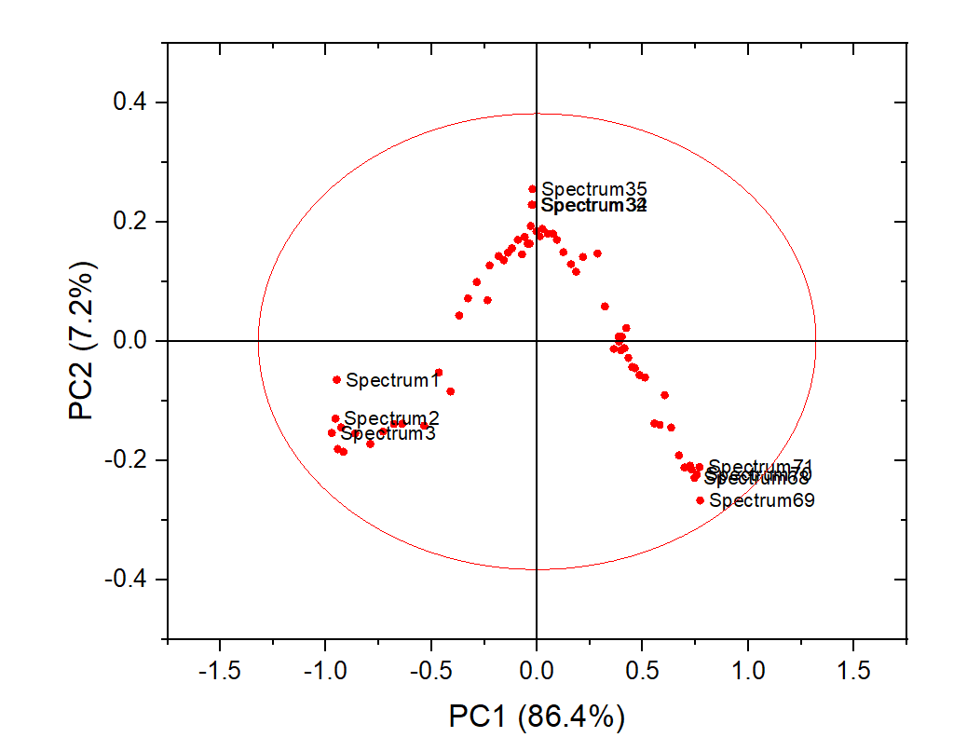

Figure S3. Score plot of the data set showing a clear reaction pathway is captured by PC1 and PC2.

Table of PCA Eigen Values and Variances:

|  |  |  |  |
| --- | --- | --- | --- |
| Principal Component Number | Eigenvalue | Percentage of Variance (%) | Cumulative (%) |
| 1 | 0.27076 | 86.35469 | 86.35469 |
| 2 | 0.02269 | 7.23675 | 93.59145 |
| 3 | 0.0104 | 3.31771 | 96.90915 |
| 4 | 0.00415 | 1.32202 | 98.23117 |
| 5 | 0.00301 | 0.9603 | 99.19148 |
| 6 | 0.00117 | 0.37356 | 99.56504 |
| 7 | 5.07E-04 | 0.16158 | 99.72661 |
| 8 | 3.20E-04 | 0.10208 | 99.8287 |
| 9 | 1.50E-04 | 0.04769 | 99.87638 |
| 10 | 8.34E-05 | 0.0266 | 99.90298 |
| 11 | 6.25E-05 | 0.01994 | 99.92292 |
| 12 | 4.34E-05 | 0.01383 | 99.93675 |
| 13 | 3.62E-05 | 0.01156 | 99.9483 |
| 14 | 2.49E-05 | 0.00795 | 99.95625 |
| 15 | 2.14E-05 | 0.00681 | 99.96306 |
| 16 | 1.78E-05 | 0.00567 | 99.96874 |
| 17 | 1.22E-05 | 0.0039 | 99.97264 |
| 18 | 1.06E-05 | 0.00339 | 99.97603 |
| 19 | 7.63E-06 | 0.00243 | 99.97846 |
| 20 | 6.76E-06 | 0.00216 | 99.98062 |
| 21 | 5.98E-06 | 0.00191 | 99.98252 |
| 22 | 5.18E-06 | 0.00165 | 99.98417 |
| 23 | 4.92E-06 | 0.00157 | 99.98574 |
| 24 | 3.35E-06 | 0.00107 | 99.98681 |
| 25 | 3.18E-06 | 0.00102 | 99.98783 |
| 26 | 2.97E-06 | 9.48E-04 | 99.98877 |
| 27 | 2.83E-06 | 9.02E-04 | 99.98968 |
| 28 | 2.33E-06 | 7.44E-04 | 99.99042 |
| 29 | 2.18E-06 | 6.95E-04 | 99.99112 |
| 30 | 2.16E-06 | 6.90E-04 | 99.9918 |
| 31 | 1.81E-06 | 5.79E-04 | 99.99238 |
| 32 | 1.65E-06 | 5.27E-04 | 99.99291 |
| 33 | 1.60E-06 | 5.11E-04 | 99.99342 |
| 34 | 1.50E-06 | 4.78E-04 | 99.9939 |
| 35 | 1.36E-06 | 4.35E-04 | 99.99433 |
| 36 | 1.31E-06 | 4.16E-04 | 99.99475 |
| 37 | 1.15E-06 | 3.68E-04 | 99.99512 |
| 38 | 1.13E-06 | 3.60E-04 | 99.99548 |
| 39 | 1.03E-06 | 3.30E-04 | 99.99581 |
| 40 | 9.49E-07 | 3.03E-04 | 99.99611 |
| 41 | 8.96E-07 | 2.86E-04 | 99.9964 |
| 42 | 8.56E-07 | 2.73E-04 | 99.99667 |
| 43 | 8.11E-07 | 2.59E-04 | 99.99693 |
| 44 | 7.49E-07 | 2.39E-04 | 99.99717 |
| 45 | 6.91E-07 | 2.20E-04 | 99.99739 |
| 46 | 6.32E-07 | 2.02E-04 | 99.99759 |
| 47 | 5.97E-07 | 1.91E-04 | 99.99778 |
| 48 | 5.82E-07 | 1.86E-04 | 99.99797 |
| 49 | 5.33E-07 | 1.70E-04 | 99.99814 |
| 50 | 5.08E-07 | 1.62E-04 | 99.9983 |
| 51 | 4.87E-07 | 1.55E-04 | 99.99845 |
| 52 | 4.69E-07 | 1.50E-04 | 99.9986 |
| 53 | 4.40E-07 | 1.40E-04 | 99.99874 |
| 54 | 4.28E-07 | 1.37E-04 | 99.99888 |
| 55 | 3.87E-07 | 1.24E-04 | 99.999 |
| 56 | 3.69E-07 | 1.18E-04 | 99.99912 |
| 57 | 3.36E-07 | 1.07E-04 | 99.99923 |
| 58 | 3.11E-07 | 9.93E-05 | 99.99933 |
| 59 | 2.90E-07 | 9.25E-05 | 99.99942 |
| 60 | 2.65E-07 | 8.45E-05 | 99.9995 |
| 61 | 2.38E-07 | 7.60E-05 | 99.99958 |
| 62 | 2.29E-07 | 7.29E-05 | 99.99965 |
| 63 | 2.17E-07 | 6.91E-05 | 99.99972 |
| 64 | 2.03E-07 | 6.48E-05 | 99.99979 |
| 65 | 1.86E-07 | 5.93E-05 | 99.99985 |
| 66 | 1.76E-07 | 5.62E-05 | 99.9999 |
| 67 | 1.60E-07 | 5.10E-05 | 99.99995 |
| 68 | 1.44E-07 | 4.60E-05 | 100 |
| 69 | 8.14E-32 | 2.60E-29 | 100 |
| 70 | 1.11E-34 | 3.53E-32 | 100 |
| 71 | 1.84E-35 | 5.87E-33 | 100 |