Supplementary Material

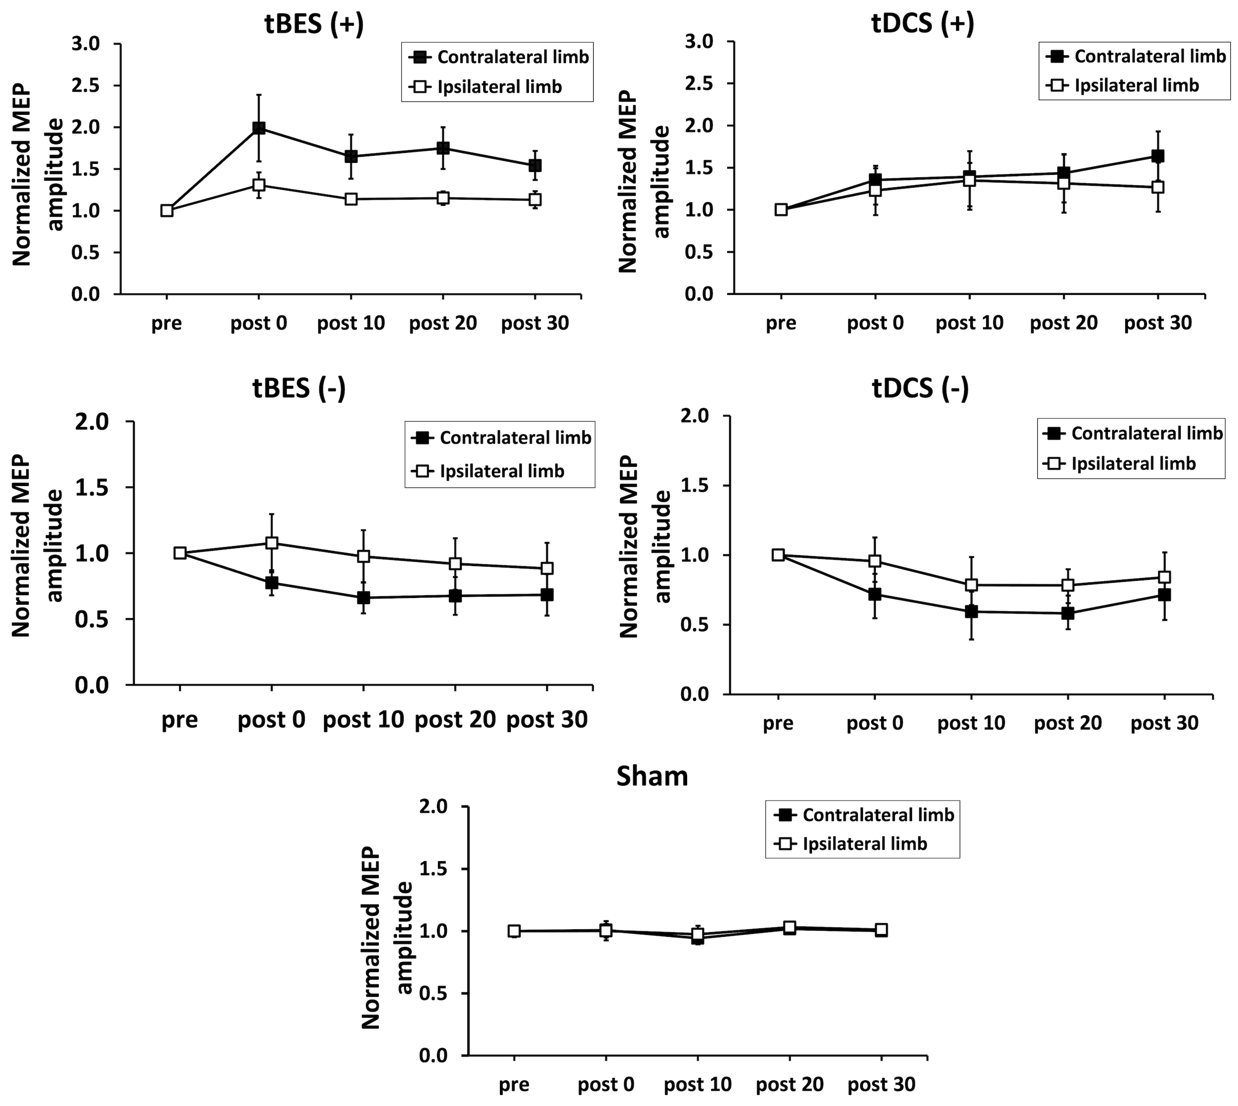

**Supplementary Figure 1.** The normalized motor-evoked potential (MEP) amplitudes for both the contralateral and ipsilateral limbs were assessed across the five intervention protocols (tBES+, tDCS+, tBES-, tDCS-, and sham). While changes in the amplitude of MEP induced by tBES (+), tDCS (+), tBES (-), tDCS (-) in the contralateral limb were greater than those in the ipsilateral limb, no statistical significance was observed. No changes in MEP were observed in either limb in the sham group.