Supplementary Material

Cohorts description
UK Biobank (Miller et al., Nature neuroscience 19.11 (2016): 1523-1536). This is a large, prospective multi-centre cohort study conducted across England, Scotland, and Wales. At baseline (2006-2010), about 500 000 participants aged 40-69 years were recruited, and extensive phenotypic and genotypic data were collected. Additionally, in 2014 UK biobank imaging study began with a plan to re-invite 100000 participants for brain, heart, and body imaging. The participants underwent 3T brain MRI scans. Within the MRI sample, we selected 13882 individuals without dementia, mild cognitive impairment (MCI), other neurological and psychiatric conditions, and good-to-excellent self-reported health. Information about image acquisition protocol in the UK Biobank can be found in https://biobank.ctsu.ox.ac.uk/crystal/refer.cgi?id=2367.
GENIC (Machado et. al., Neurobiology of Aging 71 (2018): 179-188). This is a community-based longitudinal cohort of adults aged 29 to 85 years at baseline, who were recruited through advertisements in local schools, primary care health centres, and relatives and acquaintances of the research staff of the University of La Laguna, Tenerife, Canary Islands, Spain. We selected 299 participants without dementia, MCI, neurological, psychiatric, or other systemic diseases, as well as no evidence of pathological findings in the 3T brain MRIs (e.g., stroke, tumours, hippocampal sclerosis) or a history of substance abuse. Information about image acquisition protocol in the GENIC cohort can be found in Machado et. al., 2018.
ADNI (Jack et al., J Magn Reson Imaging. 2008 Apr; 27(4):685-91). Data used to prepare this article were obtained from the Alzheimer’s Disease Neuroimaging Initiative (ADNI) database (adni.loni.usc.edu). The ADNI was launched in 2003 as a public-private partnership, led by Principal Investigator Michael W. Weiner, MD. The primary goal of ADNI has been to test whether serial MRI, positron emission tomography, other biological markers, and clinical and neuropsychological assessment can be combined to measure the progression of MCI and early AD. This longitudinal multi-centre study includes more than 2000 individuals in all levels of cognition (from unimpaired to cognitively impaired – including mild stages and dementia), aged 55-90 years, with available 1.5/3T brain MRIs, followed up over time. Within the available sample, we selected 1489 MRIs of 443 cognitively unimpaired individuals. Information about image acquisition protocol in the ADNI cohort can be found in https://adni.loni.usc.edu/methods/mri-tool/mri-analysis/.
AIBL (Rowe et al., Neurobiology of aging 31.8 (2010): 1275-1283). Data was collected by the AIBL study group. AIBL study methodology has been reported previously (Ellis et al., International psychogeriatrics 21.4 (2009): 672-687.). This is a longitudinal multi-centre study including 1100 Australian individuals that are cognitively healthy, MCI, or AD dementia, aged ≥60 years with available 1.5/3T brain MRIs. From this cohort, we selected 957 MRIs from 491 cognitively healthy individuals. Information about image acquisition protocol in the AIBL is based on ADNI protocol and can be found in https://adni.loni.usc.edu/methods/mri-tool/mri-analysis/.
AddNeuroMed (Birkenbihl et al., Journal of Alzheimer's Disease 79.1 (2021): 423-431; Simmons et al., International journal of geriatric psychiatry 26.1 (2011): 75-82). AddNeuroMed is part of the InnoMed European Union PF6 programme, designed to develop and validate novel surrogate markers in AD and includes MRI data with other biomarkers and clinical information. A total of 88 cognitively unimpaired individuals (44 females, 44 males), with 149 MRIs, with an average age of 75.1 yrs. (53.0 – 88.9 yrs.), with 1.5T brain MRIs, were included in the external dataset for validation in this study. Information about image acquisition protocol in the AIBL is based on ADNI protocol and can be found in Simmons et. al., 2011.
JADNI (Iwatsubo et al., Alzheimer's & Dementia 14.8 (2018): 1077-1087). Data used in the preparation of this article were obtained from the Japanese Alzheimer’s Disease Neuroimaging Initiative (J-ADNI) database deposited in the National Bioscience Database Center Human Database, Japan (Research ID: hum0043.v1, 2016). The J-ADNI was launched in 2007 as a public-private partnership, led by Principal Investigator Takeshi Iwatsubo, MD. The primary goal of J-ADNI has been to test whether serial magnetic resonance imaging (MRI), positron emission tomography (PET), other biological markers, and clinical and neuropsychological assessment can be combined to measure the progression of late mild cognitive impairment (MCI) and mild Alzheimer’s disease (AD) in the Japanese population. This is a large-scale observational study based on the ADNI cohort in a Japanese population and includes neuroimaging, neuropsychological and biomarker data. From this dataset, we selected 86 individuals (50 female, 36 male), with 413 MRIs, following the inclusion and exclusion criteria mentioned in the study population section of the main text, with an average age of 68.5 yrs. (60 – 86 yrs.), and with a 1.5T and 3T (385 and 28 MRIs, respectively) brain MRI. Information about image acquisition protocol in the J-ADNI cohort is based on ADNI protocol and can be found in https://adni.loni.usc.edu/methods/mri-tool/mri-analysis/.

ICD-9 AND ICD-10 CODES
Supplementary Table 1. List of ICD-10 and 9 codes of chronic diseases used as exclusion criteria in the UK Biobank. (ICD10: https://icd.who.int/browse10/2010/en#; ICD9: https://icd.codes/icd9cm).
 | ICD-10 codes | ICD-9 codes
Dementia (in AD, vascular, in other diseases classified elsewhere, unspecified, delirium superimposed on dementia, AD, other neurodegenerative disorders) | F00-F03, F051 | 290; 293-294
Cognitive impairment | G30-G32
Epilepsy | G40-G41; G405
Multiple sclerosis | G35 | 340 + 348-349 (Other conditions of the brain)
Parkinson and parkinsonism | G20-G23 | 332
Cerebrovascular disease:
Vascular syndromes of the brain in cerebrovascular diseases | G46
Subarachnoid haemorrhage | I60 | 430
Intracerebral haemorrhage | I61 | 431
Other nontraumatic intracranial haemorrhages | I62 | 432
Cerebral infarction | I63
Stroke, not specified as haemorrhage or infarction | I64
Other cerebrovascular diseases | I67
Sequelae of cerebrovascular disease | I69 | 438
Schizophrenia and delusional disorders | F20; F22; F24; F25; F28 | 295; 297
Psychiatric, mood and behavioural diseases: |  | 316 (other psychiatric factors associated with disease)
Manic episode | F30 | 296; 298 (incl. all below)
Bipolar affective disorder | F31
Recurrent depressive disorder | F33
Persistent mood [affective] disorders | F34
Other mood [affective] disorders | F38
Unspecified mood [affective] disorder | F39
Mixed anxiety and depressive disorder | F412
Dissociative [conversion] disorders | F44
Organic amnesic syndrome, not induced by alcohol and other psychoactive substances | F04
Other mental disorders due to brain damage and dysfunction and physical disease | F06
Personality and behavioural disorders due to brain disease, damage and dysfunction | F07
Unspecified organic or symptomatic mental disorder | F09
Mental and behavioural disorders due to the use of alcohol | F10 | 291; 303 (Alcohol-induced mental disorders)
Mental and behavioural disorders due to the use of opioids | F11 | 292; 304 (Drug-induced mental disorders)
Mental and behavioural disorders due to the use of cannabinoids | F12
Mental and behavioural disorders due to the use of sedatives/hypnotics | F13
Mental and behavioural disorders due to the use of cocaine | F14
Mental and behavioural disorders due to the use of stimulants, including caffeine | F15
Mental and behavioural disorders due to the use of the hallucinogen | F16
Mental and behavioural disorders due to the use of tobacco | F17
Mental and behavioural disorders due to the use of volatile solvents | F18
Mental and behavioural disorders due to multiple drug use and use of other psychoactive substances | F19
Personality disorders | F60-F63; F68 | 301
Mental retardation | F70-F73; F78-F79 | 317-319 (Intellectual disabilities)
Developmental disorders | F80-F84; F88-F89 | 299; 315
Mental disorder, not otherwise specified | F99
NOTE: The diseases above are chronic and known to severely affect the brain and/or cognition. Transient Ischemic Attacks (ICD-10 code G45) have not been excluded. We did not exclude cognitive impairment based on the cognitive test because only 2 tests have more than 50% of complete data in v2 (close to MRI), 399 and 20016 (fluid).

Chronological age distribution of used datasets in CNN1
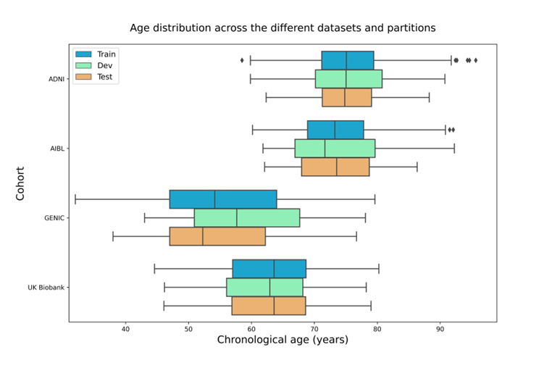
Supplementary Figure 1. Data distribution in the train, development, and test sets for the ADNI, AIBL, Genic, and UK Biobank cohorts.

Age-bias correction
Similar to previously presented brain age prediction models, we observed that the brain age was systematically predicted to be lower than the chronological age on the training and validation set and higher on younger subjects by the models. This is commonly referred to as age bias. The bias-adjusted corrected predicted brain age $({\hat{y}}_{cor}$) model proposed by (Beheshti et al., NeuroImage: Clinical 24 (2019): 102063.) is presented below, where the predicted brain age ($\hat{y}$) is a function of the chronological age (y) and the slope ($β_{1}$) and intercept ($β_{0}$) of a linear model of brain age gap against chronological age achieved from a training set.
$\hat{y}=β_{0}+β_{1}y$ (1)

${\hat{y}}_{cor}=\hat{y}-\left(β_{0}+β_{1}y\right)+y =\hat{y}-β_{0}+\left({1-β}_{1}\right)y$ (2)

Scatterplots of the brain age predictions on the CNN1 (hold-out) approach for the training and testing set of healthy individuals with applied age-bias corrections are shown in Supplementary Figure 2. The age-bias corrected scatterplots of the three cross-validated models, CNN2-4, are presented in Supplementary Figure 3.
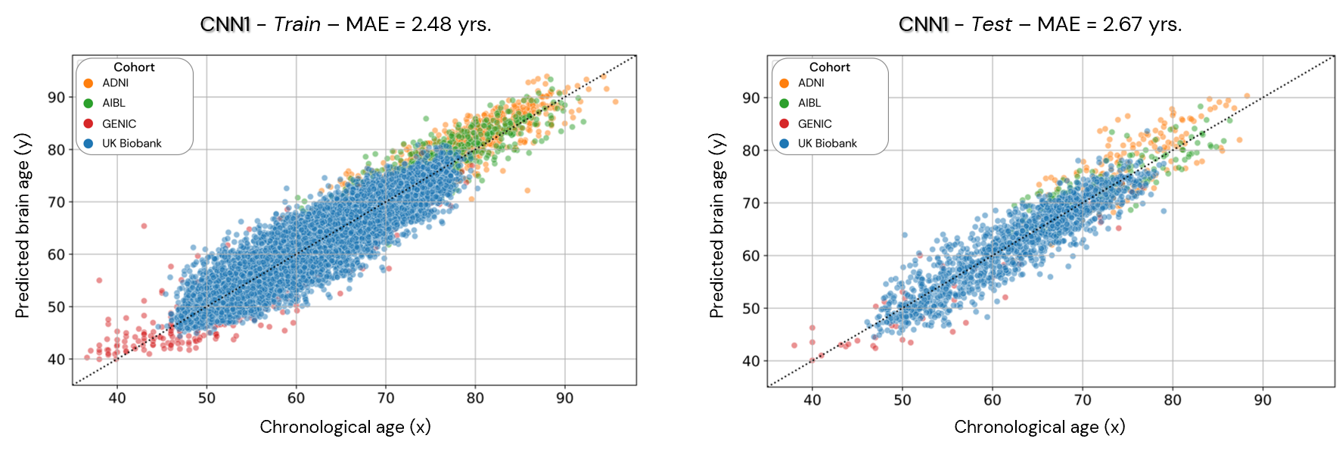
Supplementary Figure 2. Age-bias corrected scatterplots of the predicted brain age in the CNN1 model (hold-out approach) in the training and test datasets. Each coloured dot represents an individual, and each colour is a different cohort.

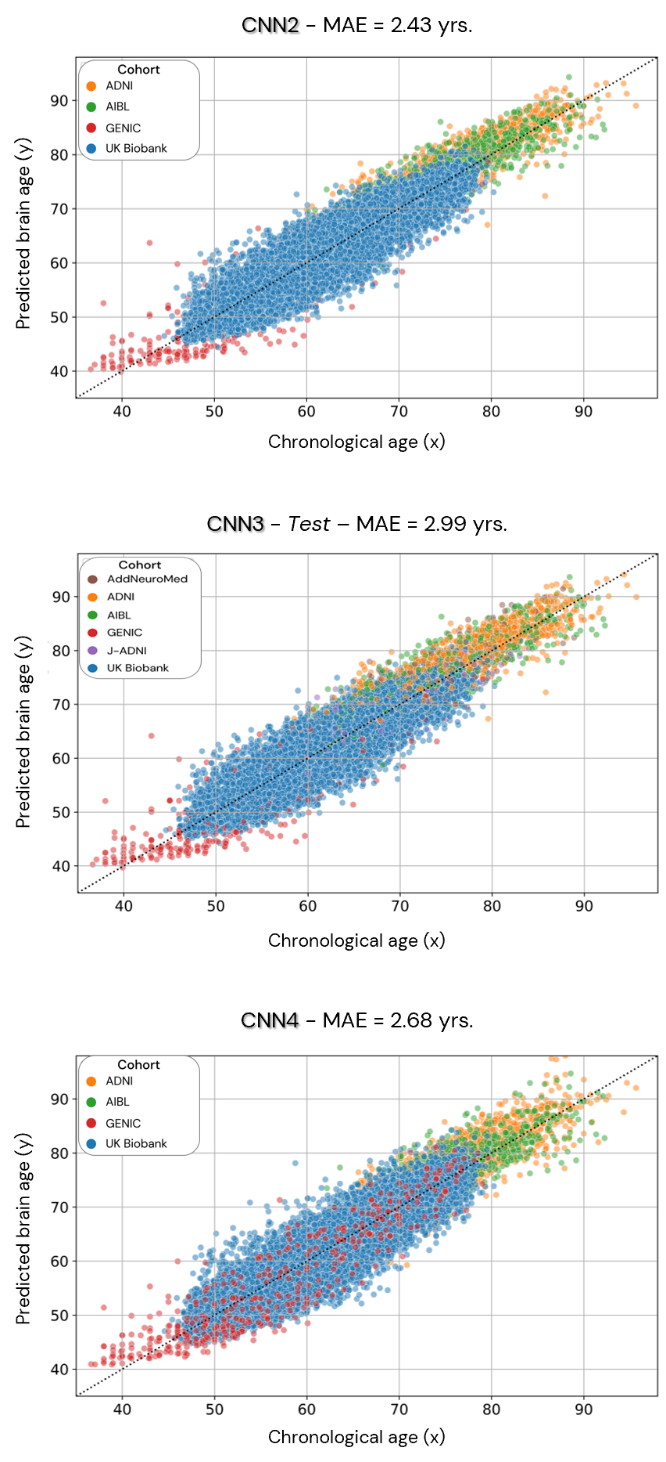
Supplementary Figure 3. Age-bias corrected scatterplots of the predicted brain age for the cross-validated models (CNN2-4). Each coloured dot represents an individual, and each colour is a different cohort.

Comparison of chronological and predicted brain age
To check the agreement between chronological and predicted brain age, we plotted the Bland-Altman differences between those measures for each trained model (CNN1-4) with 95% of limit of agreement. Supplementary Figure 4 shows the Bland-Altman analysis of the difference between chronological and predicted brain age for all trained models (CNN1 in blue, CNN2 in orange, CNN3 in green, and CNN4 in pink). The plot shows that most data fits in the 2 standard deviations from the mean of the comparison of both chronological and predicted brain age for all run models. The disagreement between the two methods of age (chronological vs. biological brain age) varies between -0.05 and 0.18.

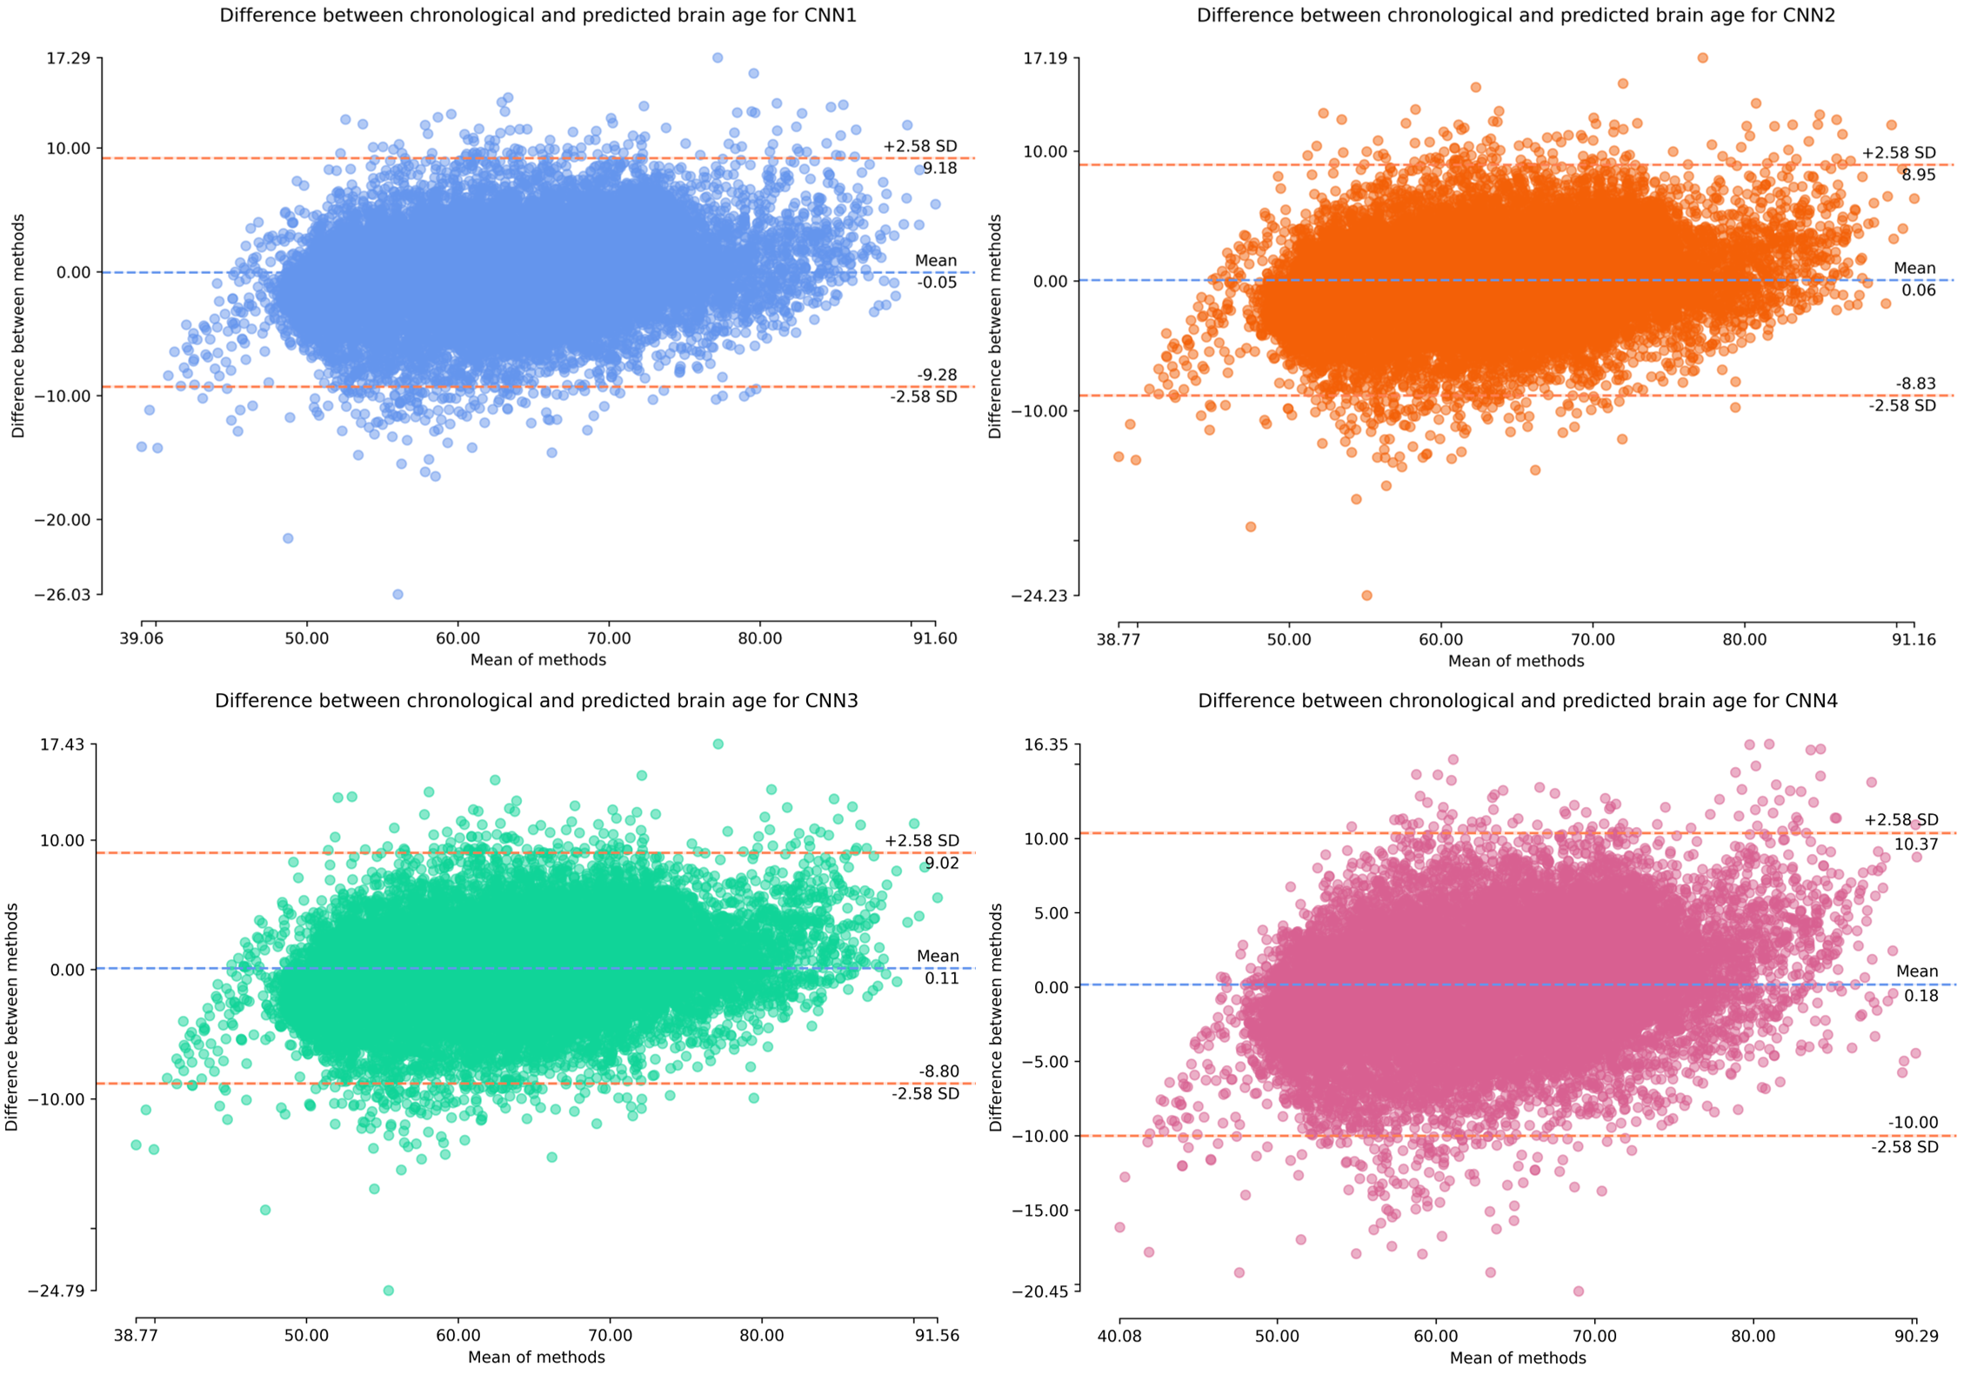
Supplementary Figure 4. Bland-Altman distribution of differences between chronological and predicted brain age for all trained models (CNN1-4).

MAE per cohort

Supplementary Table 2 presents the normalized MAE (where nMAE = (MAE/standard deviation of the cohort’s population age)) of the UK Biobank.
Supplementary Table 2. Normalized MAE for each cohort for each of the trained models.
 | Normalized MAE per Cohort
Model | AddNeuroMed | ADNI | AIBL | GENIC | J-ADNI | UK Biobank
CNN1 | 0.66 | 0.41 | 0.44 | 0.39 | 1.04 | 0.37
CNN2 | 0.60 | 0.39 | 0.41 | 0.36 | 0.98 | 0.35
CNN3 | 0.50 | 0.39 | 0.41 | 0.37 | 0.42 | 0.36
CNN4 | 0.60 | 0.48 | 0.51 | 0.41 | 0.77 | 0.40

Below, in Supplementary Table 3, are the coefficient of determination (R²) of the predictions for each cohort in the different trained CNNs.
Supplementary Table 3. The coefficient of determination for each cohort for each of the trained models.
 | R² per Cohort
Model | AddNeuroMed | ADNI | AIBL | GENIC | J-ADNI | UK Biobank
CNN1 | 0.63 | 0.83 | 0.82 | 0.87 | 0.55 | 0.88
CNN2 | 0.67 | 0.86 | 0.84 | 0.88 | 0.59 | 0.89
CNN3 | 0.77 | 0.86 | 0.84 | 0.88 | 0.85 | 0.89
CNN4 | 0.71 | 0.80 | 0.78 | 0.87 | 0.64 | 0.85

- Relevant brain regions for aging prediction

The relevant brain regions for aging prediction were calculated based on the salience maps, constructed using the SmoothGrad approach, with a kernel smoothing of 0.15. Salience maps of all individuals were calculated individually and averaged through the whole sample. Supplementary Figure 5 presents the averaged maps of the 1% percentiles of the highest absolute values of the salience maps for CNN1, 2, 3 and 4, respectively.

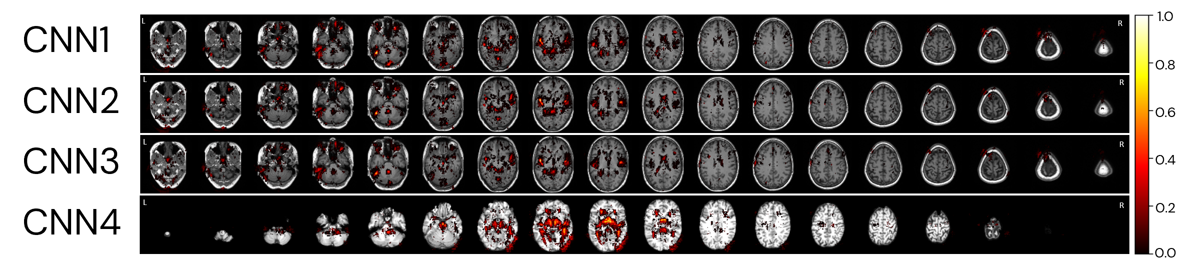
Supplementary Figure 5. Averaged salience map of the trained models.

- Brain age differences for selected individuals
Calculated brain age differences for CNN1, 2, 3 and 4, for the same individuals, used to create Figure 10, in the main manuscript. The chronological age (CA), and the brain age difference to the chronological age (GAP) of the individuals are presented in Supplementary Table 4.
Supplementary Table 4. Calculated brain age difference between chronological and predicted brain age for each model for the randomly selected individuals to plot Figure 10 in the manuscript.
Cohort | GAP considered | CA | GAP_CNN1 | GAP_CNN2 | GAP_CNN3 | GAP_CNN4
UK Biobank | -8 | 65.25 | -8.9 | -8.0 | -8.5 | -8.0
UK Biobank | -7 | 65.42 | -7.2 | -7.5 | -8.0 | -4.3
UK Biobank | -6 | 64.83 | -6.8 | -5.6 | -5.5 | -1.8
UK Biobank | -5 | 65.42 | -5.7 | -4.6 | -5.0 | 2.0
UK Biobank | -4 | 65.50 | -4.8 | -4.4 | -4.8 | -0.5
UK Biobank | -3 | 65.33 | -3.7 | -4.0 | -4.2 | -0.9
UK Biobank | -2 | 65.08 | -2.2 | -0.7 | -0.4 | 4.7
UK Biobank | -1 | 65.33 | -1.6 | -2.0 | -1.8 | 1.4
UK Biobank | 0 | 64.25 | -0.5 | -0.6 | -0.8 | -3.0
UK Biobank | 0 | 65.33 | 0.6 | 0.5 | 0.3 | 0.7
UK Biobank | 1 | 64.58 | 1.0 | -0.1 | -0.1 | -6.0
UK Biobank | 2 | 65.08 | 2.1 | 0.7 | 0.3 | -0.3
AIBL | 3 | 65.58 | 3.1 | 3.0 | 3.3 | 5.2
UK Biobank | 4 | 65.50 | 4.3 | 4.2 | 4.7 | 6.7
UK Biobank | 5 | 65.83 | 5.1 | 4.8 | 4.8 | 3.6
UK Biobank | 6 | 65.17 | 6.0 | 5.5 | 5.0 | 1.3
AIBL | 7 | 65.33 | 6.7 | 3.0 | 3.3 | -0.7
ADNI | 8 | 65.17 | 8.2 | 5.6 | 5.9 | 3.4

Individuals in each age group for the differential analysis in neuroimaging studies
For the generated image of group comparison of age and predicted brain age with a younger group, individuals were grouped based on chronological and predicted brain age. The groups are referent to the age±1 year. Supplementary Table 5 shows the number of individuals in each age group used in the analysis.
Supplementary Table 5. Number of individuals in each age group for the differential analysis on using chronological or predicted brain age in neuroimaging studies.
Age group | Chronological age | Predicted brain age
55 | 904 | 977
60 | 1131 | 1082
65 | 1474 | 1559
70 | 1542 | 1714
75 | 797 | 493
80 | 216 | 255

