**Supplementary Figure**

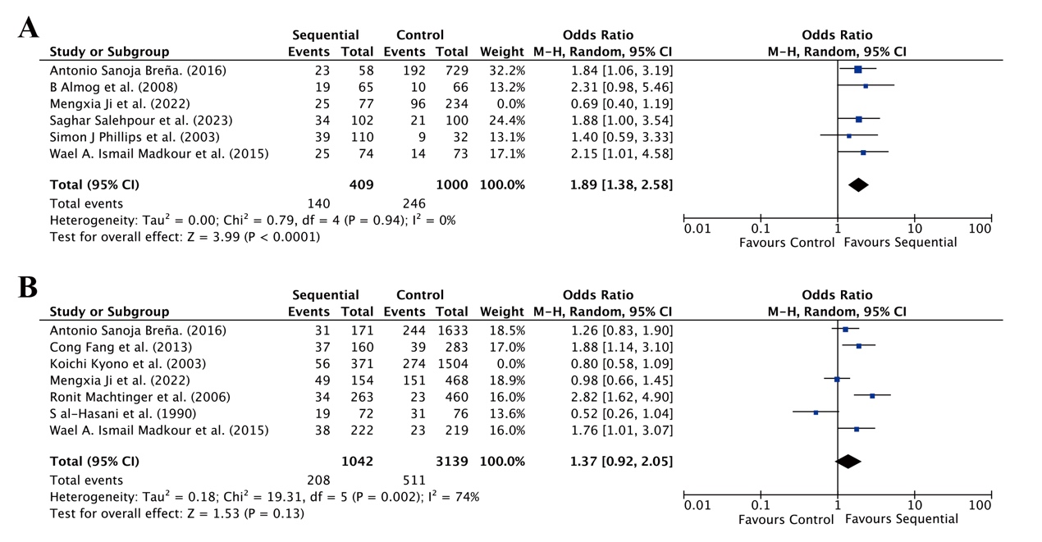

**Figure S1. Adjusted ORs for sequential transfer group and control group.** A. Ongoing pregnancy rate, B. Implantation rate.

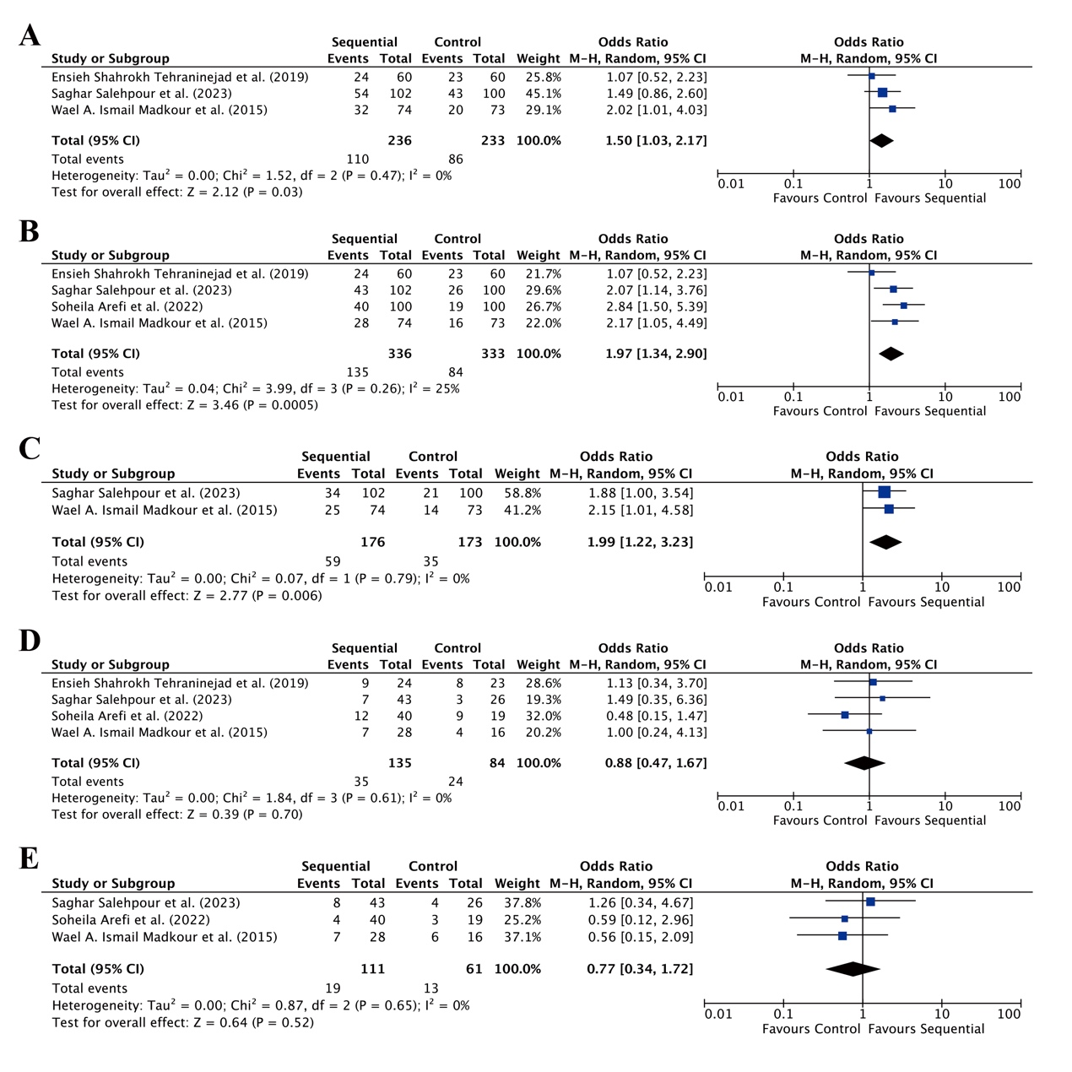

**Figure S2. RCT subgroup analysis.** A. Chemical pregnancy rate, B. Clinical pregnancy rate, C. Ongoing pregnancy rate, D. Multiple pregnancy rate, E. Miscarriage rate.

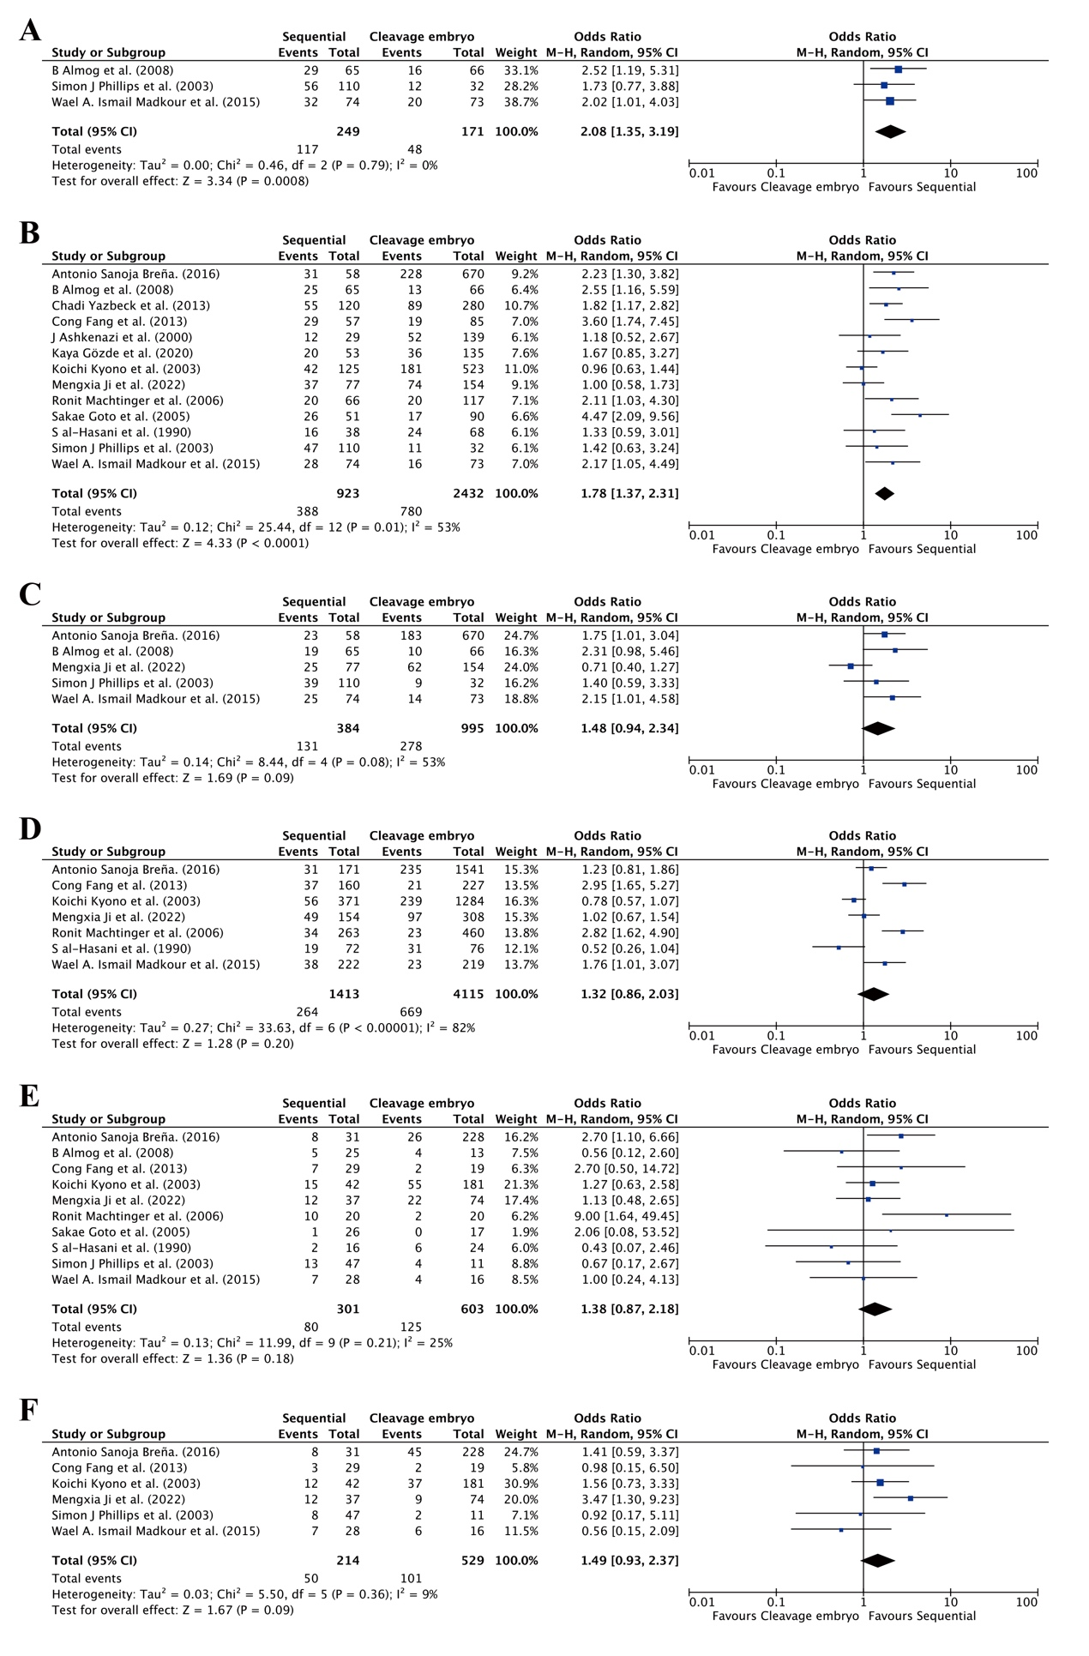

**Figure S3. Differences in assisted reproductive outcomes between sequential transfer group and cleavage embryo group.** A. Chemical pregnancy rate, B. Clinical pregnancy rate, C. Ongoing pregnancy rate, D. Implantation rate, E. Multiple pregnancy rate, F. Miscarriage rate.

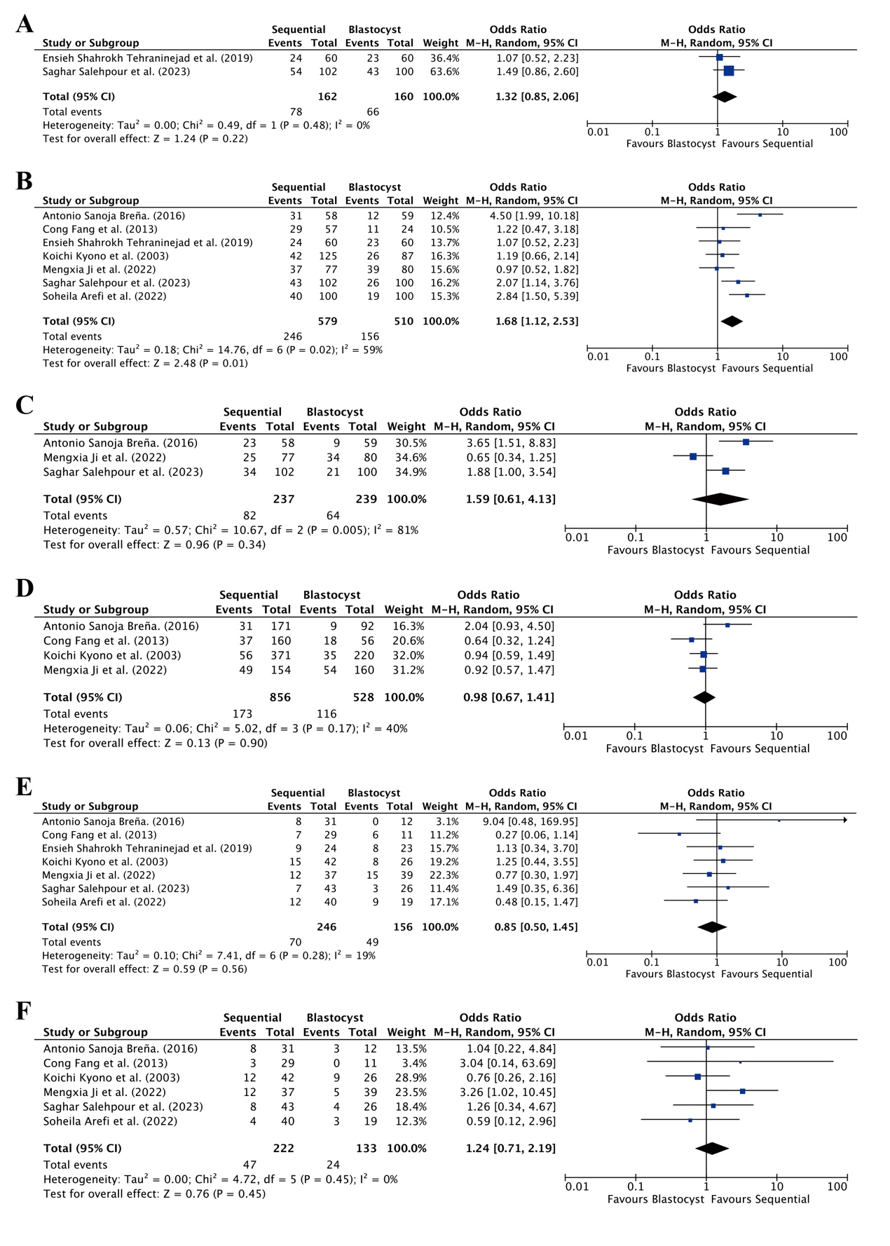

**Figure S4. Differences in assisted reproductive outcomes between sequential transfer group and blastocyst group.** A. Chemical pregnancy rate, B. Clinical pregnancy rate, C. Ongoing pregnancy rate, D. Implantation rate, E. Multiple pregnancy rate, F. Miscarriage rate.

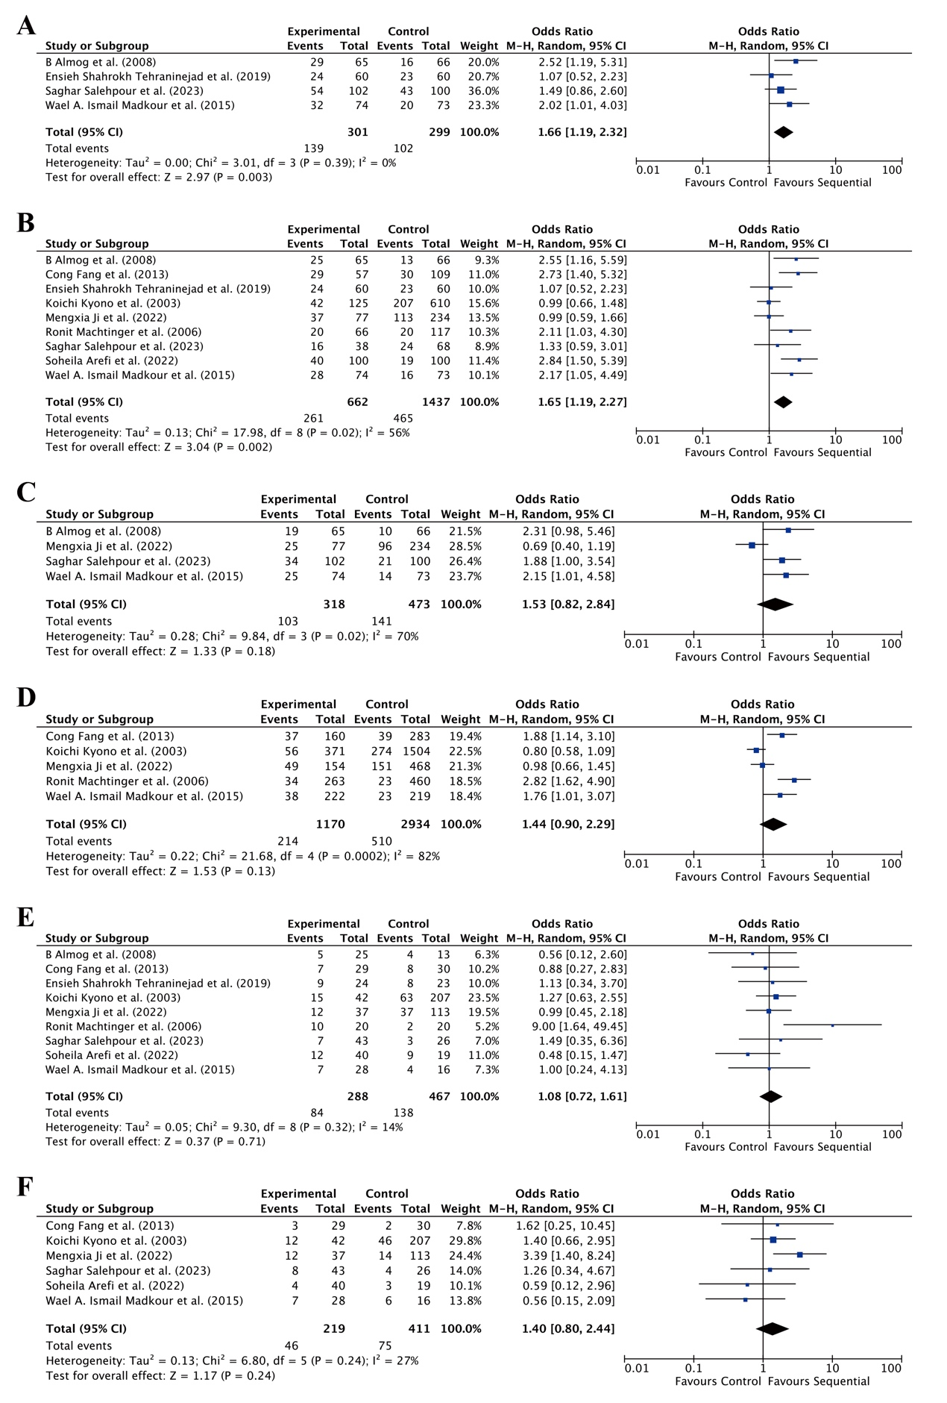

**Figure S5. Differences in assisted reproductive outcomes in RIF patients.** A. Chemical pregnancy rate, B. Clinical pregnancy rate, C. Ongoing pregnancy rate, D. Implantation rate, E. Multiple pregnancy rate, F. Miscarriage rate.