**Navigating Rice Seedling Cold Resilience: QTL Mapping in Two Inbred Line Populations and the Search for Genes**

*Michael R. Schläppi1*, Avery R. Jessel1, Aaron K. Jackson2, Huy Phan1, Melissa H. Jia2, Jeremy D. Edwards2, Georgia C. Eizenga2\**

1Department of Biological Sciences, Marquette University, Milwaukee, WI 53233, USA

2USDA-ARS Dale Bumpers National Rice Research Center, Stuttgart, AR 72160, USA

**\**Correspondence*:**

Michael Schläppi Georgia Eizenga

Department of Biological Sciences USDA-ARS

Marquette University DBNRRC

Milwaukee, WI 53233 Stuttgart, AR 72160

USA USA

Email: [michael.schlappi@marquette.edu](mailto:michael.schlappi@marquette.edu) [georgia.eizenga@usda.gov](mailto:georgia.eizenga@usda.gov)

Phone: +1 414 288-1480 Phone: +1 870 672-6104

**Keywords**: *aus* rice, chilling tolerance, heading date, IciMapping, *japonica* rice, plant height, RiceVarMap

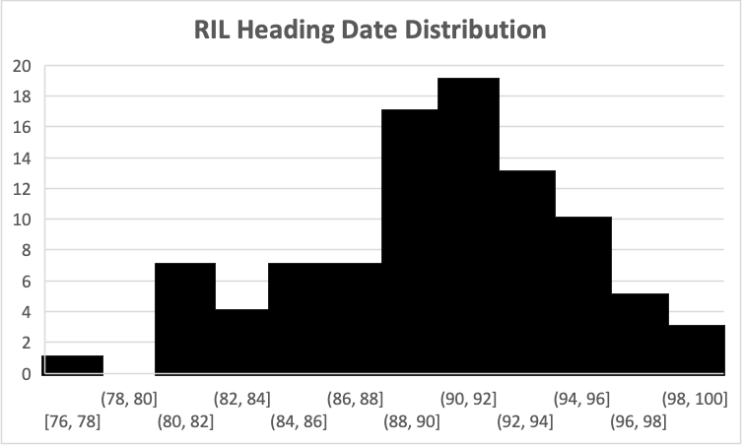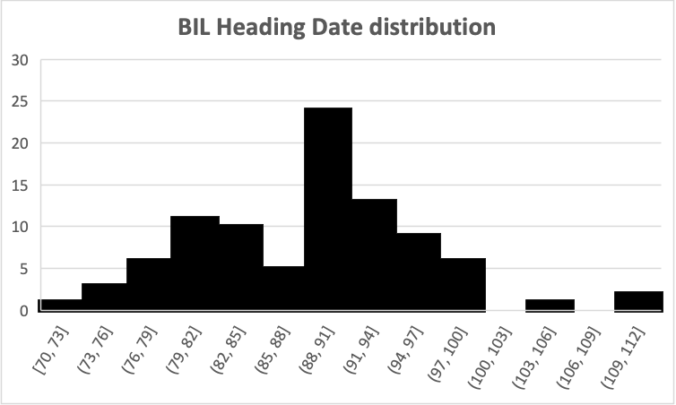

**Heading Date bins**

**Number of Plants**

**A**

Krasnodarskij 3352

WIR 911

Carolino 164

Carolino 164

**Supplementary FIGURE S1A.** Frequency distribution of heading date in F8:9 progeny of recombinant inbred lines derived from Krasnodarskij 3352 x Carolino 164 (RIL; left side), and in BC1F5:6 progeny of backcross recombinant inbred lines derived from [WIR 911 x Carolino 164] x Carolino 164 (BIL; right side). Arrows indicate the heading date values for the three parents.

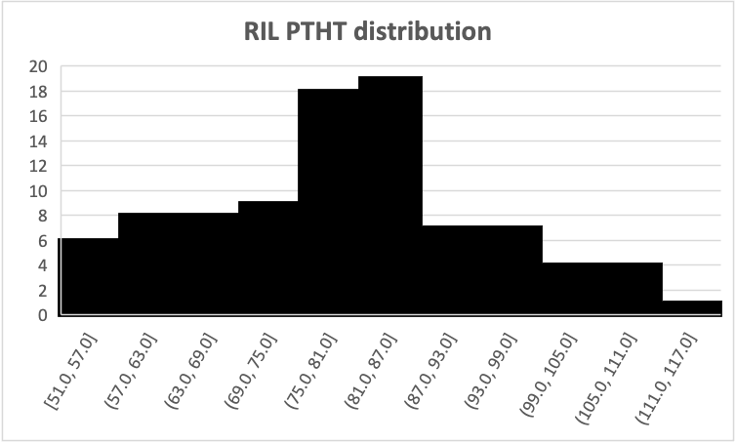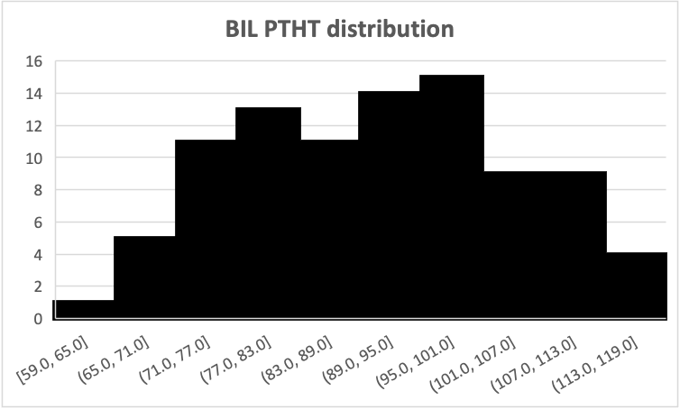

**Plant Height (PTHT) [cm] bins**

**Number of Plants**

**B**

Krasnodarskij 3352

WIR 911

Carolino 164

Carolino 164

**Supplementary FIGURE S1B.** Frequency distribution of mature plant height (PTHT, measured in cm from soil level to tip of mature panicle) F8:9 progeny of recombinant inbred lines derived from Krasnodarskij 3352 x Carolino 164 (RIL; left side), and in BC1F5:6 progeny of backcross recombinant inbred lines derived from [WIR 911 x Carolino 164] x Carolino 164 (BIL; right side). Arrows indicate the PTHT values for the three parents.

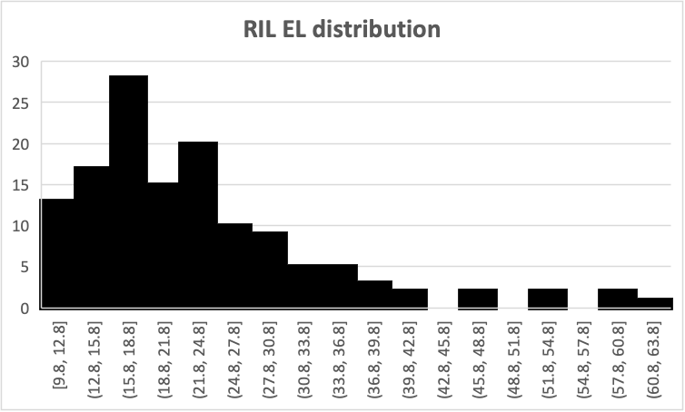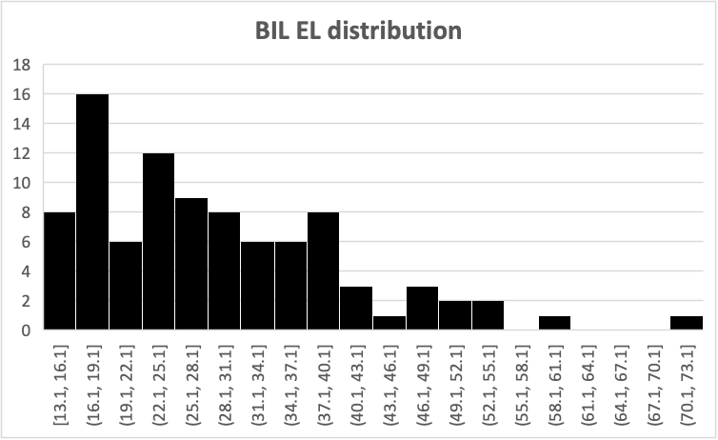

**Percent Electrolyte Leakage (EL) bins**

**Number of Plants**

**C**

Krasnodarskij 3352

WIR 911

Carolino 164

Carolino 164

**Supplementary FIGURE S1C.** Frequency distribution of percent electrolyte leakage (EL) in leaves of F8:9 progeny of recombinant inbred lines derived from Krasnodarskij 3352 x Carolino 164 (RIL; left side), and in BC1F5:6 progeny of backcross recombinant inbred lines derived from [WIR 911 x Carolino 164] x Carolino 164 (BIL; right side) after a one-week exposure to constant 10°C. Arrows indicate the EL values for the three parents.

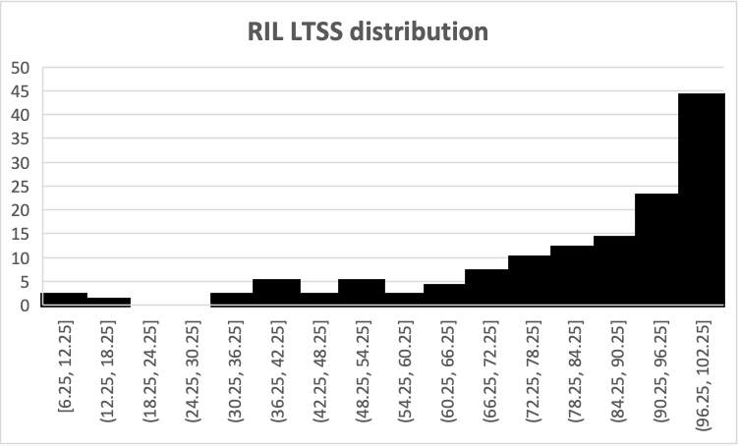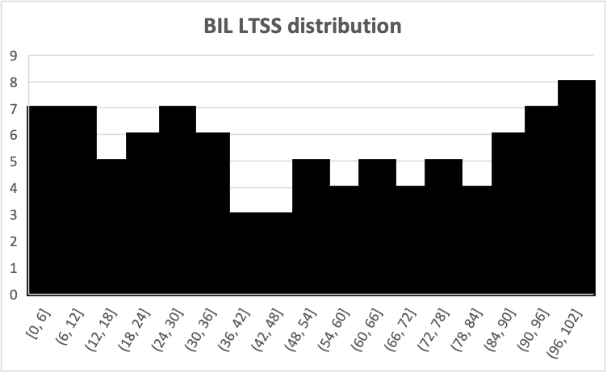

**Percent Low-Temperature Seedling Survivability (LTSS) bins**

**Number of Plants**

**D**

Krasnodarskij 3352

WIR 911

Carolino 164

Carolino 164

**Supplementary FIGURE S1D.** Frequency distribution of percent low-temperature seedling survivability (LTSS) of F8:9 progeny of recombinant inbred lines derived from Krasnodarskij 3352 x Carolino 164 (RIL; left side), and in BC1F5:6 progeny of backcross recombinant inbred lines derived from [WIR 911 x Carolino 164] x Carolino 164 (BIL; right side) after a one-week exposure to constant 10°C. Arrows indicate the LTSS values for the three parents.