Monitoring the reduction of UO3 thin film by hydrogen atoms using valence level spectroscopy. Correlating the U5f1 signal to surface hydroxyls.

G. El Jamala, T. Gouderb*, R. Eloirdib, M. Jonssona, H. Idrissb,c*.

1. School of Engineering Sciences in Chemistry, Biotechnology and Health (CBH), Department of Chemistry, Applied Physical Chemistry, KTH Royal Institute of Technology, SE-100 44 Stockholm, Sweden
2. European Commission, Joint Research Centre, Postfach 2340, DE-76215 Karlsruhe, Germany

C. Institute of Functional Interfaces (IFG), Karlsruhe Institute of Technology (KIT), DE-76215 Karlsruhe, Germany

*emails: Thomas Gouder; [Thomas.GOUDER@ec.europa.eu](mailto:Thomas.GOUDER@ec.europa.eu)

Hicham Idriss; [hicham.idriss@kit.edu](mailto:hicham.idriss@kit.edu)

|  |
| --- |
| **Peak Position (eV) Area FWHM (eV) %GL (%)** |
| 0 380.340 34609.580 1.350 30 |
| 1 381.310 53337.110 1.380 40 |
| 2 391.080 24844.900 1.400 30 |
| 3 392.090 49581.790 1.600 30 |
| 4 388.480 5438.214 2.000 50 |
| 5 384.340 2842.664 2.500 50 |
| 6 395.130 3356.155 2.800 50 |
| 7 399.070 8220.616 2.500 80 |
| 8 401.200 1805.781 2.000 70 |

**Table S1.** Peak parameters used for the fitting of the XPS U4f lines for U6+ and U5+ cations.

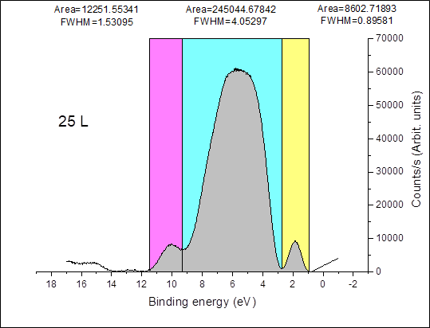

Figure S1. An example of the peak area integration method of the three structures studied by He(II) UPS of UO3 exposed to hydrogen atoms, after back ground subtraction. The figure is that of UO3 exposed to 25 L at 190K (250 seconds at 1 x 10-7 torr). The obtained peak areas have an error of about 5% for the central peak and about 10% for those of the surface hydroxyls and U5f lines.



Figure S2. The fitting parameters of the equation used for the data presented in figure 4B.