*Supplementary Material*

**3D bioprinting of dECM-incorporated hepatocyte spheroid for simultaneous promotion of cell-cell and -ECM interactions**

Min Kyeong Kim1,2,*†*, Wonwoo Jeong1,3,*†*, Seunggyu Jeon1,3, and Hyun-Wook Kang1,*

1Department of Biomedical Engineering, Ulsan National Institute of Science and Technology, Ulju-gun 44919, Ulsan, Republic of Korea

2Center for Scientific Instrumentation, Korea Basic Science Institute, Cheongju 28119, Chungbuk, Republic of Korea

3Wake Forest Institute for Regenerative Medicine, Wake Forest University School of Medicine, Winston-Salem, NC 27157, USA

*†*These authors contributed equally to this work.

**\* Correspondence:***Hyun-Wook Kang, Ph.D.*

*Department of Biomedical Engineering, Ulsan National Institute of Science and Technology*

*50, UNIST-gil, Ulsan 44919, South Korea*

*Tel.: +82 52 217 2527; E-mail address:* [*hkang@unist.ac.kr*](mailto:hkang@unist.ac.kr)

**Supplementary Table**

**Table S1. Primer sequences used for primary mouse hepatocyte**

|  |  |  |
| --- | --- | --- |
| **Gene** | **Forward (5'-3')** | **Reverse (5'-3')** |
| *ALB* | AGCCCACTGTCTTAGTGAGG | TCTTGCACACTTCCTGGTCC |
| *HNF4A* | CTAACACGATGCCCTCTCAC | GCAGGAGCTTGTAGGATTCAG |
| *CPS1* | AAGTAGAGATGGACGCTGTTG | CTTGGCTGATGGTCTGTGTAG |
| *UGT1A1* | AGATTACCCCAGGCCCATC | ATGGCTTTCTTCTCCGGAAT |
| *CYP1A2* | ATAACTTCGTGCTGTTTCTGC | ACCGCCATTGTCTTTGTAGT |
| *CYP1B1* | ATTCTCAGTGGGCAAACGG | GGATTCTAAACGACTTGGGCT |
| *CYP2E1* | GGAATGGGGAAACAGGGTAAT | GCACAGCCAATCAGAAAGGT |
| *CYP3A11* | TGGTCAAACGCCTCTCCTTGCTG | ACTGGGCCAAAATCCCGCCG |
| *GAPDH* | TGCCCCCATGTTTGTGAT | TGTGGTCATGAGCCCTTC |

**Supplementary Figures**



**Supplementary Figure 1. Characterization of dECM materials.** (A) Gross view (upper) and H&E staining results (lower) of native and decellularized porcine liver tissues. Measured DNA (B), GAGs (C) and collagen (D) contents of the native and dECM material.



**Supplementary Figure 2. Rheological property of dECM-based cell bio-inks and matrix ink.** Viscosities of the dECM-based cell bio-inks (gelatin concentration: 12.5 mg/ml, 22.5 mg/ml, 32.5 mg/ml) and matrix ink were measured according to the change in shear rate (n=3).



**Supplementary Figure 3. Measured diameters of bioprinted, dECM-incorporated PMH spheroids in the variation of dECM concentration.** After printing, the diameters were measured on day 3 (n=20, **p < 0.01, ***p < 0.001).

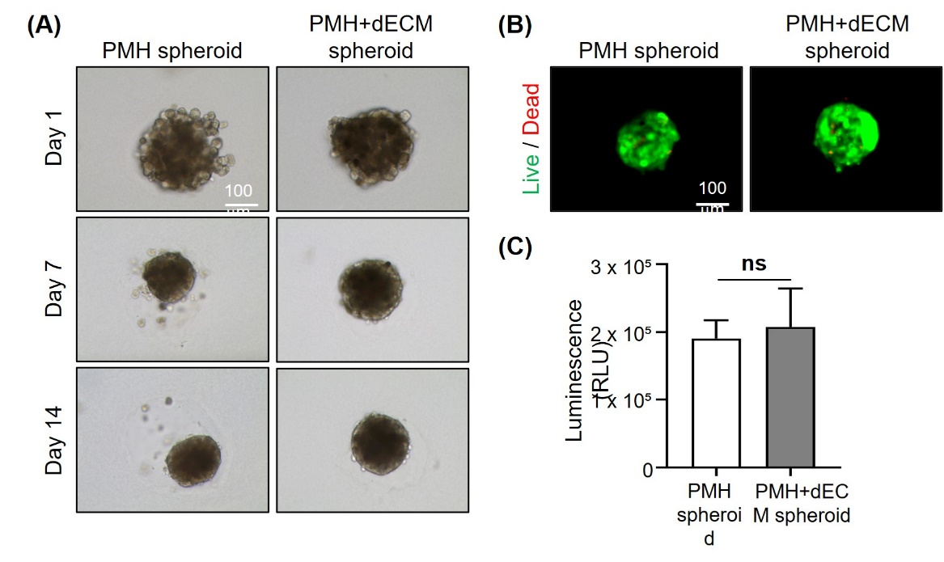

**Supplementary Figure 4. Morphology and viability of the bioprinted dECM-incorporated PMH spheroids.** Optical microscope images of PMH spheroid group and 0.5% w/v dECM group during 14 days culture (A). The live/dead staining (B) and CellTiter-Glo cell viability assay (C) of PMH spheroid group and 0.5% w/v dECM group was conducted on day 7 after printing (n=3, ns: not significant).

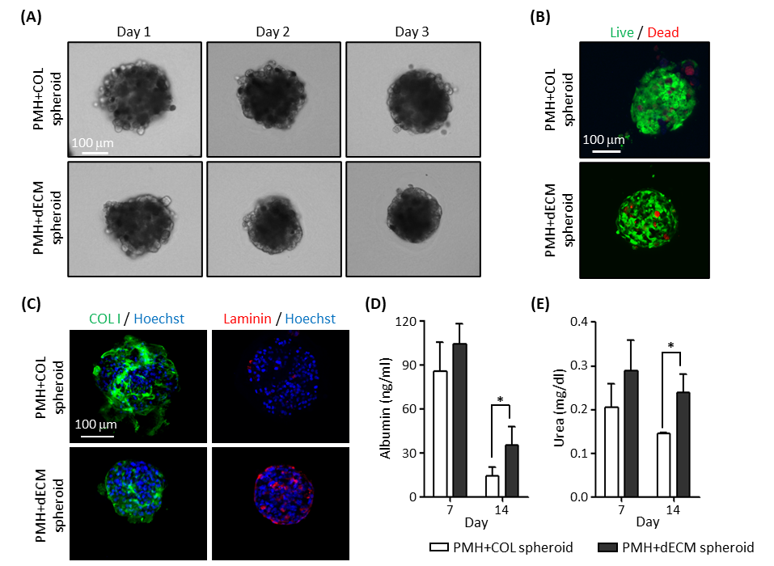

**Supplementary Figure 5. Bioprinted, collagen- and dECM-incorporated PMH spheroids and their hepatic functions.** Optical microscope images (A) and live/dead staining results (B) of collagen- and dECM-incorporated PMH spheroids. The live/dead staining was conducted on day 3 after printing. (C) Immunostaining results of the spheroids on day 3. Measured albumin (D) and urea (E) secretions of the spheroids on day 7 and 14 (n=5, *p < 0.05).