Supplementary Materials
Table S1. Summary of the experiment, all the measurements taken, and biological variables measured. TA = Total Alkalinity, pH = pH measurements, DO = Dissolved Oxygen measurements, PAM = Pulse Amplitude Modulator for measuring Photochemical Efficiency, Pulsations = Bell pulsation rate, Samples = Snap freezing of the oral arms for symbiont count, chlorophyll analysis, protein analysis, microbiome, Catalase, Superoxide Dismutase, Glutathione-S-Transferase, Size = Measuring bell diameter, Observations = observation of bleaching, lack of pulsations, discoloration, and tissue melting.
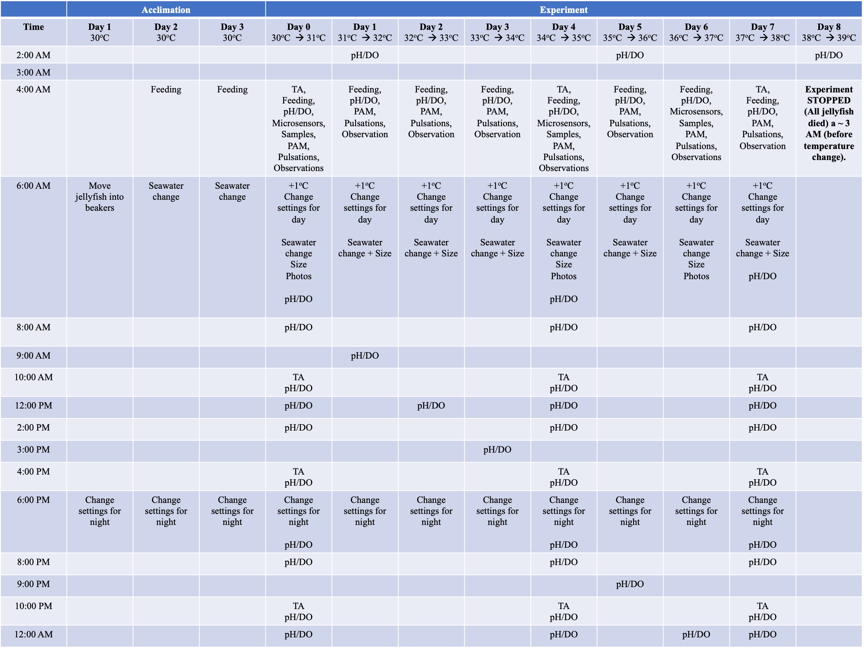
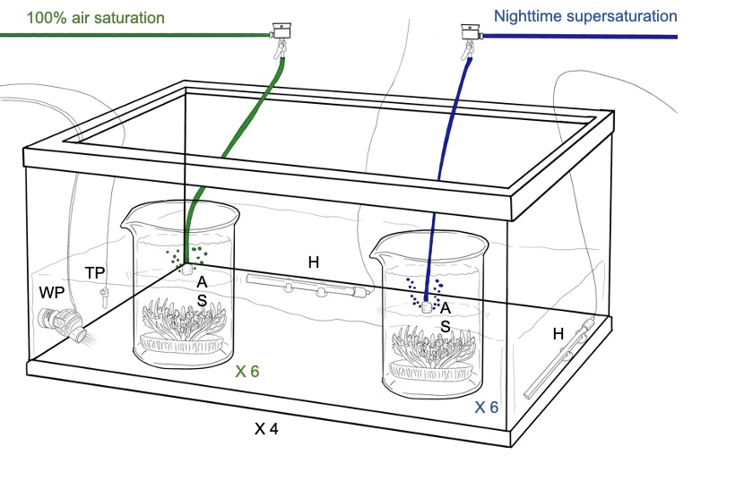
Figure S1. Schematic representation of the experimental set-up. Each water bath (4 in total) was equipped with a water pump (WP), a temperature probe (TP), and two heaters (H). The water baths were used to control the temperature, and water pumps maintained a homogeneous temperature. One C. andromeda holobiont was placed individually into glass aquaria and 12 glass aquaria were positioned in each water bath (6 per treatment, 48 in total). Gas mixtures for “Nighttime supersaturation” (green) and “100% air saturation” (blue) were mixed in a stainless-steel manifold and then delivered in equal quantities to each glass aquarium using air stones (AS) to improve gas diffusion in seawater. Secondary stainless-steel manifolds were used to manually adjust the flow rates.

Figure S2. Average temperature during the experiment. Bars represent standard deviation (± 1 SD). The blue line represents the “Nighttime supersaturation” treatment, whereas the green line represents the “100% air saturation” treatment. Average temperature is shown in the y-axis, whereas the x-axis shows the day number.
A
B
Figure S3. (A) Average dissolved oxygen in mg L⁻¹. Bars represent standard deviation (± 1 SD). The blue line represents the “Nighttime supersaturation” treatment, whereas the green line represents the “100% air saturation” treatment. Average dissolved oxygen is shown in the y-axis, whereas the x-axis shows the hours of the day. (B) Average dissolved oxygen in % air saturation. Bars represent standard deviation (± 1 SD). The blue line represents the “Nighttime supersaturation” treatment, whereas the green line represents the “100% air saturation” treatment. Average dissolved oxygen is shown in the y-axis, whereas the x-axis shows the hours of the day.
Figure S4. Average pH over time, during the days. Bars represent standard deviation (± 1 SD). The blue line represents the “Nighttime supersaturation” treatment, whereas the green line represents the “100% air saturation” treatment.
Figure S5. Average Total Alkalinity (µmol Kg⁻¹). Bars represent standard deviation (± 1 SD). The blue line represents the “Nighttime supersaturation” treatment, whereas the green line represents the “100% air saturation” treatment.
Figure S6. Average partial pressure of CO₂ (µatm). Bars represent standard deviation (± 1 SD). The blue line represents the “Nighttime supersaturation” treatment, whereas the green line represents the “100% air saturation” treatment.
Figure S7. Average bell pulsation rate (BPR) min⁻¹ of Cassiopea is shown in the y-axis, whereas the x-axis shows the treatment. In blue, the average in specimens exposed to “Nighttime supersaturation”, and in green, the average in specimens exposed to “100% air saturation”. The black line in the middle of the boxes indicates the mean and the whiskers represent the standard error (±SE).
Figure S8. Average symbiont number x 10⁴ cells ml⁻¹ per each treatment. In blue, the average in specimens exposed to “Nighttime supersaturation”, and in green, the average in specimens exposed to “100% air saturation”. The black line in the middle of the boxes indicates the mean and the whiskers represent the standard error (±SE).
Figure S9. Average symbiont number x 10⁴ cells ml⁻¹ per each treatment and temperature (Celsius). In blue, the average in specimens exposed to “Nighttime supersaturation”, and in green, the average in specimens exposed to “100% air saturation”. The error bars show the standard error (±1 SE).
Variable |  |  | Size percent change |  |  | Bell pulsation rate (BPR) |  |  | Photochemical efficiency
Transformation |  |  | - |  |  | - |  |  | Exp
Information Criterion  _{(smaller-is-better form)} |  |  | _{BIC= 528.028}  _{AIC= 513.240} |  |  | _{BIC= 1219.961}  _{AIC= 1207.418} |  |  | _{BIC=-103.873}  _{AIC=-110.818}
Repeated covariance type |  |  | AR(1) |  |  | CS |  |  | AR(1)
Source of variation/  Estimate of covariance | Df | Denominator Df | P | Df | Denominator Df | P | Df | Denominator Df | P
Oxygen | 1 | 10.000 | 0.775  _{F=1.599} | 7 | 38.913 | 0.386  _{F=0.773} | 1 | 95.397 | 0.478  _{F=0.506}
Temperature | 7 | 70.000 | <0.001  _{F=-22.771} | 1 | 37.977 | 0.002  _{F=4.062} | 7 | 186.671 | <0.001  _{F=15.575}
Oxygen x Temperature | 7 | 70.000 | 0.014  _{F=-19.189} | 7 | 38.916 | 0.121  _{F=1.780} | 7 | 186.671 | 0. 797  _{F=0.548}
Tank  Tank (Oxygen x Temperature) |  |  | P / Variance  (estimate ± 1SE)  -  - |  |  | P / Variance  (estimate ± 1SE)  7.681±8.931  1.381±4.002 |  |  | P / Variance  (estimate ± 1SE)  -  -
Table S2. Summary of results for repeated Linear Mixed Models (LMMs) comparing size percent change, bell pulsation rate (BPR), and photochemical efficiency between the two oxygen treatments (“Nighttime supersaturation” and “100% air saturations”) during the experiment (sampled at 30ºC, 34ºC, and 36ºC). Df= degrees of freedom. AIC =Akaike information criterion, BIC = Bayesian information criterion. SE = standard error. P values in bold are statistically significant (P < 0.05, α = 0.05). The random term (or ‘block’): Tank (Oxygen x Temperature) was retained in the model only when significant.

Table S3. Pairwise comparison among the interactions of temperatures for size percent change (PC, %). All pair comparisons that showed significant results are in bold (p-value <0.05). Df= degrees of freedom St. Error = Standard Error.
(I) Temperature | (J) Temperature | Mean Difference (I-J) | Std. Error | df | p-value | 95% Confidence Interval for Difference
 |  |  |  |  |  | Lower Bound | Upper Bound
30 | 31 | 2.645 | 2.665 | 70.000 | .324 | -2.669 | 7.959
30 | 32 | .413 | 2.665 | 70.000 | .877 | -4.901 | 5.728
30 | 33 | -4.659 | 2.665 | 70.000 | .085 | -9.973 | .655
30 | 34 | 8.430* | 2.665 | 70.000 | .056 | 3.115 | 13.744
30 | 35 | -4.773 | 2.665 | 70.000 | .078 | -10.087 | .542
30 | 36 | 2.336 | 2.665 | 70.000 | .384 | -2.978 | 7.650
30 | 37 | 23.176* | 2.665 | 70.000 | <.001 | 17.861 | 28.490
31 | 30 | -2.645 | 2.665 | 70.000 | .324 | -7.959 | 2.669
31 | 32 | -2.232 | 2.665 | 70.000 | .405 | -7.546 | 3.083
31 | 33 | -7.304* | 2.665 | 70.000 | .008 | -12.618 | -1.990
31 | 34 | 5.785* | 2.665 | 70.000 | .033 | .470 | 11.099
31 | 35 | -7.418* | 2.665 | 70.000 | .007 | -12.732 | -2.103
31 | 36 | -.309 | 2.665 | 70.000 | .908 | -5.623 | 5.005
31 | 37 | 20.531* | 2.665 | 70.000 | <.001 | 15.216 | 25.845
32 | 30 | -.413 | 2.665 | 70.000 | .877 | -5.728 | 4.901
32 | 31 | 2.232 | 2.665 | 70.000 | .405 | -3.083 | 7.546
32 | 33 | -5.073 | 2.665 | 70.000 | .061 | -10.387 | .242
32 | 34 | 8.016* | 2.665 | 70.000 | .004 | 2.702 | 13.331
32 | 35 | -5.186 | 2.665 | 70.000 | .056 | -10.500 | .128
32 | 36 | 1.923 | 2.665 | 70.000 | .473 | -3.392 | 7.237
32 | 37 | 22.762* | 2.665 | 70.000 | <.001 | 17.448 | 28.077
33 | 30 | 4.659 | 2.665 | 70.000 | .085 | -.655 | 9.973
33 | 31 | 7.304* | 2.665 | 70.000 | .008 | 1.990 | 12.618
33 | 32 | 5.073 | 2.665 | 70.000 | .061 | -.242 | 10.387
33 | 34 | 13.089* | 2.665 | 70.000 | <.001 | 7.774 | 18.403
33 | 35 | -.114 | 2.665 | 70.000 | .966 | -5.428 | 5.201
33 | 36 | 6.995* | 2.665 | 70.000 | .011 | 1.681 | 12.309
33 | 37 | 27.835* | 2.665 | 70.000 | <.001 | 22.520 | 33.149
34 | 30 | -8.430* | 2.665 | 70.000 | .002 | -13.744 | -3.115
34 | 31 | -5.785* | 2.665 | 70.000 | .033 | -11.099 | -.470
34 | 32 | -8.016* | 2.665 | 70.000 | .004 | -13.331 | -2.702
34 | 33 | -13.089* | 2.665 | 70.000 | <.001 | -18.403 | -7.774
34 | 35 | -13.202* | 2.665 | 70.000 | <.001 | -18.517 | -7.888
34 | 36 | -6.094* | 2.665 | 70.000 | .025 | -11.408 | -.779
34 | 37 | 14.746* | 2.665 | 70.000 | <.001 | 9.432 | 20.060
35 | 30 | 4.773 | 2.665 | 70.000 | .078 | -.542 | 10.087
35 | 31 | 7.418* | 2.665 | 70.000 | .007 | 2.103 | 12.732
35 | 32 | 5.186 | 2.665 | 70.000 | .056 | -.128 | 10.500
35 | 33 | .114 | 2.665 | 70.000 | .966 | -5.201 | 5.428
35 | 34 | 13.202* | 2.665 | 70.000 | <.001 | 7.888 | 18.517
35 | 36 | 7.109* | 2.665 | 70.000 | .009 | 1.794 | 12.423
35 | 37 | 27.948* | 2.665 | 70.000 | <.001 | 22.634 | 33.263
36 | 30 | -2.336 | 2.665 | 70.000 | .384 | -7.650 | 2.978
36 | 31 | .309 | 2.665 | 70.000 | .908 | -5.005 | 5.623
36 | 32 | -1.923 | 2.665 | 70.000 | .473 | -7.237 | 3.392
36 | 33 | -6.995* | 2.665 | 70.000 | .011 | -12.309 | -1.681
36 | 34 | 6.094* | 2.665 | 70.000 | .025 | .779 | 11.408
36 | 35 | -7.109* | 2.665 | 70.000 | .009 | -12.423 | -1.794
36 | 37 | 20.840* | 2.665 | 70.000 | <.001 | 15.525 | 26.154
37 | 30 | -23.176* | 2.665 | 70.000 | <.001 | -28.490 | -17.861
37 | 31 | -20.531* | 2.665 | 70.000 | <.001 | -25.845 | -15.216
37 | 32 | -22.762* | 2.665 | 70.000 | <.001 | -28.077 | -17.448
37 | 33 | -27.835* | 2.665 | 70.000 | <.001 | -33.149 | -22.520
37 | 34 | -14.746* | 2.665 | 70.000 | <.001 | -20.060 | -9.432
37 | 35 | -27.948* | 2.665 | 70.000 | <.001 | -33.263 | -22.634
37 | 36 | -20.840* | 2.665 | 70.000 | <.001 | -26.154 | -15.525
Table S4. Pairwise comparison among the interactions of temperature and oxygen treatment for size percent change (PC, %). All pair comparisons that showed significant results are in bold (p-value <0.05). Df= degrees of freedom St. Error = Standard Error.
Temperature | (I) Treatment | (J) Treatment | Mean Difference (I-J) | Std. Error | Df | p-value | 95% Confidence Interval for Difference
 |  |  |  |  |  |  | Lower Bound | Upper Bound
30 | Nighttime supersaturation | 100% air saturation | 1.449E-12 | 3.586 | 74.333 | 1.000 | -7.144 | 7.144
31 | Nighttime supersaturation | 100% air saturation | 8.396 | 3.586 | 74.333 | .072 | 1.251 | 15.540
32 | Nighttime supersaturation | 100% air saturation | 7.768 | 3.586 | 74.333 | .133 | .624 | 14.913
33 | Nighttime supersaturation | 100% air saturation | -1.218 | 3.586 | 74.333 | .735 | -8.362 | 5.927
34 | Nighttime supersaturation | 100% air saturation | -4.831 | 3.586 | 74.333 | .182 | -11.975 | 2.313
35 | Nighttime supersaturation | 100% air saturation | 14.791 | 3.586 | 74.333 | .076 | 7.647 | 21.936
36 | Nighttime supersaturation | 100% air saturation | -19.584* | 3.586 | 74.333 | <.001 | -26.728 | -12.440
37 | Nighttime supersaturation | 100% air saturation | 7.553 | 3.586 | 74.333 | .089 | .409 | 14.698
Table S5. Pairwise comparison among the interactions of temperatures for bell pulsation rate (BPR) min⁻¹. All pair comparisons that showed significant results are in bold (p-value <0.05). Df= degrees of freedom St. Error = Standard Error.

(I) Temperature | (J) Temperature | Mean Difference (I-J) | Std. Error | Df | p-value | 95% Confidence Interval for Difference
 |  |  |  |  |  | Lower Bound | Upper Bound
30 | 31 | -3.647 | 1.852 | 140.760 | .051 | -7.308 | .014
30 | 32 | -1.402 | 1.784 | 139.054 | .433 | -4.929 | 2.126
30 | 33 | -3.533 | 1.877 | 146.046 | .062 | -7.243 | .176
30 | 34 | -4.814* | 1.840 | 137.179 | .010 | -8.453 | -1.175
30 | 35 | -4.057* | 2.052 | 137.601 | .050 | -8.114 | -1.269E-5
30 | 36 | -9.153* | 1.958 | 138.421 | <.001 | -13.025 | -5.281
30 | 37 | -8.051* | 2.490 | 136.912 | .002 | -12.974 | -3.128
31 | 30 | 3.647 | 1.852 | 140.760 | .051 | -.014 | 7.308
31 | 32 | 2.245 | 1.762 | 137.297 | .205 | -1.238 | 5.729
31 | 33 | .114 | 1.807 | 137.145 | .950 | -3.459 | 3.686
31 | 34 | -1.167 | 1.825 | 136.554 | .524 | -4.776 | 2.443
31 | 35 | -.410 | 2.057 | 138.017 | .842 | -4.477 | 3.658
31 | 36 | -5.506* | 1.943 | 136.700 | .005 | -9.348 | -1.664
31 | 37 | -4.404 | 2.501 | 138.097 | .081 | -9.350 | .542
32 | 30 | 1.402 | 1.784 | 139.054 | .433 | -2.126 | 4.929
32 | 31 | -2.245 | 1.762 | 137.297 | .205 | -5.729 | 1.238
32 | 33 | -2.132 | 1.764 | 138.478 | .229 | -5.619 | 1.356
32 | 34 | -3.412 | 1.776 | 137.244 | .057 | -6.925 | .100
32 | 35 | -2.655 | 2.014 | 138.938 | .190 | -6.636 | 1.327
32 | 36 | -7.751* | 1.899 | 137.895 | <.001 | -11.506 | -3.996
32 | 37 | -6.649* | 2.471 | 138.893 | .008 | -11.534 | -1.764
33 | 30 | 3.533 | 1.877 | 146.046 | .062 | -.176 | 7.243
33 | 31 | -.114 | 1.807 | 137.145 | .950 | -3.686 | 3.459
33 | 32 | 2.132 | 1.764 | 138.478 | .229 | -1.356 | 5.619
33 | 34 | -1.281 | 1.834 | 138.879 | .486 | -4.907 | 2.346
33 | 35 | -.523 | 2.053 | 138.927 | .799 | -4.582 | 3.535
33 | 36 | -5.620* | 1.943 | 137.986 | .004 | -9.461 | -1.778
33 | 37 | -4.518 | 2.515 | 139.870 | .075 | -9.491 | .456
34 | 30 | 4.814* | 1.840 | 137.179 | .010 | 1.175 | 8.453
34 | 31 | 1.167 | 1.825 | 136.554 | .524 | -2.443 | 4.776
34 | 32 | 3.412 | 1.776 | 137.244 | .057 | -.100 | 6.925
34 | 33 | 1.281 | 1.834 | 138.879 | .486 | -2.346 | 4.907
34 | 35 | .757 | 2.016 | 131.433 | .708 | -3.231 | 4.745
34 | 36 | -4.339* | 1.916 | 131.263 | .025 | -8.130 | -.548
34 | 37 | -3.237 | 2.477 | 134.205 | .194 | -8.137 | 1.662
35 | 30 | 4.057* | 2.052 | 137.601 | .050 | 1.269E-5 | 8.114
35 | 31 | .410 | 2.057 | 138.017 | .842 | -3.658 | 4.477
35 | 32 | 2.655 | 2.014 | 138.938 | .190 | -1.327 | 6.636
35 | 33 | .523 | 2.053 | 138.927 | .799 | -3.535 | 4.582
35 | 34 | -.757 | 2.016 | 131.433 | .708 | -4.745 | 3.231
35 | 36 | -5.096* | 2.097 | 129.526 | .016 | -9.245 | -.947
35 | 37 | -3.994 | 2.622 | 132.918 | .130 | -9.181 | 1.192
36 | 30 | 9.153* | 1.958 | 138.421 | <.001 | 5.281 | 13.025
36 | 31 | 5.506* | 1.943 | 136.700 | .005 | 1.664 | 9.348
36 | 32 | 7.751* | 1.899 | 137.895 | <.001 | 3.996 | 11.506
36 | 33 | 5.620* | 1.943 | 137.986 | .004 | 1.778 | 9.461
36 | 34 | 4.339* | 1.916 | 131.263 | .025 | .548 | 8.130
36 | 35 | 5.096* | 2.097 | 129.526 | .016 | .947 | 9.245
36 | 37 | 1.102 | 2.540 | 132.495 | .665 | -3.922 | 6.126
37 | 30 | 8.051* | 2.490 | 136.912 | .002 | 3.128 | 12.974
37 | 31 | 4.404 | 2.501 | 138.097 | .081 | -.542 | 9.350
37 | 32 | 6.649* | 2.471 | 138.893 | .008 | 1.764 | 11.534
37 | 33 | 4.518 | 2.515 | 139.870 | .075 | -.456 | 9.491
37 | 34 | 3.237 | 2.477 | 134.205 | .194 | -1.662 | 8.137
37 | 35 | 3.994 | 2.622 | 132.918 | .130 | -1.192 | 9.181
37 | 36 | -1.102 | 2.540 | 132.495 | .665 | -6.126 | 3.922
Table S6. Pairwise comparison among the interactions of temperatures for photochemical efficiency (Fv/Fm). All pair comparisons that showed significant results are in bold (p-value <0.05). Df = degrees of freedom St. Error = Standard Error.

(I) Temperature | (J) Temperature | Mean Difference (I-J) | Std. Error | Df | p-value | 95% Confidence Interval for Difference
 |  |  |  |  |  | Lower Bound | Upper Bound
30 | 31 | .050 | .036 | 159.610 | .159 | -.020 | .121
30 | 32 | .028 | .038 | 237.802 | .466 | -.047 | .102
30 | 33 | .188* | .038 | 235.082 | <.001 | .114 | .262
30 | 34 | .125* | .042 | 235.614 | .003 | .042 | .208
30 | 35 | .242* | .044 | 234.359 | <.001 | .156 | .329
30 | 36 | .283* | .048 | 235.041 | <.001 | .189 | .377
30 | 37 | .457* | .057 | 236.258 | <.001 | .344 | .570
31 | 30 | -.050 | .036 | 159.610 | .159 | -.121 | .020
31 | 32 | -.023 | .036 | 157.693 | .528 | -.094 | .049
31 | 33 | .137* | .038 | 237.726 | <.001 | .063 | .212
31 | 34 | .075 | .043 | 236.503 | .080 | -.009 | .159
31 | 35 | .192* | .044 | 234.642 | <.001 | .104 | .279
31 | 36 | .233* | .048 | 235.156 | <.001 | .138 | .327
31 | 37 | .406* | .058 | 236.302 | <.001 | .293 | .520
32 | 30 | -.028 | .038 | 237.802 | .466 | -.102 | .047
32 | 31 | .023 | .036 | 157.693 | .528 | -.049 | .094
32 | 33 | .160* | .036 | 158.127 | <.001 | .089 | .232
32 | 34 | .098* | .043 | 237.755 | .023 | .014 | .182
32 | 35 | .215* | .044 | 235.537 | <.001 | .127 | .302
32 | 36 | .256* | .048 | 235.270 | <.001 | .160 | .351
32 | 37 | .429* | .058 | 236.308 | <.001 | .315 | .543
33 | 30 | -.188* | .038 | 235.082 | <.001 | -.262 | -.114
33 | 31 | -.137* | .038 | 237.726 | <.001 | -.212 | -.063
33 | 32 | -.160* | .036 | 158.127 | <.001 | -.232 | -.089
33 | 34 | -.063 | .041 | 180.145 | .126 | -.143 | .018
33 | 35 | .054 | .044 | 238.000 | .220 | -.033 | .141
33 | 36 | .095* | .048 | 235.853 | .049 | .000 | .190
33 | 37 | .269* | .058 | 236.307 | <.001 | .155 | .382
34 | 30 | -.125* | .042 | 235.614 | .003 | -.208 | -.042
34 | 31 | -.075 | .043 | 236.503 | .080 | -.159 | .009
34 | 32 | -.098* | .043 | 237.755 | .023 | -.182 | -.014
34 | 33 | .063 | .041 | 180.145 | .126 | -.018 | .143
34 | 35 | .117* | .046 | 160.765 | .011 | .027 | .207
34 | 36 | .158* | .051 | 237.542 | .002 | .056 | .259
34 | 37 | .331* | .061 | 237.182 | <.001 | .212 | .451
35 | 30 | -.242* | .044 | 234.359 | <.001 | -.329 | -.156
35 | 31 | -.192* | .044 | 234.642 | <.001 | -.279 | -.104
35 | 32 | -.215* | .044 | 235.537 | <.001 | -.302 | -.127
35 | 33 | -.054 | .044 | 238.000 | .220 | -.141 | .033
35 | 34 | -.117* | .046 | 160.765 | .011 | -.207 | -.027
35 | 36 | .041 | .050 | 170.113 | .419 | -.059 | .141
35 | 37 | .215* | .062 | 237.888 | <.001 | .093 | .336
36 | 30 | -.283* | .048 | 235.041 | <.001 | -.377 | -.189
36 | 31 | -.233* | .048 | 235.156 | <.001 | -.327 | -.138
36 | 32 | -.256* | .048 | 235.270 | <.001 | -.351 | -.160
36 | 33 | -.095* | .048 | 235.853 | .049 | -.190 | .000
36 | 34 | -.158* | .051 | 237.542 | .002 | -.259 | -.056
36 | 35 | -.041 | .050 | 170.113 | .419 | -.141 | .059
36 | 37 | .174* | .062 | 183.069 | .006 | .051 | .296
37 | 30 | -.457* | .057 | 236.258 | <.001 | -.570 | -.344
37 | 31 | -.406* | .058 | 236.302 | <.001 | -.520 | -.293
37 | 32 | -.429* | .058 | 236.308 | <.001 | -.543 | -.315
37 | 33 | -.269* | .058 | 236.307 | <.001 | -.382 | -.155
37 | 34 | -.331* | .061 | 237.182 | <.001 | -.451 | -.212
37 | 35 | -.215* | .062 | 237.888 | <.001 | -.336 | -.093
37 | 36 | -.174* | .062 | 183.069 | .006 | -.296 | -.051
Table S7. Summary of results for repeated Linear Mixed Models (LMMs) comparing chlorophyll and symbiont density between the two oxygen treatments (“Nighttime supersaturation” and “100% air saturations”) during the experiment (sampled at 30ºC, 34ºC, and 36ºC). Df = degrees of freedom. AIC =Akaike information criterion, BIC = Bayesian information criterion. SE = standard error. P values in bold are statistically significant (P < 0.05, α = 0.05). The random term (or ‘block’): Tank (Oxygen x Temperature) was retained in the model only when significant.

Variable |  |  | Chlorophyll |  |  | Symbiont density
Transformation |  |  | Ln(x) |  |  | Ln(x)
Information Criterion  _{(smaller-is-better form)} |  |  | _{BIC= 55.885}  _{AIC= 48.400} |  |  | _{BIC= 126.304}  _{AIC= 115.077}
Repeated covariance type |  |  | AR(1) Heterogeneous |  |  | AR(1) Heterogeneous
Source of variation/  Estimate of covariance | Df | Denominator Df | P | Df | Denominator Df | P
Oxygen | 1 | 30.102 | <0.001  _{F=20.123} | 1 | 12.934 | 0.530  _{F=0.417}
Temperature | 2 | 22.537 | <0.001  _{F=185.352} | 2 | 7.988 | 0.179  _{F=2.151}
Oxygen x Temperature | 2 | 22.537 | 0.019  _{F=4.781} | 2 | 8.246 | 0.475  _{F=0.816}
Tank  Tank (Oxygen x Temperature) |  |  | P / Variance (estimate ± 1SE)  -  - |  |  | P / Variance (estimate ± 1SE)  0.169±0.233  0.316±0.195

Table S8. Pairwise comparison among the interactions of temperature and oxygen treatment for chlorophyll (µg ml⁻¹ mg protein⁻¹). All pair comparisons that showed significant results are in bold (p-value <0.05). Df = degrees of freedom St. Error = Standard Error.
Temperature | (I) Treatment | (J) Treatment | Mean Difference (I-J) | Std. Error | Df | p-value | 95% Confidence Interval for Difference^{c}
 |  |  |  |  |  |  | Lower Bound | Upper Bound
30 | Nighttime supersaturation | 100% air saturation | .284 | .165 | 16.000 | .105 | -.067 | .634
34 | Nighttime supersaturation | 100% air saturation | .986 | .256 | 15.000 | .002 | .441 | 1.531
36 | Nighttime supersaturation | 100% air saturation | .152 | .088 | 16.971 | .102 | -.034 | .338
Table S9. Pairwise comparison among the interactions of temperatures for chlorophyll (µg ml⁻¹ mg protein⁻¹). All pair comparisons that showed significant results are in bold (p-value <0.05). Df = degrees of freedom St. Error = Standard Error.

(I) Temperature | (J) Temperature | Mean Difference (I-J) | Std. Error | Df | p-value | 95% Confidence Interval for Difference^{c}
 |  |  |  |  |  | Lower Bound | Upper Bound
30 | 34 | .746* | .152 | 25.910 | <.001 | .433 | 1.059
30 | 36 | 1.750* | .094 | 24.505 | <.001 | 1.557 | 1.943
34 | 30 | -.746* | .152 | 25.910 | <.001 | -1.059 | -.433
34 | 36 | 1.004* | .135 | 18.535 | <.001 | .720 | 1.287
36 | 30 | -1.750* | .094 | 24.505 | <.001 | -1.943 | -1.557
36 | 34 | -1.004* | .135 | 18.535 | <.001 | -1.287 | -.720
Table S10. Summary of results for repeated Linear Mixed Models (LMMs) comparing Glutathione-S-Trasferase and Superoxide Dismutase activity (umol ug⁻¹ protein min⁻¹) between the two oxygen treatments (“Nighttime supersaturation” and “100% air saturations”) during the experiment (sampled at 30ºC, 34ºC, and 36ºC). Df= degrees of freedom. AIC =Akaike information criterion, BIC = Bayesian information criterion. SE = standard error. P values in bold are statistically significant (P < 0.05, α = 0.05). The random term (or ‘block’): Tank (Oxygen x Temperature) was retained in the model only when significant.

Variable |  |  | Glutathione-S-Trasferase |  |  | Superoxide dismutase
Transformation |  |  | Sqrt(x) |  |  | Ln(x)
Information Criterion  _{(smaller-is-better form)} |  |  | _{BIC= -557.679}  _{AIC= -561.422} |  |  | _{BIC= 3.880}  _{AIC= 0.137}
Repeated covariance type |  |  | CS |  |  | CS
Source of variation/  Estimate of covariance | Df | Denominator Df | P | Df | Denominator Df | P
Oxygen | 1 | 16.000 | 0.081  _{F=3.468} | 1 | 15.383 | 0.444  _{F=0.616}
Temperature | 2 | 32 | 0.226  _{F=1.559} | 2 | 29.622 | 0.296  _{F=1.374}
Oxygen x Temperature | 2 | 32 | 0.071  _{F=2.869} | 2 | 31.320 | 0.183  _{F=1.793}
Tank  Tank (Oxygen x Temperature) |  |  | P / Variance (estimate ± 1SE)  -  - |  |  | P / Variance (estimate ± 1SE)  0.005±0.003  -

Figure S10. Average glutathione-S-transferase (GST) activity (µmol ug⁻¹ protein min⁻¹) per each temperature (30ºC, 34ºC, and 36ºC). The blue line represents the “Nighttime supersaturation” treatment, whereas the green line represents the “100% air saturation” treatment. Bars represent standard error (± 1 SE). Average GST activity is shown in the x-axis, whereas the y-axis sows both temperature (Celsius) and day number.

Figure S11. Average superoxide dismutase (SOD) activity (U protein⁻¹) per each temperature (30ºC, 34ºC, and 36ºC). The blue line represents the “Nighttime supersaturation” treatment, whereas the green line represents the “100% air saturation” treatment. Bars represent standard error (± 1 SE). Average SOD activity is shown in the x-axis, whereas the y-axis sows both temperature (Celsius) and day number.

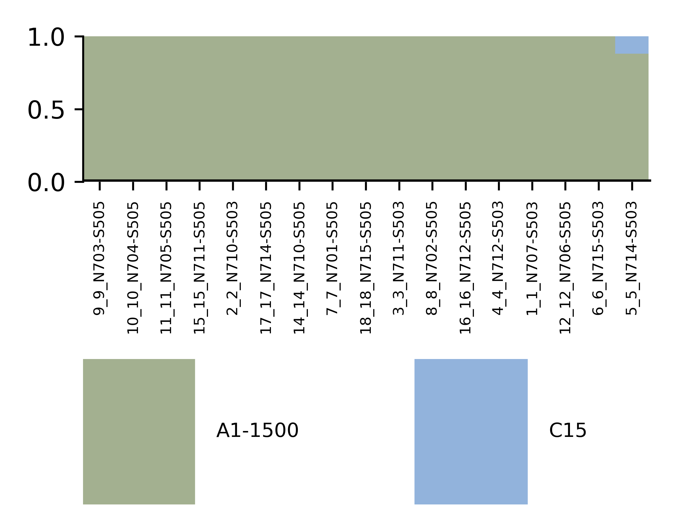
Figure S12. Symbiodiniaceae populations within Cassiopea spp samples (x-axis). Relative abundances (%, y-axis) of Symbiodiniaceae taxa within the Cassiopea sp. used in this study identified with the Symportal analytical framework. All individuals showed to be primarily colonized with Symbiodiniaceae A1-1500, corresponding to Symbiodinium microadriaticum, although a small proportion of clade C15 (genus Cladocopium; Hume et al., 2018).
Table S11. Number of OTUs and reads discarded from samples because they are not identified as bacteria. The number of OTUs and reads used are also reported.

Category | Number of OTUs | Number of reads
Discarded | 780 | 530617
Chloroplast | 113 | 18171
Mitochondria | 20 | 478
Unclassified | 89 | 2475
Archaea | 235 | 4985
Singletons | 190 | 190
Contaminants (DNA blank/PCR control) | 133 | 504318
Used for the analyses | 14205 | 9735379
Table S12. Pairwise comparison among the interactions of temperature and oxygen treatment. All pair comparisons showed significant results (adjusted p-value <0.05).

Terms of comparison | Deviance | Adjusted p-values
30°C-Supersaturation vs 38°C-Supersaturation | 1302.5 | 0.001
30°C-100% air saturation vs 38°C-Supersaturation | 1253.4 | 0.001
34°C-Supersaturation vs 38°C-Supersaturation | 1145.5 | 0.001
34°C-100% air saturation vs 38°C-Supersaturation | 1031.2 | 0.004
36°C-Supersaturation vs 38°C-Supersaturation | 991.6 | 0.005
30°C-Supersaturation vs 38°C-100% air saturation | 966 | 0.006
36°C-100% air saturation vs 38°C-Supersaturation | 962.9 | 0.006
30°C-100% air saturation vs 38°C-100% air saturation | 944.9 | 0.006
34°C-Supersaturation vs 38°C-100% air saturation | 915.8 | 0.006
30°C-Supersaturation vs 36°C-Supersaturation | 902.8 | 0.006
30°C-100% air saturation vs 36°C-Supersaturation | 882.9 | 0.007
30°C-Supersaturation vs 36°C-100% air saturation | 874.9 | 0.007
30°C-100% air saturation vs 36°C-100% air saturation | 805.9 | 0.012
38°C-Supersaturation vs 38°C-100% air saturation | 776.2 | 0.019
34°C-Supersaturation vs 36°C-Supersaturation | 717.4 | 0.027
34°C-Supersaturation vs 36°C-100% air saturation | 706.7 | 0.033
36°C-Supersaturation vs 36°C-100% air saturation | 704.7 | 0.033
36°C-Supersaturation vs 38°C-100% air saturation | 703.7 | 0.033
30°C-100% air saturation vs 34°C-100% air saturation | 696.3 | 0.033
34°C-100% air saturation vs 38°C-100% air saturation | 695.2 | 0.033
30°C-Supersaturation vs 34°C-100% air saturation | 690.9 | 0.033
36°C-100% air saturation vs 38°C-100% air saturation | 672.4 | 0.033
30°C-Supersaturation vs 34°C-Supersaturation | 665.4 | 0.033
30°C-100% air saturation vs 34°C-Supersaturation | 664.4 | 0.033
34°C-Supersaturation vs 34°C-100% air saturation | 580.1 | 0.033
34°C-100% air saturation vs 36°C-Supersaturation | 560.5 | 0.033
34°C-100% air saturation vs 36°C-100% air saturation | 551.5 | 0.033
30°C-Supersaturation vs 30°C-100% air saturation | 473 | 0.033

Figure S13. Rarefaction curves of bacteria across sample categories, Artemia (food source), tentacle (collected from jellyfish subject to different thermal/oxygen treatment) and water from the tanks used to incubate jellyfish, sampling site, and water pipe.
Figure S14. Non-metric multidimensional scaling (NMDS) reveals the distribution of Artemia food, Cassiopea jellyfish (both natural and used in the aquaria) and seawater (both natural and used in the aquaria) in the ordination space. Circles indicate the samples collected from the site before the exposure to any treatment (i.e., environmental origin).

Figure S15. The central Venn diagram shows the number of OTUs shared among seawater (both in the environment and used in the aquaria) and jellyfish (both in the environment and used in the aquaria). Additional Venn diagrams showed the number of OTUs shared among environmental and aquaria samples for jellyfish (left) and seawater (right), and for these two components in the environment (the second line, left) and aquaria (the second line, right). For the aquaria, the Artemia used to feed the jellyfish was also added as an additional source of bacteria.

Figure S16. Temperature decay patterns of jellyfish bacterial communities in “100% air saturation” (green) and “Nighttime supersaturation” (blue) conditions show the relationships between differences in temperature and the BC similarity; the relationship is tested by linear regression (R²) with a significance probability estimate (p-value).

Figure S17. (A and B) The relationship between richness (expressed as the number of OTUs) of jellyfish bacterial communities and temperature in “100% air saturation” (green) and “Nighttime supersaturation” (blue) conditions, respectively (C and D) The relationship between functional redundancy (Tax4Fun) of jellyfish bacterial communities and temperature in “100% air saturation” (green) and “Nighttime supersaturation” (blue) conditions, respectively. The relationship is tested by linear regression (R²) with a significance probability estimate (p-value) and slope.

Figure S18. Correlation of bacterial taxa abundance with temperature changes (from 30°C to 38°C) in “100% air saturation” and “Nighttime supersaturation” treatments. Red colour indicates those bacterial taxa that have their relative abundance positively correlated with increasing temperature, while blues colour those that have their relative abundance negatively correlated with increasing temperature.
Figure S19. Predicted functions obtained by FaProTax. Predicted metabolisms are plotted and their abundance expressed as Log₁₀-transformed values in “100% air saturation” and “Nighttime supersaturation” conditions along the different temperatures tested.

