**Supplementary materials**

***Figure S1.*** *An example of a commonly used avatar on the VRChat platform, displaying various actions: (A) heart gesture, (B) sitting down, and (C) thumbs up.*

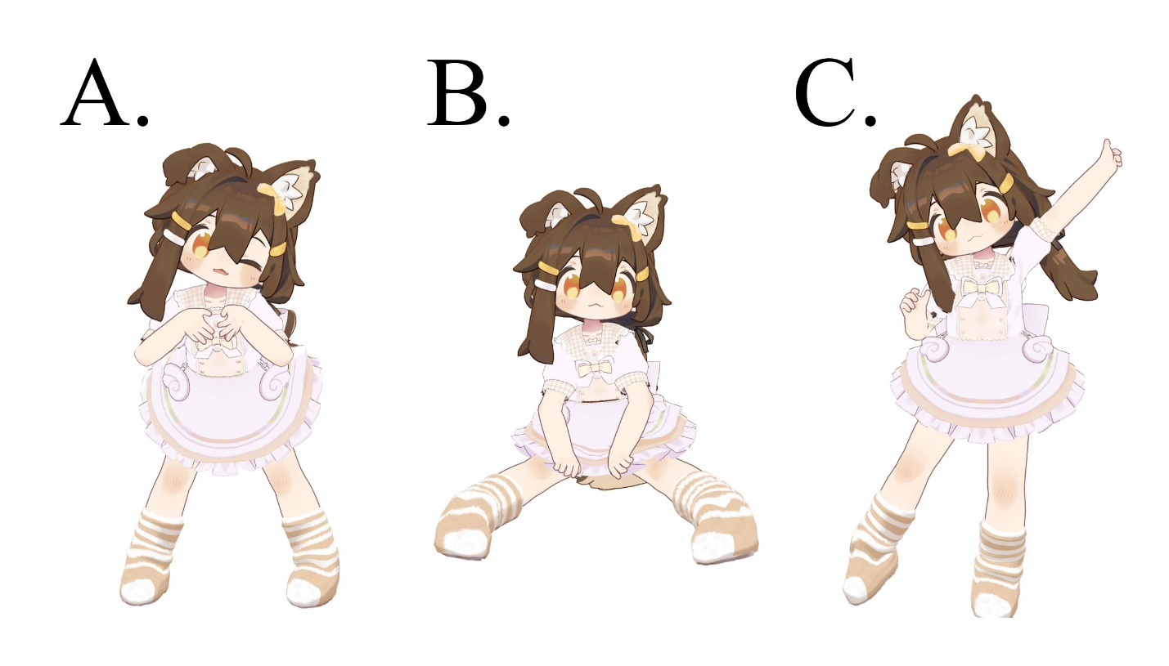

***Table S1.*** *The table presents participant information for unobtrusive observations, including observation world type, activity type, and the number of participants with different devices. The mean observation time was 36.6 minutes (SD = 38.4).*

|  |  |  |  |  |  |  |  |
| --- | --- | --- | --- | --- | --- | --- | --- |
| Observation  ID | Observation world  type | Activity  type | Main language | Participants | PC players | Three  point tracking | Six point+ tracking |
| 1 | Random World | Chatting | English | 5 | 1 | 2 | 2 |
| 2 | Random World | Chatting | English | 4 | 3 | 0 | 1 |
| 3 | Random World | Chatting | English | 6 | 3 | 2 | 1 |
| 4 | Friends+ | Gaming | Chinese | 8 | 3 | 3 | 2 |
| 5 | Friends+ | Dancing | Japanese/ body language | 22 | 3 | 2 | 17 |
| 6 | Friends+ | Chatting | Chinese/  Japanese | 10 | 3 | 2 | 5 |
| 7 | Public | Music | Japanese | 15 | 12 | 2 | 1 |
| 8 | Public | Dancing | Body language | 28 | 6 | 3 | 19 |
| 9 | Public | Chatting | English | 15 | 12 | 3 | 0 |

***Table S2.*** *The table presents participant information for interviews, including their gender identity, geographical location, most using tracking technology, and their total VRChat playtime in Steam.*

|  |  |  |  |  |  |
| --- | --- | --- | --- | --- | --- |
| Participant  ID | Gender identity | Ethnicity | Cultural background | Most using tracking technology | Total *VRChat* playtime (hours) |
| P1 | Cisgender man | Asian | Chinese, American | PC | 2471 |
| P2 | Cisgender woman | Asian | Chinese | Three-point tracking | 1257 |
| P3 | Cisgender man | Asian | Chinese, Japanese | Seven-point tracking | 2653 |
| P4 | Cisgender man | Caucasian | French | PC | 4400 |
| P5 | Cisgender man | Caucasian | American | Three-point tracking | 184 |
| P6 | Cisgender man | Caucasian | Swedish | Six-point tracking | 1353 |

### 

***Table S3.*** *Questions for Interviews*

|  |  |  |
| --- | --- | --- |
| ID | Theme | Questions |
| A | Demographic | What is your ethnicity?  How do you prefer to identify your gender?  How long is your total *VRChat* playtime on *Steam*?  When did you start to use a VR headset? How many hours per week do you typically spend using your VR headset?  Have you experienced full-body tracking? (When did you start to use full-body tracking?) |
| B | Avatar preference in *VRChat* | Which is your favourite avatar in *VRChat*, ignoring the cost?  What is the reason that you tend to use human/non-human/a mix of avatars?  How do you perceive the avatars you use? (Do they represent a specific aspect of your personality or identity, or do you see them more as tools for interaction?)  How do you perceive non-human avatars? Do you think they are more unique or express more identity compared to human avatars? |
| C | Interactions in *VRChat* | How do you interact with users who use non-human avatars?  If it is in a public world, and someone using a non-human avatar tries to interact with you, will you treat them differently than someone using a human avatar? (Will it be different in the private world?)  What do you focus on more when you are hanging out with your friends? Friends themselves or avatars? |
| D | Circumstances in *VRChat* | Are there any specific situations that let you feel more comfortable expressing yourself in *VRChat*, both verbally and non-verbally? (Why do you think they are comfortable?)  Do you think there are any differences between friends worlds and friends+ worlds? (What’s the difference?)  Are there particular environments, or activities encouraging you to express yourself more openly? Like in some narrow space or some themed events? (What elements encourage you to express yourself?) |
| E | Gender perception in *VRChat* | What do you think of making assumptions about other users’ gender in *VRChat*?  Have you made assumptions about other users’ gender in *VRChat*? (What factors contribute to these assumptions? How accurate do you think your assumptions are?) |
| F | FBT’s influences | Have you noticed any influence of your in-game expression habits on real-life interactions? (Could you provide examples of how your *VRChat* experiences have affected real-life communication?)  What impacts do you think full-body tracking can have on others who perceive your gender and identity in *VRChat*?  How do you use full-body tracking technology in *VRChat* to express or perform your gender? |

***Table S4.*** *Select transcribed interview response samples.*

|  |  |
| --- | --- |
| Quotes ID | Quotes |
| P1a | You can see others doing some fidgeting, some purposeless behaviours with conscious decisions, which may influence the assumptions of the gender others made of them. |
| P3a | The position of my knees when sitting and the position of my hands when standing will become factors for others to judge my gender, so I am more careful and cautious in *VRChat*, even though I may not care about these behaviours in real life. And I always ensure that my avatar is wearing a pair of safety knickers. |
| P4a | When they act in a certain way, you would expect someone of a certain gender, like dancing, walking, sitting in a certain way. For a guy, people don’t sit the same way. |
| P6a | Sitting pose can influence the assumption. When someone sitting with their knees goes down, it is more feminine. |
| P3b | In *VRChat*, as I act as a girl, it is stipulated that I cannot sit with my legs split when wearing a skirt, and I will also shake my hands when I am waiting for others, and I will dangle when I am standing, so as to increase my own girlish. These behaviours are basically the impressions given to me by the images of girls in anime. |
| P3c | I practice kawaii moves, everyone does that in *VRChat* because it’s cute. |
| P2a | In *VRChat*, boys learn to do those purposeless behaviours that girls usually do to misleading gender assumptions. |
| P2b | But those behaviours are just part of the stereotype I think, girls don’t always behave like those. |
| P2c | I prefer to do fewer movements and avoid doing those fidgeting stuff to hide my real gender. |
| P1b | Because I want to socialize as a human in the game, I always use human avatars in *VRChat.* |
| P2d | I prefer human avatars because their proportions are closer to mine, making movement feel more natural. |
| P2e | My avatar is just a character in the game like I’m borrowing this appearance. It doesn’t represent my personality and doesn’t resemble my real-life appearance. I treat my avatar like a virtual daughter that I can nurture. |
| P4b | I don’t use a lot of fully human avatars like usually, they have cat ears, tails and stuff like that, it’s fun, why not? You can be whatever you want in this game, so why not be something that you cannot be in real life? |
| P4c | My avatars can represent some part of my taste for sure because of course you only wear avatars you like. |
| P5a | I am related to my avatar. It’s not me, but my friends can recognize it as me, it is like my virtual agency. |
| P6b | For me, an avatar is a tool for finding other furries because of their hobbies and identities. It is also half me, it represents some part of me. |
| P3d | Most of the time, I interact with people I know and don’t pay much attention to avatars. But if someone uses an avatar that I really like and has customized it to look impressive, I might initiate interaction with them and try to get to know them. |
| P2f | If someone is not using a microphone, playing on a PC, and using a non-human avatar, I won’t interact with them. From the avatar, I can sense that our preferences are different, and it’s hard to find common ground for conversation. |
| P1c | Even though it’s the same model when different people use it, the feeling they give is different, especially when using FBT. From their gestures, you can feel their distinct personalities and the unique atmosphere they create. |
| P3e | I started to have a strong sense of immersion and felt that the avatar was me or me on the internet after using FBT, and it fully inherits my personality. |
| P2g | I spend 1/3 of my free time modifying my avatar, adding new clothes, hair, and accessories, changing gestures and expressions, and enhancing avatar functions. Another 1/3 of my free time is spent in *VRChat* testing new content and making adjustments based on the results, and only the remaining 1/3 of my free time is spent genuinely enjoying *VRChat.* |
| P3f | I spent a lot of time learning to modify avatars in Unity and Blender. I basically buy new clothes or accessories for my avatar every week, just like someone dressing up in real life. I use Unity to dress myself. |
| P3g | It takes a lot of time to learn, which can be difficult for new users. Additionally, you need to invest a lot of money in buying models and accessories. Many *VRChat* newcomers simply copy models from model worlds, but many of those models actually violate copyright laws. Without purchasing the original files, you can’t customize your avatar’s appearance. |
| P1d | Some models have clothes similar to those sold in real life, and I think those avatars are very realistic. But I also like the fantasy and cute-themed models, as they can represent different aspects of a person. People are complex and can be both cute and cool. Having unlimited avatar choices allows users to better express their multifaceted selves. |
| P6c | When it comes to customization, everything a human avatar can do, a non-human avatar can do, and even more. If they have a good-looking avatar, I am more open towards them and want to be friends with them. |
| P4d | Based on their avatar if that is a female avatar and doesn’t talk, I think it’s her. |
| P1e | I saw some people wrote in their bio, saying the avatar’s gender is their gender. I think it’s pretty cool. Why bother caring about someone’s gender in reality? |
| P3h | After guessing their gender, I pay attention to my words. If I think they are female, I don’t use foul language in front of them. |
| P3i | If I’m curious about someone who is usually mute, I try to judge if they are using a voice changer when they start talking. |
| P2h | I think people who guess whether someone has a voice changer on or off have malicious intent. |
| P3j | Friends with a deep level of role play will open a voice changer to better perform their avatar. Some men learn to produce female voices, but they often sound similar and can be identified. |
| P4e | If you hear a feminine voice, you think there is a girl. |
| P3k | I have many friends who are babiniku, which refers to male Vtubers or VRChaters who use female avatars. Some of them use male voices, some use falsetto, and some are otokonoko. Many people will write babiniku in their bio, so I think *VRChat* has the most babiniku users. Everyone likes to use anime girls. |
| P2i | Based on regular chats, social media screenshots, and various experiences, I think 80% of users in *VRChat* are male. So, before hearing their voice, I assume they are male. |
| P1f | I usually go to rooms with fewer people. If there are too many people, I get a bit socially anxious unless my friends are there. |
| P2j | I feel more comfortable in friends’ worlds, not friends+ worlds, but the ones that only my friends can join. That’s because people who are already my friends are familiar, so I can relax. |
| P4f | If I am one-on-one with someone, in some private world, vibing or listening to music, I feel very comfortable, like I am with my friends in real life. |
| P4g | Expressing my feelings or emotions is way more accessible in *VRChat* because you can choose the world and the people you want to stay with. You are with someone like face-to-face here, but face-to-face in real life could be very intimidating, and you may have social bias, like certain people from certain stuff. |
| P5b | Sometimes friends’ friends may be annoying, so I prefer to go to friends’ worlds, but if I’m with my friends, I don’t mind going to some world with more people. |
| P6d | If I am with a group of people, I feel being watched. Friends+ world is more like semi-public, I like staying in a place with fewer people, those cosy worlds. |
| P4h | Expressing my feelings or emotions is way easier in *VRChat* because you can choose the world and the people you want to stay with. You are with someone face-to-face here, but face-to-face in real life could be very intimidating, you may have social biases, like certain people from certain backgrounds. |
| P2k | I also find dancing worlds, where I don’t need to use my mic, very comfortable. I guess I just don’t like talking to strangers that much. |
| P3l | When I go to dancing or kawaii move events, there isn’t much need for verbal communication. I can communicate through body language without using my mic. I mostly attend these events for my own enjoyment and don’t worry too much about what others are doing. So, I frequently participate in dancing events, kawaii move events, and DJ events. I get nervous at avatar gatherings, where the main activity is chatting, so I don’t go there as often. |
| P1g | I usually express myself better in gaming worlds. When playing games with people I’m not familiar with, there is no awkward silence due to a lack of topics. |
| P2l | I feel more comfortable in spacious and bright settings, but that’s just me. |
| P3m | I’ve always liked small spaces, but I can’t always experience that in real life. In *VRChat*, there are many small Japanese-style closet spaces. I find it very relaxing to sleep in those spaces. |
| P1h | I like that my avatar embodies some of my ideal states, such as hairstyle, clothes I want to wear, and the impression I give to others. |
| P3n | There might be a wish to become the gender displayed in the game in reality. It’s challenging and costly to change in real life, but being able to do something in virtual reality that I cannot do in real life is interesting. When I was playing *VRChat*, I didn’t just want to be a girl, but I thought that maybe I’m actually a girl. |
| P1i | I would do some actions in *VRChat* that I wouldn’t do in real life, such as patting others on the head. |
| P4i | I’m kind of shy in real life, I got social anxiety stuff, it’s not that bad, but it’s still like there and I don't do some things. But in *VRChat*, I can do stuff that I won’t do in real life, like dancing. I danced sometimes in *VRChat*, with some friends. I really don’t do that in real life. |
| P1j | I used to not pay much attention to others when talking in real life, but now after playing *VRChat*, I feel like I can focus more on people’s reactions when I speak. |
| P4j | Expressing myslf feelings or emotions is way more easier. |
| P6e | I’m a lot more social now, I feel I’m easier to have a conversation in real life. |
| P1k | I often do some actions to show that I’m thinking, like putting my index finger on my chin and shaking my head. I found that I started doing this in real life too. |
| P2m | I often do gestures corresponding to my avatar’s expressions when I walk in real life. I didn’t have many chances to sway my leg while waiting in real life, but now I often do that in *VRChat.* |
| P3o | After using FBT, many of my *VRChat* actions have carried over into real life, such as giving a thumbs up, showing helplessness with open hands, and making big movements like spinning and hopping around when I’m alone. |
| P5c | I always do the peace sign after playing *VRChat*, and I also do that in real life. I feel I focus more on body language now…In some photogenic worlds, I do some behaviour that I wouldn’t do in real life, for a selfie. |
| P1l | I feel that the difference between playing on a PC and using FBT in VR is enormous when interacting. Others can know if you’re listening to them, your thoughts on what they’re saying, and your mood. Verbal communication is still important during interactions, but body language has become much more pronounced…In *VRChat*, because you’re wearing a VR headset, you can tell if others are listening to you, just like in real life. I think being able to see others’ reactions makes my communication smoother. When using text-based communication in social apps, not being able to see people’s reactions sometimes makes me wonder if I said something wrong. |
| P2n | In *VRChat*, when you do something, you always receive feedback from others, whether it’s verbal or through actions, and it’s very timely feedback. |
| P1m | Because the immersion is stronger in VR, any actions feel like they’re happening in real life, so I can become closer to others. And thanks to *VRChat*, cute avatars and voice changers, the gender inside is ambiguous, and I think it’s very comfortable and wonderful that the concept of gender is about to collapse. The feeling that it doesn’t matter if the inside is a man or a woman is the best. |
| P3p | In *VRChat*, when you touch each other’s ears, when you do gestures, or when you dance together, you can quickly develop a bond. In real life, doing these things would be strange. When playing MMORPGs, there isn’t such an immersive feeling, and you can’t freely control your actions, so there isn’t the same sense of quickly building relationships with others. |
| P3q | If I want to sugar with someone, apart from the appearance of the avatar, I will pay more attention to their personality and hobbies. Many of my friends, building relationships from games to reality, are all the same gender. |