Supplementary Figure 1. Flow chart of shift worker study design

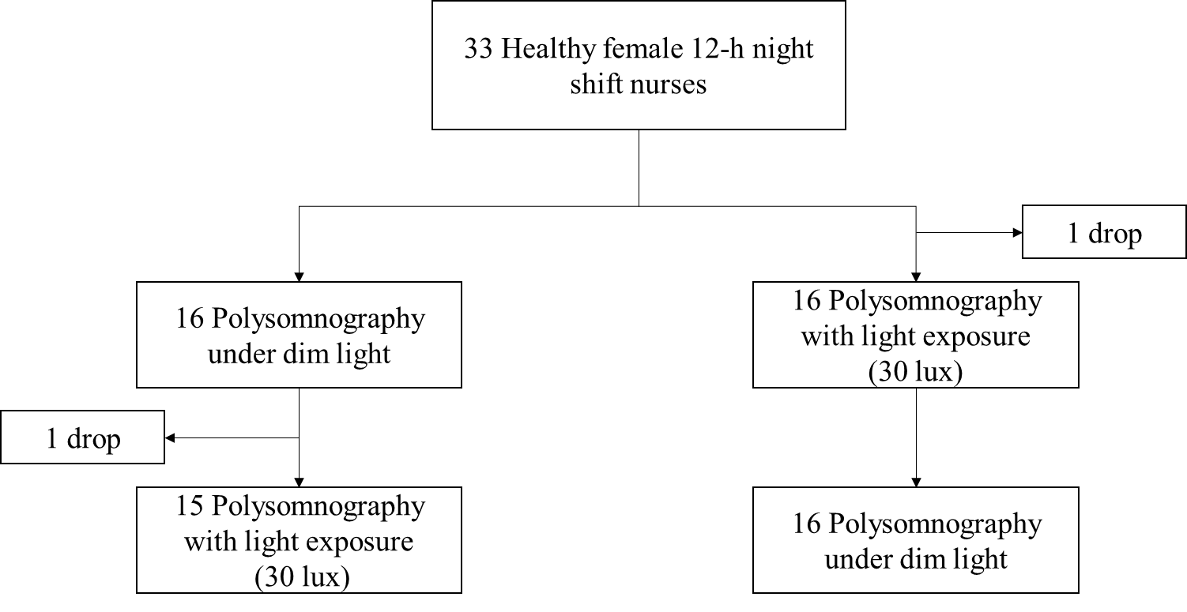

Supplementary Table 1. Comparison of absolute power across all sleep stages and EEG bands for night sleep with dim light condition vs. day sleep with dim light condition, and day sleep with dim light condition vs. day sleep with 30 lux light condition

|  |  |  |  |  |  |  |  |  |  |  |  |  |  |  |  |  |  |  |  |  |  |  |  |  |  |  |
| --- | --- | --- | --- | --- | --- | --- | --- | --- | --- | --- | --- | --- | --- | --- | --- | --- | --- | --- | --- | --- | --- | --- | --- | --- | --- | --- |
|  | Nightsleep | | | | | Day sleep | | | | | | | | | | *P*-value | | | | | | | | | | |
|  | Dim1 | | | | | Dim2 | | | | | 30lux3 | | | | | 1 vs. 2 | | | | | 2 vs. 3 | | | | | |
| Sleep stage | Slow | Delta | Theta | Alpha | Sigma | Slow | Delta | Theta | Alpha | Sigma | Slow | Delta | Theta | Alpha | Sigma | Slow | Delta | Theta | Alpha | Sigma | Slow | Delta | Theta | Alpha | Sigma |
| N1 | 7.0E-10 | 2.4E-09 | 9.3E-10 | 9.1E-10 | 2.9E-10 | 5.8E-10 | 2.3E-09 | 1.0E-09 | 1.0E-09 | 2.5E-10 | 5.8E-10 | 2.4E-09 | 1.1E-09 | 9.6E-10 | 2.5E-10 | 0.009 | 0.036 | 0.275 | 0.321 | 0.538 | 0.80 | 0.81 | 0.85 | 0.86 | 0.85 |
| N2 | 5.1E-09 | 1.8E-08 | 7.0E-09 | 6.1E-09 | 3.2E-09 | 2.3E-09 | 1.0E-08 | 5.2E-09 | 4.3E-09 | 2.0E-09 | 2.2E-09 | 9.6E-09 | 4.6E-09 | 4.0E-09 | 1.8E-09 | <0.0001 | 0.003 | 0.214 | 0.032 | 0.024 | 0.77 | 0.50 | 0.40 | 0.56 | 0.65 |
| N3 | 8.3E-10 | 3.6E-09 | 1.9E-09 | 1.5E-09 | 4.1E-10 | 5.4E-10 | 3.5E-09 | 2.7E-09 | 1.8E-09 | 4.8E-10 | 4.8E-10 | 3.2E-09 | 2.3E-09 | 1.6E-09 | 4.2E-10 | <0.0001 | <0.0001 | <0.0001 | 0.009 | 0.004 | 0.45 | 0.48 | 0.34 | 0.27 | 0.42 |
| REM | 2.2E-09 | 8.1E-09 | 3.3E-09 | 2.8E-09 | 1.3E-09 | 1.1E-09 | 5.4E-09 | 3.0E-09 | 2.4E-09 | 9.0E-10 | 1.1E-09 | 5.1E-09 | 2.7E-09 | 2.2E-09 | 8.3E-10 | 0.011 | 0.390 | 0.513 | 0.364 | 0.646 | 0.67 | 0.60 | 0.53 | 0.56 | 0.64 |