Supplementary Material

# Supplementary Data

**Supplementary materials and methods**

*Transfection in human embryonic kidney 293 (HEK293) cell line*

HEK293 cells were transduced with the pGreenFire Lenti-reporter plasmid with puromycin resistance (pGF2-ERE-rFLuc-T2A-GFP-mPGK-Puro; TR455VA-P, System Biosciences, USA) that encodes a GFP reporter and red-shifted luciferase controlled by the estrogen response element (ERE) as described by Mendenhall et al. (2012). Briefly, each well of a 6-well plate was saeeded with 3 × 105 cells (n=3) (145380, Thermo Scientific, USA) and incubated in a 37℃ chamber with 5% CO2for 24 h. The medium was aspirated, and the virus-containing medium was treated with 5 μg/mL polybrene for 8 h before aspiration. After overnight incubation of the transduced cells, puromycin (10 μg/mL) was added for selection.

Transduced cells (HEK293-ERE) were transfected with the piggyBac transposon gene expression system. The zEsr1 expression vector was custom-cloned from the vector builder (pPB-Neo-CAG>zEsr1, VB210426-1022cns, Vectorbuilder Inc., USA), and the pRP-mCherry-CAG>hyPBase plasmid (VB160216-10057, Vectorbuilder Inc., USA), which encodes the hyperactive version of the piggyBac transposase. Each well in a 6-well plate was seeded with 1 × 105 cells and incubated as previously described. The vector (1 µg) was mixed with 0.75 µL of Lipofectamine 3000 reagent in 250 µL of Opti-MEM medium and incubated for 15 min to form a DNA-lipid complex. The complexes were then transferred to the wells and incubated for 6 h. The medium was aspirated and the cells were allowed to recover overnight. After adding puromycin and neomycin (10 μg/mL and 2 μg/mL, respectively), the transfected cells (HEK293-ERE-zEsr1) were collected.

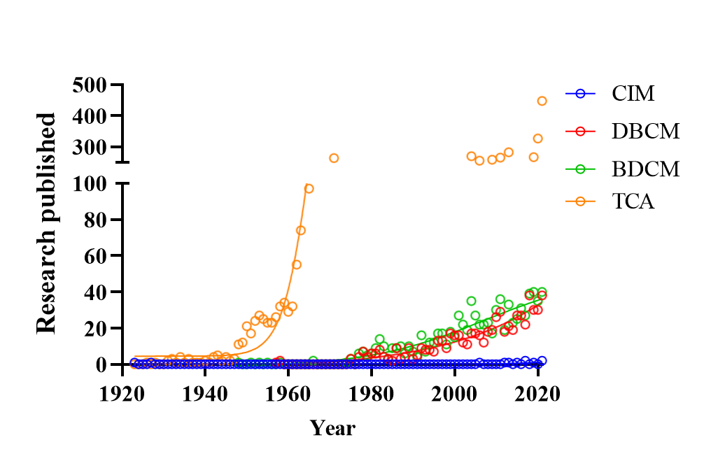

**Supplementary Figure 1.** Research published for the proposed-DBPs in this study