Supplementary Material

Seroepidemiological Investigation of Getah Virus in the China-Myanmar Border Area from 2022-2023

Hao Liu1†, Jin Hu1†, Li-Xia Li1, Zi-Shuo Lu1, Xiu-Tao Sun2, Hui-Jun Lu3, Ning-Yi Jin3, Lei Zhang4* , Li-Na Zhang5*

**\*Correspondence:** Li-Na Zhang  
zln_tiantang@163.com

Lei Zhang  
zhanglei_tcs@126.com

# Supplementary Figures

A

B

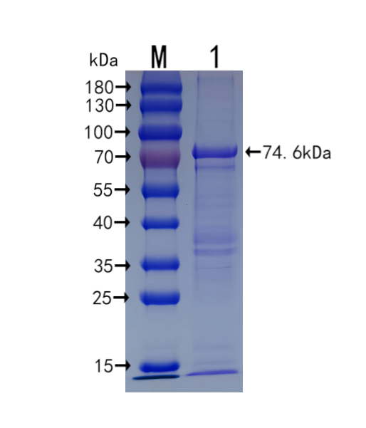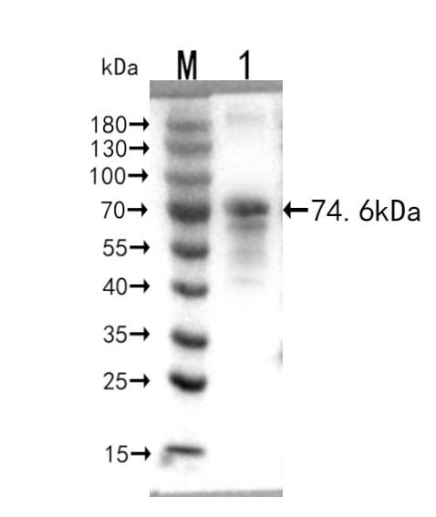

**Figure S1.** (A) SDS-PAGE analysis of E2 protein expressed in Escherichia coli. The E2 protein was 74.6kDa on SDS-PAGE.M,Marker;lane1:Purified target protein.(B)Western blotting analysis of E2 protein with an anti-His antibody.M,Marker;lane 1:Purified target protein.