**Supporting Information**

Effect of nanoporous membranes thickness in electrochemical biosensing performance: application for the detection of a wound infection biomarker

C. Toyos-Rodríguez1,2, D. Valero-Calvo1,2, A. Iglesias-Mayor1,2, A. de la Escosura-Muñiz1,2*

1 NanoBioAnalysis Group - Department of Physical and Analytical Chemistry, University of Oviedo, Julián Clavería 8, 33006, Oviedo, Spain

2 Biotechnology Institute of Asturias, University of Oviedo, Santiago Gascon Building, 33006, Oviedo, Spain

**\* Correspondence:**Corresponding Author  
**alfredo.escosura@uniovi.es**

***Figure S.1****. Schematic mechanism of the immobilization of antibodies in the inner walls of nanoporous alumina membranes.*

***Figure S.2.*** *Characterization of nanoporous alumina membranes of 60 μm thickness (A, B) and 90 μm thickness (C, D).*

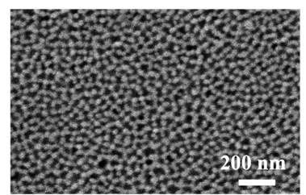

***Figure S.3****. SEM characterization of commercial nanoporous alumina membranes (top-view) with a nanopore diameter of 20 nm.*