**Supplemental Materials**

**Figure S1. The ROC curves (receiver operating characteristic curve) and the AUC (Area**

**Under Curve) value for IPM.**

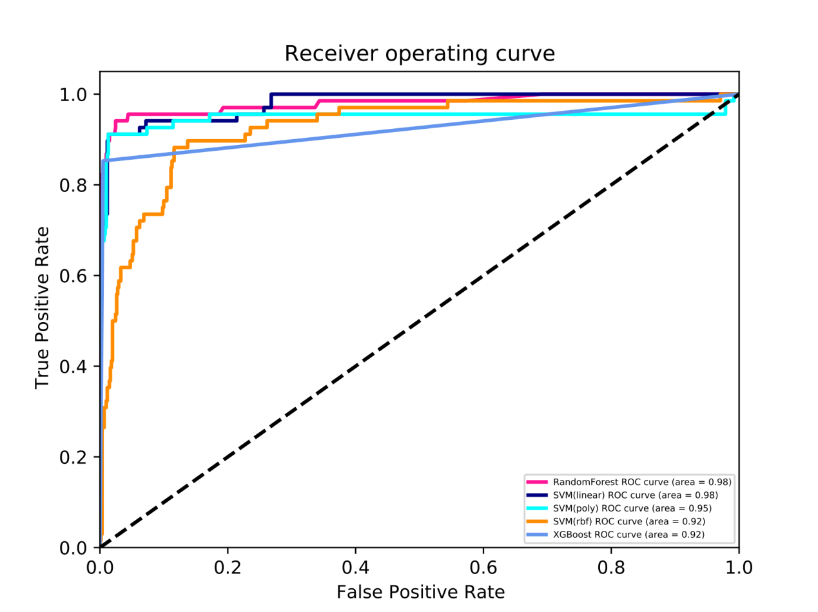

**Figure S2. The ROC curves (receiver operating characteristic curve) and the AUC (Area**

**Under Curve) value for MEM.**

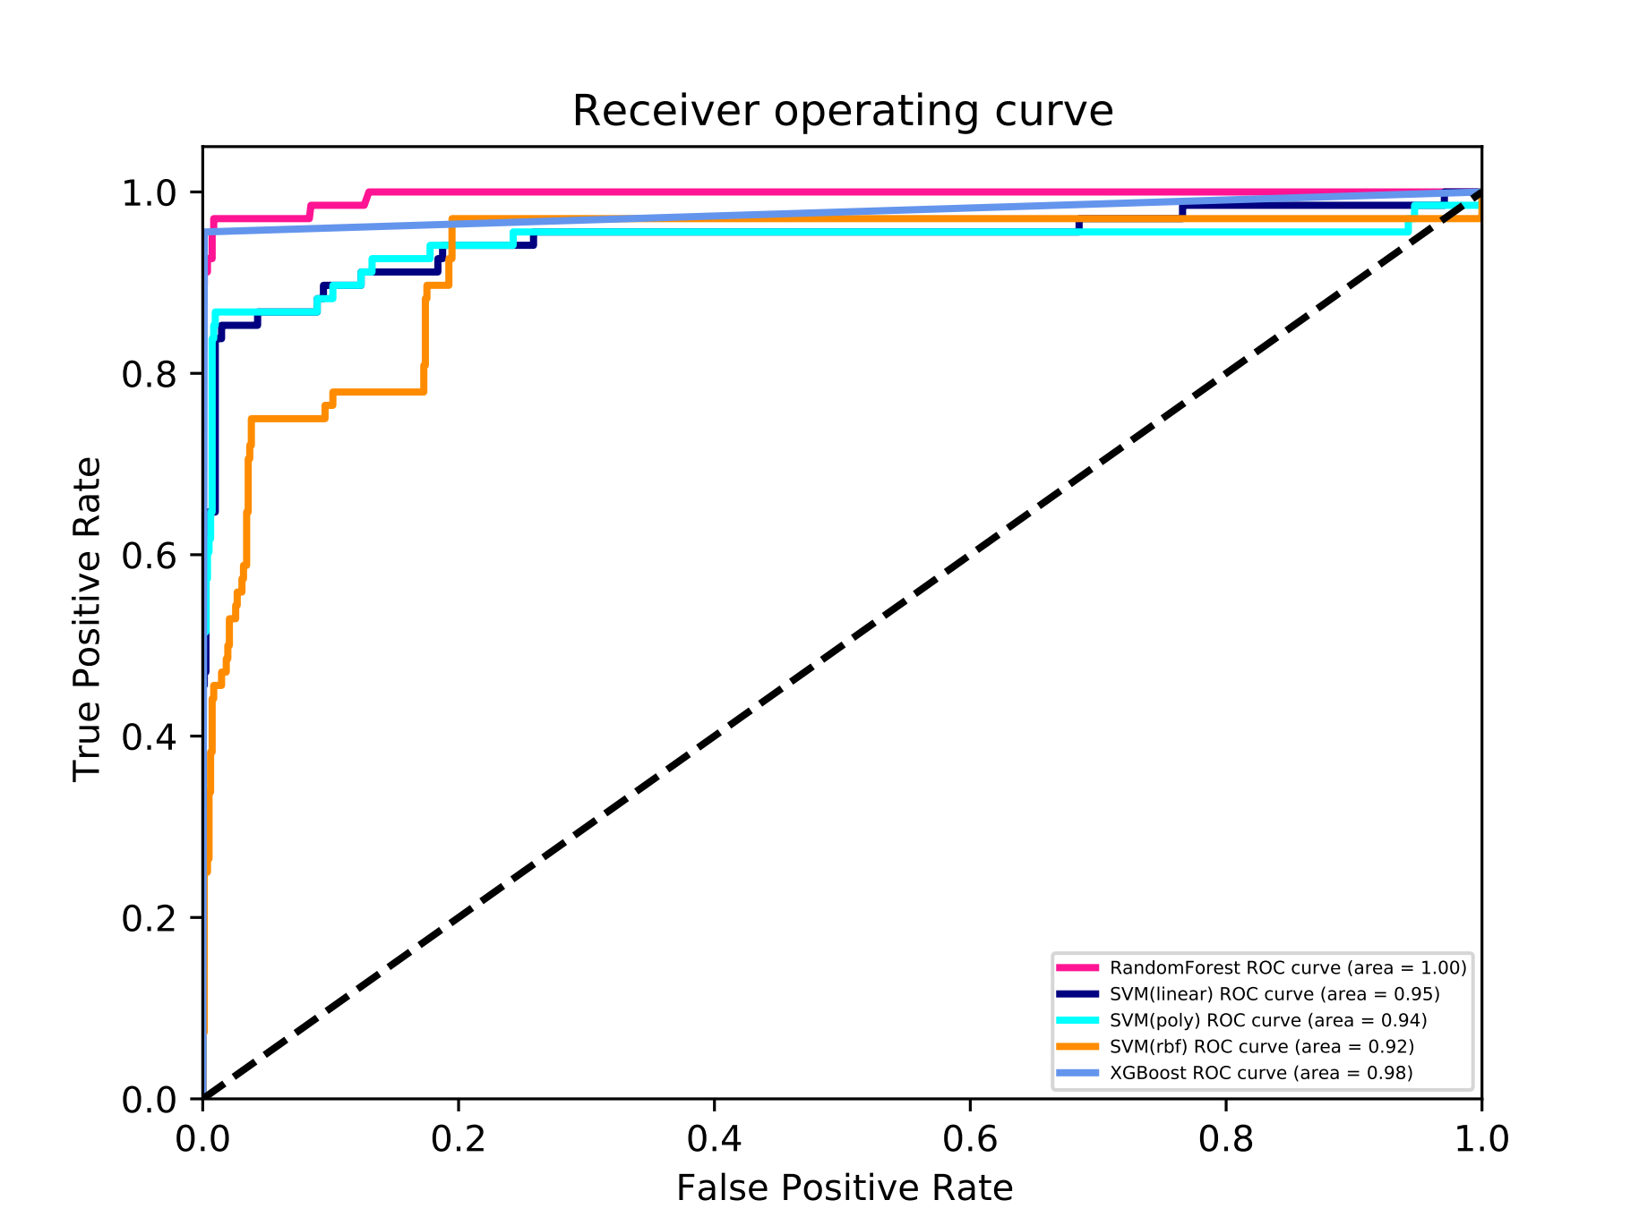

**Figure S3. The ROC curves (receiver operating characteristic curve) and the AUC (Area**

**Under Curve) value for CST.**

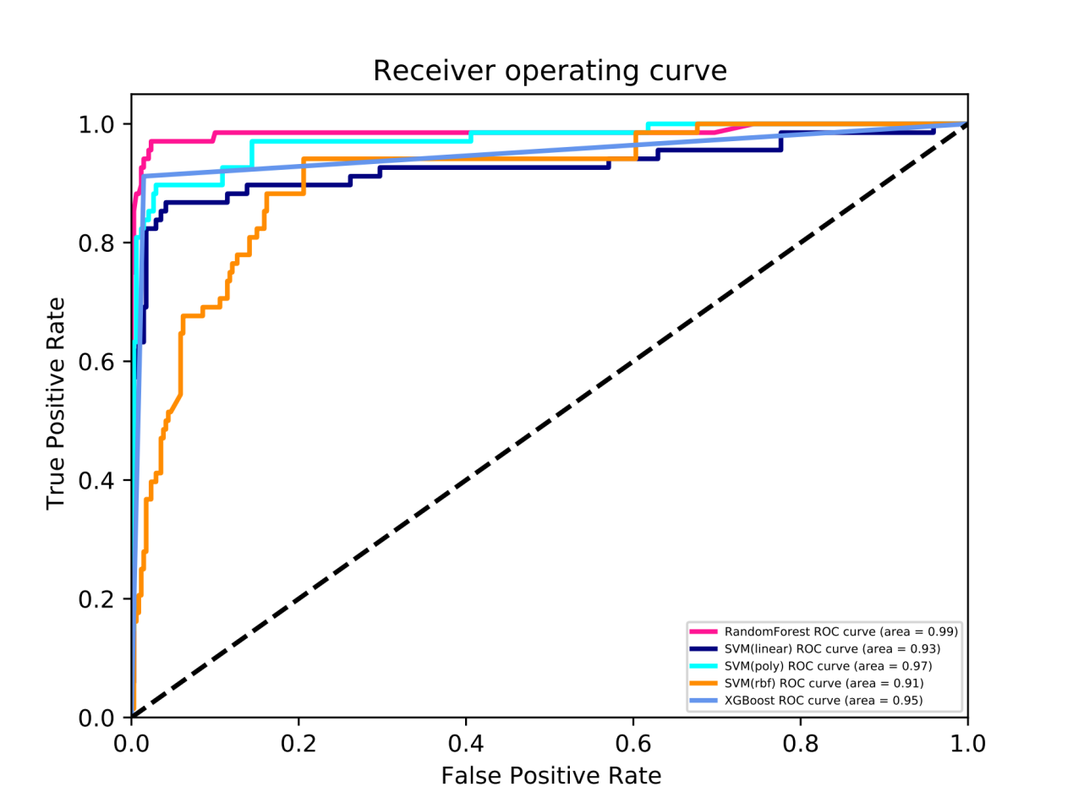

**Figure S4. The ROC curves (receiver operating characteristic curve) and the AUC (Area**

**Under Curve) value for TGC.**

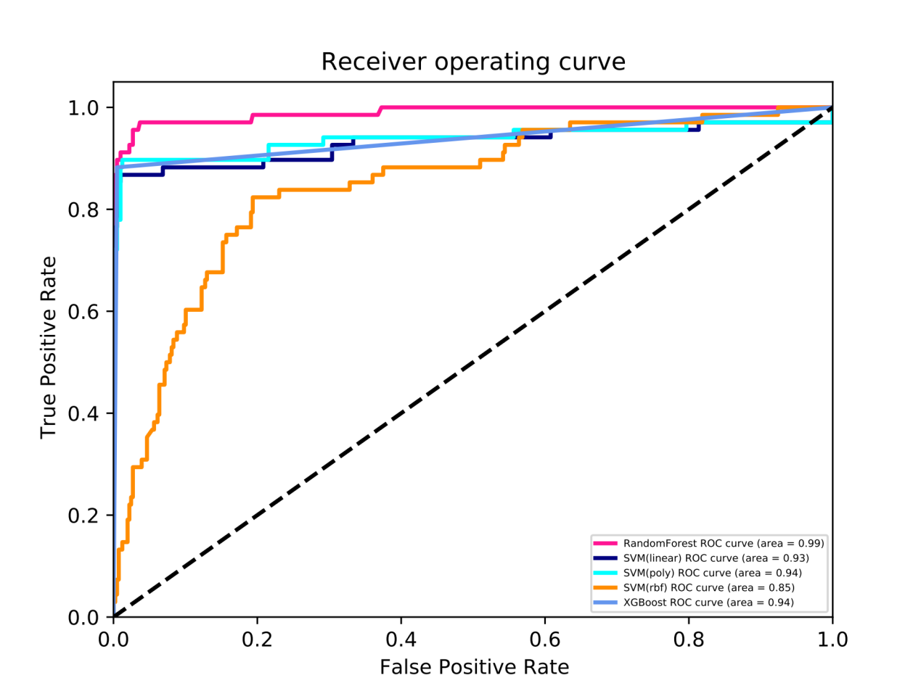

**Figure S5. The ROC curves (receiver operating characteristic curve) and the AUC (Area**

**Under Curve) value for FEP.**

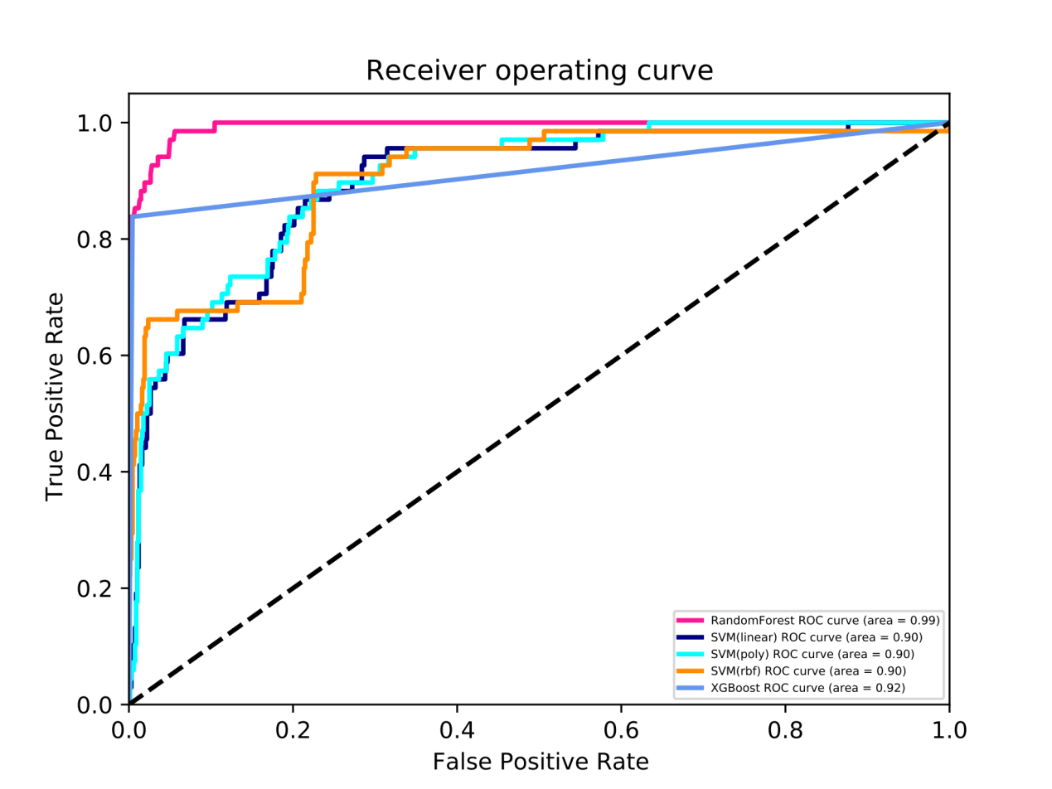

**Figure S6. The ROC curves (receiver operating characteristic curve) and the AUC (Area**

**Under Curve) value for CAZ.**

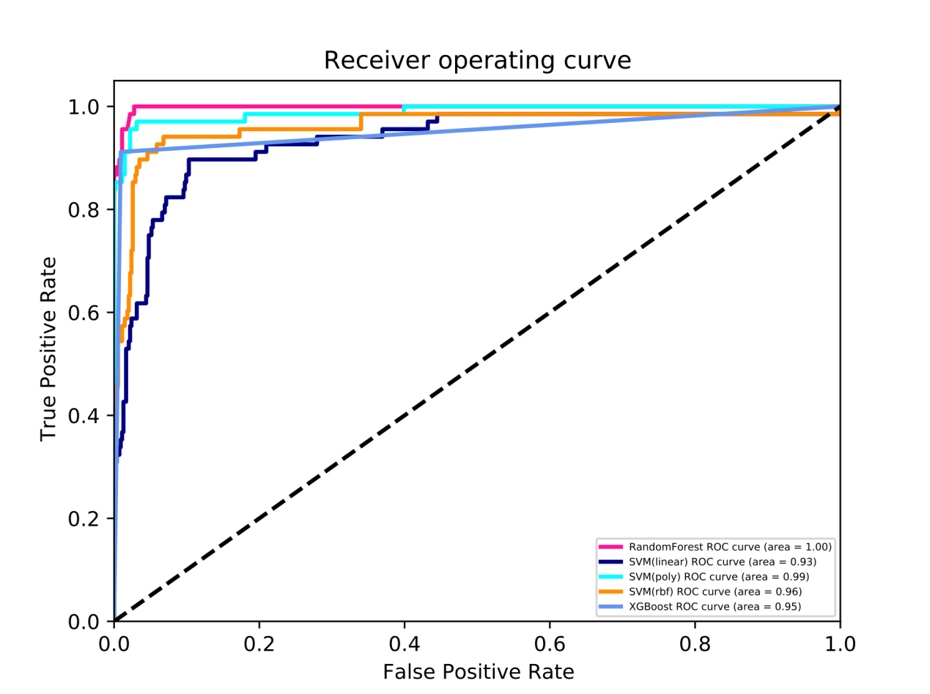

**Figure S7. The ROC curves (receiver operating characteristic curve) and the AUC (Area**

**Under Curve) value for CSL.**

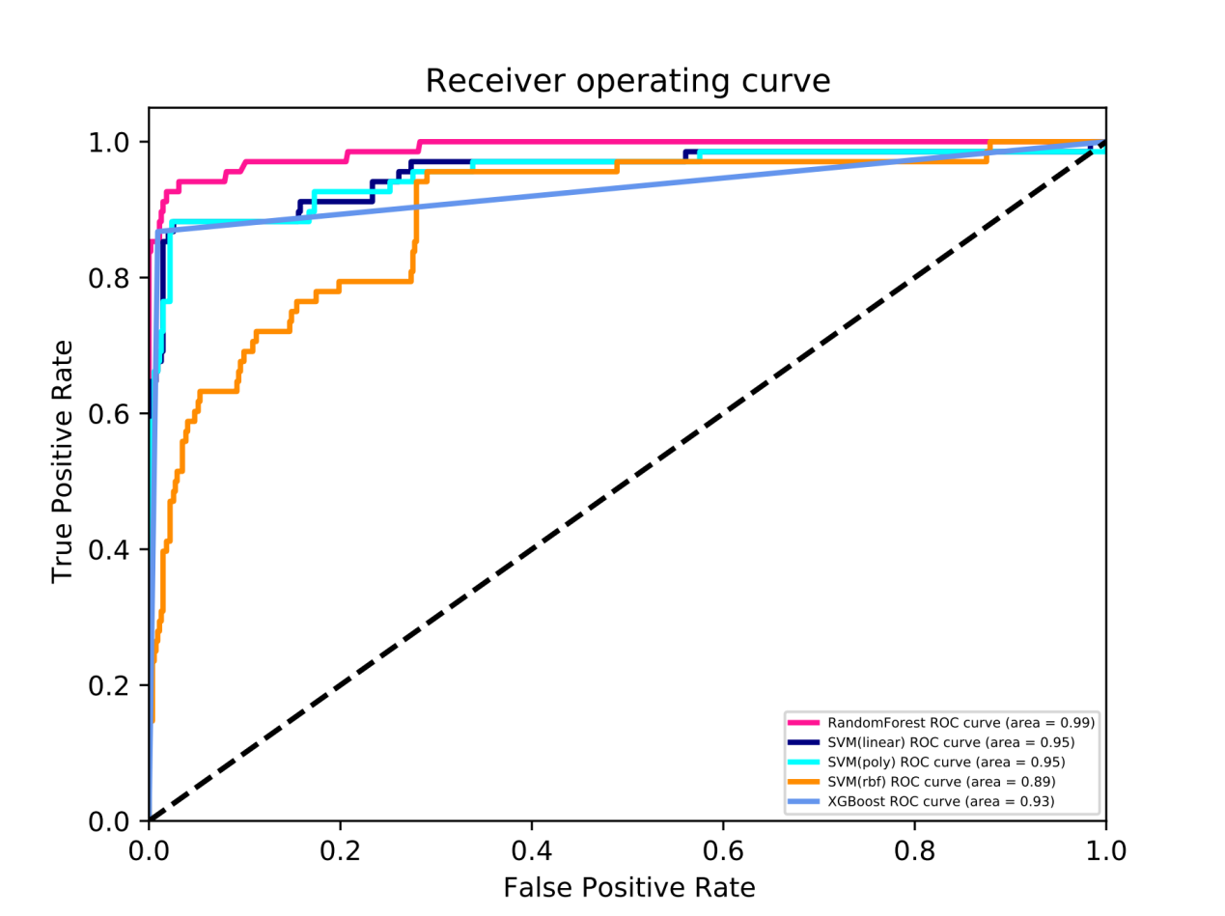

**Figure S8. The ROC curves (receiver operating characteristic curve) and the AUC (Area**

**Under Curve) value for TZP.**

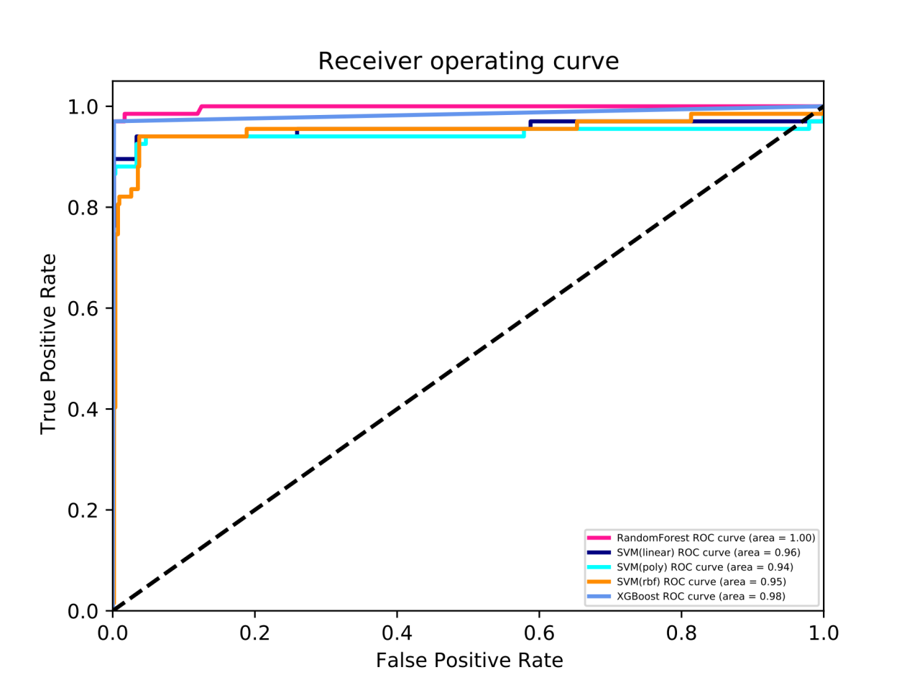

**Figure S9. The ROC curves (receiver operating characteristic curve) and the AUC (Area Under Curve) value for AMK.**

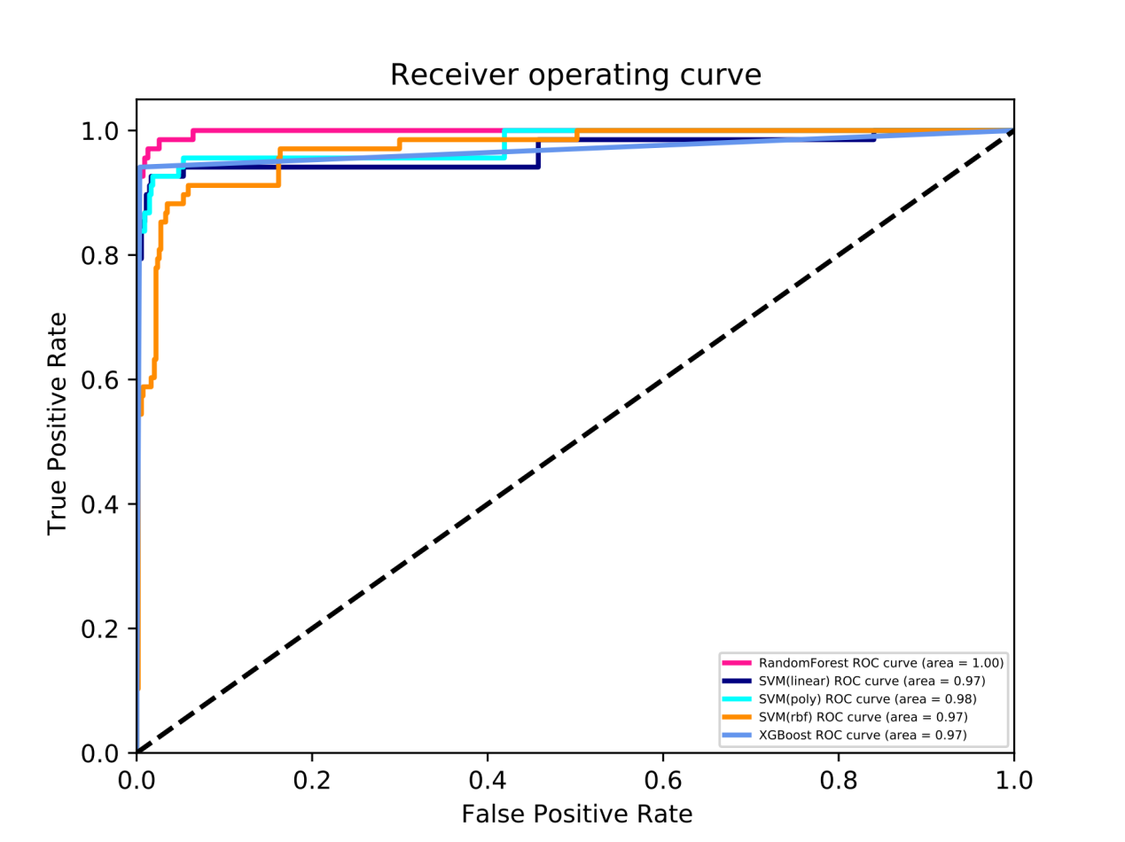

**Figure S10. The ROC curves (receiver operating characteristic curve) and the AUC (Area**

**Under Curve) value for CIP.**

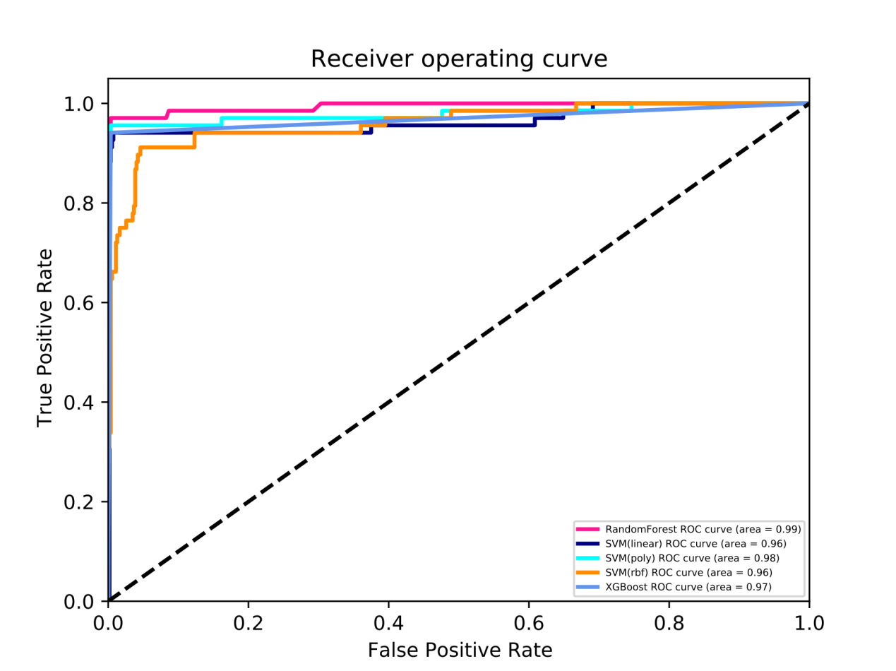

**Figure S11. The ROC curves (receiver operating characteristic curve) and the AUC (Area**

**Under Curve) value for LVX.**

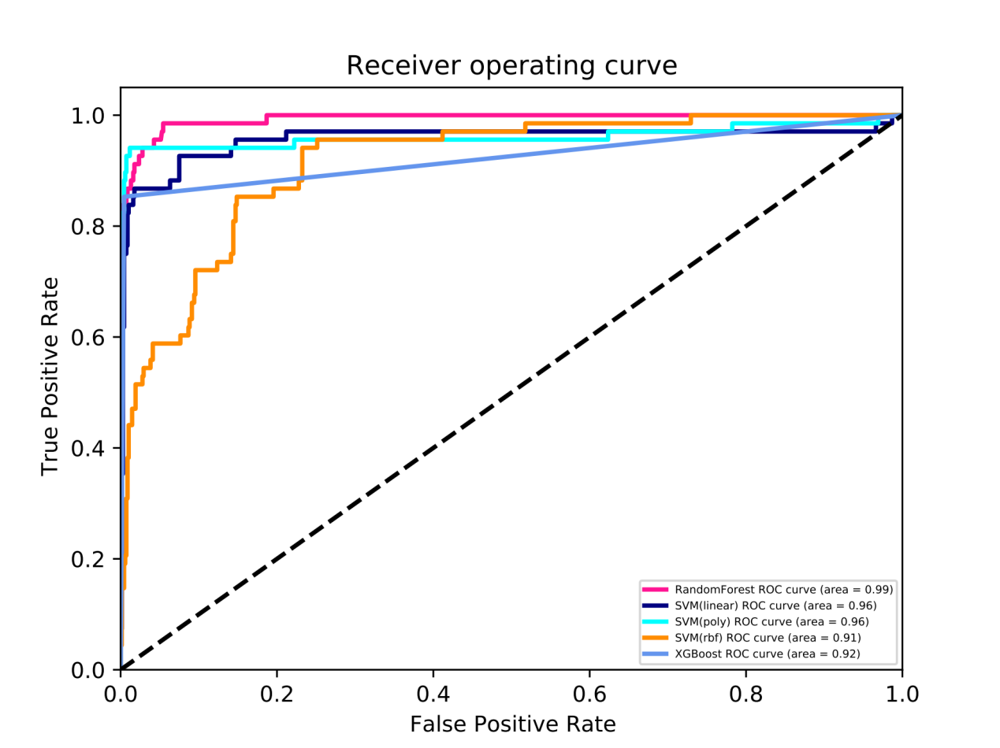

**Figure S12. The ROC curves (receiver operating characteristic curve) and the AUC (Area**

**Under Curve) value for MIN.**

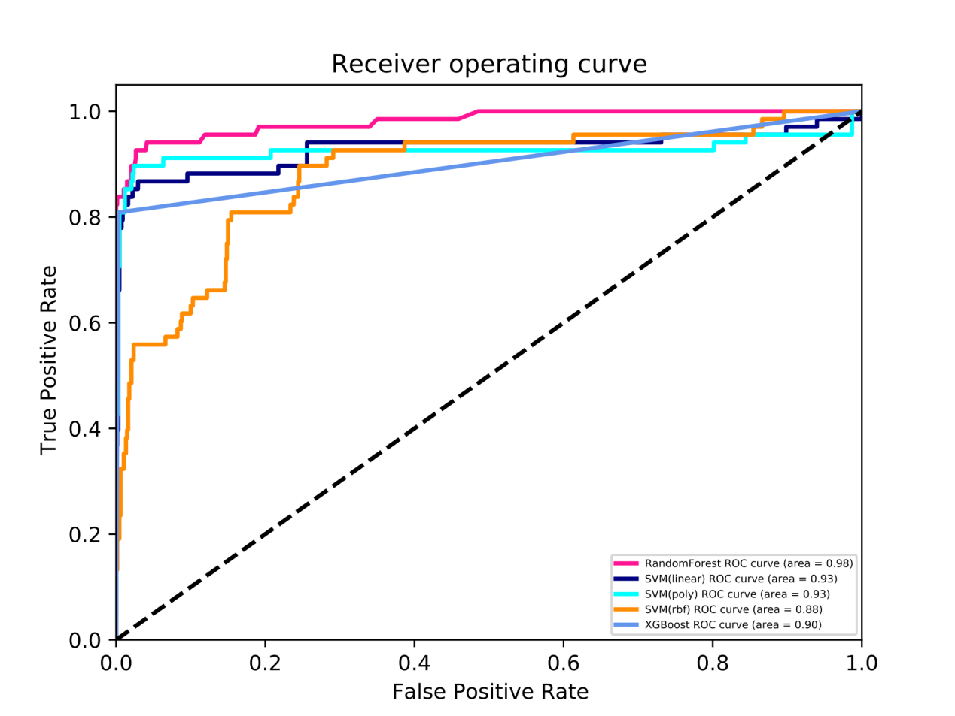

**Figure S13. The ROC curves (receiver operating characteristic curve) and the AUC (Area**

**Under Curve) value for SXT.**

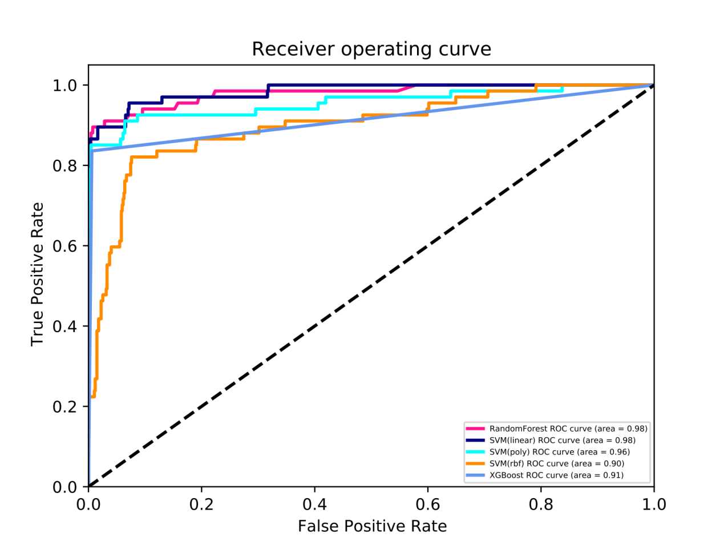

**Table S4. The average AUC values and 95% confidence interval (CI) of the cross-validation results for all five models.**



**Table S5. Prediction of the minimum inhibitory concentration (MIC) for IPM.** Horizontal axis are the prediction results and the vertical axis are the standard results.



**Table S6. Prediction of the susceptible (S), intermediate (I) and resistant (R) categories for IPM.** Horizontal axis are the prediction results and the vertical axis are the standard results.



**Table S7. Prediction of the minimum inhibitory concentration (MIC) for MEM.** Horizontal axis are the prediction results and the vertical axis are the standard results.



**Table S8. Prediction of the susceptible (S), intermediate (I) and resistant (R) categories for MEM.** Horizontal axis are the prediction results and the vertical axis are the standard results.



**Table S9. Prediction of the minimum inhibitory concentration (MIC) for CST.** Horizontal axis are the prediction results and the vertical axis are the standard results.



**Table S10. Prediction of the susceptible (S) and intermediate (I) categories for CST.** Horizontal axis are the prediction results and the vertical axis are the standard results.



**Table S11. Prediction of the minimum inhibitory concentration (MIC) for TGC.**

Horizontal axis are the prediction results and the vertical axis are the standard results.



**Table S12. Prediction of the susceptible (S), intermediate (I) and resistant (R) categories for TGC.** Horizontal axis are the prediction results and the vertical axis are the standard results.



**Table S13. Prediction of the minimum inhibitory concentration (MIC) for FEP.** Horizontal axis are the prediction results and the vertical axis are the standard results.



**Table S14. Prediction of the susceptible (S) and resistant (R) categories for FEP.** Horizontal axis are the prediction results and the vertical axis are the standard results.



**Table S15. Prediction of the minimum inhibitory concentration (MIC) for CAZ.** Horizontal axis are the prediction results and the vertical axis are the standard results.



**Table S16. Prediction of the susceptible (S), intermediate (I) and resistant (R) categories for CAZ.** Horizontal axis are the prediction results and the vertical axis are the standard results.



**Table S17. Prediction of the minimum inhibitory concentration (MIC) for CSL.** Horizontal axis are the prediction results and the vertical axis are the standard results.



**Table S18. Prediction of the susceptible (S) and resistant (R) categories for CSL.** Horizontal axis are the prediction results and the vertical axis are the standard results.



**Table S19. Prediction of the minimum inhibitory concentration (MIC) for TZP.** Horizontal axis are the prediction results and the vertical axis are the standard results.



**Table S20. Prediction of the susceptible (S) and resistant (R) categories for TZP.** Horizontal axis are the prediction results and the vertical axis are the standard results.



**Table S21. Prediction of the minimum inhibitory concentration (MIC) for AMK.** Horizontal axis are the prediction results and the vertical axis are the standard results.



**Table S22. Prediction of the susceptible (S), intermediate (I) and resistant (R) categories for AMK.** Horizontal axis are the prediction results and the vertical axis are the standard results.



**Table S23. Prediction of the minimum inhibitory concentration (MIC) for CIP.** Horizontal axis are the prediction results and the vertical axis are the standard results.



**Table S24. Prediction of the susceptible (S) and resistant (R) categories for CIP.** Horizontal axis are the prediction results and the vertical axis are the standard results.



**Table S25. Prediction of the minimum inhibitory concentration (MIC) for LVX.** Horizontal axis are the prediction results and the vertical axis are the standard results.



**Table S26. Prediction of the susceptible (S), intermediate (I) and resistant (R) categories for LVX.** Horizontal axis are the prediction results and the vertical axis are the standard results.



**Table S27. Prediction of the minimum inhibitory concentration (MIC) for MIN.** Horizontal axis are the prediction results and the vertical axis are the standard results.



**Table S28. Prediction of the susceptible (S), intermediate (I) and resistant (R) categories for MIN.** Horizontal axis are the prediction results and the vertical axis are the standard results.



**Table S29. Prediction of the minimum inhibitory concentration (MIC) for SXT.** Horizontal axis are the prediction results and the vertical axis are the standard results.



**Table S30. Prediction of the susceptible (S) and resistant (R) categories for SXT.** Horizontal axis are the prediction results and the vertical axis are the standard results.

