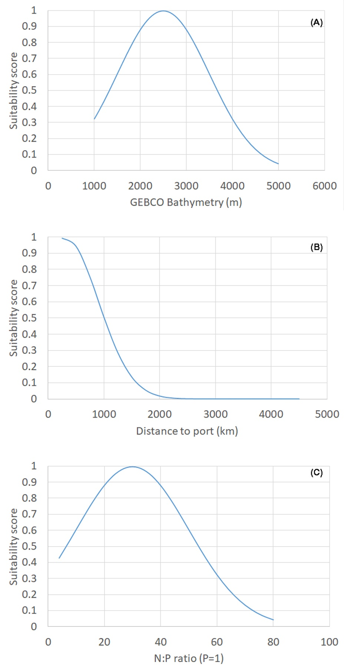

Figure S1: Gaussian function applied to: (A) GEBCO bathymetry, (B) Distance to port and (C) nutrient ratio N:P.