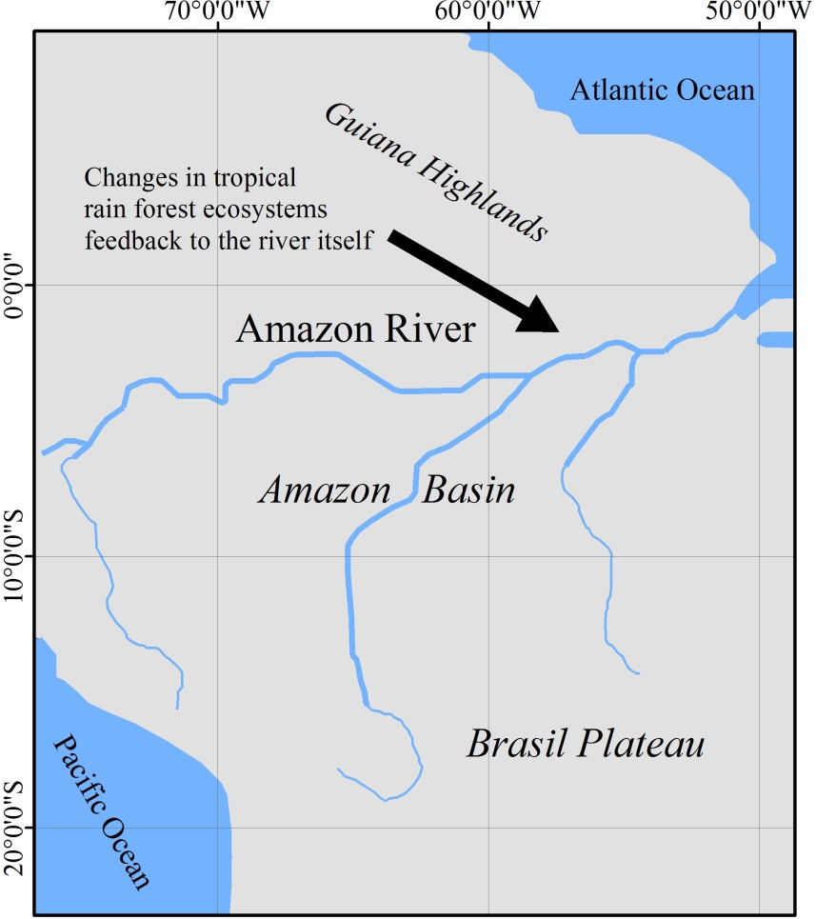

**FIGURE S1** The main EOWSD issue of Amazon River, which belongs to the humid tropical rain forest zone.

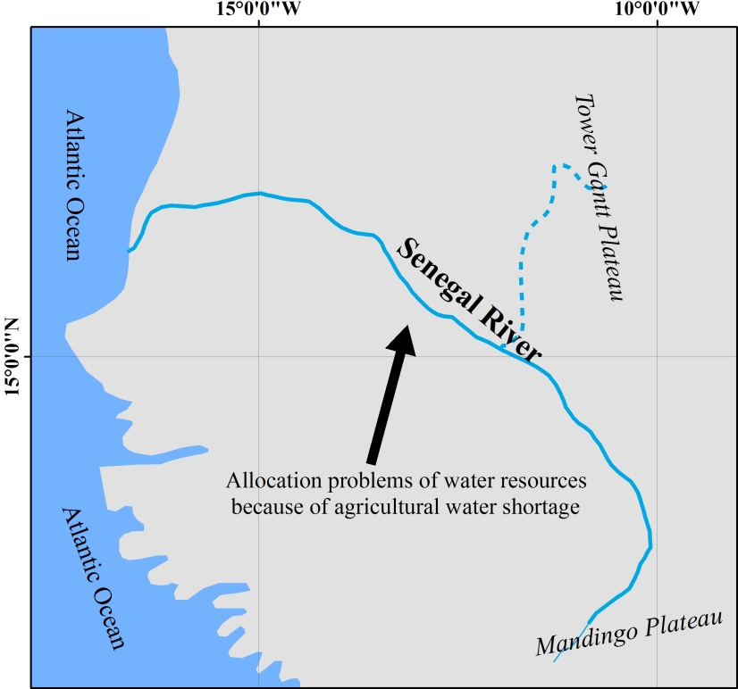

**FIGURE S2** The main EOWSD issue of Senegal River, which belongs to the tropical savanna climatic zone.

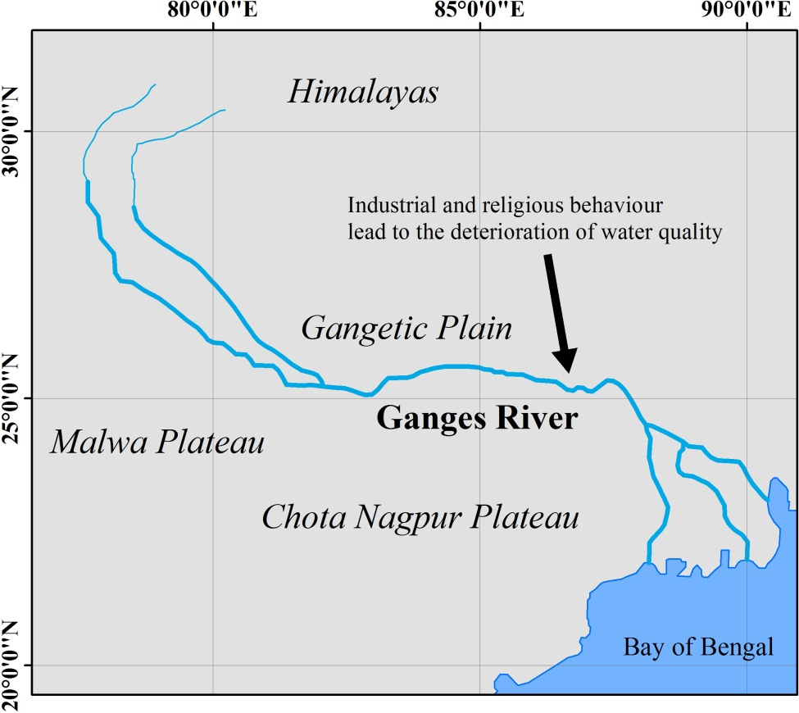

**FIGURE S3** The main EOWSD issue of Ganges River, which belongs to the humid evergreen broad-leaved forest zone.

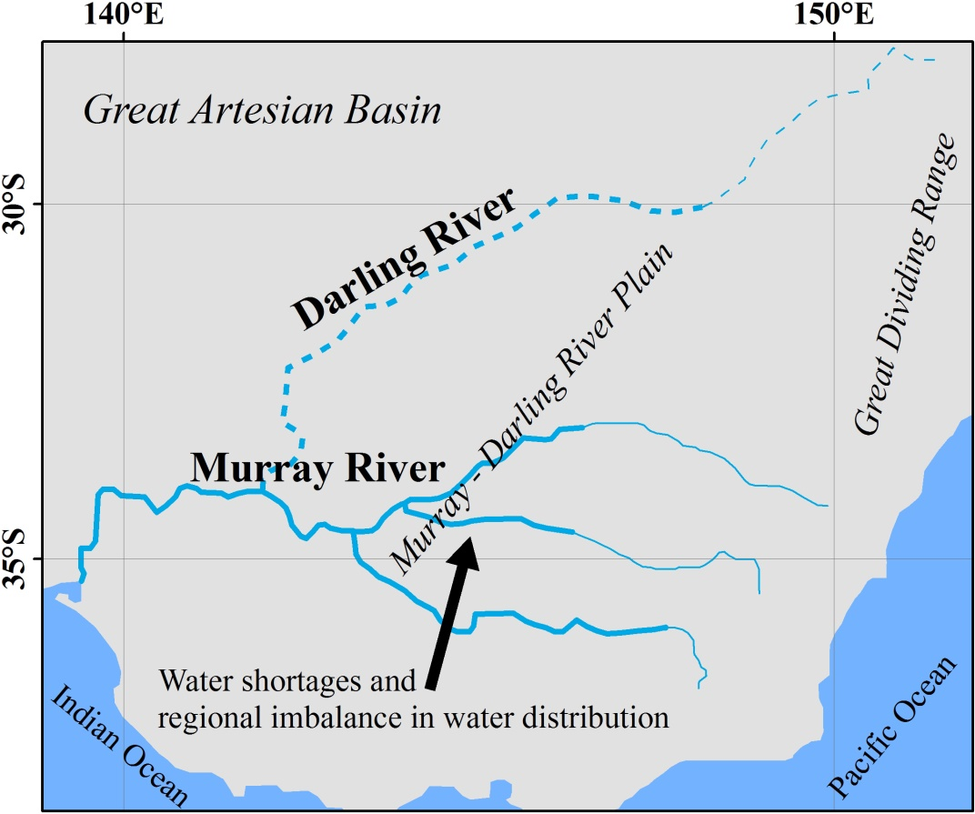

**FIGURE S4** The main EOWSD issue of Murray River, which belongs to the arid steppe-desert zone.

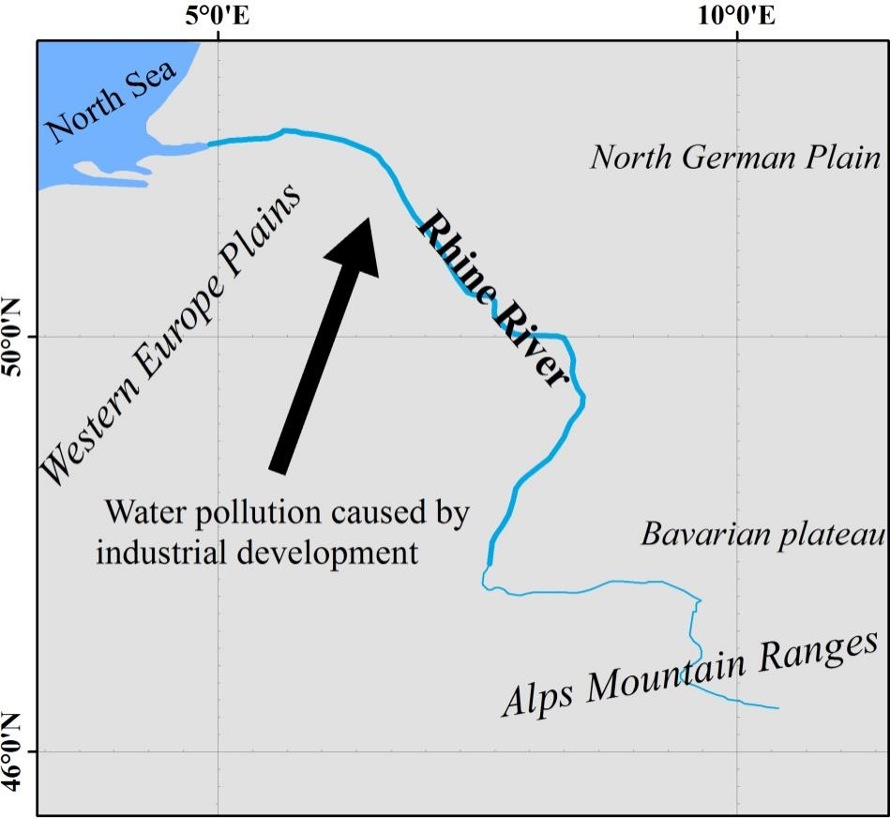

**FIGURE S5** The main EOWSD issue of Rhine River, which belongs to the humid and semihumid mixed broadleaf-conifer forest zone.

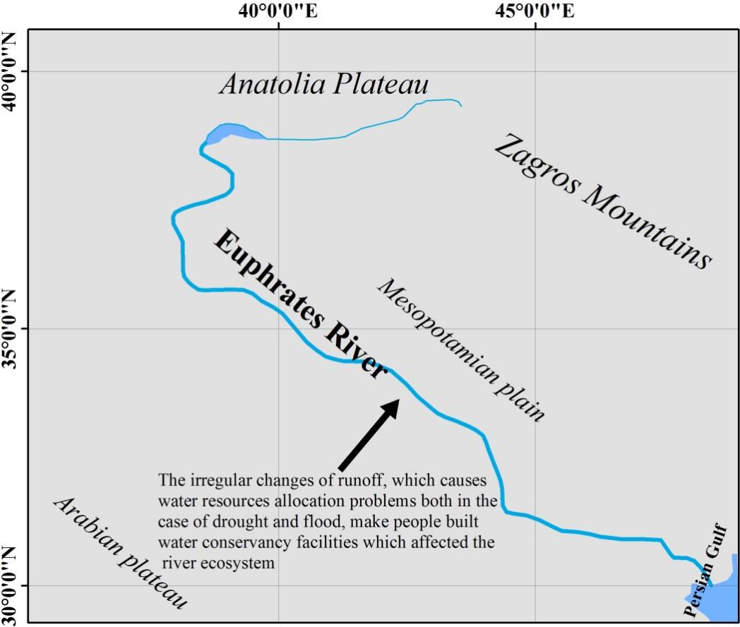

**FIGURE S6** The main EOWSD issue of Euphrates River, which belongs to the arid and semiarid steppe zone.

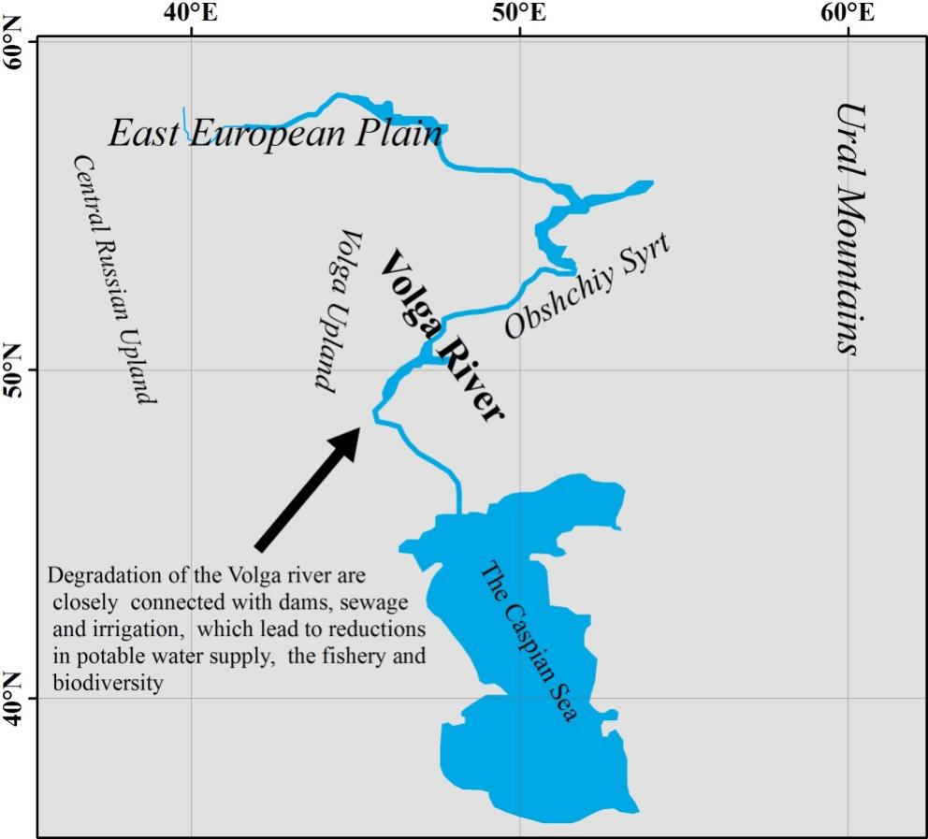

**FIGURE S7** The main EOWSD issue of Volga River, which belongs to the subpolar tundra zone.

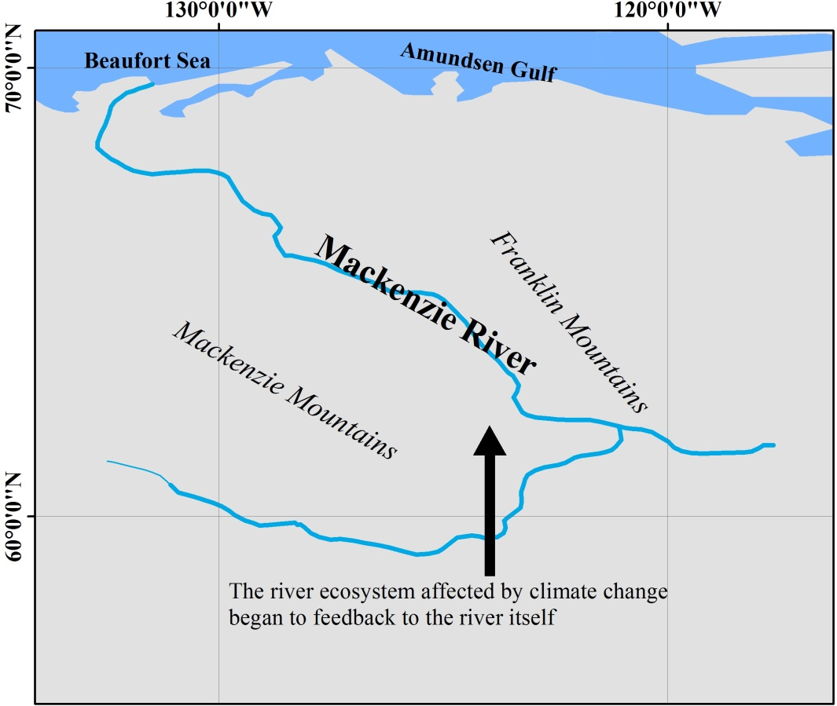

**FIGURE S8** The main EOWSD issue of Mackenzie River, which belongs to the polar ice sheet zone.

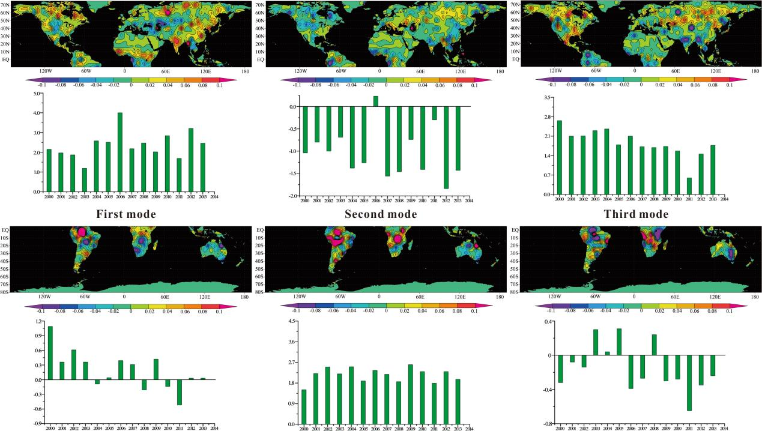

**FIGURE S9** The first three EOF modes and corresponding temporal coefficients of global NDVI in summer (June to August in the Northern Hemisphere and December to February in the Southern Hemisphere) of 2000-2014.