Supplementary Material

Supplementary Figures and Tables

Supplementary Figures
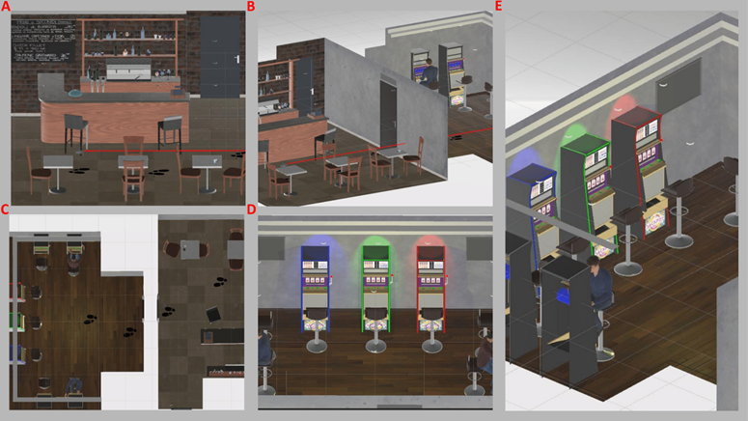
Supplementary Figure 1. Virtual Reality Gambling Scenario.
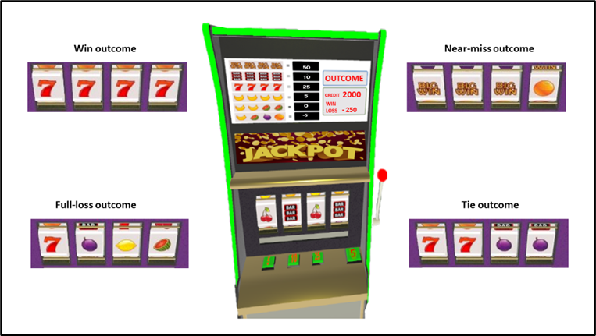
Supplementary Figure 2. Slot-machine Outcomes
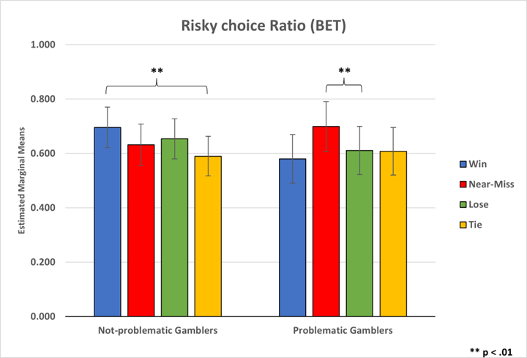
Supplementary Figure 3. Risky Choice Ratio (BET)
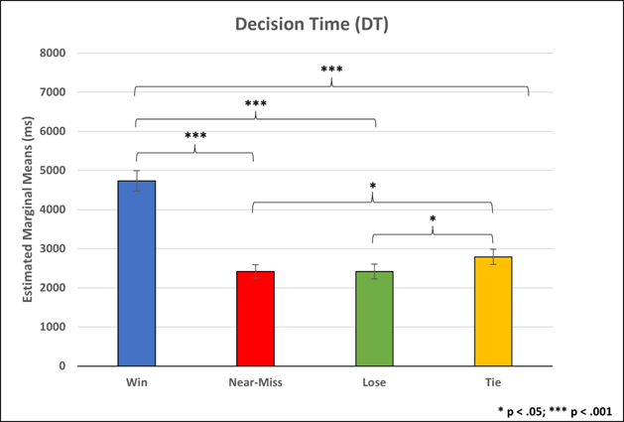
Supplementary Figure 4. Participants’ Decision Time for Placing Bets
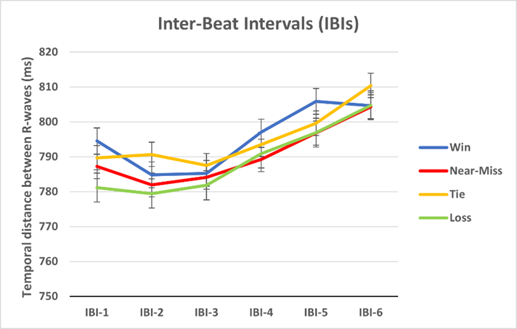
Supplementary Figure 5. Inter-Beat Intervals (IBI) for each Slot-machine Outcome

