Supplementary Material

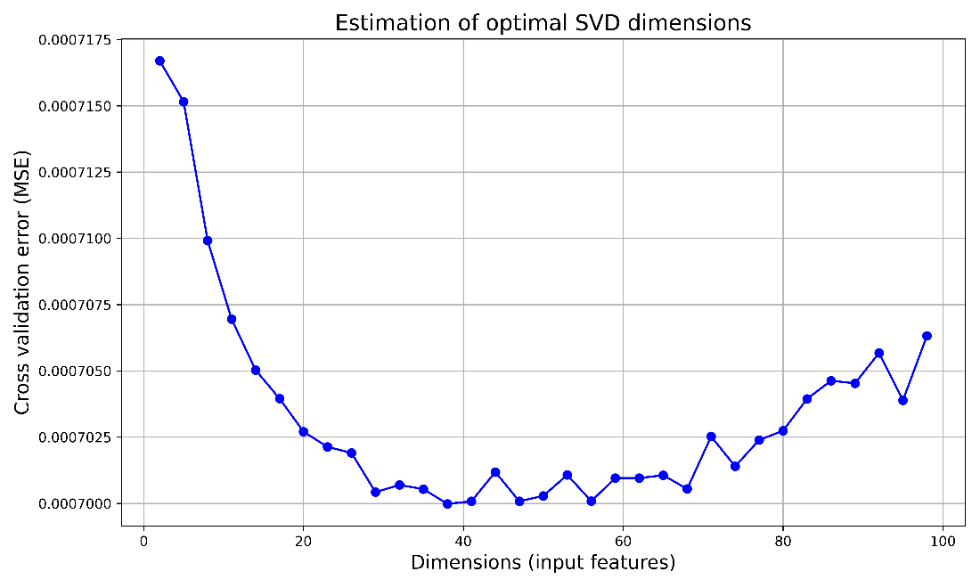
Supplementary Figure 1: Finding the optimal number of dimensions for dimensionality reduction. Here we show the test data Mean Squared reconstruction Error (MSE) after applying SVD. The smaller error indicates a more accurate reconstruction.
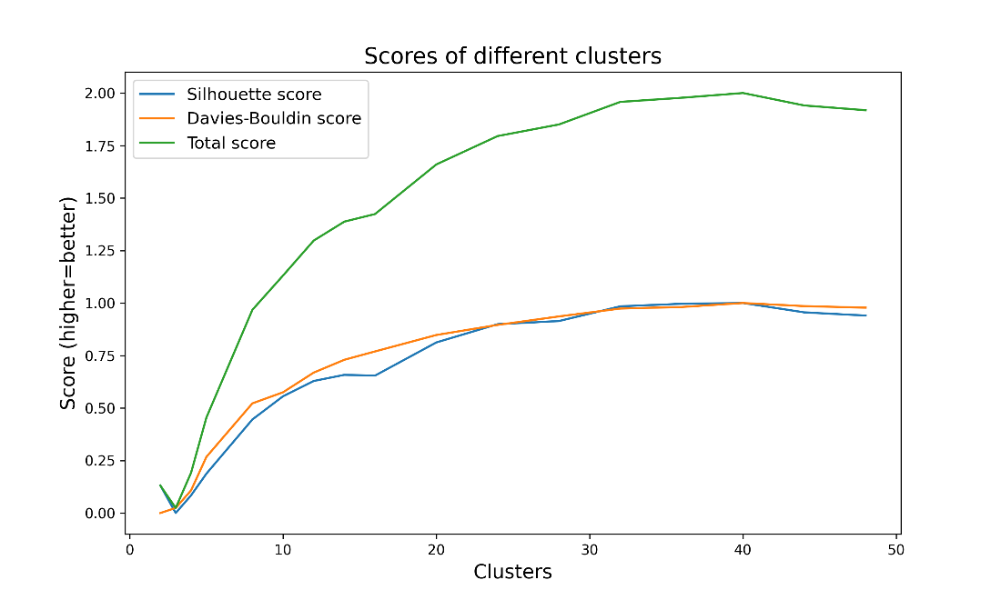
Supplementary Figure 2: Finding the optimal number of clusters using silhouette and Davies- Bouldin scores. Here we have normalized both scores between 0 and 1 with higher values indicating better clustering.

Supplementary Table 1: 74 work or professional titles included in the study picked from Statistics Finland table (https://www2.tilastokeskus.fi/en/luokitukset/ammatti). The table contains both the original Finnish terms and their corresponding English (non-official) translations.
Finnish | English
Tieto- ja viestintäteknologiajohtajat | Information and Communication Technology Directors
Tieto- ja viestintäteknologiajohtaja | Information and Communication Technology Director
Johtaja, tieto- ja viestintäteknologia | Director of Information and Communication Technology
Tietoliikennesuunnittelija | Telecommunications Planner
ICT-alan erityisasiantuntijat | ICT Sector Specialists
Tietotekniikan insinööri | Information Technology Engineer
Tietoliikenneinsinööri | Telecommunications Engineer
Tieto- ja viestintätekniikan myynnin er. | ICT Sales Specialist
Erityisasiantuntija, tieto-, viestintätekn. myynti | Specialist in IT and Communication Technology Sales
Tieto- ja viestintäteknologian erityisasiantuntija | ICT Specialist
Systeemityön erityisasiantuntijat | System Work Specialists
Sovellusarkkitehdit | Application Architects
Atk-päällikkö | IT Manager
Tietohallintopäällikkö | Information Management Director
Projektipäällikkö, tietotekniikka | Project Manager, Information Technology
Systeeminsuunnittelija | Systems Designer
ICT-liiketoiminta-analyytikko | ICT Business Analyst
ICT-järjestelmäarkkitehti | ICT Systems Architect
ICT-järjestelmäanalyytikko | ICT Systems Analyst
Muu sovellusarkkitehti | Other Application Architect
Sovellussuunnittelijat | Application Designers
Atk-suunnittelija | IT Designer
Ohjelmistosuunnittelija | Software Designer
Käyttöliittymäsuunnittelija | User Interface Designer
Sisältösuunnittelija | Content Designer
Web- ja multimediakehittäjät | Web and Multimedia Developers
Web-suunnittelija | Web Designer
Sovellusohjelmoijat | Application Programmers
Ohjelmoija, tietotekniikka | Programmer, Information Technology
Muut ohjelmisto- ja sovelluskehittäjät | Other Software and Application Developers
Muu ohjelmisto- , sovellustyön erityisasiantuntija | Other Software and Application Work Specialist
Tietokantojen,- verkkojen ja ohjelmistojen er. | Databases, Networks, and Software Specialist
Tietokantasuunnittelijat ja -vastaavat | Database Designers and Managers
Erityisasiantuntija, tietokannat | Database Specialist
Tietojärjestelmien ylläpitäjät | Information System Administrators
Järjestelmäpäällikkö | Systems Manager
Tietoverkkojen erityisasiantuntijat | Network Specialists
Tietoverkkoasiantuntija | Network Expert
Muut tietokanta- ja tietoverkkojen erityisasiantun | Other Database and Network Specialists
Tietoturvapäällikkö | Information Security Manager
Verkostonhoitaja | Network Manager
Sulautettujen järjestelmien turvallisuusasiantunt. | Embedded Systems Security Expert
Tietotekniikan teknikko | Information Technology Technician
Muu elektroniiikan ja tietotekniikan teknikko | Other Electronics and Information Technology Technician
Informaatio- ja tietoliikenneteknologian a. | Information and Telecommunications Technology Assistant
ICT-alan teknikot ja käyttäjätukihenkilöt | ICT Technicians and User Support Personnel
Käytön operaattorit | Operations Operators
Käyttöpäällikkö, tietotekniikka | IT Operations Manager
Käytönsuunnittelija, tietotekniikka | IT Operations Planner
Operaattori, tietotekniikka | Operator, Information Technology
Palvelinkeskuksen käytönvalvoja | Data Center Operator
Käytön tukihenkilöt | Support Staff
Atk-neuvoja | IT Advisor
Mikrotukihenkilö | Micro Support Personnel
Atk-yhteyshenkilö | IT Contact Person
Muu käytön tukihenkilö | Other Support Personnel
Tietoverkkoteknikot | Network Technicians
Tietoverkkoteknikko | Network Technician
Webmasterit ja -teknikot | Webmasters and Technicians
Webmaster | Webmaster
Teleliikenne- sekä radio- ja tv-teknikot | Telecommunications, Radio and TV Technicians
Lähetys- ja audiovisuaaliteknikot | Broadcasting and Audiovisual Technicians
AV-teknikko | AV Technician
Muu lähetys- tai audiovisuaaliteknikko | Other Broadcasting or Audiovisual Technician
Televiestinnän tekniset asiantuntijat | Telecommunications Technical Experts
Tekninen asiantuntija, televiestintä | Technical Expert, Telecommunications
Muu televiestinnän tekninen asiantuntija | Other Technical Expert in Telecommunications
Tallentaja, tietotekniikka | Recorder, Information Technology
Jälkikäsittelijä, tietotekniikka | Post-Processor, Information Technology
Elektroniikka-asentaja | Electronics Installer
Muu elektroniikka-, automaatiolaitteiden asentaja | Other Electronics, Automation Equipment Installer
Tieto- ja viestintäteknologian asentajat,korjaajat | Information and Communication Technology Installers and Repairers
Tietoliikenneasentaja | Telecommunications Installer
Tietotekniikka-asentaja | IT Installer

Supplementary Table 2: Full Annif output for an example job advertisement. Here neural ensemble model “yso-en” was used without upper or lower limits for term count and score thresholds.

Input: “We are looking for (Senior) Embedded Linux Designer at our office in Espoo.
You will be responsible for designing embedded software for [company name hidden] power electronics products. Your role will include software design and integrating the software and hardware into the working entity in co-operation with other project team members. You will report to the Manager of SW team.
To succeed in this position, you should have the following qualifications
-B.Sc. or M.Sc. degree within Software Engineering or Electrical Engineering
-Experience in C/C++ programming, Python and Shell scripting in embedded Yocto Linux environment
-Understanding of electronic control systems hardware is a benefit
-Experience in communication protocols is a benefit
-Fluent in English, both written and spoken
-Proactive hands-on attitude
-Good documentation skills and analytical mind set
-Good team working and communication skills
We offer you an opportunity to develop your skills in software design and power electronics as a member of a team of professionals. You will be offered interesting projects and challenges in an international environment. The position is full time. The starting date is negotiable.”
Output:
Rank | Term | Score
1 | computer programmes | 0.39095
2 | Linux | 0.20689
3 | software design | 0.18790
4 | programming | 0.17400
5 | operating systems | 0.14437
6 | software development | 0.11020
7 | ubiquitous computing | 0.10773
8 | power electronics | 0.10301
9 | software technology | 0.10113
10 | electronics | 0.09902
11 | electronic documents | 0.09115
12 | electrical engineering | 0.08457
13 | teamwork | 0.08060
14 | Espoo | 0.06872
15 | development (active) | 0.06296
16 | Into Work Project | 0.06270
17 | professional skills | 0.06222
18 | electrical engineers | 0.05936
19 | design (artistic creation) | 0.05689
20 | teams | 0.04883
21 | communication | 0.04304
22 | professional development | 0.03621
23 | know-how | 0.03494
24 | work communities | 0.03288
25 | software developers | 0.03139
26 | repertoires (arts) | 0.03082
27 | software engineering | 0.01885
28 | free software | 0.01553
29 | systems designers | 0.01401
30 | electrical designers | 0.01394
31 | electricity works | 0.01375
32 | control engineering | 0.00898
33 | competence inventory | 0.00868
34 | enterprises | 0.00866
35 | qualification | 0.00781
36 | spoken programmes and talkshows | 0.00755
37 | automation | 0.00704
38 | maintenance | 0.00575
39 | planning and design | 0.00403
40 | electronic documentation | 0.00336
41 | communications technology | 0.00318
42 | user-centeredness | 0.00225
43 | testing | 0.00204
44 | modifiability | 0.00093

Supplementary Table 3: Full Annif output for an example thesis abstract. Here neural ensemble model “yso-en” was used without upper or lower limits for term count and score thresholds.

Input: “In response to the contemporary challenge of employee dissatisfaction arising from repetitive and mundane tasks, this study explores the potential of Robotic Process Automation (RPA) to optimize individual tasks within organizational processes. Recognizing the obstacles of high costs, lengthy implementation timeframes and the complexity associated with deployment of traditional automation technologies, this study focuses on the feasibility of small-scale, single-process automation through RPA. The study involves a literature review and interviews with employees from different business sectors to gain insights, subsequently proceeding to simulated implementation of RPA. Findings reveal employee interest in RPA technology, though a common misconception persists that automation necessitates extensive planning by management. To challenge the misconception, two processes from different companies are identified and simulated for automation, showcasing the potential for employees to initiate small-scale automation. In conclusion, this study illustrates how RPA effectively enhances small-scale organizational processes through task automaton. By utilizing common tools (Office 365) and encouraging individual employees to delve into RPA, organizations can achieve increased efficiency, higher employee satisfaction, and cost-effectiveness. This study contributed insights for businesses seeking practical approaches to enhance organizational processes through RPA implementation.”
Output:
Rank | Term | Score
1 | automation | 0.56649
2 | leadership (activity) | 0.37664
3 | enterprises | 0.36515
4 | organisations (systems) | 0.35332
5 | employees | 0.28158
6 | processes | 0.21784
7 | self-evaluation | 0.14583
8 | simulation | 0.12416
9 | robots | 0.12235
10 | staff | 0.11403
11 | efficiency (properties) | 0.10534
12 | development (active) | 0.08654
13 | automation technology | 0.08395
14 | automation systems | 0.06166
15 | robotics | 0.05664
16 | quality management | 0.04483
17 | automatons | 0.03552
18 | technology | 0.02991
19 | committing oneself | 0.02923
20 | quality awards | 0.02763
21 | human resource management | 0.02763
22 | leadership (properties) | 0.02354
23 | business | 0.02056
24 | organisational changes | 0.02025
25 | business employees | 0.01431
26 | simulators | 0.01021
27 | encouragement | 0.00976
28 | success | 0.00515
29 | PC Tools Utilities | 0.00239
30 | tradition | 0.00144
31 | control systems | 0.00034

Supplementary Table 4: 28 topic clusters and their manually assigned labels found in the theses abstract data set with 18254 theses from ICT-field. For each cluster, we show 10 terms nearest to each cluster’s centroid. Table contains total 176 unique terms.
No. | Cluster Terms | Cluster Label
1. | Software development, computer programmes, repertoires, testing, applications (computer programmes), programming, software engineering, testing methods, software technology, development (active) | Software engineering
2. | Data security, safety and security, data protection, cyber security, information networks, data systems, risk management, shielding, authentication, control (prevention) | Data security
3. | Automation, data systems, processes, enterprises, development (active), product development, final projects (education), planning and design, systems, improving | Product development & Design
4. | Web pages, websites, Internet, usability, online services, content management, planning and design, final projects (education), enterprises, realization (active) | Content creation & Management
5. | Technology, information technology, development (passive), innovations, technological development, product development, final projects (education), automation, development (active), applications (computer programmes) | Technological development
6. | Projects, project work, project management, development projects, project planning, planning and design, development (active), final projects (education), project leadership, enterprises | Project management
7. | Machine learning, artificial intelligence, algorithms, neural networks (information technology), robotics, technology, robots, learning, automation, deep learning | Artificial Intelligence
8. | Games, computer games, digital games, game design, game sector, game industry, playing (games and sports), mobile games, video games, game programming | Game design, Programming & Playing
9. | Working life, work, employees, know-how, final projects (education), enterprises, development (active), staff, job description, learning | Work life
10. | Mobile devices, cell phones, applications (computer programmes), mobile apps, operating systems, smartphones, Android, programming, mobile services, mobile communications services | Mobile devices, Apps & OS
11. | Programming, programming languages, databases, computer programmes, Java, applications (computer programmes), data systems, user interfaces, object-oriented programming, final projects (education) | Programming
12. | Measurement, measuring instruments (devices), measuring methods, testing, automation, devices, electrical engineering, electronics, product development, measuring instruments (indicators) | Measurements & Testing
13. | Marketing, electronic commerce, business, enterprises, electronic business, digital marketing, business operations, Internet, services, products | E-commerce & Digital marketing
14. | Modelling (creation related to information), Three-dimensional imaging, three-dimensionality, planning and design, computer programmes, visualisation, final projects (education), computer-aided design, computer graphics, games | Computer aided design
15. | Servers, Linux, operating systems, computers, computer programmes, data systems, installation, information technology, information networks, virtualisation | Servers & OS
16. | Online services, services, cloud services, Internet, information networks, data systems, enterprises, information technology, use, applications (computer programmes) | Internet & Cloud services
17. | Windows XP, Windows 7, Windows 95, Windows 98, Windows NT, Windows 8, operating systems, Windows 10, Windows, Windows Server | Windows OS
18. | User-centeredness, usability, users, user interfaces, planning and design, product development, evaluation, user experience, web pages, final projects (education) | UI designs
19. | Wireless data transmission, wireless communication, wireless local area networks, telecommunications technology, wireless technology, mobile communication networks, data communications networks, local area networks, data transfer, wireless networks | Wireless communication
20. | Customers, customer orientation, customer service, services, customership, enterprises, marketing, development (active), customer satisfaction, customer relationship management | Customer services
21. | HTML, web pages, applications (computer programmes), websites, ASP.NET, description languages, Internet, planning and design, PHP, narrative theory | Web programming
22. | Universities of applied sciences, students, learning, teaching and instruction, study, education and training, learning environment, final projects (education), online teaching, information technology | Education & Learning
23. | Organisations (systems), leadership (activity), development (active), enterprises, self-evaluation, processes, success, business, data systems, quality awards | Organizations & Leaderships
24. | Video, video recording, editing, video equipment, image processing, production, video tape recorders, films, final projects (education), cameras | Image & Video processing
25. | Data communications networks, information networks, telecommunications technology, data communications, protocols, data transfer, local area networks, Internet, data security, enterprises | Data communication & Networks
26. | Social media, marketing, media, marketing communication, Facebook, advertising, Internet, digital marketing, online communities, enterprises | Online advertising
27. | Databases, information management, data systems, computer programmes, programming, data, applications (computer programmes), SQL, database programs, final projects (education) | Information management
28. | Research, questionnaire survey, research methods, final projects (education), evaluation, development (active), use, services, objectives, enterprises | Research & Surveys

Supplementary Table 5: 38 topic clusters and their manually assigned labels found in the job ads data set containing 107335 ads from ICT-field. For each cluster, we show 10 terms nearest to each cluster’s centroid. Table contains total 173 unique terms.
No. | Cluster Terms | Cluster Label
1. | Employment (legal relationship), working hours, employees, working life, recruitment of employees, staff, work, hiring, wages, enterprises | Employees & Staff
2. | Programming, computer programmes, software developers, programming languages, enterprises, information technology, planning and design, experiences (knowledge), development (active), know-how | Programming
3. | Information administration, municipalities, data systems, development (active), services, towns and cities, information technology, leadership (activity), tasks, organizations (systems) | Information administration
4. | Work communities, work, working life, work comfort, remote work, teamwork, success, expertise, development (active), business life | Working life
5. | Safety and security, security systems, data security, systems of supervision, safety technology, enterprises, security service sector, safety devices, passage control, data systems | Safety & Security
6. | Online services, Internet, services, enterprises, information technology, development (active), web pages, know-how, experiences (knowledge), information networks | Internet services & Information networks
7. | Information management, databases, data systems, information technology, management (control), data warehouses, development (active), enterprises, knowledge management, applications (computer programmes) | Information management
8. | Professional skills, know-how, education and training, staff, employees, working life, enterprises, experiences (knowledge), development (active), recruitment of employees | Professional skills
9. | Financial administration, electronic financial management, enterprises, development (active), personnel administration, business, data systems, services, customers, know-how | Financial administration
10. | Information technology sector, information technology, enterprises, services, know-how, recruitment of employees, experiences (knowledge), customers, customer service, employees | Information technology
11. | Access to employment, recruitment of employees, working life, employees, know-how, staff, information technology, enterprises, tasks, work | Employment
12. | Telecommunications technology, data communications, data communications networks, information networks, services, enterprises, mobile communication networks, information technology, information and communication technology sector, broadband networks | Data communication & Networks
13. | Business operations, business, enterprises, services, customers, development (active), marketing, know-how, corporate strategies, information technology | Business, Marketing & Corporate services
14. | Marketing, digital marketing, Internet, sale, social media, enterprises, electronic commerce, web pages, customers, communication | E-commerce & Digital marketing
15. | Infrastructures, consultancy agencies, management (control), language skills, languages, planning and design, projects, databases, programming, realization (active) | Consultancy
16. | Communication, customer experience, business life, customers, customer orientation, communicative skills, product development, leadership (activity), enterprises, innovations | Customer experience
17. | Personnel selection, recruitment of employees, jobseekers, access to employment, staff, labor (workforce), employees, working life, enterprises, employment (legal relationship) | Access to employment
18. | Business, development (active), enterprises, projects, know-how, services, leadership (activity), experiences (knowledge), data systems, customers | Business development
19. | Project management, project work, project leadership, projects, project planning, leadership (activity), planning and design, development (active), enterprises, customers | Project management
20. | Automation, installation, upkeep (servicing), service (maintenance), electricity sector, devices, education and training, enterprises, electrical engineering, real property | Automation
21. | Customer service, services, customers, information technology, enterprises, employees, recruitment of employees, experiences (knowledge), staff, know-how | Customer services
22. | Product development, innovations, technology, products, enterprises, planning and design, development (active), automation, know-how, experiences (knowledge) | Product development & design
23. | Cooperation (general), development (active), projects, business, enterprises, know-how, services, experiences (knowledge), leadership (activity), development projects | Business & Project cooperation
24. | Web pages, HTML, programming, JavaScript, Internet, programming languages, PHP, description languages, cascading style sheets, World Wide Web | Web programming
25. | Education and training, universities of applied sciences, universities, tasks, institutions of higher education, know-how, students, staff, development (active), teaching and instruction | Education & Learning
26. | Windows XP, Windows 95, Windows 7, Windows 98, Windows NT, Windows 8, information technology, operating systems, workstations (computing), enterprises | Windows OS
27. | Testing, testing methods, quality, computer programmes, software development, automation, quality assurance, quality control, software engineering, development (active) | Software  engineering
28. | Public health service, health services, data systems, health sector, information administration, social welfare, development (active), social sector, hospital districts, federations of municipalities | Public health
29. | Managers and executives, leadership (activity), enterprises, experiences (knowledge), working life, know-how, staff, employees, recruitment of employees, development (active) | Enterprises  & Leadership
30. | Tasks, presentations (introductions), central government, staff, defensive forces, employees, municipalities, legislation, know-how, wages | Legislation
31. | Success, organizations (systems), leadership (activity), self-evaluation, working life, development (active), enterprises, learning, career development, business life | Career  development
32. | Applications (computer programmes), design (artistic creation), planning and design, software design, product development, computer programmes, user-centeredness, management (control),  customers, user interfaces | Software  design
33. | Applications (documents), access to employment, workplaces, recruitment of employees, job application, employees, working life, staff, Internet, jobseekers | Recruitment
34. | Java ME, Java, Java EE, Java SE, programming, programming languages, Internet, enterprises, development (active), computer programmes | Java  programming
35. | Maintenance, servers, information networks, information technology, data systems, workstations (computing), Linux, operating systems, management (control), enterprises | Servers & OS
36. | Mobile devices, cell phones, operating systems, applications (computer programmes), software development, computer programmes, open-source code, software technology, Linux, product development | Mobile devices,  Apps & OS
37. | Business, enterprises, development (active), services, projects, data systems, know-how, experiences (knowledge), leadership (activity), information technology | Business &  Enterprises
38. | Customer orientation, customer service, customers, customership, marketing, services, sale, enterprises, customer relationship management, customer experience | Customership

