Supplementary Material
Supplementary Table 2. Oligonucleotide primers used in this study.
Supplementary Figure 1. Conservation analyses of the znuCBA-mepM and zniCBA loci.
Supplementary Figure 2. K. pneumoniae growth in Zn(II)-supplemented media and elemental content analyses.
Supplementary Figure 3. Morphological variation in K. pneumoniae complement strains.
Supplementary Figure 4. Characterization of the K. pneumoniae B5055 derivative strains.

Supplementary Table 2. Oligonucleotides used in this study.
Name | Sequence (5’ → 3’) | Purpose
pKD4F | tgtgtaggctggagctgcttc | Gene deletion: Amplification of KanR cassette
pKD4R_ex | catatgaatatcctccttagttcctattcc
znuA_KO_LF_F | ggcggccgcgggaattcgatGGTTCATCCAGCACCAGC | Gene deletion: znuA left flank amplification
znuA_KO_LF_R | aagcagctccagcctacacaCATCGAAATAAGTGAGTGTGATG
znuA_KO_RF_F | ctaaggaggatattcatatgCGAGGAAGTGAATACGTGAAC | Gene deletion: znuA right flank amplification
znuA_KO_RF_R | gccgcgaattcactagtgatGTTATCCACACGGGTATAGGTG
znuA_LF_chk_F | TACAATTCGCCCCTGAAGGTC | Gene deletion: Confirmation of znuA gene deletion
znuA_RF_chk_R | AACTGGCTTTGCTCACGTTTG
zniA_KO_LF_F | CCTCCTGCATCTGCTGTTTG | Gene deletion: zniA left flank amplification
zniA_KO_LF_R | agcctacacaCATTTCCTTACCCCATCAATGTG
zniA_KO_RF_F | tattcatatgCAGGTTGTCTGGTCGTCC | Gene deletion: zniA right flank amplification
zniA_KO_RF_R | TCTCCGGCAAAGCATTCC
zniA_LF_chk_F | ccgccaacgctttctgtttg | Gene deletion: Confirmation of zniA gene deletion
zniA_RF_chk_R | gattttatctgggctcgctgg
pACYC184_F | ACGGGTGCGCATAGAAATTGC | Complementation: pACYC184 amplification for gene expression from native promoter
pACYC184_F2 | CGGTGCCTGACTGCGTTAG | Complementation: pACYC184 amplification for constitutive gene expression
pACYC184_R | GCGAGAAGCAGGCCATTATCG | Complementation: pACYC184 amplification
znuA_comp_F | gataatggcctgcttctcgcACGCTTGATAACACCCTCTG | Complementation: znuA amplification
znuA_comp_R | caatttctatgcgcacccgtTGCACGTATTCACTTCCTCG
zniA_comp_F | gctaacgcagtcaggcaccgATGAAACGTAGTGCAATAG | Complementation: zniA amplification
zniA_comp_R | gataatggcctgcttctcgcTTACTTCATGCTGTTAGC
pACYC_seq_F | GCTAACGCAGTCAGGCACC | Sequencing primer for pACYC184 inserts
pACYC_seq_R | CAGCAAGACGTAGCCCAGC
rpoD562F | gaagagatggatgacgacgaagacg | Real time qPCR: housekeeping control [61]
rpoD677R | gtacgcagctcggcgaatttctcac
znuA_rt_F | CGAGACCCAGGTTCTGCTG | Real time qPCR: znuA
znuA_rt_R | CACACCACTAAGTCTGCGTTC
znuB_rt_F | GGTTATCGCCGTGACCCTG | Real time qPCR: znuB
znuB_rt_R | GTGCGCCATGATGCCCAG
znuC_rt_F | CTACCAGCCCGAGAACCAC | Real time qPCR: znuC
znuC_rt_R | GACATCTCGCTGGCTCTCAC
zniA_rt_F | CGAAAACGCTGAATGTGGTAAGC | Real time qPCR: zniA
zniA_rt_R | GAGACGGTTCGAAGGTGTGC
zniC_rt_F | TTTCTTCCGCCGGTCAGTG | Real time qPCR: zniC
zniC_rt_R | ACATCCTGCACGTTGAGAGG
zinT_rt_F | GTTAACCGAAGTGGAGCGTC | Real time qPCR: zinT
zinT_rt_R | CGAGATCGCCATTGAGCAG
zupT_rt_F | GGTAGCGCAACCTTCATTGG | Real time qPCR: zupT
zupT_rt_R | CAGGCAGCATTTCCATCAACG
pitA_rt_F | CGAAGCGATTAACGGTTTCC | Real time qPCR: pitA
pitA_rt_R | GAACGCCGAAGAAGTTGAAG
mntH_rt_F | TATCGATCCGGGTAATTTCG | Real time qPCR: mntH
mntH_rt_R | ATCAGGTTAGCCCACACCAC
sitA_rt_F | GACGTGAGCTCCATTACTAAACC | Real time qPCR: sitA
sitA_rt_R | CGTTCGAGATTAAGCCCATTGC
mepM_rt_F | TCAGGCATTCAACAATCTGC | Real time qPCR: mepM
mepM_rt_R | TTCCGGGTGGTAAATGTAGG
F-RF-pelBZniA | GCTGCCCAGCCGGCGATGGCCATGGCAAAAACGCTGAATGTGGTAAGC | Cloning: Sub-cloning of zniA for expression vector
R-RF-p52ZniA | ActaccgcgtggcaccagagcgagctcCTTCATGCTGTTAGCGATAAGCTC

SUPPLEMENTARY FIGURE 1
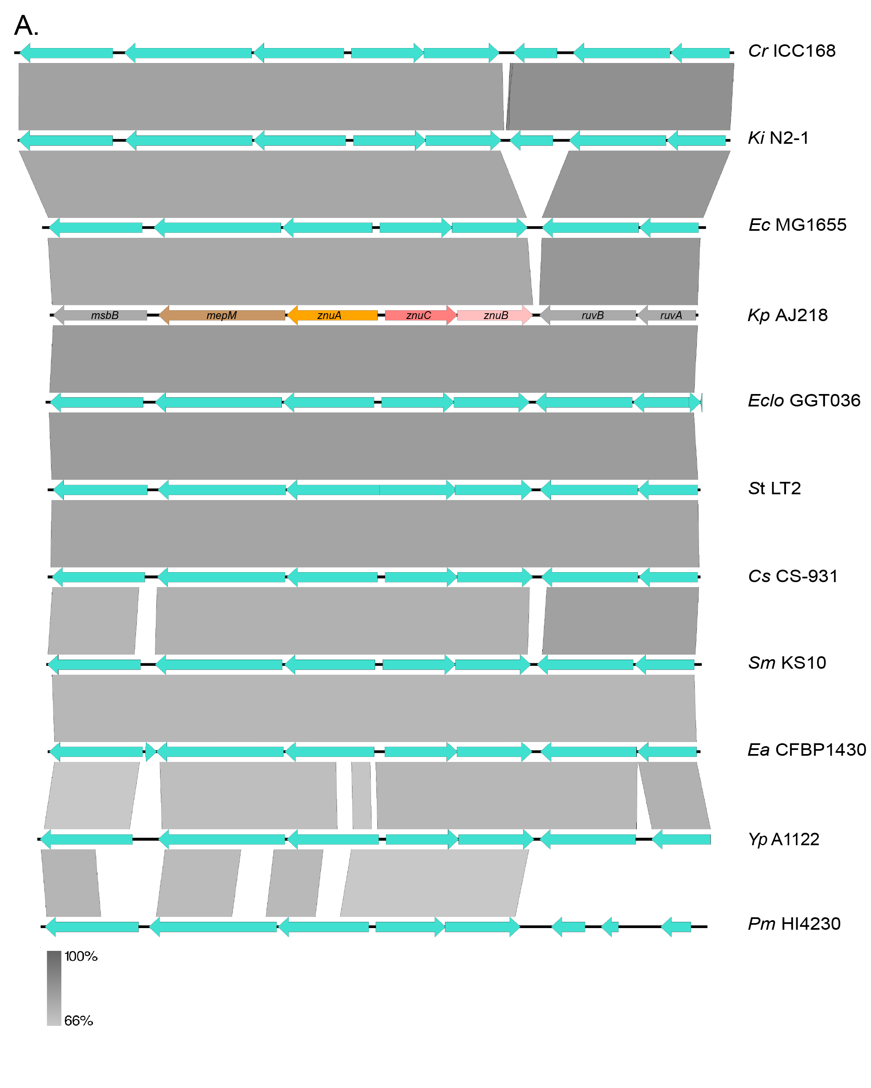
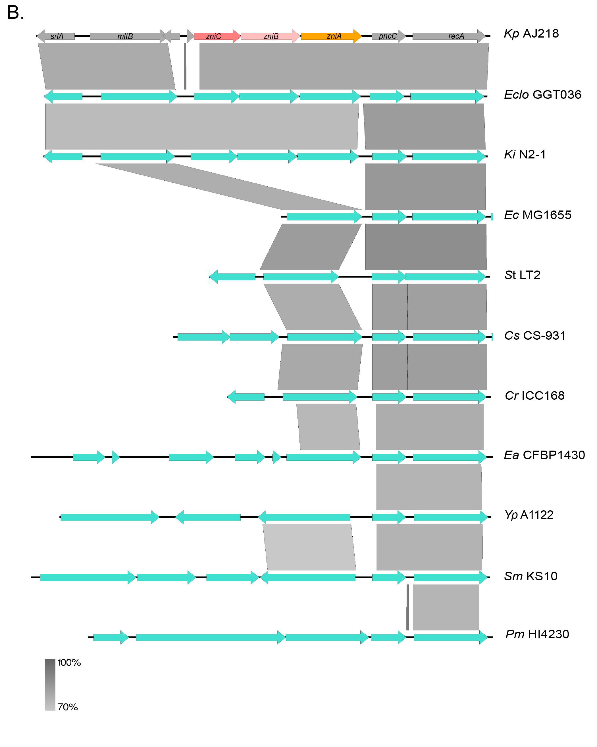Supplementary Figure 1. Conservation analysis of the znuCBA-mepM and zniCBA loci. Local genomic comparisons of the respective gene regions in the K. pneumoniae (Kp) AJ218 genome (accession NZ_LR130541), Citrobacter rodentium (Cr) ICC168 (NC_013716), Cronobacter sakazakii (Cs) CS-931 (CP027107), Enterobacter cloacae (Eclo) GGT036 (CP009756), Erwinia. amylovora (Ea) CFBP1430 (FN434113), E. coli (Ec) MG1655 (U00096), Kluyvera intermedia (Ki) N2-1 (P045845), P. mirabilis (Pm) HI4320 (NC_010554), S. enterica servar Typhimurium (St) LT2 (GCF_000006945.2), Serratia marcescens (Sm) KS10 (NZ_CP0277798), and Yersinia pestis (Yp) A1122 (NC_017168) genomes for the (A) znuCBA-mepM and (B) zniCBA loci. Genes are indicated by colored arrows with K. pneumoniae nomenclature used. Where applicable, levels of nucleotide homology between adjacent strains are indicated by the grey shading between loci, with scale bar shown.

SUPPLEMENTARY FIGURE 2
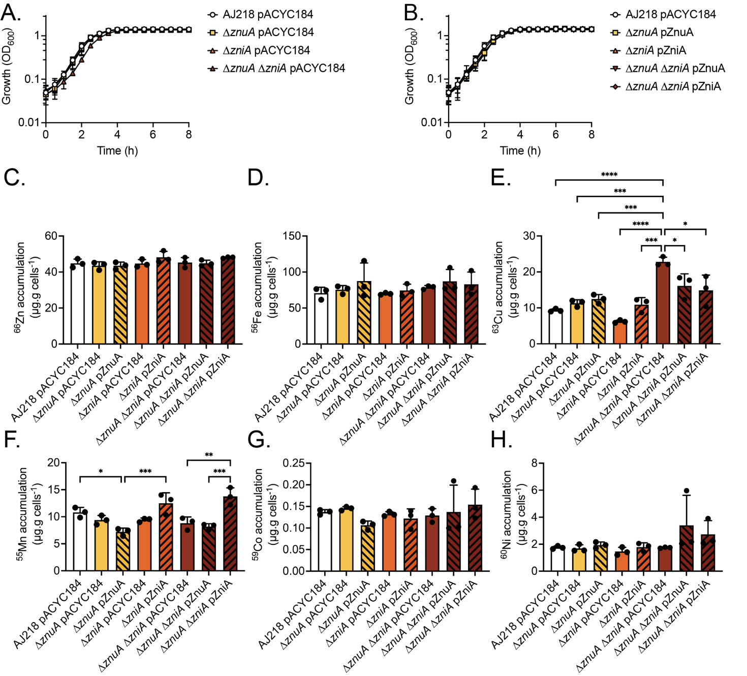Supplementary Figure 2. K. pneumoniae growth in Zn(II)-supplemented media and elemental content analyses. K. pneumoniae AJ218 pACYC184, mutant (A), and complemented strains (B) growth phenotypes in Zn(II)-supplemented media. Data represent mean OD₆₀₀ values (± SEM) from three independent experiments. Whole cell accumulation of ⁶⁶Zn (C), ⁵⁶Fe (D), ⁶³Cu (E), ⁵⁵Mn (F), ⁵⁹Co (G), and ⁶⁰Ni (H) for the wild type and derivative strains grown in Zn(II)-supplemented media. Data represent mean (± SEM) μg metal.g cells⁻¹ (dry weight) from at least three independent experiments. Statistical significance of differences was determined by one-way ANOVA analysis with Bonferroni post-test; ns, not significant; *, P < 0.05; **, P < 0.01; ***, P < 0.001; ****, P < 0.0001.

SUPPLEMENTARY FIGURE 3
Supplementary Figure 3. Morphological variation in K. pneumoniae complement strains. (A) Representative images of K. pneumoniae AJ218 wild type and complement strains grown in Zn(II)-limited media in the presence or absence of 10 µM ZnSO₄, stained with crystal violet. Scale bar (5 µM) is shown. (B) Curvature analyses of the strains using Fiji plugin MicrobeJ. Statistical significance of differences was determined by one-way ANOVA analysis with Tukey post-test. ns, not significant; *, P < 0.05; **, P < 0.01; ***, P < 0.001; ****, P < 0.0001. (C) Representative images of the wild type and derivative strains grown in Zn(II)-limited media visualized at 5 kV by field emission scanning electron microscopy. Scale bars are shown.

SUPPLEMENTARY FIGURE 4
Supplementary Figure 4. Characterization of the K. pneumoniae B5055 strains. K. pneumoniae B5055 pACYC184, mutant (A), and complemented strains (B) growth phenotypes in Zn(II)-limited media. Data represent mean OD₆₀₀ values (± SEM) from three independent experiments. Representative images of K. pneumoniae B5055 (C) and the ∆znuA ∆zniA strain (D) grown in Zn(II)-limited media, stained with crystal violet (left), visualized at 5 kV by field emission scanning electron microscopy with scale bars shown (middle) and with curvature analyses of the strains using Fiji plugin MicrobeJ (right). Statistical significance of differences was determined by one-way ANOVA analysis with Tukey post-test. ns, not significant; *, P < 0.05; **, P < 0.01; ***, P < 0.001; ****, P < 0.0001..

