Supplementary material

FCGR2/3 polymorphisms are associated with susceptibility to Kawasaki disease, but do not predict intravenous immunoglobulin resistance and coronary artery aneurysms

Paula Uittenbogaard¹†* & Stejara A. Netea^{2,3}†, Michael W.T. Tanck⁴, Judy Geissler¹, Piotr Buda⁵, Monika Kowalczyk-Domagała⁶, Magdalena Okarska-Napierała⁷, Diana van Stijn², Carline E. Tacke², US Kawasaki Disease Genetics Consortium, David P. Burgner^{8,9}, Chisato Shimizu¹⁰, Jane C. Burns¹⁰, Irene M. Kuipers¹¹, Taco W. Kuijpers^{1,2}*͛ & Sietse Q. Nagelkerke^{1,2}*͛

†These authors contributed equally to this work and share first authorship
*͛These authors contributed equally to this work and share last authorship

¹Department of Blood Cell Research, Sanquin Research Institute, University of Amsterdam (UvA), Amsterdam, The Netherlands
²Department of Pediatric Immunology, Rheumatology and Infectious Diseases, Emma Children’s Hospital, Amsterdam University Medical Center (Amsterdam UMC), UvA, Amsterdam, The Netherlands
³Department of Experimental Immunology, Amsterdam Institute for Infection & Immunity, Amsterdam UMC, UvA, Amsterdam, The Netherlands
⁴Department of Epidemiology and Data Science, Amsterdam UMC, Location UvA, Amsterdam, The Netherlands
⁵Department of Pediatrics, Nutrition and Metabolic Diseases, The Children’s Memorial Health Institute, Warsaw, Poland
⁶Department of Pediatric Cardiology, The Children’s Memorial Health Institute, Warsaw, Poland
⁷Department of Pediatrics with Clinical Assessment Unit, Medical University of Warsaw, Poland
⁸Murdoch Children’s Research Institute, Royal Children’s Hospital, Melbourne, VIC, Australia
⁹Department of Pediatrics, University of Melbourne, VIC, Australia
¹⁰Department of Pediatrics, University of California, San Diego, La Jolla, CA, United States
¹¹Department of Pediatric Cardiology, Amsterdam UMC, UvA, Amsterdam, The Netherlands

*Correspondence
Paula Uittenbogaard
P.Uittenbogaard@sanquin.nl

Supplementary Table 1. Overview of individuals that were genotyped in all the cohorts.
Clinical parameter | United States (n=447), n (%) | Australia (n=213), n (%) | The Netherlands (n=388), n (%) | Poland (n=119), n (%)
Male sex | 283 (63%) | 126 (59%) | 231 (60%) | 73 (61%)
Median age in years (IQR)  Age <1 year old at onset | 2.87 (1.52-4.83)  66 (17%) |  | 2.98 (1.17-5.00)  86 (21%) | 2.50 (1.06-4.13)  27 (22.5%)
Ethnicity  European descent  Asian  Other | 214  60  173 | 181  9  23 | 358  7  23 | 119  0  0
Treatment with IVIg  Within 10 days  Resistance | 389  94 (24%) | 127  17 (13%) | 291  76 (26%) | 102  36 (35%)
CAA  Informative cases  CAA | 442  162 (37%) | 182  32 (18%) | 386  73 (19%) | 119  43 (36%)
Trios  Complete  Incomplete | 348  38 | 104  0 | 249*  4 | 0  0
* This includes one family of 4, with two affected children.

Supplementary Table 2. Transmission disequilibrium test for the different variants at the FCGR2/3 locus in a family-based association study for KD susceptibility.

Variant (on 1 chromosome) | Allele frequency | # families* | Z | P value
FCGR2A p.His166Arg  H  R | 0.577  0.423 | 515  515 | 3.17  -3.17 | 0.0015  0.0015
FCGR2A p.Gln62Trp  Q  W | 0.887  0.113 | 261  261 | -0.415  0.415 | 0.678  0.678
FCGR2B p.Ile232Thr  I  T | 0.874  0.126 | 262  262 | 0.232  -0.232 | 0.817  0.817
FCGR3A p.Val176Phe  -  V  F  VV  FF  VF | 0.006  0.338  0.633  0.005  0.011  0.006 | 19  484  487  14  34  19 | -1.147  -0.277  0.668  0.535  0.169  -2.065 | 0.2513  0.7818  0.5039  0.5930  0.8658  0.0389
FCGR2B promoter  2B.1  2B.2  2B.4 | 0.895  0.006  0.099 | 242  18  226 | -0.551  -1.886  1.077 | 0.5818  0.0593  0.2813
FCGR2C promoter  -  2B.1  2B.2  2B.1-2B.1  2B.1-2B.2 | 0.047  0.761  0.105  0.079  0.004 | 122  422  233  182  11 | -0.616  0.443  1.181  -1.706  -0.302 | 0.5377  0.6579  0.2378  0.0881  0.7630
FCGR3B NA1/NA2/SH  -  NA1  NA2  SH  NA2-NA2  NA1-NA2  NA1-SH | 0.044  0.358  0.526  0.007  0.003  0.05  0.007 | 111  461  483  19  10  112  22 | 0.092  0.289  -0.04  -0.447  -1.265  -0.273  -0.853 | 0.9263  0.7726  0.9679  0.6547  0.2059  0.7851  0.3938
FCGR2C ORF/NC ORF/Stop  -  Stop  ORF  NC-ORF  Stop-Stop  NC-ORF-NC-ORF | 0.048  0.75  0.107  0.009  0.07  0.007 | 124  428  235  28  157  20 | -0.612  0.657  1.364  -1.89  -1.372  -0.447 | 0.5408  0.5111  0.1724  0.0588  0.1699  0.6547

Supplementary Table 3. IVIg case-control analysis in the Australian and United States combined cohort of European descent. KD patients with adequate IVIg responses are compared with patients who were resistant to IVIg therapy. This was done for all the measured CNV and SNPs at the FCGR2/3 locus. Fisher’s Exact test and single logistic regression was performed on allele frequency of the indicated allele.

Variant | Allele frequency |  | Fisher | Single logistic regression
 | IVIg resistant n=56 | IVIg responsive n=224 | P value | OR (LL95-UL95) | P value
CNR1 ≥ 2 copies  CNR1 < 2 copies | 0.93  0.07 | 0.94  0.06 | 0.76 | 0.86 (0.27-2.72) | 0.80
CNR1 ≤ 2 copies  CNR1 > 2 copies | 0.91  0.09 | 0.92  0.08 | 0.78 | 0.83 (0.29-2.35) | 0.73
CNR2 ≥ 2 copies  CNR2 < 2 copies | 1.00  0.00 | 0.98  0.02 | 0.59 | Inf (0.00-Inf) | 0.98
CNR2 ≤ 2 copies  CNR2 > 2 copies | 0.93  0.07 | 0.95  0.05 | 0.75 | 0.79 (0.25-2.53) | 0.70
CNR3 ≥ 2 copies  CNR3 < 2 copies | 1.00  0.00 | 1.00  0.00 | NA | NA | NA
FCGR2A p.166His  0 copies  1 copy  2 copies | 0.16  0.48  0.36 | 0.19  0.53  0.28 | 0.49 | 0.78 (0.51-1.21) | 0.27
FCGR2A p.62Trp  0 copies  1 copy  2 copies | 0.66  0.32  0.02 | 0.71  0.27  0.02 | 0.64 | 0.81 (0.46-1.42) | 0.45
FCGR2B p.232Thr  0 copies  1 copy  2 copies | 0.77  0.23  0.00 | 0.80  0.19  0.01 | 0.73 | 0.90 (0.46-1.76) | 0.76
FCGR3A p.176Val  0 copies  1 copy  2 copies  3 copies | 0.38  0.52  0.11  0.00 | 0.39  0.50  0.09  0.01 | 0.94 | 0.97 (0.62-1.50) | 0.88
FCGR2B promoter  0 2B.4  1 2B.4  2 2B.4 | 0.71  0.29  0.00 | 0.76  0.22  0.02 | 0.42 | 0.90 (0.50-1.63) | 0.73
FCGR2C promoter  0 2B.2  1 2B.2  2 2B.2 | 0.73  0.27  0.00 | 0.72  0.26  0.02 | 0.79 | 1.15 (0.62-2.12) | 0.65
FCGR3B NA1/NA2/SH  0 NA1  1 NA1  2 NA1  3 NA1  0 NA2  1 NA2  2 NA2  3 NA2  0 SH  1 SH | 0.07  0.50  0.43  0.00  0.41  0.52  0.07  0.00  0.95  0.05 | 0.10  0.46  0.44  0.00  0.45  0.45  0.10  0.00  0.95  0.05 | 0.85  0.71  1.00 | 0.98 (0.62-1.54)  1.01 (0.65-1.57)  0.99 (0.27-3.64) | 0.94  0.98  0.99
FCGR2C ORF/NC-ORF/Stop  0 ORF  1 ORF  2 ORF  3 ORF  0 NC-ORF  1 NC-ORF  2 NC-ORF  0 Stop  1 Stop  2 Stop  3 Stop | 0.70  0.30  0.00  0.00  0.88  0.07  0.05  0.02  0.41  0.52  0.05 | 0.71  0.26  0.02  0.00  0.95  0.02  0.03  0.05  0.34  0.51  0.10 | 0.70  0.07  0.61 | 1.06 (0.60-1.87)  0.58 (0.31-1.08)  1.12 (0.73-1.74) | 0.85  0.09  0.60

Supplementary Table 4. IVIg case-control analysis in the Dutch cohort of European descent. KD patients with adequate IVIg responses are compared with patients who were resistant to IVIg therapy. This was done for all the measured CNV and SNPs at the FCGR2/3 locus. Fisher’s Exact test and single logistic regression was performed on allele frequency of the indicated allele.

Variant | Allele frequency |  | Fisher | Single logistic regression
 | IVIg resistant n=71 | IVIg responsive n=198 | P value | OR (LL95-UL95) | P value
CNR1 ≥ 2 copies  CNR1 < 2 copies | 0.92  0.08 | 0.92  0.08 | 1.00 | 0.89 (0.33-2.39) | 0.81
CNR1 ≤ 2 copies  CNR1 > 2 copies | 0.97  0.03 | 0.92  0.08 | 0.42 | 2.83 (0.63-12.69) | 0.17
CNR2 ≥ 2 copies  CNR2 < 2 copies | 0.97  0.03 | 1.00  0.00 | 0.07 | 0.00 (0.00-Inf) | 0.99
CNR2 ≤ 2 copies  CNR2 > 2 copies | 0.93  0.07 | 0.94  0.06 | 0.78 | 0.78 (0.26-2.32) | 0.65
CNR3 ≥ 2 copies  CNR3 < 2 copies | 1.00  0.00 | 1.00  0.00 | NA | NA | NA
FCGR2A p.166His  0 copies  1 copy  2 copies | 0.17  0.52  0.31 | 0.16  0.51  0.33 | 0.98 | 1.07 (0.72-1.59) | 0.74
FCGR2A p.62Trp  0 copies  1 copy  2 copies | 0.75  0.21  0.04 | 0.72  0.27  0.01 | 0.10 | 0.97 (0.56-1.67) | 0.91
FCGR2B p.232Thr  0 copies  1 copy  2 copies | 0.72  0.28  0.00 | 0.82  0.17  0.02 | 0.12 | 0.66 (0.37-1.19) | 0.17
FCGR3A p.176Val  0 copies  1 copy  2 copies  3 copies | 0.37  0.48  0.14  0.01 | 0.37  0.49  0.13  0.01 | 0.98 | 0.92 (0.62-1.36) | 0.68
FCGR2B promoter  0 2B.4  1 2B.4  2 2B.4 | 0.76  0.23  0.01 | 0.74  0.24  0.02 | 0.95 | 1.11 (0.63-1.97) | 0.72
FCGR2C promoter  0 2B.2  1 2B.2  2 2B.2 | 0.69  0.27  0.04 | 0.72  0.26  0.02 | 0.53 | 0.82 (0.49-1.37) | 0.45
FCGR3B NA1/NA2/SH  0 NA1  1 NA1  2 NA1  0 NA2  1 NA2  2 NA2  0 SH  1 SH | 0.46  0.44  0.10  0.11  0.46  0.42  0.97  0.03 | 0.41  0.46  0.13  0.14  0.44  0.42  0.98  0.02 | 0.78  0.72  0.38 | 1.22 (0.81-1.83)  0.93 (0.63-1.39)  0.53 (0.09-3.24) | 0.34  0.74  0.49
FCGR2C ORF/NC-ORF/Stop  0 ORF  1 ORF  2 ORF  0 NC-ORF  1 NC-ORF  2 NC-ORF  0 Stop  1 Stop  2 Stop  3 Stop  4 Stop | 0.69  0.28  0.03  0.99  0.00  0.01  0.04  0.35  0.56  0.04  0.00 | 0.72  0.25  0.03  0.98  0.01  0.01  0.03  0.31  0.59  0.07  0.01 | 0.82  1.00  0.74 | 0.88 (0.53-1.47)  1.04 (0.31-3.54)  1.32 (0.88-2.01) | 0.62  0.95  0.18

Supplementary Table 5. IVIg case-control analysis in the Polish cohort of European descent. KD patients with adequate IVIg responses are compared with patients who were resistant to IVIg therapy. This was done for all the measured CNV and SNPs at the FCGR2/3 locus. Fisher’s Exact test and single logistic regression was performed on allele frequency of the indicated allele.

Variant | Allele frequency |  | Fisher | Single logistic regression
 | IVIg resistant n=36 | IVIg responsive n=66 | P value | OR (LL95-UL95) | P value
CNR1 ≥ 2 copies  CNR1 < 2 copies | 0.94  0.06 | 0.91  0.09 | 0.71 | 1.70 (0.32-8.89) | 0.53
CNR1 ≤ 2 copies  CNR1 > 2 copies | 0.86  0.14 | 0.85  0.15 | 1.00 | 1.11 (0.35-3.53) | 0.86
CNR2 ≥ 2 copies  CNR2 < 2 copies | 0.97  0.03 | 1.00  0.00 | 0.35 | 0.00 (0.00-Inf) | 0.99
CNR2 ≤ 2 copies  CNR2 > 2 copies | 0.92  0.08 | 0.97  0.03 | 0.34 | 0.34 (0.05-2.16) | 0.25
CNR3 ≥ 2 copies  CNR3 < 2 copies | 1.00  0.00 | 1.00  0.00 | NA | NA | NA
FCGR2A p.166His  0 copies  1 copy  2 copies | 0.19  0.47  0.33 | 0.14  0.56  0.30 | 0.61 | 1.06 (0.58-1.95) | 0.84
FCGR2A p.62Trp  0 copies  1 copy  2 copies | 0.72  0.22  0.06 | 0.65  0.30  0.05 | 0.66 | 1.21 (0.59-2.48) | 0.61
FCGR2B p.232Thr  0 copies  1 copy  2 copies | 0.69  0.31  0.00 | 0.77  0.23  0.00 | 0.48 | 0.67 (0.27-1.67) | 0.39
FCGR3A p.176Val  0 copies  1 copy  2 copies | 0.42  0.36  0.22 | 0.26  0.47  0.27 | 0.27 | 1.46 (0.84-2.53) | 0.18
FCGR2B promoter  0 2B.4  1 2B.4 | 0.75  0.25 | 0.74  0.26 | 1.00 | 1.04 (0.41-2.65) | 0.93
FCGR2C promoter  0 2B.2  1 2B.2  2 2B.2 | 0.64  0.36  0.00 | 0.70  0.27  0.03 | 0.51 | 0.90 (0.41-1.97) | 0.79
FCGR3B NA1/NA2/SH  0 NA1  1 NA1  2 NA1  3 NA1  0 NA2  1 NA2  2 NA2  0 SH  1 SH  2 SH | 0.08  0.42  0.47  0.03  0.44  0.47  0.08  0.97  0.03  0.00 | 0.09  0.48  0.42  0.00  0.35  0.58  0.08  0.89  0.09  0.02 | 0.62  0.60  0.62 | 0.77 (0.41-1.44)  1.27 (0.65-2.51)  3.90 (0.50-30.33) | 0.41  0.48  0.19
FCGR2C ORF/NC-ORF/Stop  0 ORF  1 ORF  2 ORF  0 NC-ORF  1 NC-ORF  2 NC-ORF  3 NC-ORF  0 Stop  1 Stop  2 Stop  3 Stop  4 Stop | 0.64  0.36  0.00  0.86  0.11  0.03  0.00  0.03  0.39  0.56  0.00  0.03 | 0.70  0.26  0.05  0.86  0.03  0.09  0.02  0.11  0.35  0.50  0.05  0.00 | 0.30  0.22  0.27 | 0.96 (0.45-2.04)  1.30 (0.63-2.71)  0.78 (0.44-1.39) | 0.91  0.48  0.40

Supplementary Table 6. Summary of studies included in meta-analysis
First author, year | Country (ethnicity) | Population size | Polymorphisms investigated and included in meta-analysis | Associations with IVIG | Associated with CAA
Taniuchi, 2005 | Japan (Asian) | 65 KD cases vs.  566 healthy controls | FcγRIIa-166H  FcγRIIIa-176V  FcγRIIIb-NA1 | Not investigated | FcγRIIA-131H
Biezeveld, 2006 | The Netherlands, (European) | 167 KD patients vs. 239 unrelated European controls | FcγRIIa-166H  FcγRIIb-232T  FcγRIIIa-176V  FcγRIIIb-NA1 | Not investigated | Not significant
Shresta, 2011 | United States (European) | 176 KD cases vs. 369 healthy parental controls | FcγRIIb-232T  FcγRIIb c.-120A | FcγRIIb c.-120A | Not investigated
Chatzikyriakidou, 2015 | Greece (European) | 47 KD cases vs. 50 controls | FcγRIIa-166H | Not investigated | Not significant
Duan, 2014 | China (Asian) | 428 KD cases vs. 493 sex-matched non-related controls | FcγRIIa-166H | Not investigated | Not significant
Abbreviations: KD = Kawasaki disease, CAA = coronary artery aneurysm

Supplementary Table 7. CAA case-control analysis in the Australian and United States combined cohort of European descent. KD patients who developed CAA are compared with patients who did not develop CAA. This was done for all the measured CNV and SNPs at the FCGR2/3 locus. Fisher’s Exact test and single logistic regression was performed on allele frequency of the indicated allele.

Variant | Allele frequency |  | Fisher | Single logistic regression
 | No CAA n=259 | CAA n=103 | P value | OR (LL95-UL95) | P value
CNR1 ≥ 2 copies  CNR1 < 2 copies | 0.92  0.08 | 0.95  0.05 | 0.37 | 0.58 (0.21-1.58) | 0.28
CNR1 ≤ 2 copies  CNR1 > 2 copies | 0.92  0.08 | 0.91  0.09 | 0.84 | 1.09 (0.49-2.46) | 0.84
CNR2 ≥ 2 copies  CNR2 < 2 copies | 0.99  0.01 | 0.99  0.01 | 1.00 | 0.84 (0.09-8.14) | 0.88
CNR2 ≤ 2 copies  CNR2 > 2 copies | 0.95  0.05 | 0.95  0.05 | 1.00 | 0.97 (0.34-2.78) | 0.95
CNR3 ≥ 2 copies  CNR3 < 2 copies | 1.00  0.00 | 1.00  0.00 | NA | NA | NA
FCGR2A p.166His  0 copies  1 copy  2 copies | 0.18  0.55  0.27 | 0.20  0.35  0.44 | 0.13 | 1.28 (0.91-1.79) | 0.16
FCGR2A p.62Trp  0 copies  1 copy  2 copies | 0.68  0.30  0.02 | 0.71  0.26  0.03 | 0.49 | 0.96 (0.61-1.50) | 0.84
FCGR2B p.232Thr  0 copies  1 copy  2 copies | 0.78  0.20  0.02 | 0.81  0.18  0.01 | 0.89 | 0.82 (0.49-1.38) | 0.46
FCGR3A p.176Val  0 copies  1 copy  2 copies  3 copies | 0.39  0.51  0.09  0.01 | 0.32  0.53  0.15  0.00 | 0.36 | 1.28 (0.91-1.81) | 0.15
FCGR2B promoter  0 2B.4  1 2B.4  2 2B.4 | 0.76  0.22  0.02 | 0.74  0.24  0.02 | 0.76 | 1.14 (0.71-1.83) | 0.58
FCGR2C promoter  0 2B.2  1 2B.2  2 2B.2 | 0.70  0.28  0.02 | 0.72  0.27  0.01 | 0.90 | 0.90 (0.57-1.44) | 0.66
FCGR3B NA1/NA2/SH  0 NA1  1 NA1  2 NA1  3 NA1  4 NA1  0 NA2  1 NA2  2 NA2  3 NA2  0 SH  1 SH | 0.09  0.47  0.43  0.01  0.004  0.46  0.44  0.10  0.004  0.94  0.06 | 0.07  0.52  0.41  0.00  0.00  0.38  0.55  0.07  0.00  0.95  0.05 | 0.70  0.14  0.80 | 0.93 (0.66-1.32)  1.11 (0.78-1.58)  0.83 (0.29-2.35) | 0.68  0.55  0.73
FCGR2C ORF/NC-ORF/Stop  0 ORF  1 ORF  2 ORF  3 ORF  0 NC-ORF  1 NC-ORF  2 NC-ORF  0 Stop  1 Stop  2 Stop  3 Stop  5 Stop | 0.69  0.28  0.02  0.004  0.94  0.03  0.03  0.05  0.35  0.54  0.06  0.004 | 0.70  0.29  0.01  0.00  0.93  0.03  0.04  0.05  0.35  0.50  0.10  0.00 | 0.95  1.00  0.79 | 0.92 (0.59-1.44)  1.06 (0.61-1.85)  1.06 (0.77-1.46) | 0.72  0.83  0.73
Supplementary Table 8. CAA case-control analysis in the Dutch cohort of European descent. KD patients who developed CAA are compared with patients who didn’t develop CAA. This was done for all the measured CNV and SNPs at the FCGR2/3 locus. Fisher’s Exact test and single logistic regression was performed on allele frequency of the indicated allele.
Variant | Allele frequency |  | Fisher | Single logistic regression
 | No CAA n=291 | CAA n=65 | P value | OR (LL95-UL95) | P value
CNR1 ≥ 2 copies  CNR1 < 2 copies | 0.92  0.08 | 0.88  0.12 | 0.33 | 1.64 (0.70-3.84) | 0.26
CNR1 ≤ 2 copies  CNR1 > 2 copies | 0.94  0.06 | 0.94  0.06 | 1 | 0.99 (0.33-3.04) | 0.99
CNR2 ≥ 2 copies  CNR2 < 2 copies | 0.99  0.01 | 1.00  0.00 | 1 | 0.00 (0-Inf) | 0.98
CNR2 ≤ 2 copies  CNR2 > 2 copies | 0.95  0.05 | 0.92  0.08 | 0.56 | 1.43 (0.51-4.06) | 0.50
CNR3 ≥ 2 copies  CNR3 < 2 copies | 1.00  0.00 | 1.00  0.00 | NA | NA | NA
FCGR2A p.166His  0 copies  1 copy  2 copies | 0.20  0.50  0.31 | 0.14  0.48  0.38 | 0.40 | 1.33 (0.90-1.97) | 0.16
FCGR2A p.62Trp  0 copies  1 copy  2 copies | 0.75  0.23  0.02 | 0.75  0.20  0.05 | 0.39 | 1.09 (0.64-1.84) | 0.76
FCGR2B p.232Thr  0 copies  1 copy  2 copies | 0.81  0.18  0.01 | 0.80  0.20  0.00 | 0.84 | 1.00 (0.53-1.90) | 0.99
FCGR3A p.176Val  0 copies  1 copy  2 copies  3 copies | 0.38  0.49  0.13  0.01 | 0.38  0.51  0.09  0.02 | 0.69 | 0.95 (0.64-1.41) | 0.80
FCGR2B promoter  0 2B.4  1 2B.4  2 2B.4 | 0.77  0.21  0.02 | 0.74  0.23  0.03 | 0.71 | 1.18 (0.70-2.01) | 0.54
FCGR2C promoter  0 2B.2  1 2B.2  2 2B.2 | 0.74  0.23  0.03 | 0.72  0.23  0.05 | 0.71 | 1.13 (0.69-1.89) | 0.63
FCGR3B NA1/NA2/SH  0 NA1  1 NA1  2 NA1  0 NA2  1 NA2  2 NA2  0 SH  1 SH | 0.42  0.47  0.11  0.13  0.45  0.42  0.98  0.02 | 0.43  0.40  0.17  0.20  0.40  0.40  1.00  0.00 | 0.35  0.45  0.60 | 1.12 (0.75-1.66)  0.82 (0.56-1.21)  0.00 (0-Inf) | 0.58  0.32  0.99
FCGR2C ORF/NC-ORF/Stop  0 ORF  1 ORF  2 ORF  0 NC-ORF  1 NC-ORF  2 NC-ORF  0 Stop  1 Stop  2 Stop  3 Stop  4 Stop | 0.74  0.23  0.03  0.98  0.01  0.01  0.03  0.30  0.60  0.07  0.00 | 0.72  0.23  0.05  1.00  0.00  0.00  0.05  0.31  0.55  0.08  0.02 | 0.67  1.00  0.59 | 1.15 (0.69-1.89)  0.00 (0-Inf)  1.00 (0.67-1.49) | 0.59  0.98  1.00

Supplementary Table 9. CAA case-control analysis in the Polish cohort of European descent. KD patients who developed CAA are compared with patients who didn’t develop CAA. This was done for all the measured CNV and SNPs at the FCGR2/3 locus. Fisher’s Exact test and single logistic regression was performed on allele frequency of the indicated allele.
Variant | Allele frequency |  | Fisher | Single logistic regression
 | No CAA n=76 | CAA n=43 | P value | OR (LL95-UL95) | P value
CNR1 ≥ 2 copies  CNR1 < 2 copies | 0.89  0.11 | 1.00  0.00 | 0.05 | 0.00 (0-Inf) | 0.99
CNR1 ≤ 2 copies  CNR1 > 2 copies | 0.89  0.11 | 0.79  0.21 | 0.17 | 2.25 (0.80-6.35) | 0.13
CNR2 ≥ 2 copies  CNR2 < 2 copies | 1.00  0.00 | 0.98  0.02 | 0.36 | Inf (0-Inf) | 0.99
CNR2 ≤ 2 copies  CNR2 > 2 copies | 0.96  0.04 | 0.91  0.09 | 0.25 | 2.50 (0.53-11.72) | 0.25
CNR3 ≥ 2 copies  CNR3 < 2 copies | 1.00  0.00 | 1.00  0.00 | NA | NA | NA
FCGR2A p.166His  0 copies  1 copy  2 copies | 0.14  0.51  0.34 | 0.14  0.51  0.35 | 1 | 1.03 (0.59-1.80) | 0.93
FCGR2A p.62Trp  0 copies  1 copy  2 copies | 0.72  0.24  0.04 | 0.60  0.35  0.05 | 0.37 | 1.48 (0.77-2.85) | 0.24
FCGR2B p.232Thr  0 copies  1 copy  2 copies | 0.76  0.24  0.00 | 0.77  0.23  0.00 | 1 | 0.98 (0.40-2.36) | 0.96
FCGR3A p.176Val  0 copies  1 copy  2 copies | 0.34  0.39  0.26 | 0.23  0.60  0.16 | 0.09 | 1.02 (0.61-1.71) | 0.95
FCGR2B promoter  0 2B.4  1 2B.4 | 0.76  0.24 | 0.77  0.23 | 1 | 0.98 (0.40-2.36) | 0.96
FCGR2C promoter  0 2B.2  1 2B.2  2 2B.2 | 0.71  0.28  0.01 | 0.63  0.35  0.02 | 0.54 | 1.43 (0.69-2.95) | 0.34
FCGR3B NA1/NA2/SH  0 NA1  1 NA1  2 NA1  3 NA1  0 NA2  1 NA2  2 NA2  0 SH  1 SH  2 SH | 0.09  0.49  0.41  0.01  0.41  0.53  0.07  0.92  0.07  0.01 | 0.14  0.47  0.40  0.00  0.23  0.58  0.19  0.88  0.12  0.00 | 0.85  0.05  0.67 | 0.83 (0.47-1.44)  2.15 (1.15-4.01)  1.24 (0.41-3.79) | 0.50  0.02  0.70
FCGR2C ORF/NC-ORF/Stop  0 ORF  1 ORF  2 ORF  0 NC-ORF  1 NC-ORF  2 NC-ORF  3 NC-ORF  0 Stop  1 Stop  2 Stop  3 Stop  4 Stop | 0.71  0.26  0.03  0.87  0.05  0.07  0.01  0.08  0.37  0.53  0.03  0.00 | 0.63  0.35  0.02  0.84  0.05  0.12  0.00  0.07  0.33  0.56  0.02  0.02 | 0.73  0.78  0.82 | 1.33 (0.66-2.68)  1.14 (0.64-2.03)  1.24 (0.72-2.11) | 0.43  0.65  0.44

Supplementary Figure 1. Meta-analysis of all tested SNPs and haplotypes for association with IVIg. Forest plots showing both the OR for common/fixed effects model and random effects model.
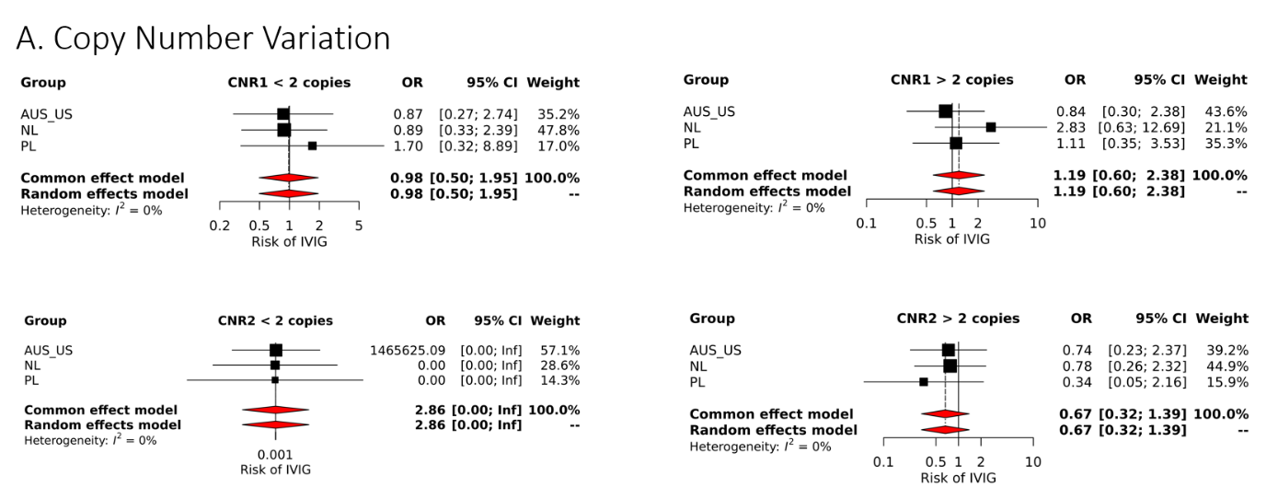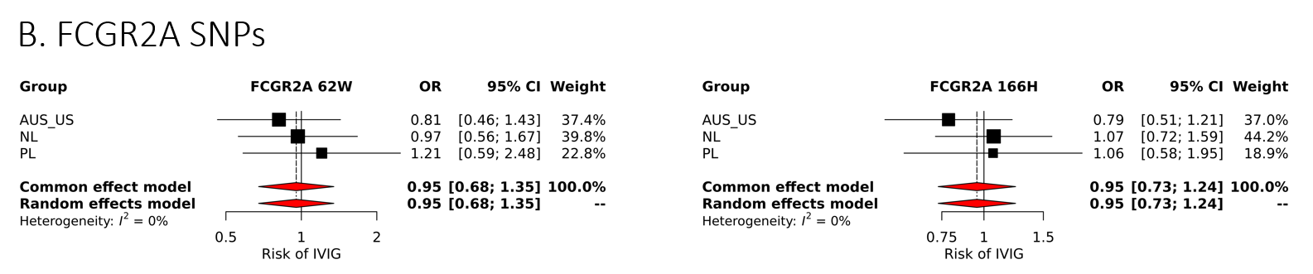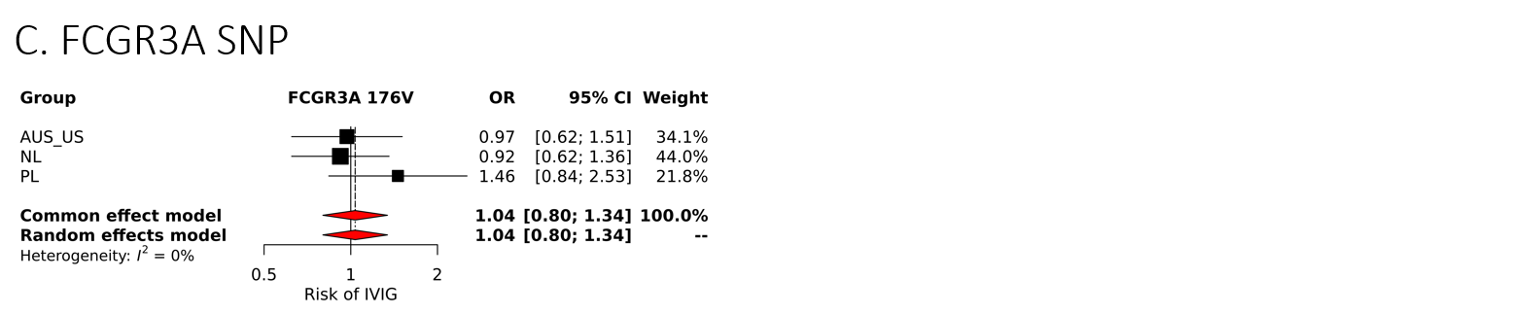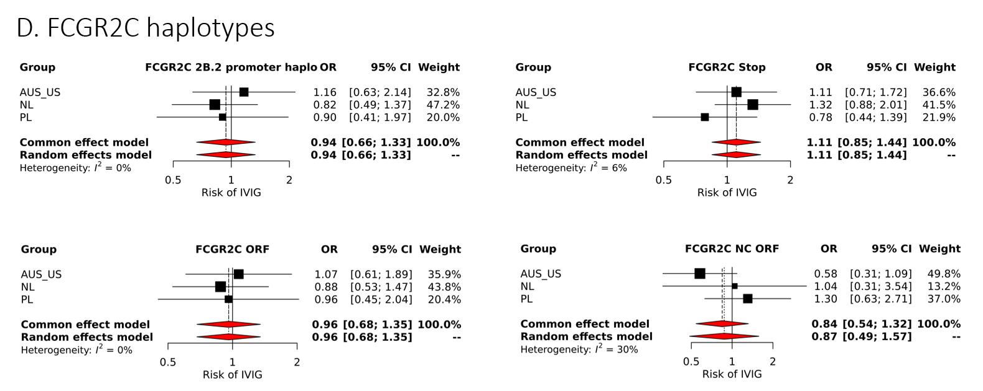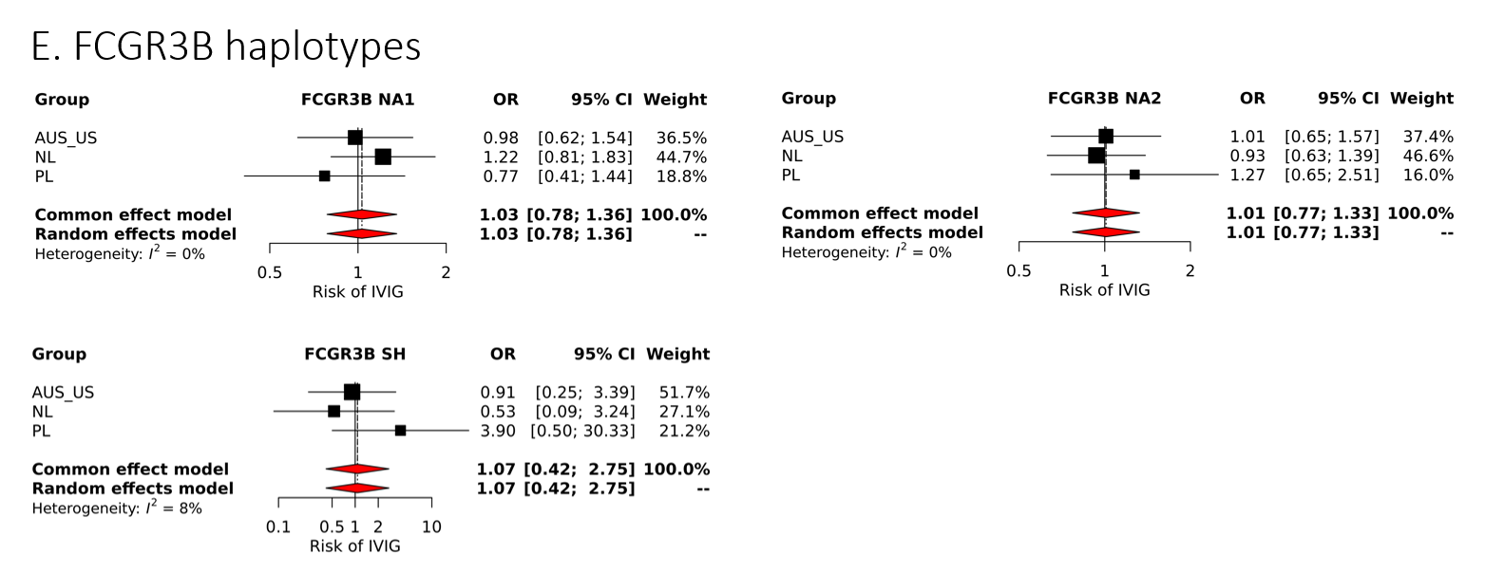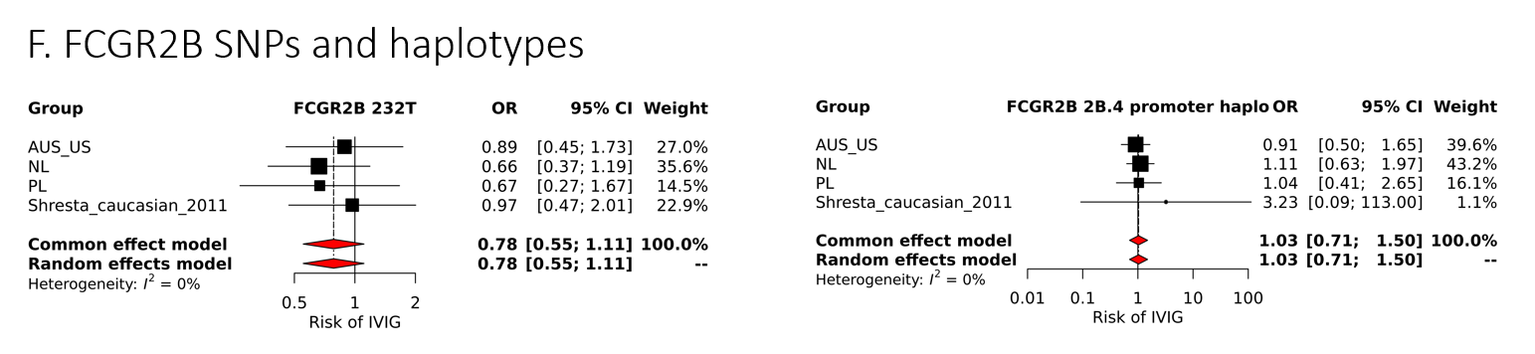
Supplementary Figure 2. Identification of studies for the meta-analysis by systematic literature review
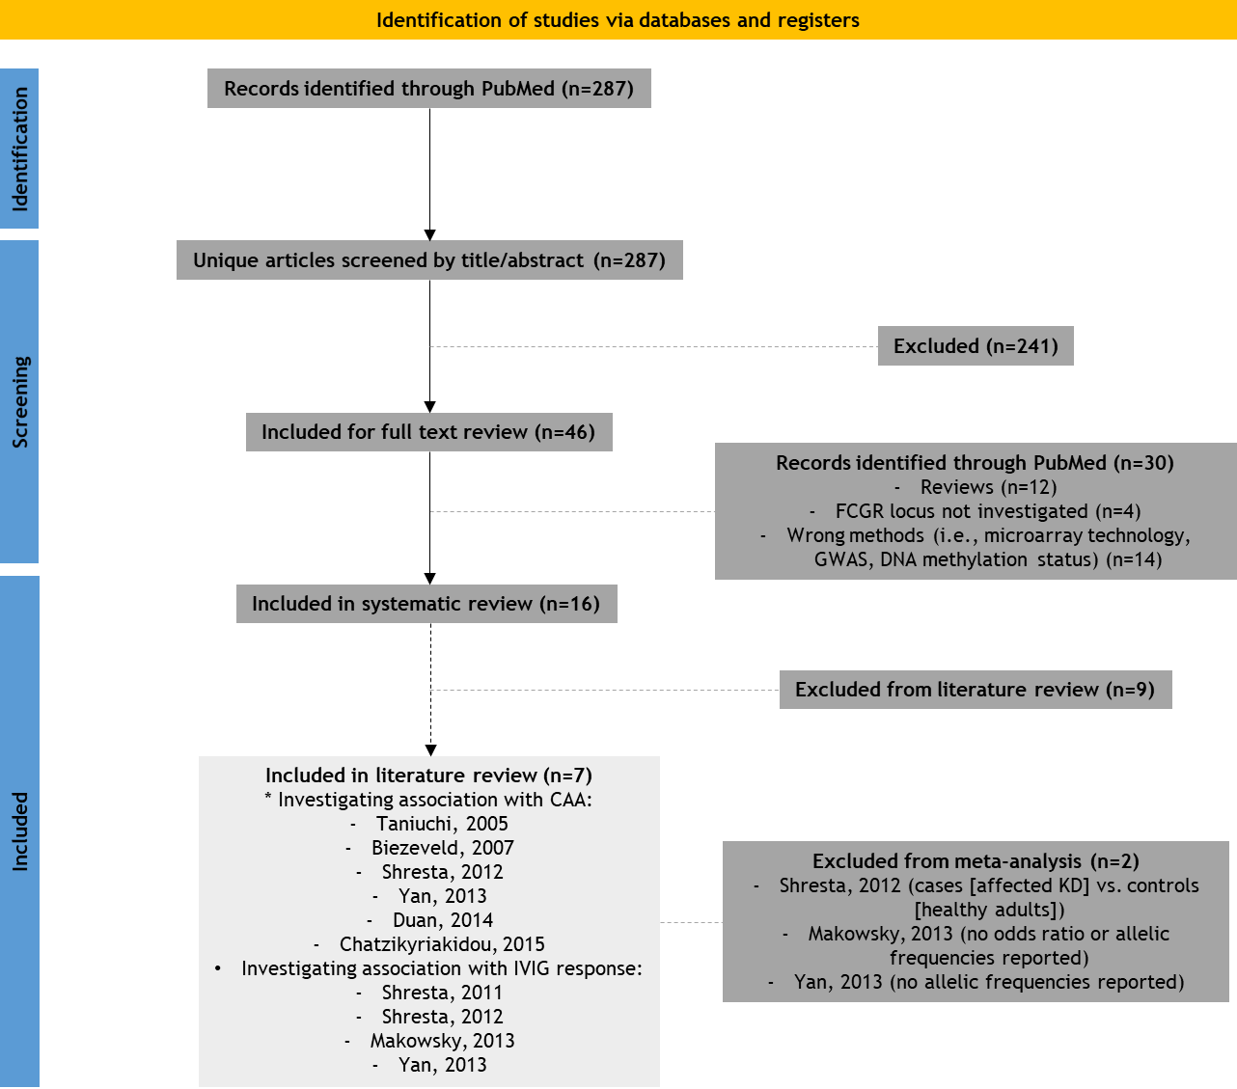

Supplementary Figure 3. Meta-analysis of all tested SNPs and haplotypes for association with CAA. Forest plots showing both the OR for common/fixed effects model and random effects model.
