Supplementary Material

## Supplementary Tables

|  |  |  |  |  |  |  |  |  |  |  |  |  |  |  |
| --- | --- | --- | --- | --- | --- | --- | --- | --- | --- | --- | --- | --- | --- | --- |
| r | dLTWL | dE | dC | deNATL | dN1+2 | dN3 | dN3.4 | dN4 | dtSATL | dtNATL | dAMO | dPDO | dsSATL | dnSATL |
| dLTWL |  | **-0.70** | -0.07 | 0.35 | **-0.88** | **-0.50** | -0.19 | -0.16 | 0.16 | **-0.52** | -0.35 | **-0.64** | -0.04 | -0.22 |
| dE |  |  | -0.39 | -0.09 | **0.91** | 0.33 | -0.12 | -0.30 | 0.27 | **0.47** | **0.40** | 0.29 | **0.40** | **-0.41** |
| dC |  |  |  | 0.28 | -0.10 | **0.67** | **0.91** | **0.98** | **-0.70** | **0.40** | **0.49** | **0.66** | **-0.65** | **0.54** |
| deNATL |  |  |  |  | -0.16 | 0.18 | 0.22 | 0.15 | -0.10 | -0.11 | **0.58** | 0.04 | -0.14 | 0 |
| dN1+2 |  |  |  |  |  | **0.52** | 0.11 | 0 | -0.01 | **0.59** | **0.53** | **0.54** | 0.16 | -0.16 |
| dN3 |  |  |  |  |  |  | **0.89** | **0.75** | **-0.61** | **0.78** | **0.69** | **0.79** | **-0.53** | 0.12 |
| dN3.4 |  |  |  |  |  |  |  | **0.95** | **-0.74** | **0.63** | **0.56** | **0.71** | **-0.70** | 0.31 |
| dN4 |  |  |  |  |  |  |  |  | **-0.73** | **0.51** | **0.47** | **0.71** | **-0.67** | **0.48** |
| dtSATL |  |  |  |  |  |  |  |  |  | **-0.48** | -0.36 | -0.30 | **0.97** | **-0.49** |
| dtNATL |  |  |  |  |  |  |  |  |  |  | **0.63** | **0.53** | -0.36 | -0.17 |
| dAMO |  |  |  |  |  |  |  |  |  |  |  | **0.56** | -0.24 | -0.06 |
| dPDO |  |  |  |  |  |  |  |  |  |  |  |  | -0.16 | 0.37 |
| dsSATL |  |  |  |  |  |  |  |  |  |  |  |  |  | **-0.42** |
| dnSATL |  |  |  |  |  |  |  |  |  |  |  |  |  |  |

**Table S1**. Pearson’s correlation coefficients between the monthly time series of the decadal component in the 12.75-14.08-year band of the water level in Lake Titicaca (dLTWL) and the central ENSO Pacific (dC), eastern ENSO Pacific (dE), extratropical North Atlantic (deNATL), Niño 1+2 (dN1+2), Niño 3 (dN3), Niño 3.4 (dN3.4), Niño 4 (dN4), tropical South Atlantic (dtSATL), tropical North Atlantic (dtNATL), southern South Atlantic (dsSATL), and northern South Atlantic (dnSATL) SST indices. Values that are statistically significant at the 95% level are shown in bold. The analysis is based on the 1921–2018 period.

|  |  |  |  |  |  |  |  |  |  |  |  |  |  |  |
| --- | --- | --- | --- | --- | --- | --- | --- | --- | --- | --- | --- | --- | --- | --- |
| r | iLTWL | iE | iC | ieNATL | In12 | In3 | iN34 | iN4 | itSATL | itNATL | iAMO | iPDO | isSATL | inSATL |
| iLTWL |  | **0.78** | 0.02 | **0.93** | **0.42** | **0.43** | 0.23 | -0.03 | **-0.56** | 0.38 | **0.77** | 0.29 | **-0.55** | **-0.52** |
| iE |  |  | 0.08 | **0.87** | **0.52** | **0.52** | 0.32 | 0.03 | -0.29 | **0.62** | **0.88** | **0.52** | -0.18 | -0.26 |
| iC |  |  |  | -0.10 | 0.20 | **0.78** | **0.89** | **0.94** | **0.62** | 0.31 | 0.32 | **0.83** | -0.38 | **0.62** |
| ieNATL |  |  |  |  | 0.25 | 0.30 | 0.10 | -0.19 | -0.46 | **0.60** | **0.87** | 0.29 | -0.29 | **-0.41** |
| iN12 |  |  |  |  |  | **0.67** | **0.51** | **0.40** | -0.31 | -0.10 | 0.24 | 0.37 | **-0.57** | -0.33 |
| iN3 |  |  |  |  |  |  | **0.96** | **0.85** | 0.28 | **0.44** | **0.59** | **0.90** | **-0.68** | 0.30 |
| iN34 |  |  |  |  |  |  |  | **0.95** | **0.50** | **0.42** | **0.48** | **0.92** | **-0.62** | **0.50** |
| iN4 |  |  |  |  |  |  |  |  | **0.60** | 0.20 | 0.20 | **0.81** | **-0.53** | **0.60** |
| itSATL |  |  |  |  |  |  |  |  |  | **0.41** | 0 | **0.55** | 0.15 | **0.99** |
| itNATL |  |  |  |  |  |  |  |  |  |  | **0.86** | **0.70** | -0.03 | **0.46** |
| iAMO |  |  |  |  |  |  |  |  |  |  |  | **0.70** | -0.28 | 0.05 |
| iPDO |  |  |  |  |  |  |  |  |  |  |  |  | -0.37 | **0.56** |
| isSATL |  |  |  |  |  |  |  |  |  |  |  |  |  | 0.14 |
| inSATL |  |  |  |  |  |  |  |  |  |  |  |  |  |  |

Table S2. Pearson correlation’s coefficients between the monthly time series of the interdecadal component in the 24.83-26.50-year band of the water level in Lake Titicaca (iLTWL) and the central ENSO Pacific (iC), eastern ENSO Pacific (iE), extratropical North Atlantic (ieNATL), Niño 1+2 (iN1+2), Niño 3 (iN3), Niño 3.4 (iN3.4), Niño 4 (iN4), tropical South Atlantic (itSATL), tropical North Atlantic (itNATL), southern South Atlantic (isSATL), and northern South Atlantic (inSATL) SST indices. Values that are statistically significant at the 95% level are shown in bold. The analysis is based on the 1921–2018 period.

|  |  |  |  |  |  |  |  |  |  |  |  |  |  |  |
| --- | --- | --- | --- | --- | --- | --- | --- | --- | --- | --- | --- | --- | --- | --- |
| r | mLTWL | mE | mC | meNATL | mN1+2 | iN3 | iN3+4 | iN4 | itSATL | itNATL | iAMO | iPDO | isSATL | inSATL |
| mLTWL |  | -0.04 | **-0.41** | **-0.77** | 0.19 | **0.68** | **0.69** | 0.21 | 0.21 | **-0.65** | **-0.84** | 0.32 | -0.30 | 0.34 |
| mE |  |  | **-0.50** | -0.38 | **0.92** | **0.65** | **0.47** | **0.66** | 0.38 | -0.36 | -0.24 | **0.90** | **0.81** | 0.20 |
| mC |  |  |  | **0.69** | -0.37 | **-0.68** | **-0.41** | -0.07 | **-0.74** | 0.31 | **0.63** | **-0.62** | **-0.45** | **-0.75** |
| meNATL |  |  |  |  | **-0.53** | **-0.79** | **-0.64** | -0.24 | -0.33 | **0.84** | **0.98** | **-0.66** | -0.31 | -0.38 |
| mN1+2 |  |  |  |  |  | **0.74** | **0.66** | **0.81** | 0.19 | **-0.62** | **-0.41** | **0.92** | **0.64** | 0.03 |
| mN3 |  |  |  |  |  |  | **0.92** | **0.68** | **0.60** | **-0.59** | **-0.72** | **0.90** | 0.29 | **0.57** |
| mN3.4 |  |  |  |  |  |  |  | **0.80** | **0.50** | **-0.51** | **-0.59** | **0.77** | -0.01 | **0.46** |
| mN4 |  |  |  |  |  |  |  |  | 0.24 | -0.34 | -0.15 | **0.75** | 0.15 | 0.07 |
| itSATL |  |  |  |  |  |  |  |  |  | 0.16 | -0.25 | **0.53** | 0.18 | **0.97** |
| itNATL |  |  |  |  |  |  |  |  |  |  | **0.85** | **-0.54** | -0.27 | 0.15 |
| iAMO |  |  |  |  |  |  |  |  |  |  |  | **-0.53** | -0.17 | -0.33 |
| iPDO |  |  |  |  |  |  |  |  |  |  |  |  | **0.62** | **0.40** |
| isSATL |  |  |  |  |  |  |  |  |  |  |  |  |  | 0.05 |
| inSATL |  |  |  |  |  |  |  |  |  |  |  |  |  |  |

Table S3. Pearson’s correlation coefficients between the monthly time series of the multidecadal component in the 30-65-year band of the water level in Lake Titicaca (mLTWL) and the central ENSO Pacific (mC), eastern ENSO Pacific (mE), extratropical North Atlantic (meNATL), Niño 1+2 (mN1+2), Niño 3 (mN3), Niño 3.4 (mN3.4), Niño 4 (mN4), tropical South Atlantic (mtSATL), tropical North Atlantic (mtNATL), southern South Atlantic (msSATL), and northern South Atlantic (mnSATL) SST indices. Values that are statistically significant at the 95% level are shown in bold. The analysis is based on the 1921–2018 period.

## Supplementary Figures

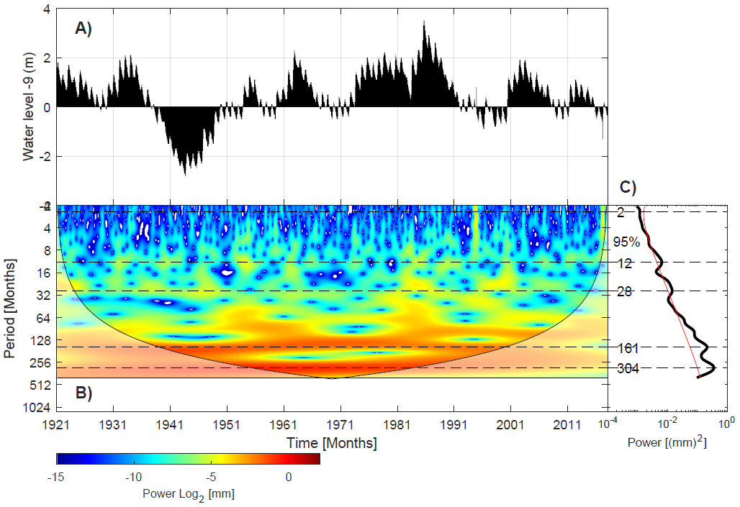

Figure S1. Monthly time series of water level in Lake Titicaca (**a**) and its continuous wavelet power spectrum (**b**). (**c**) Profile of the global power spectrum (in m2) of the detrended time series of the monthly anomalies (in m) of the water level in Lake Titicaca. The numbers indicate periods in months. The red line indicates the 95% confidence interval assuming a red noise model suggested by Torrence and Compo (1998).