# Supporting Information

Figure S 1: Map of the study location where three transects were installed in each of the nine selected forest patches (letters). In each transect, 5 plots were installed to investigate functional changes of the invaded forest understories. Letters correspond to the different forests. Inset represents the United States, with the State of Michigan with black outline and a red dot where the Edwin S. George Reserve is located.

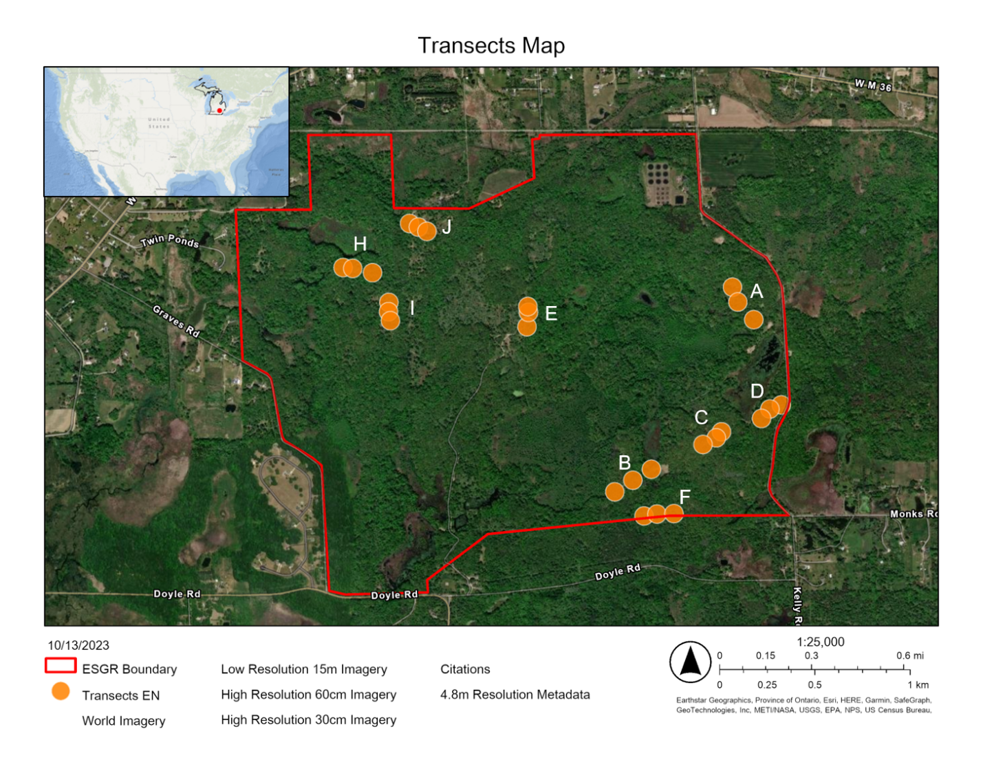

Figure S 2: Diagram of each transect set up. Note that the square sizes are not to scale.

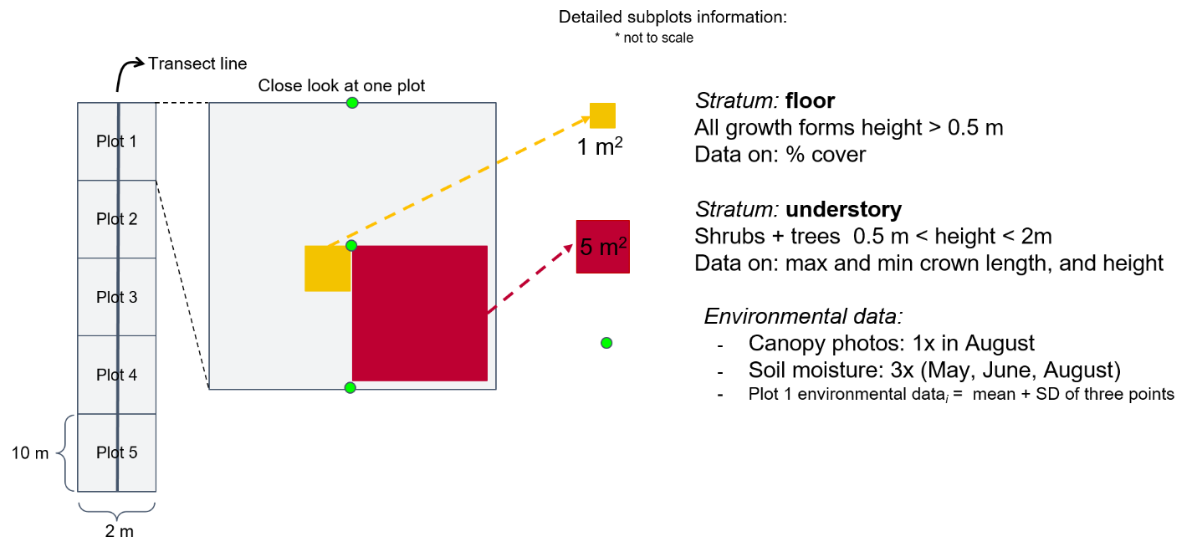

Figure S 3: Model fit. Left panels are model using values for the total community (●) and right panels (▲), for natives only. Leaf N: leaf nitrogen concentration; SLA: specific leaf area; LDMC: leaf dry matter content.

|  |  |
| --- | --- |
| **Leaf N** | |
|  |  |
| **SLA** | |
|  |  |
| **LDMC** | |
|  |  |

Table S 1: List of invasive plant species found in our survey. Growth forms and duration follows USDA PLANTS (USDA and NRCS 2022).

|  |  |  |
| --- | --- | --- |
| Scientific name | Growth Form | Duration |
| *Alliaria petiolata* (M. Bieb.) Cavara & Grande | forb | biennial |
| *Berberis thunbergii* DC. | shrub | perennial |
| *Celastrus orbiculatus* Thunb. | vine | perennial |
| *Cynanchum rossicum* (Kleopow) Borhidi | vine | perennial |
| *Elaeagnus umbellata* Thunb. | shrub | perennial |
| *Frangula alnus* Mill. | shrub | perennial |
| *Leucanthemum vulgare* Lam. | forb | perennial |
| *Lonicera tatarica* L. | shrub | perennial |
| *Rhamnus cathartica* L. | tree | perennial |
| *Robinia pseudoacacia* L. | tree | perennial |
| *Rosa multiflora* Murray | shrub | perennial |
| *Rumex crispus* L. | forb | perennial |
| *Taraxacum officinale* F. H. Wigg. | forb | perennial |
| *Torilis japonica* (Houtt.) DC. | forb | annual |
| *Veronica officinalis* L. | forb | perennial |

Table S 2: Environmental conditions of forests, raked from less invaded to most invaded forest. Soil data was collected by deploying one ion-exchange resin capsule per forest. For details on light availability data collection, refer to Figure S 1 and Main text Methods section.

|  |  |  |  |  |  |  |  |
| --- | --- | --- | --- | --- | --- | --- | --- |
| **Forest** | **Mean % Invasive cover(±SD)** | **Total soil N (ppm)** | **Soil nitrate (ppm)** | **Soil ammonium (ppm)** | **Days resin capsules were deployed** | **Light availability (%±SD)** | **Soil water (%±SD)** |
| B | 2.44 (±3.39) | 10.09 | 2.31 | 7.78 | 61 | 8.79 (±1.22) | 4.85 (±1.55) |
| C | 6.50 (±15.2) | 10.03 | 2.73 | 7.30 | 61 | 10.20 (±0.47) | 7.34 (±5.72) |
| H | 12.30 (±23.7) | 10.21 | 4.00 | 6.21 | 55 | 10.7 (±2.20) | 7.85 (±1.99) |
| J | 41.50 (±40.4) | 8.40 | 3.62 | 4.78 | 55 | 11.5 (±2.32) | 9.39 (±2.33) |
| I | 60.1 (±69.2) | 7.40 | 2.60 | 4.80 | 55 | 11.9 (±2.54) | 10.50 (±1.90) |
| F | 65.38 (±32.8) | 13.10 | 3.71 | 9.39 | 61 | 12.7 (±3.81) | 12.00 (±2.69) |
| E | 84.00 (±26.8) | 17.73 | 2.90 | 14.83 | 61 | 15.8 (±7.12) | 12.60 (±2.16) |
| D | 114.00 (±52.1) | 22.47 | 12.26 | 10.21 | 61 | 17.8 (±8.73) | 13.0 (±3.36) |
| A | 123.00 (±38.1) | 24.63 | 15.8 | 8.83 | 61 | 21.9 (±15.1) | 14.6 (±0.46) |

Table S 3: Model parameter values.

| **Parameter ID** | **Response variable** | **Description** | **Mean** | **SD** | **2.5 % quantile** | **97.5 % quantile** |
| --- | --- | --- | --- | --- | --- | --- |
| A1 | CWM leafN - total community | Intercept forest A | 24.295 | 2.537 | 19.686 | 29.588 |
| A2 | CWM leafN - total community | Intercept forest B | 23.069 | 2.234 | 18.725 | 27.494 |
| A3 | CWM leafN - total community | Intercept forest C | 23.759 | 2.263 | 19.406 | 28.089 |
| A4 | CWM leafN - total community | Intercept forest D | 23.651 | 2.484 | 18.893 | 28.670 |
| A5 | CWM leafN - total community | Intercept forest E | 24.188 | 2.552 | 19.512 | 29.541 |
| A6 | CWM leafN - total community | Intercept forest F | 23.937 | 2.396 | 19.386 | 28.738 |
| A7 | CWM leafN - total community | Intercept forest H | 23.168 | 2.269 | 18.718 | 27.628 |
| A8 | CWM leafN - total community | Intercept forest I | 24.155 | 2.452 | 19.595 | 29.200 |
| A9 | CWM leafN - total community | Intercept forest J | 23.825 | 2.434 | 19.296 | 28.743 |
| AA | CWM leafN - total community | Overall intercept | 23.787 | 2.327 | 19.409 | 28.366 |
| B1 | CWM SLA - total community | Intercept forest A | 18.235 | 2.715 | 12.848 | 23.451 |
| B2 | CWM SLA - total community | Intercept forest B | 16.389 | 2.381 | 11.762 | 20.995 |
| B3 | CWM SLA - total community | Intercept forest C | 16.758 | 2.336 | 12.201 | 21.299 |
| B4 | CWM SLA - total community | Intercept forest D | 19.835 | 3.017 | 13.947 | 25.663 |
| B5 | CWM SLA - total community | Intercept forest E | 17.420 | 2.869 | 11.723 | 23.041 |
| B6 | CWM SLA - total community | Intercept forest F | 20.473 | 2.651 | 15.308 | 25.689 |
| B7 | CWM SLA - total community | Intercept forest H | 22.185 | 2.654 | 17.028 | 27.297 |
| B8 | CWM SLA - total community | Intercept forest I | 16.232 | 2.629 | 11.119 | 21.401 |
| B9 | CWM SLA - total community | Intercept forest J | 16.157 | 2.801 | 10.608 | 21.519 |
| BB | CWM SLA - total community | Overall intercept | 18.175 | 2.664 | 12.950 | 23.291 |
| C1 | CWM LDMC - total community | Intercept forest A | 0.332 | 0.083 | 0.172 | 0.502 |
| C2 | CWM LDMC - total community | Intercept forest B | 0.329 | 0.081 | 0.171 | 0.496 |
| C3 | CWM LDMC - total community | Intercept forest C | 0.330 | 0.081 | 0.175 | 0.497 |
| C4 | CWM LDMC - total community | Intercept forest D | 0.328 | 0.086 | 0.163 | 0.504 |
| C5 | CWM LDMC - total community | Intercept forest E | 0.332 | 0.084 | 0.168 | 0.503 |
| C6 | CWM LDMC - total community | Intercept forest F | 0.331 | 0.083 | 0.174 | 0.502 |
| C7 | CWM LDMC - total community | Intercept forest H | 0.330 | 0.082 | 0.172 | 0.500 |
| C8 | CWM LDMC - total community | Intercept forest I | 0.331 | 0.083 | 0.172 | 0.504 |
| C9 | CWM LDMC - total community | Intercept forest J | 0.336 | 0.085 | 0.173 | 0.515 |
| CC | CWM LDMC - total community | Overall intercept | 0.331 | 0.082 | 0.173 | 0.500 |
| G1 | CWM leafN -natives only | Intercept forest A | 22.196 | 1.694 | 18.911 | 25.551 |
| G2 | CWM leafN -natives only | Intercept forest B | 20.913 | 1.452 | 18.109 | 23.778 |
| G3 | CWM leafN -natives only | Intercept forest C | 22.162 | 1.423 | 19.420 | 24.992 |
| G4 | CWM leafN -natives only | Intercept forest D | 22.515 | 1.768 | 19.096 | 26.116 |
| G5 | CWM leafN -natives only | Intercept forest E | 21.460 | 1.674 | 18.192 | 24.807 |
| G6 | CWM leafN -natives only | Intercept forest F | 24.256 | 1.564 | 21.187 | 27.334 |
| G7 | CWM leafN -natives only | Intercept forest H | 21.021 | 1.536 | 18.023 | 24.083 |
| G8 | CWM leafN -natives only | Intercept forest I | 23.936 | 1.601 | 20.869 | 27.149 |
| G9 | CWM leafN -natives only | Intercept forest J | 24.073 | 1.611 | 20.928 | 27.323 |
| GG | CWM leafN -natives only | Overall intercept | 22.508 | 1.563 | 19.486 | 25.612 |
| H1 | CWM SLA - natives only | Intercept forest A | 20.032 | 3.461 | 13.133 | 26.783 |
| H2 | CWM SLA - natives only | Intercept forest B | 17.505 | 3.061 | 11.512 | 23.425 |
| H3 | CWM SLA - natives only | Intercept forest C | 17.939 | 2.989 | 12.027 | 23.736 |
| H4 | CWM SLA - natives only | Intercept forest D | 20.043 | 3.593 | 13.016 | 27.046 |
| H5 | CWM SLA - natives only | Intercept forest E | 19.064 | 3.401 | 12.417 | 25.657 |
| H6 | CWM SLA - natives only | Intercept forest F | 21.895 | 3.234 | 15.380 | 28.189 |
| H7 | CWM SLA - natives only | Intercept forest H | 21.730 | 3.304 | 15.301 | 28.146 |
| H8 | CWM SLA - natives only | Intercept forest I | 17.163 | 3.278 | 10.640 | 23.476 |
| H9 | CWM SLA - natives only | Intercept forest J | 17.610 | 3.279 | 11.252 | 23.867 |
| HH | CWM SLA - natives only | Overall intercept | 19.213 | 3.173 | 12.989 | 25.298 |
| I1 | CWM LDMC - natives only | Intercept forest A | 0.357 | 0.080 | 0.198 | 0.513 |
| I2 | CWM LDMC - natives only | Intercept forest B | 0.355 | 0.078 | 0.199 | 0.504 |
| I3 | CWM LDMC - natives only | Intercept forest C | 0.357 | 0.077 | 0.205 | 0.506 |
| I4 | CWM LDMC - natives only | Intercept forest D | 0.358 | 0.081 | 0.195 | 0.515 |
| I5 | CWM LDMC - natives only | Intercept forest E | 0.357 | 0.079 | 0.201 | 0.511 |
| I6 | CWM LDMC - natives only | Intercept forest F | 0.360 | 0.078 | 0.206 | 0.515 |
| I7 | CWM LDMC - natives only | Intercept forest H | 0.357 | 0.078 | 0.203 | 0.510 |
| I8 | CWM LDMC - natives only | Intercept forest I | 0.356 | 0.079 | 0.199 | 0.508 |
| I9 | CWM LDMC - natives only | Intercept forest J | 0.364 | 0.080 | 0.207 | 0.520 |
| II | CWM LDMC - natives only | Overall intercept | 0.358 | 0.078 | 0.203 | 0.507 |
| ΣN[1,1] | Natives only | Leaf N - Leaf N | 0.313 | 0.050 | 0.225 | 0.417 |
| ΣN[2,1] | Natives only | SLA - Leaf N | -0.046 | 0.018 | -0.082 | -0.013 |
| ΣN[3,1] | Natives only | LDMC - Leaf N | 0.233 | 0.556 | -0.852 | 1.313 |
| ΣN[2,2] | Natives only | SLA - SLA | 0.072 | 0.012 | 0.050 | 0.096 |
| ΣN[3,2] | Natives only | LDMC - SLA | 0.358 | 0.263 | -0.143 | 0.888 |
| ΣN[3,3] | Natives only | LDMC - LDMC | 81.514 | 12.064 | 59.461 | 106.329 |
| ΣT[1,1] | Total community | Leaf N - Leaf N | 0.125 | 0.020 | 0.089 | 0.168 |
| ΣT[2,1] | Total community | SLA - Leaf N | -0.038 | 0.015 | -0.070 | -0.009 |
| ΣT[3,1] | Total community | LDMC - Leaf N | -0.020 | 0.351 | -0.710 | 0.671 |
| ΣT[2,2] | Total community | SLA - SLA | 0.134 | 0.022 | 0.095 | 0.179 |
| ΣT[3,2] | Total community | LDMC - SLA | 0.415 | 0.366 | -0.295 | 1.137 |
| ΣT[3,3] | Total community | LDMC - LDMC | 83.621 | 12.880 | 60.732 | 110.433 |
| diffNleafN | CWM leafN -natives only | Difference predicted slope | -0.252 | 2.899 | -5.882 | 5.527 |
| diffNSLA | CWM SLA - natives only | Difference predicted slope | 3.076 | 6.119 | -9.018 | 14.981 |
| diffNLDMC | CWM LDMC - natives only | Difference predicted slope | -0.020 | 0.169 | -0.355 | 0.312 |
| diffTleafN | CWM leafN - total community | Difference predicted slope | 10.900 | 4.589 | 2.083 | 19.976 |
| diffTSLA | CWM SLA - total community | Difference predicted slope | 5.791 | 4.506 | -3.103 | 14.643 |
| diffTLDMC | CWM LDMC - total community | Difference predicted slope | -0.010 | 0.166 | -0.336 | 0.312 |
| α1 | CWM leafN - total community | Invasive cover | 0.059 | 0.008 | 0.041 | 0.073 |
| α2 | CWM leafN - total community | Native richness | -0.211 | 0.089 | -0.382 | -0.035 |
| α3 | CWM leafN - total community | Evenness total community | -1.211 | 2.567 | -6.253 | 3.804 |
| α4 | CWM leafN - total community | Light | -0.028 | 0.046 | -0.118 | 0.061 |
| α5 | CWM leafN - total community | Soil water | 0.145 | 0.086 | -0.024 | 0.316 |
| β1 | CWM SLA - total community | Invasive cover | 0.031 | 0.009 | 0.014 | 0.048 |
| β2 | CWM SLA - total community | Native richness | 0.049 | 0.093 | -0.130 | 0.228 |
| β3 | CWM SLA - total community | Evenness total community | 4.405 | 2.626 | -0.623 | 9.644 |
| β4 | CWM SLA - total community | Light | -0.066 | 0.046 | -0.155 | 0.027 |
| β5 | CWM SLA - total community | Soil water | 0.230 | 0.093 | 0.049 | 0.412 |
| γ1 | CWM LDMC - total community | Invasive cover | 0.000 | 0.000 | -0.001 | 0.000 |
| γ2 | CWM LDMC - total community | Native richness | 0.000 | 0.003 | -0.007 | 0.006 |
| γ3 | CWM LDMC - total community | Evenness total community | -0.045 | 0.094 | -0.231 | 0.137 |
| γ4 | CWM LDMC - total community | Light | 0.001 | 0.002 | -0.003 | 0.004 |
| γ5 | CWM LDMC - total community | Soil water | -0.001 | 0.003 | -0.007 | 0.006 |
| ζ1 | CWM leafN -natives only | Invasive cover | -0.001 | 0.005 | -0.012 | 0.010 |
| ζ2 | CWM leafN -natives only | Native richness | -0.166 | 0.061 | -0.283 | -0.047 |
| ζ3 | CWM leafN -natives only | Evenness total community | 1.752 | 1.615 | -1.515 | 4.895 |
| ζ4 | CWM leafN -natives only | Light | -0.039 | 0.030 | -0.098 | 0.022 |
| ζ5 | CWM leafN -natives only | Soil water | -0.021 | 0.060 | -0.140 | 0.094 |
| η1 | CWM SLA - natives only | Invasive cover | 0.017 | 0.011 | -0.005 | 0.038 |
| η2 | CWM SLA - natives only | Native richness | 0.023 | 0.124 | -0.215 | 0.266 |
| η3 | CWM SLA - natives only | Evenness total community | 3.310 | 3.351 | -3.294 | 9.768 |
| η4 | CWM SLA - natives only | Light | -0.097 | 0.064 | -0.225 | 0.029 |
| η5 | CWM SLA - natives only | Soil water | 0.281 | 0.124 | 0.034 | 0.520 |
| θ1 | CWM LDMC - natives only | Invasive cover | 0.000 | 0.000 | -0.001 | 0.000 |
| θ2 | CWM LDMC - natives only | Native richness | 0.001 | 0.003 | -0.006 | 0.007 |
| θ3 | CWM LDMC - natives only | Evenness total community | -0.087 | 0.090 | -0.261 | 0.091 |
| θ4 | CWM LDMC - natives only | Light | 0.001 | 0.002 | -0.003 | 0.004 |
| θ5 | CWM LDMC - natives only | Soil water | -0.001 | 0.003 | -0.008 | 0.005 |
| 1/ ${}_{A}^{2}$ | CWM leafN - total community | Overall intercept | 640.645 | 2454.900 | 0.171 | 6831.499 |
| 1/ ${}_{B}^{2}$ | CWM SLA - total community | Overall intercept | 0.222 | 0.980 | 0.042 | 0.603 |
| 1/ ${}_{C}^{2}$ | CWM LDMC - total community | Overall intercept | 6306.893 | 6463.423 | 518.543 | 24253.369 |
| 1/ ${}_{G}^{2}$ | CWM leafN -natives only | Overall intercept | 0.525 | 0.352 | 0.114 | 1.411 |
| 1/ ${}_{H}^{2}$ | CWM SLA - natives only | Overall intercept | 31.847 | 456.641 | 0.042 | 7.842 |
| 1/ ${}_{I}^{2}$ | CWM LDMC - natives only | Overall intercept | 6055.506 | 6387.304 | 516.375 | 23968.419 |