**Supporting Information for**

**Water sources of the Lombok, Ombai and Timor outflows of the Indonesian Throughflow**

Yaru Guo1\*, Yuanlong Li1,2, Dezhou Yang1,2, Yuxuan Li1, Fan Wang1,2\*,and Guandong Gao1,2

1CAS Key Laboratory of Ocean Circulation and Waves, Institute of Oceanology, Chinese Academy of Sciences, Qingdao, China

2 Laoshan Laboratory, Qingdao, China

\*Author to whom any correspondence should be addressed.

1. **mail:** [yaruguo@qdio.ac.cn](mailto:bsyin@qdio.ac.cn); [fwang@qdio.ac.cn](mailto:fwang@qdio.ac.cn)

This file contains:

supplementary Figure S1;

supplementary Figure S2;

supplementary Figure S3;

supplementary Figure S4;

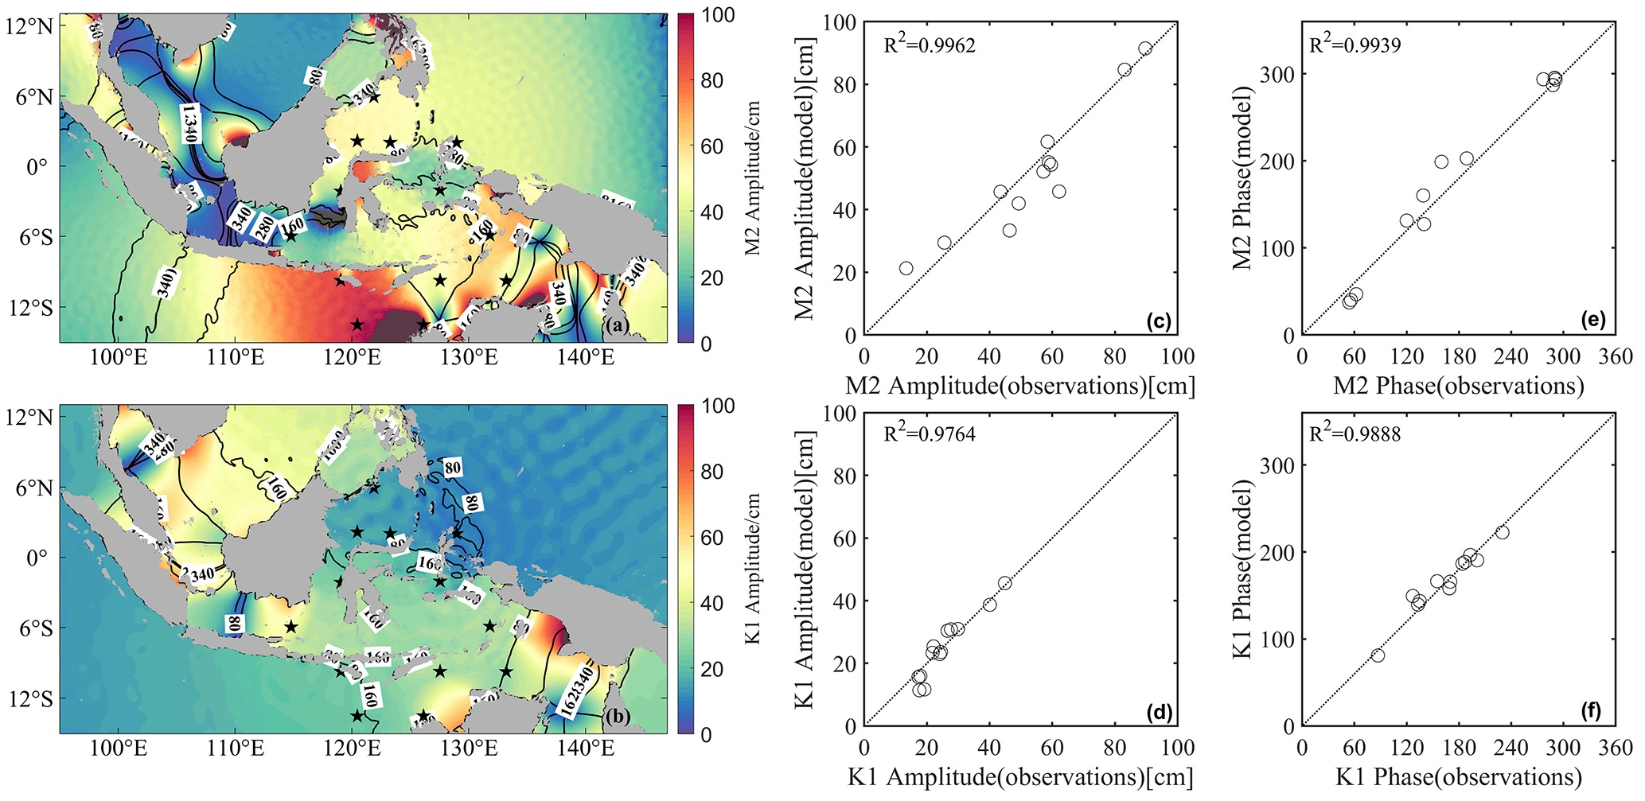

FIGURE S1. Climatology amplitude (cm) and phase (o) for the tidal constituents (a) M2 and (b) K1, derived from Regional Ocean Modeling System (ROMS) simulation. The black pentagram denotes the observed position of the TOPEX/POSEIDON (T/P) crossover data from Robertson and Ffield (2008), in which the observed (c) amplitude and (e) phase of the tidal constituent M2 are employed to validate ROMS simulation. R denotes their correlation coefficient. (d) and (f) Same as (c) and (e), but for the constituent K1.

AVS季节循环_LombokOmbaiTimor

FIGURE S2. Monthly climatology of along-strait velocity of the (a) Lombok Strait (LS; 115.9oE, 8.4oS), (b) Ombai Strait (OS; 125.0oE, 8.5oS), and (c) Timor Passage (TP; 123.0oE, 11.4oS), derived from the overlapping depth of INSTANT moorings during 2004-2006 (green line) and the ~3 km ROMS (red line).

ROMS_INSTANT_Makassar

FIGURE S3. Monthly climatology of the vertical velocity profile along the Makassar Strait (118.46oE, 2.86oS) derived from the (a) INSTANT mooring and (b) ROMS.

FigureS7_MakLif2Timor_Top100_Below700_differeDepthdiffereColor

FIGURE S4. The slowest 10 trajectories of the Makassar Strait water to (a) the top 100 m and (b) below 700 m of the TP, derived from ROMS. Different colors represent different depth levels. (c) and (d) are the same as (a) and (b) but for the Lifamatola Passage water.