Rising awareness to improve conservation of microorganisms in terrestrial ecosystems: advances and future directions in soil microbial diversity from Chile and the Antarctic Peninsula

Céline Lavergne, Léa Cabrol, Sara Cuadros-Orellana, Carolina Quinteros, Alexandra Stoll, Carolina Yáñez, Joseline Tapia, Julieta Orlando, Claudia Rojas

Figure S1. Research scopes in microbial soil diversity studies. Categories and subcategories of study focus reported from the generated dataset.

Table S1. List of the packages used in R and corresponding references. Note that complete details of every reference are available at the end of this document.

Package | Citation
bibtex | Francois & Hernangómez (2023)
readxl | Wickham & Bryan (2023)
ggplot2 | Wickham (2016)
ggpubr | Kassambara (2023)
plyr | Wickham (2011)
dplyr | Wickham, François, et al. (2023)
hrbrthemes | Rudis (2020)
tidyverse | Wickham et al. (2019)
ggfittext | Wilkins (2023)
treemapify | Wilkins (2021)
reshape2 | Wickham (2007)
purrrlyr | Henry (2022)
ggpmisc | Aphalo (2023)
tidyr | Wickham, Vaughan, et al. (2023)
vistime | Raabe (2022)
reticulate | Ushey et al. (2023)
ggalluvial | Brunson (2020); Brunson & Read (2023)
RColorBrewer | Neuwirth (2022)
gplots | Warnes et al. (2022)
wesanderson | Ram & Wickham (2018)

Bibliometric analysis
The selected studies were published in a wide range of international scientific journals (Fig. 2 of the main manuscript). A total of 149 journals were retrieved, including international or national editorials. The main scientific journals used for publication are Journal of Soil Science and Plant Nutrition (n = 22), International Journal of Systematic and Evolutionary Microbiology (n = 16), Frontiers in Microbiology (n = 15), Polar Biology (n = 13), Soil Biology & Biochemistry (n = 12), MDPI Microorganisms (n = 11), FEMS Microbiology Ecology (n = 11) and Antonie van Leeuwenhoek (n = 11). The impact factor of these main journals (at the time of writing) ranged between 1.9 and 6.1 (4.0 on average). Even if the impact factor metrics should be interpreted cautiously and rises concerns in the scientific community (Casadevall et al., 2016), it demonstrates that soil microbial diversity studies from Chile are published in good quality international, peer-reviewed journals.

Involvement of authors affiliated to Chilean institutions
The proportion of studies involving at least one author affiliated to a Chilean institution showed differences across macrozones and no tendency with time (Fig. S2 and S3). The Northern and Southern territories, followed by the Central and Central-South zones of Chile concentrated 90% of the studies on average. Generally, more than 50% of the studies included at least one author affiliated to a Chilean institution per year. More than 30% of the soil microbial diversity studies in Northern Chile (Arica and Parinacota, Tarapacá, Antofagasta, and Atacama administrative regions) did not involve any Chilean institution, highlighting a very strong international interest in the Atacama Desert as an analog for the search for life on Mars and a lack of local collaborations. Up to 72% of the studies in the Antarctic Peninsula did not include Chilean partners, which can be explained by the international status of this area according to the Antarctic Treaty, where research stations operated by different countries coexist.

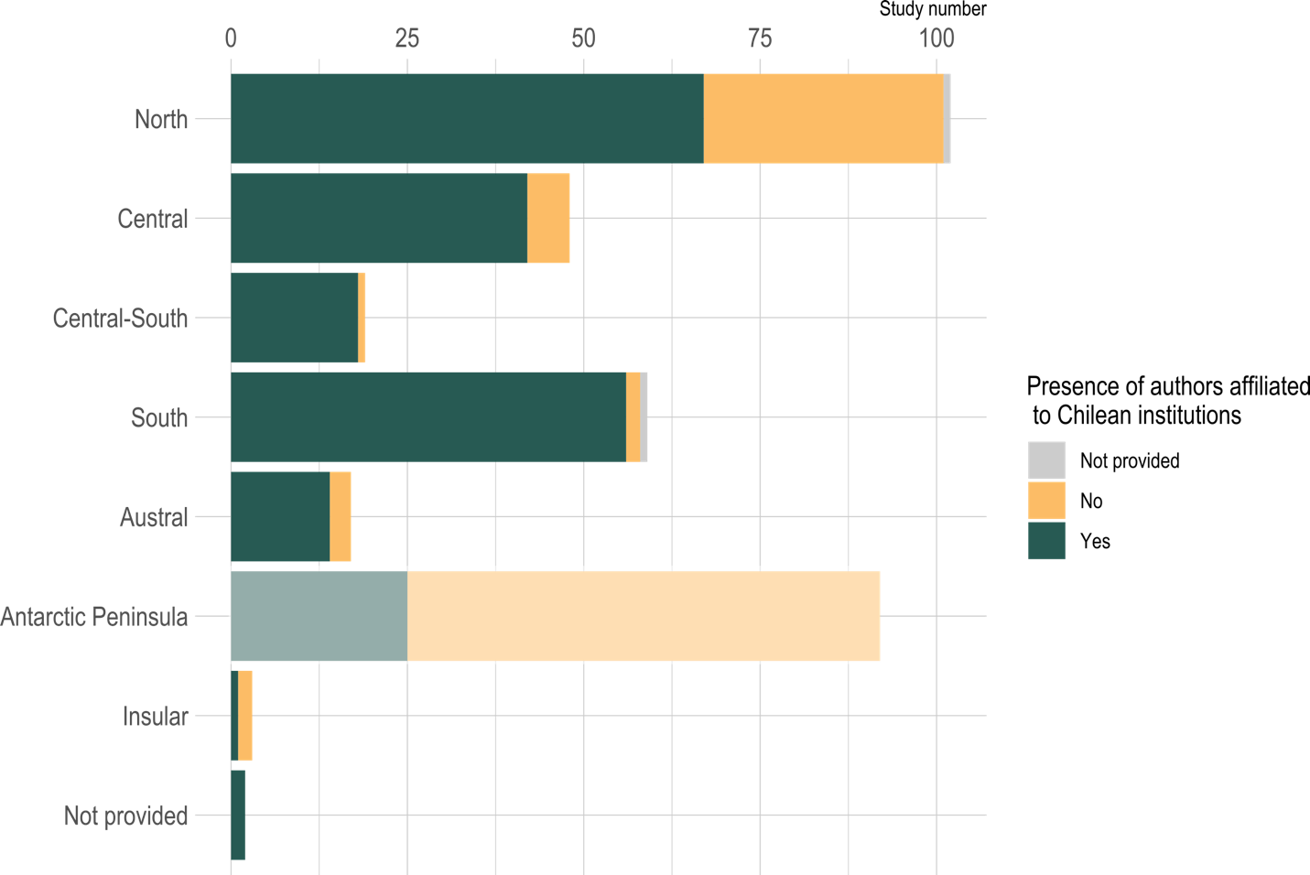

Figure S2. Affiliation of authors contributing to studies on soil microbial biodiversity per macrozone. The number of studies including at least one author affiliated to a Chilean institution in the author list per macrozone or not listing national affiliation is shown. The Antarctic Peninsula is shaded as it is an international territory.

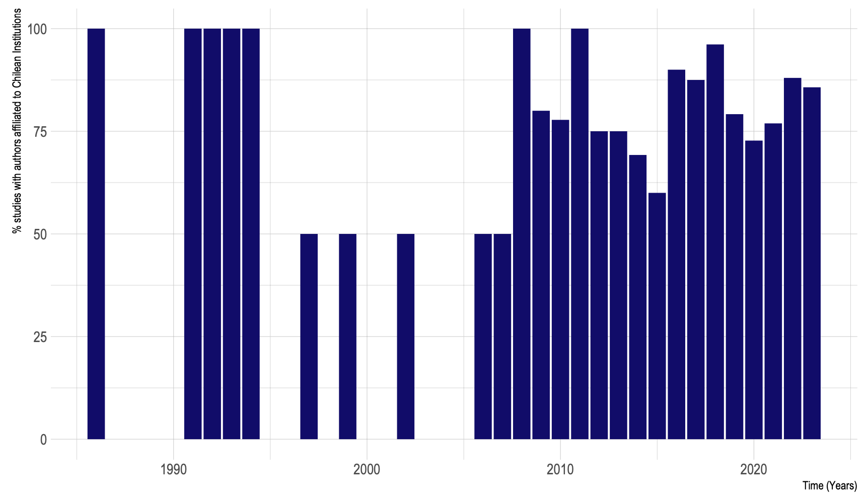
Figure S3. Percentage of studies with incorporation of authors affiliated to Chilean institutions per year. The number of studies including or not at least one author affiliated to a Chilean institution in the author list per year. The Antarctic Peninsula was not considered as it is an international territory.

References cited in the supplementary material
Aphalo, P. J. (2023). ggpmisc: Miscellaneous Extensions to “ggplot2.” https://CRAN.R-project.org/package=ggpmisc
Brunson, J. C. (2020). ggalluvial: Layered Grammar for Alluvial Plots. Journal of Open Source Software, 5(49), 2017. https://doi.org/10.21105/joss.02017
Brunson, J. C., & Read, Q. D. (2023). ggalluvial: Alluvial Plots in “ggplot2.” http://corybrunson.github.io/ggalluvial/
Casadevall, A., Bertuzzi, S., Buchmeier, M. J., Davis, R. J., Drake, H., Fang, F., Gilbert, J., Goldman, B., Imperiale, M., Matsumura, P., McAdam, A., Pasetti, M., Sandri-Goldin, R., Silhavy, T., Rice, L., Young, J.-A., & Shenk, T. (2016). ASM Journals Eliminate Impact Factor Information from Journal Websites. Applied and Environmental Microbiology, 82(18), 5479–5480. https://doi.org/10.1128/AEM.01986-16
Francois, R., & Hernangómez, D. (2023). bibtex: Bibtex Parser. https://CRAN.R-project.org/package=bibtex
Henry, L. (2022). purrrlyr: Tools at the Intersection of “purrr” and “dplyr.” https://CRAN.R-project.org/package=purrrlyr
Kassambara, A. (2023). ggpubr: “ggplot2” Based Publication Ready Plots. https://CRAN.R-project.org/package=ggpubr
Neuwirth, E. (2022). RColorBrewer: ColorBrewer Palettes. https://CRAN.R-project.org/package=RColorBrewer
Raabe, S. (2022). vistime: Pretty Timelines in R. https://CRAN.R-project.org/package=vistime
Ram, K., & Wickham, H. (2018). wesanderson: A Wes Anderson Palette Generator. https://CRAN.R-project.org/package=wesanderson
Rudis, B. (2020). hrbrthemes: Additional Themes, Theme Components and Utilities for “ggplot2.” https://CRAN.R-project.org/package=hrbrthemes
Ushey, K., Allaire, J. J., & Tang, Y. (2023). reticulate: Interface to “Python.” https://CRAN.R-project.org/package=reticulate
Warnes, G. R., Bolker, B., Bonebakker, L., Gentleman, R., Huber, W., Liaw, A., Lumley, T., Maechler, M., Magnusson, A., Moeller, S., Schwartz, M., & Venables, B. (2022). gplots: Various R Programming Tools for Plotting Data. https://CRAN.R-project.org/package=gplots
Wickham, H. (2007). Reshaping Data with the reshape Package. Journal of Statistical Software, 21(12), 1–20. http://www.jstatsoft.org/v21/i12/
Wickham, H. (2011). The Split-Apply-Combine Strategy for Data Analysis. Journal of Statistical Software, 40(1), 1–29. https://www.jstatsoft.org/v40/i01/
Wickham, H. (2016). ggplot2: Elegant Graphics for Data Analysis. Springer-Verlag New York. https://ggplot2.tidyverse.org
Wickham, H., Averick, M., Bryan, J., Chang, W., McGowan, L. D., François, R., Grolemund, G., Hayes, A., Henry, L., Hester, J., Kuhn, M., Pedersen, T. L., Miller, E., Bache, S. M., Müller, K., Ooms, J., Robinson, D., Seidel, D. P., Spinu, V., … Yutani, H. (2019). Welcome to the tidyverse. Journal of Open Source Software, 4(43), 1686. https://doi.org/10.21105/joss.01686
Wickham, H., & Bryan, J. (2023). readxl: Read Excel Files. https://CRAN.R-project.org/package=readxl
Wickham, H., François, R., Henry, L., Müller, K., & Vaughan, D. (2023). dplyr: A Grammar of Data Manipulation. https://CRAN.R-project.org/package=dplyr
Wickham, H., Vaughan, D., & Girlich, M. (2023). tidyr: Tidy Messy Data. https://CRAN.R-project.org/package=tidyr
Wilkins, D. (2021). treemapify: Draw Treemaps in “ggplot2.” https://CRAN.R-project.org/package=treemapify
Wilkins, D. (2023). ggfittext: Fit Text Inside a Box in “ggplot2.” https://CRAN.R-project.org/package=ggfittext

