Supplementary Material

**Vegetation Cover Change and its Response to Human Activities in the Southwestern Karst Region of China**

**Zhaopu Liua,** **Yushan Zhanga \***

**\* Correspondence:** Yushan Zhang; E-mail address: [zys332400@163.com](mailto:zys332400@163.com)

## Supplementary Figures

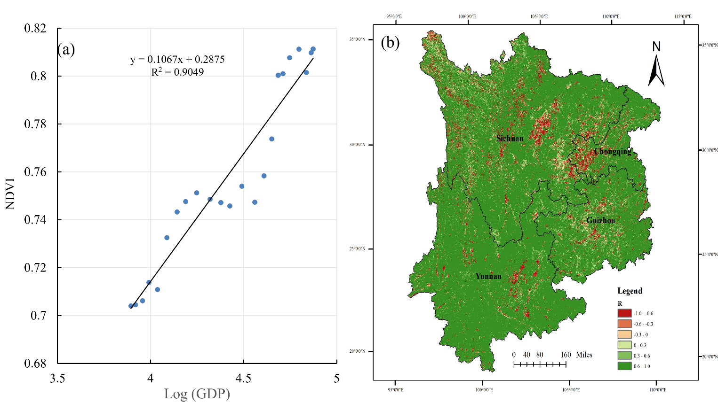

Fig. S1. Correlation between GDP changes and NDVI in the Southwest Karst Region.

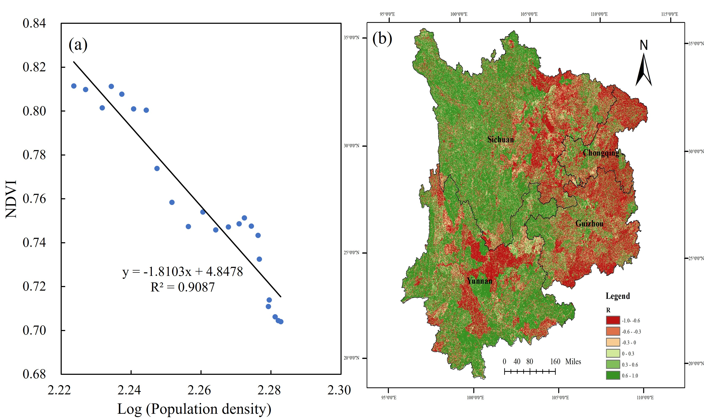

Fig.S2. Correlation between population changes and NDVI in the Southwest Karst Region.

Fig.S3. Yearly changes in labor force migration and NDVI in Southwest Karst Region.

Fig.S4. Correlation between labor migration and NDVI.

Fig.S5. Correlation between urbanization rate and NDVI in the Southwest Karst Region.

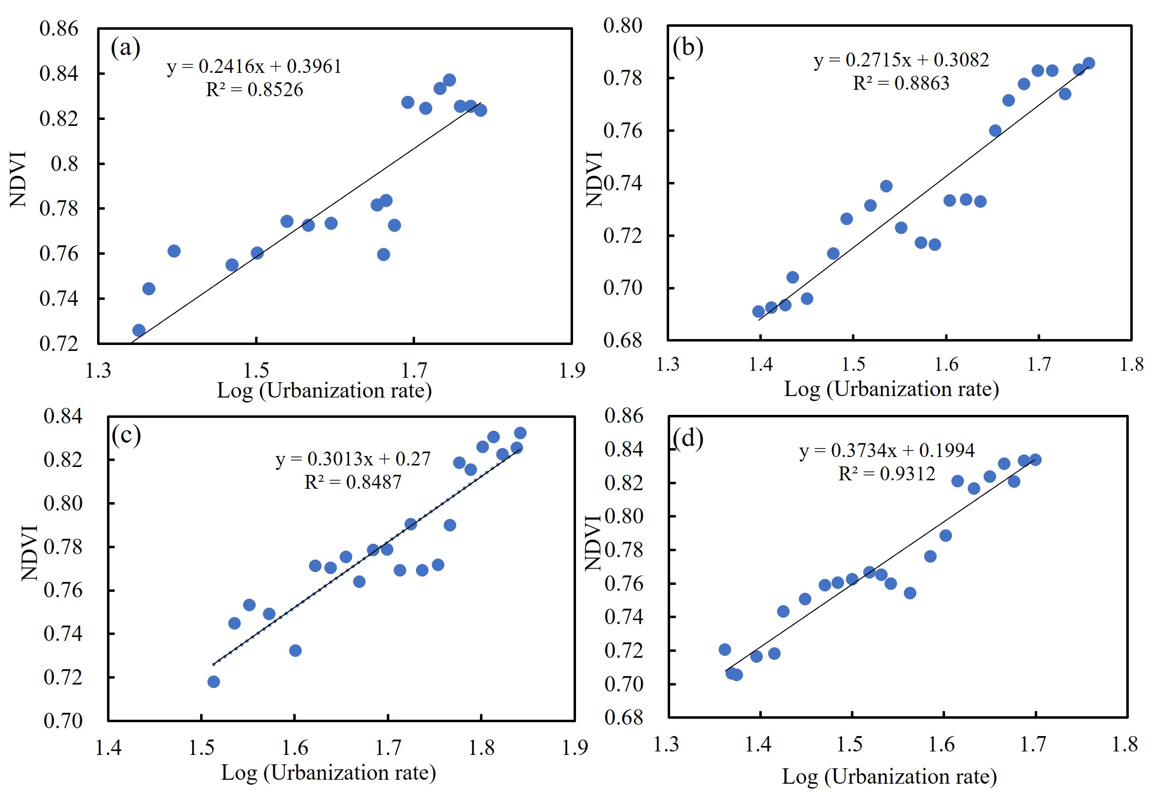

Fig.S6. Correlation between urbanization rate and NDVI in Guizhou (a), Sichuan (b), Yunnan (c), and Chongqing (d).

Fig.S7. Annual changes in afforested area and NDVI in the Southwest Karst Region.

Fig.S8. Correlation between afforestation area and NDVI in the Southwest Karst Region.