Supplementary Material

Evaluation of the combination effect of zoledronate and chemotherapeutic agents in canine osteosarcoma cells
Yoshimi Iwaki*, Stephanie E.S. Lindley, Noelle Bergman, Bruce F. Smith, Satyanarayana R. Pondugula
* Correspondence: Yoshimi Iwaki: yiktb@missouri.edu
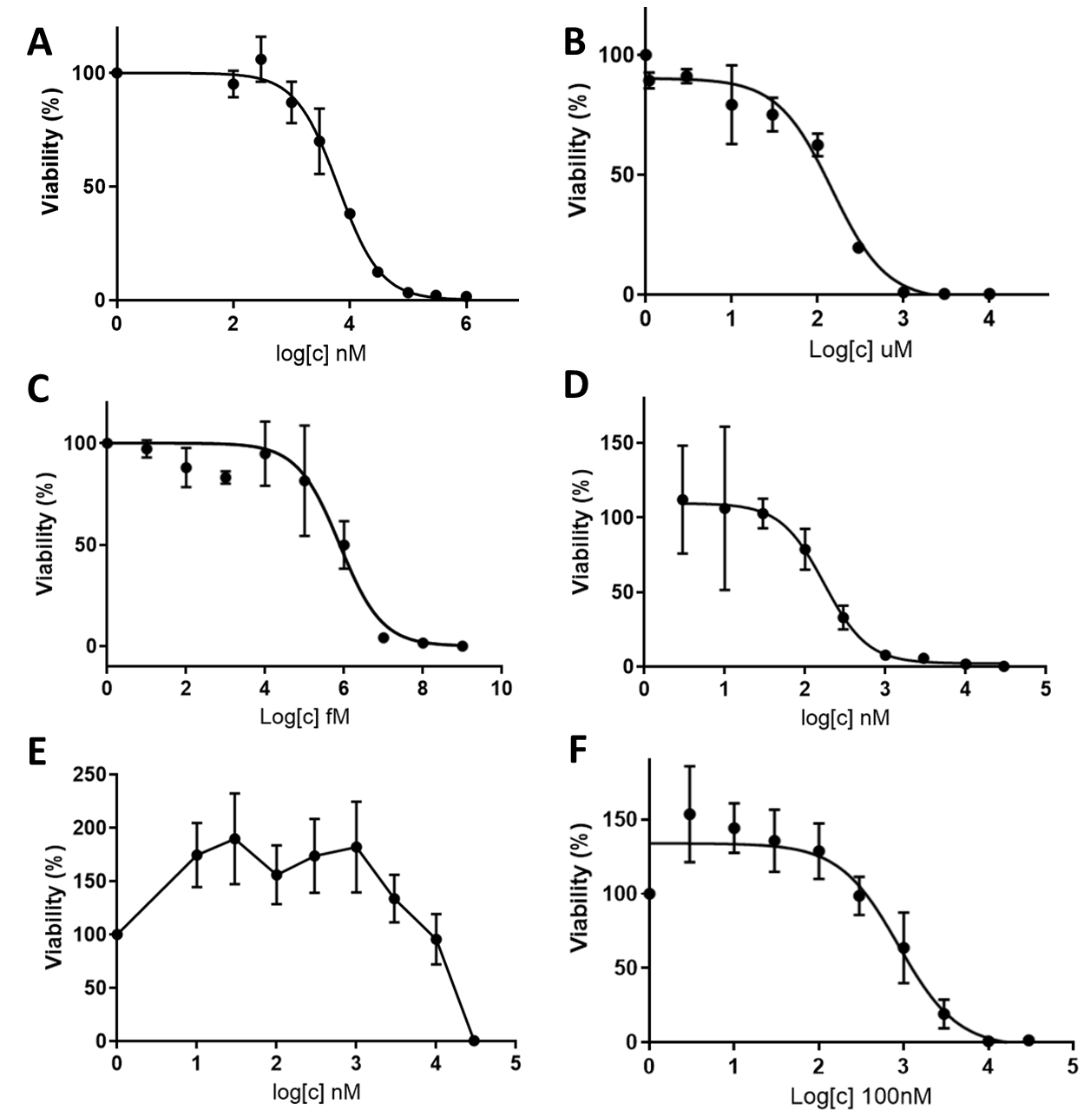
Supplementary Figure 1. Cell viability curve of D17 cells incubated with (A) zoledronate, (B) carboplatin, (C) vinorelbine, (D) doxorubicin, (E) toceranib, and (F) isophosphoramide mustard. Data expressed as mean +/- SD.

Supplementary Table 1. IC₅₋₅₀ in D17 cell
 | IC5 | IC10 | IC20 | IC50
Zoledronate | 547.5 nM | 1.00 uM | 1.95 uM | 6.04 uM
Carboplatin | 4.66 uM | 10.08 uM | 23.24 uM | 96.95 uM
Doxorubicin | 60.29 nM | 83.12 nM | 117.8 nM | 207.6 nM
Vinorelbine | 13.51 pM | 39.86 pM | 128.9 pM | 1.09 nM
Isophosphoramide | 34.2 uM | 48.7 uM | 71.4 uM | 86.9 uM

Supplementary Figure 2. Cell viability curve of primary osteosarcoma cell-1 (Ronald), incubated with (A) zoledronate, (B) carboplatin, (C) vinorelbine, (D) doxorubicin, (E) toceranib, and (F) isophosphoramide mustard. Data expressed as mean +/- SD.
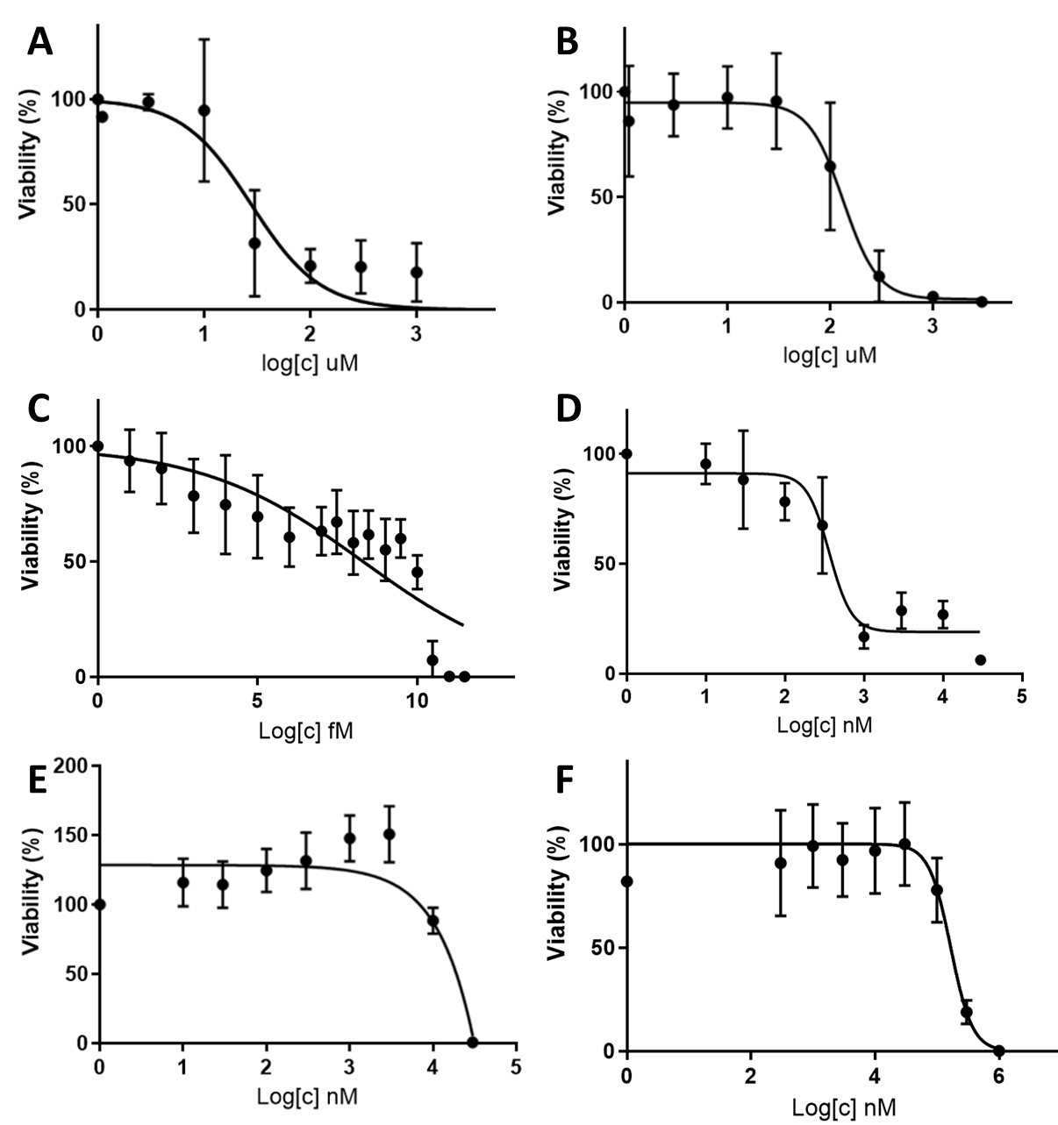

Supplementary Table 2. IC₅-₅₀ in primary osteosarcoma cell-1 (Ronald)
 | IC5 | IC10 | IC20 | IC50
Zoledronate | 3.07 uM | 5.37 uM | 9.86 uM | 27.8 uM
Carboplatin | 35.08 uM | 48.84 uM | 69.92 uM | 129.2 uM
Doxorubicin | 10.43 nM | 26.22 nM | 71.33 nM | 394.9 nM
Vinorelbine | 7.76 fM | 589.7 fM | 64.8 pM | 199.9 nM
Toceranib | 8.82 uM | 9.77 uM | 10.92 uM | X
Isophosphoramide | 50.9 uM | 68.8 uM | 95.2 uM | 166.0 uM

Supplementary Figure 3. Cell viability curve of primary osteosarcoma cell-2 (Walter), incubated with (A) zoledronate, (B) carboplatin, (C) vinorelbine, (D) doxorubicin, (E) toceranib, and (F) isophosphoramide mustard. Data expressed as mean +/- SD.
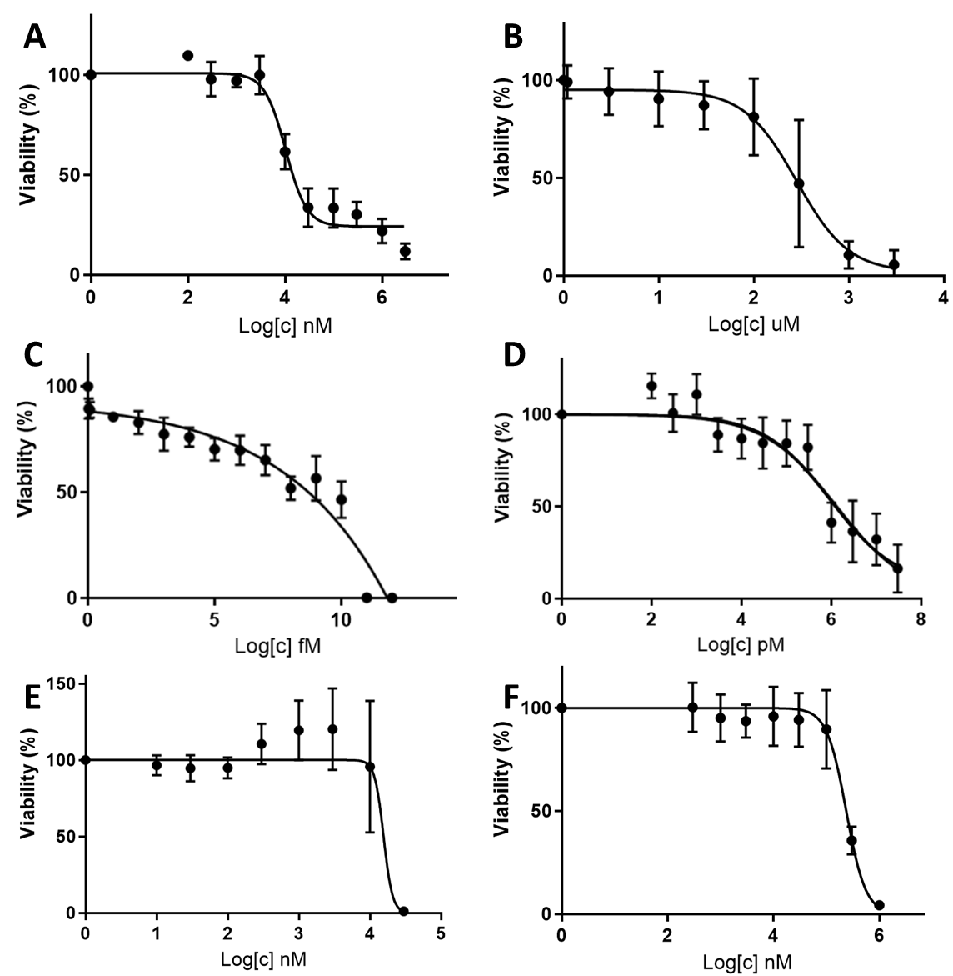

Supplementary Table 3. IC₅₋₅₀ in primary osteosarcoma cell-2 (Walter)
 | IC5 | IC10 | IC20 | IC50
Zoledronate | 270.3 nM | 726.4 nM | 2.12 uM | 13.29 uM
Carboplatin | 30.87 uM | 51.67 uM | 90.39 uM | 235.1 uM
Doxorubicin | 5.36 nM | 21.7 nM | 99.48 nM | 949.29 nM
Vinorelbine | X | 15.71 fM | 5.82 pM | 143.4 nM
Toceranib | 9.16 uM | 9.54 uM | 9.97 uM | X
Isophosphoramide | 70.29 uM | 94.39 uM | 129.97 uM | 224.56 uM

Supplementary Figure 4. Cell viability curve of MDCK cell, incubated with (A) zoledronate, (B) carboplatin, (C) vinorelbine, (D) doxorubicin, (E) toceranib, and (F) isophosphoramide mustard. Data expressed as mean +/- SD.
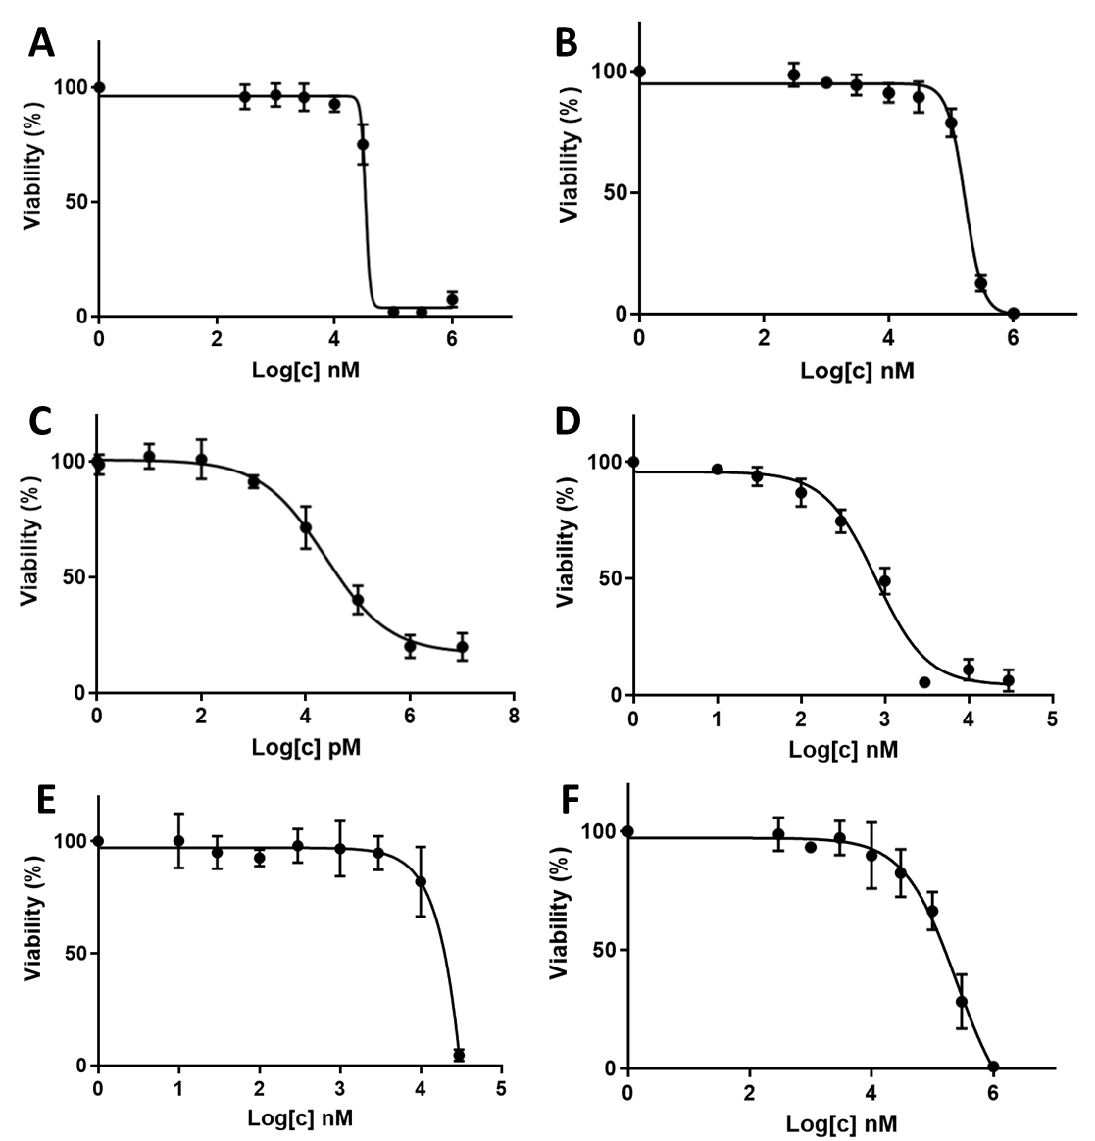

Supplementary Table 4. IC₅₋₅₀ in MDCK cell
 | IC5 | IC10 | IC20 | IC50
Zoledronate | 18.22 uM | 22.31 uM | 27.70 uM | 33.406 uM
Carboplatin | 54.90 uM | 71.52 uM | 95.31 uM | 165.69 uM
Doxorubicin | 55.38 nM | 107.3 nM | 220.1 nM | 781.5 nM
Vinorelbine | 140.4 pM | 673.1 pM | 3.68 nM | 23.73 nM
Toceranib | 7.03 uM | 8.44 uM | 10.29 uM | X
Isophosphoramide | 13.21 uM | 24.1 uM | 46.40 uM | 246.74 uM
Supplementary Table 5. Cmax of drugs from the pharmacokinetics literatures
Drug | Dose & administration | Cmax | Reference
Zoledronate | 0.25 mg/kg, IV, over 15 min | 4.4 uM (range 3.3-5.48 uM) | (1)
Carboplatin | 1.2 mg/kg, IV, over 20 min | Range 59.2 – 258.2 uM | (2)
Doxorubicin | 30 mg/m2, IV, over 30 min | 32.93 - 1067 ng/mL (range 15.3 nM - 1.83 uM) | (3, 4)
Vinorelbine | 0.4 mg/kg, IV | 56.4 - 98.3 ng/mL (range 52 - 91 nM) | (5)
Toceranib | 2.86 mg/kg, PO, every other day for 7 doses | Range 65 nM – 4.85 uM | (6)
Ifosfamide | 10 mg/kg | Range 17.2 - 47.5 uM | (7)
Citations
1. Martin-Jimenez T, De Lorimier LP, Fan TM, Freise KJ. Pharmacokinetics and Pharmacodynamics of a Single Dose of Zoledronate in Healthy Dogs. J Vet Pharmacol Ther (2007) 30(5):492-5. doi: 10.1111/j.1365-2885.2007.00883.x.
2. Chen C, Wang W, Zhou H, Huang J, Liu P, Song T, Sun M. Pharmacokinetic Comparison between Systemic and Local Chemotherapy by Carboplatin in Dogs. Reprod Sci (2009) 16(11):1097-102. Epub 20090805. doi: 10.1177/1933719109341999.
3. Kobayashi S, Sakai T, Dalrymple PD, Wood SG, Chasseaud LF. Disposition of the Novel Anticancer Agent Vinorelbine Ditartrate Following Intravenous Administration in Mice, Rats and Dogs. Arzneimittelforschung (1993) 43(12):1367-77.
4. Selting KA, Ogilvie GK, Gustafson DL, Long ME, Lana SE, Walton JA, et al. Evaluation of the Effects of Dietary N-3 Fatty Acid Supplementation on the Pharmacokinetics of Doxorubicin in Dogs with Lymphoma. Am J Vet Res (2006) 67(1):145-51. doi: 10.2460/ajvr.67.1.145.
5. Kirsch M, Weisse C, Berent A, Clifford C, Leibman N, Wittenburg L, et al. Pilot Study Comparing Serum Chemotherapy Levels after Intra-Arterial and Intravenous Administration in Dogs with Naturally Occurring Urinary Tract Tumors. Can J Vet Res (2019) 83(3):187-96.
6. Yancey MF, Merritt DA, Lesman SP, Boucher JF, Michels GM. Pharmacokinetic Properties of Toceranib Phosphate (Palladia, Su11654), a Novel Tyrosine Kinase Inhibitor, in Laboratory Dogs and Dogs with Mast Cell Tumors. J Vet Pharmacol Ther (2010) 33(2):162-71. doi: 10.1111/j.1365-2885.2009.01133.x.
7. Germann N, Urien S, Rodgers AH, Ratterree M, Struck RF, Waud WR, et al. Comparative Preclinical Toxicology and Pharmacology of Isophosphoramide Mustard, the Active Metabolite of Ifosfamide. Cancer Chemother Pharmacol (2005) 55(2):143-51. Epub 20040914. doi: 10.1007/s00280-004-0894-y.

