Quantifying Interactions in the Water-Energy-Food Nexus: Data-Driven Analysis Utilizing a Causal Inference Method
Supplemental materials

S1. WEF, GDP, and GHG data

S1.1. Historical data on agri-food production in the Canadian prairies
The Canadian Prairies plays a major role in Canada’s agri-food production. Figure S1 shows the annual average of agri-food production in the Canadian Prairie provinces from 1990 to 2020 measured in million tons per year, in Alberta, Saskatchewan, Manitoba, and the Canadian Prairies. The average agricultural crop production is calculated as 27, 32, 13, and 72 million tons per year for the aforementioned provinces, respectively. This indicates the major role of Saskatchewan in food production within the Prairies. It is worth noting that the significant sudden decrease in agri-food production between 2000-2003 in Figure S1 is most probably due to the coast-to-coast droughts which affected almost all of Canada. This drought condition has had the highest impact on Alberta in terms of food production compared to the other two provinces. As seen from the figure, food production dropped by 49%, 46%, and 14% in Alberta, Saskatchewan, and Manitoba in 2002 compared to that in the year 2000. There is a considerable increase in crop production during the year 2013 which is about 19%, 36%, and 27% in Alberta, Saskatchewan, and Manitoba, respectively. This increase is mainly due to adequate moisture levels in spring and early summer which ensures high yields for earlier-seeded crops (Oleson and Honey, 2014). Furthermore, hot and dry conditions later in the summer lead to more crop production. A good example is the production of canola and wheat which reached maximum levels in 2013 (Oleson and Honey, 2014).

Fig S1. Provincial agri-food production Mt/yr (million tons per year) of Alberta, Saskatchewan, Manitoba, and the Canadian Prairies (1990-2020)

S1.2. Historical data on water use in the Canadian Prairies
Figure S1 shows water use (in this study, water use also includes green water use for crop production) in million cubic meters (MCM) in both Canadian Prairies and individual Prairie provinces from 1990 to 2020. As seen from this figure, all three provinces show an up-trend almost linear pattern in their water use throughout the time. However, the rate of increase in water use is the highest in Saskatchewan compared to the other two provinces. It is worth mentioning that the pattern of change in water use for the Prairies as a single administrative unit is pretty similar to the patterns associated with Saskatchewan and Alberta.

Fig S2. Provincial water use in MCM/yr (million cubic meters per year) of Alberta, Saskatchewan, Manitoba, and the Canadian Prairies (1990-2020)

S1.3. Historical data on electricity generation in the Canadian Prairies
Figure S3 shows the electricity generation in the Canadian prairies as a single region and the individual Prairie provinces for the 31 years from 1990 to 2020. This figure shows that the rate of the increase in electricity generation in Alberta from 1990 to 2020 is much higher than that in Saskatchewan and Manitoba. Therefore, it can be understood that Alberta plays a major role in electricity generation not only in the Prairies but also in Canada. This consequently would pose a huge impact on the Prairies’ ecosystem, if Alberta is going to move toward renewable resources for electricity generation. As seen from the figure, there is a decreasing trend in electricity generation during recent years in all the Prairie provinces which is more highlighted in Alberta. This is probably due to the declining energy demand during the Covid-19 pandemic led to the closure of large factories, limitation of transportation, and reduction of people’s activity. The

Fig S3. Provincial electricity generation (GWh) of Alberta, Saskatchewan, Manitoba, and the Canadian Prairies (1990-2020)
amount of electricity generation has consequently decreased as a result of declining energy demand.

S1.4. GDP data as an economic metric in the Canadian Prairies
GDP is an important factor that can capture the size of an economy and provide information on economic performance. Integrating GDP with WEF resources is crucial to building an appropriate framework for having a coherent analysis of the WEF nexus. Figure S4 shows the GDP expressed as million chained (2012) dollars amount for WEF-related industries (water transportation, pipeline transportation, energy sector, mining, quarrying, and oil and gas extraction, utilities, crop production, support activities for crop and animal production, and food manufacturing) in the Prairies and any individual province within the Prairies from 1997 up to 2020 (Statistics Canada, 2018a, 2020a). It should be mentioned that the total annual GDP of such industries is 61%, 67%, 20%, and 57% of the total GDP of all industries in Alberta, Saskatchewan, Manitoba, and the Prairies, respectively. The figure indicates that Alberta has the highest GDP value among Prairie provinces. This is because Alberta has experienced substantial investments in the energy sector and mining, quarrying, oil and gas extraction. It can be seen from the figure that there is a considerable uptrend pattern in GDP for Alberta, Manitoba, and the Prairies over time, while this increase is less pronounced in Saskatchewan. However, as the Covid-19 pandemic has influenced the global economy dramatically, a decline in GDP in recent years is visible in all Prairie provinces.
- Alberta | - Saskatchewan
- Manitoba | - The Canadian Prairies

Fig S4. The GDP of industries related to WEF resources in the Canadian Prairie provinces (1997-2020)

S1.5. GHG data as an environmental metric in the Canadian Prairies
Greenhouse gas (GHG) emissions can cause climate change by trapping heat and making the planet warmer. Human activities including burning fossil fuels (coal, oil, and natural gas), deforestation and changing land use, and agriculture (livestock) are responsible for the increase in the concentration of GHGs in the atmosphere. Figure S5 shows GHG emissions based on the mega-tons of CO₂ equivalent in the Canadian Prairie provinces and the whole region as a single region for the 30 years from 1990-2019.

Fig S5. Greenhouse gas (GHG) emissions (megatons of CO₂ equivalent) of Alberta, Saskatchewan, Manitoba, and the Canadian Prairies (1990-2019)

S2. Evaluation of the Water-Energy-Food nexus in the Canadian Prairie provinces and the Prairies
Regarding inter-provincial TB rivers between Alberta and Saskatchewan, on one hand, water flows from Alberta to Saskatchewan in Lodge Creek, Battle Creek, South Saskatchewan, Red Deer, Beaver, and North Saskatchewan Rivers; on the other hand, water flows from Saskatchewan to Alberta in Clearwater river, located in Mackenzie river basin-Athabasca subbasin (Cold Lake Beaver River Basin Advisory Committee, 2006; Government of Alberta, 2010; Prairie Provinces Water Board, 1969; “Transboundary Waters | International Joint Commission”, 2021). The net transferred water through the aforementioned TB rivers between these two provinces is equal to 10 bcm/y (billion cubic meters per year) and flows from Alberta to Saskatchewan which is equal to 10% of Alberta’s annual average available water. The amount of water flowing from Alberta into the Northwest Territories and British Columbia in Canada and Montana in the US (represented as “others” in Figure 2) is 55% of the annual average available water. The net amount of water flowing from Saskatchewan into Manitoba, located downstream of the Canadian Prairie region, across TB rivers (Churchill, Saskatchewan, Assiniboine, and Qu’Appelle) is 43% (41 bcm/y) of Saskatchewan’s annual average available water. A high portion of this transferred water then flows into Hudson Bay from Manitoba (Manitoba Agriculture and Resource, 2021). The amount of water transferred from Saskatchewan and Manitoba to the US through Poplar, Souris, and Milk river basins is 0.3% (261 mcm) and 0.2% (177 mcm) of their annual average available water, respectively (“Transboundary Waters | International Joint Commission” 2021).
As shown in Figure 2, more than 92% of the total water is used in the food sector in each province. The ratio of TWU (excluding the water used for hydropower) to total available water in the food sector is 0.46 for Saskatchewan, while this ratio is 0.34 and 0.14 for Alberta and Manitoba, respectively. This indicates that a larger portion of water is used in the food sector in Saskatchewan compared to the other two provinces as expected. Because Saskatchewan is the largest exporter of different agricultural products such as lentils, peas, durum wheat, oats, mustard seed and canola in Canada and has 32 Mt annual average crop production. In Manitoba, the TWU in the food sector is minimal with respect to total available water. This can be explained by two reasons: i) the area of cultivated farmland in Manitoba is less than that of Alberta and Saskatchewan, and ii) the province holds more available water as it is located in the Prairies downstream.
As indicated in the WEF nexus shown in Figure 2, the amount of water used in the energy sector in Alberta is calculated as 15% of BWU which is equal to 0.41 bcm/y. This amount is 48% (0.21 bcm/y) and 88% (1.7 bcm/y) of BWU in Saskatchewan and Manitoba, respectively. This clearly shows that energy generation in Manitoba is more dependent on water resources compared to Alberta and Saskatchewan. It has been reported that 97% of electricity generation in Manitoba is obtained through hydropower stations on the Nelson River in Northern Manitoba (Canada Energy Regulator, 2018). As to the amount of energy used in the water sector, it can be seen from the figure that all three Prairie provinces provide almost the same amount of energy to be used in the water sector with respect to their total energy generation. However, there is a big difference in the net amount of energy used in the water sector in the Prairie provinces (56, 20, and 6.6 PJ/y for Alberta, Saskatchewan, and Manitoba).
As to the amount of food used in energy generation, Figure 2 demonstrates that there are no significant food resources used in energy generation. This amount is 4%, 2%, and 3% of Prairie provinces’ total food production for Alberta, Saskatchewan, and Manitoba, respectively. Biomass which falls in the category of the food sector is one of the common renewable sources used for energy generation. However, Prairie provinces, particularly Saskatchewan, do not have a high potential for biomass exploitation compared to some other Canadian provinces such as British Columbia and Ontario (Government of Canada, 2014). Even though the Canadian Prairie provinces are planning to move toward renewable energy, there are several factors such as availability and transportation cost that would impact the feasibility of using these kinds of energy. Figure 2 also shows that the amount of energy used in the food sector is considerable compared to that used in the water sector and it is 1%, 4%, and 4% in Alberta, Saskatchewan, and Manitoba, respectively. The energy used in food production can be consumed in several sectors such as agriculture, transportation, food processing, and food handling. Saskatchewan is considered to have more than two-fifth of Canada’s total crops field (Statistics Canada, 2017) and more than 40% of its crops field is using automated technology that requires a high amount of energy for running throughout the year. Regarding oil production, Alberta is by far the leading oil-producing province in Canada with more than 80% of Canada’s oil production and then Saskatchewan with more than 10% contribution (Government of Canada, 2019). More than half of the Crude oil exports go outside Canada, mainly to the US (more than 95%) and a small portion (less than 5%) to Europe, Asia, and the Caribbean. Therefore, Canada is an important source of oil supply in global markets (Government of Canada, 2021). In the case of food production use in the water sector, to the author's knowledge, no significant activity has been found neither in the literature nor in available Canada’s database.
As seen from Figure 3, 2% of energy generation in the Canadian Prairies is used in the food sector. This indicates that the food sector is a major consumer of energy generation compared to the water sector in the Canadian Prairies. The most common source of energy used in the food sector, in the Prairies, is natural gas which accounts for 30% of total energy generation in the Canadian Prairies. Irrigation is more energy use intensive than rainfed agriculture as it requires more energy for pumping water through pipelines to supply the agricultural lands. Therefore, the majority of energy used in the food sector is consumed for irrigation rather than rainfed agriculture in the Prairies. It has been reported that Alberta is the home for the vast majority of irrigated areas in Canada (Statistics Canada, 2020b, 2018b). As a result, the majority of energy used for irrigation is consumed in Alberta. This indicates that the more change in irrigation land area and/or pattern occurs in Alberta, the more significant impact we have on energy distribution in the food sector. On the other hand, 3% of total food production in terms of biomass is used by the energy sector to produce biofuels or biopower production within the Prairies, annually. Alberta is known for being one of the Canadian provinces where they possess the largest biomass capacity. Even though biomass is better for the environment than tractional fuels, burning biomass for energy generation can still cause pollution and this, in turn, would impact the food and water quality. Therefore, Alberta, here, is also playing a major role in the Prairies in terms of its biomass emission (either from burning, harvesting or transportation). It should be mentioned that the vast majority of energy generation, namely 68% of total energy generation, and food production (around 49%) is consumed by the regions outside of the Canadian Prairies. This shows that the Canadian Prairies can be considered as one of the largest exporters of energy and food not only in Canada but also in the world.
It is crucial for the managers and policymakers to have information on the Prairies provinces’ contribution in terms of water use and water consumption in different sectors to ensure water use sustainability. Therefore, Figure S6 has been provided to illustrate water use in different sectors within the Canadian Prairie provinces highlighting the individual contributions in the Prairie. In Figure S6-a, the internal doughnut chart (InDoCh) shows the distribution of the average annual GWU (88.9 bcm/y) among the three provinces of Alberta, Saskatchewan, and Manitoba in the Canadian Prairies, while the external doughnut chart (ExDoCh) represents the distribution of the average annual BWU for the aforementioned provinces. According to the ExDoCh in Figure S6-a, it can be seen that Alberta is the major consumer of the total Prairies’ blue water resources
IntDoCh: Internal doughnut chart bcm: billion cubic meters
ExDoCh: External doughnut chart Mt: Million tons crop production
Int: Internal PJ: Petajoule
Ext: External

Int: 88.9 bcm/y  Ext: 4.4 bcm/y | Int: 2.1 bcm/y  Ext: 72.6 Mt/y
- IntDoCh: Green water use (GWU)  ExtDoCh: Blue water use (BWU) | - IntDoCh: Irrigation water for agri-food  ExtDoCh: Total agricutural production
- IntDoCh: Consumptive water use for energy generation  ExtDoCh: Energy generation | - IntDoCh: Total water use for energy generation  ExtDoCh: Energy generation
Fig S6. Comparing the contribution of the Canadian Prairie provinces in a) blue and green water use within the region for all sectors, b) total irrigation water for agri-food production and crop production, c) their energy generation by considering just consumptive water use, d) their energy generation by considering total water use

(61%), mainly due to having more irrigated cropland area compared to Saskatchewan and Manitoba. On the other hand, Saskatchewan is the major consumer of average annual GWU (49%) which is mostly used for rainfed croplands in Saskatchewan (Figure S6-a, InDoCh). Figure S6-b shows the contribution of each province in using the total irrigation water for agri-food products (InDoCh) and the annual Prairies’ agricultural production (ExDoCh) in the Canadian Prairies. Alberta consumes 91% of the irrigation water in the Canadian Prairies to gain 37% of the Prairies’ agricultural products, while Saskatchewan and Manitoba only consume 6% and 3% of Prairies’ irrigation water to gain 44% and 19% of Prairies’ agricultural products, respectively. Consumptive water use and the total water use (InDoCh) for the Prairies’ energy generation (ExDoCh) are shown in Figure S6-c and Figure S6-d, respectively. Based on Figures S6-c and S6-d, Manitoba is seen as the most efficient province among the three Canadian Prairie provinces in terms of less consumptive water for energy generation since it has a lower ratio of consumptive water to total water use compared to the other two provinces.

S3. Correlation
Alberta |  | Saskatchewan | Manitoba | The Canadian prairies
a)
Log10 of Food Production
(x10⁶ ton yr⁻¹)

 | Log10 of Water Use (x10⁶ m³ yr⁻¹) | Log10 of Water Use (x10⁶ m³ yr⁻¹) | Log10 of Water Use (x10⁶ m³ yr⁻¹) | Log10 of Water Use (x10⁶ m³ yr⁻¹)
b)
Log10 of Energy Generation (x10³ GWh yr⁻¹)

 | Log10 of Water Use (x10⁶ m³ yr⁻¹) | Log10 of Water Use (x10⁶ m³ yr⁻¹) | Log10 of Water Use (x10⁶ m³ yr⁻¹) | Log10 of Water Use (x10⁶ m³ yr⁻¹)
c)
Log10 of Food Production
(x10⁶ Mt yr⁻¹)

 | Log10 of Energy Generation (x10³ GWh yr⁻¹) | Log10 of Energy Generation (x10³ GWh yr⁻¹) | Log10 of Energy Generation (x10³ GWh yr⁻¹) | Log10 of Energy Generation (x10³ GWh yr⁻¹)
Fig S7. Correlation of a) water use with food production, b) water use with energy generation, and c) energy generation with food production based on annual data of 31 years (1990-2020) in Alberta, Saskatchewan, Manitoba, and the Canadian prairies
 | Alberta | Saskatchewan | Manitoba | The Canadian prairies
a)
Log10 of GDP
(x10⁶ chained $2012)
 | Log10 of Water Use (x10⁶ m³ yr⁻¹) | Log10 of Water Use (x10⁶ m³ yr⁻¹) | Log10 of Water Use (x10⁶ m³ yr⁻¹) | Log10 of Water Use (x10⁶ m³ yr⁻¹)
b)
Log10 of GDP
(x10⁶ chained $2012)
 | Log10 of Food Production (x10⁶ Mt yr⁻¹) | Log10 of Food Production (x10⁶ Mt yr⁻¹) | Log10 of Food Production (x10⁶ Mt yr⁻¹) | Log10 of Food Production (x10⁶ Mt yr⁻¹)
c)
Log10 of GDP  (x10⁶ chained $2012) |  | G
 | Log10 of Energy Generation (x10³ GWh yr⁻¹) | Log10 of Energy Generation (x10³ GWh yr⁻¹) | Log10 of Energy Generation (x10³ GWh yr⁻¹) | Log10 of Energy Generation (x10³ GWh yr⁻¹)
Fig S8. Correlation of a) water use, b) food production, and c) energy generation as independent variables against GDP in Alberta, Saskatchewan, Manitoba, and the Canadian prairies
 | Alberta | Saskatchewan | Manitoba | The Canadian prairies
a)
Log10 of GHG
(Mt CO₂ eq.)
 | Log10 of Water Use (x10⁶ m³ yr⁻¹) | Log10 of Water Use (x10⁶ m³ yr⁻¹) | Log10 of Water Use (x10⁶ m³ yr⁻¹) | Log10 of Water Use (x10⁶ m³ yr⁻¹)
b)
Log10 of GHG
(Mt CO₂ eq.)
 | Log10 of Food Production (x10⁶ Mt yr⁻¹) | Log10 of Food Production (x10⁶ Mt yr⁻¹) | Log10 of Food Production (x10⁶ Mt yr⁻¹) | Log10 of Food Production (x10⁶ Mt yr⁻¹)
c)
Log10 of GHG
(Mt CO₂ eq.)
 | Log10 of Energy Generation (x10³ GWh yr⁻¹) | Log10 of Energy Generation (x10³ GWh yr⁻¹) | Log10 of Energy Generation (x10³ GWh yr⁻¹) | Log10 of Energy Generation (x10³ GWh yr⁻¹)
Fig S9. Correlation of a) water use, b) food production, and c) energy generation as independent variables against GHG emissions in Alberta, Saskatchewan, Manitoba, and the Canadian prairies

 | Alberta | Saskatchewan
Log10 of GHG
(Mt CO₂ eq.)
 | Log10 of GDP (x10⁶ chained $2012) | Log10 of GDP (x10⁶ chained $2012)
 | Manitoba | The Canadian prairies
Log10 of GHG
(Mt CO₂ eq.)
 | Log10 of GDP  (x10⁶ chained $2012) | Log10 of GDP  (x10⁶ chained $2012)

Fig S10. Correlation of a) water use, b) food production, and c) energy generation as independent variables against GHG emissions in Alberta, Saskatchewan, Manitoba, and the Canadian prairies

S4. Pearson’s and Spearman’s correlation coefficients
The p-values of Pearson’s and Spearman’s correlation coefficients have been used to determine the significance of a linear and non-linear relationship between two variables, respectively (see Table S1). The p-value for the Pearson correlation coefficient is calculated as below (Freund and Johnson, 2018; Gibbons and Chakraborti, 2014):
- computing Pearson correlation coefficient (r) between two variables
- calculating the t-statistic using $t= \frac{r\sqrt{n-2}}{\sqrt{1-r^{2}}}$ , where n is the sample size
- calculating the p-value using the cumulative distribution function of the t-distribution with degrees of freedom (n-2). The p-value represents the probability of obtaining a t-statistic as extreme as the one calculated, assuming that the null hypothesis of no correlation is true.
Also, the p-value for Spearman’s correlation is calculated as follows:
- computing Spearman’s correlation coefficient (rho) between two variables
- calculating the z-statistic using the following formula: $z=0.5 [\log\left(1+rho\right)-\log{(1-rho)]}$
- calculating the p-value using the cumulative distribution function (CDF) of the standard normal distribution. The p-value represents the probability of obtaining a z-statistic as extreme as the one calculated, assuming that the null hypothesis of no correlation is true.
Table S1. Values of Pearson’s and Spearman’s correlation coefficients of W-E sectors in Alberta and W-E and F-E in Manitoba
 | P-value
 | Pearson Correlation Coefficient (linear) | Spearman’s Correlation Coefficient (non-linear)
W-E Manitoba | 0.51 | 0.89
F-E Manitoba | 0.34 | 0.13
W-E Alberta | 0.17 | 0.012

S5. Causation

S5.1. The best-fitted statistical distribution

 | Alberta | Saskatchewan | Manitoba | The Canadian prairies
Log10 of Water  (x10⁶ m³ yr⁻¹) | 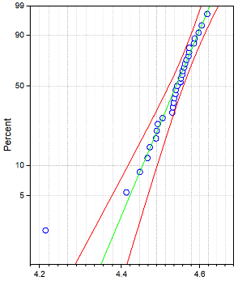 | 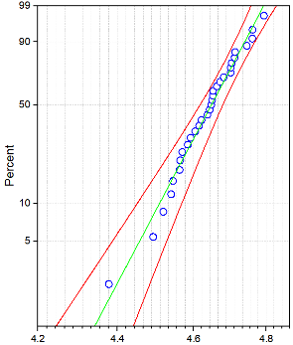 | 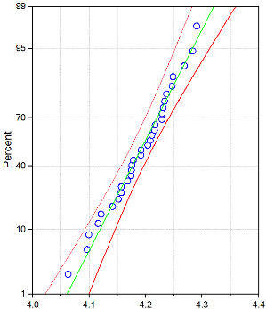 | 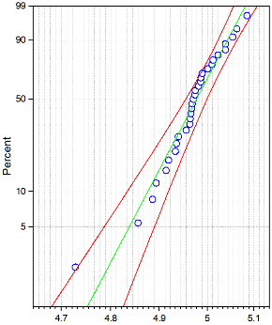
 | Weibull Distribution  Shape= 99.26006  Scale= 4.55491 | Weibull Distribution  Shape= 61.97613  Scale= 4.67634 | Normal Distribution  Mean= 4.1907  StDev= 0.0558 | Weibull Distribution  Shape= 91.49635  Scale= 4.99695
Log10 of  Food  (x10⁶ ton yr⁻¹) | 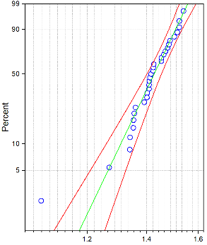 | 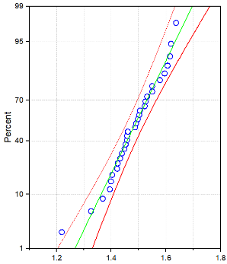 | 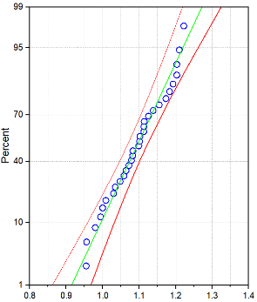 | 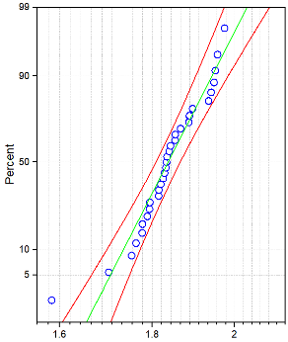
 | Weibull Distribution  Shape= 21.82544  Scale= 1.45154 | Normal Distribution  Mean= 1.48148  StDev= 0.09244 | Normal Distribution  Mean= 1.09319  StDev= 0.07672 | Gamma Distribution  Shape= 518.52426  Scale= 0.00355
Log10 of Energy  (x10³ GWh  yr⁻¹) | 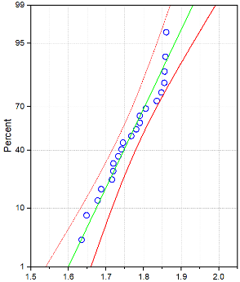 | 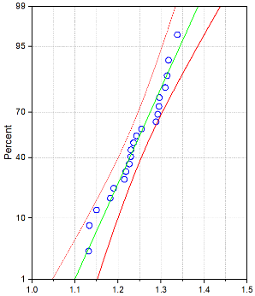 | 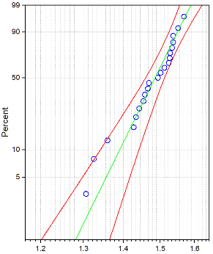 | 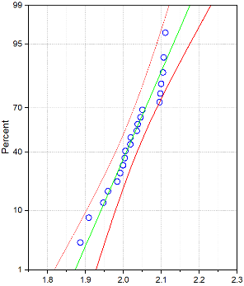
 | Normal Distribution  Mean= 1.76516  StDev= 0.07135 | Normal Distribution  Mean= 1.28233  StDev= 0.0785 | Weibull Distribution  Shape= 28.50735  Scale= 1.50486 | Normal Distribution  Mean= 2.02396  StDev= 0.06516
Fig S11. The best-fitted statistical distribution function of each WEF, GDP, and GHG sector in Alberta, Saskatchewan, Manitoba, and the Canadian prairies. Blue dots, green lines, and red lines represent original data, best-fitted statistical distribution, and lower (25th percentile) and upper (75th percentile) quartiles, respectively. (continued on next page)

 | Alberta | Saskatchewan | Manitoba | The Canadian prairies
Log10 of GDP  (x10⁶ chained 2012$) | 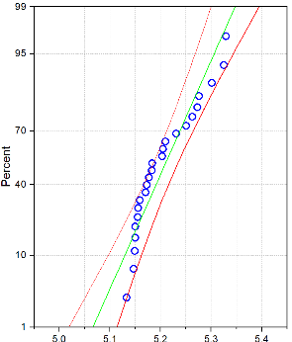 | 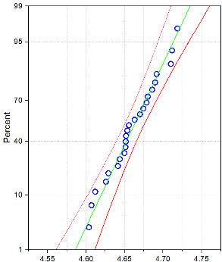 | 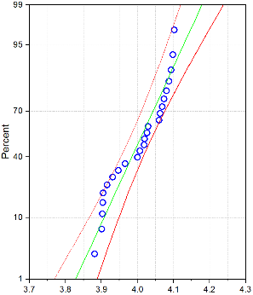 | 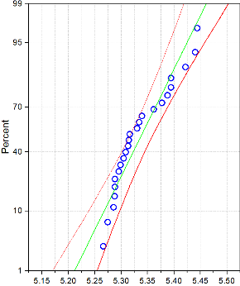
 | Normal Distribution  Mean= 5.20665  StDev= 0.06033 | Normal Distribution  Mean= 4.66059  StDev= 0.03206 | Weibull Distribution  Shape= 66.0045  Scale= 4.03873 | Normal Distribution  Mean= 5.3364  StDev= 0.05355
Log 10 of GHGs emission  (Mt CO₂ eq.) | 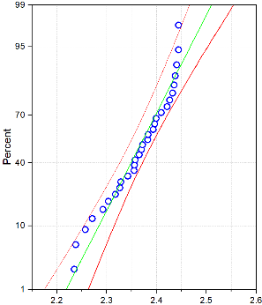  Normal Distribution  Mean= 2.36467  StDev= 0.06268 | 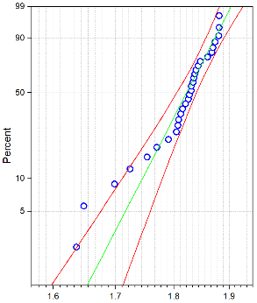  Weibull Distribution  Shape= 43.5144  Scale= 1.83809 | 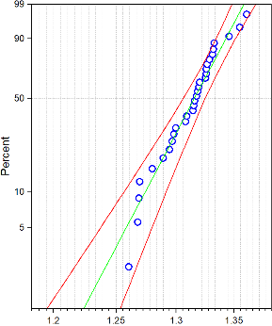  Weibull Distribution  Shape= 58.59271  Scale= 1.3237 | 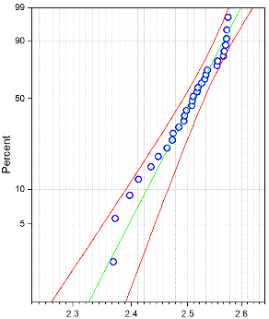  Weibull Distribution  Shape= 55.39606  Scale= 2.52774
Fig S11. (continued)

S5.2. Data generation
 |  | Alberta | Saskatchewan | Manitoba | The Canadian prairies
W-F | Log10 of Food Production (x10⁶ ton yr⁻¹)
 |  | Log10 Water Use (x10⁶m³yr⁻¹) | Log10 Water Use (x10⁶m³yr⁻¹) | Log10 Water Use (x10⁶m³yr⁻¹) | Log10 Water Use (x10⁶m³yr⁻¹)
W-E | Log10 of Energy Generation (x10³ GWh yr⁻¹)
 |  | Log10 Provincial Water Use (x10⁶m³yr⁻¹) | Log10 Provincial Water Use (x10⁶m³yr⁻¹) | Log10 Provincial Water Use (x10⁶m³yr⁻¹) | Log10 Provincial Water Use (x10⁶m³yr⁻¹)
F-E | Log10 of Energy Generation (x10³ GWh yr⁻¹)
 |  | Log10 of Food Production (x10⁶ ton yr⁻¹) | Log10 of Food Production (x10⁶ ton yr⁻¹) | Log10 of Food Production (x10⁶ ton yr⁻¹) | Log10 of Food Production (x10⁶ ton yr⁻¹)
Fig S12. Data Generation based on the best-fitted distribution functions of WEF sectors and the correlation among pairs of them in Alberta, Saskatchewan, Manitoba, and the Canadian prairies

 |  | Alberta | Saskatchewan | Manitoba | The Canadian prairies
W-GDP | Log10 of GDP  (x10⁶ chained $2012)
 |  | Log10 Water Use (x10⁶m³yr⁻¹) | Log10 Water Use (x10⁶m³yr⁻¹) | Log10 Water Use (x10⁶m³yr⁻¹) | Log10 Water Use (x10⁶m³yr⁻¹)
F-GDP | Log10 of GDP  (x10⁶ chained $2012)
 |  | Log10 of Food Production (x10⁶ ton yr⁻¹) | Log10 of Food Production (x10⁶ ton yr⁻¹) | Log10 of Food Production (x10⁶ ton yr⁻¹) | Log10 of Food Production (x10⁶ ton yr⁻¹)
E-GDP | Log10 of GDP  (x10⁶ chained $2012)
 |  | Log10 of Energy Generation (x10³ GWh yr⁻¹) | Log10 of Energy Generation (x10³ GWh yr⁻¹) | Log10 of Energy Generation (x10³ GWh yr⁻¹) | Log10 of Energy Generation (x10³ GWh yr⁻¹)

Fig S13. Data Generation based on the best-fitted distribution functions of WEF and GDP sectors and the correlation among them in Alberta, Saskatchewan, Manitoba, and the Canadian prairies

 |  | Alberta | Saskatchewan | Manitoba | The Canadian prairies
W-GHG | Log10 of GHG  (Mt CO₂ eq.)
 |  | Log10 Water Use (x10⁶m³yr⁻¹) | Log10 Water Use (x10⁶m³yr⁻¹) | Log10 Water Use (x10⁶m³yr⁻¹) | Log10 Water Use (x10⁶m³yr⁻¹)
F-GHG | Log10 of GHG  (Mt CO₂ eq.)
 |  | Log10 of Food Production (x10⁶ ton yr⁻¹) | Log10 of Food Production (x10⁶ ton yr⁻¹) | Log10 of Food Production (x10⁶ ton yr⁻¹) | Log10 of Food Production (x10⁶ ton yr⁻¹)
E-GHG | Log10 of GHG  (Mt CO₂ eq.)
 |  | Log10 of Energy Generation (x10³ GWh yr⁻¹) | Log10 of Energy Generation (x10³ GWh yr⁻¹) | Log10 of Energy Generation (x10³ GWh yr⁻¹) | Log10 of Energy Generation (x10³ GWh yr⁻¹)

Fig S14. Data Generation based on the best-fitted distribution functions of WEF and GHG sectors and the correlation among them in Alberta, Saskatchewan, Manitoba, and the Canadian prairie

S5.3. Multispatial Convergence Cross Mapping (mCCM)

Alberta |  | Saskatchewan | Manitoba | The Canadian prairies
a)
W-F | 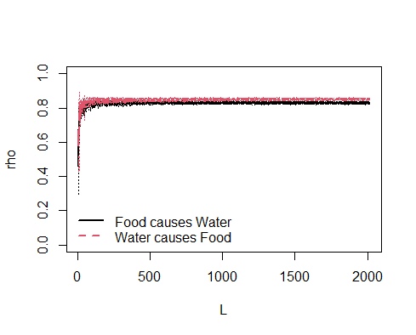 | 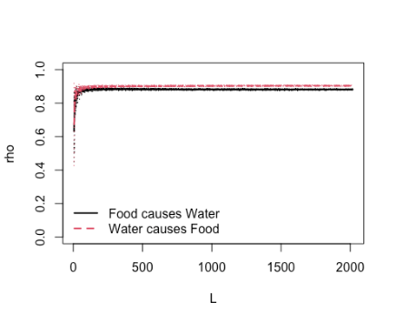 | 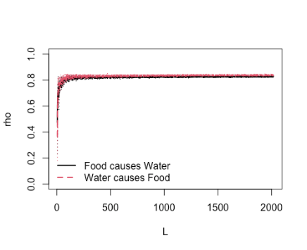 | 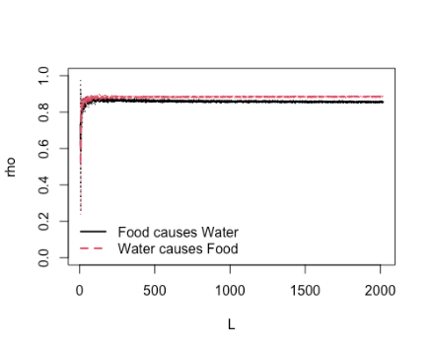
b)
W-E | 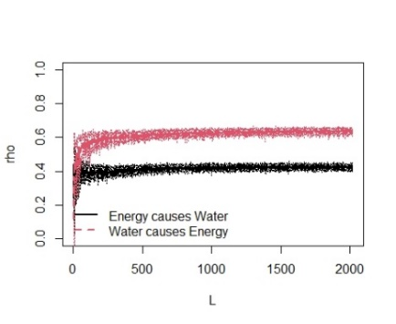 | 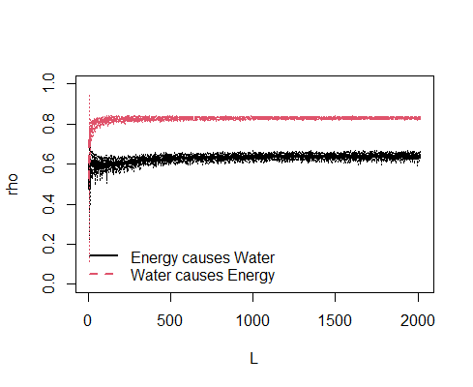 | 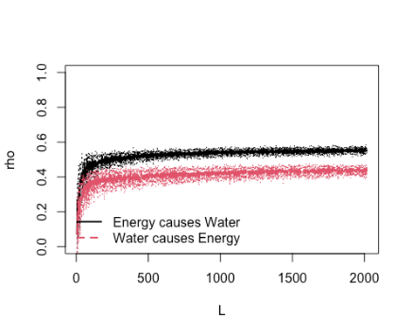 | 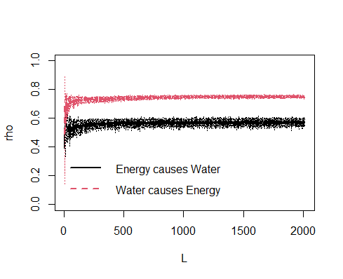
c)
E-F | 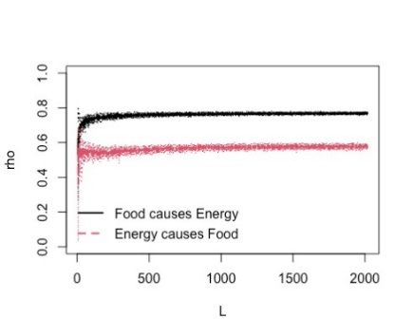 | 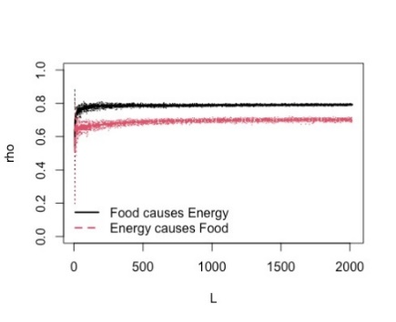 | 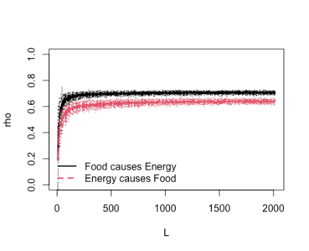 | 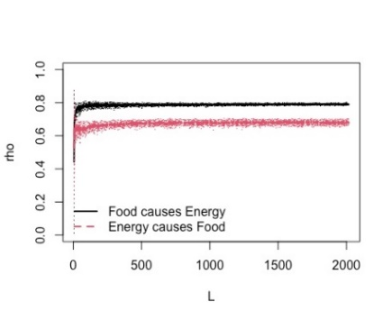

Fig S15. Multi-spatial convergence cross-mapping results for a) Water use-Food production, b) Water use-Energy generation, and c) Energy generation-Food production in Alberta, Saskatchewan, Manitoba, and the Canadian prairies. Rho values (y-axis) and L values (x-axis) represent the relative strength of causal influence and length of the data series, respectively.

 | Alberta | Saskatchewan | Manitoba | The Canadian prairies
a)
W – GDP | 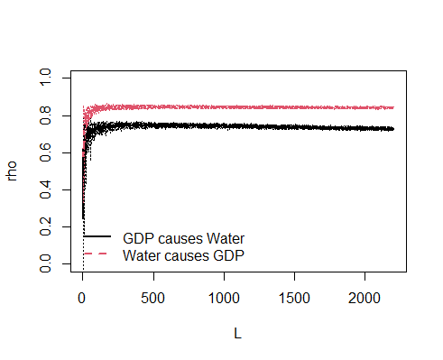 | 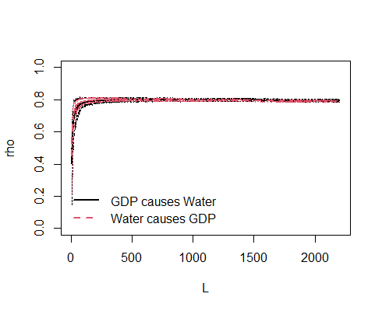 | 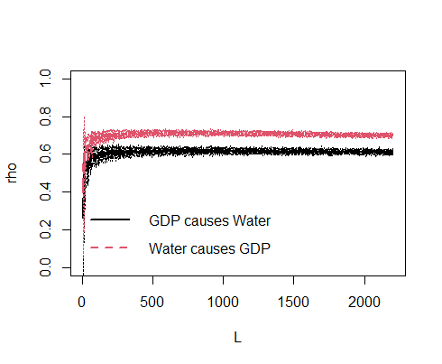 | 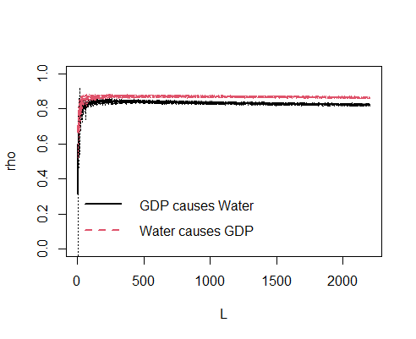
b)
F – GDP | 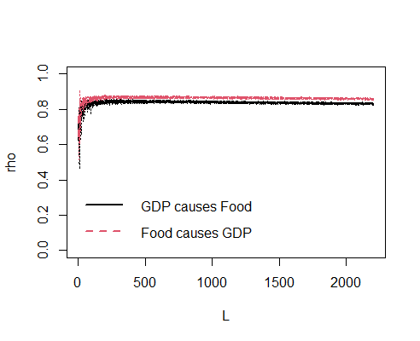 | 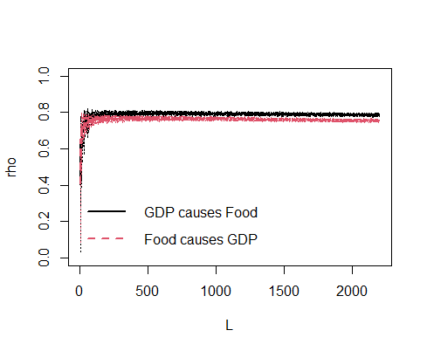 | 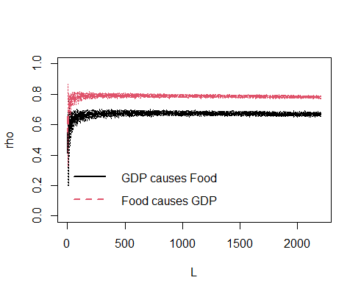 | 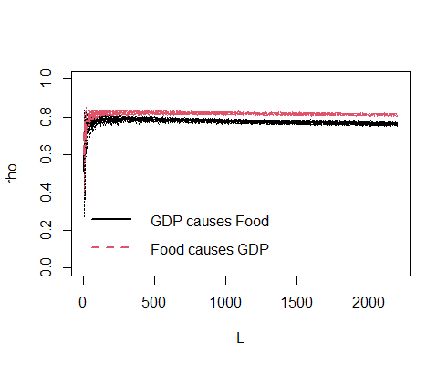
c)
E – GDP | 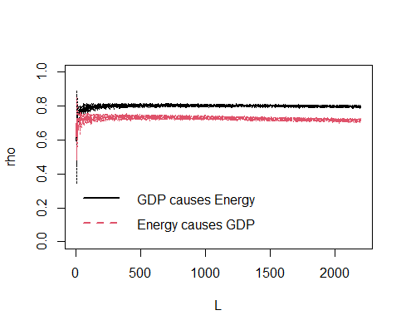 | 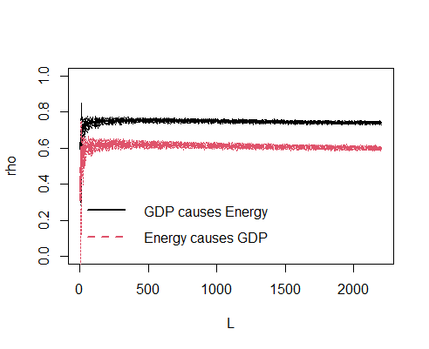 | 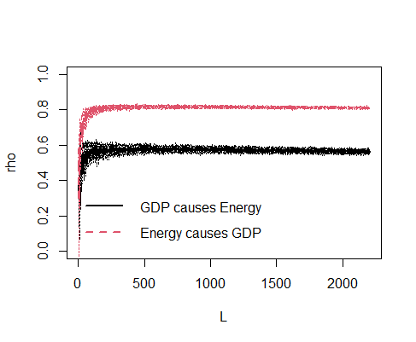 | 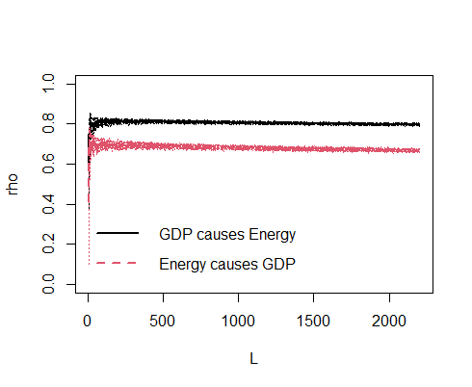
Fig S16. Multi-spatial convergence cross-mapping results for a) GDP-Water use, b) GDP-Food production, and c) GDP-Energy generation in Alberta, Saskatchewan, Manitoba, and the Canadian prairies. Rho values (y-axis) and L values (x-axis) represent the relative strength of causal influence and length of the data series, respectively.
 | Alberta | Saskatchewan | Manitoba | The Canadian prairies
a)
W – GHG | 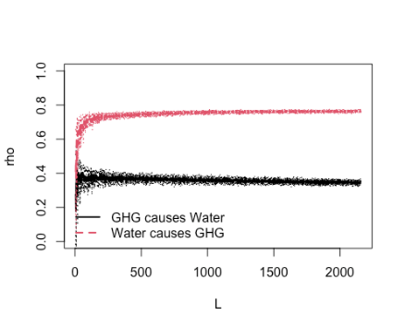 | 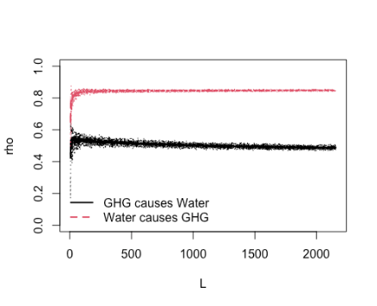 | 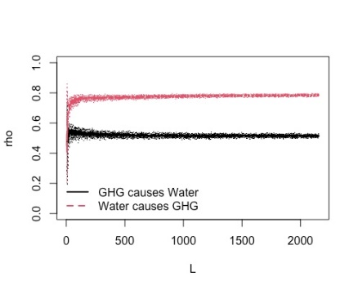 | 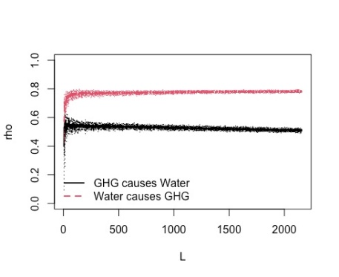
b)
F – GHG | 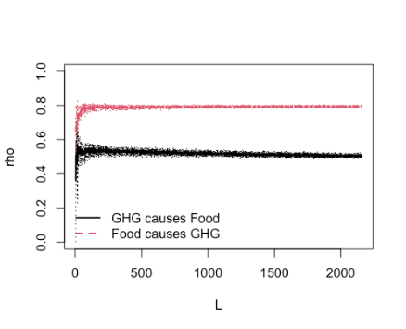 | 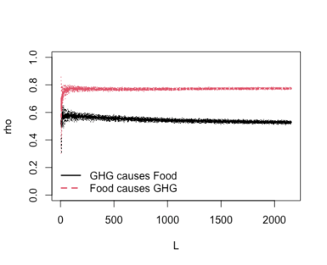 | 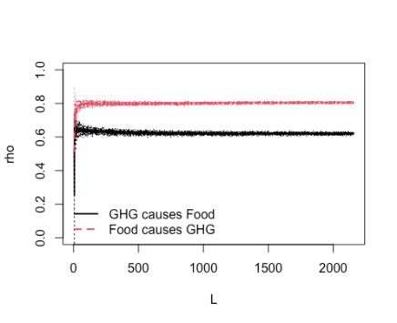 | 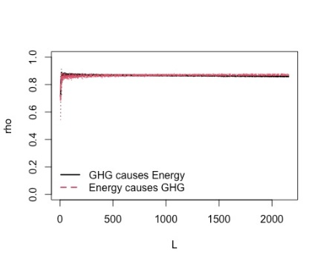
c)
E – GHG | 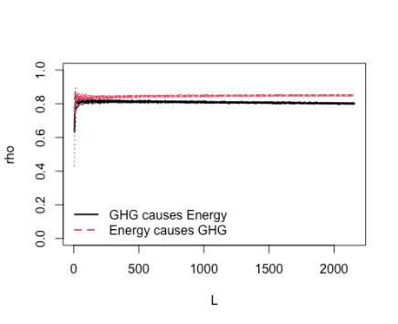 | 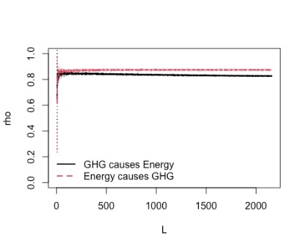 | 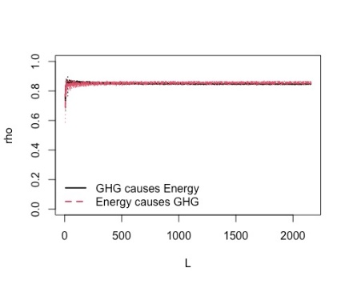
Fig S17. Multi-spatial convergence cross-mapping results for a) GHG emissions-Water use, b) GHG emissions-Food production, and c) GHG emissions-Energy generation in Alberta, Saskatchewan, Manitoba, and the Canadian prairies. Rho values (y-axis) and L values (x-axis) represent the relative strength of causal influence and length of the data series, respectively

Fig S18. Multi-spatial convergence cross-mapping results for GDP-GHG emissions in Alberta, Saskatchewan, Manitoba, and the Canadian prairies. Rho values (y-axis) and L values (x-axis) represent the relative strength of causal influence and length of the data series, respectively

 | Alberta | Saskatchewan | Manitoba | The Canadian prairies
a)
GDP – GHG | 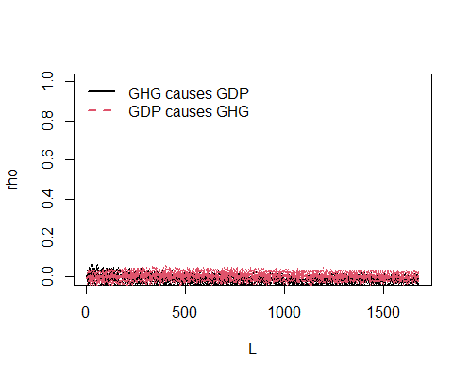 | 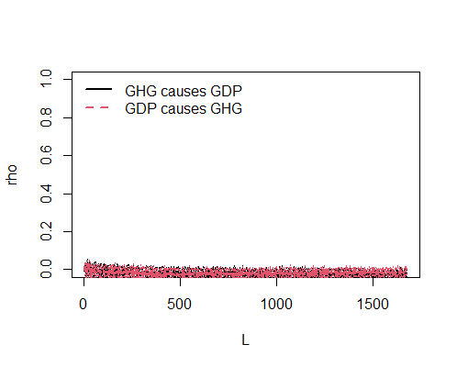 | 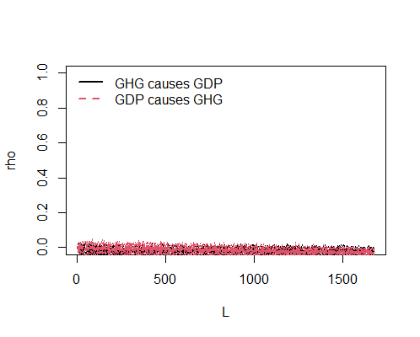 | 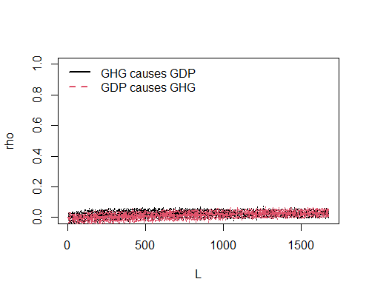

Reference
Canada Energy Regulator, 2018. CER – Provincial and Territorial Energy Profiles - Manitoba. URL https://www.cer-rec.gc.ca/en/data-analysis/energy-markets/provincial-territorial-energy-profiles/provincial-territorial-energy-profiles-manitoba.html (accessed 10.28.21).
Cold Lake Beaver River Basin Advisory Committee (BAC), 2006. Cold Lake Beaver River Basin Water Management Plan .
Freund, S., Johnson, R.A., 2018. Probability And Statistics For Engineers Global Edition. Pearson Education London.
Gibbons, J.D., Chakraborti, S., 2014. Nonparametric statistical inference. CRC press.
Government of Alberta, 2010. Water For Life: Facts and Information On water in Alberta.
Government of Canada, 2021. Crude Oil Industry Overview. URL https://www.nrcan.gc.ca/our-natural-resources/energy-sources-distribution/clean-fossil-fuels/crude-oil-industry-overview/18078 (accessed 11.22.21).
Government of Canada, 2019. Crude oil facts. URL https://www.nrcan.gc.ca/science-and-data/data-and-analysis/energy-data-and-analysis/energy-facts/crude-oil-facts/20064 (accessed 10.8.21).
Government of Canada, 2014. Renewable Energy. URL https://www.nrcan.gc.ca/our-natural-resources/energy-sources-distribution/renewable-energy/about-renewable-energy/7295 (accessed 11.17.21).
Manitoba Agriculture and Resource, 2021. Engaging Manitobans on Water Management.
Oleson, B., Honey, J., 2014. Agricultural Review 2013 and Outlook 2014.
Prairie Provinces Water Board, 1969. Master agreement on apportionment.
Statistics Canada, 2020a. Gross domestic product (GDP) at basic prices, by industry, monthly (x 1,000,000). https://doi.org/https://doi.org/10.25318/3610043401-eng
Statistics Canada, 2020b. Agricultural irrigation patterns in Canada from 2012 to 2018. URL https://www150.statcan.gc.ca/n1/pub/16-508-x/16-508-x2021001-eng.htm (accessed 11.24.21).
Statistics Canada, 2018a. North American Industry Classification System (NAICS) Canada.
Statistics Canada, 2018b. Irrigation volume by province and drainage region. https://doi.org/https://doi.org/10.25318/3810023901-eng
Statistics Canada, 2017. Farm and farm operator data. URL https://www150.statcan.gc.ca/n1/pub/95-640-x/2016001/article/14807-eng.htm (accessed 11.17.21).
Transboundary Waters | International Joint Commission (IJC), 2021. URL https://www.ijc.org/en/watersheds (accessed 9.28.21).

