Investigation of Anti-Nociceptive, Anti-Inflammatory Potential and ADMET Studies of Pure Compounds Isolated from Isodon rugosus Wall. ex Benth.

Osama M. Alshehri^{1,}, Anwar Zeb², Syed Muhammad Mukarram Shah², Mater H. Mahnashi³, Saeed Ahmed Asiri⁴, Omaish Alqahtani⁵, Abdul Sadiq⁶, Muhammad Ibrar⁷, Saleh Alshamrani^{*1}, Muhammad Saeed Jan^{7*}.

¹Department of Clinical Laboratory Sciences, College of Applied Medical Sciences, Najran University, Najran, Saudi Arabia (Omalshehri@nu.edu.sa)
²Department of Pharmacy, University of Swabi, Swabi, KP, Pakistan; (zebrph@gmail.com); (mukaramshah@uoswabi.edu.pk)
³Department of pharmaceutical chemistry, college of pharmacy, Najran University, Najran, Kingdom of Saudi Arabia (matermaha@gmail.com)
⁴Department of Clinical Laboratory Sciences, Faculty of Applied Medical Sciences, Najran University, 1988, Najran, 61441, Saudi Arabia. (saaasiri@nu.edu.sa)
⁵Department of Pharmacognosy, College of Pharmacy, Najran University, KSA (osalqahtani@nu.edu.sa)
⁶Department of Pharmacy, Univeristy of Malakand, Chakdara, Dir Lower, KP, Pakistan (sadiquom@yahoo.com)
⁷Department of Pharmacy, Bacha Khan University, Charsadda 24420, KP, Pakistan (meet_ibrar@yahoo.com)

Corresponding Author
*Dr. Muhammad Saeed Jan, Department of Pharmacy, Bacha Khan University, Charsadda, KP, Pakistan. (saeedjan@bkuc.edu.pk) Contact: 0092 315 3109610 & Saleh Alshamrani (SAALSHAMRANI@NU.EDU.SA)

Figure S1: ¹H NMR spectrum of Compound 1.

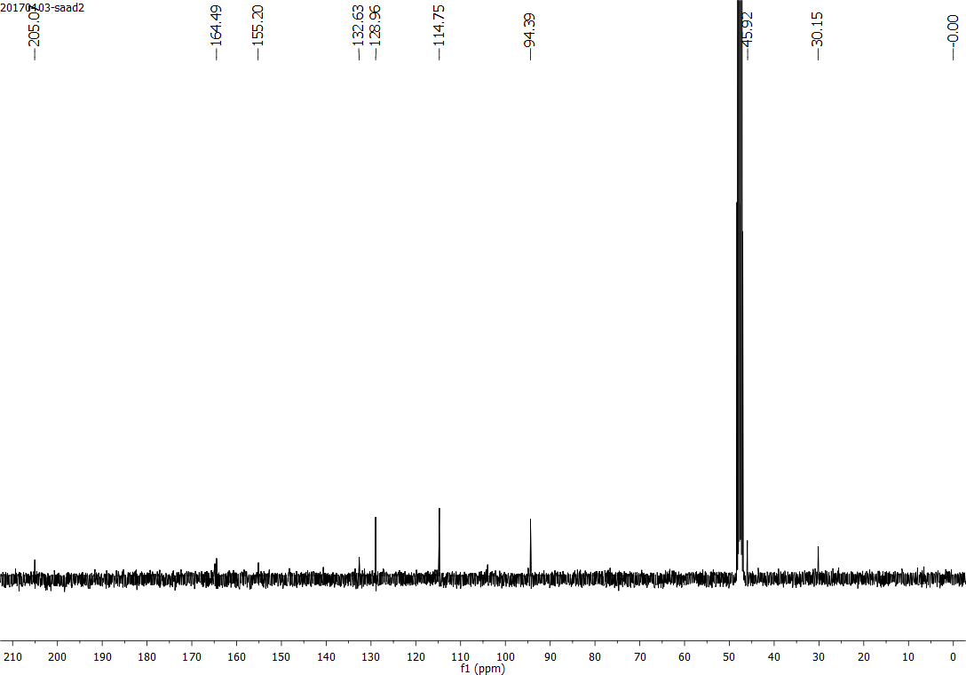
Figure S2: ¹³C NMR spectrum of Compound 1.

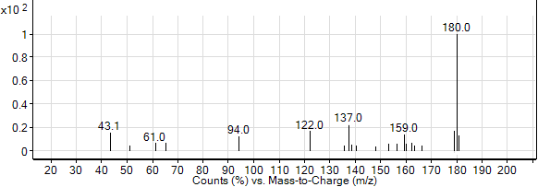
Figure S3: Mass spectrum of compound 1.

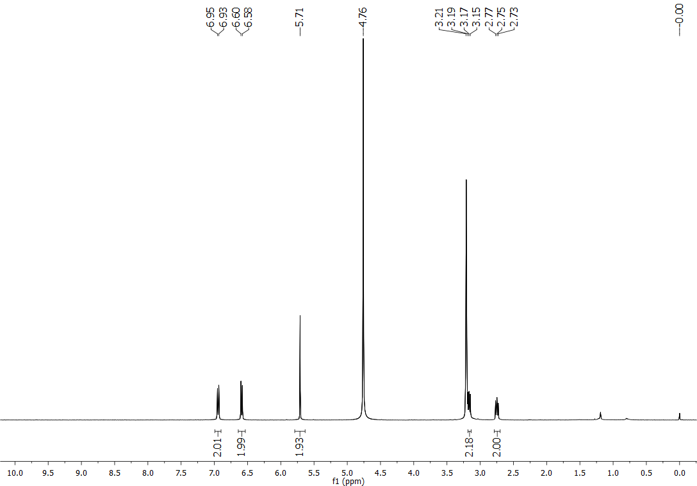
Figure S4: ¹H NMR spectrum of compound 2.
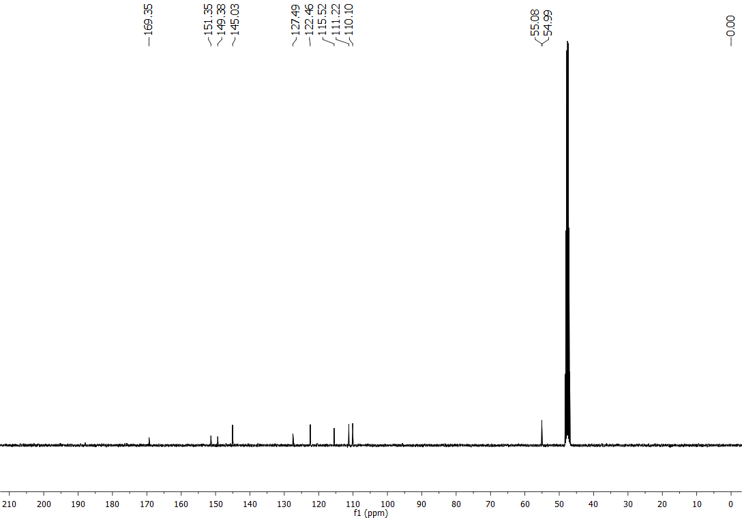
Figure S5: ¹³C NMR spectrum of compound 2.

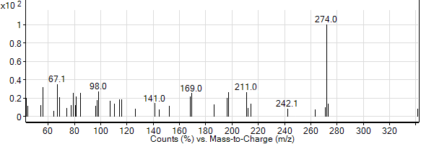
Figure S6: Mass spectrum of compound 2.

