**SUPPLEMENTARY MATERIAL**

**Table of Contents**

S1 Model Parameters

Table S1: Compartment parameters

Table S2: Portal organ data

Table S3: Other organ data

Table S4: Liver cell data

Table S5: Kinetic data

Table S6: Model calibration data

S2 Supplementary Figures

Figure S1: Schematic of sub-compartments for other tissue

Figure S2: Model calibration diagnostic plots

Figure S3: Model validation to adult rat data

Figure S4: Model validation to Q4W treatment data

Figure S5: Model validation to bolus treatment data

Figure S6: Global sensitivity analysis using PRCC method

Figure S7: Protein time-courses varying Jin and ktranslate

Figure S8: Virtual patient example

Figure S9: Local sensitivity study with recycling mechanism

Figure S10: Simulations varying cellular uptake rate

**S1 Model parameters**

**Table S1**. Compartment parameters. Macrophage volumes are calculated by multiplying cellular volume to macrophage fraction. Flow to lymph node was calculated by plasma flow/500. Portal organ volume and flow are calculated by taking the sum of portal organ data shown in table S2. Other organ volume and flow are calculated by taking the sum of other organ data shown in table S3. Volume of each tissue compartment is cited from: (1). Macrophage fraction from each tissue type is cited from: (2)

|  |  |  |  |  |  |  |  |  |
| --- | --- | --- | --- | --- | --- | --- | --- | --- |
| Compartment Parameters | | | | | | | | |
| Comp | Plasma Volume (ml) | Interstitial Volume (ml) | Cellular Volume (ml) | Macrophage Fraction | Macrophage Volume (ml) | Plasma Flow (ml/h) | Flow to Lymph Node (ml/hr) | Ref |
| Venous | 2.702 |  |  | 0.02 | 0.054 |  |  | (1,2) |
| Lung | 0.0689 | 0.078 | 0.212 | 0.04 | 0.0085 | 1188.452 | 2.377 | (1,2) |
| Arterial | 0.675 |  |  | 0.02 | 0.0135 |  |  | (1,2) |
| Portal Organ | 0.154 | 0.62 | 2.545 |  | 0.225 | 322.2 | 0.644 | (1,2) |
| Liver | 0.3996 | 0.76 | 3.191 | 0.1 | 0.319 | 8.51 | 0.017 | (1,2) |
| Other Organ | 1.747 | 13.06 | 54.15 |  | 1.376 | 851.04 | 1.702 | (1,2) |
| Lymph Node | 0.343 |  | 0.343 | 0.04 | 0.0137 | 6.78 | 0.0136 | (1,2) |

**Table S2.** Portal organ data. Macrophage volume and flow to lymph node was calculated as indicated in table S1 caption. All the volume and flow data were then summed up as portal organ volume/flow data shown in table S1. Volume of each portal organ is cited from: (1). Macrophage fraction of each portal organ is cited from: (2).

|  |  |  |  |  |  |  |  |  |
| --- | --- | --- | --- | --- | --- | --- | --- | --- |
| Portal Organ Data | | | | | | | | |
| Compartment | Plasma Volume (ml) | Interstitial Volume (ml) | Cellular Volume (ml) | Macrophage Fraction | Macrophage Volume (ml) | Plasma Flow (ml/h) | Flow to LN (ml/h) | ref |
| Small Intestine | 0.0237 | 0.259 | 1.178 | 0.04 | 0.047 | 160.61 | 0.321 | (1,2) |
| Large Intestine | 0.0136 | 0.149 | 0.68 | 0.04 | 0.0272 | 63.76 | 0.128 | (1,2) |
| Spleen | 0.0999 | 0.165 | 0.474 | 0.3 | 0.142 | 72.24 | 0.144 | (1,2) |
| Pancreas | 0.0163 | 0.0516 | 0.214 | 0.04 | 0.0086 | 25.59 | 0.051 | (1,2) |

**Table S3**. Other organ data. Macrophage volume and flow to lymph node was calculated as indicated in table S1 caption. All the volume and flow data were then summed up as other organ volume/flow data shown in table S1. Macrophage fraction for thymus and other are assumed to be 0.04. Volume of each other organ is cited from: (1). Macrophage fraction of each other organ is cited from: (2).

|  |  |  |  |  |  |  |  |  |
| --- | --- | --- | --- | --- | --- | --- | --- | --- |
| Other Organ Data | | | | | | | | |
| Compartment | Plasma Volume (ml) | Interstitial Volume (ml) | Cellular Volume (ml) | Macrophage Fraction | Macrophage Volume (ml) | Plasma Flow (ml/h) | Flow to LN (ml/h) | ref |
| Heart | 0.0117 | 0.044 | 0.239 | 0.02 | 0.0048 | 60.936 | 0.122 | (1,2) |
| Kidney | 0.0394 | 0.108 | 0.534 | 0.02 | 0.0107 | 147.295 | 0.295 | (1,2) |
| Muscle | 0.799 | 4.712 | 29.821 | 0.02 | 0.596 | 373.28 | 0.747 | (1,2) |
| Skin | 0.558 | 4.921 | 8.887 | 0.02 | 0.178 | 80.71 | 0.161 | (1,2) |
| Brain | 0.015 | 0.122 | 0.528 | 0.04 | 0.021 | 26.35 | 0.0527 | (1,2) |
| Adipose | 0.109 | 1.679 | 7.962 | 0.04 | 0.318 | 90.395 | 0.181 | (1,2) |
| Thymus | 0.0016 | 0.0049 | 0.021 | 0.04 | 0.00083 | 4.92 | 0.00985 | (1,2) |
| Bone | 0.138 | 1.16 | 4.8 | 0.04 | 0.19 | 24.78 | 0.0496 | (1,2) |
| Other | 0.076 | 0.31 | 1.357 | 0.04 | 0.054 | 42.37 | 0.0847 | (1,2) |

**Table S4**. Liver cell parameters. Hepatocyte and Kupffer cell volumes were calculated by multiplying liver volume by hepatocyte/Kupffer cell fraction.

|  |  |  |  |
| --- | --- | --- | --- |
| Liver Cell Compartment | | | |
| Cell Type | Cellular Fraction | Volume (ml) | Ref |
| Hepatocyte | 0.75 | 2.39 | (2) |
| Kupffer Cell | 0.1 | 0.319 | (2) |

**Table S5.** Kinetic parameters.

|  |  |  |  |  |
| --- | --- | --- | --- | --- |
| Kinetic Data | | | | |
| Parameter | Model Value | Unit | Description | Reference |
| Jin | 0.0017 | L/hr | Functional transfer rate of LNP from vascular to interstitial | Estimated |
| Kup | 0.9063 | 1/hr | Uptake rate by cell | Estimated |
| Sigma_i | 0.2 |  | Interstitial reflection coefficient | a |
| Kdeg_LNP | 1.6486 | 1/hr | Endosomal degradation | Estimated |
| Kescape | 0.0056 | 1/hr | Escape of LNP from endosome | Estimated |
| Ktranslate | 61540 | 1/hr | Translation rate | Estimated |
| Kdeg_mRNA | 0.1232 | 1/hr | Degradation of mRNA | Estimated |
| Kdeg_protein | 0.0189 | 1/hr | Degradation of UGT | Estimated |
| Kon_Bil | 3.6 | 1/(nM*hr) | Binding of UGT to bilirubin | b |
| Koff_Bil | 932 | 1/hr | Binding off of UGT from Bilirubin | c |
| Kcat_Bil | 3.96 | 1/hr | Catalytic rate | d |
| Ksyn_Bil | 6.49 | nmol/hr | Synthetic rate of bilirubin | Estimated |
| Kdeg_Bil_slow | 0.0126 | 1/hr | Slow degradation rate of bilirubin | e |
| Kdeg_Bil_fast | 0.2483 | 1/hr | Fast degradation rate of bilirubin | Estimated |

a) Lymphatic reflection coefficient was chosen to be 0.2 since the diameter of lymphatic vessels is much larger than the paracellular pore diameter (3).

b) Typical protein-protein binding rate (4).

c) Calculated based on Km=0.2 uM, and Km = (kcat+koff)/kon.

d) Measured in liver microsome (5).

e) Measured in Gunn rat (6).

**Table S6.** Parameters for model calibration

|  |  |  |  |  |  |  |  |
| --- | --- | --- | --- | --- | --- | --- | --- |
| Parameter | Mean | Standard Error | CV% | AIC | BIC | Log likelyhood | Note |
| $$J_{in}$$ | 0.0017 | 0.00032 | 79.9 | -432.6 | -431.9 | 224.2 | a |
| $$k_{up}$$ | 0.9063 | 0.1 | 47.2 |
| $$k_{deg}^{LNP}$$ | 1.6486 | 0.82 | 49.8 |
| $$k_{deg}^{mRNA}$$ | 0.1232 | 0.433 | 1492.1 |
| $$k_{escape}$$ | 0.0056 | 0.012 | 881.4 |
| $$k_{deg}^{UGT}$$ | 0.0189 | 0.005 | 128.2 | 161 | 163.2 | -78.5 | b |
| $$k_{translate}$$ | 61540 | 8321 | 63.4 |
| $$k_{syn}^{Bil}$$ | 6.4884 | 0.2669 | 39.2 | 1228.7 | 1231.2 | -613.3 | c |
| $$k_{deg}^{Bil,fast}$$ | 0.31 | 0.04 | 56 | 209.2 | 210.1 | -103.6 | d |

Nine parameters were estimated through four fitting processes, utilizing the ‘fminunc’ function with a constant error model. We also tested other estimation methods but found no significant differences in the results. The detailed fitting process and the data set used are explained below. The data used for model calibration can be accessed on the following website (https://www.ncbi.nlm.nih.gov/pmc/articles/PMC6391595/). The resulting observed data versus prediction, as well as residual distribution, can be found in the supplementary figures in the subsequent section.

1. Tissue transport rate ($J_{in}$), cellular uptake rate ($k_{up}$), LNP endosomal degradation rate ($k_{deg}^{LNP}$), mRNA degradation rate ($k_{deg}^{mRNA}$), and mRNA escape rate ($k_{escape}$) were all estimated by fitting to liver mRNA data. The data set used was from a 0.3 mg/kg single bolus treatment experiment group, observed over a 72-hour period for juvenile rats. Due to the high number of estimates, the resulting CV% was larger. Therefore, each parameter was fitted individually to obtain more reasonable CV% values.
2. UGT degradation rate ($k_{deg}^{UGT}$) and mRNA translation rate ($k_{translate}$) were estimated by fitting to liver UGT protein exposure data. The data set used was from a 0.3 mg/kg single bolus treatment experiment group, observed over a 72-hournperiod for juvenile rats.
3. Bilirubin synthesis rate ($k_{syn}^{Bil}$) was estimated by fitting to liver bilirubin level data. The data set used was from luciferase control case for adult rats.
4. Fast degradation rate for bilirubin ($k_{deg}^{Bil,fast}$) was estimated by fitting to liver bilirubin level data. The data set used was from a 0.5 mg/kg single bolus treatment experiment group, observed over a 32-day period for adult rats.

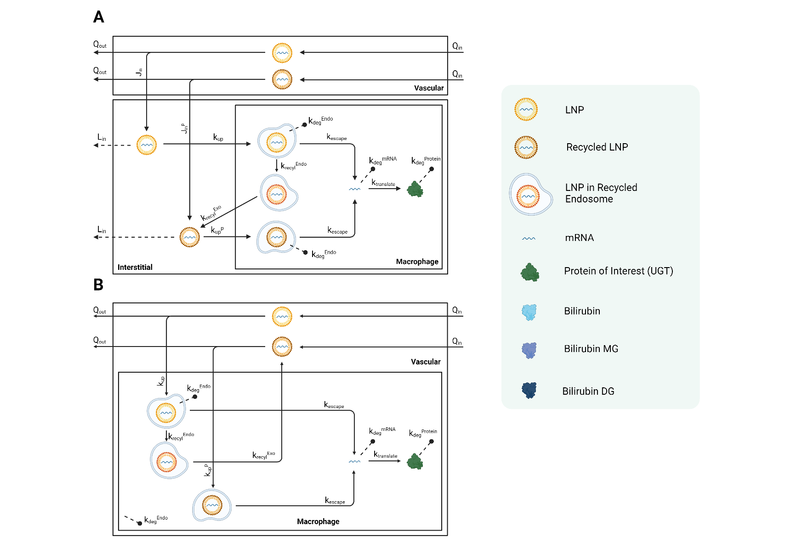**S2 Supplementary Figures**

**Figure S1.** Schematic of sub-compartments for other tissue. (A) Sub-compartments for non-liver organs. (B) Sub-compartments for blood (venous and arterial).

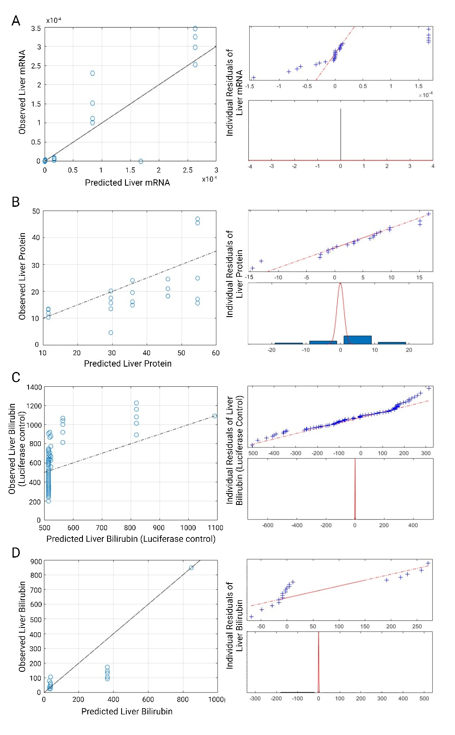

**Figure S2.** Diagnostic plots for model calibration to juvenile liver mRNA (A), juvenile liver protein (B), adult liver bilirubin with luciferase control case (C), and adult liver bilirubin level with 0.5 mg/kg treatment (D) are presented. In each panel, the observed data and compared with the model predictions, and the resulting error residuals are plotted.



**Figure S3**. Model validation to adult rat data. Simulation of plasma mRNA (A), liver mRNA (B), total bilirubin level (C) and liver protein levels (D) are compared to data. Average weight is set to 195 grams, average initial bilirubin level is set to 647 nmol, and dosage of 0.3 mg/kg is used.



**Figure S4**. Model simulation of Q4W treatment schedule with 0.5 mg/kg dosage is compared to raw data.



**Figure S5**. Model validation of single bolus dosage administration varying dosage by 0.1 mg/kg (A)**,** and 0.2 mg/kg (B). Single bolus treatment of 0.5 mg/kg data were used for model calibration to estimate fast degradation rate of bilirubin (C). Simulation results are compared to raw data.



**Figure S6.** Global sensitivity analysis using PRCC method. (A) Ranking of negatively correlated parameters determining hepatocyte protein AUC. (B) Ranking of positively correlated parameters determining hepatocyte protein AUC. (C) Ranking of negatively correlated parameters determining liver mRNA. (D) Ranking of positively correlated parameters determining liver mRNA. Super script ‘Hep’ in $k_{deg}^{mRNA,Hep}$ indicates mRNA degradation rate in hepatocyte, and ‘OO’ denotes degradation rate in macrophage located in other organs.



**Figure S7**. UGT production time courses varying Jin (A) and translation rate (B). Each of parameters are varied from 0.2 to 5 fold, and simulations were carried for 100 hours. Dosage was fixed to 0.2 mg/kg, and recycling mechanism was turned off.



**Figure S8**. Example of virtual population. 10 virtual patients were randomly chosen from 2-weekly administration schedule (A). Among 10 patients, 5 were receiving 0.05 mg/kg (B), and 5 were receiving 0.5 mg/kg (C). Dosing schedules are indicated by vertical dashed black lines in (A).



**Figure S9**. Re-run of local sensitivity analysis with recycling and redistribution mechanisms of LNP.



**Figure S10**. Simulation varying cellular uptake rate. (A) Hepatocyte UGT protein level over time. (B) hepatocyte total mRNA level, including LNP, recycled LNP and escaped mRNA. (C) Hepatocyte original LNP and recycled LNP. (D) Hepatocyte escaped mRNA level. Dosage is fixed to 0.2 mg/kg, and recycling mechanism was included.

1. Shah DK, Betts AM. Towards a platform PBPK model to characterize the plasma and tissue disposition of monoclonal antibodies in preclinical species and human. J Pharmacokinet Pharmacodyn. 2012 Feb;39(1):67–86.

2. Aborig M, Malik PRV, Nambiar S, Chelle P, Darko J, Mutsaers A, et al. Biodistribution and Physiologically-Based Pharmacokinetic Modeling of Gold Nanoparticles in Mice with Interspecies Extrapolation. Pharmaceutics [Internet]. 2019 Apr 1 [cited 2023 Sep 26];11(4). Available from: /pmc/articles/PMC6523871/

3. Garg A, Balthasar JP. Physiologically-based pharmacokinetic (PBPK) model to predict IgG tissue kinetics in wild-type and FcRn-knockout mice. J Pharmacokinet Pharmacodyn. 2007 Oct;34(5):687–709.

4. Schlosshauer M, Baker D. Realistic protein-protein association rates from a simple diffusional model neglecting long-range interactions, free energy barriers, and landscape ruggedness. Protein Science. 2004 Jun;13(6):1660–9.

5. Udomuksorn W, Elliot DJ, Lewis BC, Mackenzie PI, Yoovathaworn K, Miners JO. Influence of mutations associated with Gilbert and Crigler-Najjar type II syndromes on the glucuronidation kinetics of bilirubin and other UDP-glucuronosyltransferase 1A substrates. Pharmacogenet Genomics [Internet]. 2007 Dec [cited 2023 Sep 19];17(12):1017–29. Available from: https://journals.lww.com/jpharmacogenetics/fulltext/2007/12000/influence_of_mutations_associated_with_gilbert_and.2.aspx

6. Calvert RT, Hulshoff A, Buice RG, Kostenbauder HB. Bilirubin Dynamics in the Gunn Rat during Phototherapy. J Pharm Sci. 1978 Feb 1;67(2):205–9.