Supplementary Material

**How can multiculturalism be celebrated through teacher training in Israel?**

Noa Shapira and Meital Amzalag

**\* Correspondence:** Noa Shapira: shapira.noa@mx.kinneret.ac.il

**Figure 1** *The TPD program timeline*

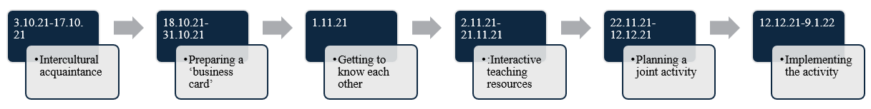

**Table 1.** *Results from a Factor Analysis of the Online Questionnaire*

|  |  |  |  |  |
| --- | --- | --- | --- | --- |
|  | Item | Factor 1: Cultural Influences | Factor 2: Positive Attitudes Toward Multiculturalism |  |
|  | 10. My culture influences my behavior. | 0.95 |  |  |
|  | 9. My culture influences my beliefs and attitudes. | 0.92 |  |  |
|  | 2. In my opinion, it is not a bad thing to marry someone from a different culture. |  | 0.67 |  |
|  | 12. I feel comfortable when I am in the company of people with a different cultural or ethnic background than mine. |  | 0.66 |  |
|  | 8. I will agree that my son/daughter marries a spouse who is not from our culture. |  | 0.66 |  |
|  | 11. I have more patience for people from different cultures than my own. |  | 0.58 |  |
|  | 6. Multicultural education is more important than reading, math, and digital literacy. |  | 0.54 |  |
|  | 7. I have friends from other cultures. |  | 0.41 |  |

**Figure 2** *Core Components Themes*

*Note*. The numbers represent the number of quotes that emerged for each sub-theme, and therefore, there may be instances where the same participant is counted more than once.

**Figure 3** *Online Interaction Themes and Sub-themes*

*Note*. The numbers represent the number of quotes that emerged for each sub-theme, and therefore, there may be instances where the same participant is counted more than once.

**Table 2.** *Visuals of the Participants’ Identities*

|  |  |  |  |
| --- | --- | --- | --- |
| Valley⎯the place where I grew up | I come from a religious-national family | I am a moshav member who lives in the desert | Bedouin traditional settlement |
|  |  |  |  |

**Table 3.** *Visuals of the Participants’ Values*

|  |  |  |  |
| --- | --- | --- | --- |
| Accept others⎯here are two of my hard of hearing students | Physical activity, nature, simplicity, challenges, and enjoyment of simple things and places that are close to us | Every person is first of all a P E R S O N! | I am a citizen of the world |
|  |  |  |  |

**Table 4.** *Visuals of the Participants’ Families*

|  |  |
| --- | --- |
| My family | My grandparents’ yard |
|  |  |

**Figure 4.** *Visiting the Participants’ Father’s Muslim Village*

**Figure 5.** *Visit and Prayer in the Participants’ Jewish Home*

**Table 5.** *Visuals of the Participants’ Traditional Food*

|  |  |  |
| --- | --- | --- |
| Tripolitanian food | Bedouin food | Moroccan food |
|  |  |  |