Supplemental material
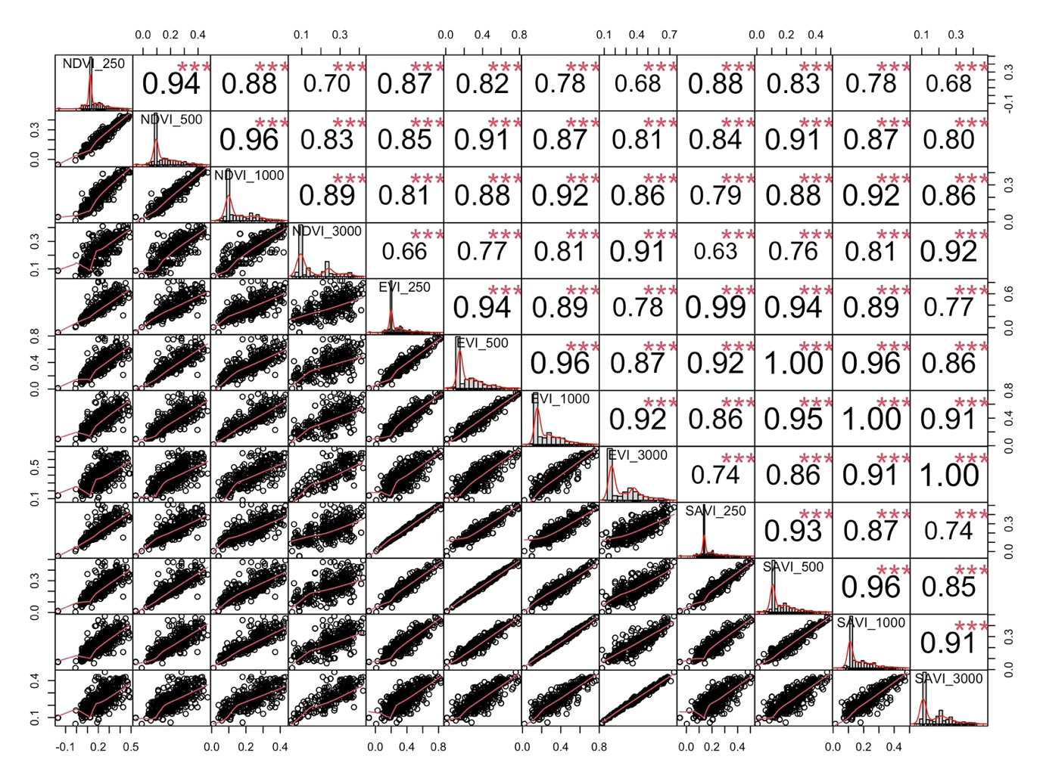
Figure S1. Correlations between estimates of greenness including NDVI 250, NDVI 500, NDVI 1000, NDVI 3000, EVI 250, EVI 500, EVI 1000, EVI 3000, SAVI 250, SAVI 500, SAVI 1000, SAVI 3000

Table S1. Changes in mental health, perceived nature exposure, and greenness in Bangladesh and Egypt during lockdown vs. the current time (N = 1216).
 | Bangladesh (N=556) |  |  |  | Egypt (N=660) |  |  |  | Country Differences (N=1216)
 | Lockdown | Current | Differenceª |  | Lockdown | Current | Differenceª |  | ΔBangladesh | ΔEgypt | Differenceª
 |  |  | t | p |  |  | t | p |  |  | t | p
Mental health
Anxiety | 2.5 | 2.13 | -4.86 | <.000 | 2.6 | 2.31 | -5.44 | <.000 | -0.37 | -0.28 | -1.06 | .29
Depression | 2.52 | 2.15 | -4.60 | <.000 | 2.89 | 2.76 | -2.05 | .041 | -0.36 | -0.12 | -2.55 | .011
Perceived exposure
Indoor plants | 1.437 | 1.275 | -3.83 | 0.000 | 1.27 | 0.76 | -10.57 | 0.000 | -0.16 | -0.51 | 5.32 | 0.000
Window views | 2.04 | 2.2 | 6.81 | 0.001 | 0.71 | 0.54 | 17.91 | 0.000 | 0.16 | -0.17 | 5.96 | 0.000
Hours spent outdoors | 1.55 | 1.86 | 3.29 | 0.000 | 1.92 | 2.77 | -5.62 | 0.000 | 0.305 | 0.85 | 8.209 | 0.000
Greenness
NDVI₅₀₀ | 0.21 | 0.19 | 12.23 | 0.000 | 0.07 | 0.1 | -48.49 | 0.000 | -0.02 | -0.03 | 1.721 | 0.85
Notes: ªt-test comparing lockdown and current means

Table S2. VIF Scores
 | Bangladesh |  | Egypt
 | Anxiety | Depression | Anxiety | Depression
Gender | 1.164 | 1.164 | 1.033 | 1.033
Age | 1.133 | 1.133 | 1.439 | 1.439
Marital status | 1.099 | 1.099 | 1.507 | 1.507
Current place of residence (urban) | 1.051 | 1.051 | 1.041 | 1.041
Monthly family income | 1.111 | 1.111 | 1.043 | 1.043
COVID-19 diagnosis | 1.029 | 1.029 | 1.064 | 1.064
Presence of long-standing illness | 1.034 | 1.034 | 1.249 | 1.249
Habit of smoking | 1.188 | 1.188 | 1.14 | 1.14
BMI | 1.067 | 1.067 | 1.012 | 1.012
Δ indoor plants | 1.105 | 1.105 | 1.033 | 1.033
Δ window views of nature | 1.12 | 1.12 | 1.027 | 1.027
Δ time spent outdoors | 1.038 | 1.038 | 1.022 | 1.022
Δ NDVI₅₀₀ | 1.028 | 1.028 | 1.026 | 1.026

Table S3. Skewness and Kurtosis Scores

 | Bangladesh |  | Egypt
 | Anxiety | Depression | Anxiety | Depression
Skewness | -0.237 | -0.073 | 0.323 | -0.128
Kurtosis | 0.874 | 0.957 | 2.199 | 0.683

Table S4. Cronbach’s Alpha Scores

 | Bangladesh |  | Egypt
 | Lockdown | Current | Lockdown | Current
Depression | 0.552 | 0.658 | 0.684 | 0.84
Anxiety | 0.582 | 0.658 | 0.617 | 0.669

