**Supplementary Material**

Characteristics of bacterial communities in rhizosphere and bulk soil in Fe-deficient citrus growing in coastal saline-alkali land

Tianchi Jiang a†, Jiuzhou Chen a†, Yu Huang b†, Xiaoyan Chang a†,Yuping Wu c,Gaoping Liu d, Runze Wang a, Kuan Xu a, Lingli Lu a, Haizhong Line* and Shengke Tian a*

**Author affiliations and addresses:s**

aMOE Key Laboratory of Environmental Remediation and Ecological Health, College of Environmental and Resource Sciences, Zhejiang University, Hangzhou 310058, China

bXiangshan Agricultural and Rural Bureau, Ningbo, China

cNingbo Agricultural and Rural Bureau, Ningbo, China

dHuangyan Agricultural and Rural Bureau, Taizhou, China

eAgricultural Technology Extension Center of Huangyan District, Taizhou, China †These authors contributed equally to this work.

**\*Corresponding author:**

MOE Key Laboratory of Environmental Remediation and Ecological Health, College of Environmental and Resource Sciences, Zhejiang University, Hangzhou 310058, China. E-mail: [tiansk@zju.edu.cn](mailto:tiansk@zju.edu.cn). Tel.: +86-571-88982515, Fax: +86-157-88982907.

Agricultural Technology Extension Center of Huangyan District, Taizhou 318020, China. E-mail: [hyhaizi@163.com](mailto:hyhaizi@163.com). Tel.: +86-0576-84219351.

**Summary of the numbers in supporting information:**

Number of pages: 4

Number of Tables: 3

**Table S1.** Physicochemical properties of the soil collected from the town of ShiPu in Ningbo City, Zhejiang Province, China

|  |  |
| --- | --- |
| **Analysis index** | **Value** |
| pH | 7.64±0.14 |
| EC (ds·m-1) | 1.70±0.09 |
| TC (%) | 1.43±0.01 |
| TN (g·kg-1) | 1.29±0.17 |
| K (g·kg-1) | 13.55±2.05 |
| Ca (g·kg-1) | 12.82±1.38 |
| Mg (g·kg-1) | 15.16±1.43 |
| Na (g·kg-1) | 9.62±0.43 |
| Zn (mg·kg-1) | 138.95±15.83 |
| Fe (g·kg-1) | 25.70±1.15 |
| Mn (mg·kg-1) | 930.27±95.92 |
| Cu (mg·kg-1) | 32.69±1.90 |

**Table. S2**. Salt anion content in the rhizosphere and bulk of coastal soil profiles. Significant differences in soil depth are indicated by small letters (P < 0.05); significant difference between rhizosphere and bulk soil is indicated by asterisks (* < 0.05, ** < 0.01)

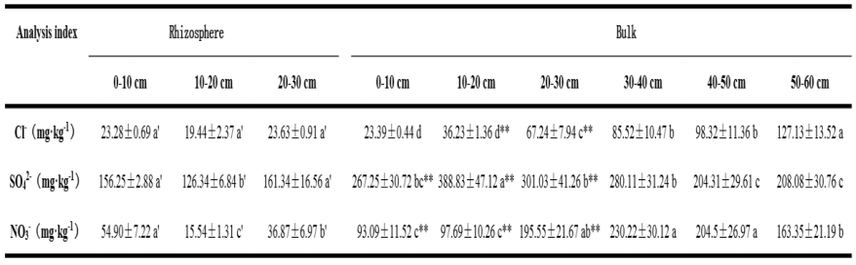

**Table S3.** Network topological indices of bacterial communities in the rhizosphere and bulk soil



**Table S4**. Bacterial composition of functional modules in the rhizosphere in response to soil nutrient variables

|  |  |  |  |  |  |
| --- | --- | --- | --- | --- | --- |
| **Module** | **Phylum** | **Class** | **Order** | **Family** | **Genus** |
| **Module 3** | Proteobacteria | Alphaproteobacteria | Rhodospirillales | Rhodospirillaceae | Skermanella |
| Proteobacteria | Alphaproteobacteria | Rhodospirillales | Rhodospirillaceae | Thalassobaculum |
| Proteobacteria | Alphaproteobacteria | Rhodobacterales | Hyphomonadaceae | Woodsholea |
| Proteobacteria | Alphaproteobacteria | Caulobacterales | Caulobacteraceae | Mycoplana |
| Proteobacteria | Betaproteobacteria | Burkholderiales | Comamonadaceae | Hydrogenophaga |
| Proteobacteria | Betaproteobacteria | Burkholderiales | Comamonadaceae | Methylibium |
| Proteobacteria | Betaproteobacteria | Burkholderiales | Burkholderiaceae | NA |
| Actinobacteria | Actinobacteria | Actinomycetales | Streptomycetaceae | Streptomyces |
| Chloroflexi | Chloroflexi | Roseiflexales | NA | NA |
| Firmicutes | Bacilli | Bacillales | NA | NA |
| **Module 7** | Proteobacteria | Alphaproteobacteria | Rhodospirillales | NA | NA |

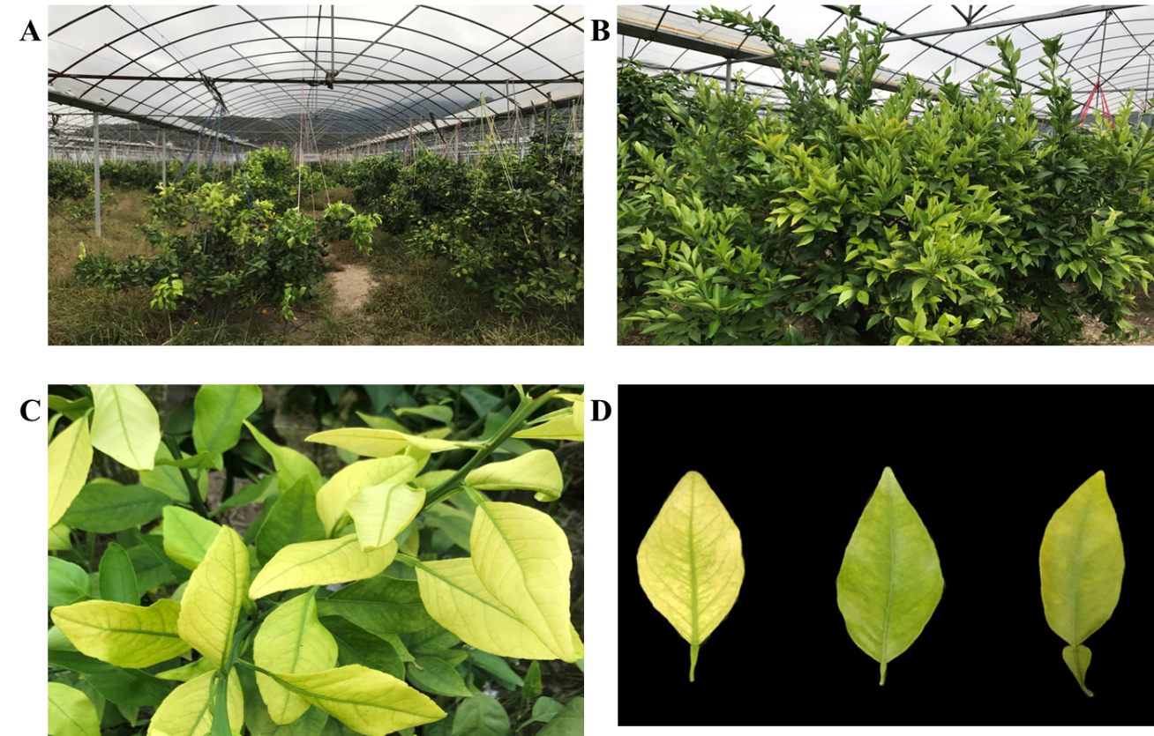

**Figure S4.** Citrus trees in saline-alkali land showed obvious iron deficiency yellowing.

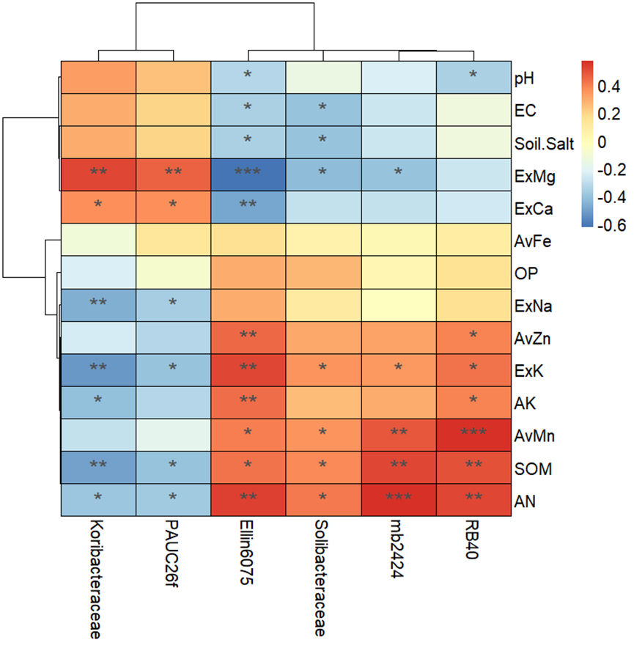

**Figure S5.** The heatmap shows the correlations between different Acidobacteria family and environmental factors. Asterisk indicates the correlation coefficient (*P < 0.05, **P < 0.01, ***P < 0.001).