Legends to Table

Supplementary Table S1 Predicted discontinuous B-cell epitopes in the final vaccine construct.
Supplementary Table S2 Intermolecular interaction details between TLRs and vaccine of the docked complexes.

Legends to figure
Supplementary Figure S1 Class combined population coverage of predicted T-cell epitopes (A) World and (B) Indian population.
Supplementary Figure S2 Structure prediction and modelling of the vaccine construct (A) 2D structure prediction and (B) 3D structure of the modelled vaccine.
Supplementary Figure S3 Interacting residues of different TLR receptors with vaccine (A) TLR-2 with vaccine (B) TLR-4 with vaccine (C) TLR-7 with vaccine (D) TLR-9 with vaccine.
Supplementary Figure S4. Normal mode analysis of docked complex. (A) NMA mobility of the vaccine-TLR-2 complex with affine-model arrows, (B) Deformability plot, (C) B-factor plot, (D) Eigenvalue plot, (E) Normal mode variance plot, (F) Covariance map and (G) Elastic network.
Supplementary Figure S5. Normal mode analysis of docked complex. (A) NMA mobility of the vaccine-TLR-9 complex with affine-model arrows, (B) Deformability plot, (C) B-factor plot, (D) Eigenvalue plot, (E) Normal mode variance plot, (F) Covariance map and (G) Elastic network.

Supplementary Table S1 Predicted discontinuous B-cell epitopes in the final vaccine construct.

S. No. | Discontinuous B-cell epitopes | Number of residues | Score
1 | DPLPPPLAPDFLSPPAE | 18 | 0.963
2 | GEAPPVPVAYSVNWDAIAQCESGGNWSINTGNGYYGGLRFTAGTWRANGGSGSAANASREEQIRVAENVLRSQGIRAWPVCGRR | 84 | 0.753
3 | MLRLVVGALLLVLAFAGGYAVAACKTVTLTVDGTAMRVTTMKSRVIDIVEENGFSVDDRDDLYPAAGVQVHDADTIVLRRSRPLQISLDGHDAKQVWTTASTVDEALAQLAMTDTAPASRASRVPLSGMALVSAKTVVHPVEGM | 144 | 0.741
4 | GEAAKSSAHVQELYAAYSPEKIFHVIAAYSSAGSADAPMKNARTTLIAAAGTVTTSPAGIANADDAGLDPAVGFDPNLPPAPDAAPVDTPPAPEDAGF | 99 | 0.683

Supplementary Table S2 Intermolecular interaction details between TLRs and vaccine of the docked complexes.

Complex | No. of salt bridges | No. of Hydrogen bonds | No. of Non-bonded contacts
TLR-2- vaccine | - | - | 140
TLR-4- vaccine | 8 | 24 | 311
TLR-7- vaccine | 8 | 16 | 225
TLR-9- vaccine | 4 | 24 | 258

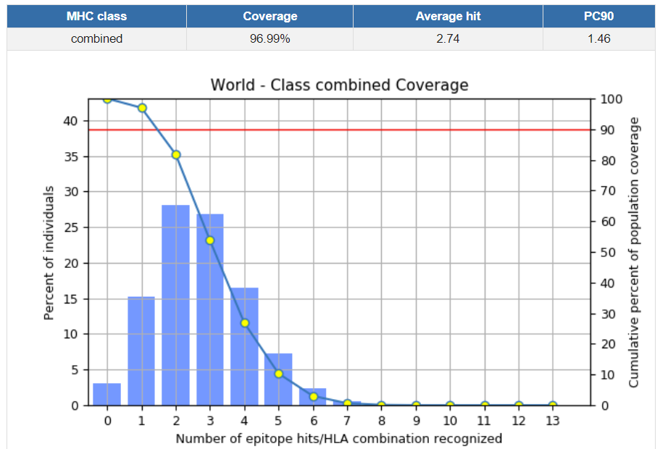
(A)
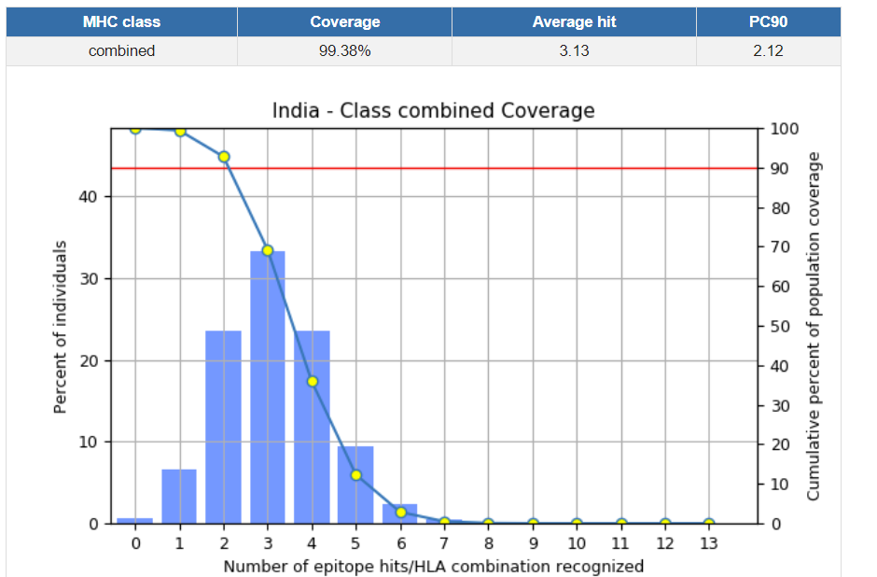
(B)
Supplementary Figure S1. Class combined population coverage of predicted T-cell epitopes (A) World and (B) Indian population.

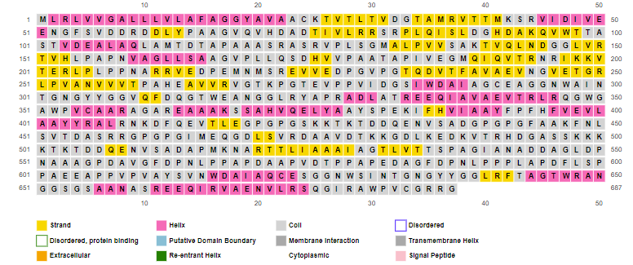
(A)
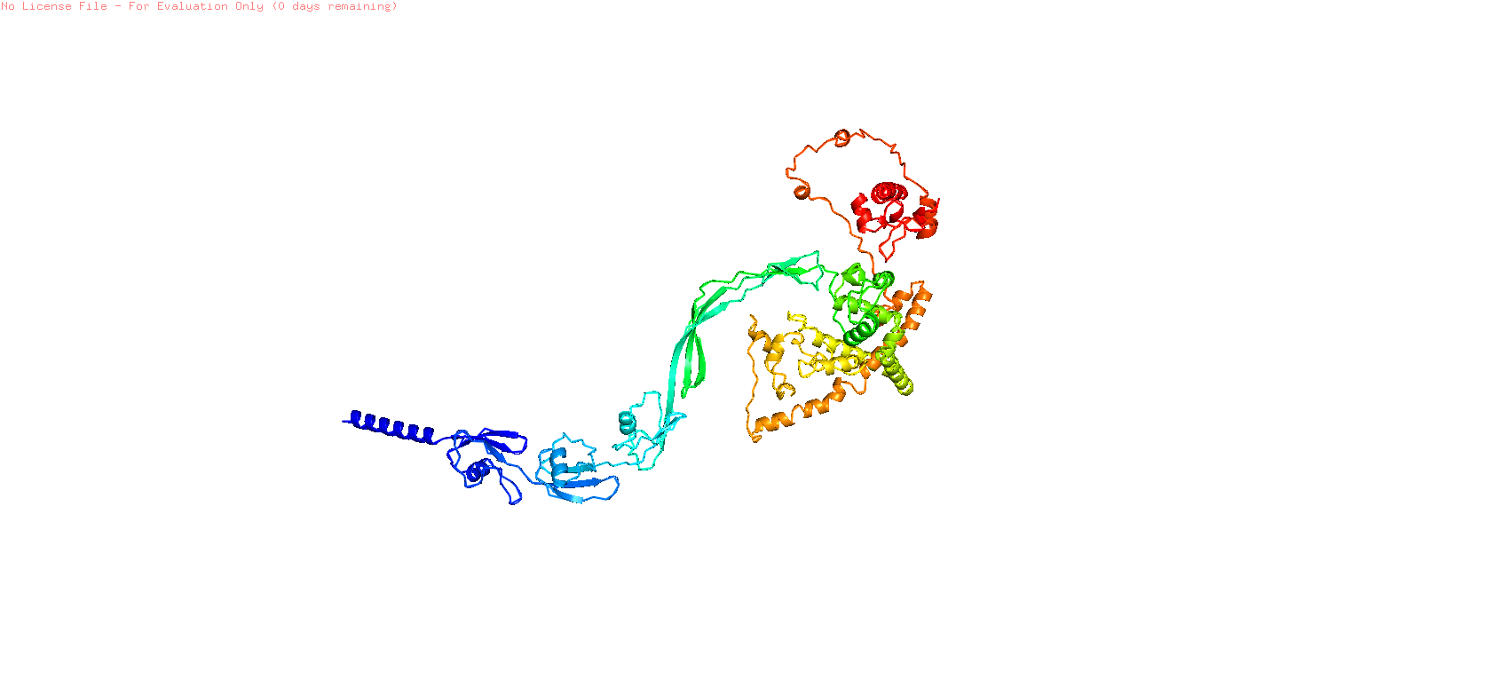
(B)
Supplementary Figure S2. Structure prediction and modelling of the vaccine construct (A) 2D structure prediction and (B) 3D structure of the modelled vaccine.

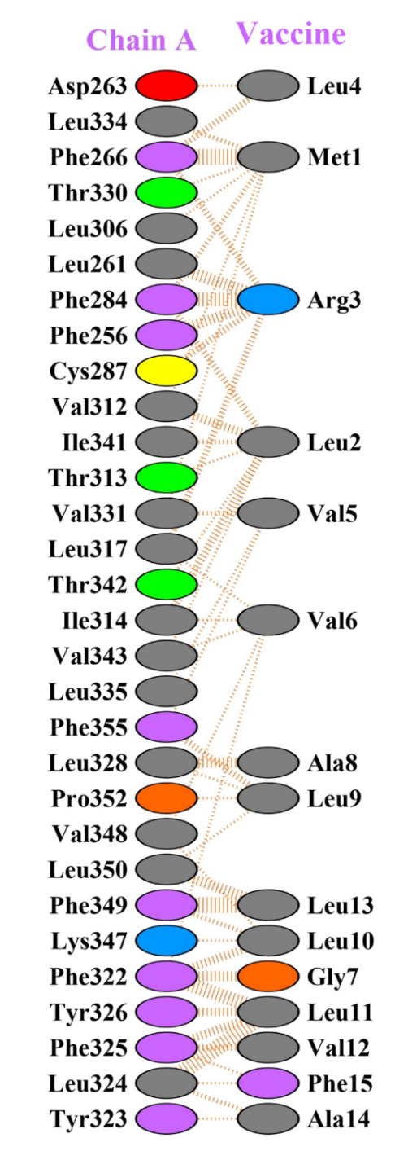
(A)
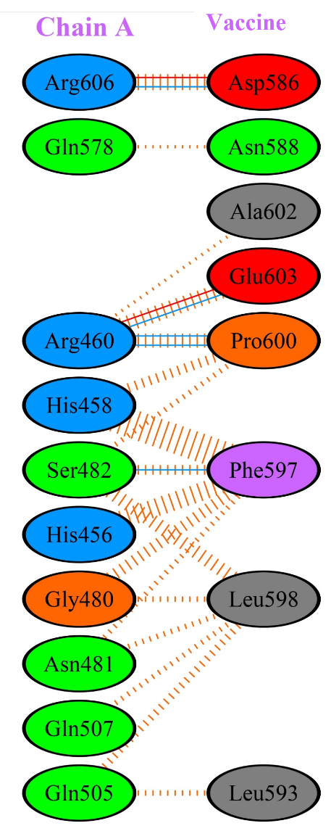 | 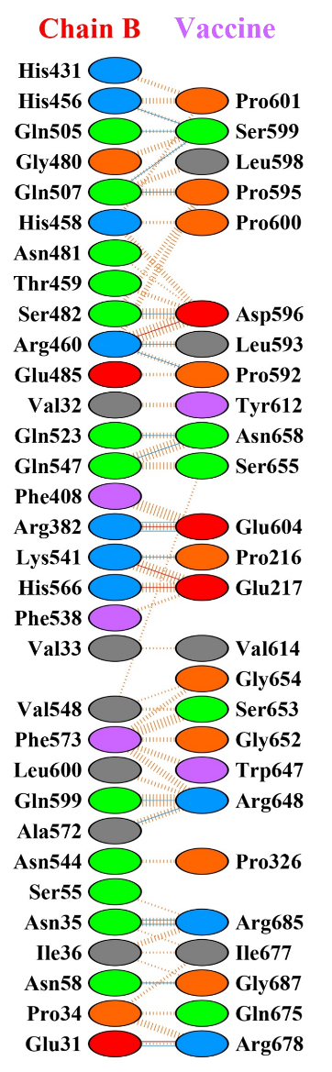
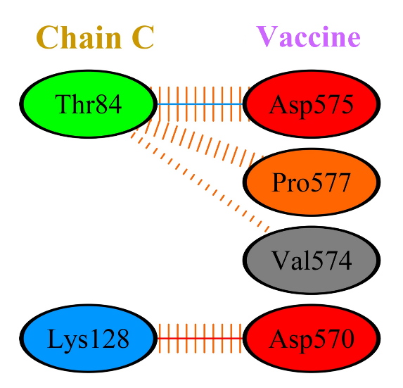 | 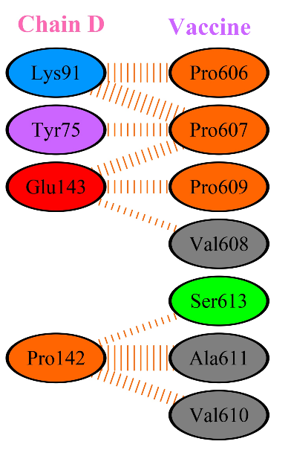
(B)
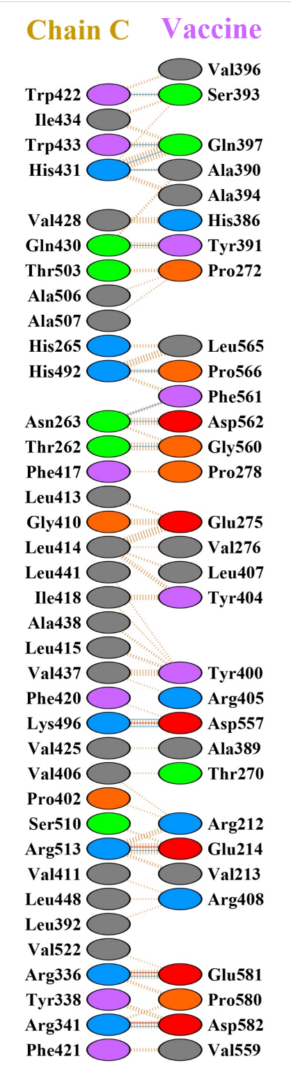 | 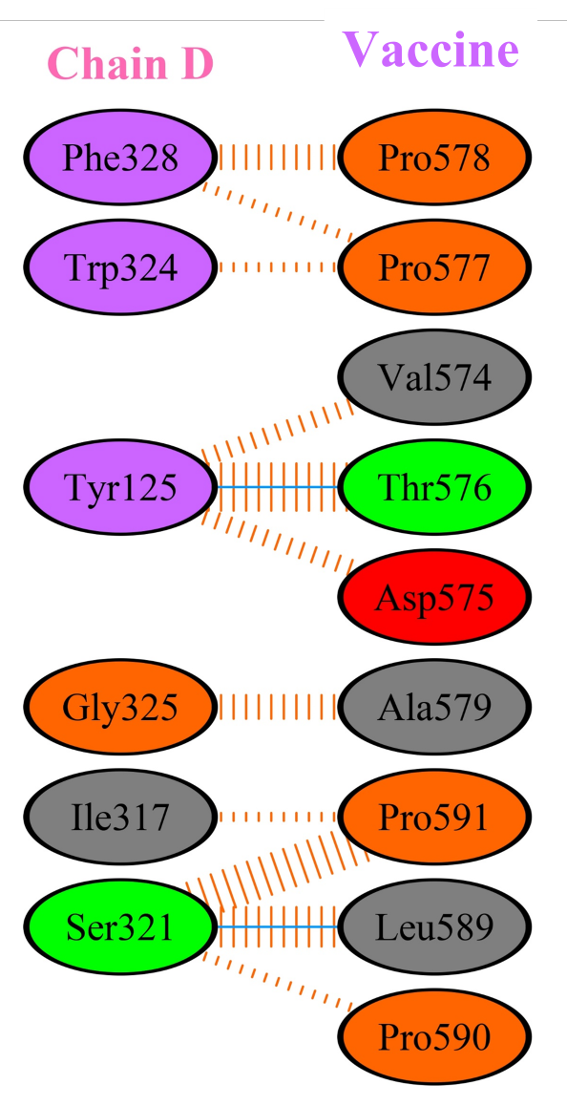
(C)
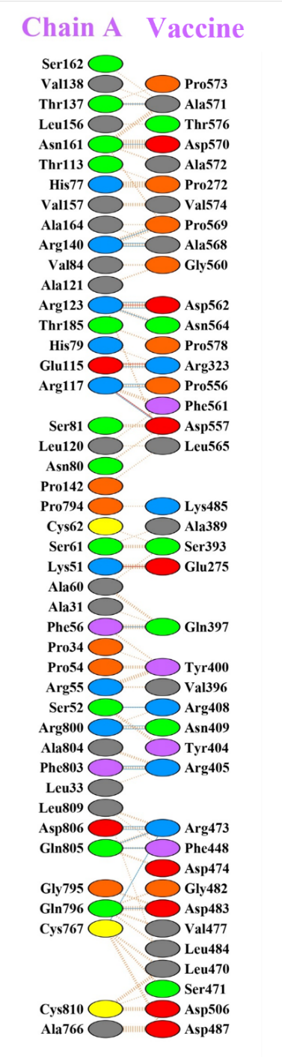
(D)
Supplementary Figure S3. Interacting residues of different TLR receptors with vaccine (A) TLR-2 with vaccine (B) TLR-4 with vaccine (C) TLR-7 with vaccine (D) TLR-9 with vaccine.

 | 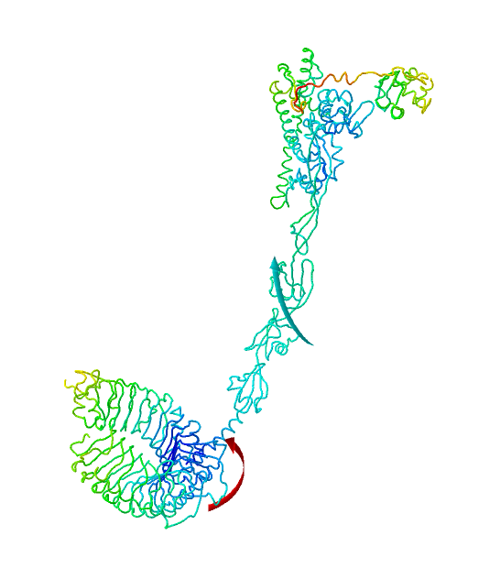
 | (A)
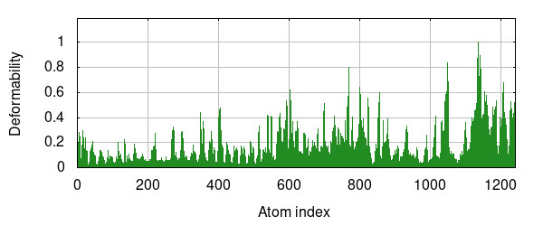 |  |  | 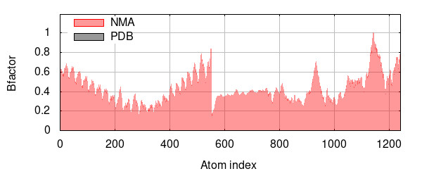
(B) |  |  | (C)
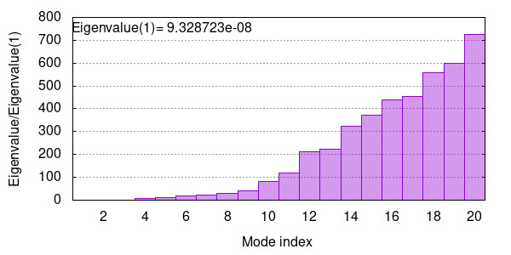 |  |  | 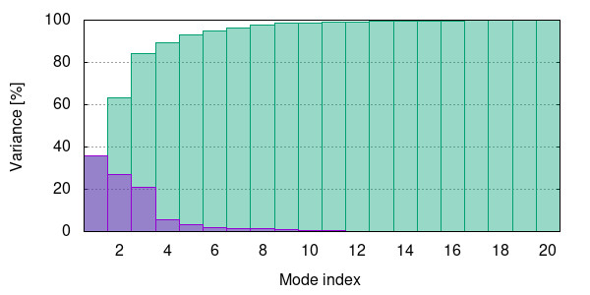
(D) |  |  | (E)
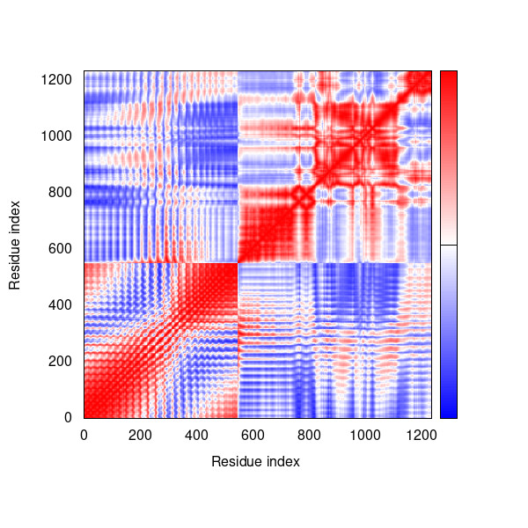 |  |  | 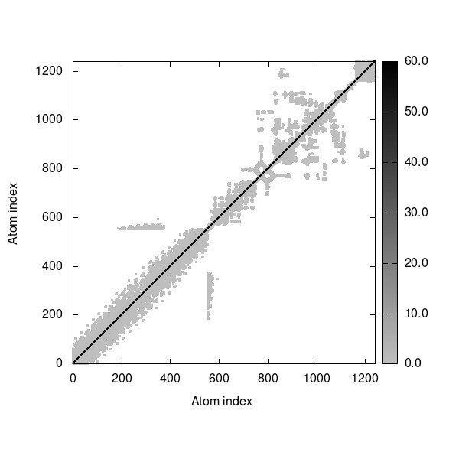
(F) |  |  | (G)
Supplementary Figure S4. Normal mode analysis of docked complex. (A) NMA mobility of the vaccine-TLR-2 complex with affine-model arrows, (B) Deformability plot, (C) B-factor plot, (D) Eigenvalue plot, (E) Normal mode variance plot, (F) Covariance map and (G) Elastic network.

 | 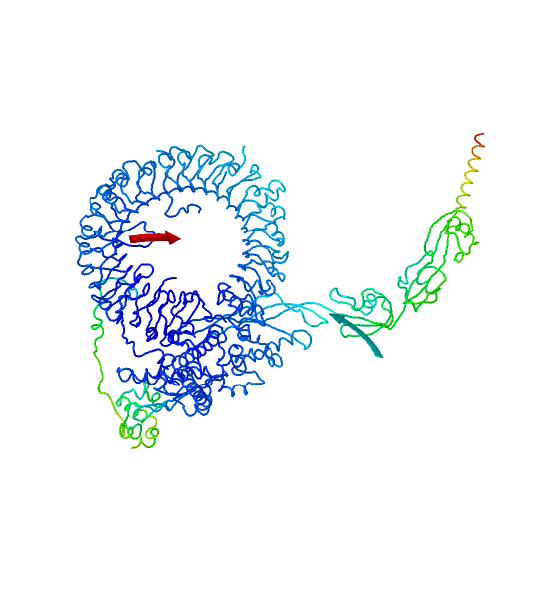
 | (A)
 | 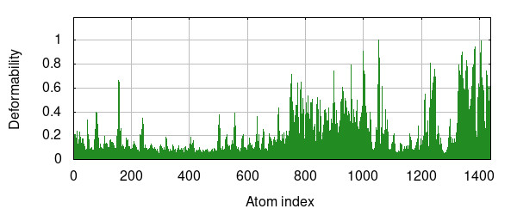 |  |  | 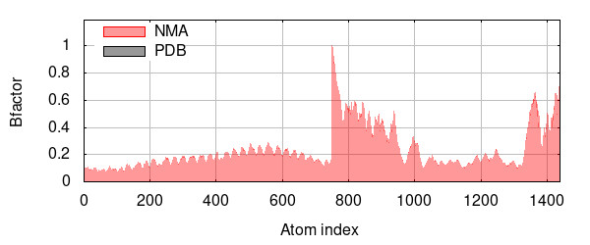
 | (B) |  |  | (C)
 | 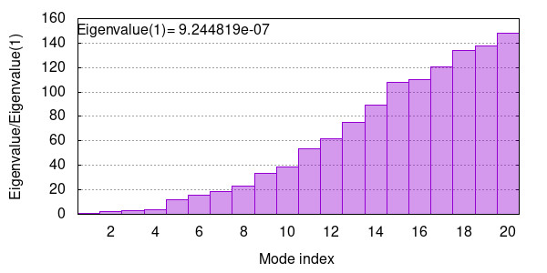 |  |  | 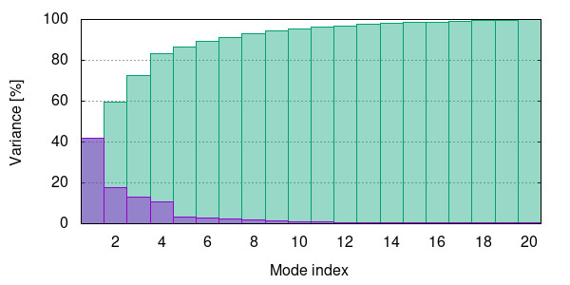
 | (D) |  |  | (E)
 | 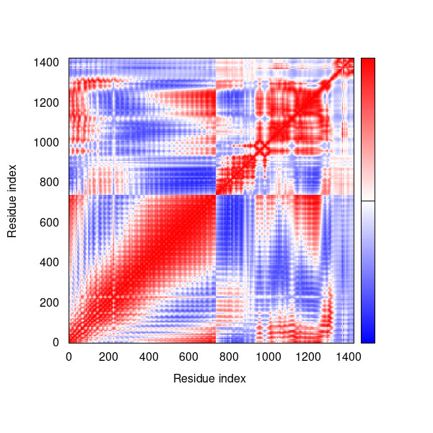 |  |  | 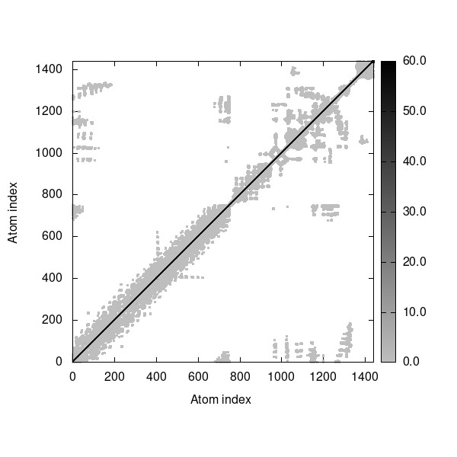
 | (F) |  |  | (G)
 | Supplementary Figure S5. Normal mode analysis of docked complex. (A) NMA mobility of the vaccine-TLR-9 complex with affine-model arrows, (B) Deformability plot, (C) B-factor plot, (D) Eigenvalue plot, (E) Normal mode variance plot, (F) Covariance map and (G) Elastic network.

