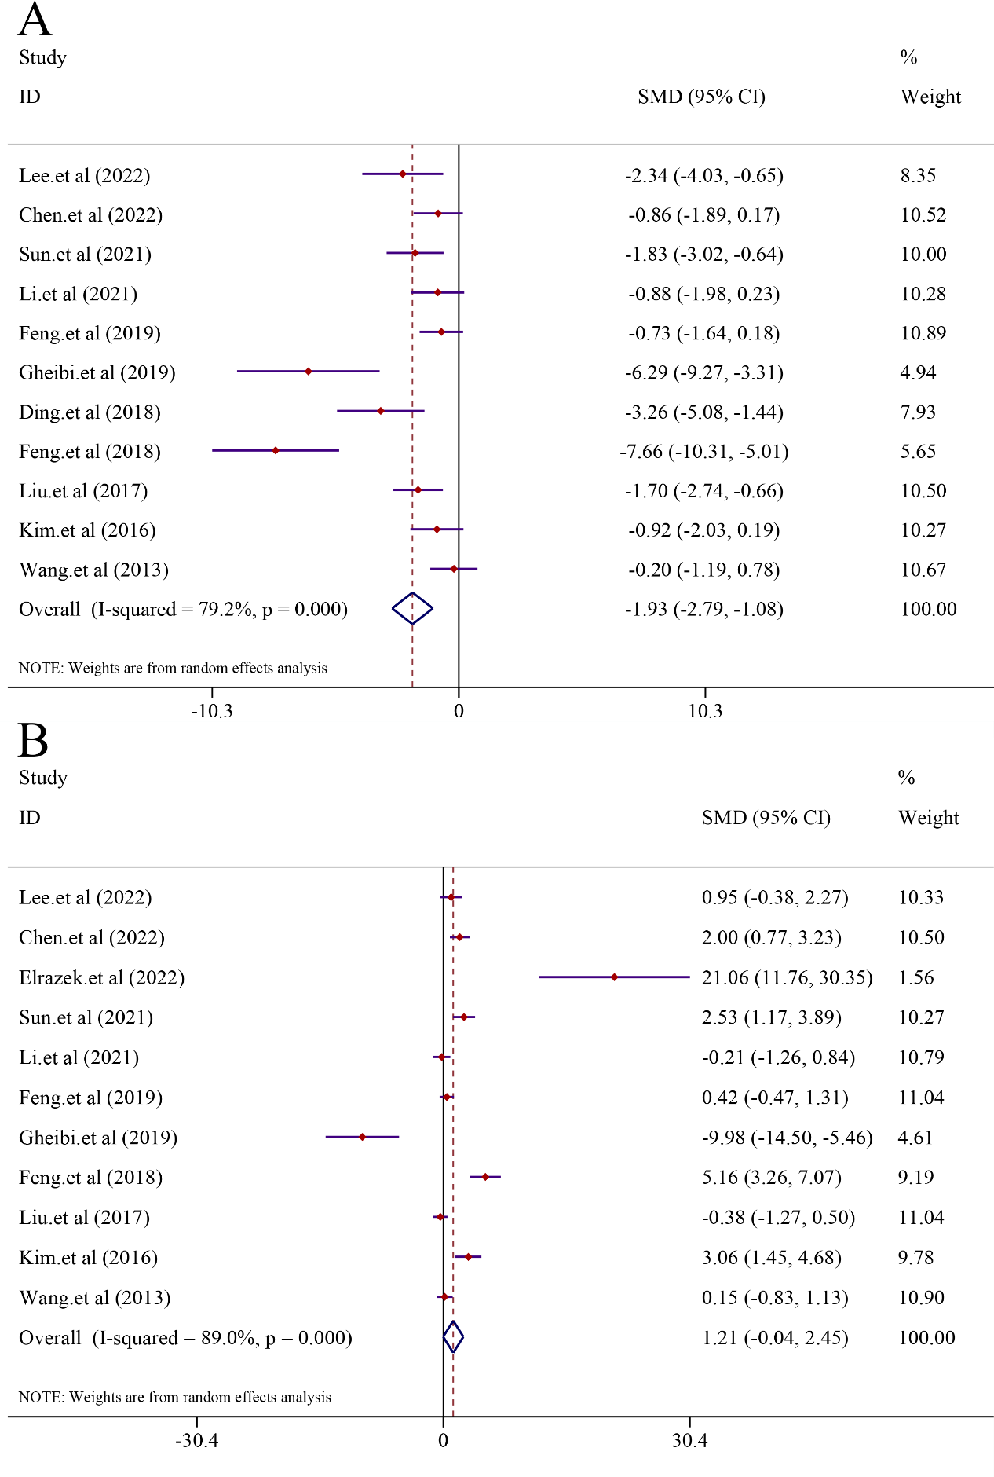 Supplementary Figure 1. Effect of curcumin on LDL and HDL levels in NAFLD

(A. Pooled effect of HDL. B. Pooled effect of LDL)



Supplementary Figure 2. Effect of curcumin on Insulin, Glucose and HOMA-IR levels in NAFLD

(A. Pooled effect of Insulin. B. Pooled effect of Glucose. C. Pooled effect of HOMA-IR.)

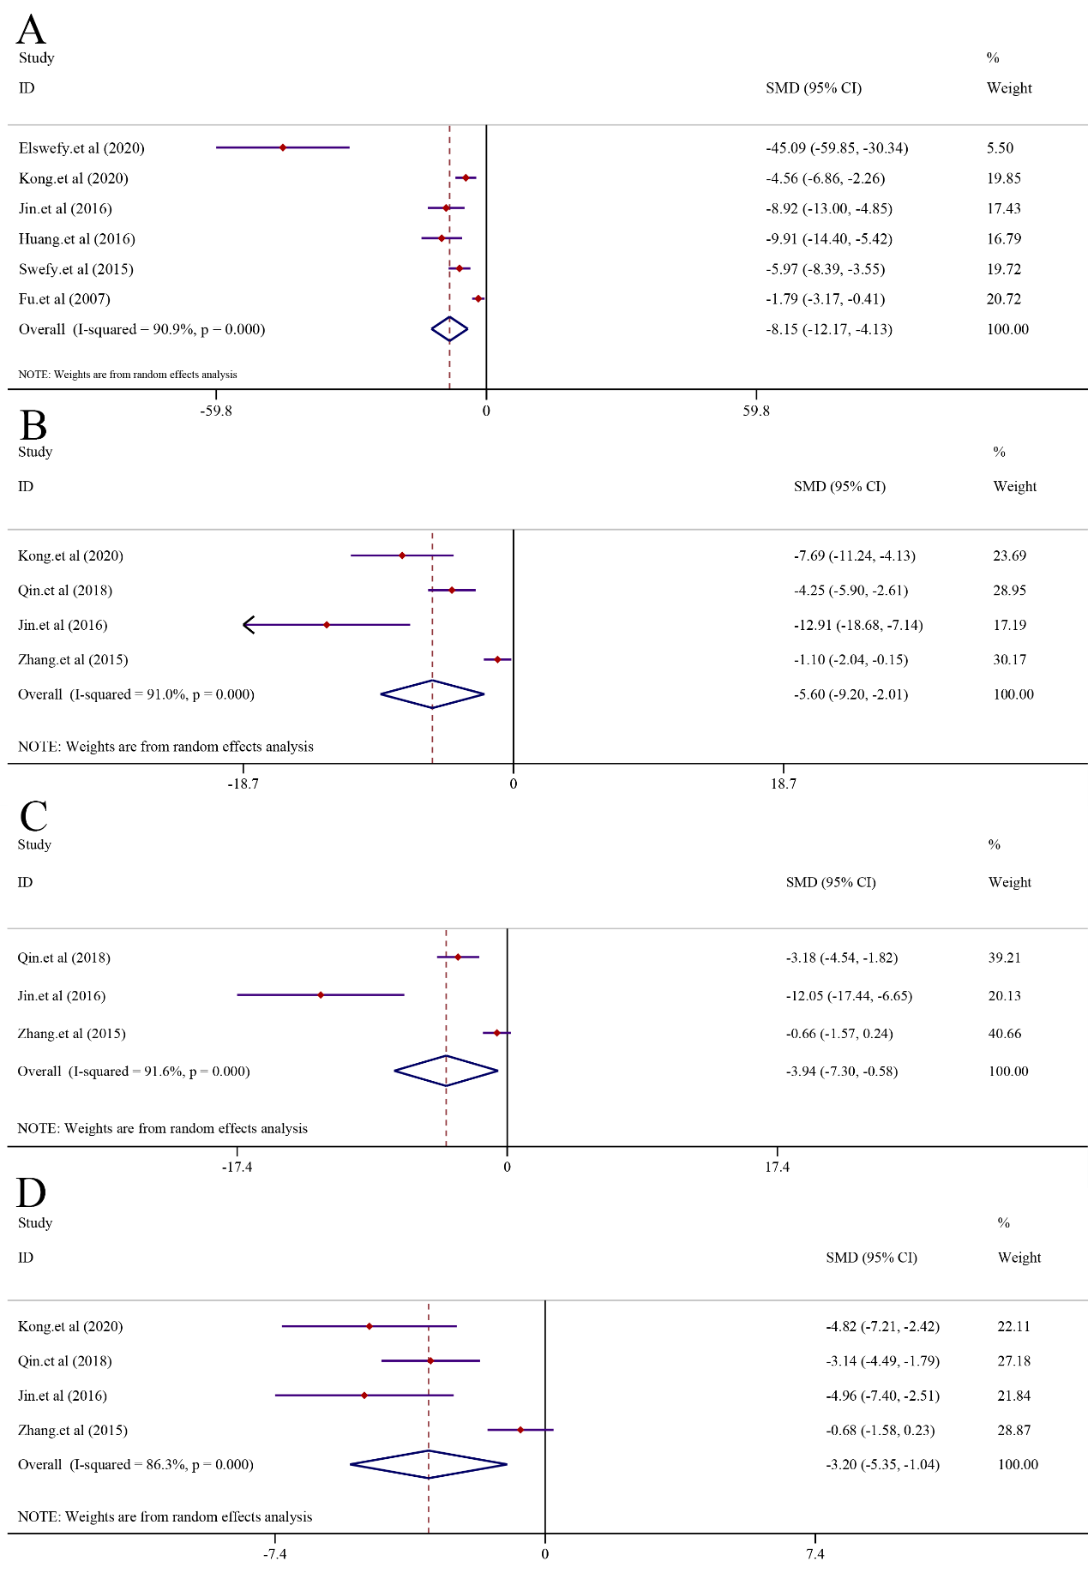 Supplementary Figure 3. Effect of curcumin on Hydroxyproline, Hyaluronidase, Laminin and Procollagen Ⅲ in liver fibrosis

1. Pooled effect of Hydroxyproline. B. Pooled effect of Hyaluronidase. C. Pooled effect of Laminin. D. Pooled effect of Procollagen Ⅲ

IL-1β,P=0.000

Supplementary Figure 4. Effect of curcumin on IL-1β levels.

C:/Users/喷火龙/Desktop/GSH,MDA.tifGSH,MDA

Supplementary Figure 5. 3D dose/time-effect images. (A)GSH; (B)MDA

C:/Users/喷火龙/Desktop/敏感性分析/未标题-1.tif未标题-1

Supplementary Figure 6. The plot of Sensitivity test. (A) ALT; (B) AST; (C) TNF-α; (D) IL-6;

1. IL-1β.

C:/Users/喷火龙/Desktop/Egger's/未标题-1.tif未标题-1

Supplementary Figure 7. Egger’s publication bias plot. (A) ALT; (B) AST; (C) TNF-α; (D) IL-6;

1. IL-1β.