Supplementary Material

Supplementary Tables
Table S1: P-values of the main effects and interaction effects of irrigation scheduling and nutrient stress on nutrient concentrations of corn biomass sampled at the vegetative stage under overhead irrigation and SSDI systems.
Effects | N | P | K | Mg | Ca | S | B | Zn | Mn | Fe | Cu | Mo
 | ----------------------------------------------------------- Overhead --------------------------------------------------------
IS | 0.046 | 0.927 | 0.669 | 0.833 | 0.641 | 0.787 | 0.972 | 0.597 | 0.943 | 0.499 | 0.617 | 0.587
NS | 0.000 | 0.001 | 0.305 | 0.003 | 0.001 | 0.393 | 0.287 | 0.000 | 0.000 | 0.088 | 0.382 | 0.001
IS×NS | 0.020 | 0.243 | 0.676 | 0.386 | 0.855 | 0.882 | 0.738 | 0.520 | 0.934 | 0.706 | 0.660 | 0.277
 | ------------------------------------------------------------ SSDI -------------------------------------------------------------
IS | 0.024 | 0.477 | 0.610 | 0.869 | 0.939 | 0.137 | 0.333 | 0.795 | 0.654 | 0.907 | 0.701 | 0.895
NS | 0.000 | 0.077 | 0.232 | 0.267 | 0.029 | 0.222 | 0.000 | 0.026 | 0.013 | 0.003 | 0.006 | 0.000
IS × NS | 0.590 | 0.491 | 0.611 | 0.660 | 0.604 | 0.662 | 0.153 | 0.401 | 0.709 | 0.296 | 0.913 | 0.384
Bold texts highlight significant effects (P < 0.05). SSDI: Subsurface drip irrigation; IS: Irrigation schedule; NS: Nutrient stress.

Table S2: P-values of the main effects and interaction effects of irrigation scheduling and nutrient stress on biomass and nutrient uptake of corn sampled at the vegetative stage under overhead irrigation and SSDI systems.
Effects | Biomass | N | P | K | Mg | Ca | S | B | Zn | Mn | Fe | Cu | Mo
 | --------------------------------------------------------------- Overhead -------------------------------------------------------------
IS | 0.051 | 0.039 | 0.140 | 0.035 | 0.032 | 0.037 | 0.059 | 0.071 | 0.063 | 0.142 | 0.121 | 0.062 | 0.051
NS | 0.000 | 0.000 | 0.000 | 0.000 | 0.000 | 0.000 | 0.000 | 0.000 | 0.000 | 0.000 | 0.000 | 0.000 | 0.002
IS×NS | 0.125 | 0.019 | 0.402 | 0.069 | 0.333 | 0.125 | 0.112 | 0.131 | 0.264 | 0.156 | 0.193 | 0.253 | 0.781
 | ----------------------------------------------------------------- SSDI -----------------------------------------------------------------
IS | 0.514 | 0.788 | 0.434 | 0.433 | 0.525 | 0.599 | 0.848 | 0.487 | 0.890 | 0.513 | 0.825 | 0.896 | 0.334
NS | 0.000 | 0.000 | 0.000 | 0.000 | 0.000 | 0.000 | 0.000 | 0.000 | 0.000 | 0.000 | 0.000 | 0.000 | 0.004
IS×NS | 0.963 | 0.926 | 0.929 | 0.935 | 0.821 | 0.809 | 0.870 | 0.813 | 0.775 | 0.767 | 0.913 | 0.714 | 0.570
Bold texts highlight significant effects (P < 0.05). SSDI: Subsurface drip irrigation; IS: Irrigation schedule; NS: Nutrient stress.

Table S3: P-values of the main effects and interaction effects of irrigation scheduling and nutrient stress on growth and yield parameters of corn under overhead irrigation and SSDI systems.
Effects | Grain  yield | Plant  height | Stover | Harvest  index | TSW | Ear  height | Ear  length | Ear  diameter | Ear grain rows
 | -------------------------------------------------- Overhead --------------------------------------------------
IS | 0.099 | 0.354 | 0.660 | 0.584 | 0.937 | 0.301 | 0.841 | 0.323 | 0.382
NS | 0.003 | 0.244 | 0.000 | 0.003 | 0.145 | 0.065 | 0.023 | 0.000 | 0.000
IS×NS | 0.913 | 0.298 | 0.581 | 0.909 | 0.852 | 0.120 | 0.971 | 0.063 | 0.111
 | -------------------------------------------------- SSDI --------------------------------------------------
IS | 0.039 | 0.337 | 0.034 | 0.795 | 0.867 | 0.445 | 0.243 | 0.426 | 0.892
NS | 0.000 | 0.029 | 0.000 | 0.018 | 0.008 | 0.400 | 0.148 | 0.002 | 0.012
IS×NS | 0.831 | 0.132 | 0.878 | 0.621 | 0.421 | 0.611 | 0.444 | 0.267 | 0.682

Bold texts highlight significant effects (P < 0.05). SSDI: Subsurface drip irrigation; IS: Irrigation schedule; NS: Nutrient stress; TSW: Thousand seed weight.

Supplementary Figure
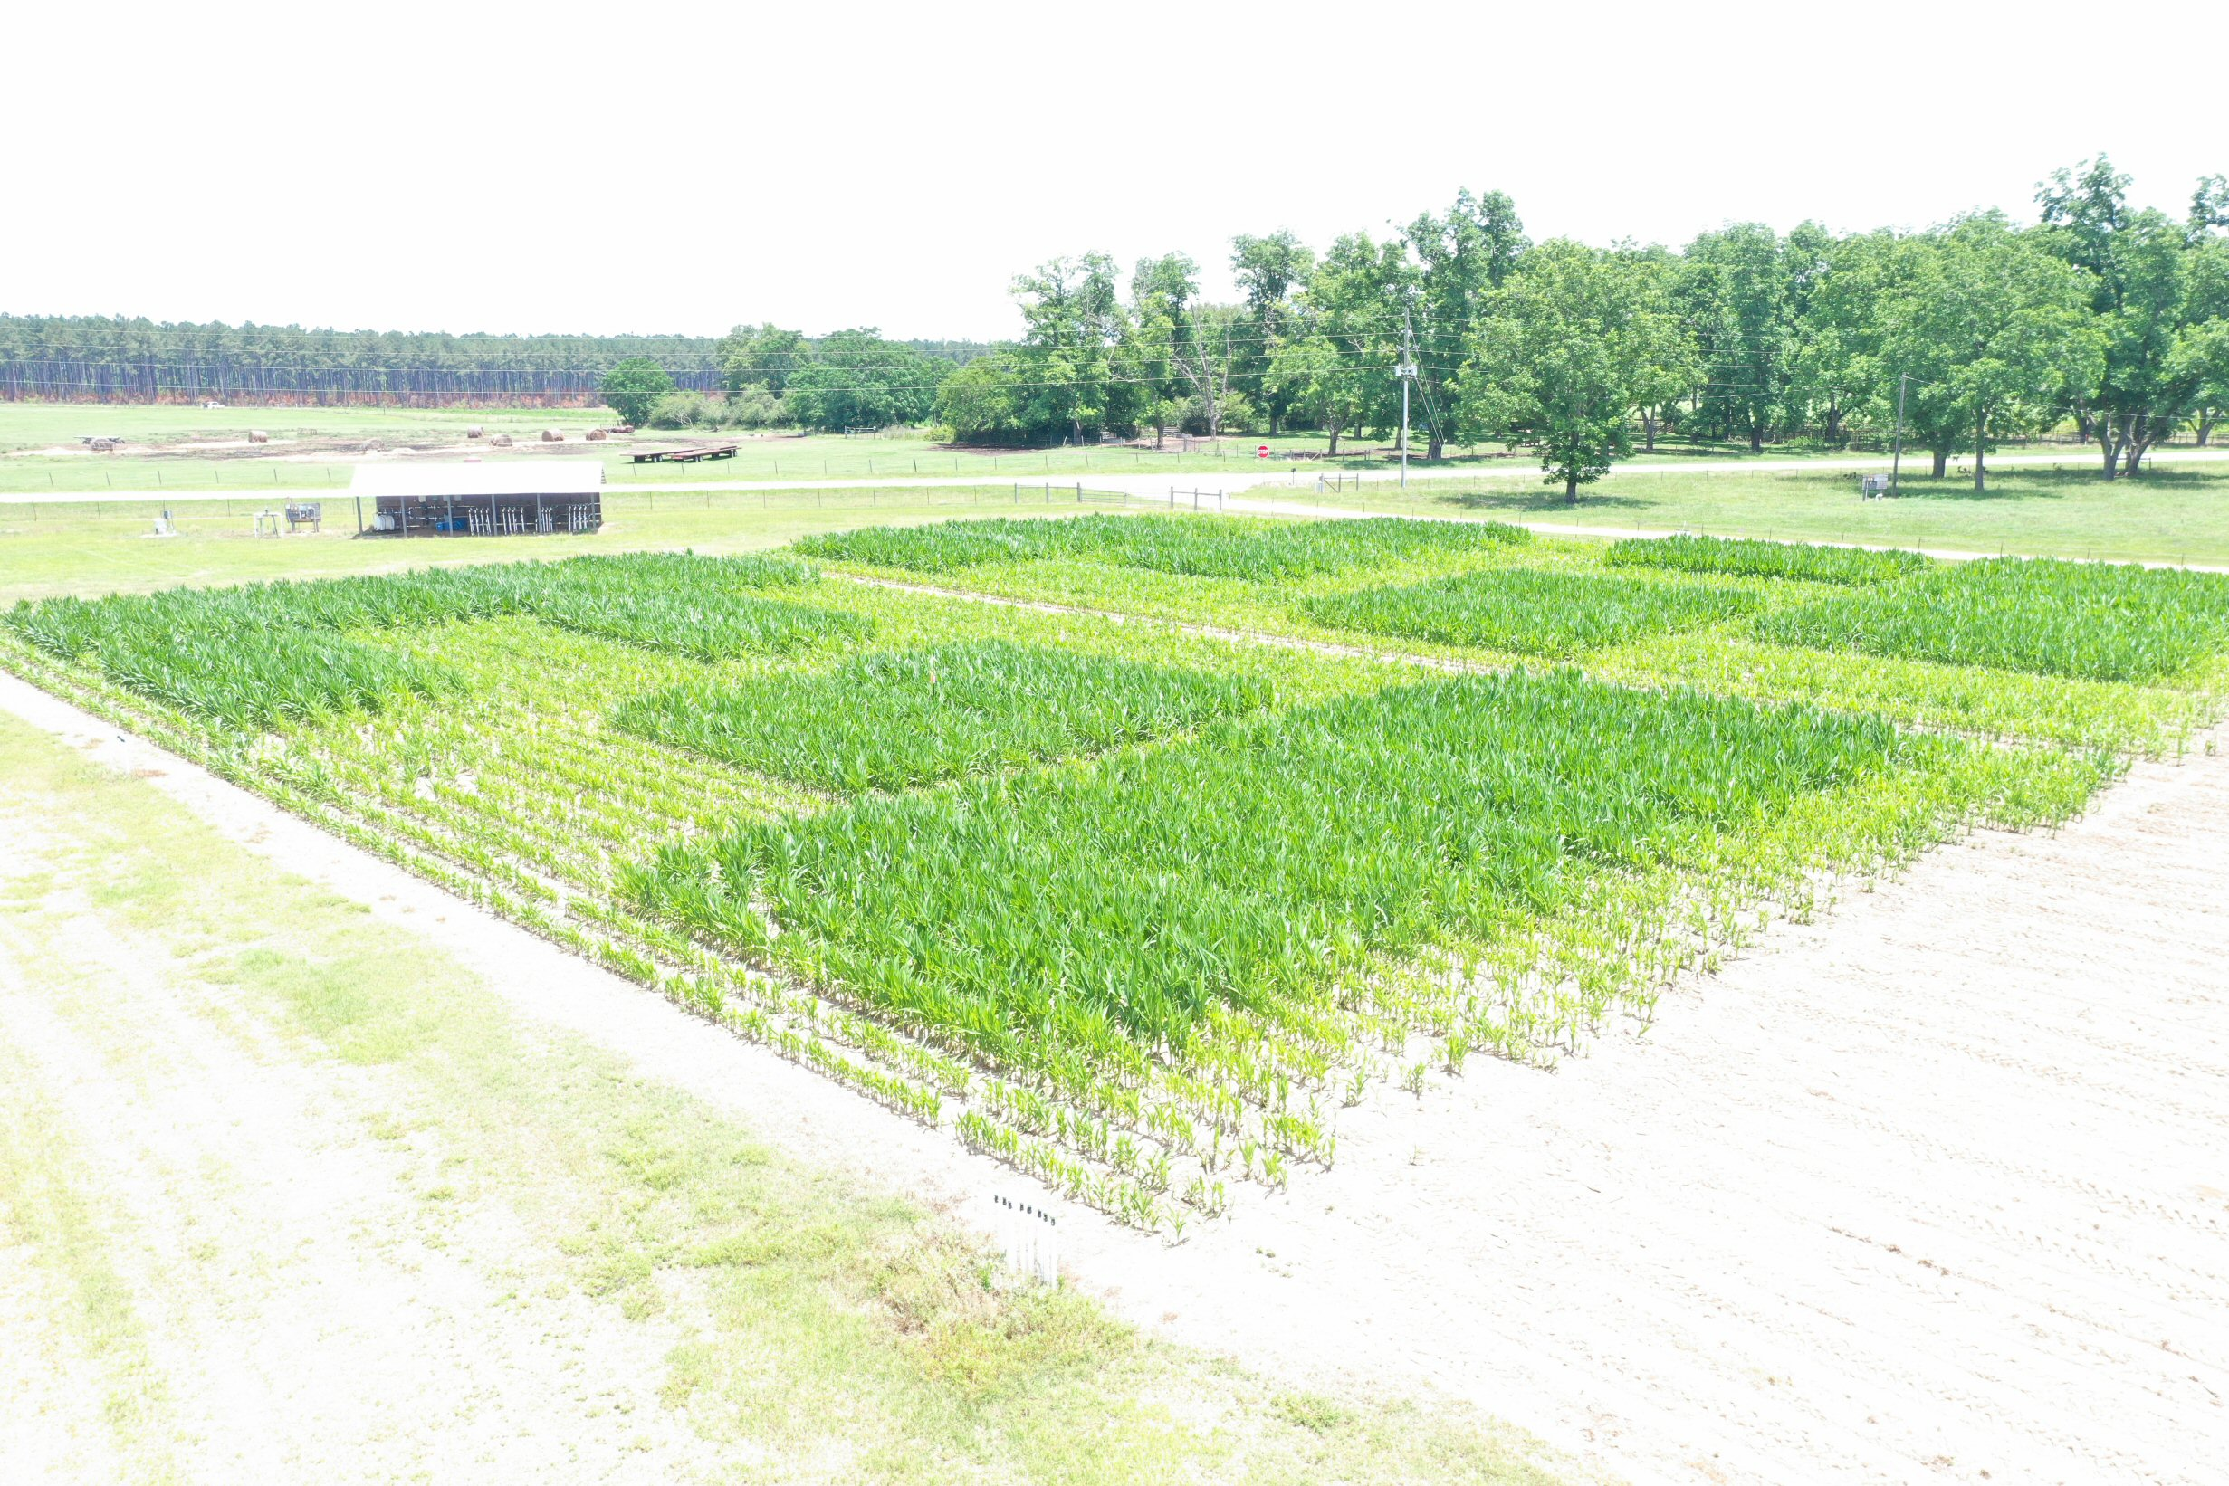
Figure S1. Drone image of the subsurface drip irrigation field in Camilla, GA, USA, showing poor growth of the early season nutrient stress plots. The early season nutrient stress plots received no nutrient application until the V6 growth stage.

