Supplementary Table S1: Major chemicals from Z. roseum leaf extract predicted to have certain biological activity.
Name | Predicted biological Activity/MOA
3,4 dihydroxybenzoic acid | Anti-inflammatory  Leukotriene-B4 20-monooxygenase inhibitor  Antiinfective
 | Prostaglandin-A1 DELTA-isomerase inhibitor
 | Peroxidase inhibitor
 | Mucomembranous protector
 | Histamine release inhibitor
 | Antimutagenic
 | Antipyretic
Epicatechin | Membrane integrity agonist
 | Hepatoprotectant
 | Mucomembranous protector
 | Antioxidant
 | Lipid peroxidase inhibitor
 | Cardioprotectant
 | Histamine release inhibitor
Trans-Ferulic acid | Antiinflammatory
 | Mucomembranous protector
 | Peroxidase inhibitor
 | TNF expression inhibitor
 | Antipyretic
 | Membrane permeability inhibitor
 | Antimutagenic
Rosmarinic acid | Reductant
 | Antihypoxia
 | Inhibition of lipid peroxidase
 | Agonist of membrane integrity
 | Inhibition of membrane permeability
 | TNF expression inhibitor
 | Antidiabetic
Rutin hydrate | Antiinflammatory  Membrane permeability inhibitor
 | Inhibition of lipid peroxidase
 | Hepatoprotectant
 | Proliferative diseases treatment
 | Antioxidant
 | Kinase inhibitor
 | Antineoplastic
 | Cardioprotectant
Myricetin | Antiinflammatory  Interleukin 4 antagonist  Cardioprotectant
 | Inhibition of peroxidase
 | Inhibition of mutagenesis
 | Inhibition of kinase
 | Antioxidant
 | Agonist of apoptosis
 | Antihemorrhagic
p-Coumaric acid | Protector of mucomembrane  Prostaglandin-E2 9-reductase inhibitor  Antiinflammatory
 | Antimutagenic
 | Antihypoxic
 | Reductant
TNF expression inhibitor
Peroxidase inhibitor
Antiseptic

Supplementary Table S2: The number of hydrogen bonds and the binding affinity were discovered following molecular docking.
Ligand | No of hydrogen bond | Binding affinity (kcal/mol)
Celecoxib | 4 | -8.7
3,4 Dihydroxy benzoic acid | 2 | -5.8
(-) Epicatechin | 2 | -7.0
Trans-ferulic acid | 2 | -6.5
Rosmarinic acid | 4 | -6.2
Rutin hydrate | 8 | -8.5
Myricetin | 2 | -7.7
p-Coumaric acid | 2 | -6.3

Supplementary Table S3: ADMET Characteristics of phenolic compounds identified in ZrlME.
Name | BBB-penetration | MDCK | Caco-2 | HIA | PPB | Skin permeation | Toxicity
3,4 dihydroxy benzoic acid | 0.442883 | 23.6995 | 18.3046 | 74.749630 | 27.115512 | -3.31434 | None
Epicatechin | 0.394913 | 44.3849 | 0.656962 | 66.707957 | 100.0 | -4.29301 | None
Trans-ferulic acid | 0.758419 | 228.559 | 21.1177 | 90.603297 | 50.414225 | -1.87204 | None
Rosmarinic acid | 0.104434 | 0.20263 | 20.7246 | 62.487577 | 86.242087 | -3.32759 | None
Rutin hydrate | 0.028625 | 0.13668 | 9.08073 | 0.941542 | 67.257863 | -4.08573 | None
Myricetin | 0.110308 | 4.88225 | 0.991395 | 40.964049 | 96.784810 | -4.5272 | None
p- Coumaric acid | 0.694635 | 75.0598 | 21.1093 | 92.095876 | 63.055072 | -1.70767 | None

Supplementary Table S4: Risks associated with compounds’ bioactivity and toxicity.
Compounds | Structure | Bioactivity |  |  |  |  |  | Toxicity Risks
 |  | GPCRL | EI | PI | NRL | KI | ICM | Drug Likeness | Drug score
3,4 dihydroxy benzoic acid | 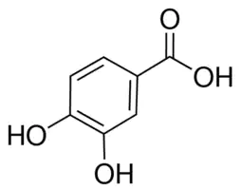 | -0.88 | -0.34 | -1.09 | -0.58 | -1.10 | -0.35 | -0.12 | 0.43
Epicatechin |  | 0.41 | 0.47 | 0.26 | 0.60 | 0.09 | 0.14 | 1.92 | 0.89
Trans ferulic acid |  | -0.47 | -0.12 | -0.81 | -0.14 | -0.72 | -0.30 | 1.12 | 0.19
Rosmarinic acid |  | 0.17 | 0.24 | 0.15 | 0.57 | -0.18 | -0.08 | -2.07 | 0.50
Rutin hydrate | 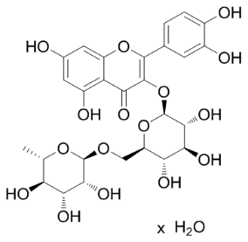 | -0.05 | 0.12 | -0.07 | -0.23 | -0.14 | -0.52 | 3.31 | 0.57
Myricetin |  | -0.06 | 0.30 | -0.20 | 0.32 | 0.28 | -0.18 | 0.75 | 0.47
p-Coumaric acid | 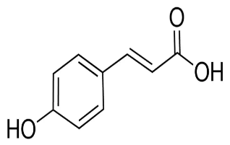 | -0.56 | -0.15 | -0.87 | -0.12 | -0.91 | -0.26 | 0.58 | 0.79
Celecoxib | 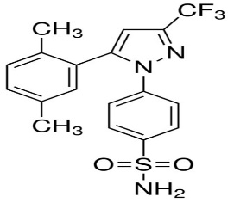 | -0.06 | 0.17 | -0.06 | -0.28 | 0.01 | -0.27 | -8.11 | 0.37

