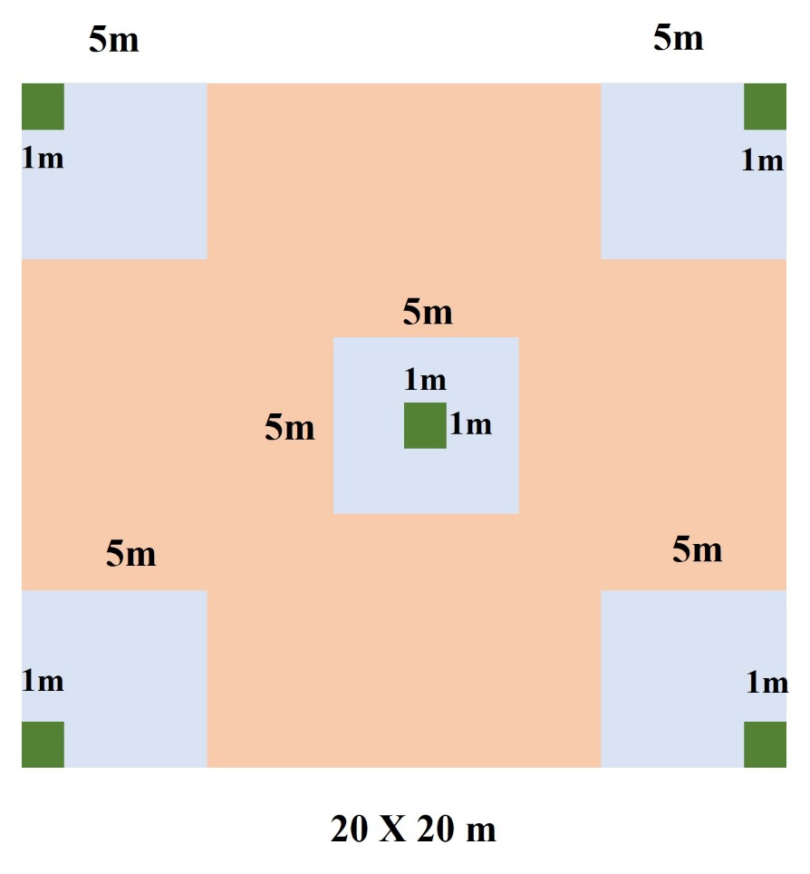

**Fig S1.** 20m×20m sample plot, 20 × 20 m is for tree sampling, 5 m × 5 m is for shrub sampling, and 1 × 1 m is for herb species sampling

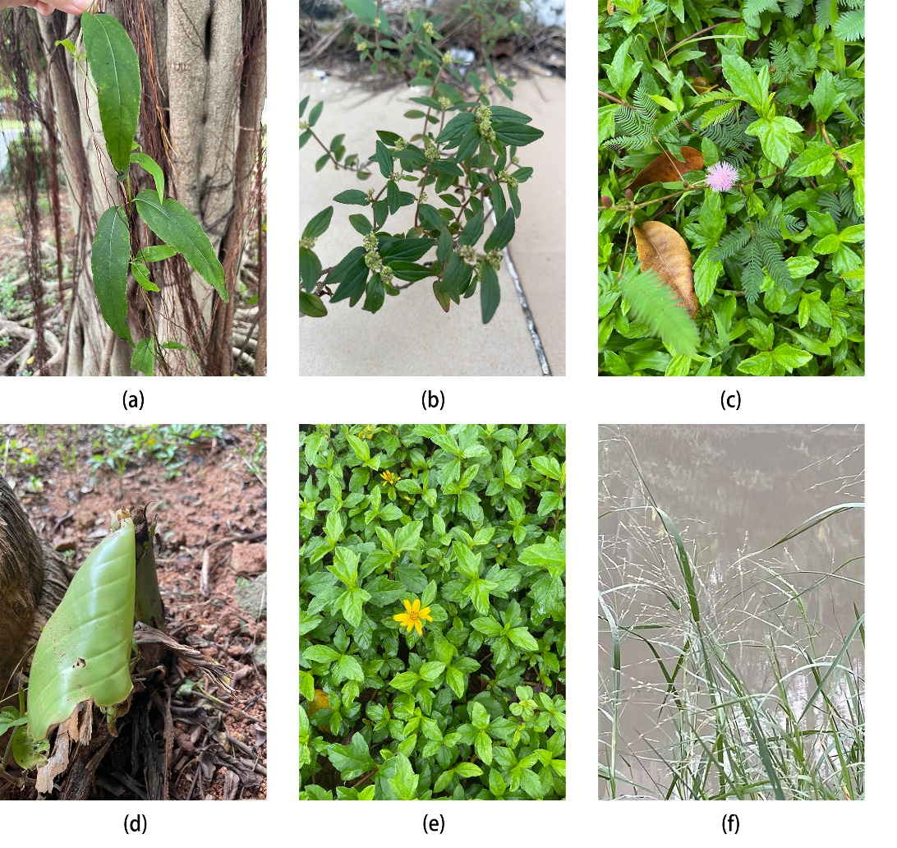

**Fig.S2** Examples of exotic spontaneous species within different urban functional units.

(a) *Bignonia capreolata* L. (b) *Euphorbia hirta* Linn*.* (c) *Mimosa pudica* Linn*.* (d) *Ravenala madagascariensis* Sonn*.* (e) *Sphagneticola calendulacea* (L.) Pruski (f) *Panicum repens* Linn.

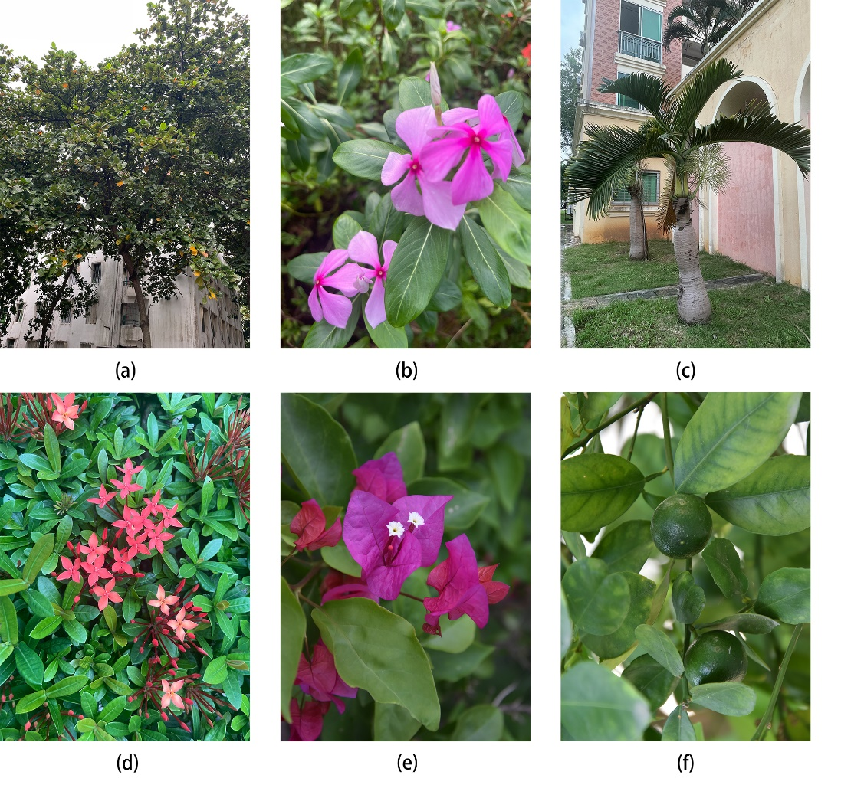

**Fig.S3** Examples of cultivated species within different urban functional units.

(a) *Terminalia catappa* Linn. (b) *Catharanthus roseus* (Linn.) G. Don. (c) *Hyophorbe lagenicaulis* (L. H. Bailey) H. E. Moore*.* (d) *Ixora chinensis* Lam. (e) *Bougainvillea glabra* Choisy (f) *Citrus microcarpa* Bunge.

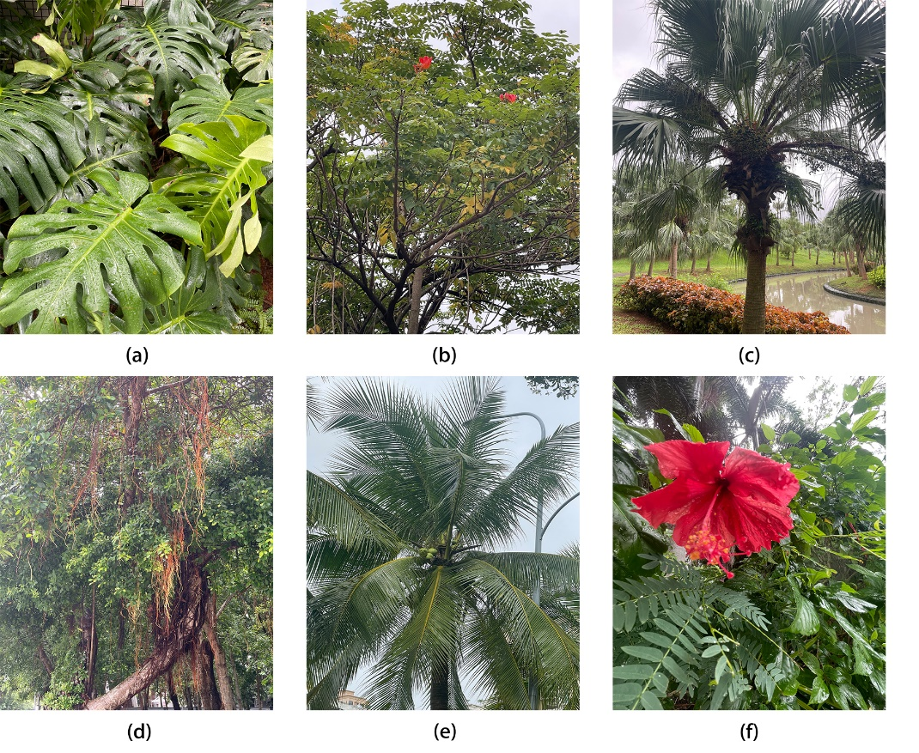

**Fig.S4** Examples of native cultivated species within different urban functional units.

(a) *Monstera deliciosa* Liebm. (b) *Spathodea campanulata* Beauv. (c) *Livistona chinensis* (Jacq.) R.Br. ex Mart. (d) *Ficus microcarpa* L. f. (e) *Cocos nucifera* L*inn. (f) Hibiscus rosa-sinensis* Linn.

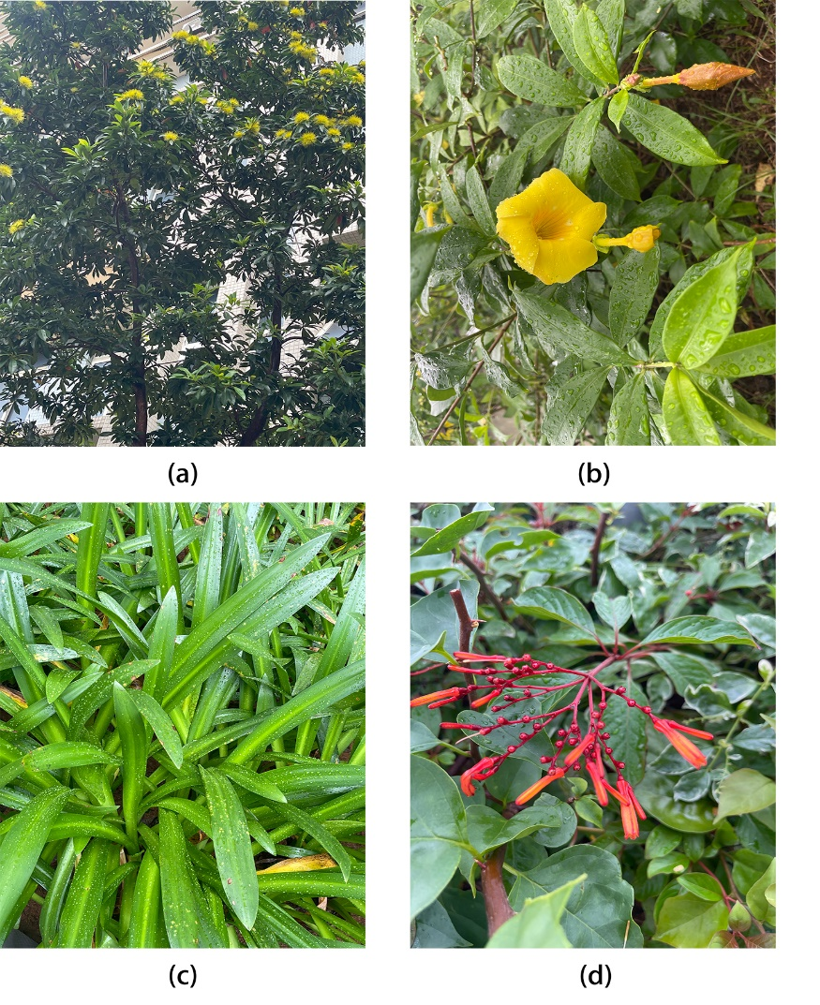

**Fig.S5** Examples of exotic cultivated species within different urban functional units.

(a) *Xanthostemon chrysanthus* (F.Muell.) Benth*.* (b) *Allamanda cathartica* L. (c) *Hymenocallis littoralis* (Jacq.) Salisb.(d) *Hamelia patens* Jacq.

**Table S1.** Different data acquisition methods.

|  |  |  |
| --- | --- | --- |
|  | Factors | Methods |
|  | NP | See section 2.3 for detailed data |
|  | PD |  |
|  | LSI |  |
|  | CONTAG |  |
| Landscape index | CONNECT |  |
| COHESION |  |
| SPLIT |  |
| PR |  |
| SHEI |  |
| Socioeconomic variables | Construction age (years) | Construction age obtained from Baidu and field investigation query (http://www.baidu.com/). |
| Population density(inhabitants/km2) | The population density was calculated through field investigation, and the population of each household in China was 2.62 (http://www.stats.gov.cn/). The number of families in the study area was obtained through field investigation, and the population density data was obtained by multiplying the number of families by the average number of households 2.62. |
| Housing price (CNY/Yuan) | Housing price data through Anjuke query (www.anjuke.com). |
| Greening management factors | Fertilizing frequency (times/year) | Data were obtained from interviews with conservation managers in the study area |
| Maintenance frequency (times/year) |
| Watering frequency (times/year) |
| Geographical factors | Distance from fresh water (m) | ENVI 5.3 software was used for measurement distance from fresh water |
| Longitude | Longitude and latitude data are captured using the mobile phone global Positioning System (GPS). |
| Latitude |  |
| Distance from main road (m) | ENVI 5.3 software was used for measurement distance from main road |
| Traffic flow | Traffic flow data were obtained through field surveys. Average the number of cars passing in 10 minutes at three different times 8:00 a.m., 12:00 p.m., and 6:00 p.m. |
| Plant richness | Tree species | - |
| Shrub species | - |
| Herb species | - |
| Land use factor | Trees and shrubs area | See section 2.3 for detailed data |
| Herb area |
| Water area |
| Built-up area |
| Sandland area |
| Greening percentage |
|  | Above Ground Biomass (AGB) | We calculated AGB for each plant species with a diameter at breast height （DBH） ≥ 2 cm in each sampled plot using a formula: $$AGB=0.4π{(\frac{dbh}{2})}^{2}×(height + 300) × (plant density)$$ |

Table S2: Results from regression models predicting the number of native spontaneous species. The undeveloped and recreation and leisure districts' land types of UFU were excluded from the models because of their low sample size. - indicates that the variable was not included in the final model.

|  |  |  |  |  |  |  |  |  |  |  |  |
| --- | --- | --- | --- | --- | --- | --- | --- | --- | --- | --- | --- |
| **Predictors** | | Industry and business district  (N=29) | | Public affairs service districts  (R2 = 0.48**, N=44) | | Recreation and leisure districts (N=4) | | Residential districts  (R2 = 0.52*, N=35) | | Transportation  (N=25) | |
| **β coefficient** | ***P*-value** | **β coefficient** | ***P*-value** | **β coefficient** | ***P*-value** | **β coefficient** | ***P*-value** | **β coefficient** | ***P*-value** |
| **(Intercept)** | | - | - | 3.029 | <0.001  *** | - | - | -1.270 | 0.420 | - | - |
| Landscape index | NP | - | - | - | - | - | - | -4.317 | 0.046* | - | - |
| PD | - | - | -1.352 | 0.193 | - | - | 3.056 | 0.098. | - | - |
| LSI | - | - | - | - | - | - | -1.451 | 0.381 | - | - |
| CONTAG | - | - | - | - | - | - | 1.591 | 0.249 | - | - |
| CONNECT | - | - | 0.357 | 0.154 | - | - | -1.506 | 0.001** | - | - |
| COHESION | - | - | -1.672 | 0.150 | - | - | 2.918 | 0.205 | - | - |
| SPLIT | - | - | - | - | - | - | 0.776 | 0.368 | - | - |
| PR | - | - | - | - | - | - | 2.205 | 0.025* | - | - |
| SHEI | - | - | -2.761 | 0.090. | - | - | 5.646 | 0.017* | - | - |
| Socioeconomic variables | Construction age (years) | - | - | 0.519 | 0.217 | - | - | -3.831 | 0.028* | - | - |
| Population density(inhabitants/km2) | - | - | -1.115 | 0.029* | - | - | -1.431 | 0.306 | - | - |
| Housing price (CNY/Yuan) | - | - | - | - | - | - | 2.206 | 0.218 | - | - |
| Greening management factors | Fertilizing frequency (times/year) | - | - | - | - | - | - | - | - | - | - |
| Maintenance frequency (times/year) | - | - | - | - | - | - | - | - | - | - |
| Watering frequency (times/year) | - | - | 0.510 | 0.077. | - | - | -0.703 | 0.098. | - | - |
| Geographical factors | Distance from fresh water (m) | - | - | 0.882 | 0.078. | - | - | - | - | - | - |
| Longitude | - | - | - | - | - | - | - | - | - | - |
| Latitude | - | - | 2.339 | 0.221 | - | - | - | - | - | - |
| Distance from main road (m) | - | - | -0.462 | 0.128 | - | - | 0.818 | 0.020* | - | - |
| Traffic flow | - | - | 0.892 | 0.016* | - | - | - | - | - | - |
| Plant richness | Tree species | - | - | 0.470 | 0.075. | - | - | 1.493 | 0.013* | - | - |
| Shrub species | - | - | 0.337 | 0.211 | - | - | 0.766 | 0.060. | - | - |
| Herb species | - | - | - | - | - | - | -0.551 | 0.083. | - | - |
| Land use factor | Trees and shrubs area | - | - | 6.040 | 0.129 | - | - | -3.148 | 0.169 | - | - |
| Herb area | - | - | - | - | - | - | 2.513 | 0.374 | - | - |
| Water area | - | - | - | - | - | - | -5.247 | 0.432 | - | - |
| Built-up area | - | - | -3.063 | 0.242 | - | - | 4.097 | 0.226 | - | - |
| Sandland area | - | - | 4.147 | 0.079 | - | - | -4.472 | 0.380 | - | - |
| Greening percentage | - | - | -0.929 | 0.004** | - | - | 0.810 | 0.103 | - | - |
|  | AGB | - | - | - | - | - | - | -1.465 | 0.042* | - | - |

Signif. codes: 0 ‘***’ 0.001 ‘**’ 0.01 ‘*’ 0.05

Table S3: Results from regression models predicting the number of exotic spontaneous species. The undeveloped and recreation and leisure districts' land types of UFU were excluded from the models because of their low sample size. - indicates that the variable was not included in the final model.

|  |  |  |  |  |  |  |  |  |  |  |  |
| --- | --- | --- | --- | --- | --- | --- | --- | --- | --- | --- | --- |
| **Predictors** | | Industry and business district  (N=29) | | Public affairs service districts  (R2 = 0.48 ***, N=44) | | Recreation and leisure districts (N=4) | | Residential districts  (R2 = 0.78***, N=35) | | Transportation  (N=25) | |
| **β coefficient** | ***P*-value** | **β coefficient** | ***P*-value** | **β coefficient** | ***P*-value** | **β coefficient** | ***P*-value** | **β coefficient** | ***P*-value** |
| **(Intercept)** | | - | - | 1.014 | 0.007** | - | - | 1.231 | 0.032* | - | - |
| Landscape index | NP | - | - | -1.121 | 0.072. | - | - | - | - | - | - |
| PD | - | - | 2.183 | 0.023* | - | - | -0.357 | 0.099. | - | - |
| LSI | - | - | - | - | - | - | - | - | - | - |
| CONTAG | - | - | - | - | - | - | -1.072 | 0.273 | - | - |
| CONNECT | - | - | -0.279 | 0.199 | - | - | 0.812 | 0.005** | - | - |
| COHESION | - | - | 2.157 | 0.064. | - | - | - | - | - | - |
| SPLIT | - | - | 0.705 | 0.090. | - | - | 1.952 | < 0.001  *** | - | - |
| PR | - | - | - | - | - | - | - | - | - | - |
| SHEI | - | - | - | - | - | - | -4.319 | 0.002** | - | - |
| Socioeconomic variables | Construction age (years) | - | - | - | - | - | - | 3.220 | < 0.001  *** | - | - |
| Population density(inhabitants/km2) | - | - | 0.656 | 0.081. | - | - | -1.301 | 0.110 | - | - |
| Housing price (CNY/Yuan) | - | - | -0.381 | 0.163 | - | - | -0.600 | 0.037* | - | - |
| Greening management factors | Fertilizing frequency (times/year) | - | - | 0.670 | 0.149 | - | - | 2.040 | 0.001** | - | - |
| Maintenance frequency (times/year) | - | - | -0.293 | 0.231 | - | - | -1.985 | < 0.001  *** | - | - |
| Watering frequency (times/year) | - | - | - | - | - | - | - | - | - | - |
| Geographical factors | Distance from fresh water (m) | - | - | -0.523 | 0.196 | - | - | 1.833 | < 0.001  *** | - | - |
| Longitude | - | - | - | - | - | - | - | - | - | - |
| Latitude | - | - | -2.282 | 0.254 | - | - | 2.964 | 0.056. | - | - |
| Distance from main road (m) | - | - | - | - | - | - | 0.703 | 0.010* | - | - |
| Traffic flow | - | - | -0.705 | 0.039* | - | - | -0.676 | 0.009** | - | - |
| Plant richness | Tree species | - | - | 0.558 | 0.058 | - | - | 0.768 | < 0.001  *** | - | - |
| Shrub species | - | - | 0.800 | 0.005** | - | - | -1.418 | < 0.001  *** | - | - |
| Herb species | - | - | 0.437 | 0.098. | - | - | 0.644 | 0.014* | - | - |
| Land use factor | Trees and shrubs area | - | - | - | - | - | - | 1.379 | 0.256 | - | - |
| Herb area | - | - | - | - | - | - | -2.444 | 0.083. | - | - |
| Water area | - | - | - | - | - | - | - | - | - | - |
| Built-up area | - | - | - | - | - | - | 0.965 | 0.308 | - | - |
| Sandland area | - | - | - | - | - | - | -15.484 | < 0.001  *** | - | - |
| Greening percentage | - | - | - | - | - | - | - | - | - | - |
|  | AGB | - | - | - | - | - | - | 1.168 | 0.001** | - | - |

Signif. codes: 0 ‘***’ 0.001 ‘**’ 0.01 ‘*’ 0.0

Table S4: Results from regression models predicting the number of native cultivated species. The undeveloped and recreation and leisure districts' land types of UFU were excluded from the models because of their low sample size. - indicates that the variable was not included in the final model.

Signif. codes: 0 ‘***’ 0.001 ‘**’ 0.01 ‘*’ 0.0

|  |  |  |  |  |  |  |  |  |  |  |  |
| --- | --- | --- | --- | --- | --- | --- | --- | --- | --- | --- | --- |
| **Predictors** | | Industry and business district  (N=29) | | Public affairs service districts  (R2 = 0.69 ***, N=44) | | Recreation and leisure districts (N=4) | | Residential districts  (R2 = 0.35*, N=35) | | Transportation  (N=25) | |
| **β coefficient** | ***P*-value** | **β coefficient** | ***P*-value** | **β coefficient** | ***P*-value** | **β coefficient** | ***P*-value** | **β coefficient** | ***P*-value** |
| **(Intercept)** | | - | - | 2.462 | < 0.001  *** | - | - | 2.823 | < 0.001  *** | - | - |
| Landscape index | NP | - | - | - | - | - | - | 2.889 | 0.025* | - | - |
| PD | - | - | 0.953 | 0.136 | - | - | -2.197 | 0.031* | - | - |
| LSI | - | - | - | - | - | - | - | - | - | - |
| CONTAG | - | - | 1.366 | 0.063. | - | - | - | - | - | - |
| CONNECT | - | - | - | - | - | - | 0.309 | 0.359 | - | - |
| COHESION | - | - | 1.185 | 0.074. | - | - | -2.200 | 0.0213* | - | - |
| SPLIT | - | - | - | - | - | - | -0.588 | 0.146 | - | - |
| PR | - | - | 0.795 | 0.002** | - | - | -1.405 | 0.010* | - | - |
| SHEI | - | - | 1.758 | 0.025* | - | - | -1.658 | 0.022* | - | - |
| Socioeconomic variables | Construction age (years) | - | - | 0.886 | < 0.001  *** | - | - | 2.312 | 0.035* | - | - |
| Population density(inhabitants/km2) | - | - | -0.435 | 0.022* | - | - | 1.986 | 0.022* | - | - |
| Housing price (CNY/Yuan) | - | - | - | - | - | - | - | - | - | - |
| Greening management factors | Fertilizing frequency (times/year) | - | - | - | - | - | - | -0.80 | 0.197 | - | - |
| Maintenance frequency (times/year) | - | - | 0.226 | 0.065. | - | - | 0.639 | 0.109 | - | - |
| Watering frequency (times/year) | - | - | -0.688 | < 0.001  *** | - | - | - | - | - | - |
| Geographical factors | Distance from fresh water (m) | - | - | 0.915 | < 0.001  *** | - | - | - | - | - | - |
| Longitude | - | - | - | - | - | - | - | - | - | - |
| Latitude | - | - | 1.390 | 0.145 | - | - | -2.612 | 0.100 | - | - |
| Distance from main road (m) | - | - | 0.632 | < 0.001  *** | - | - | -0.244 | 0.342 | - | - |
| Traffic flow | - | - | 0.234 | 0.179 | - | - | - | - | - | - |
| Plant richness | Tree species | - | - | -0.595 | < 0.001  *** | - | - | -0.251 | 0.367 | - | - |
| Shrub species | - | - | 0.193 | 0.162 | - | - | -0.546 | 0.131 | - | - |
| Herb species | - | - | 0.200 | 0.134 | - | - | 0.748 | 0.003** | - | - |
| Land use factor | Trees and shrubs area | - | - | -3.478 | 0.013* | - | - | -1.628 | 0.338 | - | - |
| Herb area | - | - | 1.436 | 0.050. | - | - | - | - | - | - |
| Water area | - | - | -5.040 | < 0.001  *** | - | - | 6.755 | 0.218 | - | - |
| Built-up area | - | - | - | - | - | - | -2.240 | 0.050 | - | - |
| Sandland area | - | - | - | - | - | - | - | - | - | - |
| Greening percentage | - | - | 0.504 | 0.002** | - | - | - | - | - | - |
|  | AGB | - | - | 12.462 | < 0.001  *** | - | - | - | - | - | - |

Table S5: Results from regression models predicting the number of exotic cultivated species. The undeveloped and recreation and leisure districts' land types of UFU were excluded from the models because of their low sample size. - indicates that the variable was not included in the final model.

|  |  |  |  |  |  |  |  |  |  |  |  |
| --- | --- | --- | --- | --- | --- | --- | --- | --- | --- | --- | --- |
| **Predictors** | | Industry and business district  (N=29) | | Public affairs service districts  (R2 = 0.48 ***, N=44) | | Recreation and leisure districts (N=4) | | Residential districts  (R2 = 0.65***, N=35) | | Transportation  (N=25) | |
| **β coefficient** | ***P*-value** | **β coefficient** | ***P*-value** | **β coefficient** | ***P*-value** | **β coefficient** | ***P*-value** | **β coefficient** | ***P*-value** |
| **(Intercept)** | | - | - | 2.708 | < 0.001*** | - | - | 2.496 | <0.001*** | - | - |
| Landscape index | NP | - | - | - | - | - | - | -1.615 | 0.004** | - | - |
| PD | - | - | -2.467 | 0.011* | - | - | - | - | - | - |
| LSI | - | - | - | - | - | - | - | - | - | - |
| CONTAG | - | - | -2.365 | 0.039* | - | - | 1.778 | 0.131 | - | - |
| CONNECT | - | - | - | - | - | - | -0.304 | 0.207 | - | - |
| COHESION | - | - | -2.043 | 0.028* | - | - | - | - | - | - |
| SPLIT | - | - | - | - | - | - | - | - | - | - |
| PR | - | - | -0.726 | 0.025* | - | - | - | - | - | - |
| SHEI | - | - | -2.797 | 0.020* | - | - | 2.938 | 0.029* | - | - |
| Socioeconomic variables | Construction age (years) | - | - | -0.977 | 0.001** | - | - | -3.421 | <0.001*** | - | - |
| Population density(inhabitants/km2) | - | - | - | - | - | - | -0.973 | 0.115 | - | - |
| Housing price (CNY/Yuan) | - | - | 0.458 | 0.023* | - | - | - | - | - | - |
| Greening management factors | Fertilizing frequency (times/year) | - | - | - | - | - | - | -0.550 | 0.169 | - | - |
| Maintenance frequency (times/year) | - | - | - | - | - | - | - | - | - | - |
| Watering frequency (times/year) | - | - | 0.303 | 0.120 | - | - | - | - | - | - |
| Geographical factors | Distance from fresh water (m) | - | - | - | - | - | - | - | - | - | - |
| Longitude | - | - | - | - | - | - | - | - | - | - |
| Latitude | - | - | -2.572 | 0.044* | - | - | - | - | - | - |
| Distance from main road (m) | - | - | - | - | - | - | - | - | - | - |
| Traffic flow | - | - | - | - | - | - | - | - | - | - |
| Plant richness | Tree species | - | - | 0.960 | < 0.001*** | - | - | 0.953 | <0.001*** | - | - |
| Shrub species | - | - | -0.259 | 0.217 | - | - | 0.710 | 0.010* | - | - |
| Herb species | - | - | 0.509 | 0.017* | - | - | - | - | - | - |
| Land use factor | Trees and shrubs area | - | - | -5.267 | 0.074. | - | - | 1.741 | 0.236 | - | - |
| Herb area | - | - | - | - | - | - | - | - | - | - |
| Water area | - | - | 4.960 | 0.030* | - | - | - | - | - | - |
| Built-up area | - | - | 4.175 | 0.026* | - | - | - | - | - | - |
| Sandland area | - | - | -2.043 | 0.201 | - | - | 11.585 | 0.001** | - | - |
| Greening percentage | - | - | - | - | - | - | - | - | - | - |
|  | AGB | - | - | - | - | - | - | - | - | - | - |

Signif. codes: 0 ‘***’ 0.001 ‘**’ 0.01 ‘*