Supplementary Material

# 1 The experiment

**Figure S1: Sample stock chart as displayed during the portfolio formation phase.**

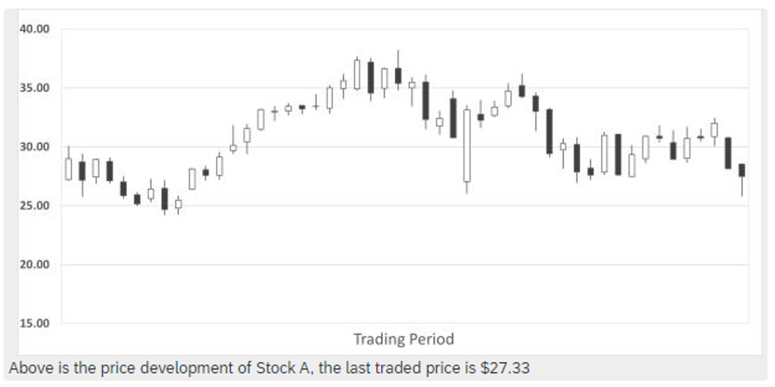

**Figure S2: Sample stock chart and trading decision during the trading phase.**

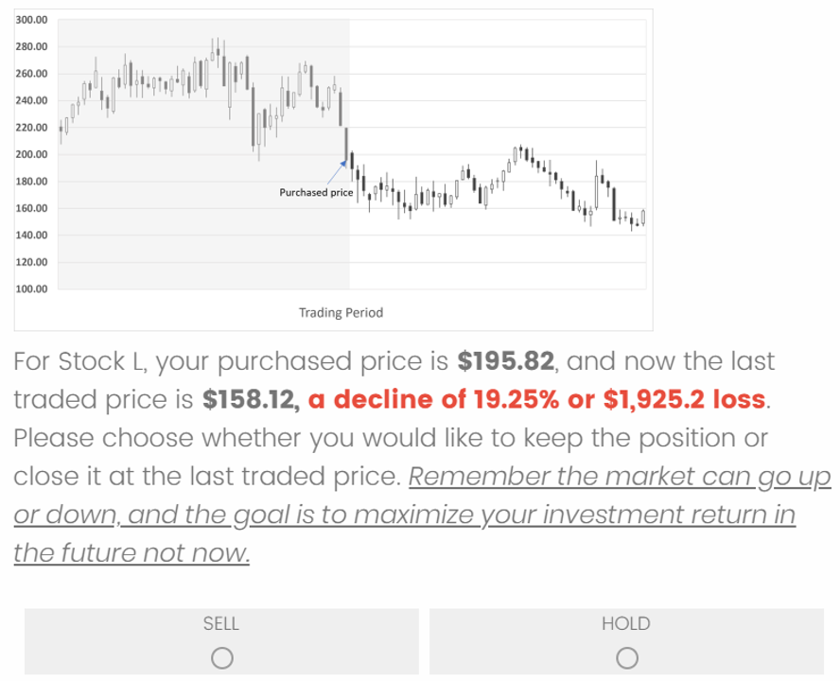

## General experimental instruction

On the following pages, you will be shown 14 candlestick charts of tradable stocks. You get to invest a total of 10 stocks from a pool of 14 stocks.

In Part 1, you will be provided with a candlestick chart for the 50 previous trading periods for each selectable stock and the latest traded price (based on historical data of actual tradable stocks). Based on this information, you will then be asked to decide which ten stocks to buy. Your goal is to select the ten stocks that you would like to formulate as a portfolio.

In Part 2, you will be presented with a candlestick chart for each invested stock. You will be given an opportunity to decide for each stock whether you want to hold it or sell it.

Hence, your task is to maximize your portfolio performance in the future. The participant with the highest portfolio performance will receive a bonus payment of GBP 20 (or equivalent value in your local currency). If more than one participant achieves the highest portfolio performance, we will use a lucky draw to select one participant for the bonus.

## Experiment instruction for the portfolio formation phase

**Part 1 – Portfolio Formulation**

You are managing your wealth of $100,000, and you start investing in the stock market in the hope of getting additional money to prepare for large capital expenditures in the future, like buying a decent car, acquiring a house, education for children, etc.

To diversify your investment and formulate an investment portfolio, you decide to adopt a simple strategy by investing in ten stocks and investing $10,000 for each stock.

Below are the 14 stocks that you shortlisted, you will choose ten out of the 14 stocks below to form your investment portfolio.

## Experimental instruction for the investment realization stage

**Part 2 – Investment Realization**

After 50 trading periods, you decide to review your portfolio and check the profit and loss.

At this stage, you will be given an opportunity to either SELL or HOLD for each stock you have invested.

If you choose to sell a stock, the investment return of that stock is realized and will be reflected in your final investment return.

If you choose to hold a stock, the investment return will have a chance of further up or down. The investment return of that stock will be evaluated as of the future trading periods and to be reflected in your final investment return.

Your decisions will have a direct impact on your investment return in the future, so it is important to think carefully.

Good luck and remember your task is to maximize the investment return in the future (24 months in the future)!

## Statement displayed to the control group

**Little Facts of Stocks and Bonds**

Belgium claims to be home to the first exchange, with an exchange in Antwerp dating back to 1531. During the 16th century, the East India Company became the first publicly-traded company as it issued stock and paid dividends on proceeds from its voyages. The London Stock Exchange was created in 1773 and was followed by the New York Stock Exchange less than 20 years later.

The earliest recorded bond dates back to 2400 BCE, as a stone tablet that recorded debt obligations that guaranteed repayment of grain. During the Middle Ages, governments began issuing debts to fund war efforts. In the 17th century, the Bank of England was created to finance the British Navy. The United States also began issuing Treasury bonds to support the Revolutionary War.

# Participant demographics

The table below reports the distribution of participants in terms of gender, age, and trading experience across the three measurements.

**Table S1: Summary statistics of demographic information.**

|  |  |  |  |  |
| --- | --- | --- | --- | --- |
|  |  | Measurement 1 | Measurement 2 | Measurement 3 |
| No. of Participants |  | 132 | 118 | 108 |
| Gender | Male | 51 (38.64%) | 47 (39.83%) | 45 (41.67%) |
|  | Female | 80 (60.61%) | 70 (59.32%) | 62 (57.41%) |
|  | Preferred not to say | 1 (0.76%) | 1 (0.85%) | 1 (0.93%) |
|  |  |  |  |  |
| Age Group | 18-25 | 18 | 15 | 12 |
|  | 26-35 | 40 | 35 | 31 |
|  | 36-45 | 35 | 32 | 29 |
|  | 46-55 | 27 | 25 | 24 |
|  | 55+ | 12 | 11 | 12 |
|  | *Mean* | *38.79* | *39.13* | *39.95* |
|  | *Standard Deviation* | *11.96* | *11.99* | *12.14* |
|  |  |  |  |  |
| Trading Experience (years) | 0 | 89 | 81 | 70 |
|  | 5-10 | 29 | 26 | 25 |
|  | 6-10 | 4 | 3 | 4 |
|  | 10+ | 9 | 8 | 9 |
|  | Preferred not to say | 1 | 0 | 0 |
|  | *Mean* | *1.94* | *1.89* | *2.23* |
|  | *Standard Deviation* | *4.36* | *4.38* | *4.73* |
|  |  |  |  |  |

# Stock universe for Measurement 2 and Measurement 3

**Table S2: Stock Depicted in Choice Sets - Measurement 2**

|  |  |  |  |
| --- | --- | --- | --- |
| **Stock** | **Pre-Decision Return** | **Post-Decision Return** | **Post-Decision Total Return** |
| **3M Company** | -26.90% | -1.57% | 5.34% |
| **The Boeing Company** | 5.90% | -38.56% | -38.19% |
| **JPMorgan Chase & Co.** | -7.06% | 16.47% | 22.94% |
| **Cisco Systems, Inc.** | 8.58% | 34.99% | 42.67% |
| **Verizon Communications Inc.** | 7.39% | -11.43% | -3.36% |
| **The Procter & Gamble Company** | 1.37% | 31.30% | 37.92% |
| **Apple Inc.** | -15.28% | 129.69% | 133.10% |
| **Goldman Sachs Group Inc.** | -31.49% | 59.23% | 65.93% |
| **The Walt Disney Company** | -1.8% | 7.82% | 7.82% |
| **Amgen Inc.** | 8.19% | -4.95% | 0.70% |
| **Average Return** | -5.11% | 22.30% | 27.49% |

*Note*. (1) Pre-decision return reflects the stock performance from January 2018 to December 2018 and was shown to the participants when making their sell/hold decisions in Measurement 2. (2) The post-decision returns and post-decision total returns reflect stock performance from January 2019 to December 2020, consisting of 24 months of price action. Returns over the 24-month periods are unknown to participants. (3) The calculation for the post-decision return above return does not include dividend payout, it only considers the price return. However, the post-decision total return considers both price return and dividend payout.

**Table S3: Stock Depicted in Choice Sets - Measurement 3**

|  |  |  |  |
| --- | --- | --- | --- |
| **Stock** | **Pre-Decision Return** | **Post-Decision Return** | **Post-Decision Total Return** |
| **Goldman Sachs Group Inc.** | -35.30% | 49.05% | 55.78% |
| **The Procter & Gamble Company** | 0.70% | 51.62% | 59.73% |
| **Pfizer Inc.** | 16.26% | -9.52% | -2.33% |
| **AT&T Inc.** | -26.19% | -6.84% | 10.30% |
| **Nvidia Corporation** | -39.10% | 250.87% | 252.82% |
| **The Walt Disney Company** | -4.57% | 60.83% | 62.80% |
| **Visa Inc.** | 11.06% | 58.43% | 60.43% |
| **Oracle Corporation** | -7.22% | 33.96% | 38.64% |
| **Mastercard Inc.** | 18.64% | 82.21% | 84.21% |
| **Netflix Inc.** | 21.71% | 60.17% | 60.17% |
| **Average Return** | -4.40% | 63.08% | 68.26% |

*Note*. (1) Pre-decision return reflects the stock performance from January 2018 to December 2018 and was shown to the participants when making their sell/hold decisions in Measurement 3. (2) The post-decision returns and post-decision total returns reflect stock performance from January 2019 to December 2020, consisting of 24 months of price action. These returns are unknown to participants. (3) The calculation for the post-decision return above return does not include dividend payout, it only considers the price return. However, the post-decision total return considers both price return and dividend payout.

# Robustness analysis using the Weber and Camerer method

**Table S4: Linear Regression – Effect of the intervention on the disposition effect measured based on the Weber and Camerer (1998) method.**

|  |  |  |  |  |  |  |  |
| --- | --- | --- | --- | --- | --- | --- | --- |
|  | *Disposition Effect – Weber and Camerer* | | | | | | |
|  | Measure-ment 1 | Measure-ment 2 | Measure-ment 3 | Measure-ment 1 | Measure-ment 2 | Measure-ment 3 | |
| Intercept | 0.712 *** | 0.325 ** | 0.206 | 0.688 ** | 0.669 * | -0.008 | |
|  | (0.075) | (0.104) | (0.107) | (0.206) | (0.270) | (0.333) | |
| Treatment | -0.485 *** | -0.418 ** | -0.163 | -0.494 *** | -0.417 ** | -0.177 | |
|  | (0.125) | (0.145) | (0.149) | (0.129) | (0.149) | (0.155) | |
| Age |  |  |  | 0.000 | -0.008 | 0.004 | |
|  |  |  |  | (0.005) | (0.006) | (0.007) | |
| Male |  |  |  | -0.002 | -0.054 | -0.001 | |
|  |  |  |  | (0.062) | (0.168) | (0.167) | |
| Trading Experience | |  |  | 0.044 | -0.028 | 0.148 | |
|  |  |  |  | (0.144) | (0.181) | (0.162) | |
| N | 115 | 106 | 101 | 114 | 104 | 99 | |
| R2 | 0.117 | 0.075 | 0.012 | 0.120 | 0.093 | 0.026 | |
| Standard errors are heteroskedasticity robust. *** p < 0.001; ** p < 0.01; * p < 0.05.  Notably, the number of observations is lower compared to the disposition effect calculated as per Odean (1998) given that some participants made no sell decisions at all in which case the disposition effect after Weber and Camerer (1998) is not defined. | | | | | | |

# Effect of the intervention on the percentage of losses realized

**Table S5: Linear Regression – Effect of the intervention on the percentage of losses realized.**

|  |  |  |  |  |  |  |  |
| --- | --- | --- | --- | --- | --- | --- | --- |
|  | *Percentage of Losses Realized (PLR)* | | | | | | |
|  | Measure-ment 1 | Measure-ment 2 | Measure-ment 3 | Measure-ment 1 | Measure-ment 2 | Measure-ment 3 | |
| Intercept | 0.157 *** | 0.200 *** | 0.288 *** | 0.294 * | 0.094 | 0.333 * | |
|  | (0.040) | (0.035) | (0.043) | (0.129) | (0.101) | (0.140) | |
| Treatment | 0.318 *** | 0.194 *** | 0.133 * | 0.320 *** | 0.203 ** | 0.127 | |
|  | (0.070) | (0.056) | (0.067) | (0.072) | (0.060) | (0.072) | |
| Age |  |  |  | -0.003 | 0.003 | -0.002 | |
|  |  |  |  | (0.003) | (0.002) | (0.003) | |
| Male |  |  |  | -0.006 | -0.000 | 0.063 | |
|  |  |  |  | (0.103) | (0.067) | (0.080) | |
| Trading Experience | |  |  | -0.108 | -0.065 | -0.012 | |
|  |  |  |  | (0.083) | (0.062) | (0.078) | |
| N | 132 | 118 | 108 | 131 | 116 | 106 | |
| R2 | 0.14 | 0.091 | 0.036 | 0.172 | 0.115 | 0.050 | |
| Standard errors are heteroskedasticity robust. *** p < 0.001; ** p < 0.01; * p < 0.05. | | | | | | |

Table S6: Linear Regression – Effect of the intervention on the percentage of gains realized.

|  |  |  |  |  |  |  |  |
| --- | --- | --- | --- | --- | --- | --- | --- |
|  | *Percentage of Gains Realized (PGR)* | | | | | | |
|  | Measure-ment 1 | Measure-ment 2 | Measure-ment 3 | Measure-ment 1 | Measure-ment 2 | Measure-ment 3 | |
| Intercept | 0.363 *** | 0.396 *** | 0.419 *** | 0.353 *** | 0.415 *** | 0.206 | |
|  | (0.035) | (0.041) | (0.042) | (0.094) | (0.112) | (0.119) | |
| Treatment | -0.062 | -0.090 | -0.034 | -0.060 | -0.083 | -0.041 | |
|  | (0.047) | (0.056) | (0.060) | (0.049) | (0.060) | (0.064) | |
| Age |  |  |  | 0.000 | -0.000 | 0.004 | |
|  |  |  |  | (0.002) | (0.002) | (0.003) | |
| Male |  |  |  | -0.002 | -0.049 | 0.053 | |
|  |  |  |  | (0.051) | (0.069) | (0.067) | |
| Trading Experience | |  |  | -0.006 | 0.003 | 0.061 | |
|  |  |  |  | (0.055) | (0.070) | (0.066) | |
| N | 132 | 118 | 108 | 131 | 116 | 106 | |
| R2 | 0.013 | 0.022 | 0.003 | 0.014 | 0.029 | 0.045 | |
| Standard errors are heteroskedasticity robust. *** p < 0.001; ** p < 0.01; * p < 0.05. | | | | | | |

# Robustness Analysis on Participants with Trading Experience

**Table S7: Linear Regression – Effect of the intervention on the disposition effect.**

|  |  |  |  |  |  |  |  |
| --- | --- | --- | --- | --- | --- | --- | --- |
|  | *Disposition Effect* | | | | | | |
|  | Measure-ment 1 | Measure-ment 2 | Measure-ment 3 | Measure-ment 1 | Measure-ment 2 | Measure-ment 3 | |
| Intercept | 0.244 * | 0.217 | 0.320 * | -0.290 | 0.317 | 0.084 | |
|  | (0.103) | (0.122) | (0.397) | (0.283) | (0.358) | (0.402) | |
| Treatment | -0.337 * | -0.405 * | -0.411 * | -0.393 ** | -0.466 ** | -0.443 * | |
|  | (0.148) | (0.156) | (0.165) | (0.144) | (0.162) | (0.163) | |
| Age |  |  |  | 0.020 * | 0.002 | 0.011 | |
|  |  |  |  | (0.007) | (0.011) | (0.001) | |
| Male |  |  |  | 0.005 | -0.002 | -0.131 | |
|  |  |  |  | (0.007) | (0.151) | (0.167) | |
| Trading Experience | |  |  | -0.029 * | -0.018 | -0.015 | |
|  |  |  |  | (0.013) | (0.017) | (0.011) | |
| N | 42 | 29 | 37 | 42 | 29 | 36 | |
| R2 | 0.118 | 0.214 | 0.154 | 0.289 | 0.27 | 0.227 | |
| *Note.* Standard errors are heteroskedasticity robust. *** p < 0.001; ** p < 0.01; * p < 0.05. | | | | | | |