Appendix A
Scales from PIRLS 2021 that were utilized in the present study.
Disorderly Behavior During Reading Lessons
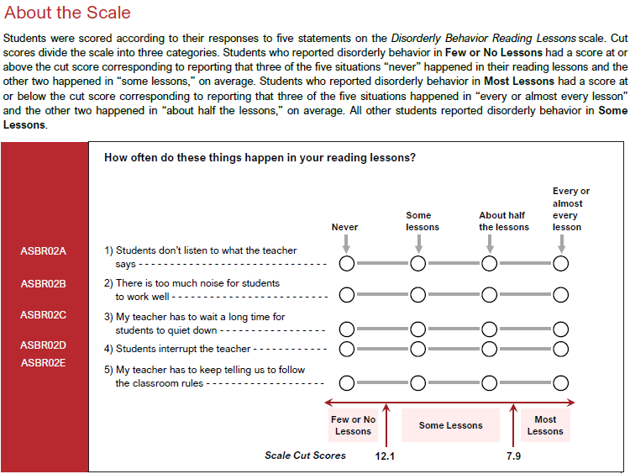

Students Like Reading
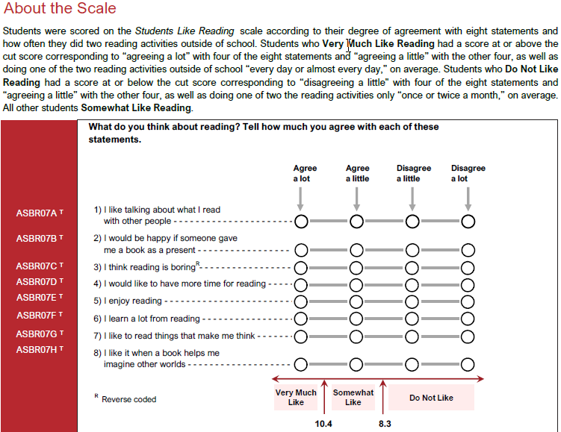

Students Engaged in Reading Lessons
