Supplementary materials
Supplementary materials for
Propagation and Impacts on Roadway of Mining-Induced Far-Field Strong Tremors: Insights from Numerical Simulations
Zepeng Han ^{ab}, Linming Dou ^{ab}*, Siyuan Gong ^{ab}, Jinrong Cao ^{ab}, Shuai Chen ^{abc}, Bing Hu ^{d}, Yongyuan Li ^{d}, Kezhi Zeng ^{e}
a State Key Laboratory of Coal Exploration and Intelligent Mining, China University of Mining and Technology, Xuzhou 221116, China;
b School of Mines, China University of Mining and Technology, Xuzhou 221116, China;
c School of Mechanical and Mining Engineering, University of Queensland, QLD 4072, Australia;
d Huaneng Coal Technology Research Co., Ltd, Beijing 100000, China;
e Dongtan Coal Mine,Yankuang Energy Group, Yanzhou 250014, China.
* Corresponding author: E-mail: lmdou@126.com (Linming Dou)

Contents of this file
- Fig S1 to S5
- Table S1 and S3

Introduction
This file contains 5 figures and 3 tables. The figure includes the calibration process of strain-softening parameters (Figure S1), the determination of the natural vibration period of the model (Figure S2), the attenuation rules of S-wave propagating in the model with different frequencies (Figure S3), and the plastic zone caused by the action of S-wave of different frequencies (Figure S4), BSR cloud images after S waves of different frequencies (Figure S5). The table includes the formation structure and mechanical parameter measurement results of 170 boreholes (Table S1), the mechanical parameters of rock in the numerical model (Table S2), and the mechanical parameters of coal in the numerical model (Table S3).

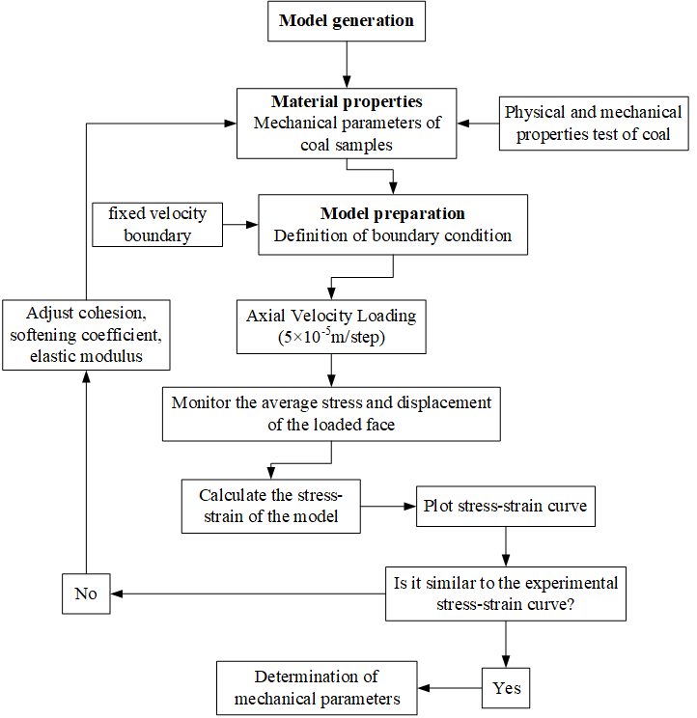
Figure S1. Procedure for Calibrating Strain Softening Parameters.

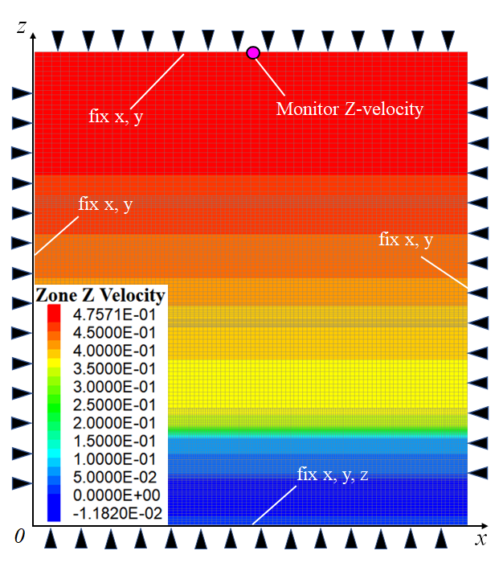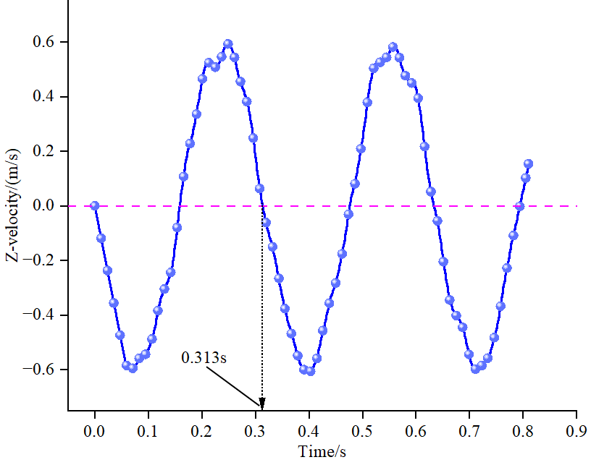
(a) (b)
Figure S2. Calculate the Model's Natural Frequency.

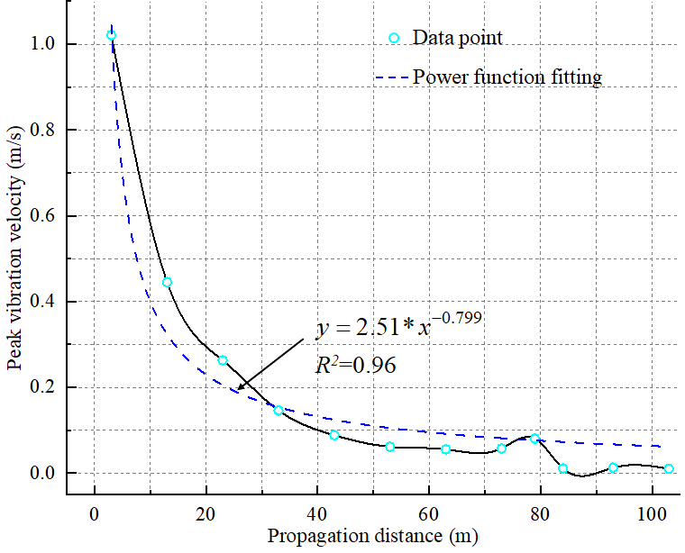  (a) 20Hz | 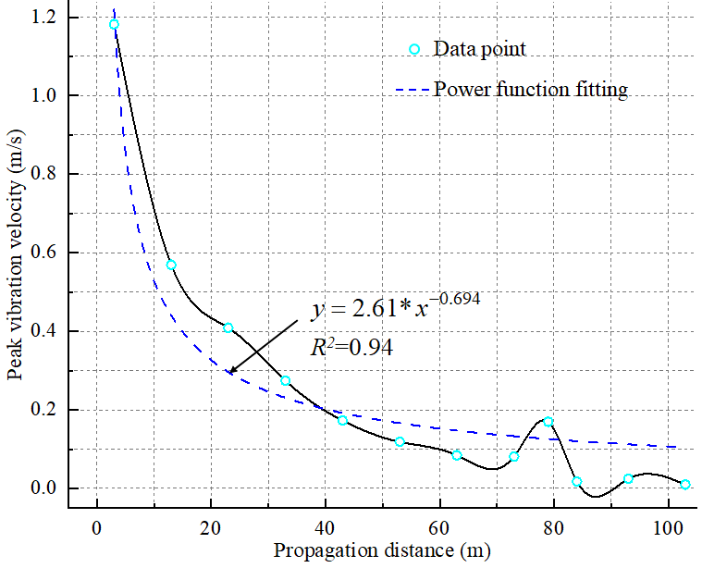  (b) 40Hz
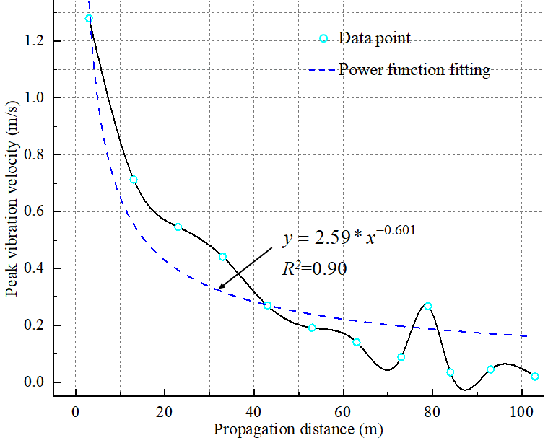  (c) 70Hz | 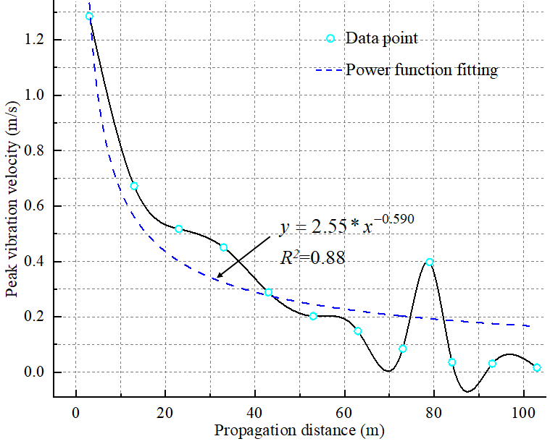  (d) 100Hz
Figure S3. S-wave Attenuation Patterns at Varying Frequencies.

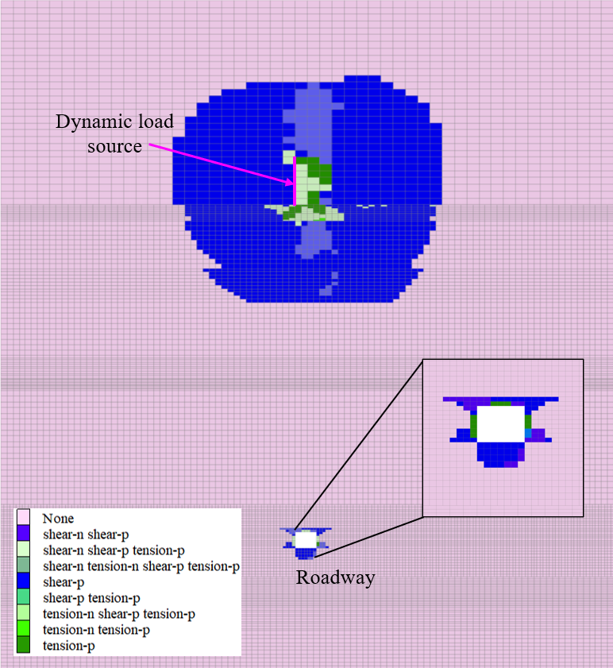  (a) 2Hz | 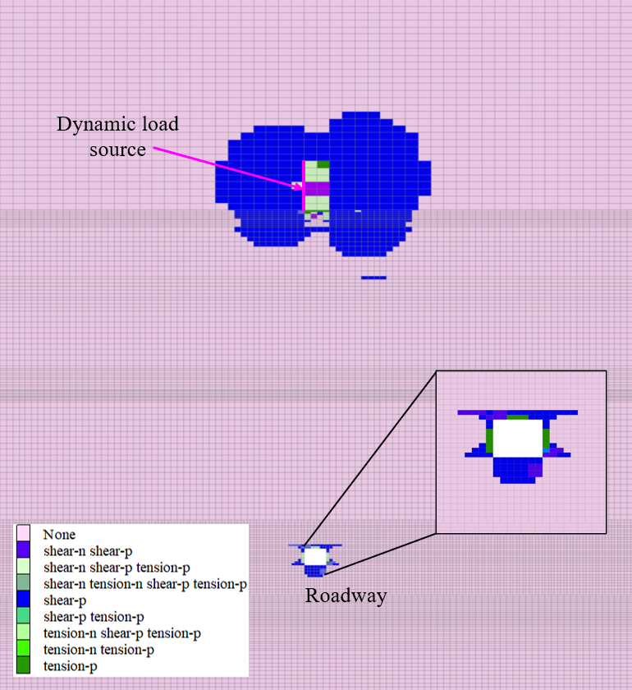  (b) 10Hz
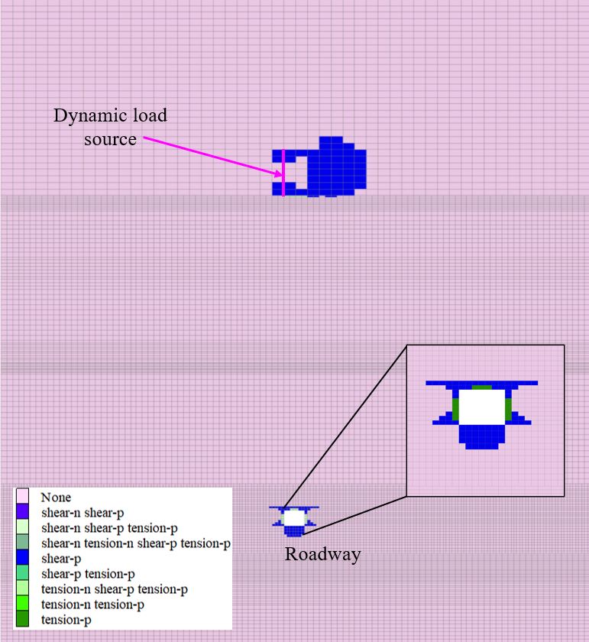  (c) 50Hz | 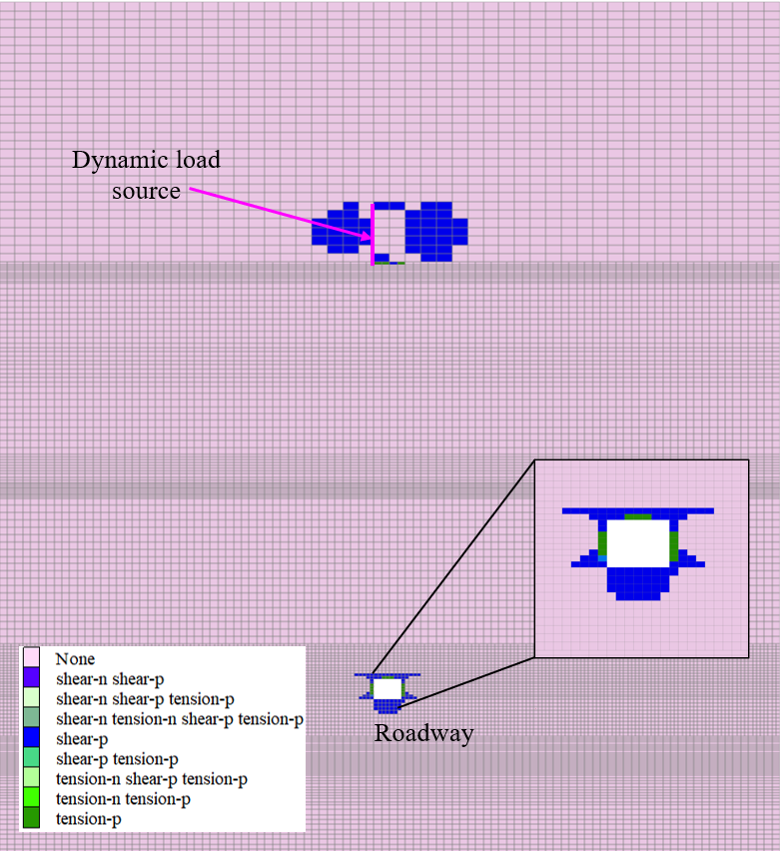  (d) 100Hz
Figure S4. Plastic failure caused by S-wave.

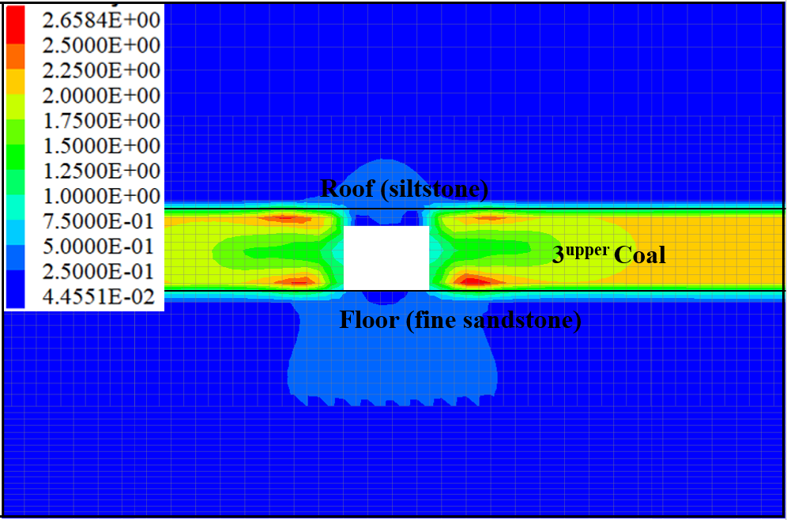  (a) 2Hz | 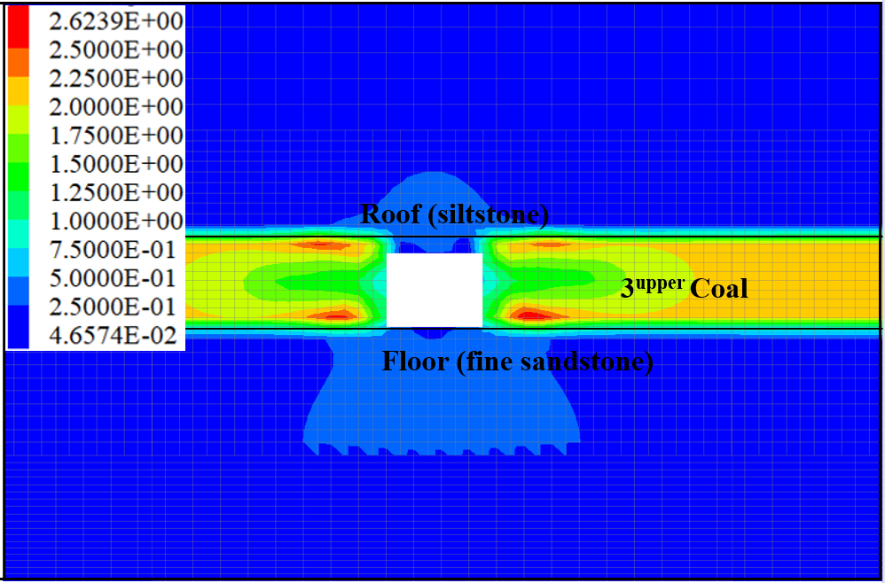  (b) 5Hz
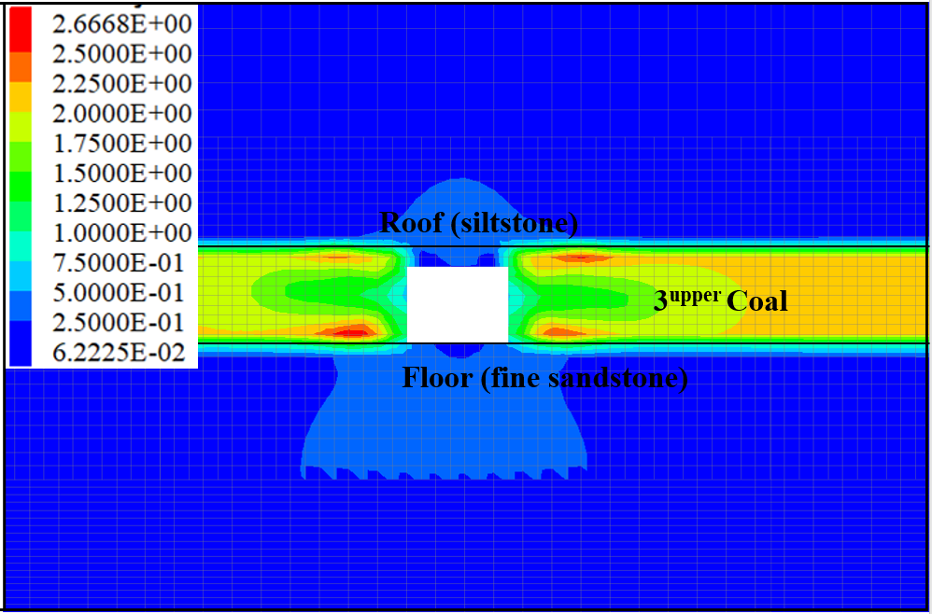  (c) 60Hz | 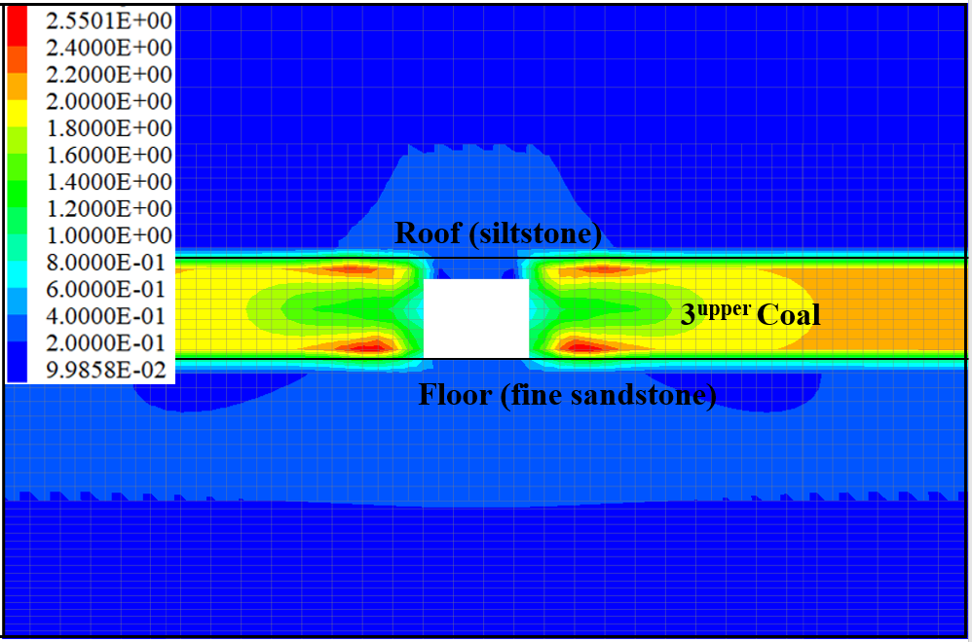  (d) 100Hz
Figure S5. BSR Cloud Images After Different S-wave Loadings.

Table S1. Physical and mechanical parameters of overlying strata in No.6 mining area (170 drilling).
Number | Lithology | Thickness/m | Compressive strength/MPa | Tensile strength/MPa | Elastic modulus/GPa | Poisson’s ratio
1 | Soil | 123.08 | – | – | – | –
2 | Siltstone | 115.66 | 85.60 | 8.17 | 21.01 | 0.29
3 | Fine sandstone | 21.06 | 68.35 | 5.14 | 20.66 | 0.26
4 | Medium sandstone | 24.66 | 50.97 | 7.06 | 12.45 | 0.22
5 | Fine sandstone | 337.66 | 63.22 | 6.29 | 18.70 | 0.22
6 | Mudstone | 8.65 | – | – | – | –
7 | Fine sandstone | 13.38 | 46.76 | 3.17 | 9.85 | 0.30
8 | Medium sandstone | 5.50 | 103.01 | 6.65 | 30.13 | 0.27
9 | Sandy mudstone | 3.08 | 54.87 | 2.47 | 13.80 | 0.26
10 | Medium sandstone | 30.87 | 90.25 | 8.61 | 36.63 | 0.23
11 | Claystone | 1.10 | 28.44 | 2.74 | 15.00 | 0.33
12 | Siltstone | 1.69 | 74.88 | 6.46 | 24.23 | 0.25
13 | Medium sandstone | 0.72 | 106.58 | 6.23 | 43.35 | 0.24
14 | Siltstone | 5.73 | 107.14 | 7.57 | 50.89 | 0.26
15 | 3^{upper} coal | 5.39 | – | – | – | –

Table S2. Parameters for Coal and Rock in Numerical Model.
Lithology | Thickness/m | Density/(kg.m⁻³) | UTS/MPa | E/GPa | Poisson's ratio | Cohesion/MPa | friction /°
fine sandstone | 9.5 | 2670 | 3.13 | 16.85 | 0.27 | 14.30 | 44.7
siltstone | 5.7 | 2490 | 1.65 | 8.33 | 0.33 | 13.18 | 31.0
3_{under} Coal | 3.5 | 1300 | 1.60 | 1.00 | 0.23 | 3.8 | 30
siltstone | 4 | 2490 | 1.65 | 8.33 | 0.33 | 13.18 | 31.0
fine sandstone | 7 | 2670 | 3.13 | 16.85 | 0.27 | 14.30 | 44.7
3^{upper} Coal | 5 | 1300 | 1.60 | 1.00 | 0.23 | 3.8 | 30
siltstone | 5.7 | 2490 | 1.65 | 8.33 | 0.33 | 13.18 | 31.0
medium sandstone | 28 | 2720 | 3.51 | 24.07 | 0.24 | 24.03 | 32.2
siltstone | 3 | 2490 | 1.65 | 8.33 | 0.33 | 13.18 | 31.0
medium sandstone | 5.5 | 2720 | 3.51 | 24.07 | 0.24 | 24.03 | 32.2
fine sandstone | 13 | 2670 | 3.13 | 16.85 | 0.27 | 14.30 | 44.7
mudstone | 8.3 | 2640 | 2.41 | 7.76 | 0.37 | 12.57 | 29.7
fine sandstone | 11.6 | 2670 | 3.13 | 16.85 | 0.27 | 14.30 | 44.7
siltstone | 4 | 2490 | 1.65 | 8.33 | 0.33 | 13.18 | 31.0
fine sandstone | 50 | 2670 | 3.13 | 16.85 | 0.27 | 14.30 | 44.7

Table S3. Mechanical Parameters of Coal.
Density/  (kg.m⁻³) | Elastic Modulus/  GPa | Poisson | Cohesion/  MPa | Friction/  ° | Tension/  MPa | softening  factor | residual cohesion/  MPa
1300 | 1 | 0.23 | 3.8 | 30 | 1.6 | 1.5% | 0.2

