Supplementary Material

## Supplementary Tables

**Table S1.** Landsat metadata for 1994 and 2021.

**(A)** Landsat metadata for 1994.

|  |  |  |  |
| --- | --- | --- | --- |
| S/N | LANDSAT_ID | Date | Time |
| 1 | LT05_L1TP_141054_19940114_20170116_01_T1 | 1994-01-14 | 04:14:55 |
| 2 | LT05_L1TP_141054_19940130_20170116_01_T1 | 1994-01-30 | 04:14:45 |
| 3 | LT05_L1TP_141054_19940404_20170114_01_T1 | 1994-04-04 | 04:13:48 |
| 4 | LT05_L1TP_141054_19940420_20170115_01_T1 | 1994-04-20 | 04:13:30 |
| 5 | LT05_L1TP_141054_19940506_20170115_01_T1 | 1994-05-06 | 04:13:12 |
| 6 | LT05_L1TP_141054_19940522_20170114_01_T1 | 1994-05-22 | 04:12:55 |
| 7 | LT05_L1TP_141054_19940607_20170113_01_T1 | 1994-06-07 | 04:12:37 |
| 8 | LT05_L1TP_141054_19940623_20170114_01_T1 | 1994-06-23 | 04:12:16 |
| 9 | LT05_L1TP_141054_19940709_20170113_01_T1 | 1994-07-09 | 04:11:50 |
| 10 | LT05_L1TP_141054_19940810_20170113_01_T1 | 1994-08-10 | 04:10:57 |
| 11 | LT05_L1TP_141054_19940826_20170112_01_T1 | 1994-08-26 | 04:10:34 |
| 12 | LT05_L1TP_141054_19940911_20170214_01_T1 | 1994-09-11 | 04:10:10 |
| 13 | LT05_L1TP_141054_19940927_20170112_01_T1 | 1994-09-27 | 04:09:44 |
| 14 | LT05_L1TP_141054_19941013_20170111_01_T1 | 1994-10-13 | 04:09:15 |
| 15 | LT05_L1TP_141054_19941029_20170111_01_T1 | 1994-10-29 | 04:08:42 |
| 16 | LT05_L1TP_141055_19940114_20170115_01_T1 | 1994-01-14 | 04:15:19 |
| 17 | LT05_L1TP_141055_19940130_20170116_01_T1 | 1994-01-30 | 04:15:09 |
| 18 | LT05_L1TP_141055_19940404_20170114_01_T1 | 1994-04-04 | 04:14:12 |
| 19 | LT05_L1TP_141055_19940420_20170114_01_T1 | 1994-04-20 | 04:13:54 |
| 20 | LT05_L1TP_141055_19940506_20170114_01_T1 | 1994-05-06 | 04:13:36 |
| 21 | LT05_L1TP_141055_19940522_20170114_01_T1 | 1994-05-22 | 04:13:19 |
| 22 | LT05_L1TP_141055_19940607_20170113_01_T1 | 1994-06-07 | 04:13:01 |
| 23 | LT05_L1TP_141055_19940623_20170114_01_T1 | 1994-06-23 | 04:12:40 |
| 24 | LT05_L1TP_141055_19940709_20170114_01_T1 | 1994-07-09 | 04:12:14 |
| 25 | LT05_L1TP_141055_19940810_20170113_01_T1 | 1994-08-10 | 04:11:21 |
| 26 | LT05_L1TP_141055_19940826_20170113_01_T1 | 1994-08-26 | 04:10:58 |
| 27 | LT05_L1TP_141055_19940911_20170112_01_T1 | 1994-09-11 | 04:10:34 |
| 28 | LT05_L1TP_141055_19940927_20170112_01_T1 | 1994-09-27 | 04:10:08 |
| 29 | LT05_L1TP_141055_19941013_20170112_01_T1 | 1994-10-13 | 04:09:39 |
| 30 | LT05_L1TP_141055_19941029_20170111_01_T1 | 1994-10-29 | 04:09:06 |
| 31 | LT05_L1TP_141055_19941130_20170110_01_T1 | 1994-11-30 | 04:08:02 |
| 32 | LT05_L1TP_141055_19941216_20170110_01_T1 | 1994-12-16 | 04:07:32 |
| 33 | LT05_L1TP_142054_19940630_20170114_01_T1 | 1994-06-30 | 04:18:16 |
| 34 | LT05_L1TP_142054_19940716_20170114_01_T1 | 1994-07-16 | 04:17:49 |
| 35 | LT05_L1TP_142054_19940817_20170112_01_T1 | 1994-08-17 | 04:16:58 |
| 36 | LT05_L1TP_142054_19940918_20170112_01_T1 | 1994-09-18 | 04:16:10 |
| 37 | LT05_L1TP_142054_19941004_20170112_01_T1 | 1994-10-04 | 04:15:43 |
| 38 | LT05_L1TP_142054_19941020_20170111_01_T1 | 1994-10-20 | 04:15:12 |
| 39 | LT05_L1TP_142054_19941121_20170111_01_T1 | 1994-11-21 | 04:14:04 |
| 40 | LT05_L1TP_142054_19941207_20170110_01_T1 | 1994-12-07 | 04:13:36 |
| 41 | LT05_L1TP_142054_19941223_20170110_01_T1 | 1994-12-23 | 04:13:05 |

**(B)** Landsat metadata for 2021.

|  |  |  |  |
| --- | --- | --- | --- |
| S/N | LANDSAT_ID | Date | Time |
| 1 | LC08_L1TP_141053_20210124_20210305_01_T1 | 2021-01-24 | 04:53:16 |
| 2 | LC08_L1TP_141053_20210209_20210305_01_T1 | 2021-02-09 | 04:53:13 |
| 3 | LC08_L1TP_141053_20210225_20210304_01_T1 | 2021-02-25 | 04:53:08 |
| 4 | LC08_L1TP_141053_20210313_20210317_01_T1 | 2021-03-13 | 04:53:00 |
| 5 | LC08_L1TP_141053_20210329_20210402_01_T1 | 2021-03-29 | 04:52:55 |
| 6 | LC08_L1TP_141053_20210414_20210424_01_T1 | 2021-04-14 | 04:52:49 |
| 7 | LC08_L1TP_141053_20210430_20210508_01_T1 | 2021-04-30 | 04:52:40 |
| 8 | LC08_L1TP_141053_20210516_20210525_01_T1 | 2021-05-16 | 04:52:43 |
| 9 | LC08_L1TP_141053_20210601_20210608_01_T1 | 2021-06-01 | 04:52:52 |
| 10 | LC08_L1TP_141053_20210617_20210622_01_T1 | 2021-06-17 | 04:52:58 |
| 11 | LC08_L1TP_141053_20210703_20210713_01_T1 | 2021-07-03 | 04:53:01 |
| 12 | LC08_L1TP_141053_20210719_20210729_01_T1 | 2021-07-19 | 04:53:04 |
| 13 | LC08_L1TP_141053_20210804_20210811_01_T1 | 2021-08-04 | 04:53:12 |
| 14 | LC08_L1TP_141053_20210820_20210827_01_T1 | 2021-08-20 | 04:53:17 |
| 15 | LC08_L1TP_141053_20210905_20210910_01_T1 | 2021-09-05 | 04:53:22 |
| 16 | LC08_L1TP_141053_20210921_20210925_01_T1 | 2021-09-21 | 04:53:25 |
| 17 | LC08_L1TP_141053_20211007_20211013_01_T1 | 2021-10-07 | 04:53:31 |
| 18 | LC08_L1TP_141053_20211023_20211103_01_T1 | 2021-10-23 | 04:53:33 |
| 19 | LC08_L1TP_141053_20211210_20211215_01_T1 | 2021-12-10 | 04:53:29 |
| 20 | LC08_L1TP_141053_20211226_20211230_01_T1 | 2021-12-26 | 04:53:24 |
| 21 | LC08_L1TP_141054_20210108_20210307_01_T1 | 2021-01-08 | 04:53:45 |
| 22 | LC08_L1TP_141054_20210124_20210305_01_T1 | 2021-01-24 | 04:53:40 |
| 23 | LC08_L1TP_141054_20210209_20210305_01_T1 | 2021-02-09 | 04:53:37 |
| 24 | LC08_L1TP_141054_20210225_20210304_01_T1 | 2021-02-25 | 04:53:32 |
| 25 | LC08_L1TP_141054_20210313_20210317_01_T1 | 2021-03-13 | 04:53:23 |
| 26 | LC08_L1TP_141054_20210329_20210402_01_T1 | 2021-03-29 | 04:53:18 |
| 27 | LC08_L1TP_141054_20210414_20210424_01_T1 | 2021-04-14 | 04:53:13 |
| 28 | LC08_L1TP_141054_20210430_20210508_01_T1 | 2021-04-30 | 04:53:04 |
| 29 | LC08_L1TP_141054_20210516_20210525_01_T1 | 2021-05-16 | 04:53:07 |
| 30 | LC08_L1TP_141054_20210601_20210608_01_T1 | 2021-06-01 | 04:53:16 |
| 31 | LC08_L1TP_141054_20210617_20210622_01_T1 | 2021-06-17 | 04:53:22 |
| 32 | LC08_L1TP_141054_20210703_20210713_01_T1 | 2021-07-03 | 04:53:25 |
| 33 | LC08_L1TP_141054_20210719_20210729_01_T1 | 2021-07-19 | 04:53:28 |
| 34 | LC08_L1TP_141054_20210804_20210811_01_T1 | 2021-08-04 | 04:53:36 |
| 35 | LC08_L1TP_141054_20210820_20210827_01_T1 | 2021-08-20 | 04:53:41 |
| 36 | LC08_L1TP_141054_20210905_20210910_01_T1 | 2021-09-05 | 04:53:46 |
| 37 | LC08_L1TP_141054_20210921_20210925_01_T1 | 2021-09-21 | 04:53:49 |
| 38 | LC08_L1TP_141054_20211007_20211013_01_T1 | 2021-10-07 | 04:53:55 |
| 39 | LC08_L1TP_141054_20211023_20211103_01_T1 | 2021-10-23 | 04:53:57 |
| 40 | LC08_L1TP_141054_20211210_20211215_01_T1 | 2021-12-10 | 04:53:53 |
| 41 | LC08_L1TP_141054_20211226_20211230_01_T1 | 2021-12-26 | 04:53:48 |
| 42 | LC08_L1TP_141055_20210108_20210307_01_T1 | 2021-01-08 | 04:54:09 |
| 43 | LC08_L1TP_141055_20210124_20210305_01_T1 | 2021-01-24 | 04:54:04 |
| 44 | LC08_L1TP_141055_20210209_20210305_01_T1 | 2021-02-09 | 04:54:01 |
| 45 | LC08_L1TP_141055_20210225_20210304_01_T1 | 2021-02-25 | 04:53:56 |
| 46 | LC08_L1TP_141055_20210313_20210317_01_T1 | 2021-03-13 | 04:53:47 |
| 47 | LC08_L1TP_141055_20210329_20210402_01_T1 | 2021-03-29 | 04:53:42 |
| 48 | LC08_L1TP_141055_20210414_20210424_01_T1 | 2021-04-14 | 04:53:37 |
| 49 | LC08_L1TP_141055_20210430_20210508_01_T1 | 2021-04-30 | 04:53:28 |
| 50 | LC08_L1TP_141055_20210516_20210525_01_T1 | 2021-05-16 | 04:53:31 |
| 51 | LC08_L1TP_141055_20210601_20210608_01_T1 | 2021-06-01 | 04:53:40 |
| 52 | LC08_L1TP_141055_20210617_20210622_01_T1 | 2021-06-17 | 04:53:46 |
| 53 | LC08_L1TP_141055_20210703_20210713_01_T1 | 2021-07-03 | 04:53:49 |
| 54 | LC08_L1TP_141055_20210719_20210729_01_T1 | 2021-07-19 | 04:53:52 |
| 55 | LC08_L1TP_141055_20210804_20210811_01_T1 | 2021-08-04 | 04:54:00 |
| 56 | LC08_L1TP_141055_20210820_20210827_01_T1 | 2021-08-20 | 04:54:05 |
| 57 | LC08_L1TP_141055_20210905_20210910_01_T1 | 2021-09-05 | 04:54:10 |
| 58 | LC08_L1TP_141055_20210921_20210925_01_T1 | 2021-09-21 | 04:54:13 |
| 59 | LC08_L1TP_141055_20211007_20211013_01_T1 | 2021-10-07 | 04:54:19 |
| 60 | LC08_L1TP_141055_20211023_20211103_01_T1 | 2021-10-23 | 04:54:21 |
| 61 | LC08_L1TP_141055_20211210_20211215_01_T1 | 2021-12-10 | 04:54:16 |
| 62 | LC08_L1TP_141055_20211226_20211230_01_T1 | 2021-12-26 | 04:54:12 |
| 63 | LC08_L1TP_142053_20210131_20210306_01_T1 | 2021-01-31 | 04:59:26 |
| 64 | LC08_L1TP_142053_20210216_20210304_01_T1 | 2021-02-16 | 04:59:22 |
| 65 | LC08_L1TP_142053_20210304_20210312_01_T1 | 2021-03-04 | 04:59:16 |
| 66 | LC08_L1TP_142053_20210320_20210328_01_T1 | 2021-03-20 | 04:59:07 |
| 67 | LC08_L1TP_142053_20210405_20210409_01_T1 | 2021-04-05 | 04:59:03 |
| 68 | LC08_L1TP_142053_20210421_20210501_01_T1 | 2021-04-21 | 04:58:57 |
| 69 | LC08_L1TP_142053_20210507_20210517_01_T1 | 2021-05-07 | 04:58:47 |
| 70 | LC08_L1TP_142053_20210523_20210529_01_T1 | 2021-05-23 | 04:58:58 |
| 71 | LC08_L1TP_142053_20210608_20210615_01_T1 | 2021-06-08 | 04:59:06 |
| 72 | LC08_L1TP_142053_20210624_20210630_01_T1 | 2021-06-24 | 04:59:11 |
| 73 | LC08_L1TP_142053_20210710_20210720_01_T1 | 2021-07-10 | 04:59:13 |
| 74 | LC08_L1TP_142053_20210726_20210804_01_T1 | 2021-07-26 | 04:59:19 |
| 75 | LC08_L1TP_142053_20210811_20210819_01_T1 | 2021-08-11 | 04:59:25 |
| 76 | LC08_L1TP_142053_20210827_20210901_01_T1 | 2021-08-27 | 04:59:30 |
| 77 | LC08_L1TP_142053_20210912_20210916_01_T1 | 2021-09-12 | 04:59:35 |
| 78 | LC08_L1TP_142053_20210928_20211001_01_T1 | 2021-09-28 | 04:59:38 |
| 79 | LC08_L1TP_142053_20211014_20211019_01_T1 | 2021-10-14 | 04:59:43 |
| 80 | LC08_L1TP_142053_20211115_20211125_01_T1 | 2021-11-15 | 04:59:39 |
| 81 | LC08_L1TP_142053_20211201_20211208_01_T1 | 2021-12-01 | 04:59:40 |
| 82 | LC08_L1TP_142053_20211217_20211223_01_T1 | 2021-12-17 | 04:59:38 |
| 83 | LC08_L1TP_142054_20210131_20210306_01_T1 | 2021-01-31 | 04:59:50 |
| 84 | LC08_L1TP_142054_20210216_20210304_01_T1 | 2021-02-16 | 04:59:46 |
| 85 | LC08_L1TP_142054_20210304_20210312_01_T1 | 2021-03-04 | 04:59:40 |
| 86 | LC08_L1TP_142054_20210320_20210328_01_T1 | 2021-03-20 | 04:59:31 |
| 87 | LC08_L1TP_142054_20210405_20210409_01_T1 | 2021-04-05 | 04:59:27 |
| 88 | LC08_L1TP_142054_20210421_20210501_01_T1 | 2021-04-21 | 04:59:20 |
| 89 | LC08_L1TP_142054_20210507_20210517_01_T1 | 2021-05-07 | 04:59:11 |
| 90 | LC08_L1TP_142054_20210523_20210529_01_T1 | 2021-05-23 | 04:59:22 |
| 91 | LC08_L1TP_142054_20210608_20210615_01_T1 | 2021-06-08 | 04:59:30 |
| 92 | LC08_L1TP_142054_20210624_20210630_01_T1 | 2021-06-24 | 04:59:34 |
| 93 | LC08_L1TP_142054_20210710_20210720_01_T1 | 2021-07-10 | 04:59:36 |
| 94 | LC08_L1TP_142054_20210726_20210804_01_T1 | 2021-07-26 | 04:59:42 |
| 95 | LC08_L1TP_142054_20210811_20210819_01_T1 | 2021-08-11 | 04:59:49 |
| 96 | LC08_L1TP_142054_20210827_20210901_01_T1 | 2021-08-27 | 04:59:54 |
| 97 | LC08_L1TP_142054_20210912_20210916_01_T1 | 2021-09-12 | 04:59:58 |
| 98 | LC08_L1TP_142054_20210928_20211001_01_T1 | 2021-09-28 | 05:00:02 |
| 99 | LC08_L1TP_142054_20211014_20211019_01_T1 | 2021-10-14 | 05:00:07 |
| 100 | LC08_L1TP_142054_20211115_20211125_01_T1 | 2021-11-15 | 05:00:03 |
| 101 | LC08_L1TP_142054_20211201_20211208_01_T1 | 2021-12-01 | 05:00:04 |
| 102 | LC08_L1TP_142054_20211217_20211223_01_T1 | 2021-12-17 | 05:00:02 |

**Table S2.** Error matrix for the classified LULC maps of 1994 and 2021.

**(A)** Error matrix for the classified LULC map of 1994.

|  |  |  |  |  |  |  |  |
| --- | --- | --- | --- | --- | --- | --- | --- |
| 1994 | Agriculture | Scrub land | Forest | Other land | Waterbody | Total | User’s Accuracy |
| Agriculture | 100 | 4 | 6 | 6 | 7 | 123 | 81.3 |
| Forest | 8 | 4 | 215 | 2 | 4 | 233 | 92.3 |
| Other land | 7 | 0 | 1 | 25 | 0 | 33 | 75.8 |
| Scrub land | 1 | 26 | 5 | 1 | 2 | 35 | 74.3 |
| Waterbody | 0 | 0 | 10 | 1 | 55 | 66 | 83.3 |
| Total | 116 | 34 | 237 | 35 | 68 | 490 |  |
| Producer’s accuracy (%) | 86.2 | 76.5 | 90.7 | 71.4 | 80.9 |  |  |
|  |  |  |  |  | Overall Accuracy (%) | | 85.9 |

**(B)** Error matrix for the classified LULC map of 2021.

|  |  |  |  |  |  |  |  |
| --- | --- | --- | --- | --- | --- | --- | --- |
| 2021 | Agriculture | Scrub land | Forest | Other land | Waterbody | Total | User’s Accuracy |
| Agriculture | 140 | 4 | 4 | 3 | 7 | 158 | 88.6 |
| Forest | 8 | 4 | 170 | 2 | 4 | 188 | 90.4 |
| Other land | 7 | 0 | 1 | 30 | 0 | 38 | 78.9 |
| Scrub land | 1 | 55 | 2 | 1 | 2 | 61 | 90.2 |
| Waterbody | 0 | 0 | 6 | 1 | 50 | 57 | 87.7 |
| Total | 156 | 63 | 183 | 37 | 63 | 502 |  |
| Producer’s accuracy (%) | 89.7 | 87.3 | 92.9 | 81.1 | 79.4 |  |  |
|  |  |  |  |  | Overall Accuracy (%) | | 88.6 |

## Supplementary Figures

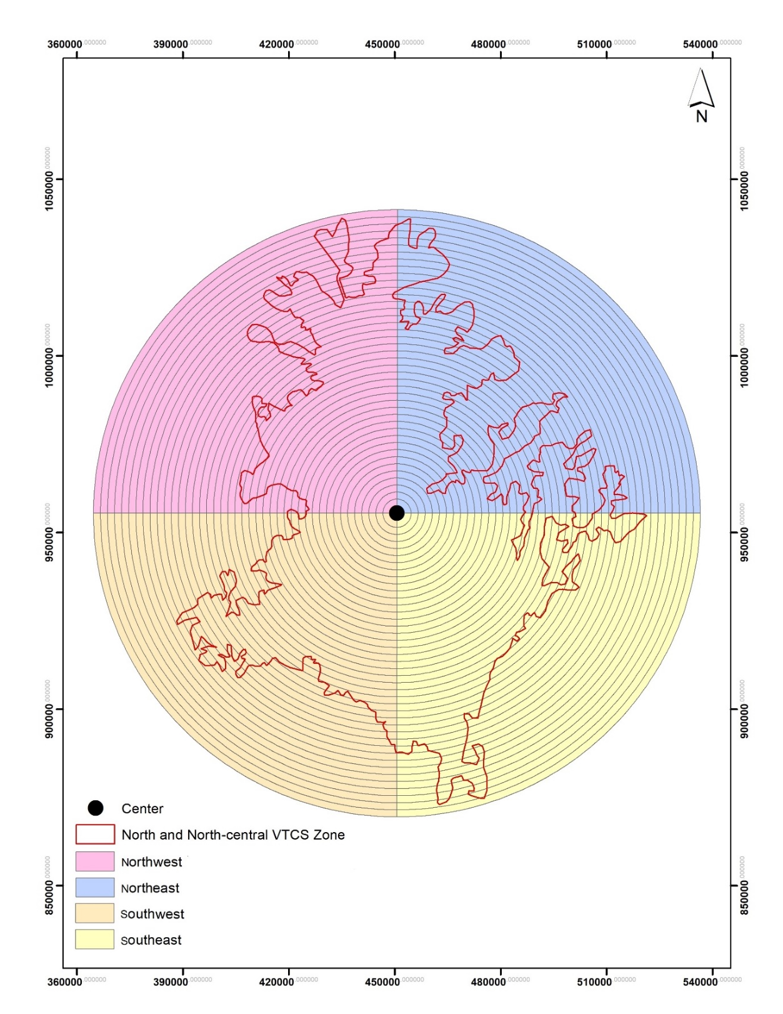

**Fig. S1** GIS-based concentric rings from the centre of the study area and four quadrants to extract multidirectional LULC to analyse LULC change.