Supplementary materials
Supplementary Figure 1: perceptual features that make spiders dangerous, distinguished for spider’s orientation
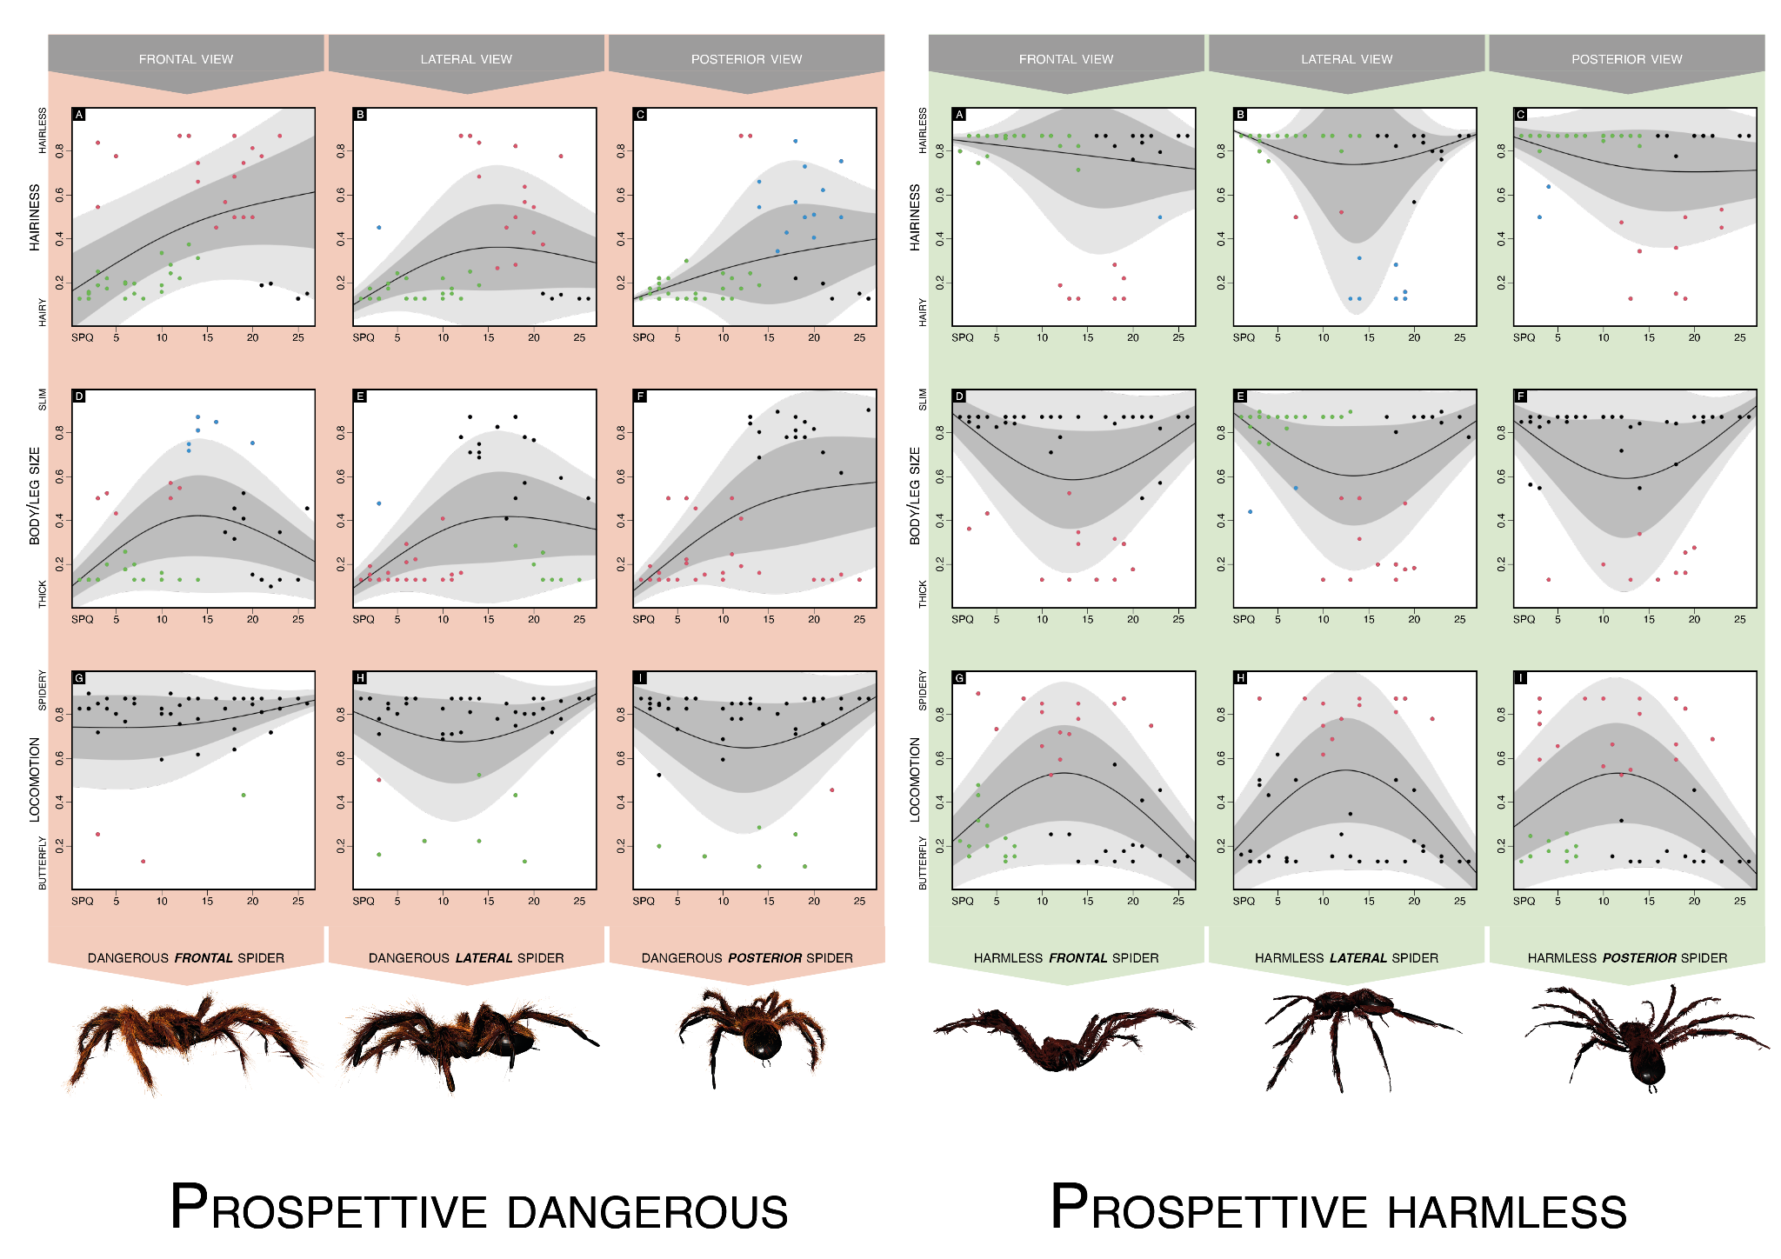

Supplementary Figure 2: perceptual features that make spiders harmless, distinguished for spider’s orientation
Supplementary Figure 3: replication of main Figure 2 based on means
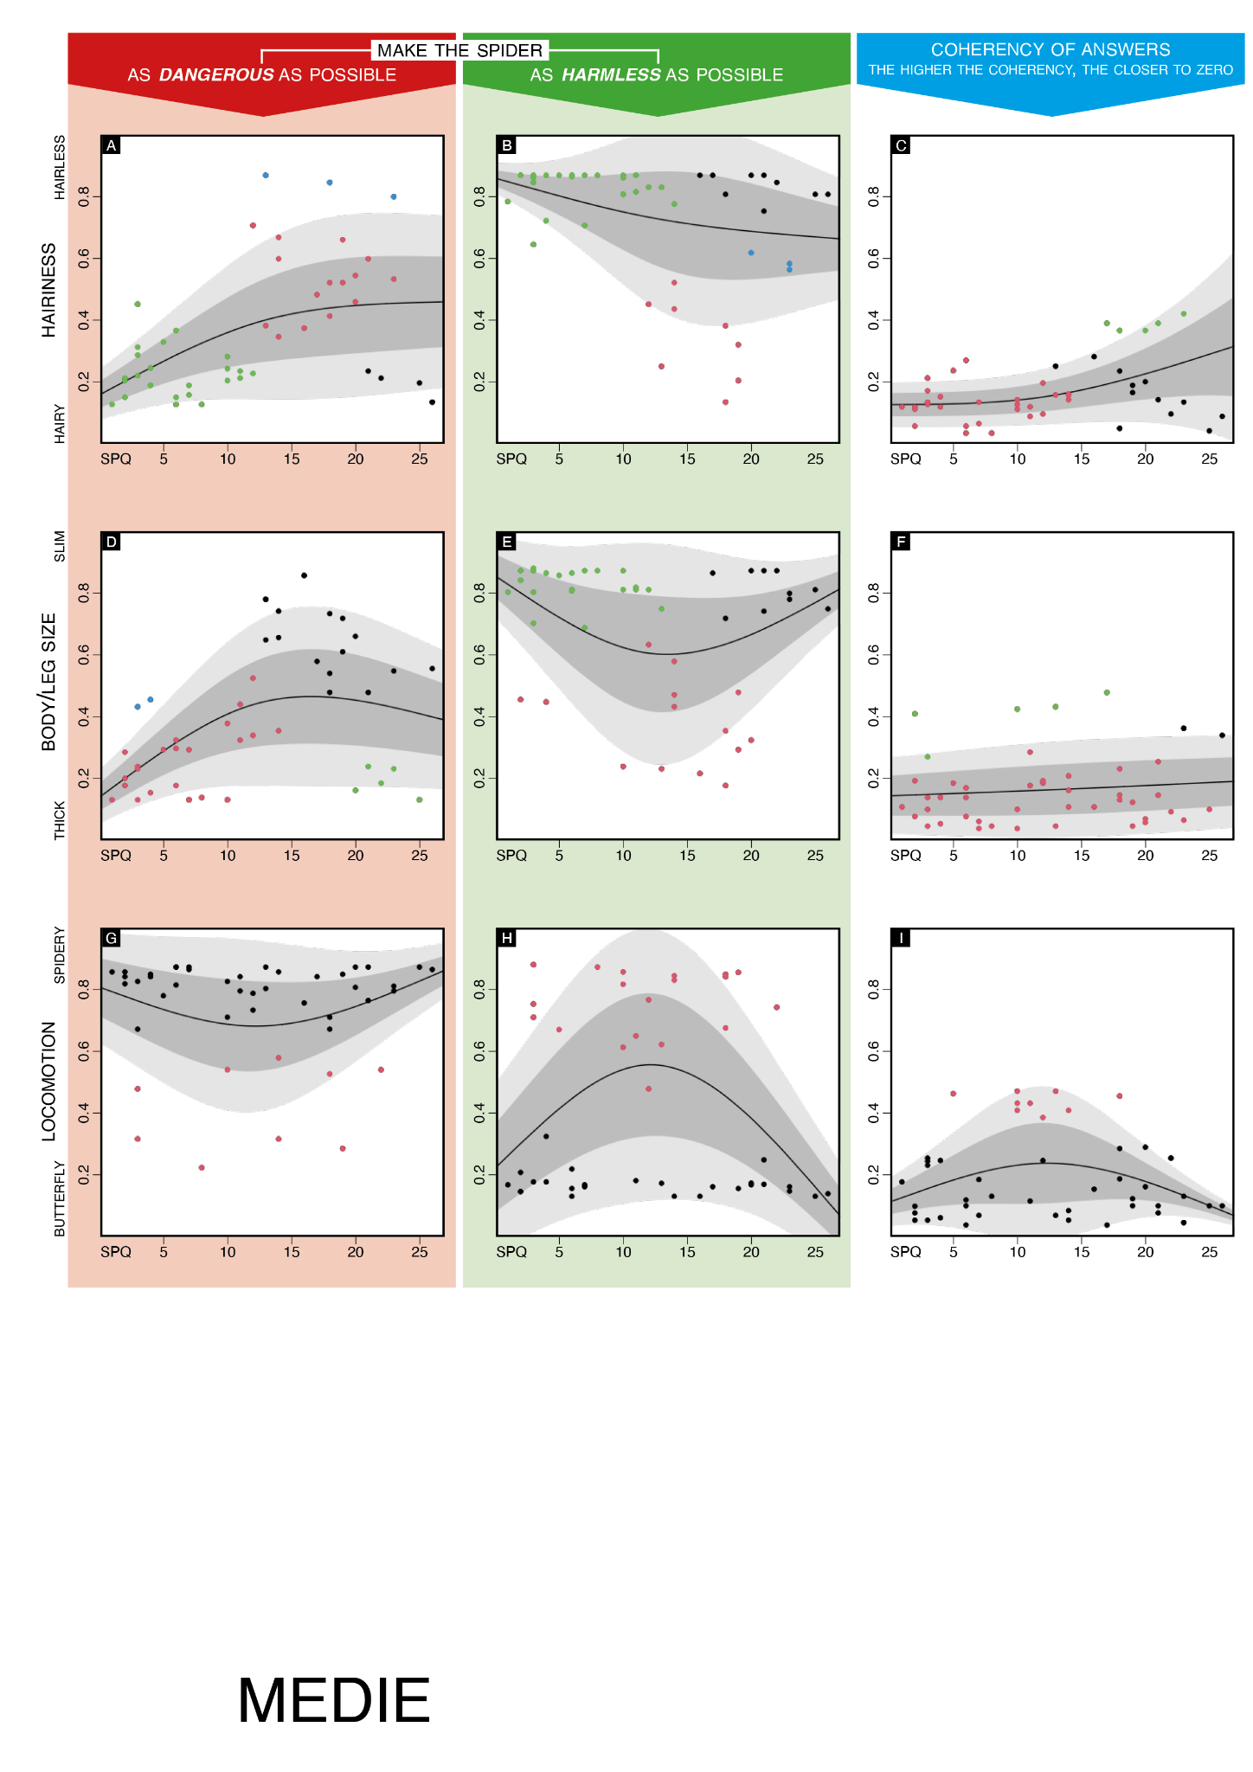

Supplementary Figure 4: replication of main Figure 2 based on medians
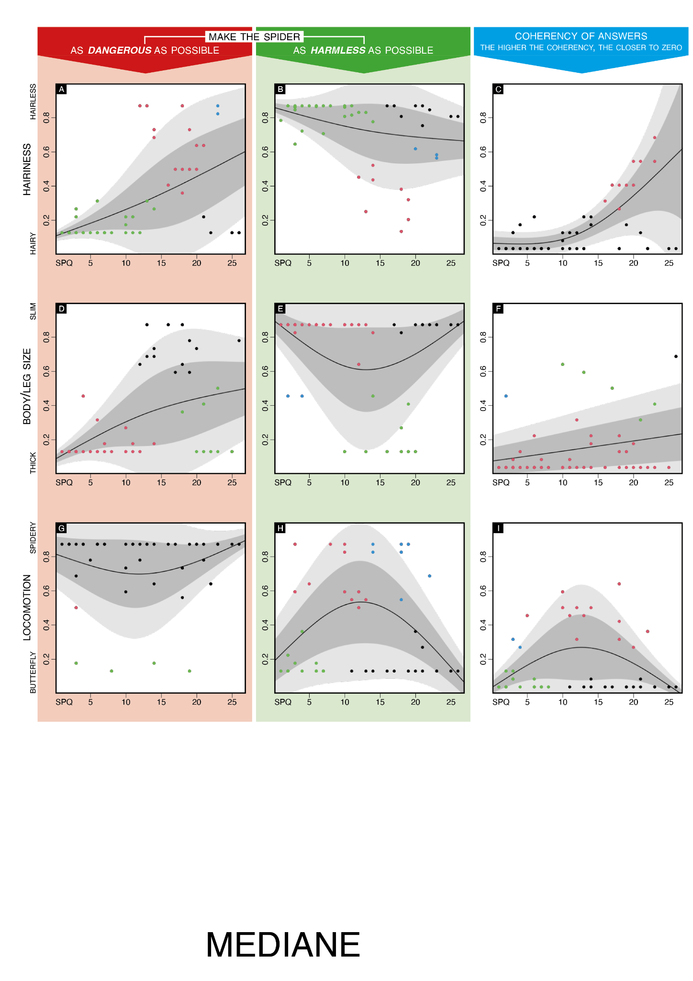
Supplementary Figure 5: replication of main Figure 2 with clustering based on all features simultaneously (including SPQ)
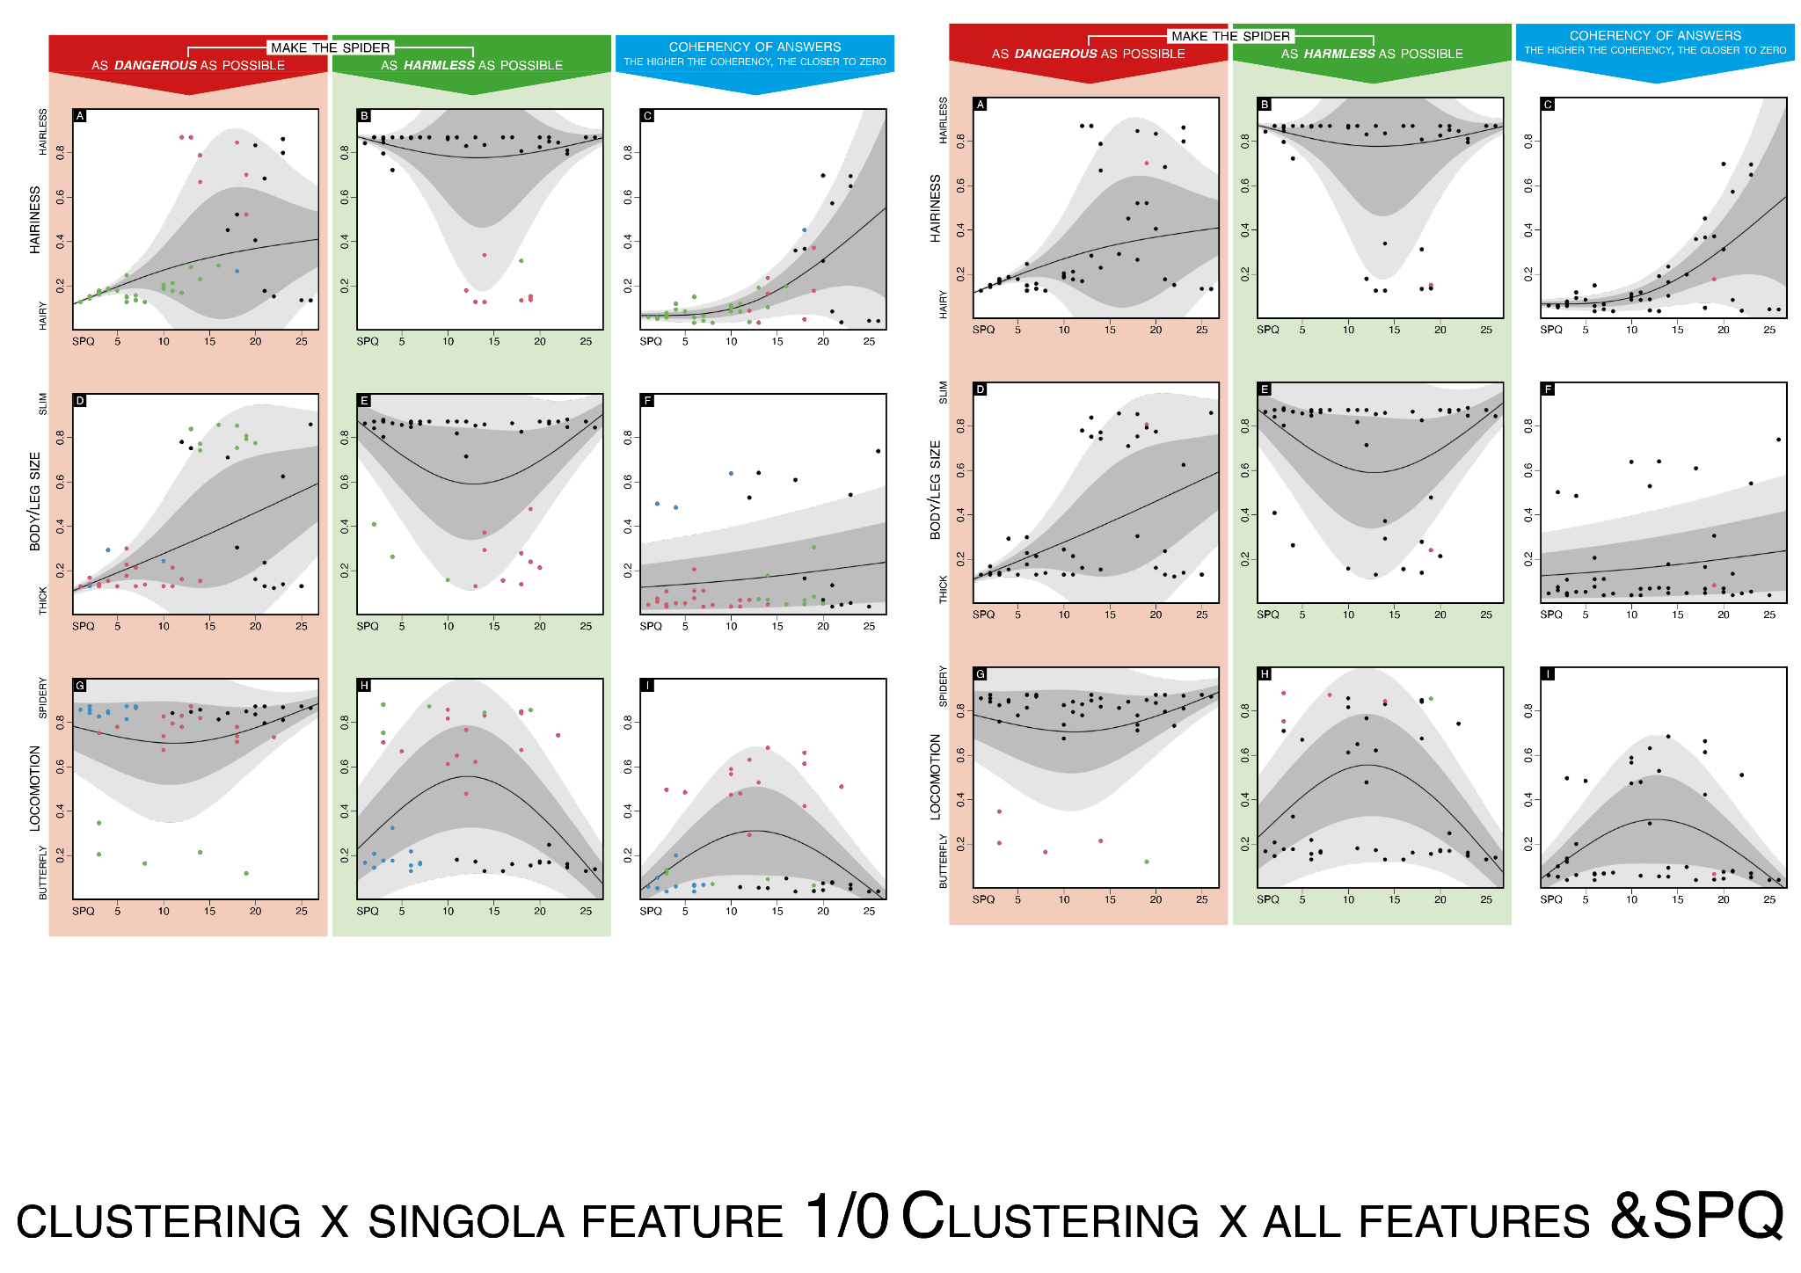
Supplementary Figure 6: replication of main Figure 2 with clustering based on all perceptual features simultaneously (excluding SPQ)
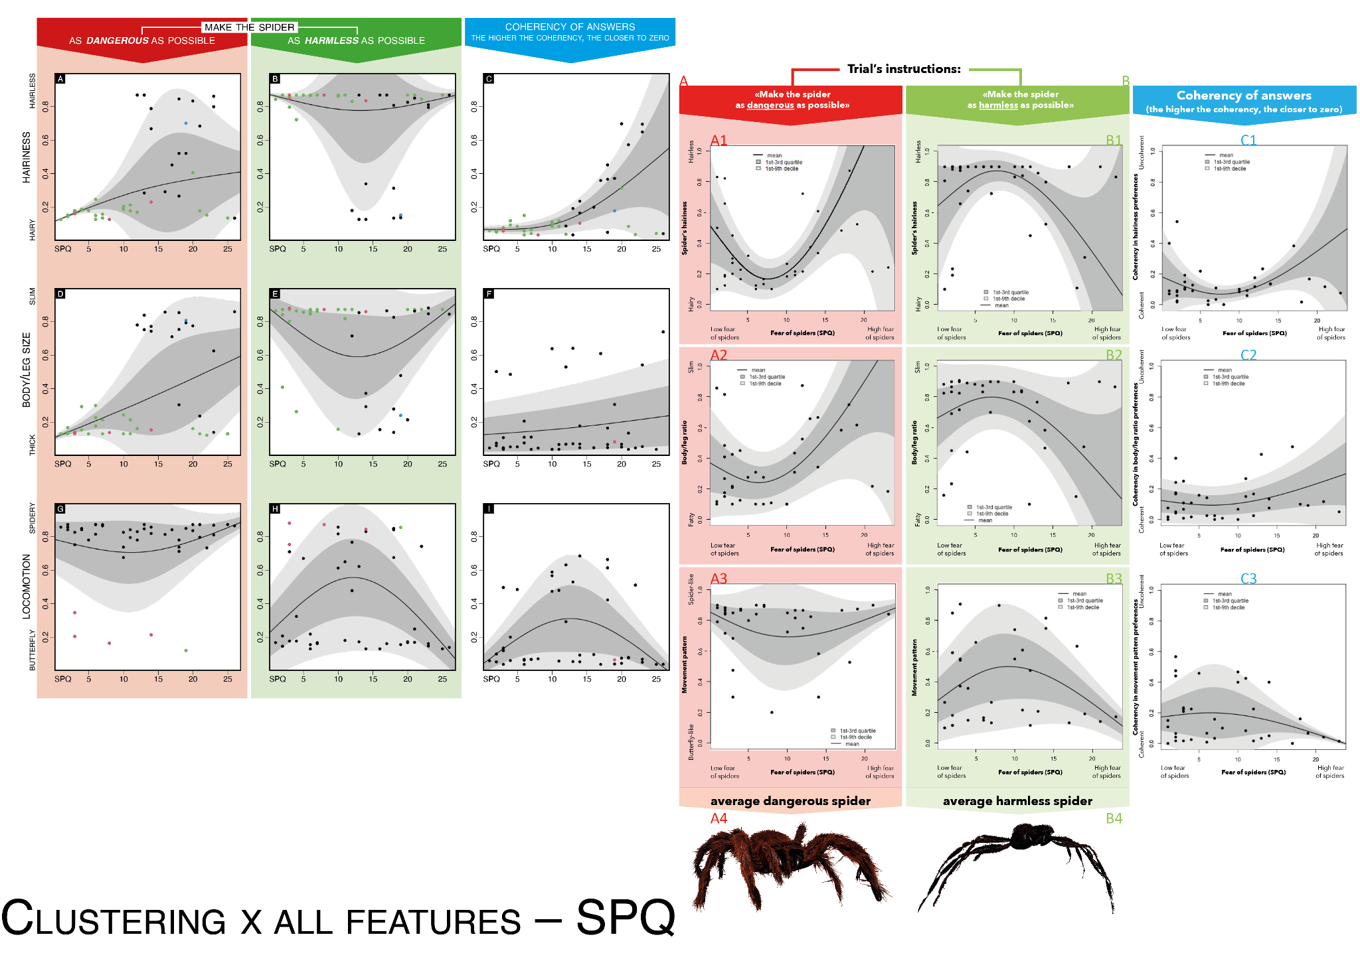

Supplementary Figure 7: replication of main Figure 2 with clustering based on each perceptual feature in both its harmless and dangerous version (excluding SPQ)

