Population genomic analysis of the greater amberjack (*Seriola dumerili*) in the Mediterranean and the Northeast Atlantic, based on SNPs, microsatellites and mitochondrial DNA sequences

Aikaterini Katirtzoglou, Dimitris Tsaparis, Evangelos Kolios, Antonios Magoulas, Constantinos C. Mylonas, Ioannis Fakriadis, Tereza Manousaki, Costas S. Tsigenopoulos

**SUPPLEMENTARY MATERIAL**

**Supplementary Table 1**: The eleven dinucleotide microsatellite markers used in the present study (Renshaw et al., 2007), their accession numbers and the fluorescent dyes employed.

|  |  |  |  |  |
| --- | --- | --- | --- | --- |
| **Locus** | **GenBank** | **Dye** | **ForwardPrimersequence (5’–3’)** | **ReversePrimersequence (5’–3’)** |
| Sdu29 | DQ883568 | FAM | CCTTGCCATACCGATGCCAG | GACTGCTCTGCCTGCTTGTTG |
| Sdu31 | DQ883569 | FAM | CACATTTGGACGGATTCTTC | GCTGTTATCCTCCAGTGCT |
| Sdu32 | DQ883570 | Atto-550 | CCTGTGAGAGCATTTGGTAT | GTGCTTGTCTCTTCTGTCAT |
| Sdu34 | DQ883572 | Atto-565 | CCTTGTGTTGTATCTGCTGTAA | GGAATAAACCTCGTCTGTCA |
| Sdu36 | DQ883573 | HEX | CTGTTATGAAGCAGTGAAGAGG | GGACCATCCTGCTCTGACA |
| Sdu37 | DQ883574 | Atto-565 | CCTCTAATGGACTTCAGCG | GGTTATTTTGAGAGCCGTC |
| Sdu39 | DQ883575 | FAM | AGTGGCTTCTGCTGCTGT | CGTGTGCGTGCTTGTAAA |
| Sdu40 | DQ883576 | Atto-550 | CGATGCTTTCAACTCCGACACAC | CCATCCTTCATCAGCAACAACATCC |
| Sdu41 | DQ883577 | HEX | AGCGTGGACAGTTTATGG | GTCTGTTTACTGGTCGCA |
| Sdu43 | DQ883578 | HEX | CAGAAGAAGAGCGTGGTGGAGAG | CAGAAGAAGAGCGTGGTGGAGAG |
| Sdu46 | DQ883580 | FAM | GCAGTGTGAGCCATACATTAC | CTACAGGACAAAAGCCATT |

**Supplementary Table 2**: Control region haplotypes of *S. dumerili* (assignedto haplogroups) and *S. rivoliana* with their sites of originused for the construction of the network in Figure 2. (NTE: North Tenerife, TE: Tenerife, AZ: Azores, TEB: Tenerife Segvic-Bubić, GC: Gran Canaria, TUN: Tunisia, SSI: South Sicily, NSI: North Sicily, ESI: East Sicily, LA: Lampedusa, AS: Astakos, CR: North Crete, CH: Chalkidiki, TU: Mersin, Turkey, CY: Cyprus)

|  |  |  |  |
| --- | --- | --- | --- |
| **Region** | **Haplogroup** | **Haplotype** | **Acc. Number** |
| AS | B | H01 | PP329347 |
| AS | A | H02 | PP329348 |
| CY | B | H03 | PP329349 |
| CY | B | H04 | PP329350 |
| GC | A | H05 | PP329351 |
| CR | A | H06 | PP329352 |
| CR | B | H07 | PP329353 |
| AS,CY | A | H08 | PP329354 |
| AS,CY | A | H09 | PP329355 |
| TE | A | H10 | PP329356 |
| TE | A | H11 | PP329357 |
| TE | A | H12 | PP329358 |
| TE | B | H13 | PP329359 |
| NTE | B | H14 | PP329360 |
| NTE,TE | A | H15 | PP329361 |
| NTE | A | H16 | PP329362 |
| NTE | A | H17 | PP329363 |
| GC,NTE,TE | A | H18 | PP329364 |
| CY,LA | A | H19 | PP329365 |
| CY,LA | A | H20 | PP329366 |
| LA | A | H21 | PP329367 |
| LA | A | H22 | PP329368 |
| CY,TU,AS | A | H23 | PP329369 |
| CH | B | H24 | PP329370 |
| NSI | B | H25 | Šegvić-Bubić et al. 2016 |
| NSI | A | H26 | Šegvić-Bubić et al. 2016 |
| LA,AS,NSI | A | H27 | Šegvić-Bubić et al. 2016 |
| ESI | A | H28 | Šegvić-Bubić et al. 2016 |
| CY,TU,ESI | A | H29 | Šegvić-Bubić et al. 2016 |
| NSI | B | H30 | Šegvić-Bubić et al. 2016 |
| NSI | A | H31 | Šegvić-Bubić et al. 2016 |
| CY,LA,NTE,TE,NSI | A | H32 | Šegvić-Bubić et al. 2016 |
| CHA,AS,NSI | A | H33 | Šegvić-Bubić et al. 2016 |
| SSI | B | H34 | Šegvić-Bubić et al. 2016 |
| SSI | A | H35 | Šegvić-Bubić et al. 2016 |
| SSI | A | H36 | Šegvić-Bubić et al. 2016 |
| CY,TU,CR,AS,NSI,SSI | A | H37 | Šegvić-Bubić et al. 2016 |
| SSI | A | H38 | Šegvić-Bubić et al. 2016 |
| AS,CHA,LA,CR,SSI | A | H39 | Šegvić-Bubić et al. 2016 |
| AS,LA,SSI,ESI,NSI | A | H40 | Šegvić-Bubić et al. 2016 |
| ESI | A | H41 | Šegvić-Bubić et al. 2016 |
| CHA,CY,LA,TU,NTE,TE,AS,NSI,ESI | A | H42 | Šegvić-Bubić et al. 2016 |
| TEB | A | H43 | Šegvić-Bubić et al. 2016 |
| TEB | A | H44 | Šegvić-Bubić et al. 2016 |
| TEB | A | H45 | Šegvić-Bubić et al. 2016 |
| TEB | A | H46 | Šegvić-Bubić et al. 2016 |
| TEB | B | H47 | Šegvić-Bubić et al. 2016 |
| TEB | B | H48 | Šegvić-Bubić et al. 2016 |
| NSI,TUN | A | H49 | Šegvić-Bubić et al. 2016 |
| CH,LA,AS,TUN,SSI,NSI,ESI | A | H50 | Šegvić-Bubić et al. 2016 |
| CH,CY,GC,LA,TU,NTE,TE,AS,TU,NSI,ESI,SSI | A | H51 | Šegvić-Bubić et al. 2016 |
| CH,CY,LA,TU,TE,AS,TUN,NSI,ESI,SSI | B | H52 | Šegvić-Bubić et al. 2016 |
| AZ | Seriola rivoliana | H53 | Šegvić-Bubić et al. 2016 |
| AZ | Seriola rivoliana | H54 | Šegvić-Bubić et al. 2016 |
| AZ | Seriola rivoliana | H55 | Šegvić-Bubić et al. 2016 |
| AZ | Seriola rivoliana | H56 | Šegvić-Bubić et al. 2016 |
| AZ | Seriola rivoliana | H57 | Šegvić-Bubić et al. 2016 |
| AZ,LA | Seriola rivoliana | H58 | Šegvić-Bubić et al. 2016 |

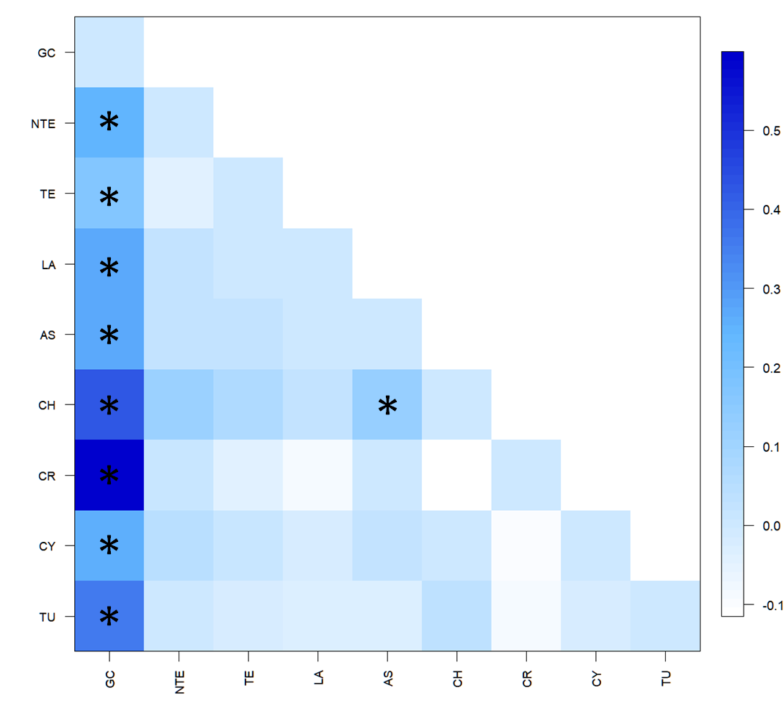

**Supplementary Figure 1:** PairwiseΦst values for the nine populations and the control region mtDNA data set (395 bp). Statistically significant values (p<0.05, 50,000 permutations) are indicated with asterisks (GC: Gran Canaria, NTE: North Tenerife, TE: Tenerife, LA: Lampedusa, AS: Astakos, CH: Chalkidiki, CR: North Crete, CY: Cyprus, TU: Mersin, Turkey).

**Supplementary Table 3:** Population structure cases tested in AMOVA (haplotypic format) for the control region mtDNA data. Four different scenarios of population structure were tested based on geographical criteria. Fixation indices (FCT, FSC, FST) are genetic structure indices, used to explain the source of the variations. Statistically significant values (p<0.05, 99,999 permutations) are indicated with an asterisk (GC: Gran Canaria, NTE: North Tenerife, TE: Tenerife, LA: Lampedusa, AS: Astakos, CH: Chalkidiki, CR: North Crete, CY: Cyprus, TU: Mersin Turkey).

|  |  |  |  |  |
| --- | --- | --- | --- | --- |
|  | **Case 1** | **Case 2** | **Case 3** | **Case 4** |
|  | GC, NT, TE  (Group1)    LA, AS, CH,CR,CY,TU  (Group 2) | GC  (Group1)    NTE, TE  (Group 2)    LA, AS, CH, CR,CY,TU  (Group 3) | GC  (Group1)    NTE, TE  (Group 2)    LA, AS, CH, CR  (Group 3)    CY,TU  (Group 4) | GC  (Group1)    NTE, TE  (Group 2)    LA, AS  (Group 3)    CH, CR, CY,TU  (Group 4) |
| **Variation (%)** | | | | |
| **Among groups** | 9.19 | 11.01 | 5.81 | 7.75 |
| **Among populations within groups** | 1.66 | 0.49 | 1.28 | -0.43 |
| **Within populations** | 89.15 | 88.50 | 92.91 | 92.68 |
| **Fixation indices** | | | | |
| **FCT** | 0.0919* | 0.1101* | 0.0581 | 0.0775* |
| **FSC** | 0.0183 | 0.0056 | 0.0136 | -0.0047 |
| **FST** | 0.1085* | 0.1150* | 0.0709* | 0.0732* |

**Supplementary Table 4:** Diversity indices and standard errors (in parentheses) for 254 *S. dumerili* samples analyzed for ten microsatellite loci. n: number of individuals, A: mean number of alleles per locus, Au: corrected mean number of alleles per locus, Ho: observed heterozygosity, Heu: expected heterozygosity, Np: mean number of private alleles. Inbreeding coefficient (FIS) estimates; the asterisk indicates values that are statistically significant (p<0.05) (GC: Gran Canaria, NTE: North Tenerife, TE: Tenerife, LA: Lampedusa, AS: Astakos, CH: Chalkidiki, CR: North Crete, CY: Cyprus, TU: Mersin Turkey).

|  |  |  |  |  |  |  |  |
| --- | --- | --- | --- | --- | --- | --- | --- |
| **Population** | **n** | **A** | **Au** | **Ηο** | **Ηe,u** | **Np** | **FIS** |
| **GC** | 25 | 4,40 (0.31) | 4.30 (0.30) | 0.740 (0.079) | 0.624 (0.054) | 0.20 (0.13) | -0.190 |
| **NTE** | 13 | 6.90 (0.77) | 4.50 (0.40) | 0.762 (0.047) | 0.738 (0.038) | 0.30 (0.15) | -0.033 |
| **TE** | 22 | 8.00 (1.11) | 5.00 (0.39) | 0.727 (0.048) | 0.760 (0.036) | 0.30 (0.21) | -0.033 |
| **LA** | 45 | 8.30 (1.12) | 4.30 (0.47) | 0.617 (0.040) | 0.688 (0.036) | 0.20 (0.13) | 0.104* |
| **AS** | 54 | 9.70 (1.33) | 4.20 (0.51) | 0.683 (0.040) | 0.710 (0.037) | 0.50 (0.27) | 0.038 |
| **CH** | 18 | 6.20 (0.80) | 4.50 (0.50) | 0.674 (0.037) | 0.701 (0.036) | - | 0.040 |
| **CR** | 4 | 4.10 (0.53) | 4.10 (0.53) | 0.700 (0.073) | 0.696 (0.072) | - | -0.006 |
| **CY** | 55 | 9.30 (0.98) | 4.20 (0.47) | 0.676 (0.039) | 0.711 (0.037) | 0.30 (0.15) | 0.049 |
| **TU** | 17 | 6.80 (0.89) | 4.50 (0.48) | 0.641 (0.050) | 0.694 (0.041) | - | 0.079 |
| **Total** | 254 | 7.08 (0.35) | 3.79 (0.21) | 0.691 (0.017) | 0.703 (0.015) | - | 0.040(0.013*) |

**Supplementary Table 5:** Pairwise Fst values for 254 *S. dumerili* samples and nine populations analyzed for ten microsatellite loci. The asterisk indicates values that are statistically significant (p<0.05) (GC: Gran Canaria, NTE: North Tenerife, TE: Tenerife, LA: Lampedusa, AS: Astakos, CH: Chalkidiki, CR: North Crete, CY: Cyprus, TU: Mersin Turkey)

|  |  |  |  |  |  |  |  |  |
| --- | --- | --- | --- | --- | --- | --- | --- | --- |
|  | GC | NTE | TE | LA | AS | CH | CR | CY |
| GC | - |  |  |  |  |  |  |  |
| NTE | 0,1272* | - |  |  |  |  |  |  |
| TE | 0,0915* | 0,0087 | - |  |  |  |  |  |
| LA | 0,1443* | 0,0300* | 0,0442* | - |  |  |  |  |
| AS | 0,1463* | 0,0209* | 0,0402* | -0,0016 | - |  |  |  |
| CH | 0,1615* | 0,0290* | 0,0462* | -0,0039 | 0,0060 | - |  |  |
| CR | 0,1792* | 0,0440* | 0,0573* | -0,0116 | -0,0072 | -0,0048 | - |  |
| CY | 0,1444* | 0,0213* | 0,0400* | 0,0007 | -0,0031 | 0,0006 | 0,0006 | - |
| TU | 0,1510* | 0,0297* | 0,0545* | 0,0063 | 0,0020 | 0,0084 | 0,0104 | 0,0049 |

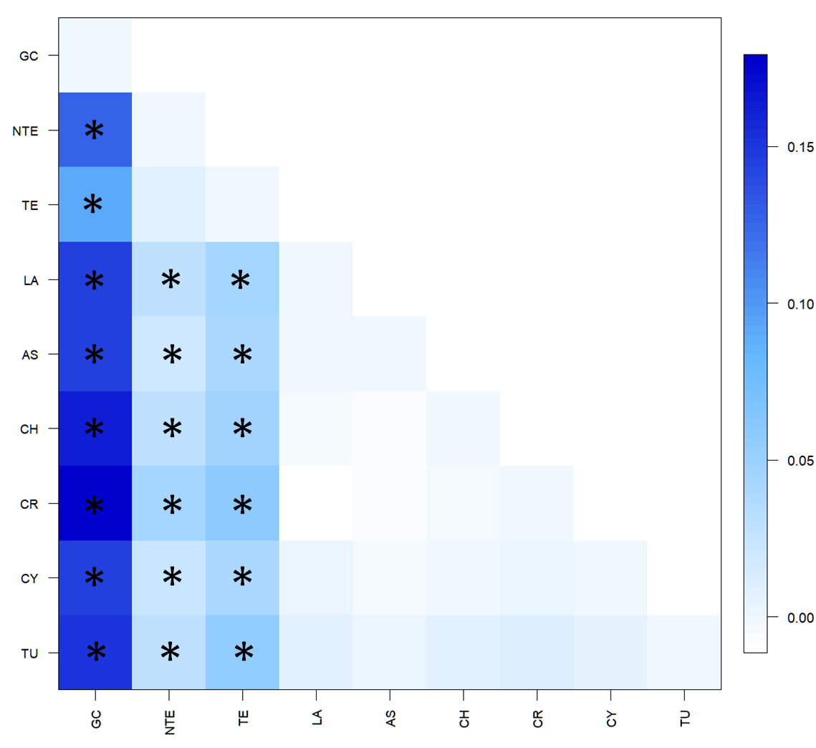

**Supplementary Figure 2:** PairwiseFST values of the nine populations analyzed in the current study for ten microsatellite loci. Statistically significant values (p<0.05, 50,000 permutations) are indicated with asterisks (GC: Gran Canaria, NTE: North Tenerife, TE: Tenerife, LA: Lampedusa, AS: Astakos, CH: Chalkidiki, CR: North Crete, CY: Cyprus, TU: Mersin Turkey).

**Supplementary Table 6:** Population structure cases tested in AMOVA for the microsatellites data set. Four different scenarios of population structure were tested based on geographical criteria. Fixation indices (FCT, FSC, FST) are genetic structure indices, used to explain the source of the variations. Statistically significant values (p<0.05, 99,999 permutations) are indicated with an asterisk (GC: Gran Canaria, NTE: North Tenerife, TE: Tenerife, LA: Lampedusa, AS: Astakos, CH: Chalkidiki, CR: North Crete, CY: Cyprus, TU: Mersin Turkey).

|  |  |  |  |  |
| --- | --- | --- | --- | --- |
|  | **Case 1** | **Case 2** | **Case 3** | **Case 4** |
|  | GC, NT, TE  (Group1)    LA, AS, CH,CR,CY,TU  (Group 2) | GC  (Group1)    NTE, TE  (Group 2)    LA, AS, CH, CR,CY,TU  (Group 3) | GC  (Group1)    NTE, TE  (Group 2)    LA, AS, CH, CR  (Group 3)    CY,TU  (Group 4) | GC  (Group1)    NTE, TE  (Group 2)    LA, AS  (Group 3)    CH, CR, CY,TU  (Group 4) |
| **Variation (%)** | | | | |
| **Among groups** | 5.43 | 8.36 | 5.12 | 4.80 |
| **Among populations within groups** | 1.65 | 0.06 | 0.05 | 0.20 |
| **Within populations** | 92.92 | 91.58 | 94.83 | 95.00 |
| **Fixation indices** | | | | |
| **FCT** | 0.0543* | 0.0836* | 0.0512* | 0.0480 |
| **FSC** | 0.0174* | 0.0007 | 0.0005 | 0.0022 |
| **FST** | 0.0708* | 0.0842* | 0.0517* | 0.0500 |

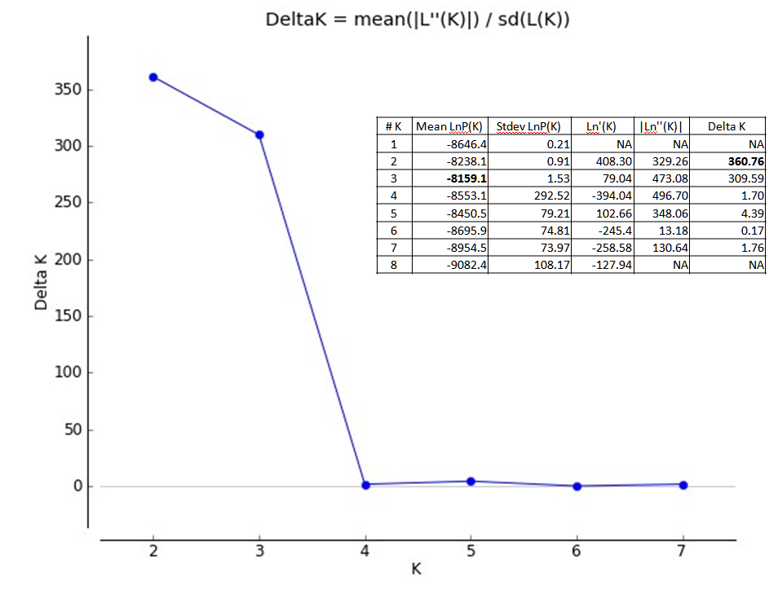

**Supplementary Figure 3:** Results of STRUCTURE analysis [mean LnP(K)] and STRUCTURE HARVESTER for microsatellites data (K=1-8, 20 replicates).

**Supplementary Table 7:** Population map and individual statistics from Stacks. The sample name is displayed on the first column and on the second the population ID. In the third column, the number of reads assigned to each individual after cleaning and demultiplexing (process_radtags). In the fourth column, the proportion of properly paired reads per individual is shown; samples in bold and red were removed from the analysis due to the low alignment rate. Finally, the last column shows the effective mean coverage per sample.

|  |  |  |  |  |  |  |  |  |  |
| --- | --- | --- | --- | --- | --- | --- | --- | --- | --- |
| Sample | PopID | Retained reads | Properly paired (%) | Mean coverage | Sample | PopID | Retained reads | Properly paired (%) | Mean coverage |
| GC_01 | 1 | 493001 | 95.63 | 97.305 | AS_23 | 5 | 792092 | 92.56 | 146.008 |
| GC_02 | 1 | 8066 | **43.70** |  | AS_24 | 5 | 908757 | 97.10 | 189.499 |
| GC_03 | 1 | 512671 | 93.98 | 93.460 | AS_25 | 5 | 2838905 | 95.51 | 396.338 |
| GC_04 | 1 | 1404285 | 95.13 | 203.058 | ASK_01 | 5 | 2406917 | 89.45 | 309.336 |
| GC_05 | 1 | 917982 | 94.49 | 145.965 | ASK_02 | 5 | 1616870 | 91.65 | 230.540 |
| GC_06 | 1 | 1430290 | 96.35 | 203.558 | ASK_03 | 5 | 6961613 | 94.78 | 811.972 |
| GC_07 | 1 | 118180 | 94.45 | 18.592 | ASK_04 | 5 | 209388 | 90.98 | 61.102 |
| GC_08 | 1 | 3722929 | 95.84 | 476.490 | ASK_05 | 5 | 1237045 | 92.40 | 179.546 |
| GC_09 | 1 | 980671 | 88.65 | 153.643 | ASK_06 | 5 | 1036582 | 87.43 | 161.548 |
| GC_10 | 1 | 3364219 | 92.16 | 404.618 | ASK_07 | 5 | 3153606 | 91.34 | 402.292 |
| GC_11 | 1 | 1305834 | 88.87 | 186.556 | ASK_08 | 5 | 128856 | 89.24 | 57.846 |
| GC_12 | 1 | 1176576 | 89.71 | 170.051 | ASK_09 | 5 | 1500072 | 91.04 | 217.790 |
| GC_13 | 1 | 1563584 | 92.13 | 223.312 | ASK_10 | 5 | 5707239 | 94.11 | 687.080 |
| GC_14 | 1 | 5129332 | 91.87 | 591.305 | ASK_11 | 5 | 7397652 | 92.42 | 854.618 |
| GC_15 | 1 | 3762095 | 89.99 | 449.130 | ASK_12 | 5 | 3105606 | 90.96 | 405.769 |
| GC_16 | 1 | 3426707 | 91.76 | 420.748 | ASK_13 | 5 | 2056857 | 92.61 | 290.488 |
| GC_17 | 1 | 2665972 | 91.45 | 340.247 | ASK_14 | 5 | 5788318 | 94.56 | 683.148 |
| GC_18 | 1 | 1920395 | 93.25 | 278.201 | ASK_16 | 5 | 7513712 | 93.26 | 851.643 |
| GC_19 | 1 | 609733 | 93.50 | 117.553 | ASK_17 | 5 | 529768 | 90.44 | 92.483 |
| GC_20 | 1 | 4518888 | 86.70 | 512.327 | ASK_18 | 5 | 3250909 | 94.58 | 425.887 |
| GC_21 | 1 | 1612816 | 86.52 | 215.845 | ASK_19 | 5 | 473554 | 93.10 | 98.773 |
| GC_22 | 1 | 5082094 | 86.42 | 566.167 | ASK_20 | 5 | 1107863 | 92.78 | 159.677 |
| GC_23 | 1 | 55451 | 86.16 | 31.830 | ASK_21 | 5 | 1237562 | 90.61 | 182.989 |
| GC_24 | 1 | 2151266 | 89.90 | 291.047 | ASK_22 | 5 | 2288305 | 92.84 | 303.417 |
| GC_25 | 1 | 1149703 | 93.56 | 178.412 | ASK_24 | 5 | 1791923 | 95.57 | 262.326 |
| NTE_23 | 2 | 233483 | 96.53 | 73.501 | ASK_25 | 5 | 781001 | 94.28 | 135.468 |
| NTE_24 | 2 | 1633123 | 91.34 | 227.308 | ASK_26 | 5 | 3505218 | 96.15 | 460.933 |
| NTE_25 | 2 | 3803121 | 94.36 | 459.354 | ASK_28 | 5 | 5902678 | 96.01 | 733.841 |
| NTE_26 | 2 | 2818289 | 93.25 | 359.786 | ASK_30 | 5 | 3599906 | 95.24 | 465.095 |
| NTE_27 | 2 | 575735 | 91.90 | 96.028 | ASK_31 | 5 | 128122 | 89.42 | 58.062 |
| NTE_28 | 2 | 196478 | 91.10 | 51.730 | ASK_32 | 5 | 1503874 | 93.64 | 224.305 |
| NTE_29 | 2 | 4461198 | 93.39 | 529.894 | ASK_33 | 5 | 2613961 | 94.11 | 344.777 |
| NTE_30 | 2 | 863612 | 93.15 | 132.297 | CH_01 | 6 | 1583174 | 91.99 | 222.630 |
| NTE_32 | 2 | 170780 | 92.02 | 49.096 | CH_02 | 6 | 17076668 | 94.72 | 1.731.951 |
| NTE_33 | 2 | 2301470 | 92.85 | 301.540 | CH_03 | 6 | 3159178 | 92.12 | 399.353 |
| NTE_34 | 2 | 1173983 | 95.74 | 168.045 | CH_04 | 6 | 2152054 | 95.94 | 320.690 |
| NTE_35 | 2 | 2368132 | 92.56 | 311.197 | CH_05 | 6 | 4060743 | 94.29 | 492.161 |
| NTE_31 | 2 | 317471 | 94.29 | 68.169 | CH_06 | 6 | 7090867 | 95.18 | 827.502 |
| TE_01 | 3 | 4905006 | 95.31 | 612.564 | CH_07 | 6 | 3533472 | 90.95 | 446.891 |
| TE_02 | 3 | 7667862 | 95.68 | 863.710 | CH_08 | 6 | 6260302 | 89.57 | 705.549 |
| TE_03 | 3 | 491384 | 93.33 | 92.722 | CH_09 | 6 | 7255413 | 91.39 | 817.713 |
| TE_04 | 3 | 1871458 | 93.71 | 261.777 | CH_10 | 6 | 4175753 | 89.97 | 489.836 |
| TE_05 | 3 | 646573 | 93.44 | 119.927 | CH_11 | 6 | 3307604 | 88.31 | 403.823 |
| TE_06 | 3 | 2098292 | 96.04 | 276.494 | CH_12 | 6 | 3660348 | 88.29 | 438.872 |
| TE_07 | 3 | 1160626 | 93.60 | 186.058 | CH_13 | 6 | 2676939 | 92.96 | 358.408 |
| TE_08 | 3 | 2177895 | 93.23 | 302.485 | CH_14 | 6 | 11436691 | 91.06 | 1.209.669 |
| TE_09 | 3 | 9974663 | 93.18 | 1.098.434 | CH_15 | 6 | 2929455 | 90.98 | 384.520 |
| TE_10 | 3 | 2516119 | 92.94 | 331.206 | CH_16 | 6 | 4719303 | 94.78 | 598.048 |
| TE_11 | 3 | 1736199 | 94.36 | 261.575 | CH_17 | 6 | 7268102 | 92.66 | 844.216 |
| TE_12 | 3 | 3038412 | 92.91 | 403.551 | CH_18 | 6 | 13201779 | 95.17 | 1.469.481 |
| TE_13 | 3 | 842825 | 94.79 | 144.826 | CR_15 | 7 | 5680323 | 95.31 | 685.608 |
| TE_14 | 3 | 3920453 | 95.67 | 495.351 | CR_23 | 7 | 4255547 | 95.15 | 535.208 |
| TE_15 | 3 | 392368 | 92.52 | 85.117 | CR_27 | 7 | 2729709 | 94.50 | 358.348 |
| TE_16 | 3 | 1893829 | 95.92 | 282.292 | CR_29 | 7 | 4092919 | 96.01 | 515.941 |
| TE_17 | 3 | 393115 | 93.25 | 92.671 | CY_01 | 8 | 97721 | 96.61 | 42.803 |
| TE_18 | 3 | 662282 | 93.10 | 125.877 | CY_02 | 8 | 1109873 | 97.15 | 197.267 |
| TE_19 | 3 | 362217 | 93.72 | 83.328 | CY_03 | 8 | 552366 | 97.97 | 132.901 |
| TE_20 | 3 | 1723723 | 94.12 | 260.101 | CY_04 | 8 | 95865 | 97.04 | 43.690 |
| TE_21 | 3 | 285004 | 93.74 | 65.434 | CY_05 | 8 | 460431 | 96.89 | 113.186 |
| TE_22 | 3 | 566082 | 94.87 | 116.146 | CY_06 | 8 | 179626 | 93.43 | 41.219 |
| LA_02 | 4 | 2375966 | 96.80 | 313.960 | CY_07 | 8 | 679440 | 96.00 | 118.438 |
| LA_04 | 4 | 168670 | 93.18 | 49.083 | CY_08 | 8 | 1645575 | 96.29 | 253.126 |
| LA_05 | 4 | 1222296 | 94.49 | 162.805 | CY_09 | 8 | 1825600 | 96.83 | 290.032 |
| LA_06 | 4 | 3410823 | 96.52 | 448.745 | CY_10 | 8 | 173144 | 97.01 | 58.803 |
| LA_08 | 4 | 1089021 | 95.01 | 165.213 | CY_11 | 8 | 2408841 | 97.02 | 304.950 |
| LA_09 | 4 | 351382 | 95.38 | 76.580 | CY_12 | 8 | 592992 | 97.60 | 130.319 |
| LA_10 | 4 | 2000101 | 94.94 | 270.315 | CY_13 | 8 | 679029 | 97.34 | 143.684 |
| LA_11 | 4 | 1888744 | 93.17 | 250.795 | CY_14 | 8 | 51518 | 93.64 | 17.406 |
| LA_14 | 4 | 1055370 | 96.11 | 162.716 | CY_15 | 8 | 631593 | 96.43 | 125.257 |
| LA_15 | 4 | 609233 | 94.06 | 104.161 | CY_16 | 8 | 179647 | 96.15 | 58.816 |
| LA_16 | 4 | 1154919 | 93.95 | 174.356 | CY_17 | 8 | 84764 | 90.75 | 35.985 |
| LA_17 | 4 | 1551712 | 95.69 | 213.945 | CY_18 | 8 | 529285 | 95.84 | 101.745 |
| LA_18 | 4 | 2055664 | 96.14 | 281.205 | CY_19 | 8 | 751020 | 96.76 | 138.384 |
| LA_19 | 4 | 154656 | 95.82 | 52.172 | CY_20 | 8 | 223620 | 97.05 | 58.613 |
| LA_20 | 4 | 1571896 | 96.63 | 221.889 | CY_21 | 8 | 199610 | 96.17 | 65.117 |
| LA_21 | 4 | 14156 | **49.75** |  | CY_22 | 8 | 151086 | 96.51 | 62.640 |
| LA_22 | 4 | 3456646 | 96.41 | 423.825 | CY_23 | 8 | 390409 | 97.74 | 101.525 |
| LA_23 | 4 | 2592943 | 96.73 | 343.291 | CY_24 | 8 | 80055 | 95.44 | 32.004 |
| LA_24 | 4 | 495767 | 95.29 | 97.614 | CY_25 | 8 | 591995 | 97.12 | 130.110 |
| LA_25 | 4 | 824573 | 95.90 | 144.915 | CY_26 | 8 | 27337 | 89.21 | 10.325 |
| LA_26 | 4 | 736435 | 94.93 | 130.270 | CY_27 | 8 | 150536 | 96.02 | 57.632 |
| LA_27 | 4 | 4005420 | 95.98 | 516.584 | CY_28 | 8 | 17655 | 94.65 | 19.275 |
| LA_29 | 4 | 963793 | 95.93 | 147.994 | CY_29 | 8 | 408985 | 95.20 | 85.414 |
| LA_30 | 4 | 3517486 | 96.41 | 424.409 | CY_30 | 8 | 978588 | 94.15 | 151.817 |
| LA_31 | 4 | 5007 | **43.94** |  | CY_31 | 8 | 3062840 | 93.82 | 399.395 |
| LA_32 | 4 | 1005215 | 94.00 | 158.619 | CY_32 | 8 | 1743545 | 95.36 | 246.218 |
| LA_33 | 4 | 3313828 | 96.59 | 391.397 | CY_33 | 8 | 3739194 | 94.82 | 460.850 |
| LA_34 | 4 | 3373711 | 94.60 | 420.758 | CY_34 | 8 | 7480486 | 95.91 | 886.160 |
| LA_35 | 4 | 709631 | 92.62 | 124.956 | CY_35 | 8 | 1107110 | 92.79 | 160.203 |
| LA_36 | 4 | 1506904 | 91.55 | 213.572 | CY_36 | 8 | 4150932 | 94.72 | 517.255 |
| LA_37 | 4 | 5602451 | 93.05 | 638.239 | CY_37 | 8 | 165791 | 93.81 | 49.480 |
| LA_38 | 4 | 4584578 | 93.53 | 547.555 | CY_38 | 8 | 3649829 | 95.34 | 463.061 |
| LA_39 | 4 | 4013836 | 94.49 | 501.470 | CY_39 | 8 | 1446682 | 95.65 | 217.039 |
| LA_40 | 4 | 2925523 | 95.25 | 373.170 | CY_40 | 8 | 1857193 | 94.69 | 265.171 |
| LA_41 | 4 | 660449 | 94.14 | 119.841 | CY_41 | 8 | 1180841 | 94.01 | 176.875 |
| LA_42 | 4 | 4774423 | 94.89 | 560.570 | CY_42 | 8 | 7974149 | 91.44 | 900.669 |
| LA_43 | 4 | 417774 | 94.54 | 91.850 | CY_43 | 8 | 1656321 | 94.74 | 239.067 |
| LA_44 | 4 | 1761322 | 94.18 | 248.353 | CY_44 | 8 | 4675413 | 94.75 | 559.508 |
| LA_45 | 4 | 144928 | 94.13 | 50.647 | CY_45 | 8 | 1901261 | 93.55 | 269.083 |
| LA_46 | 4 | 15199501 | 95.54 | 1.617.988 | CY_46 | 8 | 2131186 | 95.00 | 297.453 |
| LA_47 | 4 | 648178 | 92.95 | 121.959 | CY_47 | 8 | 94124 | 96.28 | 49.891 |
| LA_48 | 4 | 1859366 | 92.36 | 257.871 | CY_48 | 8 | 2762754 | 94.80 | 376.911 |
| LA_49 | 4 | 4265026 | 95.77 | 524.676 | CY_49 | 8 | 446414 | 91.19 | 90.587 |
| LA_50 | 4 | 4296601 | 93.57 | 530.065 | CY_50 | 8 | 6009037 | 94.65 | 718.730 |
| LA_51 | 4 | 2944910 | 93.93 | 376.702 | CY_51 | 8 | 816711 | 93.69 | 140.264 |
| AS_01 | 5 | 1762042 | 91.57 | 248.766 | CY_52 | 8 | 2651358 | 93.38 | 359.129 |
| AS_02 | 5 | 663451 | 92.77 | 118.862 | CY_53 | 8 | 1604807 | 94.63 | 235.929 |
| AS_03 | 5 | 4041750 | 91.30 | 479.259 | CY_54 | 8 | 3404003 | 95.42 | 450.141 |
| AS_04 | 5 | 4952249 | 97.10 | 667.353 | CY_55 | 8 | 886830 | 92.94 | 150.434 |
| AS_05 | 5 | 7043572 | 94.09 | 830.266 | CY_56 | 8 | 4966509 | 94.49 | 591.407 |
| AS_06 | 5 | 3281782 | 92.41 | 400.964 | TU_01 | 9 | 3466319 | 94.09 | 446.520 |
| AS_07 | 5 | 1560788 | 94.22 | 221.969 | TU_02 | 9 | 1691577 | 93.40 | 252.229 |
| AS_08 | 5 | 2401177 | 97.16 | 369.982 | TU_03 | 9 | 2065319 | 95.11 | 303.884 |
| AS_09 | 5 | 2410767 | 94.23 | 321.080 | TU_04 | 9 | 1803252 | 95.16 | 265.000 |
| AS_10 | 5 | 3328013 | 94.66 | 432.811 | TU_05 | 9 | 562237 | 91.86 | 113.817 |
| AS_11 | 5 | 8087560 | 95.42 | 947.158 | TU_06 | 9 | 9097585 | 93.44 | 1.027.328 |
| AS_12 | 5 | 4639369 | 95.94 | 593.290 | TU_07 | 9 | 18104565 | 93.65 | 1.945.245 |
| AS_13 | 5 | 2401006 | 92.29 | 313.662 | TU_08 | 9 | 2167992 | 91.66 | 287.152 |
| AS_14 | 5 | 1264952 | 93.42 | 200.747 | TU_09 | 9 | 352795 | 90.77 | 81.063 |
| AS_15 | 5 | 4676611 | 93.69 | 552.053 | TU10 | 9 | 1994629 | 92.86 | 284.084 |
| AS_16 | 5 | 1890512 | 94.88 | 283.550 | TU_11 | 9 | 3459202 | 92.01 | 411.610 |
| AS_17 | 5 | 995768 | 95.55 | 186.440 | TU_12 | 9 | 1726482 | 92.97 | 244.267 |
| AS_18 | 5 | 857356 | 94.41 | 159.695 | TU_13 | 9 | 1246359 | 94.92 | 203.200 |
| AS_19 | 5 | 1056740 | 93.02 | 180.066 | TU_14 | 9 | 5713425 | 95.19 | 700.272 |
| AS_20 | 5 | 4144054 | 93.55 | 514.513 | TU_15 | 9 | 2063112 | 92.45 | 285.667 |
| AS_21 | 5 | 662962 | 96.07 | 133.009 | TU_16 | 9 | 5084555 | 94.78 | 612.804 |
| AS_22 | 5 | 1871763 | 93.09 | 266.096 | TU_17 | 9 | 326696 | 90.61 | 81.579 |

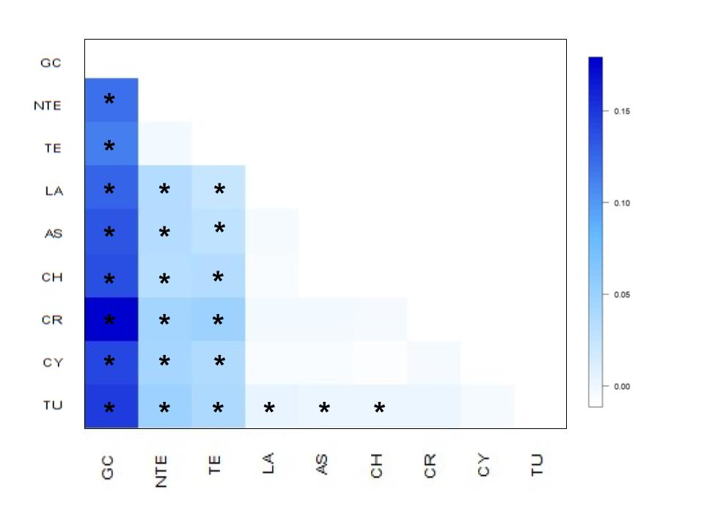

**Supplementary Figure 4:** Heatmap of pairwise FST matrix with significance level of 0.05 and 10,000 permutations for the SNP data. The scale of FST values is represented with color intensity and statistically significant FST values (p < 0.05) are displayed with an asterisk (*).

**Supplementary Table 8:** Pairwise FST matrix from SNP markers. The asterisk indicates values that are statistically significant (p<0.05), Arlequin (Lischer & Excoffier, 2012)

|  |  |  |  |  |  |  |  |  |  |
| --- | --- | --- | --- | --- | --- | --- | --- | --- | --- |
| Pop | GC | NTE | TE | LA | AS | CH | CR | CY | TU |
| GC | - |  |  |  |  |  |  |  |  |
| NTE | 0.10594* | - |  |  |  |  |  |  |  |
| TE | 0.10051* | 0.0067 | - |  |  |  |  |  |  |
| LA | 0.11155* | 0.0380* | 0.0280* | - |  |  |  |  |  |
| AS | 0.11704* | 0.0383* | 0.0321* | 0.0047* | - |  |  |  |  |
| CH | 0.12012* | 0.0353* | 0.0375* | 0.0041 | 0.0000 | - |  |  |  |
| CR | 0.15341* | 0.0457* | 0.0482* | 0.0075 | 0.0064 | 0.0055 | - |  |  |
| CY | 0.12284* | 0.0430* | 0.0385* | 0.0042 | 0.0043 | 0.0027 | 0.0060 | - |  |
| TU | 0.12840* | 0.0480* | 0.0404* | 0.0112* | 0.0105* | 0.0107* | 0.0099 | 0.0052 | - |

**Supplementary Table 9:** Inbreeding coefficient (FIS) estimates based on 1,051 SNP markers for the nine populations studied. Hardy-Weinberg exact significance tests were conducted for each population marked with an asterisk (*) for p-value <0,01.

|  |  |  |
| --- | --- | --- |
| Pop ID | Location | FIS |
| 1 | Gran Canaria | 0.1531* |
| 2 | North Tenerife | 0.3017 |
| 3 | Tenerife | 0.3067* |
| 4 | Lampedusa | 0.2831* |
| 5 | Astakos | 0.2771* |
| 6 | Chalkidiki | 0.1930* |
| 7 | North Crete | 0.0862 |
| 8 | Cyprus | 0.2765* |
| 9 | Mersin | 0.2467* |

**Supplementary Table 10:** Population structure cases tested in locus-by-locus AMOVA for the SNP data. Four different scenarios of population structure were tested based on geographical criteria and pairwise FST results. Fixation indices (FCT, FSC, FST) are genetic structure indices, used to explain the source of the variations. Statistically significant values (p<0.05, 99,999 permutations) are indicated with an asterisk (GC: Gran Canaria, NTE: North Tenerife, TE: Tenerife, LA: Lampedusa, AS: Astakos, CH: Chalkidiki, CR: North Crete, CY: Cyprus, TU: Mersin Turkey).

|  |  |  |  |  |
| --- | --- | --- | --- | --- |
|  | **Case 1** | **Case 2** | **Case 3** | **Case 4** |
|  | GC, NT, TE  (Group1)    LA, AS, CH,CR,CY,TU (Group 2) | GC  (Group1)    NTE, TE  (Group 2)    LA, AS, CH, CR,CY,TU  (Group 3) | GC  (Group1)    NTE, TE  (Group 2)    LA, AS, CH, CR  (Group 3)    CY,TU  (Group 4) | GC  (Group1)    NTE, TE  (Group 2)    LA, AS  (Group 3)    CH, CR, CY,TU  (Group 4) |
| **Variation (%)** | | | | |
| **Among groups** | 4.05 | 6.56 | 4.19 | 3.77 |
| **Among populations within groups** | 2.07 | 0.78 | 0.72 | 0.83 |
| **Within populations** | 93.88 | 92.66 | 95.10 | 95.40 |
| **Fixation indices** | | | | |
| **FCT** | 0.0405* | 0.0656* | 0.0419* | 0.0377* |
| **FSC** | 0.0216* | 0.0084 | 0.0075 | 0.0086* |
| **FST** | 0.0612* | 0.0734* | 0.0490* | 0.0460* |

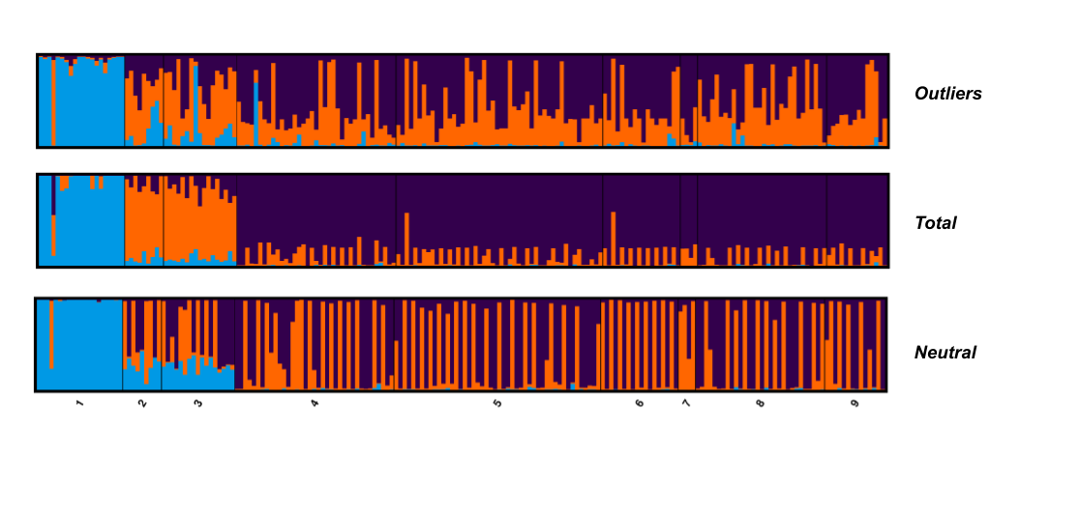**Supplementary Figure 5:** Bayesian individual assignment implemented in STRUCTURE for K=3; the y-axis represents the proportions of membership of greater amberjack individual genotypes for a) outlier loci, b) total loci, and c) neutral loci, along with origin locations of the specimens.

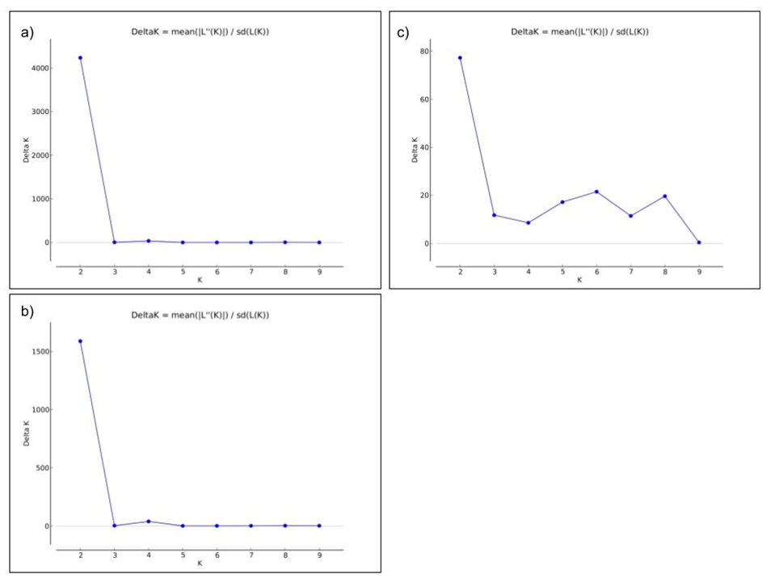

**Supplementary Figure 6:**  ΔK values for K=1 to 10 for a) the total number of loci, b) the neutral loci, and c) the outlier loci. The Evanno’s ΔK criterion is the ratio of the mean of the posterior probability of K, and its standard deviation between successive values of K.

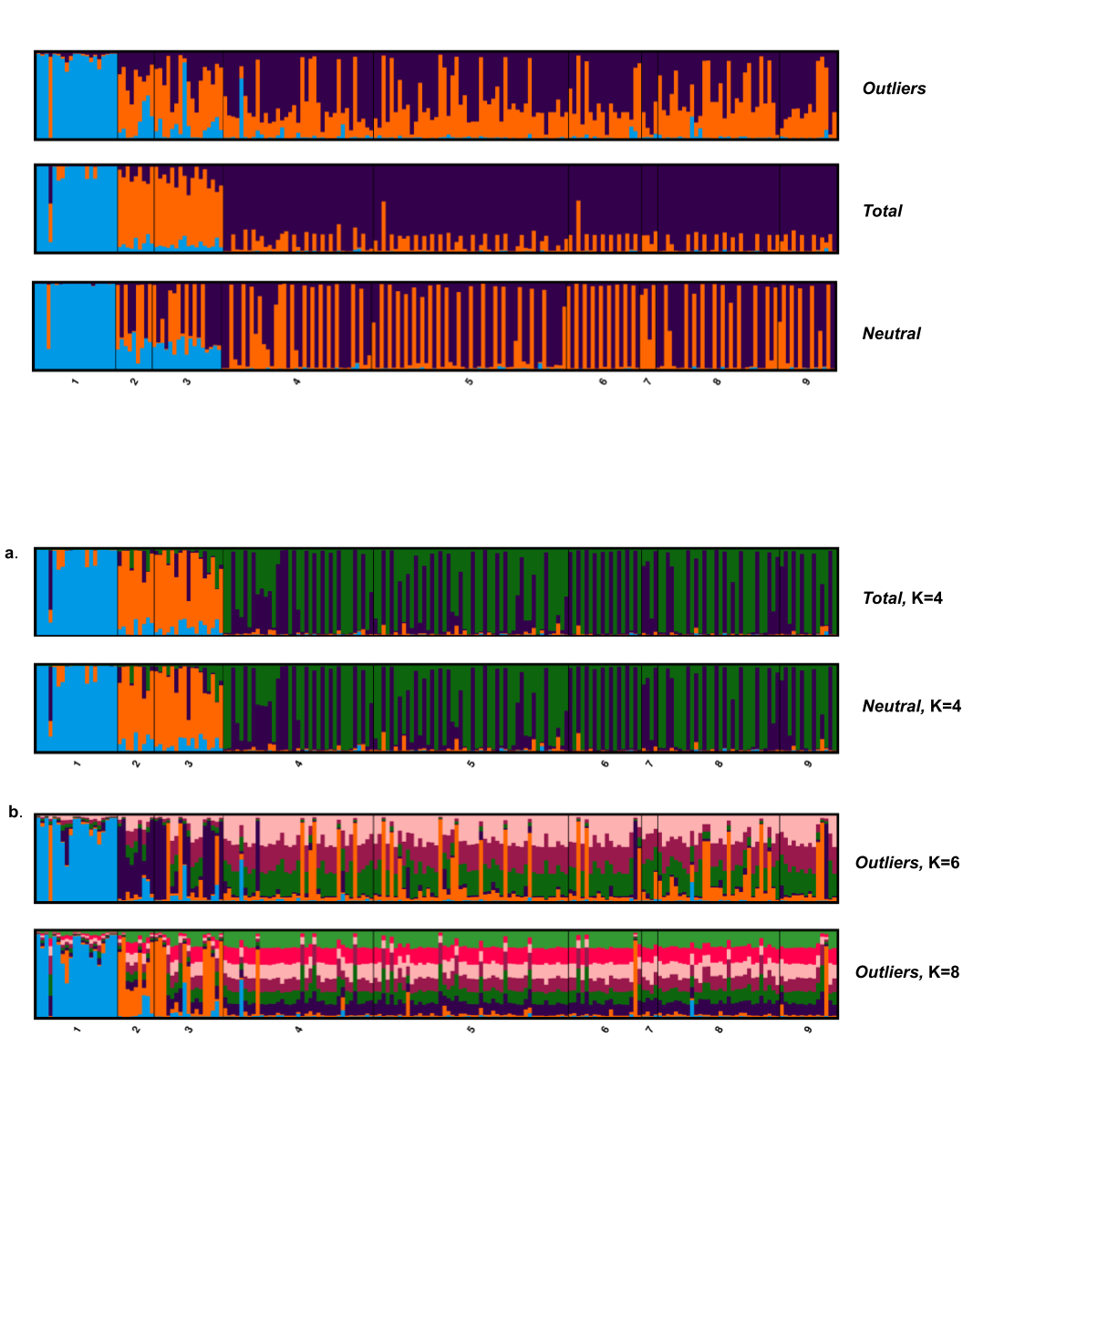

**Supplementary Figure 7:** Bayesian individual assignment implemented in STRUCTURE. The y-axis represents the proportions of membership of greater amberjack individual genotypes and the x-axis denotes the origin of the individuals for a) K=4 for total and neutral loci, and b) for K=6 and K=8 for outlier loci, respectively.

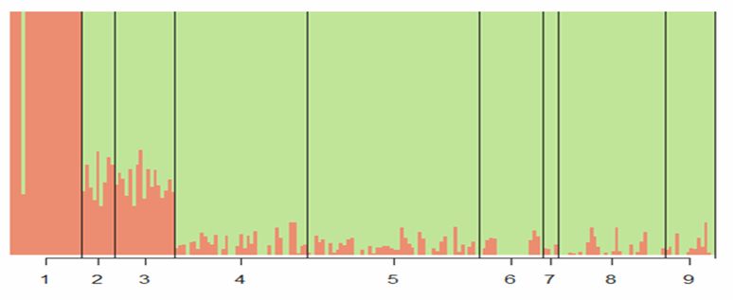

**Supplementary Figure 8:** Ancestry analysis Q-plot for all loci. Membership coefficient plot (Q-plot) produced by ADMIXTURE, provides additional evidence on the existence of two genetic groups in the data. The clustering scenario of the populations is the same produce by STRUCTURE

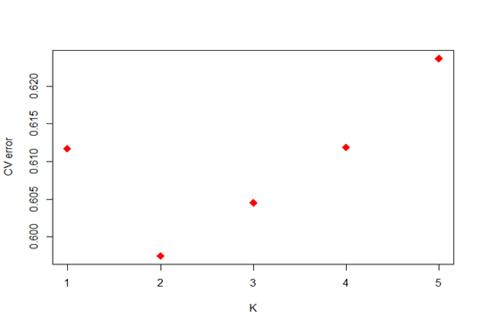

**Supplementary Figure 9:** Cross Validation (CV) Error for consecutive values of K in the ancestry analysis. The CV error is the criterion for choosing the best K in the ADMIXTURE software and the lowest value here is for K=2.

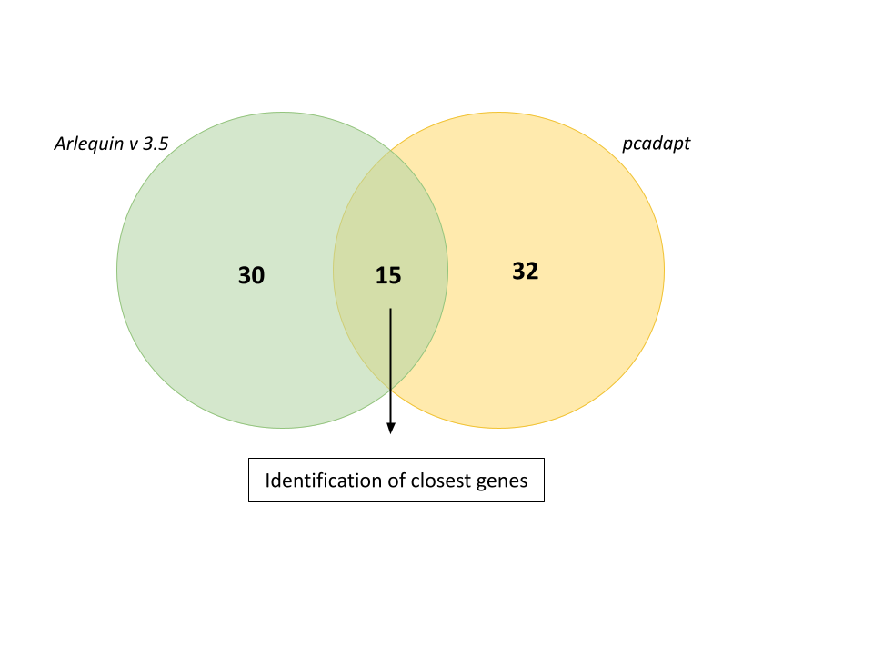

**Supplementary Figure 10:** Venn diagram representing the potential outliers that occurred by two approaches and the overlapping sites. Thirty loci were identified by Arlequin, and thirty-two by pcadapt. Fifteen loci in total were identified by both detection methods.