Supplemental Figures and Tables.
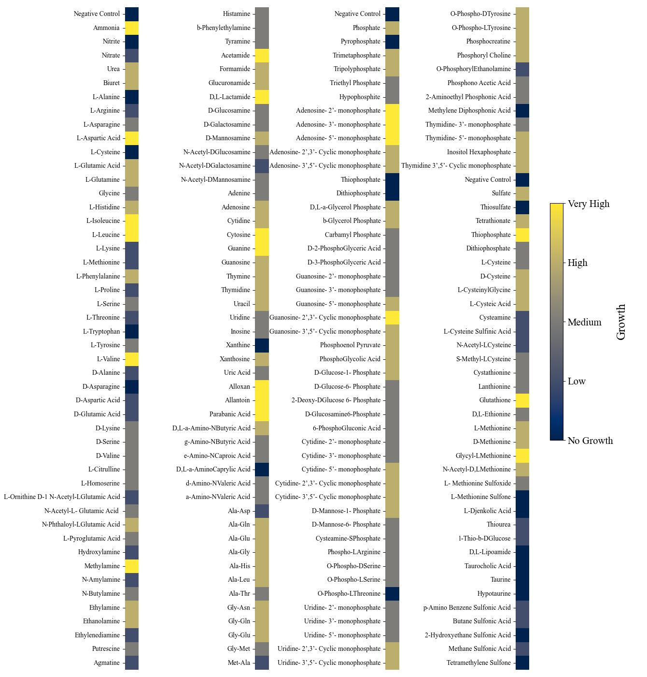
Figure S1. Biolog Results from Nitrogen (left two columns), Phosphorus (third column) and Sulfur (last column) sources. Growth was classified into categories based on the maximum OD₇₅₀ value achieved on each substrate as compared to the negative control for each nutrient source and plate.

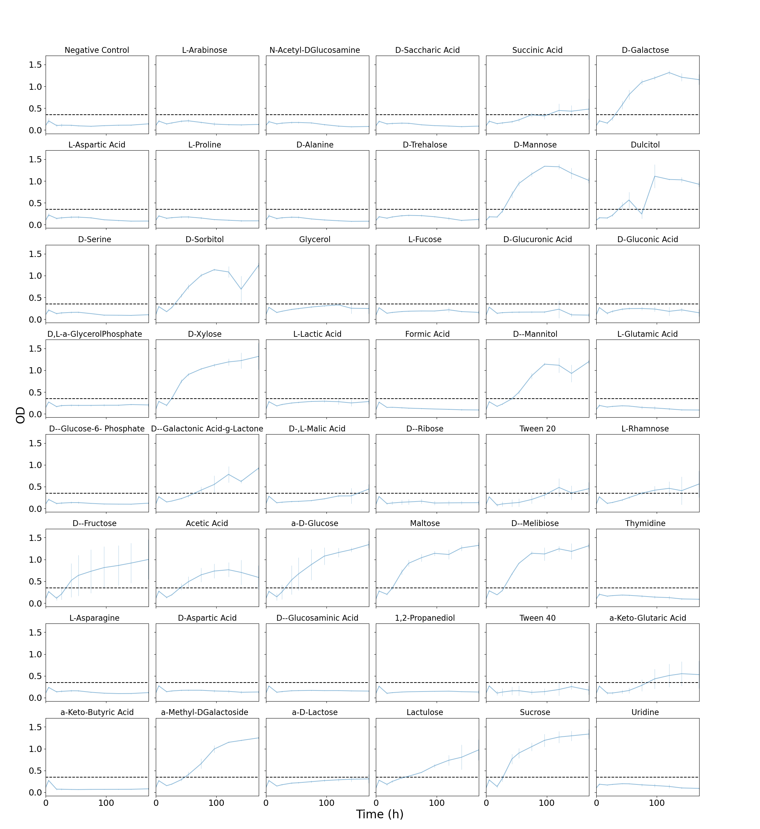
Figure S2. First set of the Biolog Growth Data for carbon sources as measured at 750 nm. Black dashed line represents the threshold for growth/no growth set based on the negative control value.
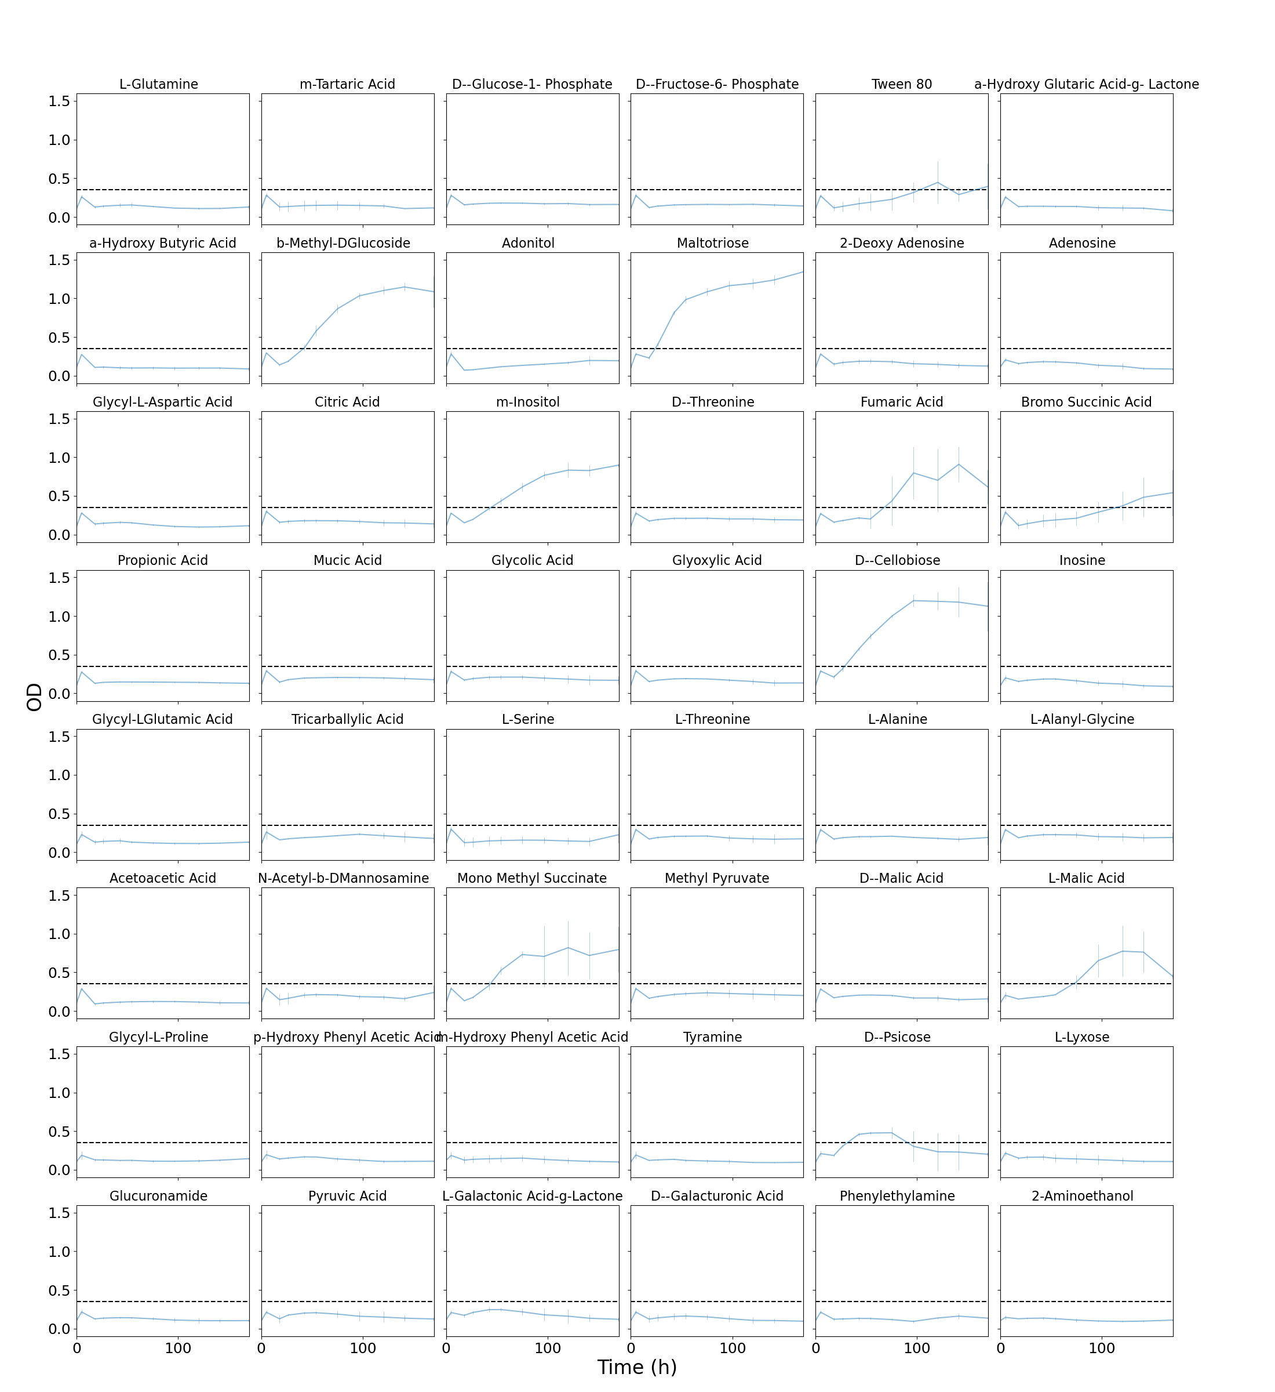
Figure S3. Second set of the Biolog Growth Data for carbon sources as measured at 750 nm. Blue lines are OD measured at 750 nm. Black dashed line represents the threshold for growth/no growth set based on the negative control value (as displayed in Figure S1).
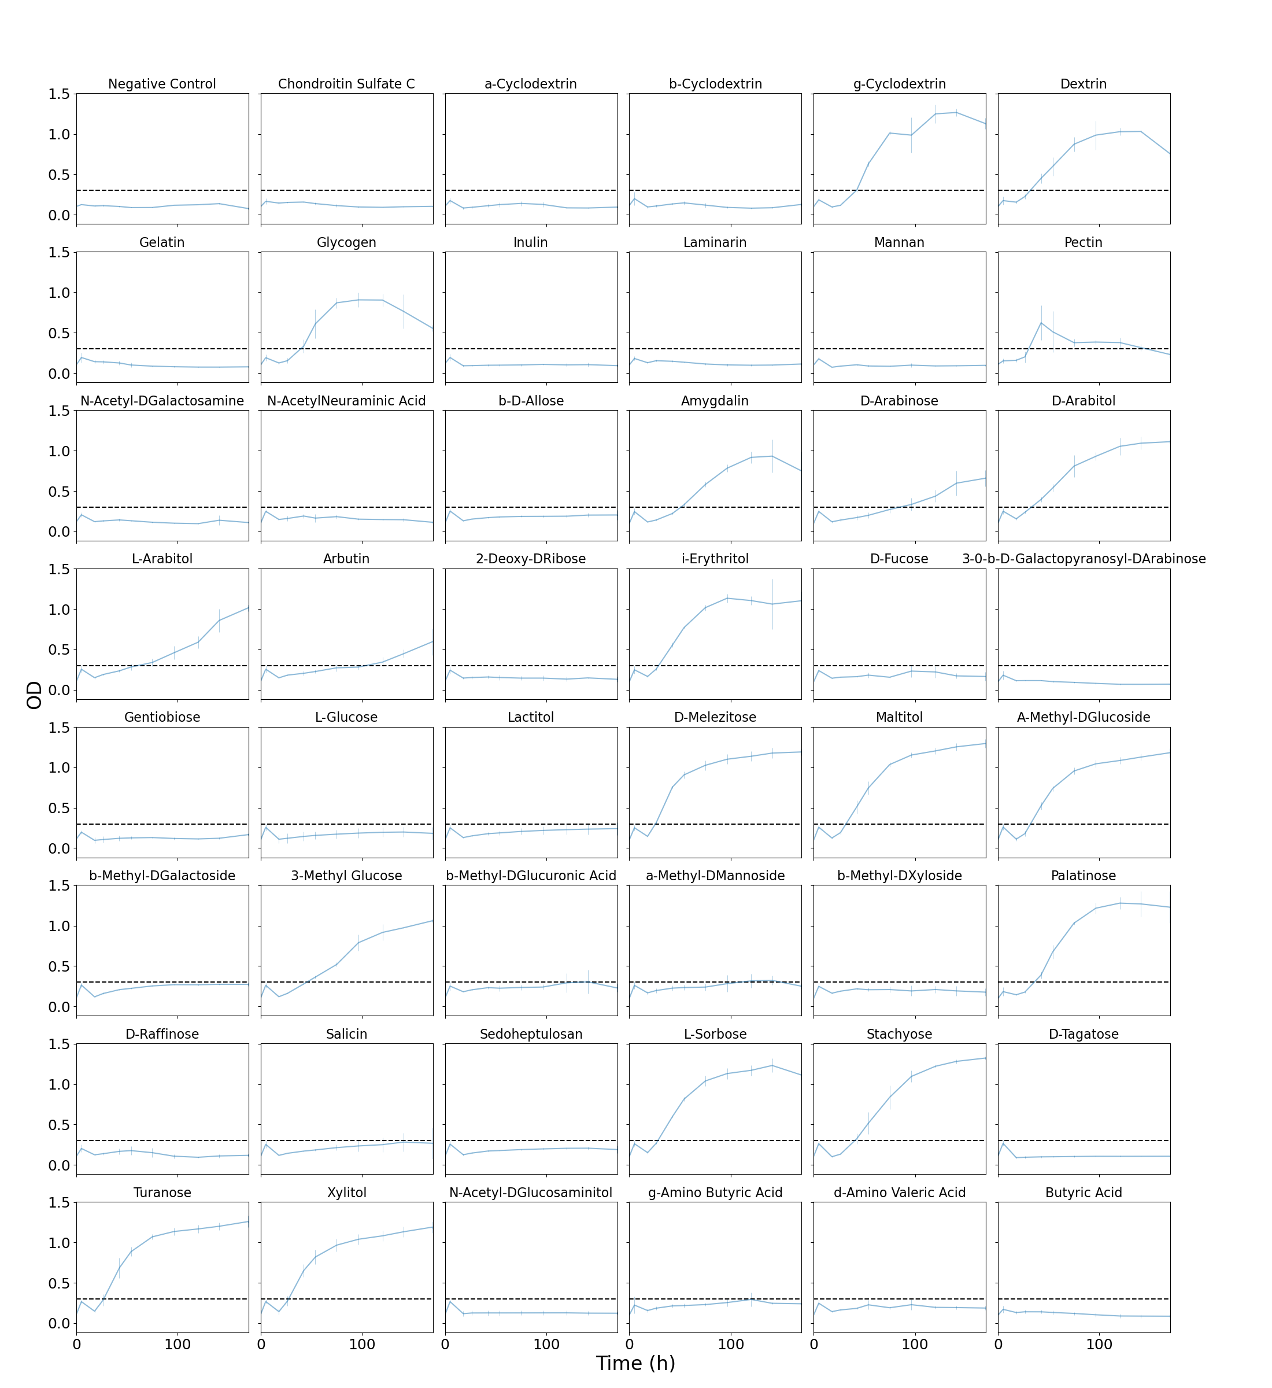
Figure S4. Third set of the Biolog Growth Data for carbon sources as measured at 750 nm. Blue lines are OD measured at 750 nm. Black dashed line represents the threshold for growth/no growth set based on the negative control value.

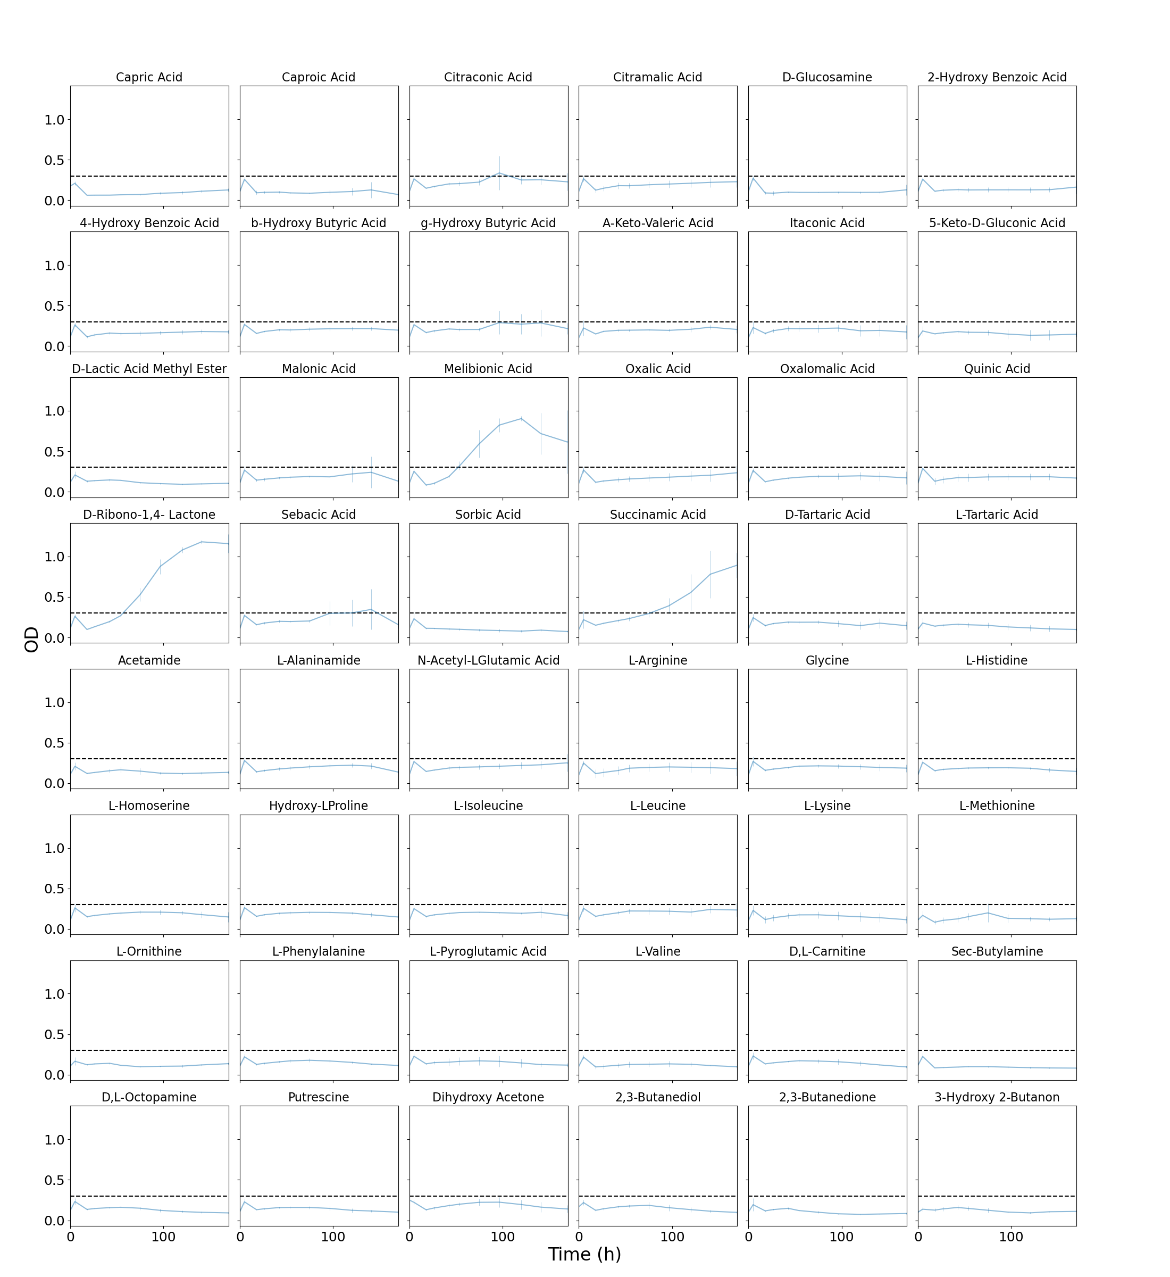
Figure S5. Fourth set of the Biolog Growth Data for carbon sources as measured at 750 nm. Blue lines are OD measured at 750 nm. Black dashed line represents the threshold for growth/no growth set based on the negative control value (as displayed in Figure S3).

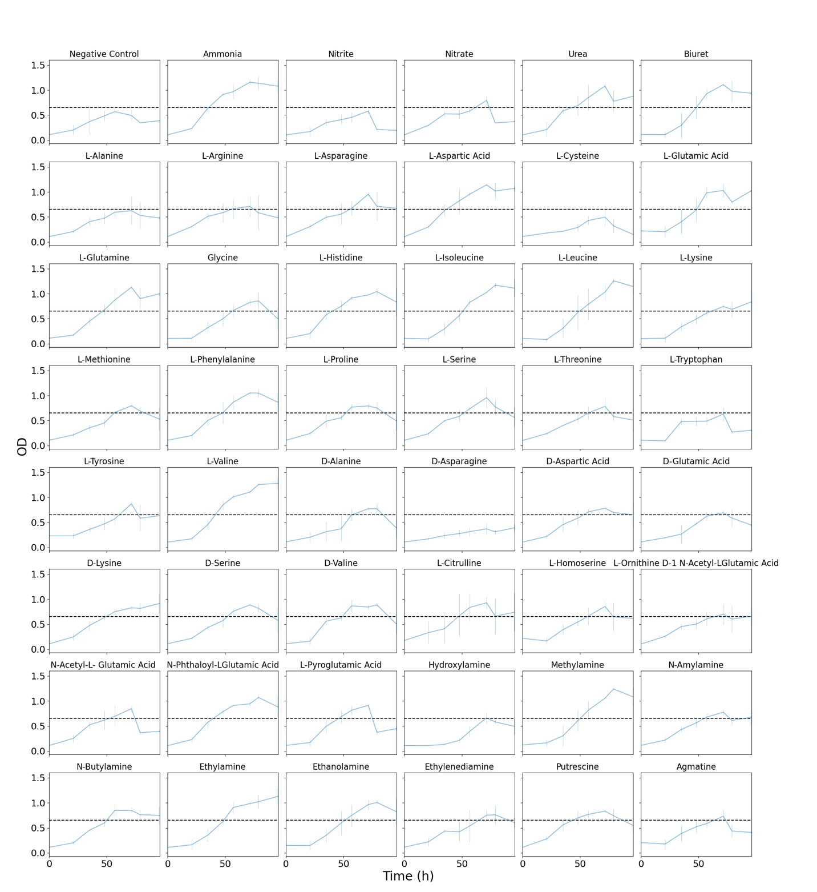
Figure S6. First half of the Biolog Growth Data for nitrogen sources as measured at 750 nm. Blue lines are OD measured at 750 nm. Black dashed line represents the threshold for growth/no growth set based on the negative control value.

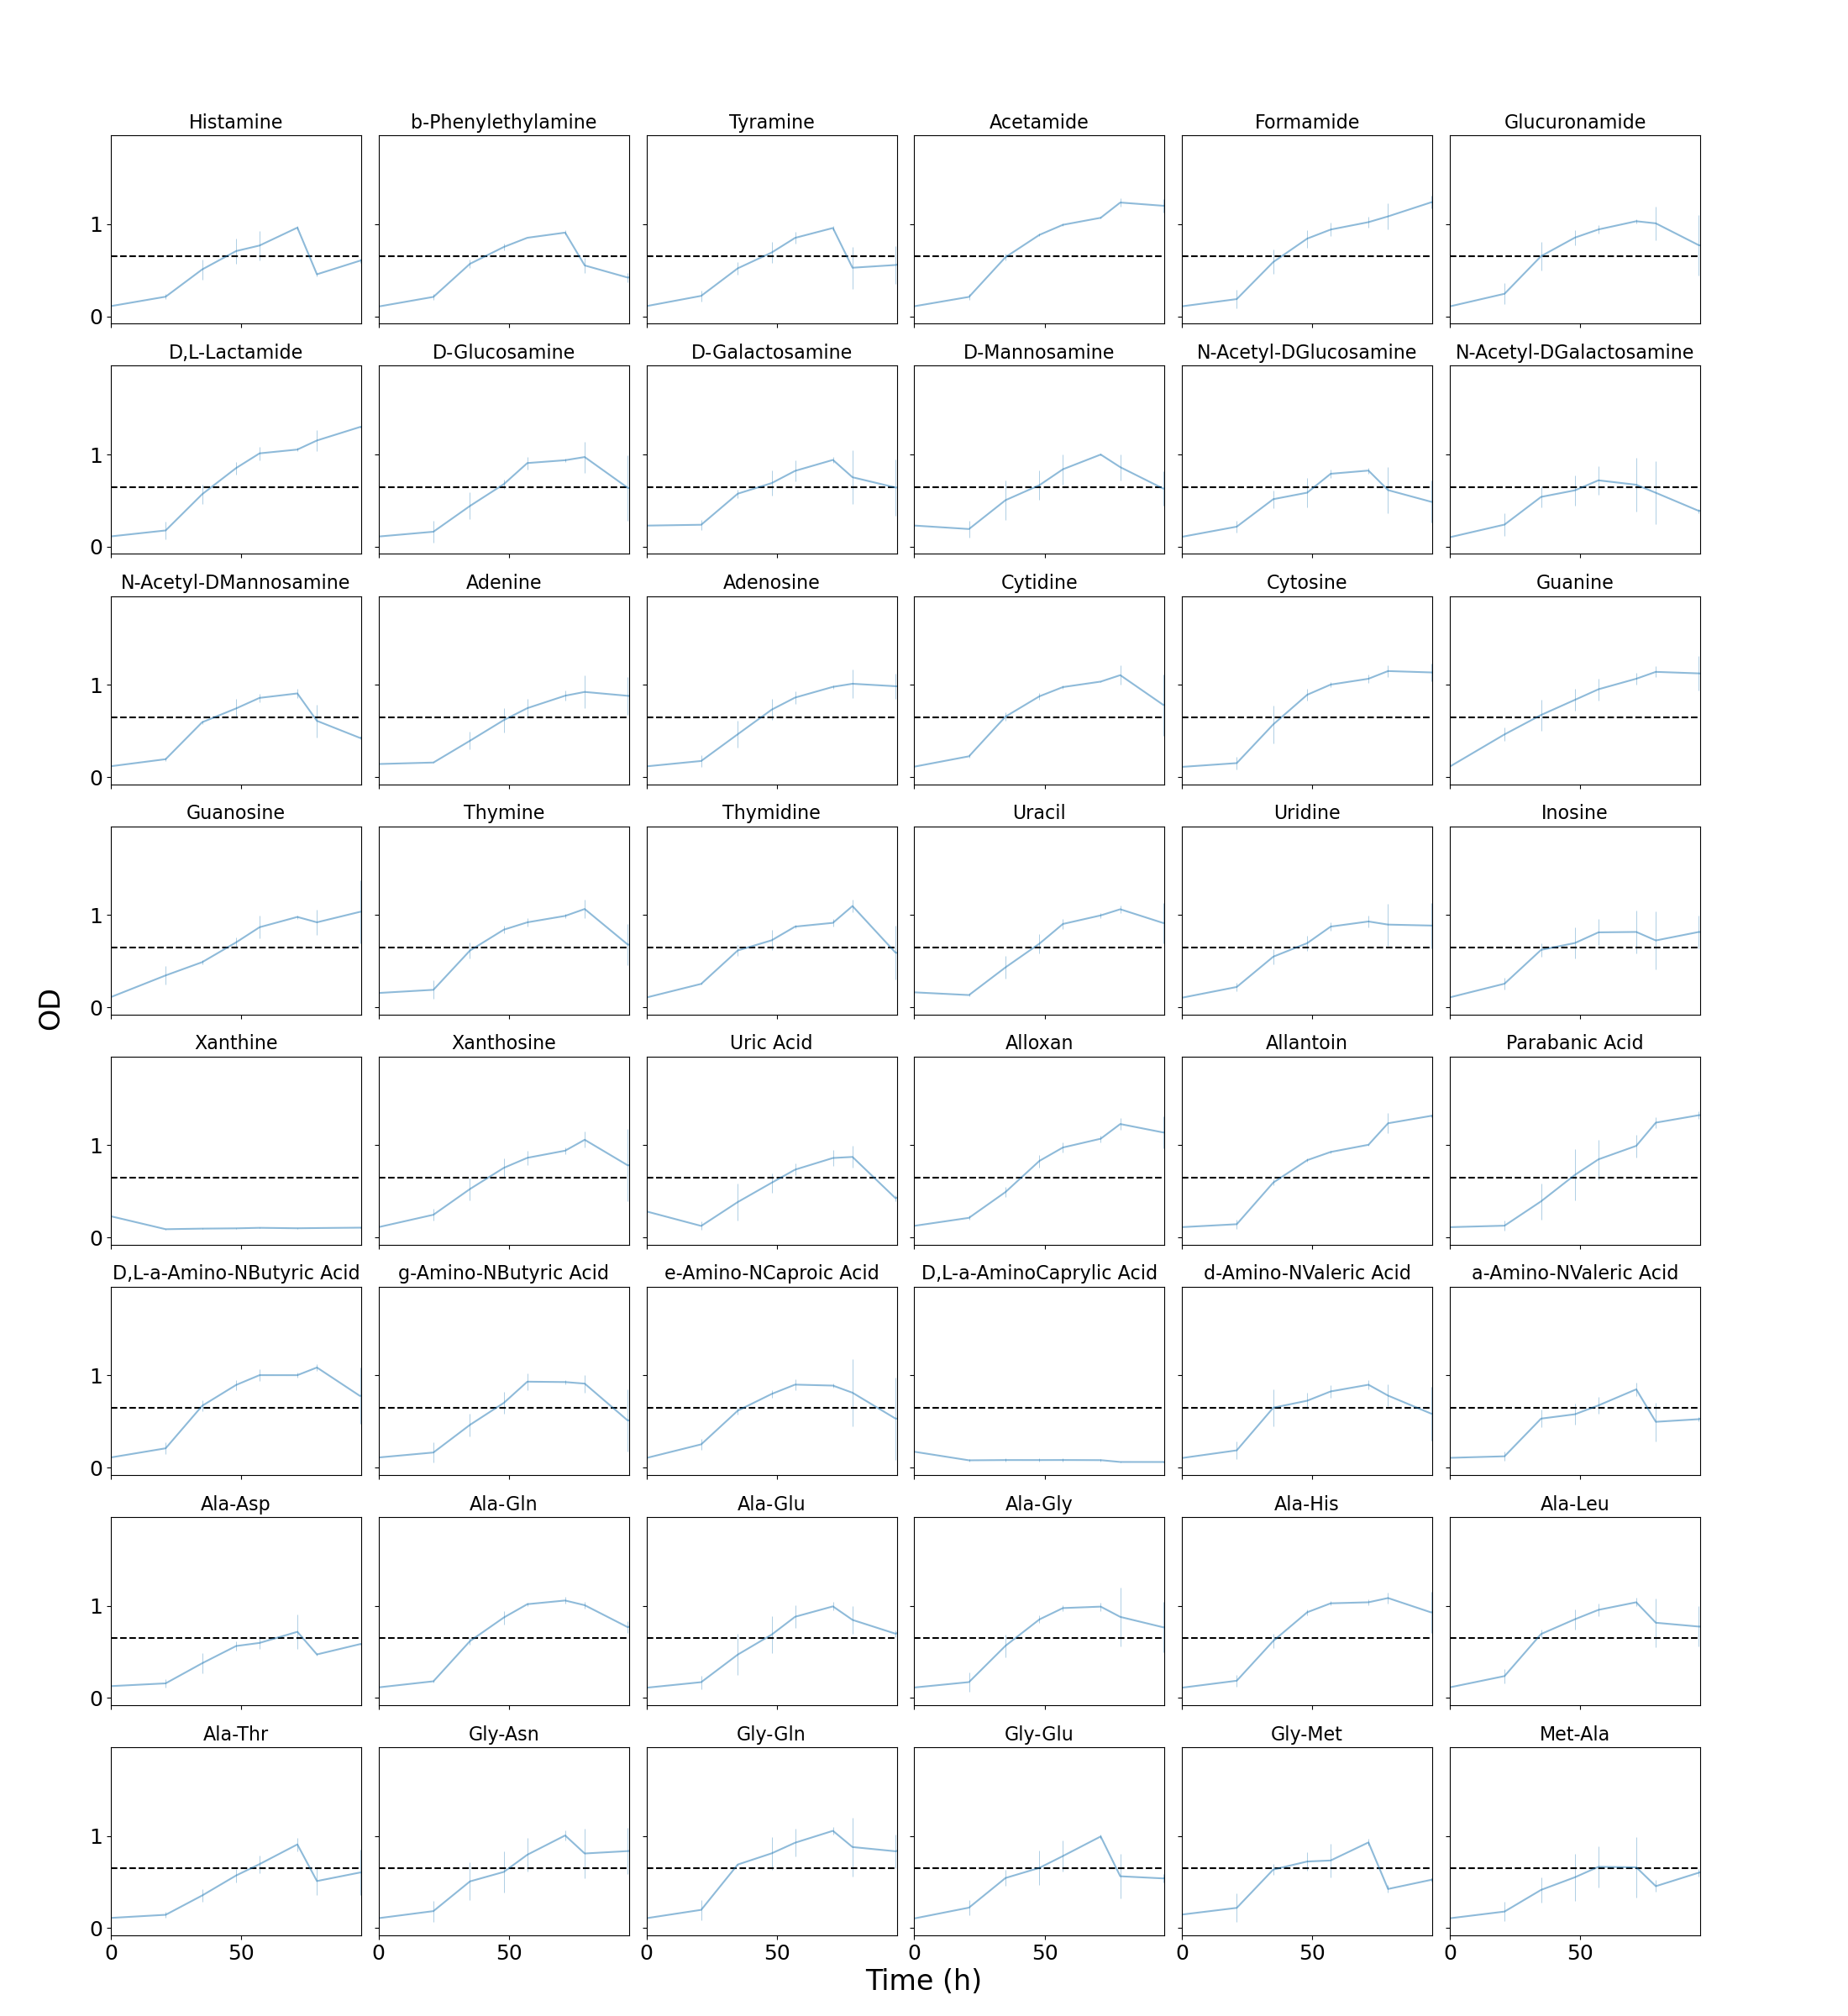
Figure S7. Second half of the Biolog Growth Data for nitrogen sources as measured at 750 nm. Blue lines are OD measured at 750 nm. Black dashed line represents the threshold for growth/no growth set based on the negative control value (as displayed in Figure S5).

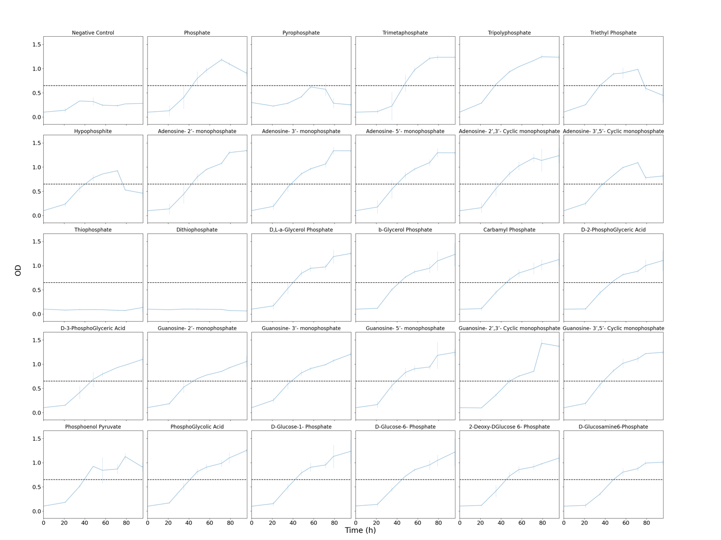
Figure S8. First set of Biolog growth data for phosphorus sources as measured at 750 nm. Blue lines are OD measured at 750 nm. Black dashed line represents the threshold for growth/no growth set based on the negative control value.
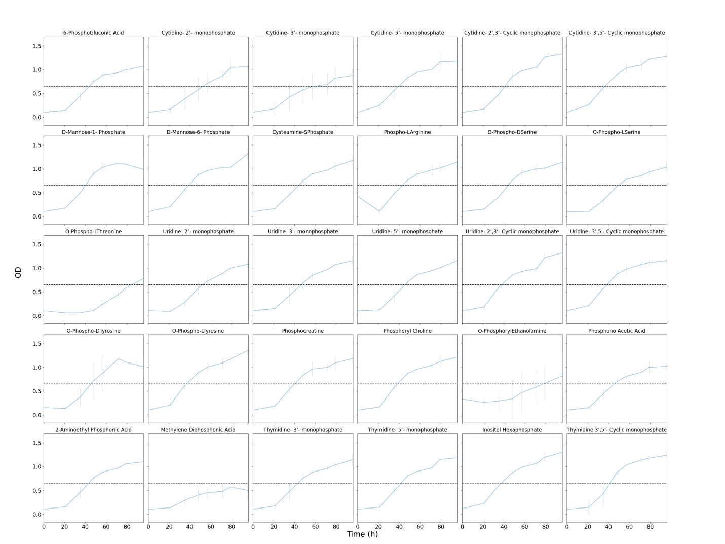
Figure S9. Second set of Biolog growth data for phosphorus sources as measured at 750 nm. Blue lines are OD measured at 750 nm. Black dashed line represents the threshold for growth/no growth set based on the negative control value.

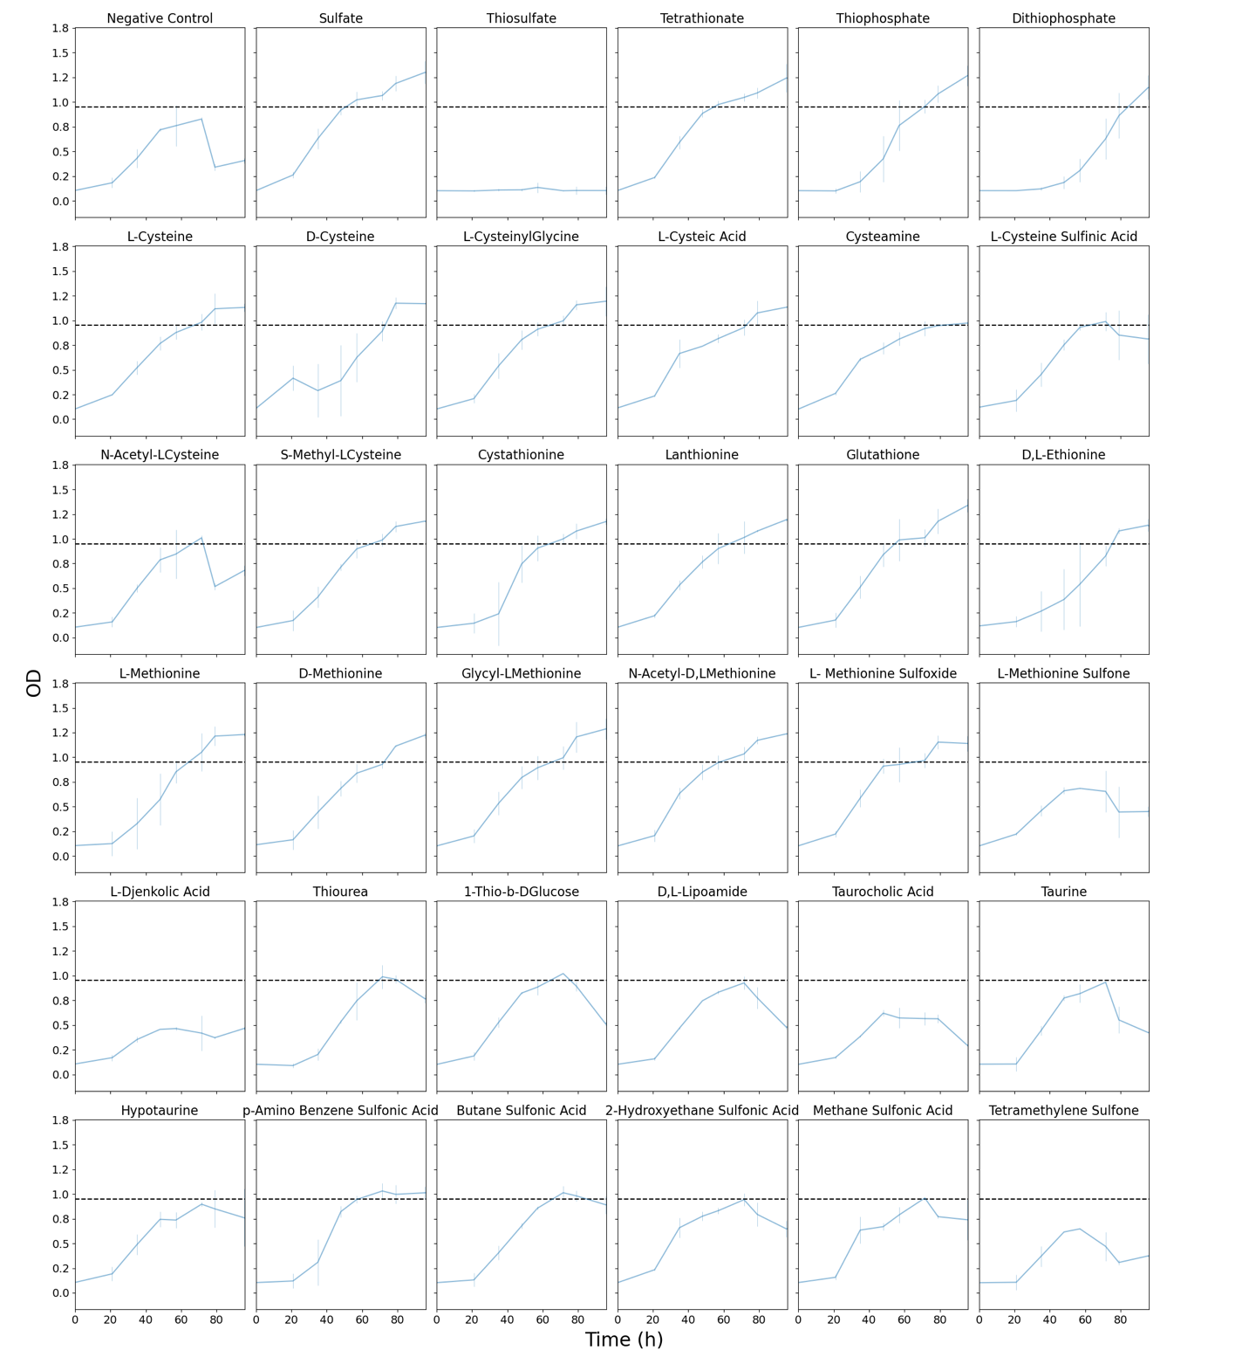
Figure S10. Biolog Growth Data for sulfur sources as measured at 750 nm. Blue lines are OD measured at 750 nm. Black dashed line represents the threshold for growth/no growth set based on the negative control value (as displayed in Figure S1).
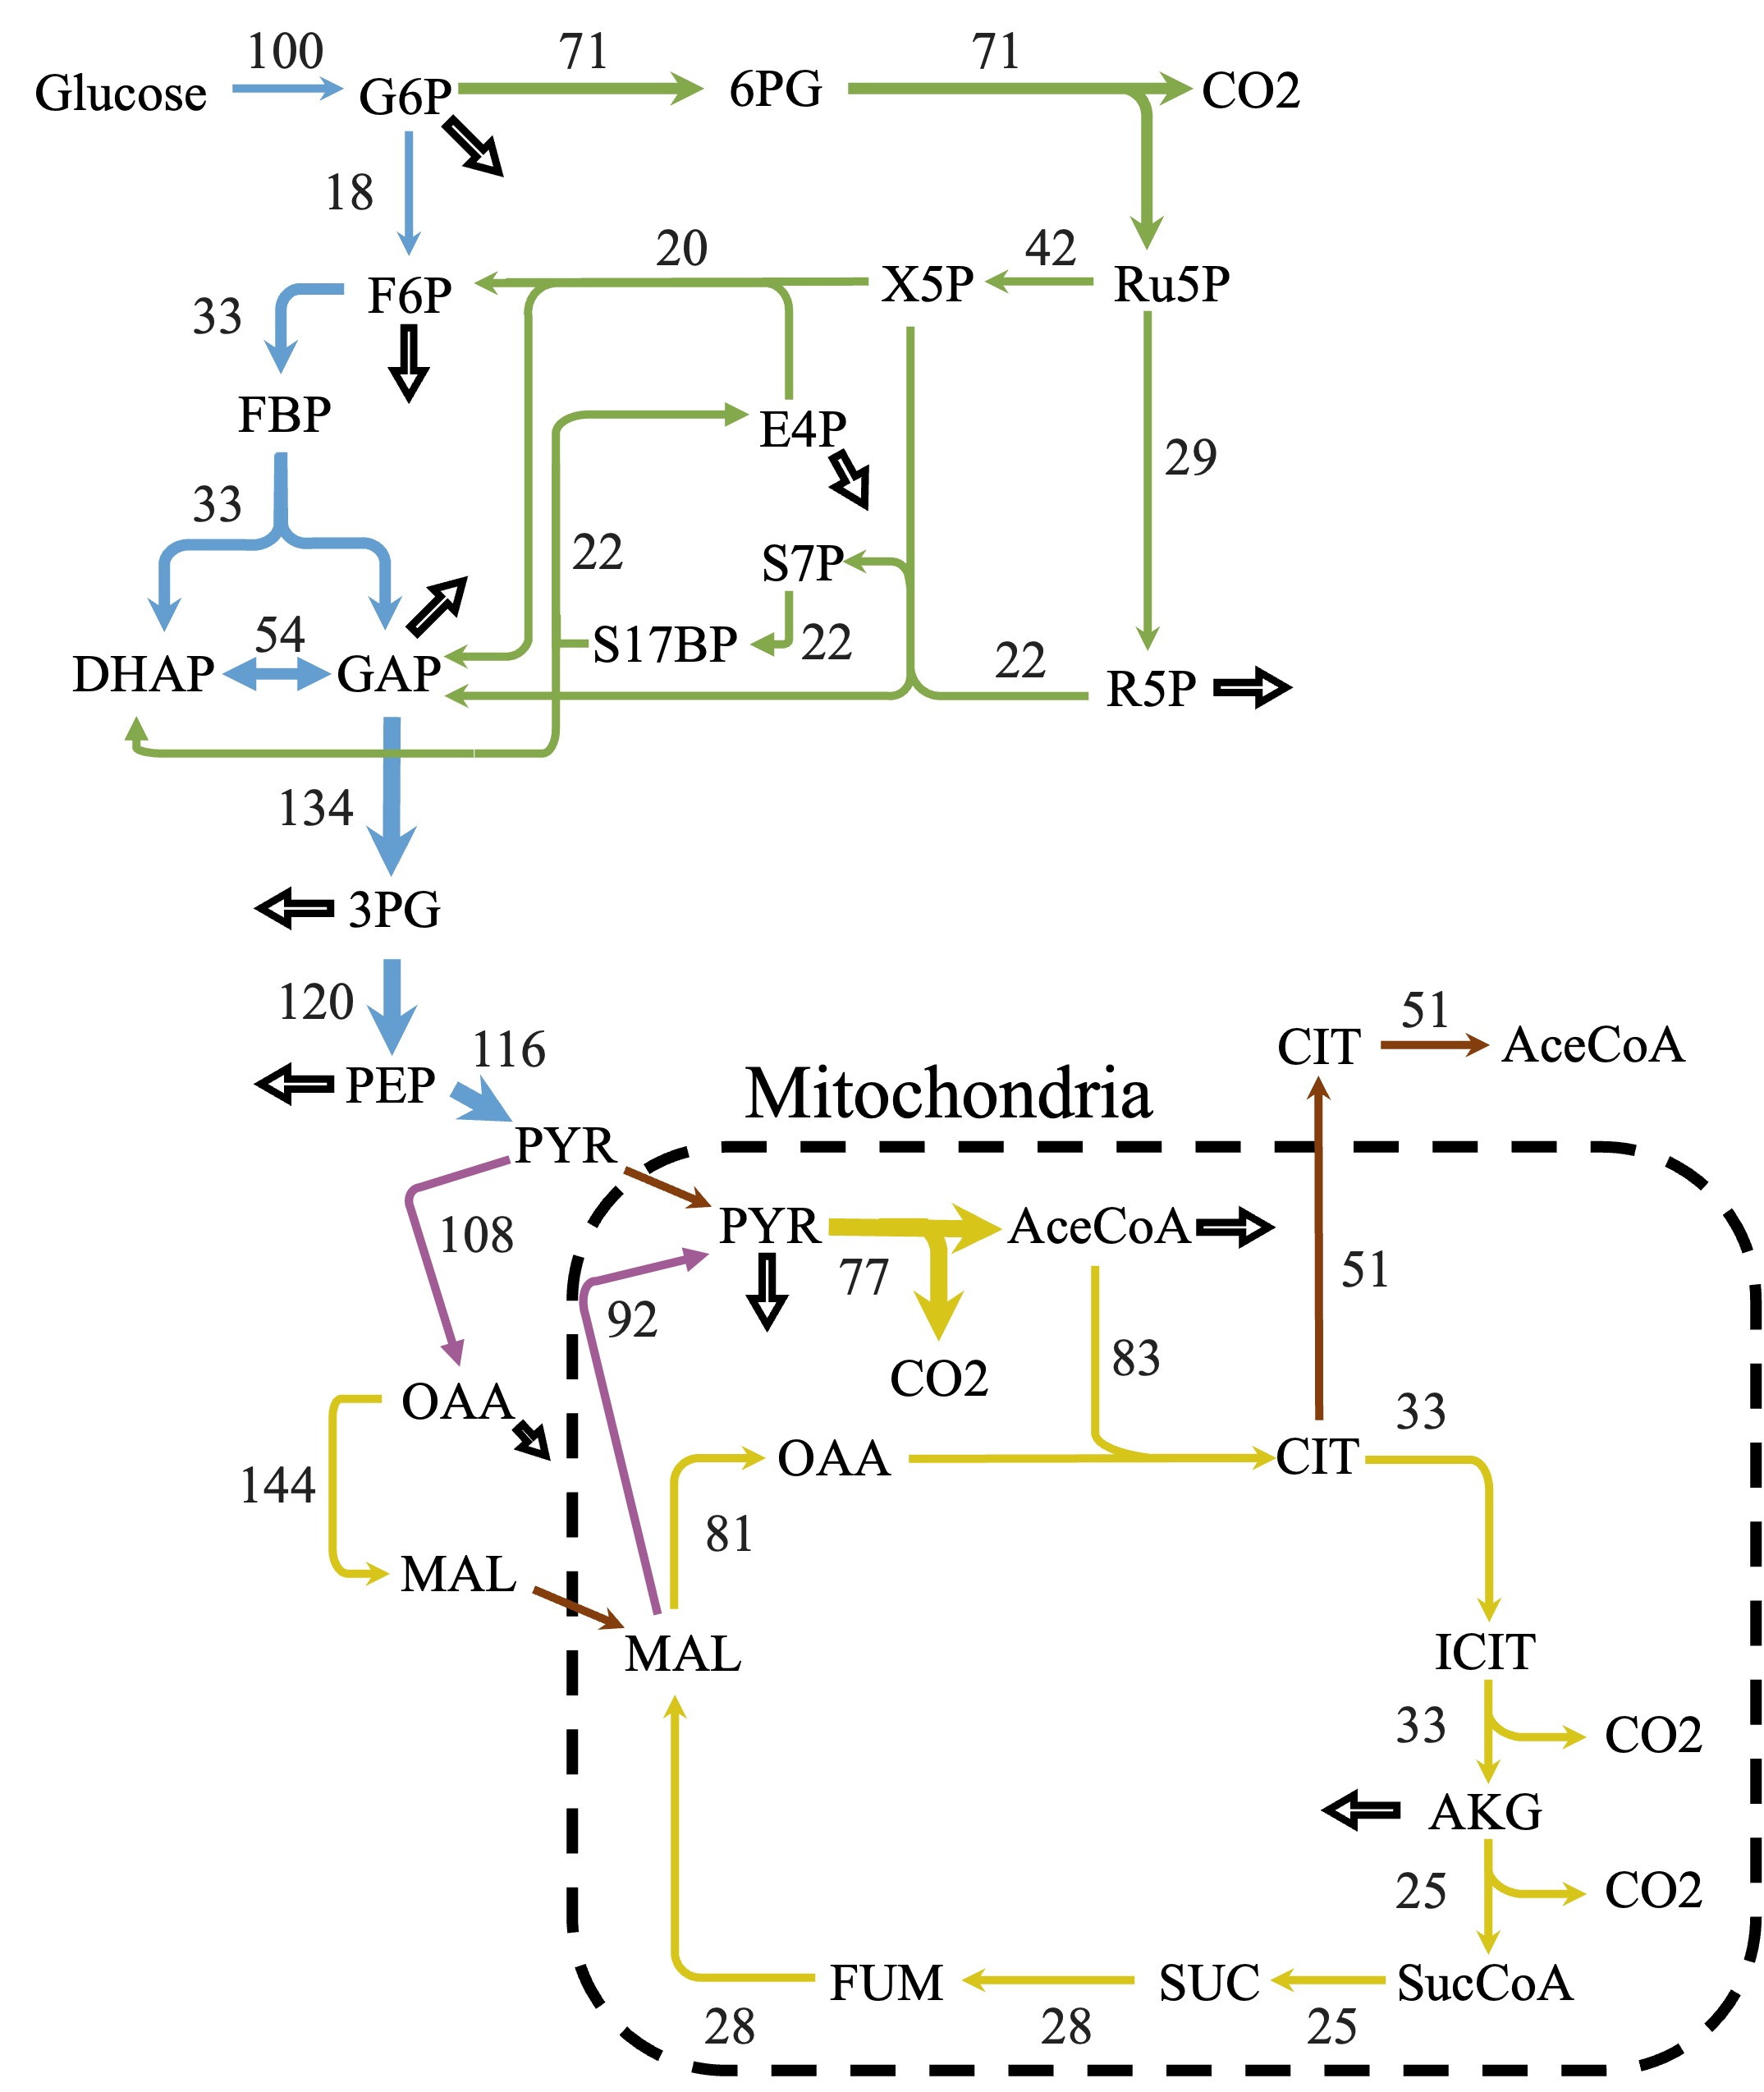
Figure S11. Predicted metabolic flux map predicted from model iLst996 when redox cycles are blocked. The central carbon predicted flux values using parsimonious flux balance analysis and with an uptake of 1 mmol/gDCW/h of glucose. Flux values were normalized to a percentage of carbon source uptake. Colors correspond to different metabolic pathways. Blue – glycolysis, Green – pentose phosphate pathway, yellow – citric acid cycle, purple – anaplerotic reactions, brown – transport reactions. Hollow arrows represent biomass drainage reactions.

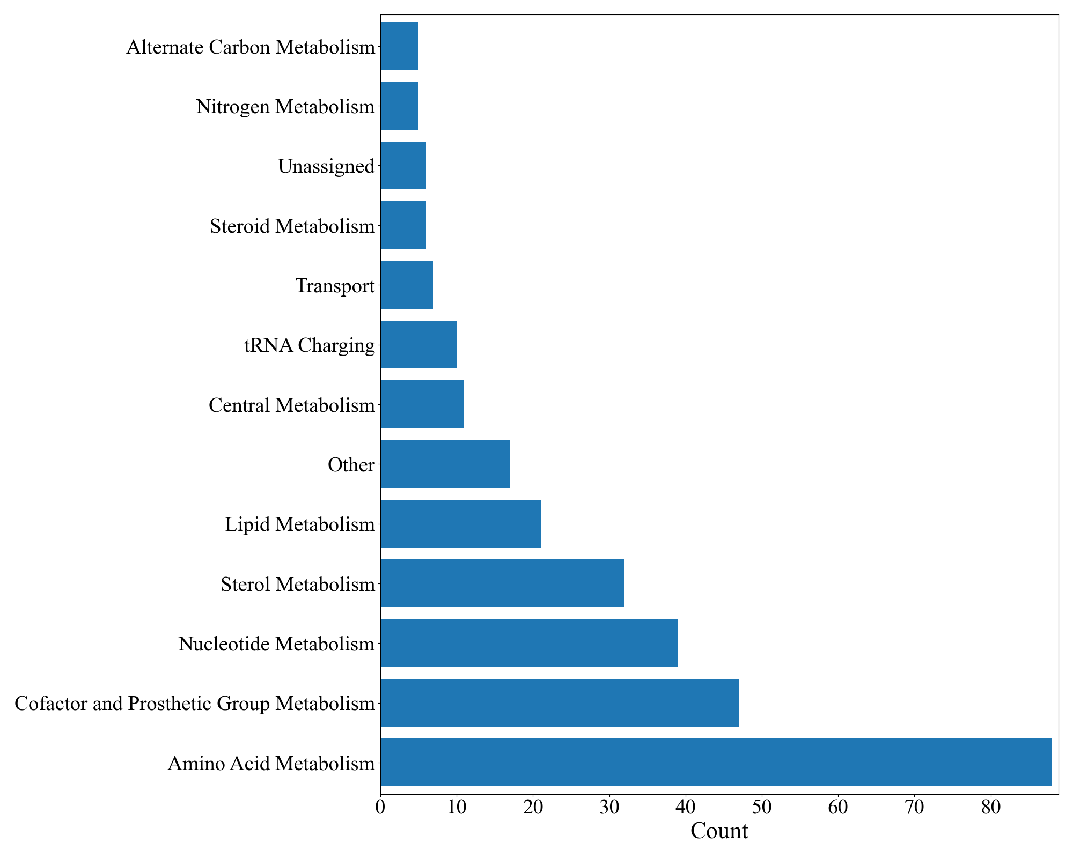
Figure S12. Pathways of Essential Genes.

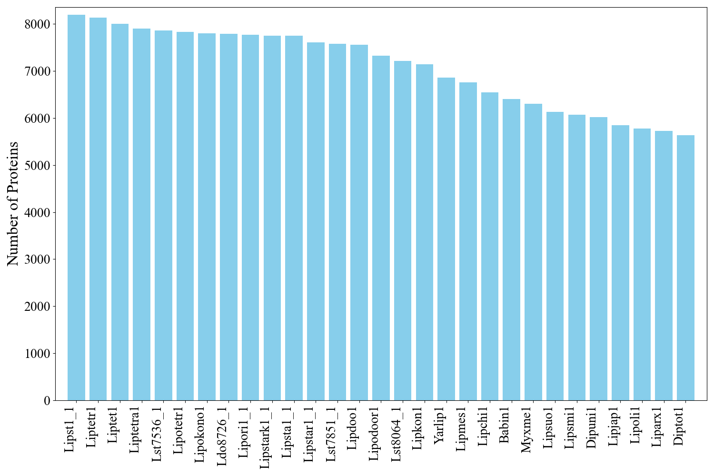
Figure S13. Protein counts of the orthoMCL analyzed species.

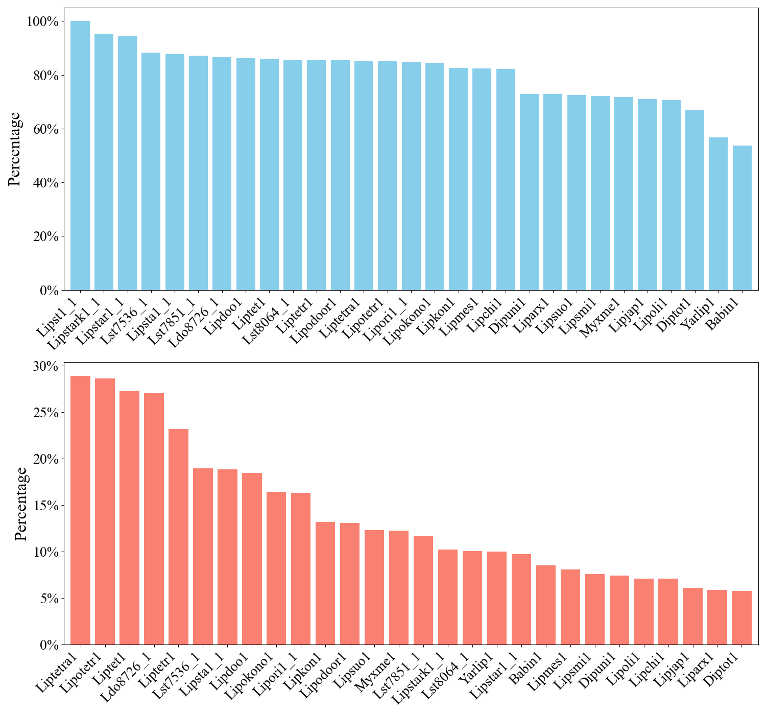
Figure S14. Percent presence of species’ genes in groups with a L. starekeyi NRRL Y-11557 gene (top) and those without (bottom).

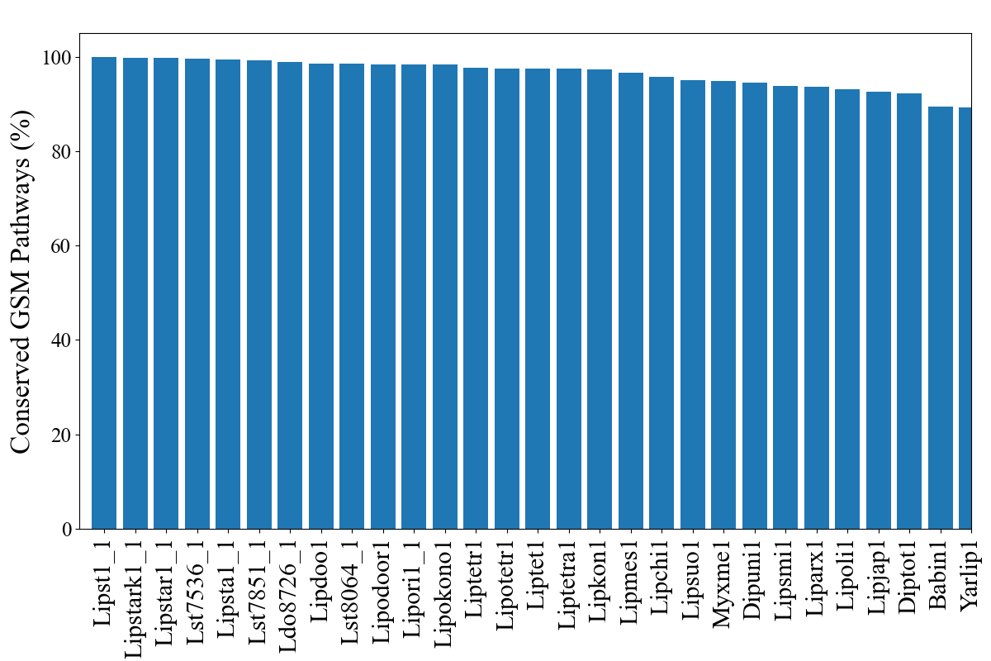
Figure 15. Precent of conserved GSM reactions in each organism. The percentage represents the number of reactions in the GSM for which there is an ortholog gene present in the specified organism.

Tables.
Table S1. Updated L. starkeyi Biomass Equation
Reaction ID
BIOMASS_Ls | '0.6542899047921068 13BDglcn_c + 0.12116467064111869 16BDglcn_c + 0.0008767124745935498 5mthf_c + 0.45552 alatrna_c + 0.141799 argtrna_c + 0.132431 asntrna_c + 0.204341 asptrna_c + 96.233892 atp_c + 0.0016522920994288411 btn_m + 0.0005685306148572357 ca2_c + 0.001224527478154046 camp_c + 0.021186648694289174 chitin_c + 1.1e-05 clpn_LS_m + 0.0005261641507693166 coa_c + 0.045479 ctp_c + 0.0003587482846154432 cu2_c + 0.040268 cystrna_c + 0.003483 datp_c + 0.003166 dctp_c + 0.00278 dgtp_c + 0.003587 dttp_c + 0.005033 ergst_r + 1e-05 ergstest_LS_r + 0.0005131808795165673 fad_c + 0.00040794804936270397 fe2_c + 0.00040794804936270397 fe3_c + 0.115471 glntrna_c + 0.199788 glutrna_c + 0.3540121239284534 glycogen_c + 0.442117 glytrna_c + 0.0013119937265936208 gthrd_c + 0.050529 gtp_c + 92.341901 h2o_c + 0.0004721810755605166 hemeA_m + 0.060743 histrna_c + 0.201923 iletrna_c + 0.4002284696078455 k_c + 0.293113 leutrna_c + 0.0021231065148574896 lipopb_m + 0.16701 lystrna_c + 0.5520903768009253 mannan_r + 0.065101 mettrna_c + 0.0421723983491937 mg2_c + 0.0008828624451869573 mlthf_c + 0.00041478135002204577 mn2_c + 0.017834231390816097 na1_c + 0.0006067970985495497 nad_c + 0.0005432474024176711 nadp_c + 6e-06 pa_LS_r + 0.000172 pc_LS_r + 0.000107 pe_LS_r + 0.108322 phetrna_c + 0.20874 protrna_c + 4.3e-05 ps_LS_r + 0.010348 psphings_r + 4.2e-05 ptd1ino_LS_r + 0.0044580453501545745 ptrc_c + 0.0016399921582420259 pydx5p_c + 0.0005056642487912913 q9_m + 0.0006764967652748358 ribflv_c + 0.40151 sertrna_c + 0.0027107703715608823 spmd_c + 0.0009067789974946536 thf_c + 0.0009518787818463092 thmpp_c + 0.226918 thrtrna_c + 0.015970790301013598 tre_c + 0.00182 triglyc_LS_r + 0.025613 trptrna_c + 0.077745 tyrtrna_c + 0.050281 utp_c + 0.273459 valtrna_c + 0.00034849833362643056 zn2_c + 0.005191 zymst_r + 1e-05 zymstest_LS_d --> 96.183832 adp_c + 96.183832 h_c + 96.183832 pi_c + 2.000000000002e-06 ppi_c'

Table S2. Lipid yields on different carbon sources (uptake set at 1 mmol/gDCW/h), at 10% biomass yields.
 | Maximum predicted growth rate (h⁻¹) | Maximum theoretical lipid yield (g TAG/g substrate) | Maximum theoretical lipid yield (Cmol TAG/ Cmol substrate)
Glucose | 0.0889 | 0.30 | 0.57
Xylose | 0.0731 | 0.29 | 0.55
Sucrose | 0.1786 | 0.31 | 0.57
Gluconate | 0.0814 | 0.25 | 0.52
Maltose | 0.1786 | 0.31 | 0.57
Glycerol | 0.0511 | 0.33 | 0.65
Acetate | 0.0227 | 0.25 | 0.47
Palmitic acid | 0.2691 | 0.83 | 0.84

